 | 
Faculty of Technology and Engineering
Chandubhai S. Patel Institute of Technology (CSPIT)
Department of Computer Science & Engineering
Date: 22/07/2026
Laboratory Manul
Academic Year | : | 2026-27 | Semester | : | 3rd
Course code | : | ITUE203 | Course name | : | WEB DEVELOPMENT FRAMEWORKS

Practical – 12:-
Event Management and Secure Poster Uploads

Problem Statement:- Develop a secure PHP and MySQL event-management module for StudentHub. The system must provide an administrator login and dashboard, allow authorised administrators to create, view, update, and delete events, display uploaded event posters, validate poster type and size, show success and error messages, and restrict unauthorised users from protected pages.
Objective:- To implement a secure event-management workflow using PHP, MySQL, sessions, prepared statements, and validated file uploads. The module provides separate administrative access, event CRUD operations, poster storage, validation feedback, and access control for the StudentHub portal.

- Admin login and dashboard:-

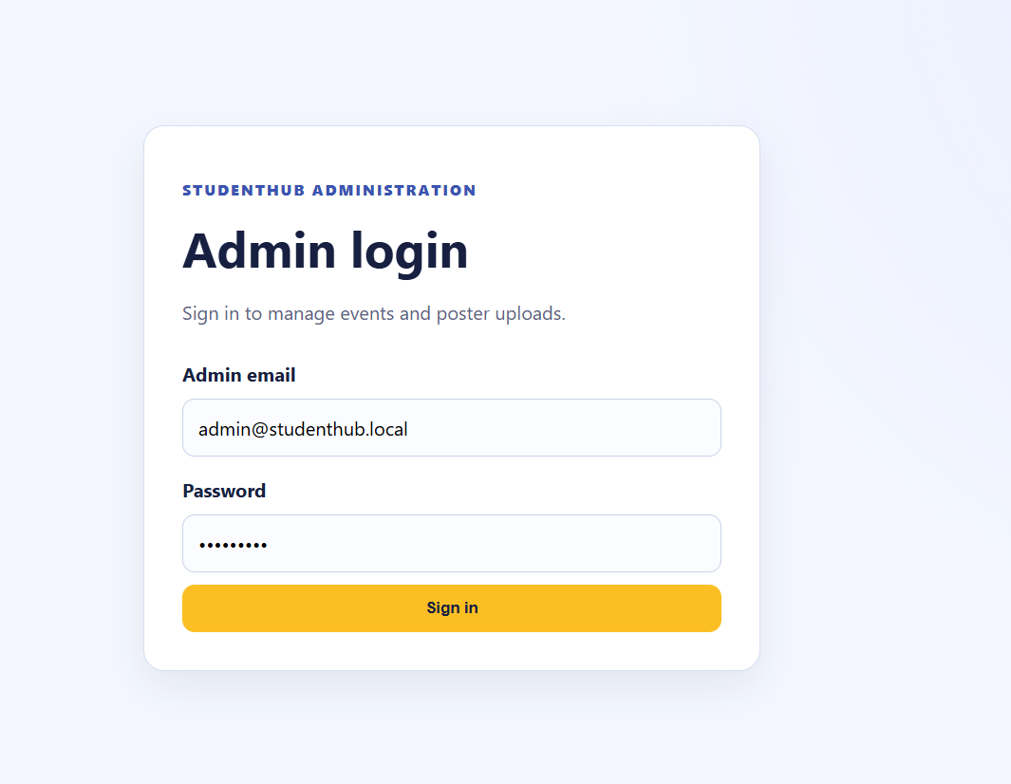

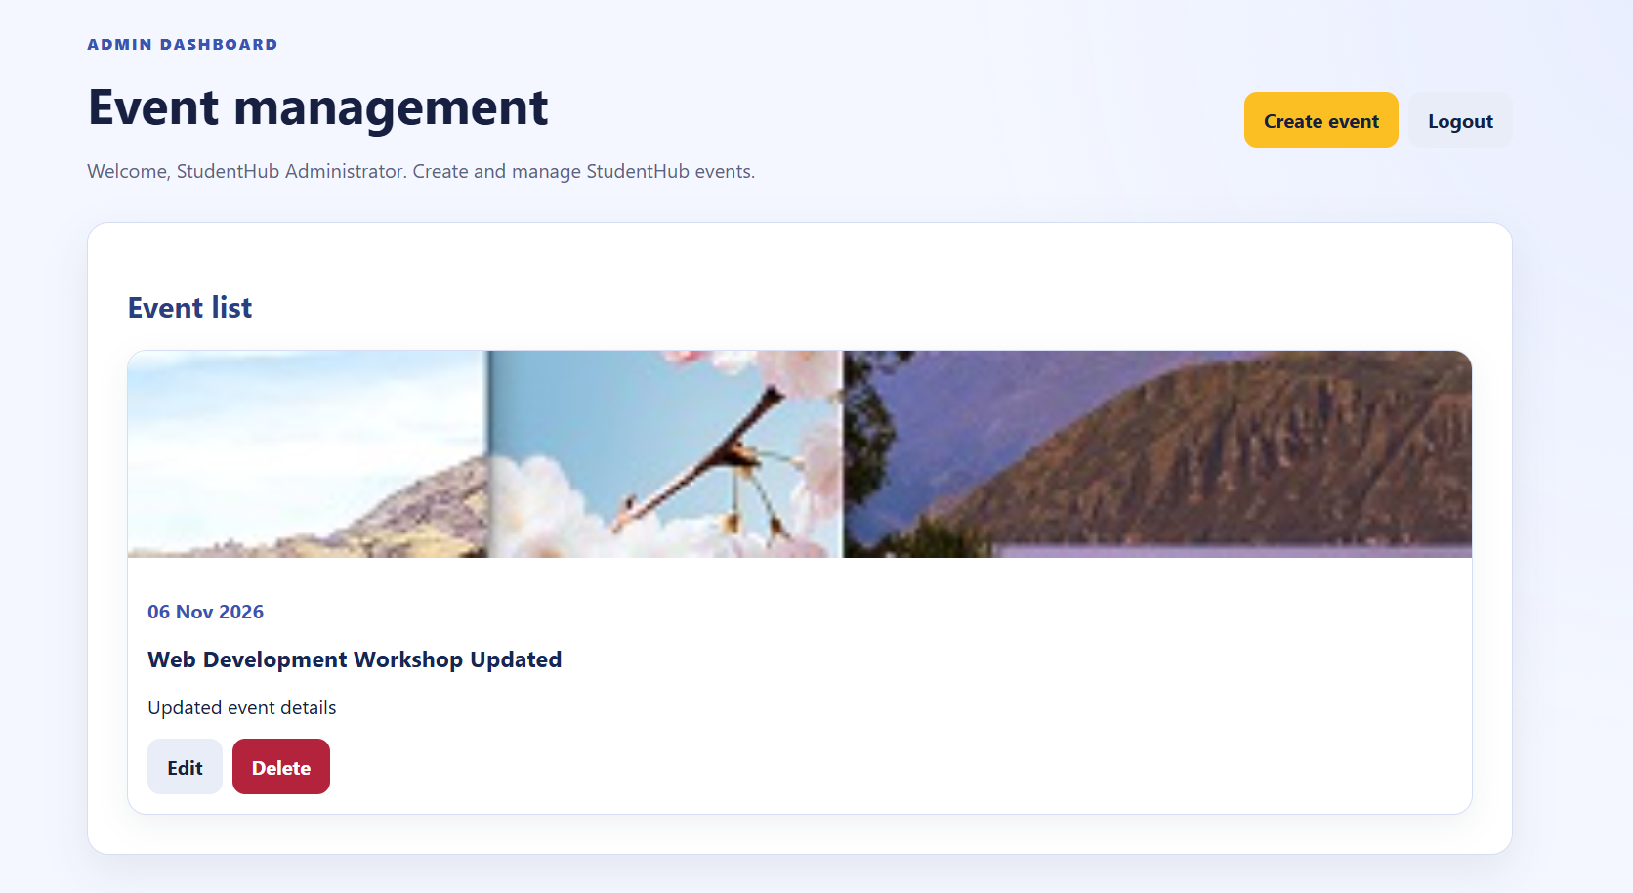

- Successful event creation:-

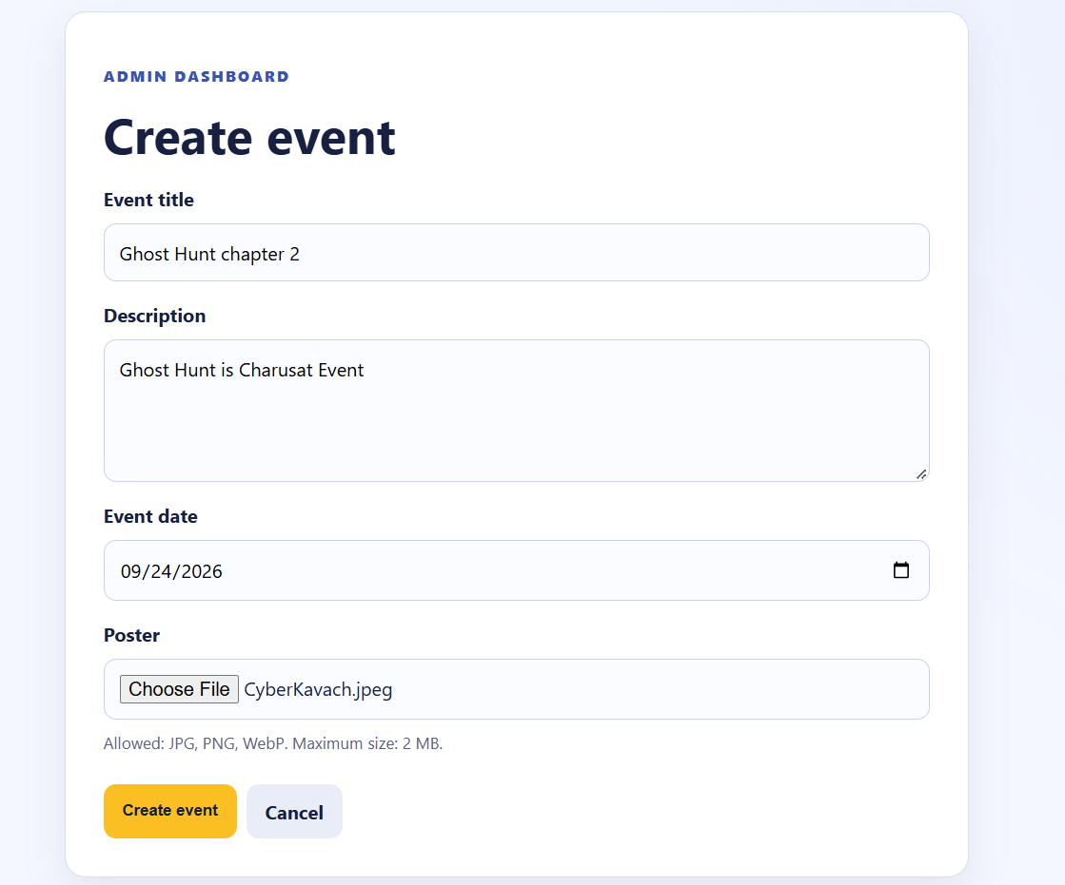

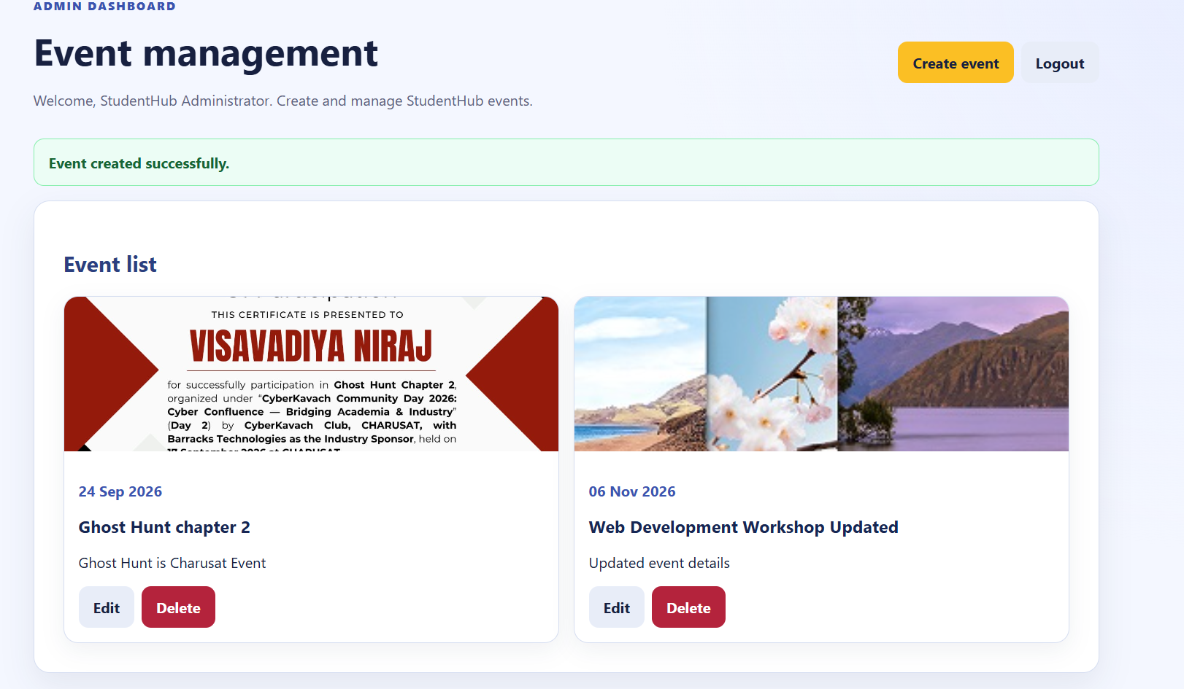

- Event list with uploaded posters:-

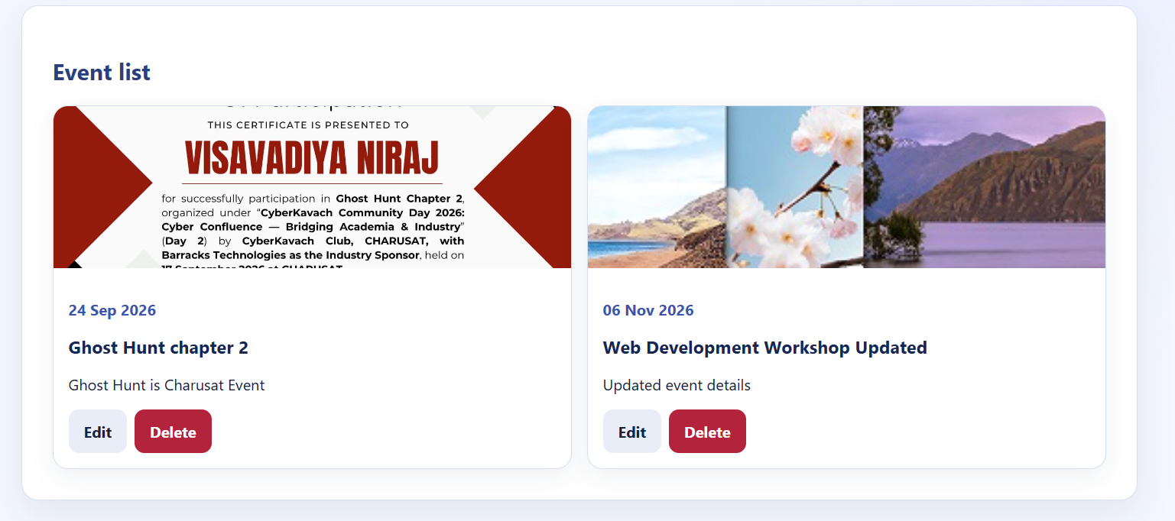

- Successful event update:-

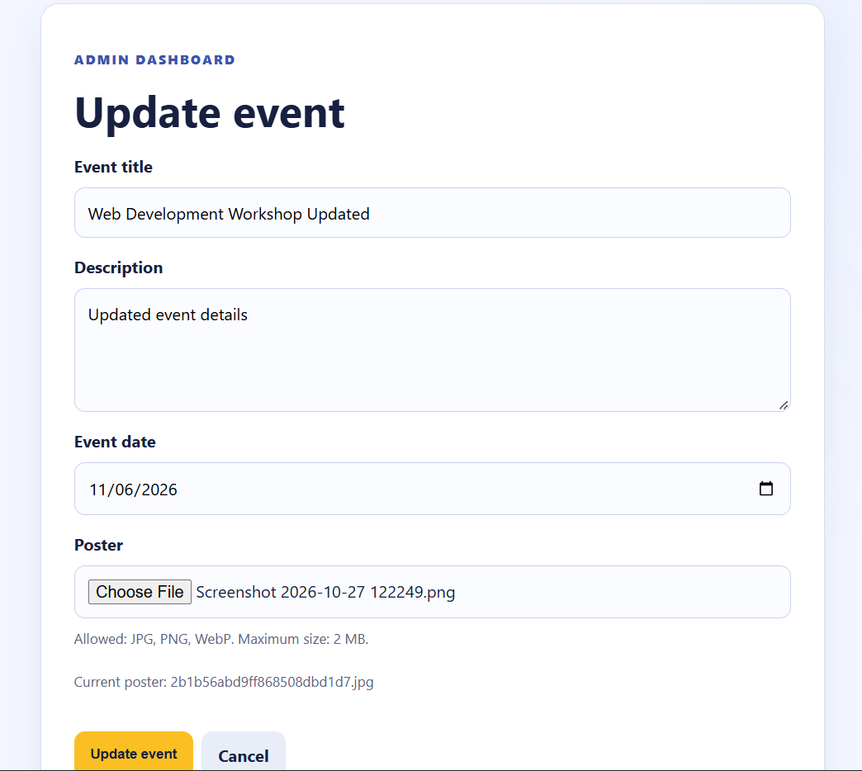

Updated Image here:-

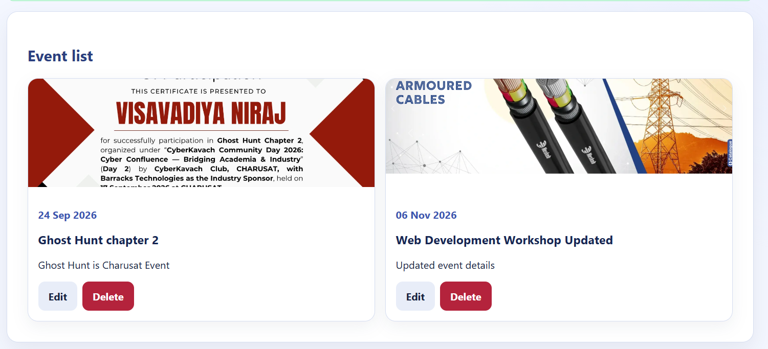

- Successful event deletion:-

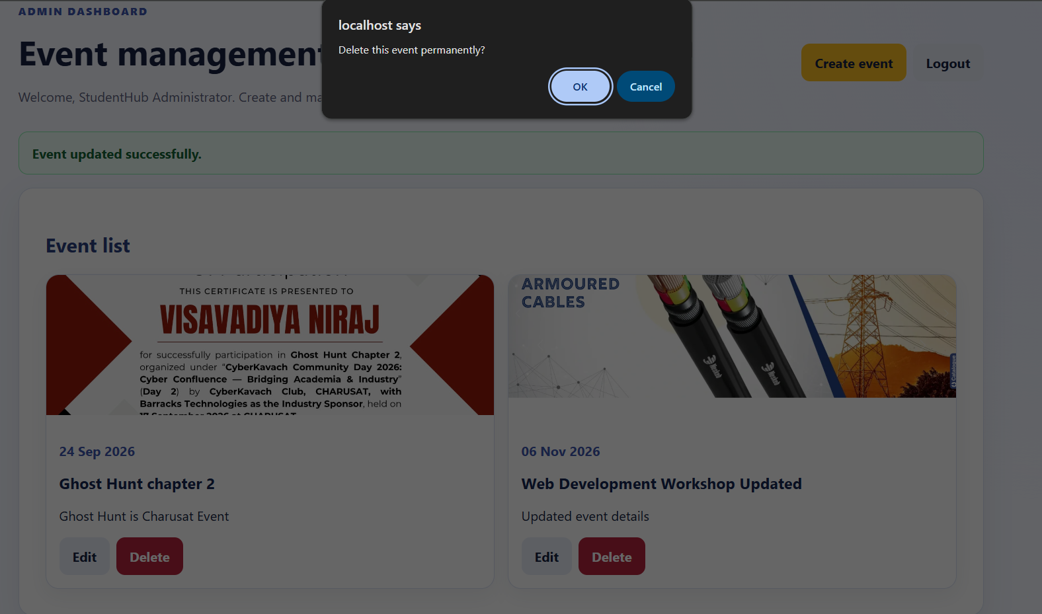

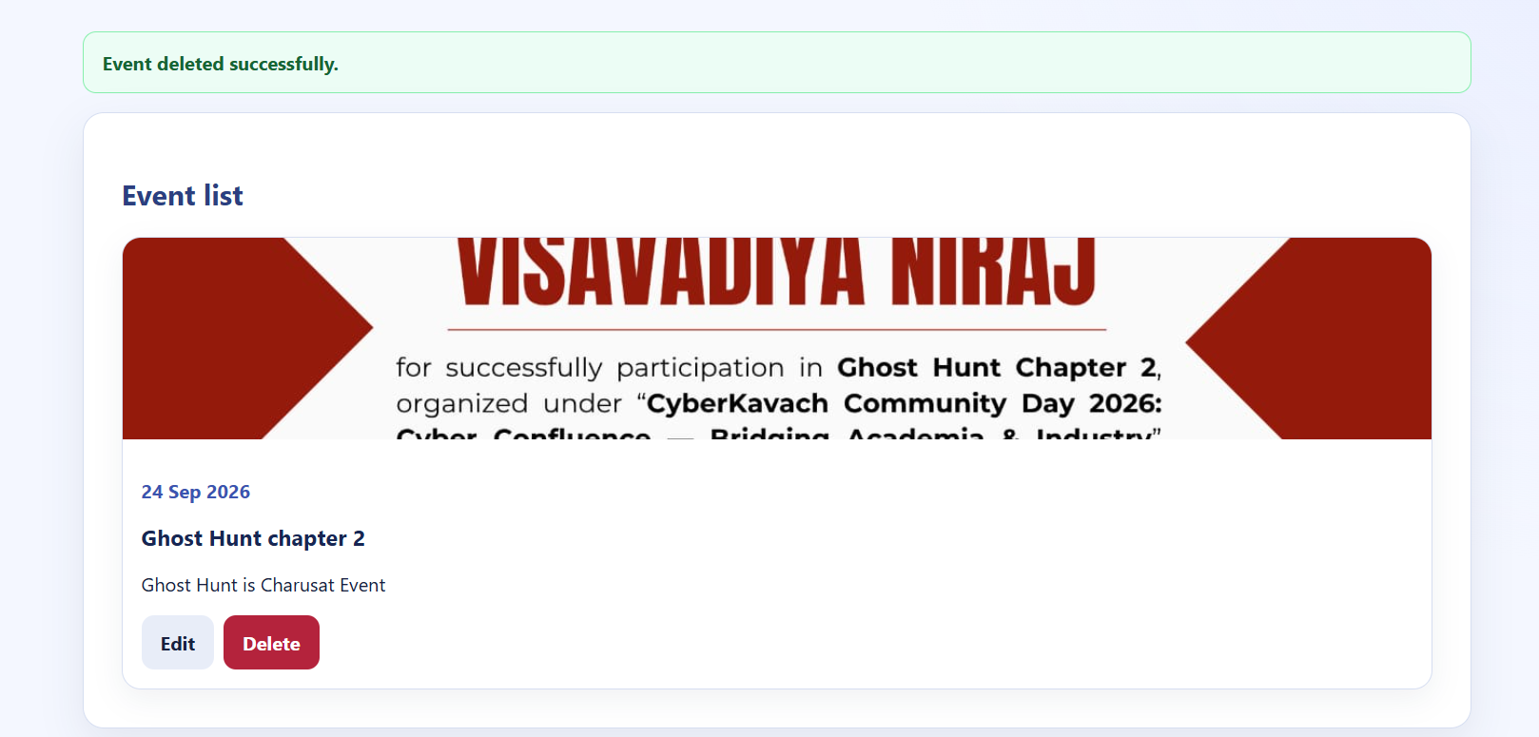

- Valid poster upload:-

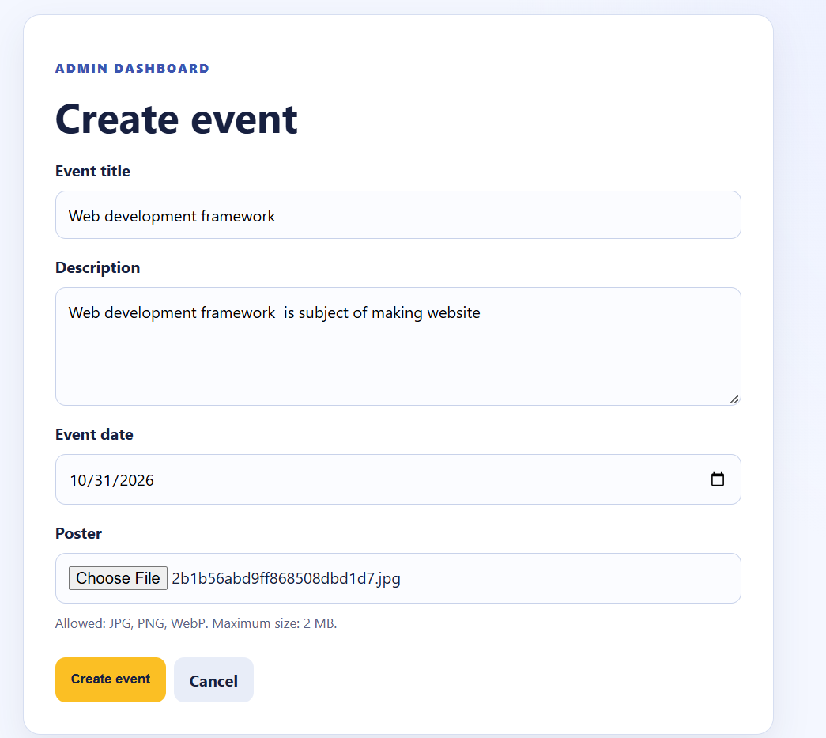

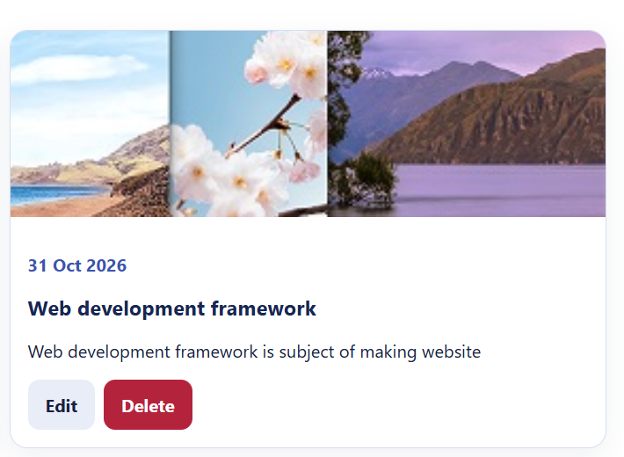

- Invalid file type validation:-

Allowed only JPS,PNG,WebP:-

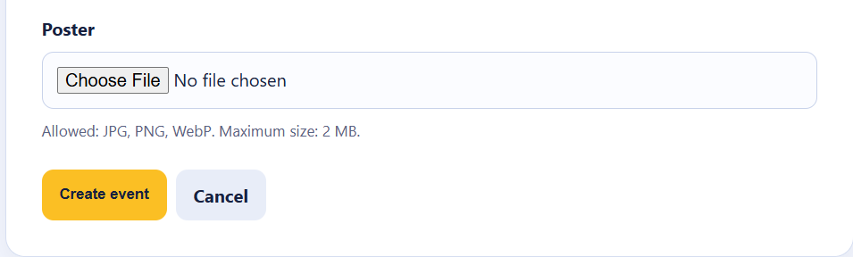

- File size limit validation:-

Allowed max size 2Mb:-

- Success and error messages:-

Success:-
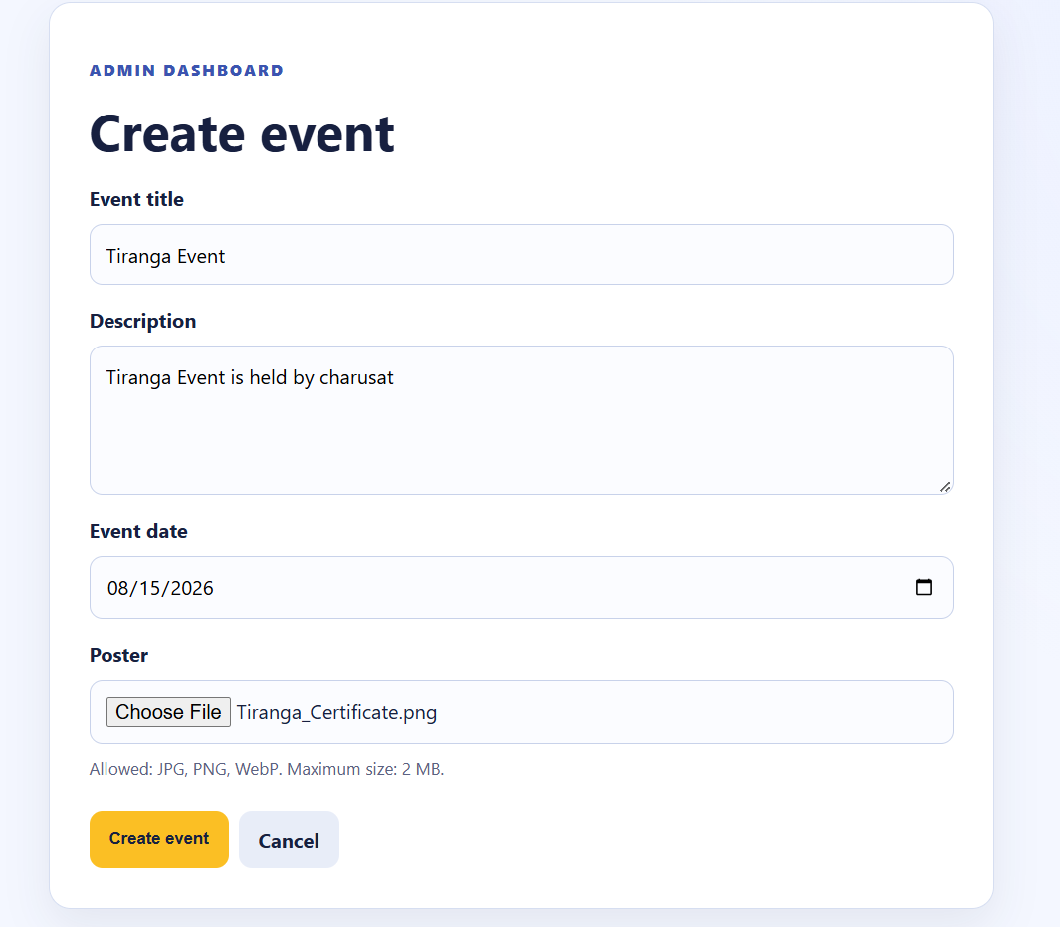

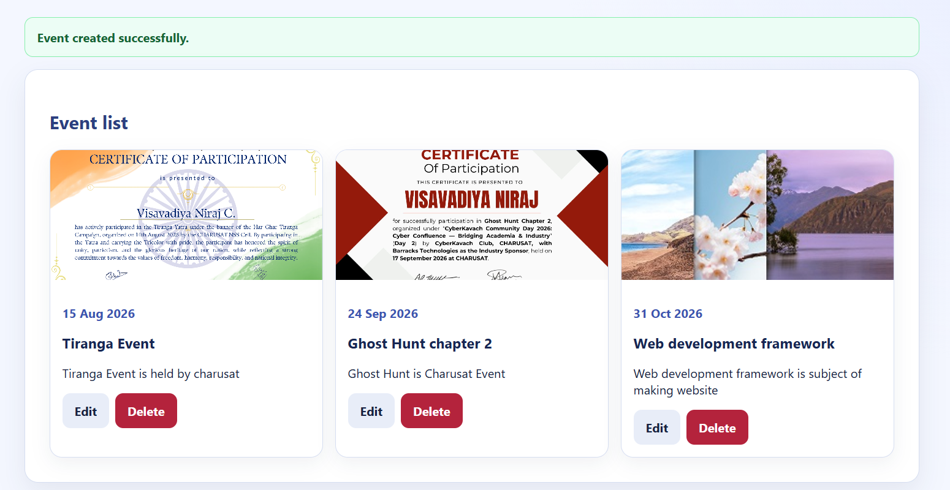

Error:-

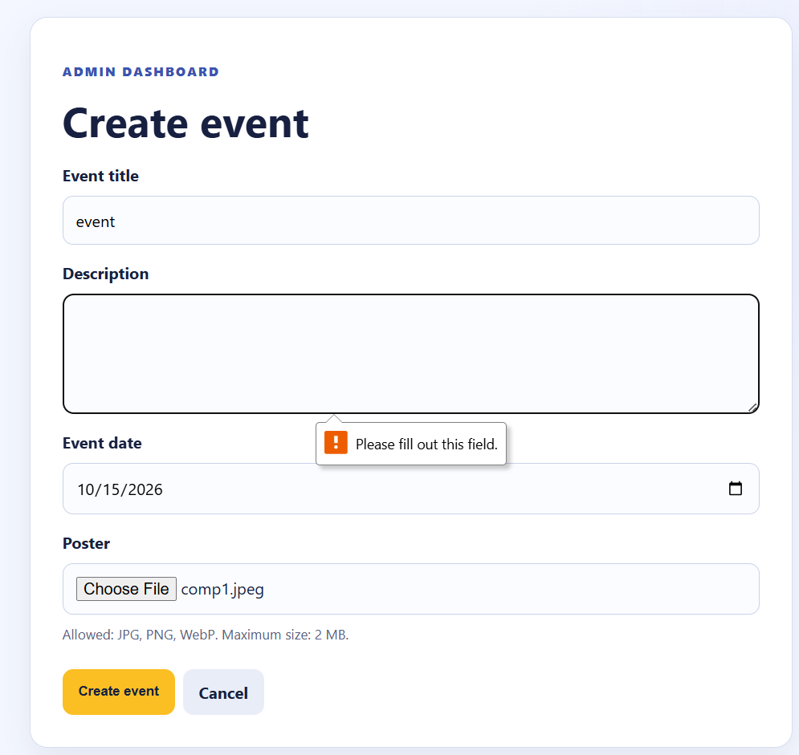

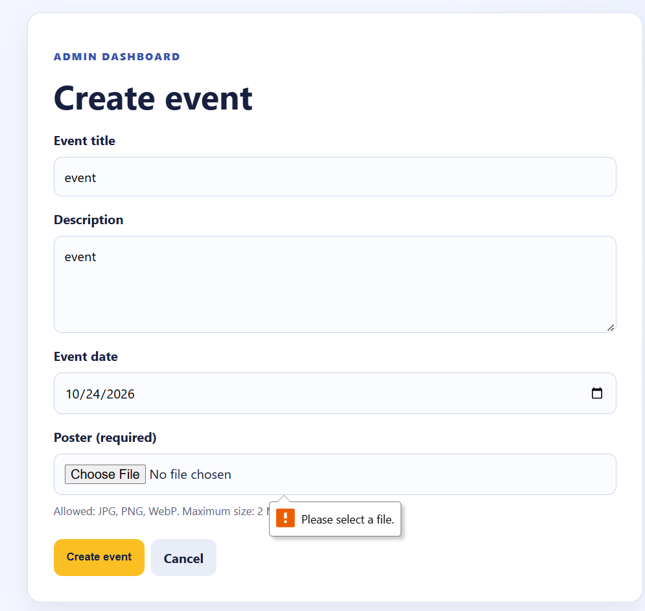

- Unauthorized user access restriction:-

When I try to open direct my admin_dashboard.php through URL it shows this ,

