PRACTICAL – 1(A)
Aim: To create and implement a Java coin-operated snack vending program using an enum and switch expression to convert coin types into values, while practicing Scanner, loops, conditional logic, and calculating the change returned after reaching the required price.
Code Screenshot:
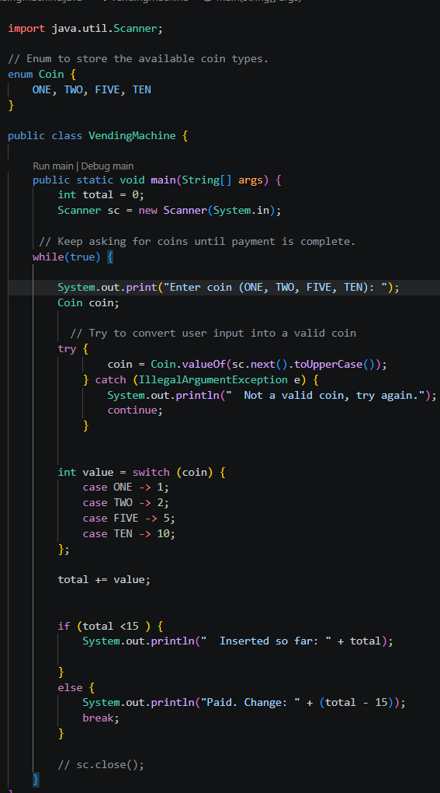
Output Screenshot:
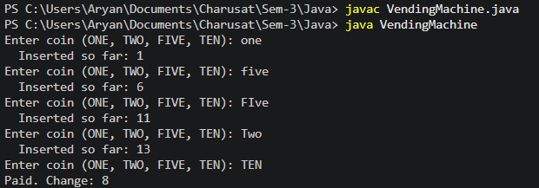

Practicle-1(B)
Aim: To create and implement a Java toll collection program using a record Vehicle and switch expressions to calculate toll charges, maintain vehicle type counters, use loops and user input, and determine the vehicle type with the highest count along with the total toll collected.
Code Screenshot:
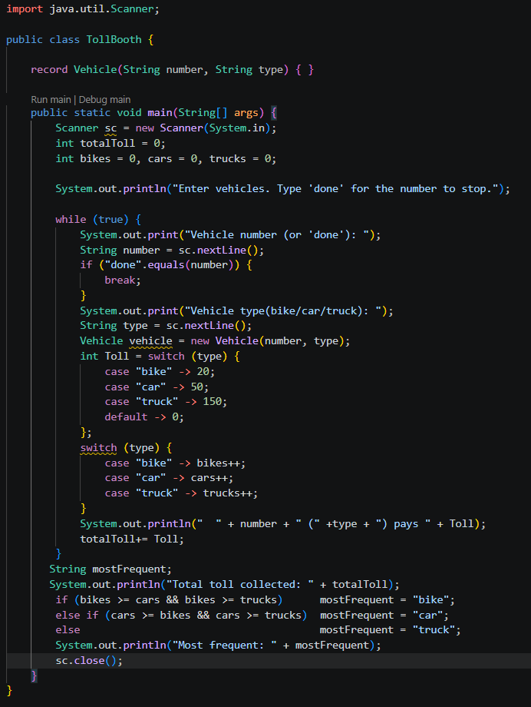

Output Screenshot:
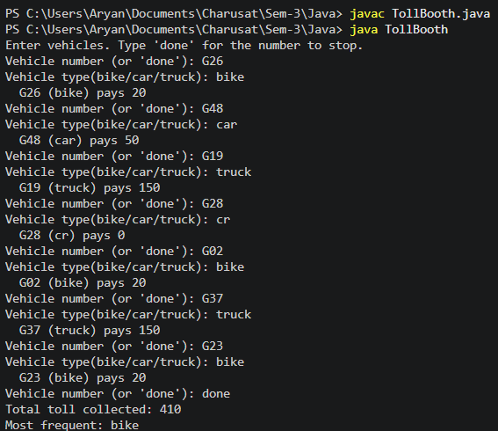

- Question-Answer: -
- What is the role of the JVM, and what file does the javac compiler produce?
- JVM (Java Virtual Machine) runs Java programs by converting bytecode into machine code.
- The javac compiler converts a .java file into a .class file containing Java bytecode.
- How does a switch expression differ from a traditional switch statement?
- A switch expression directly returns a value and uses -> syntax without break.
- A traditional switch statement only controls program flow and requires break to avoid fall-through.
- Why is an enum a good choice for a fixed set of menu options, and a record for read-onlydata?
- Enum is a good choice for a fixed set of menu options because it allows only predefined values.
- Record is good for read-only data because its fields are immutable and cannot be changed after the object is created.

Learning Outcome:
After completing these programs, students will be able to use Java enums and records to model fixed values and read-only data, take user input using the Scanner class, apply switch expressions, loops, and conditional statements to solve problems, perform basic calculations, maintain counters and totals, and develop simple real-world applications such as a vending machine and a toll booth using
modern Java features.

GitHub Repositories: -
https://github.com/d26it116/OOP/tree/159f27c0b1a369ac4529973d98446af6a77befb1/Practicle-1

