Practicle-3(A).
Aim: To create and implement a Java Point class using private fields, constructors, and method overriding, including toString(), equals(), and hashCode(), and to identify and count distinct points by comparing their coordinates.

Code Screenshot:
- Point.java
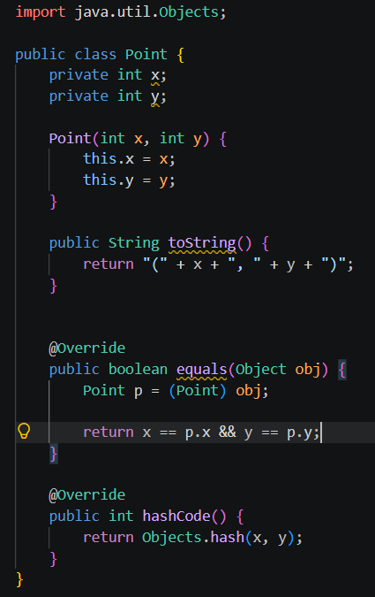

- Driver.java
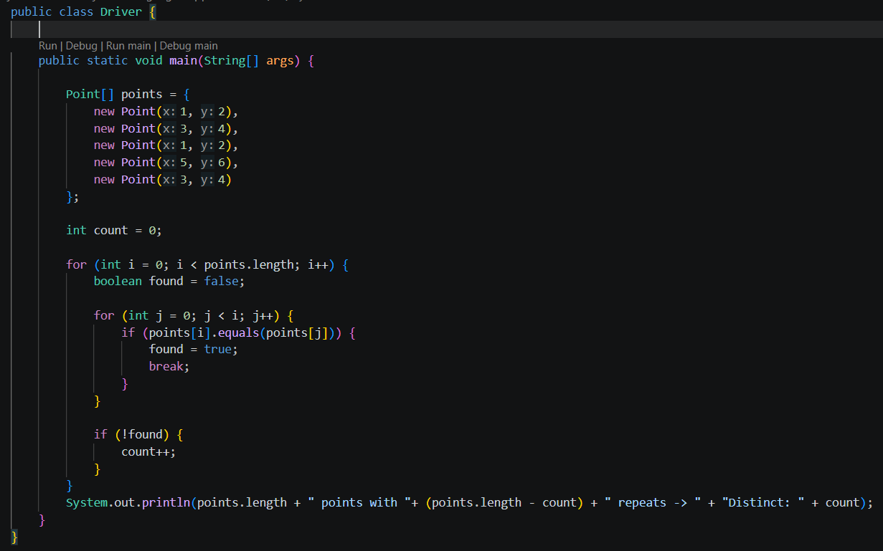
Output Screenshot:

Practicle-3(B)
Aim: To create and implement a Java Card class using encapsulation, constructors, and method overriding with toString(), equals(), and hashCode(), and to identify duplicate cards by comparing their rank and suit.

Code Screenshot:
- Card.java
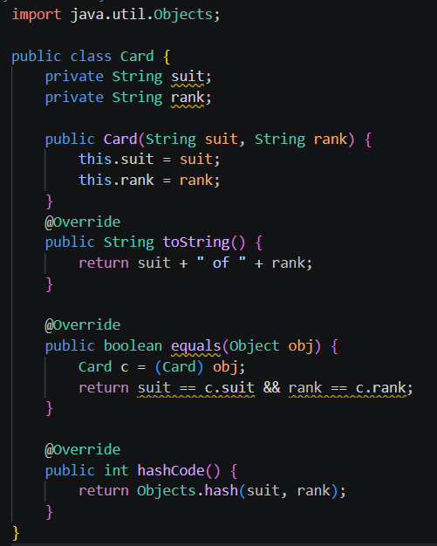

- Driver.java
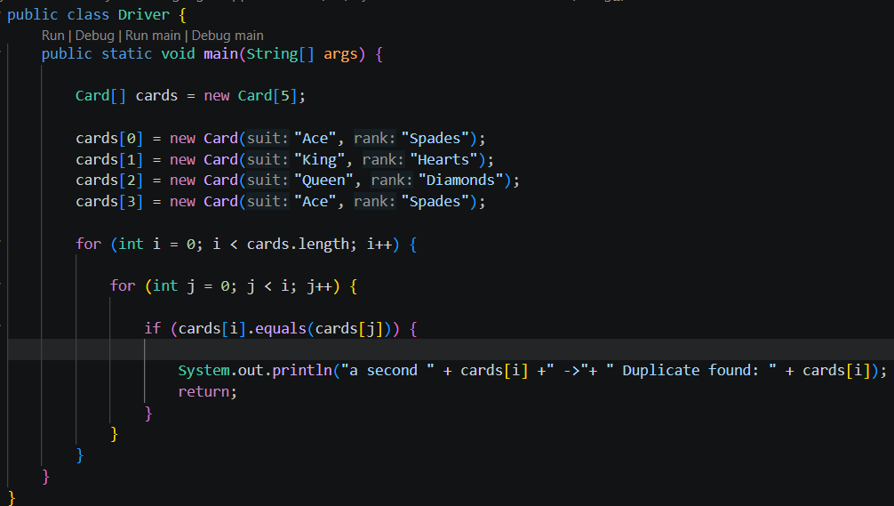

Output Screenshot:
- Question-Answer: -
- Why must equals() and hashCode() be overridden together?
- equals() and hashCode(): They must be overridden together so equal objects always have the same hash code, especially in collections like HashSet and HashMap.
- What does the default Object.toString() return, and why override it?
- Default toString(): It returns the class name followed by the object's hash code. We override it to display meaningful object information.
- What is the difference between a static nested class and an inner class?
- Static nested vs inner class: A static nested class does not need an outer-class object, while an inner class is associated with an instance of the outer class.
Learning Outcome:
The learning outcome is to understand and implement equals(), hashCode(), and toString() methods in Java. Students will learn how to compare objects based on their data and identify duplicate objects. They will understand how arrays can be used to store and process objects. They will also learn to check distinct values and handle duplicate records. This activity improves understanding of object comparison and object-oriented programming.
GitHub Repositories: -
https://github.com/d26it116/OOP/tree/159f27c0b1a369ac4529973d98446af6a77befb1/Practicle-3

