Practicle-4(A)
Aim: To create and implement a Java password strength checker using string methods or regular expressions to validate length, uppercase letters, digits, and special characters, and to classify passwords as Weak, Medium, or Strong based on the number of rules satisfied.

Code Screenshot:
- PasswordChecker.java
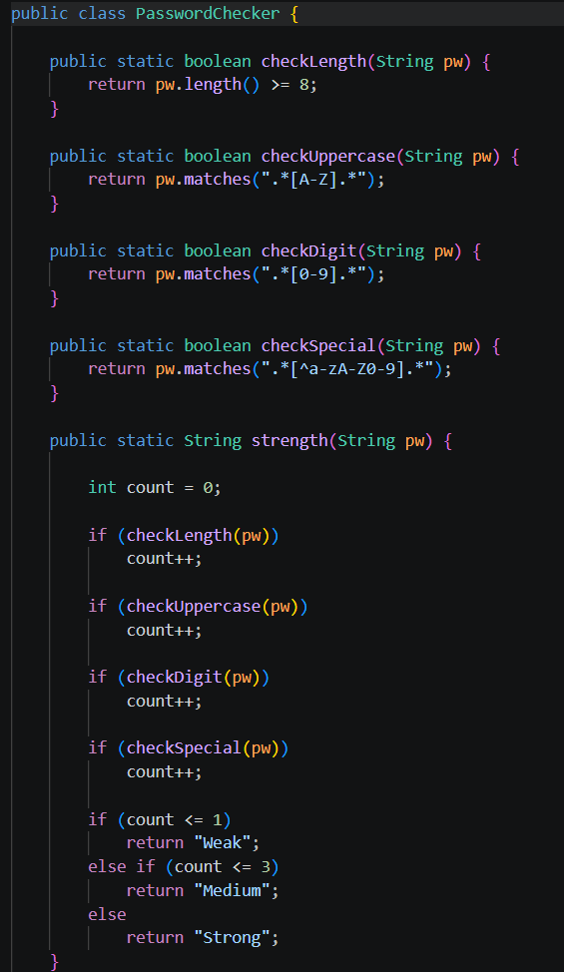

- Driver.java
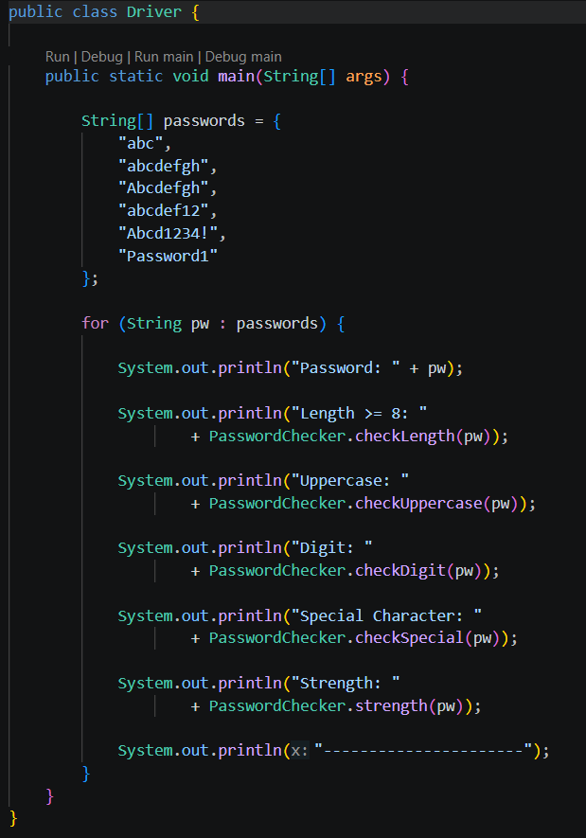
Output Screenshot:
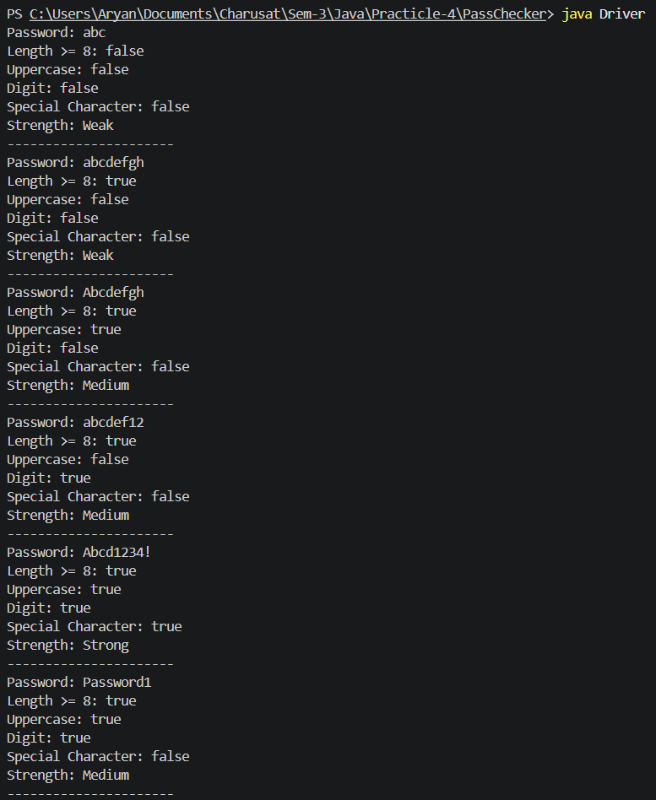

Practicle-4(B)
Aim: To develop a Java chat-log filtering program using arrays, user input, split(), loops, case-insensitive string searching, and StringBuilder to identify matching messages and generate a simple report.

Code Screenshot:
- ChatFilter.java
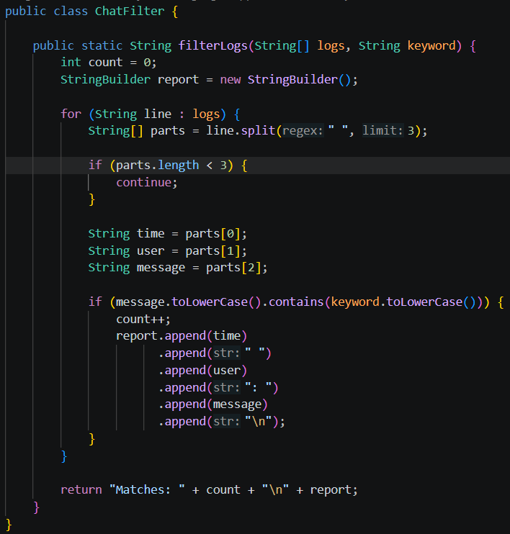

- Drive.java
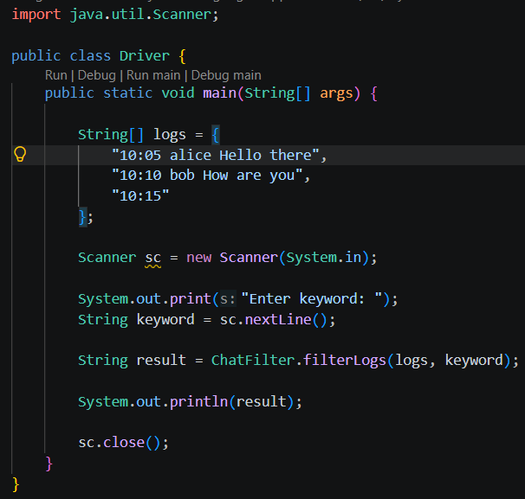
Output Screenshot:
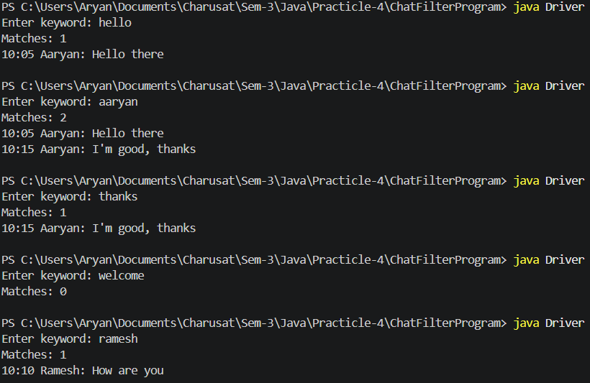
Learning Outcome: -
The learning outcome is to understand string handling and validation in Java using regular expressions and string methods. Students will learn to check password strength based on multiple conditions. They will practice arrays, loops, string splitting, and case-insensitive searching. They will also learn to use StringBuilder for creating reports efficiently. These programs improve problem-solving skills and practical Java programming knowledge.

GitHub Repositories: -
https://github.com/d26it116/OOP/tree/159f27c0b1a369ac4529973d98446af6a77befb1/Practicle-4

