Practicle-5(A)
Aim: - 1. Shape areas: an abstract Shape with abstract area(); subclasses Circle, Rectangle, Triangle. Put a mix in a Shape[] and loop once to print each area and the running total, tracking the largest — one loop handling every shape through polymorphism.
Code Screenshot:
- ShapeAreaCalculator.java
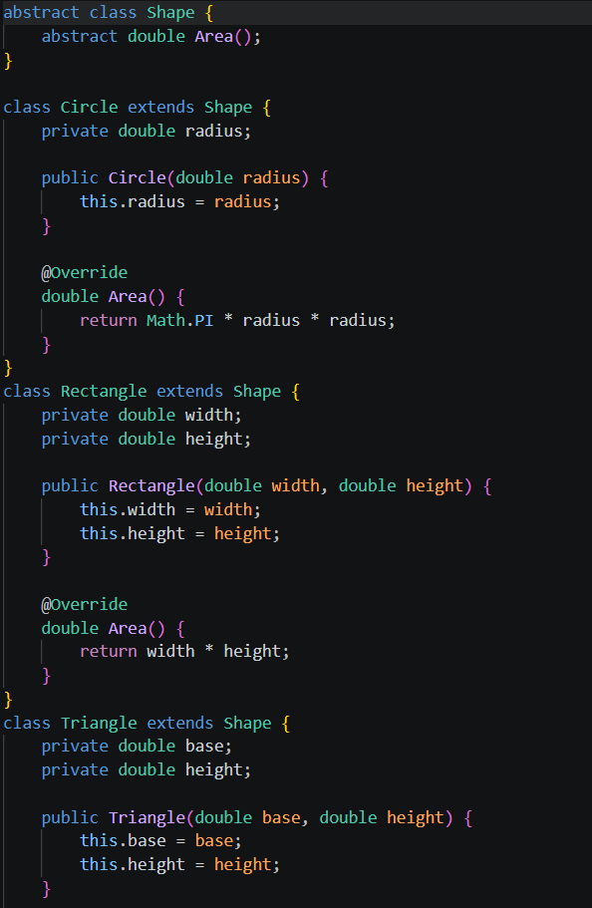
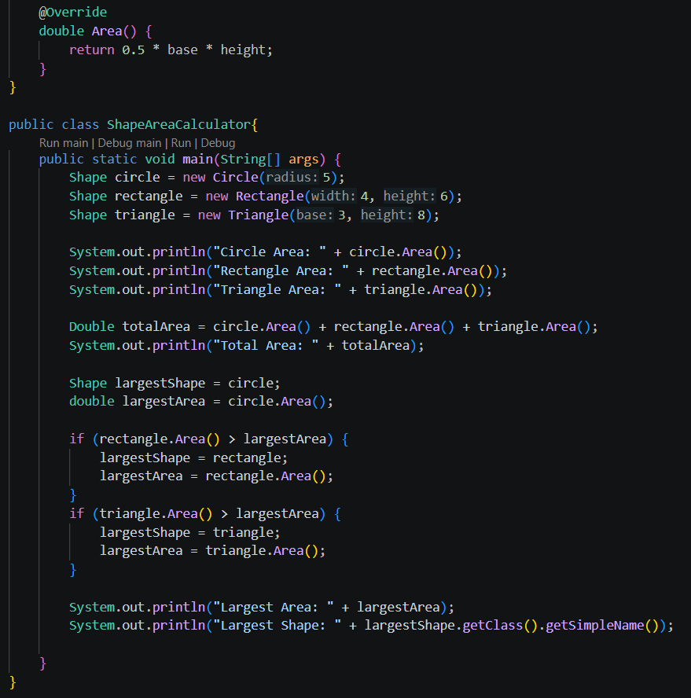

Output Screenshot:
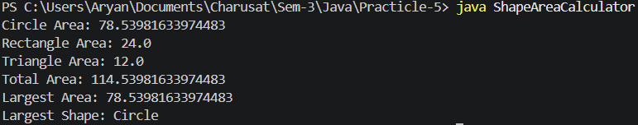

Practicle-5(B)
Payroll: an abstract Employee with abstract monthlySalary(); FullTime (fixed), PartTime (hours × rate) and Intern (stipend), each calling super for the shared name/id. Loop a mixed array to print each salary and the total; use instanceof to
add a note only for interns.
Code Screenshot:
- Payroll.java
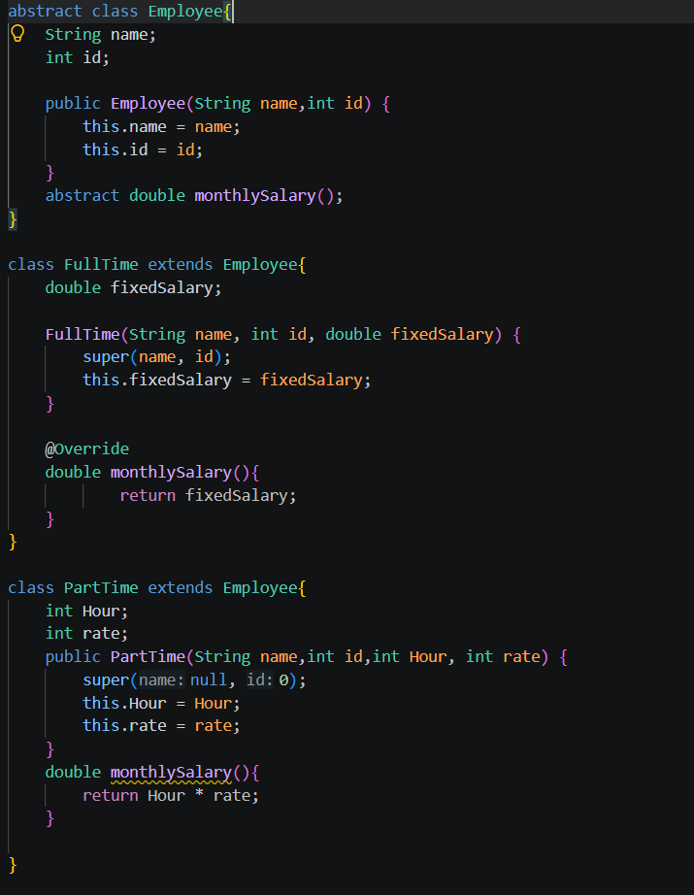

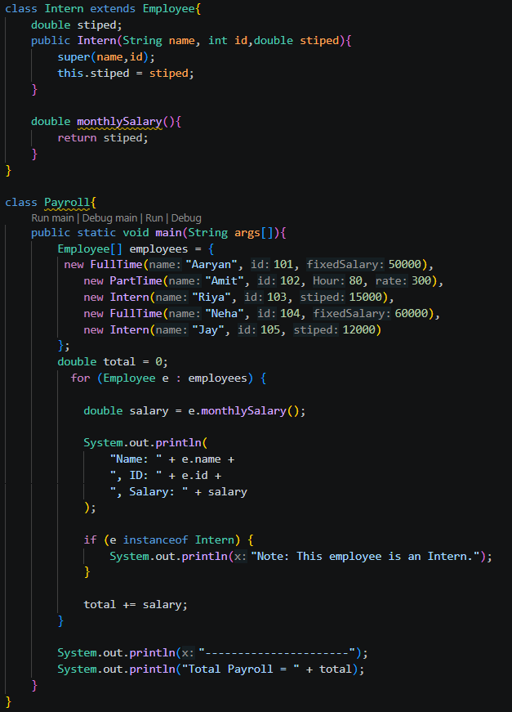

Output Screenshot:
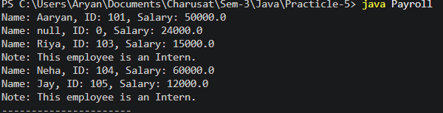
- Question-Answer: -
- What is the difference between an abstract class and a concrete class?
• Abstract class: Cannot be directly instantiated; may contain abstract methods.
• Concrete class: Can be instantiated and provides implementations for its methods.
- What is dynamic method dispatch (run-time polymorphism)?
• The method to execute is decided at run time based on the actual object.
• Example: Animal a = new Dog(); → a.sound() calls Dog's sound().
- What does the super keyword do in a subclass constructor?
Calls the parent class constructor.
Used to initialize inherited/shared data.
Example: super(name, id);
Learning Outcome:
These programs help you learn abstract classes, abstract methods, inheritance, method overriding, and runtime polymorphism in Java. In the Shape program, Shape is an abstract class and Circle, Rectangle, and Triangle override area(), while a single Shape[] loop calculates each area, total area, and largest area. In the Payroll program, Employee is an abstract class, and FullTime, PartTime, and Intern override monthlySalary(); super() is used to initialize common name and id, while polymorphism allows one Employee[] loop to calculate all salaries, and instanceof identifies interns.
GitHub Repositories: -
https://github.com/d26it116/OOP/tree/f56e999ce74034c711c4846bf929b56d671dc207/Practicle-5

