Practicle-8(A)
Aim: - 1. Guarded calculator: read two numbers and an operator; throw a custom
DivideByZeroException and catch invalid-number input separately, printing a clear message each time; loop until a valid calculation succeeds and use finally to log each attempt.
Code Screenshot:
- Guarded_calculator.java
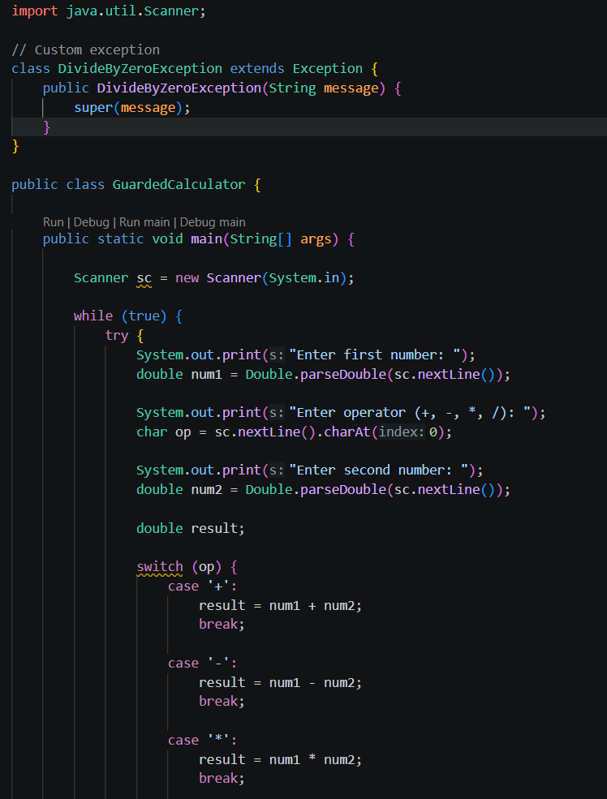
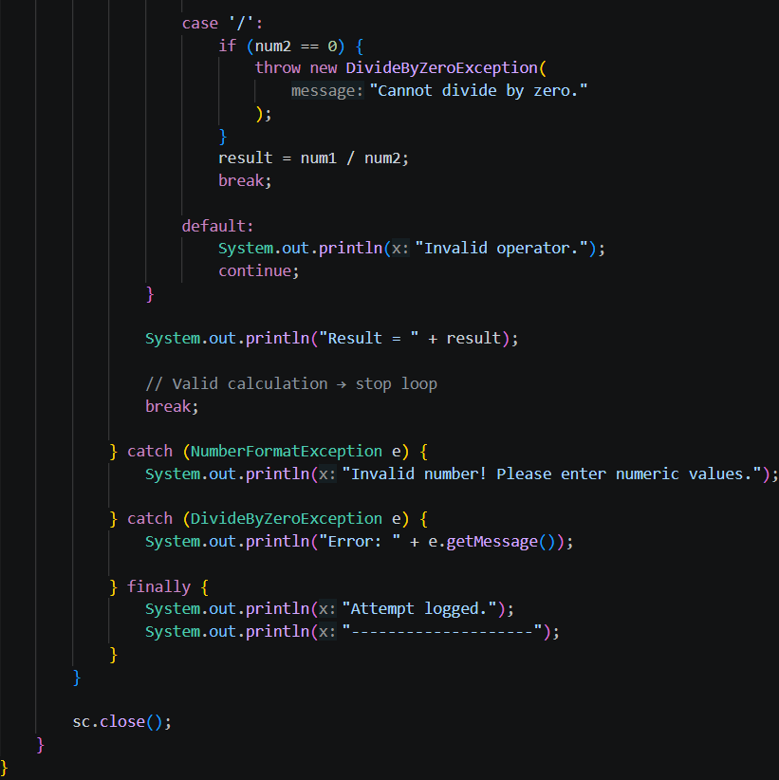

Output Screenshot:
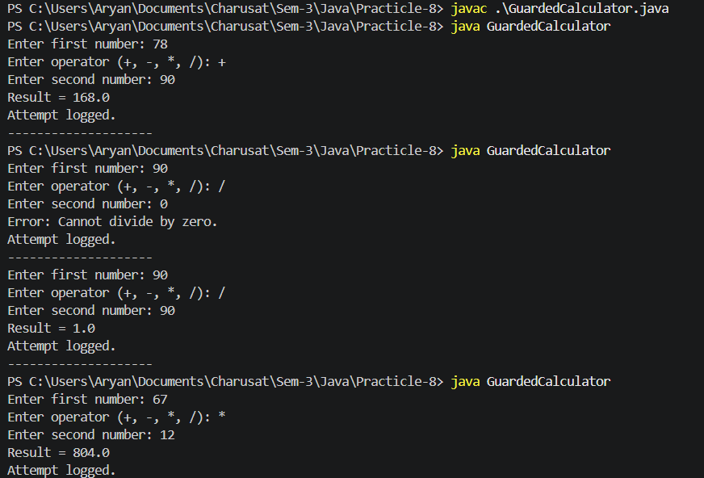

Practicle-8(B)
Payroll: Stock issue: a Warehouse where issue(item, qty) throws a custom checked OutOfStockException carrying the shortfall, and InvalidQuantityException for qty ≤ 0. Process a list of requests, catching and reporting each failure without stopping the run.

Code Screenshot:
- Stock_issue.java
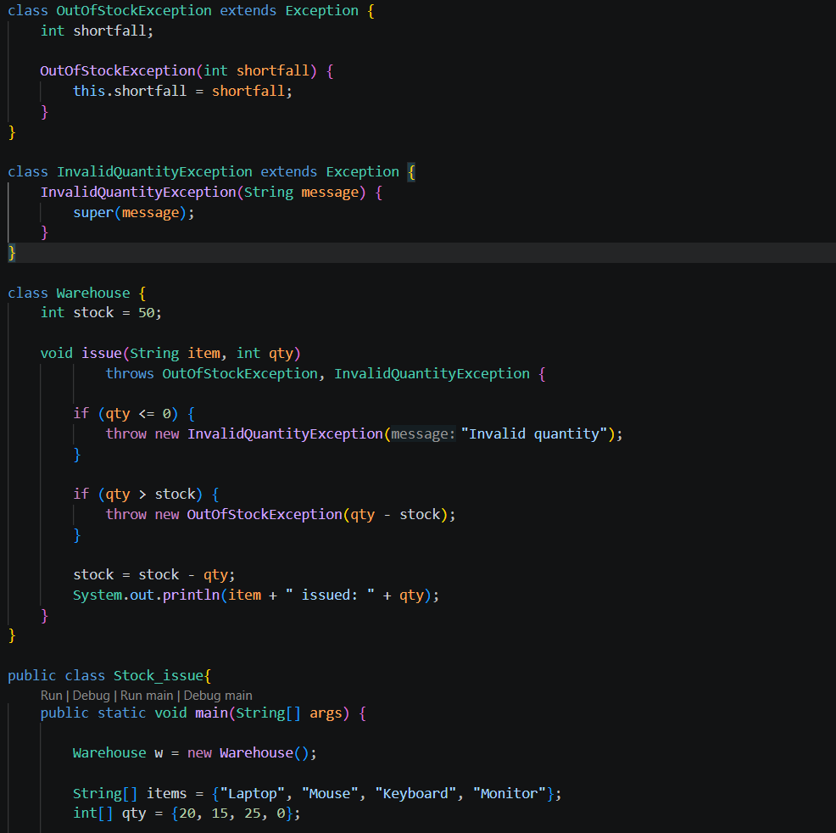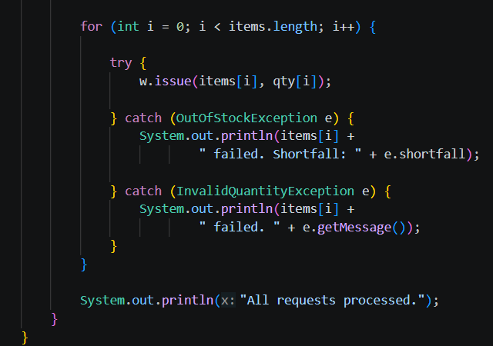

Output Screenshot:
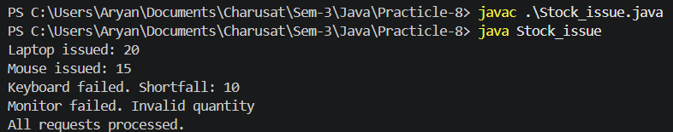
- Question-Answer: -
- What is the difference between a checked and an unchecked exception?
- Checked: Checked at compile time and must be handled or declared. Example: IOException.
- Unchecked: Occurs at runtime and does not need to be explicitly handled. Example: NullPointerException.
- What is the purpose of the finally block, and when does it run?
- Purpose of finally:
finally is used for cleanup code. It normally runs whether an exception occurs or not.
- How does try-with-resources guarantee a resource is closed?
- Try-with-resources:
It automatically closes resources after the try block finishes, even if an exception occurs.
Learning Outcome:
This practical demonstrated exception handling in Java using custom checked exceptions. The Guarded Calculator handled invalid numbers and division by zero, while the Stock Issue program handled invalid quantities and insufficient stock. Both programs showed how try-catch, custom exceptions, loops, and finally can make programs safe, reliable, and able to continue after errors.
GitHub Repositories: -
https://github.com/d26it116/OOP/tree/a34d8df62dc77150b0408c4a7c50e44340b3a486/Practicle-8

