Practicle-9(A)
Aim: - Counter race: several threads each increment a shared counter many times. Run it without synchronization to watch the total come out too low, then make the increment synchronized and confirm it is exactly right every run.Code Screenshot:
- Counter_race.java
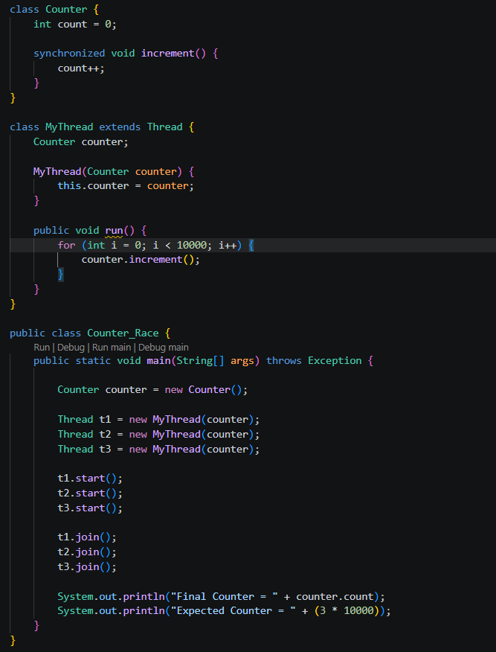
Output Screenshot:
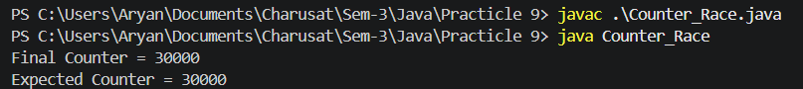

Practicle-9(B)
Payroll: Seat booking race: a shared seatsLeft of 5 with about 10 threads each trying to book one seat. Without synchronization show that more than 5 can succeed (oversell); with a synchronized book() exactly 5 do.
Code Screenshot:
- Seat_booking_race.java
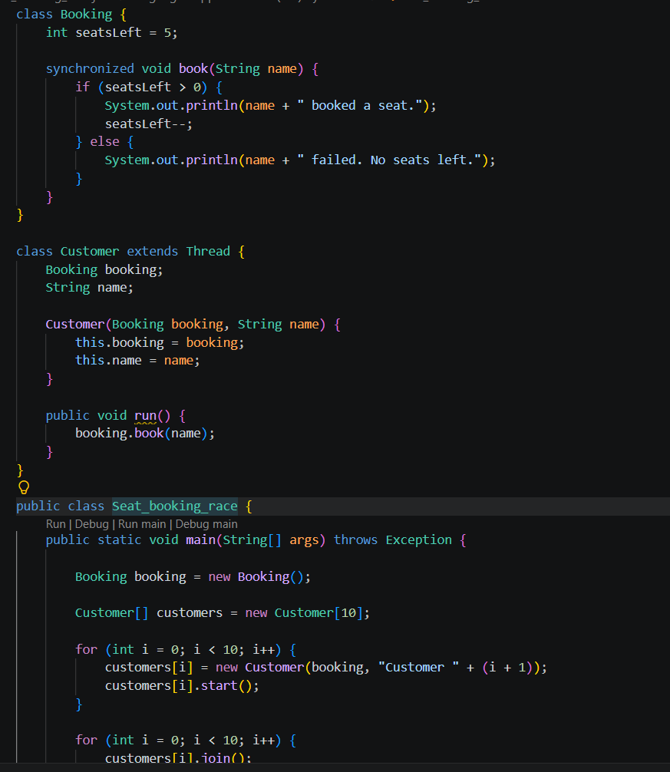
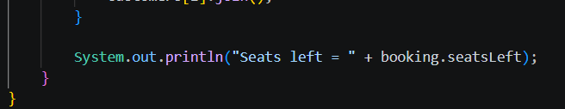
Output Screenshot:
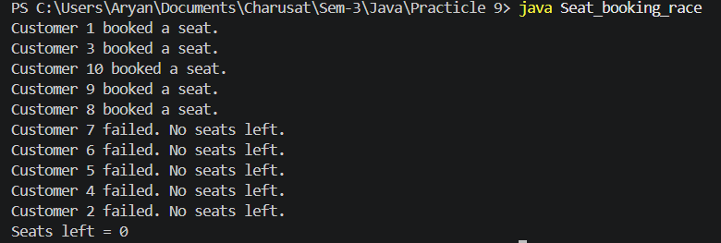
- Question-Answer: -
- What is a race condition, and why does it occur here?
- A race condition occurs when multiple threads access and modify the same data at the same time.
- Here, many customers access seatsLeft together. Two threads may see the same available seat and both try to book it, causing incorrect booking/overselling.
- What does the synchronized keyword do?
- synchronized allows only one thread at a time to execute the synchronized method.
- synchronized void book(String name)
- It prevents multiple customers from booking the same seat at the same time.
- What are the states in a thread’s life cycle?
- New – Thread is created.
- Runnable – Thread is ready to run.
- Running – Thread is executing.
- Blocked/Waiting – Thread is waiting for a resource or another thread.
- Terminated – Thread has finished execution

.Learning Outcome:
Conclusion
This practical demonstrated the use of multithreading and synchronization in Java. The seat booking program showed how a race condition can occur when multiple threads access shared data at the same time. By using the synchronized keyword, only one thread can book a seat at a time, preventing overselling and ensuring that exactly 5 seats are booked.
GitHub Repositories: -
https://github.com/d26it116/OOP/tree/715126a7bfc4241f00ab17bd801b548106a18e25/Practicle%209

