Practical-1

Aim: Part A — Practice Programs:
Work these in your lab-NN/ folder before the project: do the first one or two in the lab:

1. Vending machine (VendingMachine.java, main in this file)
(a) Define an enum Coin with constants ONE, TWO, FIVE, TEN.
(b) In main, set a snack price of 15 and a running total of 0; create a Scanner.
(c) Loop: read a coin name, use a switch expression to convert the Coin to its value (ONE→1, TWO→2, FIVE→5, TEN→10), add it to the total, and print the total so far.
(d) Stop the loop once the total reaches 15 or more.
(e) Print the change to return (total − 15).
Expected output: TEN then FIVE prints “Paid. Change: 0”; TEN then TEN prints “Paid. Change: 5”.

2. Toll booth (TollBooth.java, main in this file)
(a) Define a record Vehicle(String number, String type).
(b) In main, keep a running toll total and three counters (bike, car, truck).
(c) Loop until the user types “done” for the number: build a Vehicle, use a switch expression on its type for the toll (bike→20, car→50, truck→150), add to the total, and increment that type’s counter.
(d) After the loop, print the total toll and the type with the highest count.
Expected output: two cars + one bike → “Total toll: 120”, “Most frequent: car”.

Code:

1.
import java.util.Scanner;

public class VendingMachine {
enum Coin {ONE, TWO, FIVE, TEN}
public static void main(String[] args) {
int price = 15;
int total = 0;
Scanner sc = new Scanner(System.in);
while (total < price) {
System.out.print("Enter coin (ONE, TWO, FIVE, TEN): ");
Coin coin = Coin.valueOf(sc.next().toUpperCase());
int value = switch (coin) {
case ONE -> 1;
case TWO -> 2;
case FIVE -> 5;
case TEN -> 10;
};
total += value;
System.out.println("Total so far: " + total);
}
System.out.println("Paid. Change: " + (total - price));
sc.close();
}
}

Output:
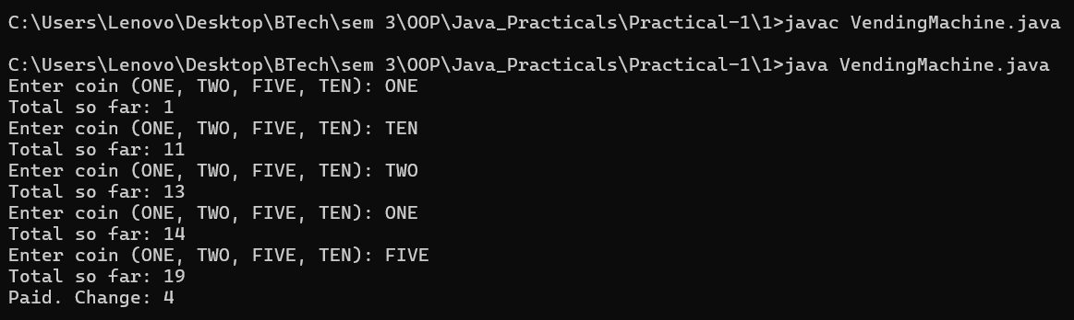
2.
import java.util.Scanner;

public class TollBooth {
public static void main(String[] args) {
Scanner sc = new Scanner(System.in);
int totalToll = 0;
int bikeCount = 0;
int carCount = 0;
int truckCount = 0;
while (true) {
System.out.print("Enter vehicle number: ");
String number = sc.next();
if (number.equalsIgnoreCase("done")) {
break;
}
System.out.print("Enter vehicle type (bike/car/truck): ");
String type = sc.next().toLowerCase();
int toll = switch (type) {
case "bike" -> 20;
case "car" -> 50;
case "truck" -> 150;
default -> 0;
};
totalToll += toll;
switch (type) {
case "bike" -> bikeCount++;
case "car" -> carCount++;
case "truck" -> truckCount++;
}
}
String mostFrequent;
if (bikeCount == carCount && carCount == truckCount) {
mostFrequent = "No frequent Car";
} else if (bikeCount >= carCount && bikeCount >= truckCount) {
mostFrequent = "bike";
} else if (carCount >= bikeCount && carCount >= truckCount) {
mostFrequent = "car";
} else {
mostFrequent = "truck";
}
System.out.println("Total toll: " + totalToll);
System.out.println("Most frequent: " + mostFrequent);
sc.close();
}
}

Output:

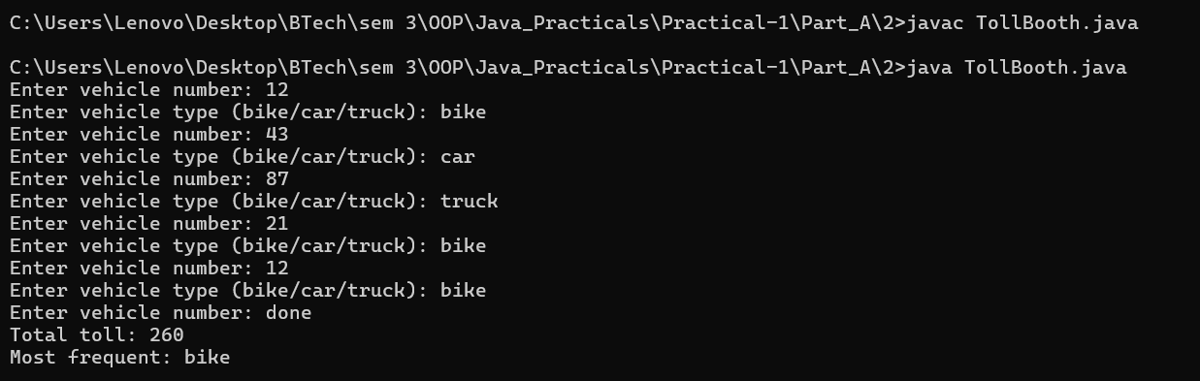

Part B — Project Work (Hour 2): MiniBank

AIM: MiniBank is the console banking application you will build across the whole semester. In this first lab you set up your tools and create the project and its menu shell — the screen the user navigates. Every later lab attaches one real banking feature behind these menu options.

- Set up your environment: open the project in GitHub Codespaces (or install JDK 17+ and an IDE locally), and create a private GitHub repository named oop-minibank-<rollno>; add the faculty as a collaborator.
- Create a public class named MiniBank that contains the main method.
- Define a record named BankInfo with two String fields, name and branch (a record is a short, read-only class; Java auto-generates its constructor and field accessors). Print one BankInfo object as the application header.
- Define an enum named MenuOption with the constants OPEN_ACCOUNT, DEPOSIT, WITHDRAW, TRANSFER and EXIT — these are the actions MiniBank will offer.
- Display the numbered menu to the user and read the chosen number with a Scanner.
- Use a switch expression on the choice to print a short placeholder for that option (for example, “Deposit — to be implemented in a later lab”). Keep showing the menu in a loop until the user selects EXIT, then print a goodbye message.

CODE:
MiniBank.java
import java.util.Scanner;
public class MiniBank {
// Record to store bank information
record BankInfo(String name, String branch) {}
// Enum for menu options
enum MenuOption {
OPEN_ACCOUNT,
DEPOSIT,
WITHDRAW,
TRANSFER,
EXIT
}
public static void main(String[] args) {
Scanner sc = new Scanner(System.in);
// Display application header
BankInfo bank = new BankInfo("MiniBank", "Ahmedabad");
System.out.println("================================");
System.out.println(" " + bank.name());
System.out.println(" Branch: " + bank.branch());
System.out.println("================================");
int choice;
// Display menu until the user selects EXIT
do {
System.out.println("\n===== MiniBank Menu =====");
System.out.println("1. Open Account");
System.out.println("2. Deposit");
System.out.println("3. Withdraw");
System.out.println("4. Transfer");
System.out.println("5. Exit");
System.out.print("Enter your choice: ");
choice = sc.nextInt();
if (choice < 1 || choice > 5) {
System.out.println("Invalid choice! Please try again.");
continue;
}
MenuOption option = MenuOption.values()[choice - 1];
// Switch expression
String message = switch (option) {
case OPEN_ACCOUNT ->
"Open Account - to be implemented in a later lab";
case DEPOSIT ->
"Deposit - to be implemented in a later lab";
case WITHDRAW ->
"Withdraw - to be implemented in a later lab";
case TRANSFER ->
"Transfer - to be implemented in a later lab";
case EXIT ->
"Thank you for using MiniBank!";
};
System.out.println(message);
} while (choice != 5);
sc.close();
}
}

OUTPUT:

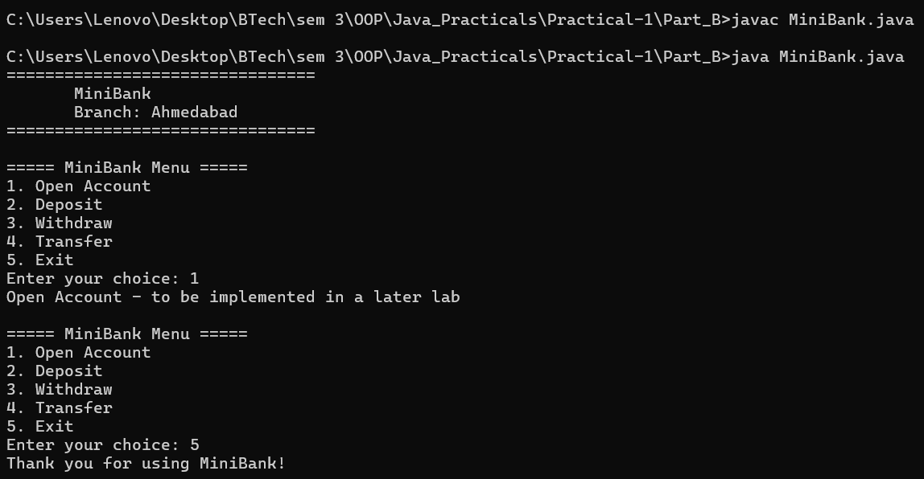
Learning Outcome:

Vending Machine — Learning Outcomes

Learned to define and use an enum in Java to represent different coin types.
Understood the use of switch expressions to convert coin names into their respective values.
Practiced using Scanner and loops to accept repeated user input.
Learned to calculate the total payment and stop accepting coins when the price is reached.
Understood how to calculate and display the change returned to the user.

Toll Booth — Learning Outcomes

Learned to define and use a record in Java to store vehicle details.
Understood the use of switch expressions to calculate toll charges based on vehicle types.
Practiced using loops and Scanner to accept vehicle details until the user enters done.
Learned to maintain the total toll amount and count different types of vehicles.
Understood how to determine and display the most frequent vehicle type after processing all vehicles.

