Practical-10

Aim: Part A — Practice Programs:
Work these in your lab-NN/ folder before the project: do the first one or two in the lab:

1. Thread-pool runner: with a fixed pool of 3 (ExecutorService), submit about 10 Runnable tasks that print their id and sleep briefly; shut down and await completion, observing the few threads being reused.

- Producer–consumer: one thread adds numbers to a small shared buffer and another removes them, coordinated with wait()/notify(); produce and consume a fixed number of items in order with none lost.

Code:

1.ThreadPoolRunner.java
import java.util.concurrent.ExecutorService;
import java.util.concurrent.Executors;

public class ThreadPoolRunner {
public static void main(String[] args) {
ExecutorService executor = Executors.newFixedThreadPool(3);
for (int i = 1; i <= 10; i++) {
int taskId = i;
executor.submit(() -> {
System.out.println("Task " + taskId +
" running on " + Thread.currentThread().getName());
try {
Thread.sleep(1000);
} catch (InterruptedException e) {
Thread.currentThread().interrupt();
}
System.out.println("Task " + taskId +
" completed by " + Thread.currentThread().getName());
});
}
executor.shutdown();
try {
if (executor.awaitTermination(30, java.util.concurrent.TimeUnit.SECONDS)) {
System.out.println("All tasks completed.");
} else {
System.out.println("Timeout: Some tasks are still running.");
}
} catch (InterruptedException e) {
System.out.println("Main thread interrupted.");
}
}
}

Output:
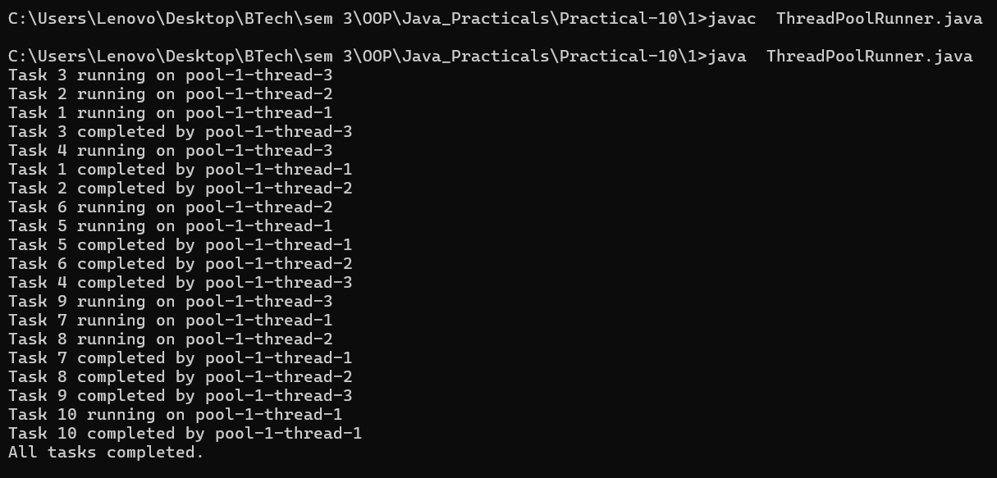

2.ProducerConsumer.java
class SharedBuffer {

private int[] buffer = new int[3];
private int count = 0;
private int in = 0;
private int out = 0;
synchronized void produce(int value) throws InterruptedException {
while (count == buffer.length) {
wait();
}
buffer[in] = value;
in = (in + 1) % buffer.length;
count++;
System.out.println("Produced: " + value);
notify();
}
synchronized int consume() throws InterruptedException {
while (count == 0) {
wait();
}
int value = buffer[out];
out = (out + 1) % buffer.length;
count--;
System.out.println("Consumed: " + value);
notify();
return value;
}
}
public class ProducerConsumer {
public static void main(String[] args) {
SharedBuffer buffer = new SharedBuffer();
Thread producer = new Thread(() -> {
try {
for (int i = 1; i <= 10; i++) {
buffer.produce(i);
Thread.sleep(100);
}
} catch (InterruptedException e) {
Thread.currentThread().interrupt();
}
});

Thread consumer = new Thread(() -> {
try {
for (int i = 1; i <= 10; i++) {
buffer.consume();
Thread.sleep(150);
}
} catch (InterruptedException e) {
Thread.currentThread().interrupt();
}
});
producer.start();
consumer.start();
try {
producer.join();
consumer.join();
} catch (InterruptedException e) {
Thread.currentThread().interrupt();
}
System.out.println("All items produced and consumed.");
}
}

Output:
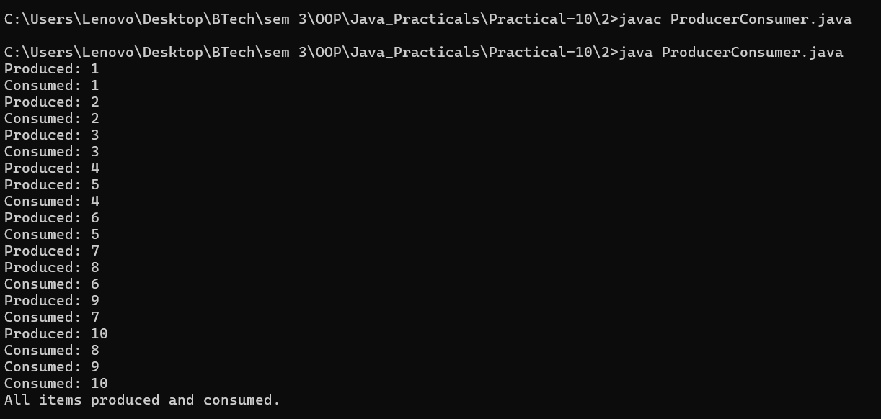
Part B — Project Work (Hour 2): MiniBank

AIM: Building on basic threads, this lab gives MiniBank a proper transaction engine. You process a batch of transactions on a managed thread pool, coordinate two threads with wait/notify, and learn to avoid deadlock with consistent lock ordering — the way back-office systems process many transactions safely.

1. Create a class named TransactionProcessor that holds an ExecutorService created with Executors.newFixedThreadPool(4). Add a method submit(Runnable task) that calls execute(), and a method stop() that calls shutdown() and awaitTermination().
2. Create Runnable tasks that each perform a deposit or withdrawal; submit many of them, then stop the processor and wait for completion.
3. Build a simple producer-consumer: one thread adds transactions to a shared array buffer and another thread processes them, using wait() and notify() inside synchronized blocks.
4. Create a deadlock: two threads transfer money A to B and B to A, locking the two accounts in opposite order. Then fix it by always locking the account with the smaller accountNumber first.

Learning Outcome:

- Thread Pool Runner Program:

• Understand the concept of a thread pool and its use in Java multithreading.
• Learn to create a fixed thread pool using Executors.newFixedThreadPool(3).
• Understand how to submit multiple tasks using ExecutorService.
• Learn how a limited number of threads execute multiple tasks and are reused.
• Understand thread management using shutdown() and task completion using awaitTermination().
• Learn to handle thread interruption using InterruptedException.

- Producer Consumer Program:

• Understand inter-thread communication using wait() and notify().
• Learn synchronization using the synchronized keyword to prevent simultaneous access to shared data.
• Understand how a bounded buffer works using an array and circular queue indexes.
• Learn how a producer adds items and a consumer removes items in FIFO (First In, First Out) order.
• Understand how threads coordinate when the buffer is full or empty.
• Gain practical knowledge of multithreading and thread coordination in Java.

