Practical-11

Aim: Part A — Practice Programs:
Work these in your lab-NN/ folder before the project: do the first one or two in the lab

- Save/load: make a small class Serializable, save an array of its objects to a file with ObjectOutputStream, then read it back into fresh objects and confirm the values survived. Mark one field transient and show it is not saved.

- Log analyzer: create a few text files, then use Path/Files to read each line by line and count the total lines and how many contain a keyword across all files; also print each file’s size from its attributes.

Code:

- SaveLoad.java
import java.io.*;

class Student implements Serializable {
int id;
String name;
transient String password;
Student(int id, String name, String password) {
this.id = id;
this.name = name;
this.password = password;
}
void display() {
System.out.println("ID: " + id);
System.out.println("Name: " + name);
System.out.println("Password: " + password);
System.out.println();
}
}
public class SaveLoad {
public static void main(String[] args) {
Student[] students = {
new Student(1, "Maitry", "abc123"),
new Student(2, "Rahul", "xyz456"),
new Student(3, "Priya", "pqr789")
};
try {
ObjectOutputStream out =
new ObjectOutputStream(new FileOutputStream("students.dat"));
out.writeObject(students);
out.close();
System.out.println("Objects saved successfully.\n");
} catch (IOException e) {
System.out.println("Error while saving: " + e);
}
try {
ObjectInputStream in =
new ObjectInputStream(new FileInputStream("students.dat"));
Student[] loadedStudents = (Student[]) in.readObject();
in.close();
System.out.println("Objects loaded successfully.\n");
for (Student s : loadedStudents) {
s.display();
}
} catch (IOException | ClassNotFoundException e) {
System.out.println("Error while loading: " + e);
}
}
}

Output:
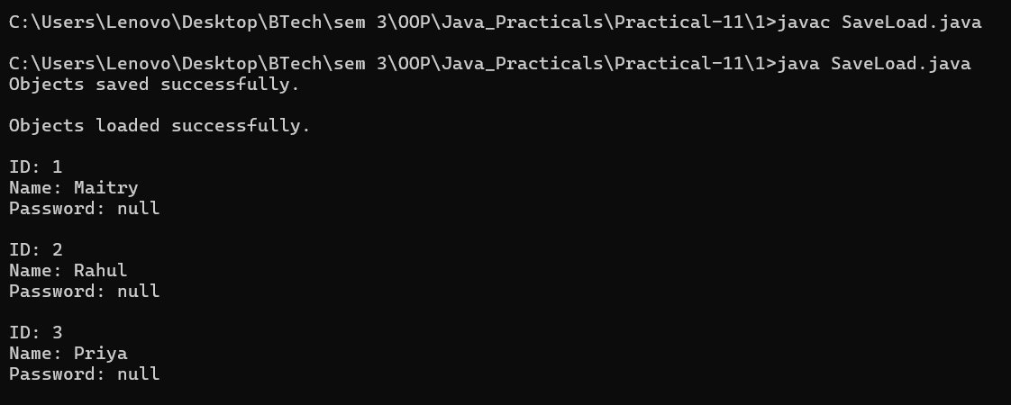

- LogAnalyzar.java
import java.io.*;
import java.nio.file.*;
import java.nio.file.attribute.BasicFileAttributes;
import java.util.*;

public class LogAnalyzar {
public static void main(String[] args) {
try {
Files.write(Paths.get("log1.txt"), Arrays.asList(
"Server started",
"User login successful",
"Error: connection failed",
"Server stopped"
));
Files.write(Paths.get("log2.txt"), Arrays.asList(
"User login successful",
"Database connected",
"Error: timeout occurred",
"Error: file not found",
"User logout"
));
Files.write(Paths.get("log3.txt"), Arrays.asList(
"Server started",
"Error: file not found",
"Backup completed"
));
Path[] files = {
Paths.get("log1.txt"),
Paths.get("log2.txt"),
Paths.get("log3.txt")
};
String keyword = "Error";
int totalLines = 0;
int keywordLines = 0;
for (Path path : files) {
int fileLines = 0;
int fileKeywordLines = 0;
try (BufferedReader reader = Files.newBufferedReader(path)) {
String line;
while ((line = reader.readLine()) != null) {
fileLines++;
totalLines++;
if (line.contains(keyword)) {
fileKeywordLines++;
keywordLines++;
}
}
}
BasicFileAttributes attributes =
Files.readAttributes(path, BasicFileAttributes.class);
System.out.println("File: " + path.getFileName());
System.out.println("Size: " + attributes.size() + " bytes");
System.out.println("Lines: " + fileLines);
System.out.println("Lines containing \"" +
keyword + "\": " + fileKeywordLines);
System.out.println();
}
System.out.println("----- Overall Result -----");
System.out.println("Total lines: " + totalLines);
System.out.println("Lines containing \"" +
keyword + "\": " + keywordLines);
} catch (IOException e) {
System.out.println("Error: " + e.getMessage());
}
}
}

Output:
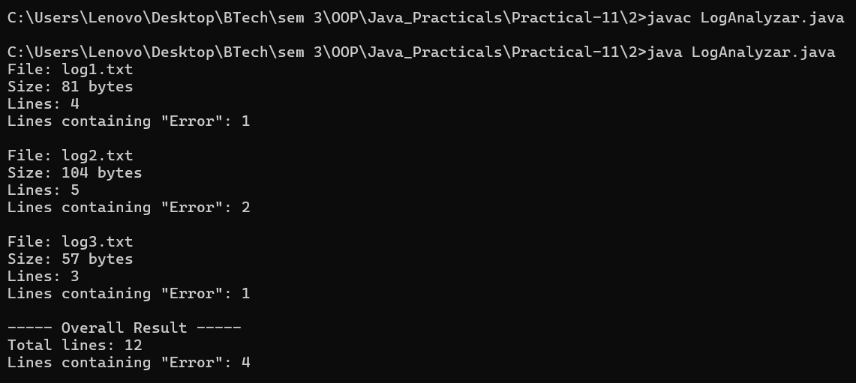

Part B — Project Work (Hour 2): MiniBank

AIM: So far MiniBank forgets everything when it closes. In this lab you add the persistence and reporting layer: you make the model Serializable and save/load all accounts to a file, write an append-only transaction log, and then use NIO to walk the logs and produce an end-of-day summary report.

1. Make Account (and its subclasses and Customer) implement Serializable, and add a private static final long serialVersionUID field.
2. Create a class named StatePersister with a public static method void save(Account[] accounts, Path file) that uses ObjectOutputStream inside try-with-resources, and a public static method Account[] load(Path file) that uses ObjectInputStream.
3. Create a class named TransactionLog with a public static method void append(Path file, String line) that uses Files.write(...) with CREATE and APPEND.
4. Create a class named ReportGenerator that walks the logs folder using
Files.newDirectoryStream, reads each file line by line with a BufferedReader, and adds up the total deposits and total withdrawals in long variables; also read file details (size, last-modified) using Files.readAttributes, then write the summary to a report file.
- In main, save the accounts, reload them into a new array and print them to confirm the data survived, then generate and print the report.

Code:

import java.util.Scanner;
import java.io.IOException;
import java.nio.file.Path;
import java.nio.file.Files;
import model.*;
import util.AnnotationValidator;
import util.StatementFormatter;
import util.BankResource;
import util.StatePersister;
import util.TransactionLog;
import util.ReportGenerator;
import service.CommandParser;
import exception.BankException;
import exception.InsufficientFundsException;
import exception.InvalidAmountException;
import static util.Validator.isValidMobile;
public class MiniBank {
public static void main(String[] args) {
Scanner sc = new Scanner(System.in);
BankInfo bank = new BankInfo("MiniBank", "Ahmedabad");
System.out.println("================================");
System.out.println(" " + bank.name());
System.out.println(" Branch: " + bank.branch());
System.out.println("================================");
// Create customers
Customer c1 = new Customer(
"Amit", "amit@gmail.com", "9876543210",
new Customer.Address(
"ABC Road", "Ahmedabad", "380001"));
Customer c2 = new Customer(
"Neha", "neha@gmail.com", "9876543211",
new Customer.Address(
"XYZ Road", "Surat", "395001"));
Customer c3 = new Customer(
"Rahul", "rahul@gmail.com", "9876543212",
new Customer.Address(
"Main Road", "Vadodara", "390001"));
System.out.println("\n===== Customers =====");
System.out.println(c1.getCustomerId() + " " + c1.getName());
System.out.println(c2.getCustomerId() + " " + c2.getName());
System.out.println(c3.getCustomerId() + " " + c3.getName());
// Create different account types
Account[] accounts = {
new SavingsAccount(c1.getName(), 1000, 500),
new CurrentAccount(c2.getName(), 0, 2000),
new FixedDepositAccount(c3.getName(), 2000)
};
// Demonstrate deposit and withdrawal
try {
accounts[0].deposit(500);
accounts[0].withdraw(200);
accounts[1].deposit(1000);
accounts[1].withdraw(300);
} catch (BankException e) {
System.out.println(
"Bank operation error: " + e.getMessage());
} finally {
System.out.println("Initial account operations completed.");
}
// Display accounts and interest
System.out.println("\n===== Account Details =====");
for (Account account : accounts) {
System.out.println(account);
System.out.println("Interest Rate: "
+ account.interestRate() + "%");
System.out.println("Yearly Interest: Rs. "
+ String.format("%.2f", account.yearlyInterest()));
System.out.println("----------------------------");
}
// WithdrawRule using an anonymous class
WithdrawRule anonymousRule = new WithdrawRule() {
@Override
public boolean allow(Account account, long amount) {
return account.canWithdraw(amount);
}
};
// WithdrawRule using a lambda expression
WithdrawRule lambdaRule =
(account, amount) -> account.canWithdraw(amount);
System.out.println("\n===== Withdraw Rules =====");
System.out.println("Anonymous class allows withdrawal: "
+ anonymousRule.allow(accounts[0], 500));
System.out.println("Lambda allows withdrawal: "
+ lambdaRule.allow(accounts[0], 500));
System.out.println("Fixed deposit withdrawal allowed: "
+ lambdaRule.allow(accounts[2], 100));
// Demonstrate marker interface
System.out.println("\n===== Premium Check =====");
if (accounts[0] instanceof Premium) {
System.out.println("Savings account is marked Premium.");
}
// Demonstrate static import
System.out.println("\n===== Mobile Validation =====");
System.out.println("Mobile valid: "
+ isValidMobile("9876543210"));
// Display statement
System.out.println("\n===== Account Statement =====");
System.out.println(StatementFormatter.buildStatement(accounts[0]));
// Parse a command
System.out.println("\n===== Command Parser =====");
try {
Command command =
CommandParser.parse("DEPOSIT AC0001 500");
System.out.println("Type: " + command.type());
System.out.println("Account: " + command.accountNumber());
System.out.println("Amount: " + command.amount());
} catch (IllegalArgumentException e) {
System.out.println("Command error: " + e.getMessage());
}
// Annotation validation
System.out.println("\n--- Annotation Validation Test ---");
SavingsAccount testAccount =
new SavingsAccount("Test User", -500, 100);
String[] errors = AnnotationValidator.validate(testAccount);
if (errors.length == 0) {
System.out.println("Account is valid.");
} else {
for (String error : errors) {
System.out.println("Validation Error: " + error);
}
}
// Custom exception handling: insufficient funds
System.out.println("\n===== Exception Handling =====");
try {
accounts[0].withdraw(5000);
} catch (InsufficientFundsException e) {
System.out.println("Withdrawal failed: " + e.getMessage());
System.out.println("Shortfall: Rs. " + e.getShortfall());
} catch (InvalidAmountException e) {
System.out.println("Invalid withdrawal: " + e.getMessage());
} finally {
System.out.println("Withdrawal attempt completed.");
}
// Invalid deposit test
try {
accounts[0].deposit(-100);
} catch (InvalidAmountException e) {
System.out.println("Deposit failed: " + e.getMessage());
} finally {
System.out.println("Deposit attempt completed.");
}
// Transfer test
try {
accounts[0].transfer(accounts[1], 200);
} catch (BankException e) {
System.out.println("Transfer failed: " + e.getMessage());
} finally {
System.out.println("Transfer attempt completed.");
}
// Try-with-resources demonstration
System.out.println("\n===== Try-With-Resources =====");
try (BankResource resource = new BankResource()) {
resource.performTask();
} catch (Exception e) {
System.out.println("Resource error: " + e.getMessage());
}
// ==================================================
// FILE PERSISTENCE, TRANSACTION LOGGING AND REPORTING
// ==================================================
System.out.println("\n===== File Persistence =====");
Path stateFile = Path.of("data", "accounts.dat");
Path logsFolder = Path.of("logs");
Path logFile = logsFolder.resolve("transactions.log");
Path reportFile = Path.of("reports", "end_of_day.txt");
try {
// 1. Save account array
StatePersister.save(accounts, stateFile);
System.out.println("Accounts saved successfully.");
// 2. Load accounts into a new array
Account[] loadedAccounts = StatePersister.load(stateFile);
System.out.println("\n===== Reloaded Accounts =====");
for (Account account : loadedAccounts) {
System.out.println(account);
}
// 3. Create sample logs only if the log file is new.
// In actual transactions, append only after successful operations.
Files.createDirectories(logsFolder);
if (!Files.exists(logFile)) {
TransactionLog.append(logFile, "DEPOSIT 500");
TransactionLog.append(logFile, "WITHDRAW 100");
TransactionLog.append(logFile, "DEPOSIT 250");
}
// 4. Generate the end-of-day report
System.out.println("\n===== End-of-Day Report =====");
ReportGenerator.generate(logsFolder, reportFile);
System.out.println("Report saved to: "
+ reportFile.toAbsolutePath());
} catch (IOException | ClassNotFoundException e) {
System.out.println(
"File operation failed: " + e.getMessage());
}
// Menu shell
int choice = 0;
do {
System.out.println("\n===== MiniBank Menu =====");
System.out.println("1. Open Account");
System.out.println("2. Deposit");
System.out.println("3. Withdraw");
System.out.println("4. Transfer");
System.out.println("5. Exit");
System.out.print("Enter your choice: ");
if (!sc.hasNextInt()) {
System.out.println("Please enter a number.");
sc.next();
continue;
}
choice = sc.nextInt();
if (choice < 1 || choice > 5) {
System.out.println("Invalid choice! Please try again.");
continue;
}
MenuOption option = MenuOption.values()[choice - 1];
String message = switch (option) {
case OPEN_ACCOUNT ->
"Open Account - to be implemented in a later lab";
case DEPOSIT ->
"Deposit - to be implemented in a later lab";
case WITHDRAW ->
"Withdraw - to be implemented in a later lab";
case TRANSFER ->
"Transfer - to be implemented in a later lab";
case EXIT ->
"Thank you for using MiniBank!";
};
System.out.println(message);
} while (choice != 5);
sc.close();
}
enum MenuOption {
OPEN_ACCOUNT, DEPOSIT, WITHDRAW, TRANSFER, EXIT
}
}

OUTPUT:

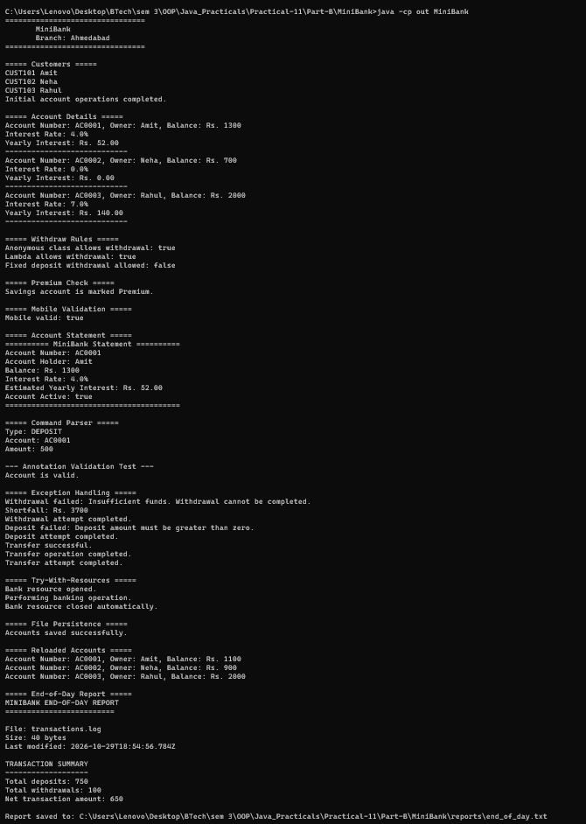
Learning Outcome:

- Save and Load Program:

• Learned how to implement the Serializable interface to enable objects to be serialized.
• Understood how to save an array of student objects into a file using ObjectOutputStream.
• Learned how to retrieve stored objects from a file using ObjectInputStream.
• Understood the use of the transient keyword to prevent sensitive data, such as passwords, from being serialized.
• Learned how to handle exceptions such as IOException and ClassNotFoundException during file operations.
• Verified that student details are preserved after saving and loading objects from a file.

- Log Analyzar Program:

• Learned how to create and write text files using the Files and Paths classes.
• Understood how to read files line by line using BufferedReader.
• Learned how to count the total number of lines and identify lines containing a specific keyword.
• Understood how to retrieve file information, such as file size, using BasicFileAttributes.
• Practiced processing multiple files using arrays, loops, and conditional statements.
• Learned how to handle file-related exceptions using IOException and display the analysis results.

