Practical-12

AIM: Part A — Practice Programs (Hour 1). Work these in your lab-NN/ folder before the project: do the first one or two in the lab:

1. Word frequency: split a paragraph into words, count each in a HashMap, and print the words sorted by frequency (highest first) using a Comparator.

- Unique visitors: from a list of login names with repeats, use a HashSet to count unique users and a LinkedHashSet to keep first-seen order; print the unique count and the first three distinct names.

Code:

- WorkFrequency.java
import java.util.*;
public class WordFrequency {
public static void main(String[] args) {
String paragraph = "java is easy java is powerful java";
String[] words = paragraph.toLowerCase().split("\\s+");
HashMap<String, Integer> map = new HashMap<>();
for (String word : words) {
map.put(word, map.getOrDefault(word, 0) + 1);
}
List<Map.Entry<String, Integer>> list =
new ArrayList<>(map.entrySet());
list.sort((a, b) ->
b.getValue().compareTo(a.getValue()));
System.out.println("Word Frequency:");
for (Map.Entry<String, Integer> entry : list) {
System.out.println(
entry.getKey() + " : " + entry.getValue());
}
}
}

OUTPUT:

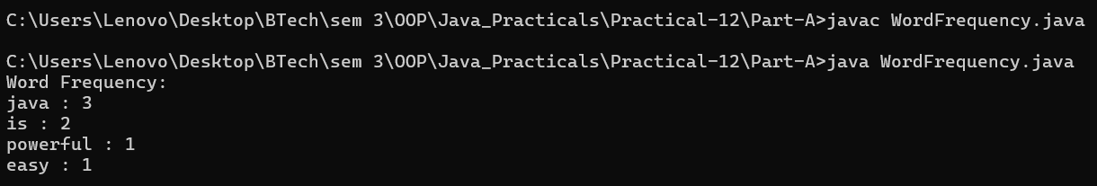

Code:

- UniqueVisitor.java
import java.util.*;

public class UniqueVisitors {
public static void main(String[] args) {
String[] logins = {
"Amit", "Priya", "Rahul", "Amit",
"Neha", "Priya", "Karan"
};
HashSet<String> set = new HashSet<>();
LinkedHashSet<String> orderedSet = new LinkedHashSet<>();
for (String name : logins) {
set.add(name);
orderedSet.add(name);
}
System.out.println("Unique Visitors: " + set.size());
System.out.println("First Three Distinct Names:");
int count = 0;
for (String name : orderedSet) {
if (count == 3) {
break;
}
System.out.println(name);
count++;
}
}
}

OUTPUT:

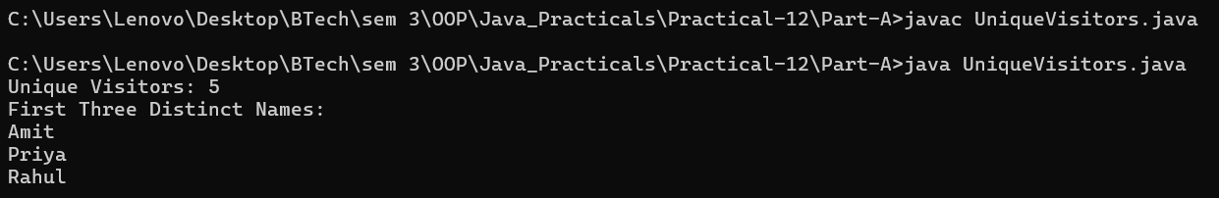

Part B — Project Work (Hour 2): MiniBank

AIM: Until now accounts have lived in a plain array, which is hard to search and grow. In this lab you upgrade MiniBank’s storage to the Collections Framework — a HashMap keyed by account number, sorting with a Comparator, and a thread-safe map for concurrent access. This is the Milestone 2 checkpoint.

1. Create a class named AccountStore that keeps accounts in a HashMap<String, Account> using the account number as the key. Add methods add(Account account), get(String accountNumber) and getAll().
2. Keep a transaction history in an ArrayList<String>.
3. Add a method sortedByBalance() that returns an ArrayList<Account> sorted with a Comparator.
4. Make Account implement Comparable<Account> by comparing account numbers in compareTo().
5. In the TransactionProcessor, use a ConcurrentHashMap for the shared accounts so it is thread-safe.
6. In main, add several accounts to the store and print them sorted by balance.

Code:

import java.util.Scanner;
import java.io.IOException;
import java.nio.file.Path;
import java.nio.file.Files;
import model.*;
import util.AnnotationValidator;
import util.StatementFormatter;
import util.BankResource;
import util.StatePersister;
import util.TransactionLog;
import util.ReportGenerator;
import service.CommandParser;
import exception.BankException;
import exception.InsufficientFundsException;
import exception.InvalidAmountException;
import static util.Validator.isValidMobile;
public class MiniBank {
public static void main(String[] args) {
Scanner sc = new Scanner(System.in);
BankInfo bank = new BankInfo("MiniBank", "Ahmedabad");
System.out.println("================================");
System.out.println(" " + bank.name());
System.out.println(" Branch: " + bank.branch());
System.out.println("================================");
// Create customers
Customer c1 = new Customer(
"Amit", "amit@gmail.com", "9876543210",
new Customer.Address(
"ABC Road", "Ahmedabad", "380001"));
Customer c2 = new Customer(
"Neha", "neha@gmail.com", "9876543211",
new Customer.Address(
"XYZ Road", "Surat", "395001"));
Customer c3 = new Customer(
"Rahul", "rahul@gmail.com", "9876543212",
new Customer.Address(
"Main Road", "Vadodara", "390001"));
System.out.println("\n===== Customers =====");
System.out.println(c1.getCustomerId() + " " + c1.getName());
System.out.println(c2.getCustomerId() + " " + c2.getName());
System.out.println(c3.getCustomerId() + " " + c3.getName());
// Create different account types
Account[] accounts = {
new SavingsAccount(c1.getName(), 1000, 500),
new CurrentAccount(c2.getName(), 0, 2000),
new FixedDepositAccount(c3.getName(), 2000)
};

// ===== Collections Framework: Milestone 2 =====
System.out.println("\n===== Account Store =====");
AccountStore store = new AccountStore();
// Add accounts to HashMap-based store
for (Account account : accounts) {
store.add(account);
}
System.out.println("Total accounts: " + store.size());
// Search for an account
Account found = store.get(accounts[0].getAccountNumber());
if (found != null) {
System.out.println("Found account: " + found);
}
// Store transaction history
store.addTransaction("DEPOSIT 500");
store.addTransaction("WITHDRAW 200");
store.addTransaction("TRANSFER 100");
System.out.println("\nTransaction History:");
for (String transaction : store.getTransactionHistory()) {
System.out.println(transaction);
}
// Sort accounts by balance
System.out.println("\n===== Accounts Sorted by Balance =====");
for (Account account : store.sortedByBalance()) {
System.out.println(
account.getAccountNumber()
+ " | " + account.getOwnerName()
+ " | Balance: " + account.getBalance()
);
}
// Demonstrate Comparable: sort by account number
System.out.println("\n===== Accounts Sorted by Account Number =====");
java.util.ArrayList<Account> byNumber = store.getAll();
java.util.Collections.sort(byNumber);
for (Account account : byNumber) {
System.out.println(
account.getAccountNumber() + " | " + account.getOwnerName()
);
}
// Demonstrate ConcurrentHashMap in TransactionProcessor
System.out.println("\n===== Thread-Safe Account Map =====");
TransactionProcessor processor = new TransactionProcessor();
for (Account account : accounts) {
processor.addAccount(account);
}
System.out.println(
"Accounts in concurrent map: " + processor.getAccounts().size()
);
System.out.println(
"Retrieved account: "
+ processor.getAccount(accounts[0].getAccountNumber())
);
processor.stop();
// Demonstrate deposit and withdrawal
try {
accounts[0].deposit(500);
accounts[0].withdraw(200);
accounts[1].deposit(1000);
accounts[1].withdraw(300);
} catch (BankException e) {
System.out.println(
"Bank operation error: " + e.getMessage());
} finally {
System.out.println("Initial account operations completed.");
}
// Display accounts and interest
System.out.println("\n===== Account Details =====");
for (Account account : accounts) {
System.out.println(account);
System.out.println("Interest Rate: "
+ account.interestRate() + "%");
System.out.println("Yearly Interest: Rs. "
+ String.format("%.2f", account.yearlyInterest()));
System.out.println("----------------------------");
}
// WithdrawRule using an anonymous class
WithdrawRule anonymousRule = new WithdrawRule() {
@Override
public boolean allow(Account account, long amount) {
return account.canWithdraw(amount);
}
};
// WithdrawRule using a lambda expression
WithdrawRule lambdaRule =
(account, amount) -> account.canWithdraw(amount);
System.out.println("\n===== Withdraw Rules =====");
System.out.println("Anonymous class allows withdrawal: "
+ anonymousRule.allow(accounts[0], 500));
System.out.println("Lambda allows withdrawal: "
+ lambdaRule.allow(accounts[0], 500));
System.out.println("Fixed deposit withdrawal allowed: "
+ lambdaRule.allow(accounts[2], 100));
// Demonstrate marker interface
System.out.println("\n===== Premium Check =====");
if (accounts[0] instanceof Premium) {
System.out.println("Savings account is marked Premium.");
}
// Demonstrate static import
System.out.println("\n===== Mobile Validation =====");
System.out.println("Mobile valid: "
+ isValidMobile("9876543210"));
// Display statement
System.out.println("\n===== Account Statement =====");
System.out.println(StatementFormatter.buildStatement(accounts[0]));
// Parse a command
System.out.println("\n===== Command Parser =====");
try {
Command command =
CommandParser.parse("DEPOSIT AC0001 500");
System.out.println("Type: " + command.type());
System.out.println("Account: " + command.accountNumber());
System.out.println("Amount: " + command.amount());
} catch (IllegalArgumentException e) {
System.out.println("Command error: " + e.getMessage());
}
// Annotation validation
System.out.println("\n--- Annotation Validation Test ---");
SavingsAccount testAccount =
new SavingsAccount("Test User", -500, 100);
String[] errors = AnnotationValidator.validate(testAccount);
if (errors.length == 0) {
System.out.println("Account is valid.");
} else {
for (String error : errors) {
System.out.println("Validation Error: " + error);
}
}
// Custom exception handling: insufficient funds
System.out.println("\n===== Exception Handling =====");
try {
accounts[0].withdraw(5000);
} catch (InsufficientFundsException e) {
System.out.println("Withdrawal failed: " + e.getMessage());
System.out.println("Shortfall: Rs. " + e.getShortfall());
} catch (InvalidAmountException e) {
System.out.println("Invalid withdrawal: " + e.getMessage());
} finally {
System.out.println("Withdrawal attempt completed.");
}
// Invalid deposit test
try {
accounts[0].deposit(-100);
} catch (InvalidAmountException e) {
System.out.println("Deposit failed: " + e.getMessage());
} finally {
System.out.println("Deposit attempt completed.");
}
// Transfer test
try {
accounts[0].transfer(accounts[1], 200);
} catch (BankException e) {
System.out.println("Transfer failed: " + e.getMessage());
} finally {
System.out.println("Transfer attempt completed.");
}
// Try-with-resources demonstration
System.out.println("\n===== Try-With-Resources =====");
try (BankResource resource = new BankResource()) {
resource.performTask();
} catch (Exception e) {
System.out.println("Resource error: " + e.getMessage());
}
// ==================================================
// FILE PERSISTENCE, TRANSACTION LOGGING AND REPORTING
// ==================================================
System.out.println("\n===== File Persistence =====");
Path stateFile = Path.of("data", "accounts.dat");
Path logsFolder = Path.of("logs");
Path logFile = logsFolder.resolve("transactions.log");
Path reportFile = Path.of("reports", "end_of_day.txt");
try {
// 1. Save account array
StatePersister.save(accounts, stateFile);
System.out.println("Accounts saved successfully.");
// 2. Load accounts into a new array
Account[] loadedAccounts = StatePersister.load(stateFile);
System.out.println("\n===== Reloaded Accounts =====");
for (Account account : loadedAccounts) {
System.out.println(account);
}
// 3. Create sample logs only if the log file is new.
// In actual transactions, append only after successful operations.
Files.createDirectories(logsFolder);
if (!Files.exists(logFile)) {
TransactionLog.append(logFile, "DEPOSIT 500");
TransactionLog.append(logFile, "WITHDRAW 100");
TransactionLog.append(logFile, "DEPOSIT 250");
}
// 4. Generate the end-of-day report
System.out.println("\n===== End-of-Day Report =====");
ReportGenerator.generate(logsFolder, reportFile);
System.out.println("Report saved to: "
+ reportFile.toAbsolutePath());
} catch (IOException | ClassNotFoundException e) {
System.out.println(
"File operation failed: " + e.getMessage());
}
// Menu shell
int choice = 0;
do {
System.out.println("\n===== MiniBank Menu =====");
System.out.println("1. Open Account");
System.out.println("2. Deposit");
System.out.println("3. Withdraw");
System.out.println("4. Transfer");
System.out.println("5. Exit");
System.out.print("Enter your choice: ");
if (!sc.hasNextInt()) {
System.out.println("Please enter a number.");
sc.next();
continue;
}
choice = sc.nextInt();
if (choice < 1 || choice > 5) {
System.out.println("Invalid choice! Please try again.");
continue;
}
MenuOption option = MenuOption.values()[choice - 1];
String message = switch (option) {
case OPEN_ACCOUNT ->
"Open Account - to be implemented in a later lab";
case DEPOSIT ->
"Deposit - to be implemented in a later lab";
case WITHDRAW ->
"Withdraw - to be implemented in a later lab";
case TRANSFER ->
"Transfer - to be implemented in a later lab";
case EXIT ->
"Thank you for using MiniBank!";
};
System.out.println(message);
} while (choice != 5);
sc.close();
}
enum MenuOption {
OPEN_ACCOUNT, DEPOSIT, WITHDRAW, TRANSFER, EXIT
}
}

OUTPUT:

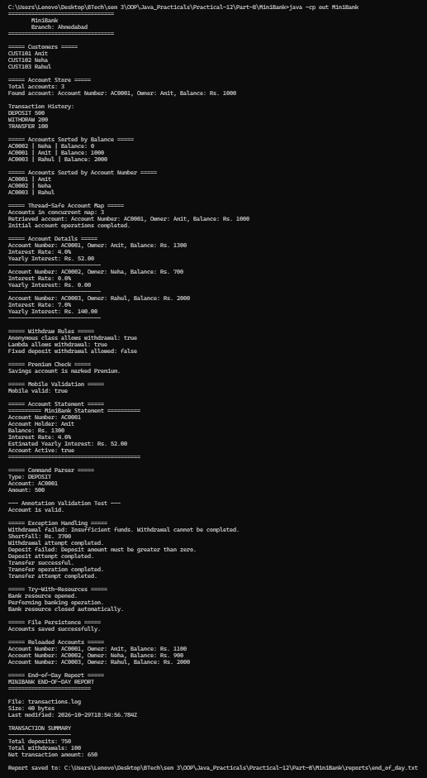
Learning Outcome:

Word Frequency — Learning Outcomes

Learned to split a paragraph into individual words and process text in Java.
Understood how to use a HashMap to store words and count their frequencies.
Practiced using a Comparator to sort words by frequency in descending order.
Learned to iterate through map entries and display words with their occurrence counts.
Understood how Java Collections help perform efficient text analysis and data sorting.

2. Unique Visitors — Learning Outcomes
Learned to use a HashSet to store unique login names and eliminate duplicates.
Understood how to use a LinkedHashSet to preserve the order in which names first appear.
Practiced counting distinct users from a list containing repeated login names.
Learned to retrieve and display the first three distinct names in insertion order.
Understood the differences between HashSet and LinkedHashSet and their applications in data management.

