Practical-13

AIM: Part A — Practice Programs (Hour 1). Work these in your lab-NN/ folder before the project: do the first one or two in the lab:

- Generic containers: a generic Box<T> with get/set and a Pair<A,B>; use them with different types to show type safety without casts, and write a generic method that returns the first element of any array.

- Bounded stats: a generic method <N extends Number> double average(N[] values) that works for Integer[], Double[] and Long[]; note why it refuses non-Number types.

Code:

- GenericContainers.java
class Box<T> {
private T value;
public void set(T value) {
this.value = value;
}
public T get() {
return value;
}
}
class Pair<A, B> {
private A first;
private B second;
public Pair(A first, B second) {
this.first = first;
this.second = second;
}
public A getFirst() {
return first;
}
public B getSecond() {
return second;
}
}
public class GenericContainers {
// Generic method to return the first element
public static <T> T firstElement(T[] array) {
return array[0];
}
public static void main(String[] args) {
Box<Integer> b1 = new Box<>();
b1.set(100);
System.out.println("Integer Box: " + b1.get());
Box<String> b2 = new Box<>();
b2.set("Hello Java");
System.out.println("String Box: " + b2.get());
Pair<String, Integer> p1 = new Pair<>("Amit", 20);
System.out.println("Name: " + p1.getFirst());
System.out.println("Age: " + p1.getSecond());
Integer[] numbers = {10, 20, 30};
String[] names = {"Java", "Python", "C++"};
System.out.println("First Number: " + firstElement(numbers));
System.out.println("First Name: " + firstElement(names));
}
}

OUTPUT:

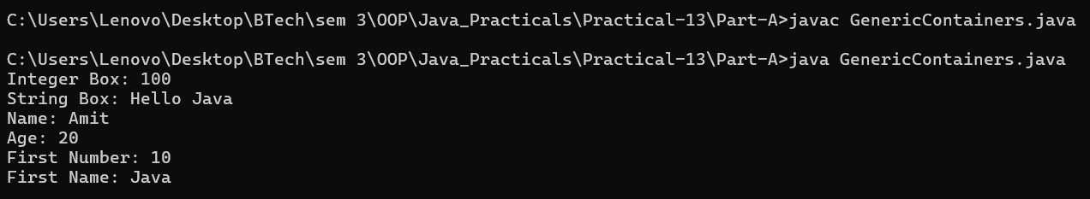

Code:

- BoundedStats.java
public class BoundedStats {
public static <N extends Number> double average(N[] values) {
double sum = 0;
for (N value : values) {
sum += value.doubleValue();
}
return sum / values.length;
}
public static void main(String[] args) {
Integer[] a = {10, 20, 30};
Double[] b = {2.5, 3.5, 4.5};
Long[] c = {100L, 200L, 300L};
System.out.println("Integer Average: " + average(a));
System.out.println("Double Average: " + average(b));
System.out.println("Long Average: " + average(c));
}
}

OUTPUT:

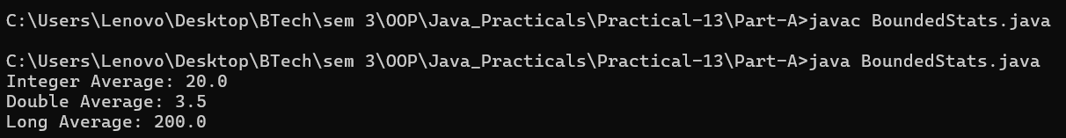

Part B — Project Work (Hour 2): MiniBank

AIM: The HashMap store from the previous lab works only for accounts. In this lab you make MiniBank’s storage reusable: one generic Repository<T> that stores any type safely and finds each object’s key through the @Id annotation by reflection — the repository pattern used in real data-access layers. The service layer in Practical 14 will use it.

1. Create a generic class named Repository<T> that holds a HashMap<String, T>. Add methods T save(T entity), T findById(String id), ArrayList<T> findAll() and boolean delete(String id).
2. Inside save(), find the id by reflection: look for the field marked @Id (from Practical 7) and read its value as the map key.
3. Add a method marked @SafeVarargs called saveAll(T... items) that saves several objects at once.
4. Add one generic method with a bounded type parameter, for example static <N extends Number> double average(N[] values).
5. In main, create a Repository<Account>, save several accounts, fetch one by id, and print all of them.

Code:

import java.util.Scanner;
import java.io.IOException;
import java.nio.file.Path;
import java.nio.file.Files;
import model.*;
import util.AnnotationValidator;
import util.StatementFormatter;
import util.BankResource;
import util.StatePersister;
import util.TransactionLog;
import util.ReportGenerator;
import service.CommandParser;
import exception.BankException;
import exception.InsufficientFundsException;
import exception.InvalidAmountException;
import static util.Validator.isValidMobile;
public class MiniBank {
public static void main(String[] args) {
Scanner sc = new Scanner(System.in);
BankInfo bank = new BankInfo("MiniBank", "Ahmedabad");
System.out.println("================================");
System.out.println(" " + bank.name());
System.out.println(" Branch: " + bank.branch());
System.out.println("================================");
// Create customers
Customer c1 = new Customer(
"Amit", "amit@gmail.com", "9876543210",
new Customer.Address(
"ABC Road", "Ahmedabad", "380001"));
Customer c2 = new Customer(
"Neha", "neha@gmail.com", "9876543211",
new Customer.Address(
"XYZ Road", "Surat", "395001"));
Customer c3 = new Customer(
"Rahul", "rahul@gmail.com", "9876543212",
new Customer.Address(
"Main Road", "Vadodara", "390001"));
System.out.println("\n===== Customers =====");
System.out.println(c1.getCustomerId() + " " + c1.getName());
System.out.println(c2.getCustomerId() + " " + c2.getName());
System.out.println(c3.getCustomerId() + " " + c3.getName());
// Create different account types
Account[] accounts = {
new SavingsAccount(c1.getName(), 1000, 500),
new CurrentAccount(c2.getName(), 0, 2000),
new FixedDepositAccount(c3.getName(), 2000)
}

// ===== Generic Repository Practical =====
System.out.println("\n===== Generic Repository =====");
Repository<Account> accountRepository = new Repository<>();
// Save all accounts
accountRepository.saveAll(accounts);
System.out.println("Accounts saved: "
+ accountRepository.findAll().size());
// Fetch one account by ID
String searchId = accounts[0].getAccountNumber();
Account foundAccount = accountRepository.findById(searchId);
System.out.println("\nAccount found by ID:");
if (foundAccount != null) {
System.out.println(foundAccount);
} else {
System.out.println("Account not found");
}
// Display all accounts
System.out.println("\nAll Accounts:");
for (Account account : accountRepository.findAll()) {
System.out.println(account);
}
// Demonstrate delete
// Uncomment these lines if you want to test deletion:
// boolean deleted = accountRepository.delete(searchId);
// System.out.println("Account deleted: " + deleted);
// Demonstrate bounded generic method
Integer[] numbers = {10, 20, 30, 40};
System.out.println("\nAverage: "
+ Repository.average(numbers));

// ===== Collections Framework: Milestone 2 =====
System.out.println("\n===== Account Store =====");
AccountStore store = new AccountStore();
// Add accounts to HashMap-based store
for (Account account : accounts) {
store.add(account);
}
System.out.println("Total accounts: " + store.size());
// Search for an account
Account found = store.get(accounts[0].getAccountNumber());
if (found != null) {
System.out.println("Found account: " + found);
}
// Store transaction history
store.addTransaction("DEPOSIT 500");
store.addTransaction("WITHDRAW 200");
store.addTransaction("TRANSFER 100");
System.out.println("\nTransaction History:");
for (String transaction : store.getTransactionHistory()) {
System.out.println(transaction);
}
// Sort accounts by balance
System.out.println("\n===== Accounts Sorted by Balance =====");
for (Account account : store.sortedByBalance()) {
System.out.println(
account.getAccountNumber()
+ " | " + account.getOwnerName()
+ " | Balance: " + account.getBalance()
);
}
// Demonstrate Comparable: sort by account number
System.out.println("\n===== Accounts Sorted by Account Number =====");
java.util.ArrayList<Account> byNumber = store.getAll();
java.util.Collections.sort(byNumber);
for (Account account : byNumber) {
System.out.println(
account.getAccountNumber() + " | " + account.getOwnerName()
);
}
// Demonstrate ConcurrentHashMap in TransactionProcessor
System.out.println("\n===== Thread-Safe Account Map =====");
TransactionProcessor processor = new TransactionProcessor();
for (Account account : accounts) {
processor.addAccount(account);
}
System.out.println(
"Accounts in concurrent map: " + processor.getAccounts().size()
);
System.out.println(
"Retrieved account: "
+ processor.getAccount(accounts[0].getAccountNumber())
);
processor.stop();
// Demonstrate deposit and withdrawal
try {
accounts[0].deposit(500);
accounts[0].withdraw(200);
accounts[1].deposit(1000);
accounts[1].withdraw(300);
} catch (BankException e) {
System.out.println(
"Bank operation error: " + e.getMessage());
} finally {
System.out.println("Initial account operations completed.");
}
// Display accounts and interest
System.out.println("\n===== Account Details =====");
for (Account account : accounts) {
System.out.println(account);
System.out.println("Interest Rate: "
+ account.interestRate() + "%");
System.out.println("Yearly Interest: Rs. "
+ String.format("%.2f", account.yearlyInterest()));
System.out.println("----------------------------");
}
// WithdrawRule using an anonymous class
WithdrawRule anonymousRule = new WithdrawRule() {
@Override
public boolean allow(Account account, long amount) {
return account.canWithdraw(amount);
}
};
// WithdrawRule using a lambda expression
WithdrawRule lambdaRule =
(account, amount) -> account.canWithdraw(amount);
System.out.println("\n===== Withdraw Rules =====");
System.out.println("Anonymous class allows withdrawal: "
+ anonymousRule.allow(accounts[0], 500));
System.out.println("Lambda allows withdrawal: "
+ lambdaRule.allow(accounts[0], 500));
System.out.println("Fixed deposit withdrawal allowed: "
+ lambdaRule.allow(accounts[2], 100));
// Demonstrate marker interface
System.out.println("\n===== Premium Check =====");
if (accounts[0] instanceof Premium) {
System.out.println("Savings account is marked Premium.");
}
// Demonstrate static import
System.out.println("\n===== Mobile Validation =====");
System.out.println("Mobile valid: "
+ isValidMobile("9876543210"));
// Display statement
System.out.println("\n===== Account Statement =====");
System.out.println(StatementFormatter.buildStatement(accounts[0]));
// Parse a command
System.out.println("\n===== Command Parser =====");
try {
Command command =
CommandParser.parse("DEPOSIT AC0001 500");
System.out.println("Type: " + command.type());
System.out.println("Account: " + command.accountNumber());
System.out.println("Amount: " + command.amount());
} catch (IllegalArgumentException e) {
System.out.println("Command error: " + e.getMessage());
}
// Annotation validation
System.out.println("\n--- Annotation Validation Test ---");
SavingsAccount testAccount =
new SavingsAccount("Test User", -500, 100);
String[] errors = AnnotationValidator.validate(testAccount)
if (errors.length == 0) {
System.out.println("Account is valid.");
} else {
for (String error : errors) {
System.out.println("Validation Error: " + error);
}
}
// Custom exception handling: insufficient funds
System.out.println("\n===== Exception Handling =====");
try {
accounts[0].withdraw(5000);
} catch (InsufficientFundsException e) {
System.out.println("Withdrawal failed: " + e.getMessage());
System.out.println("Shortfall: Rs. " + e.getShortfall());
} catch (InvalidAmountException e) {
System.out.println("Invalid withdrawal: " + e.getMessage());
} finally {
System.out.println("Withdrawal attempt completed.");
}
// Invalid deposit test
try {
accounts[0].deposit(-100);
} catch (InvalidAmountException e) {
System.out.println("Deposit failed: " + e.getMessage());
} finally {
System.out.println("Deposit attempt completed.");
}
// Transfer test
try {
accounts[0].transfer(accounts[1], 200);
} catch (BankException e) {
System.out.println("Transfer failed: " + e.getMessage());
} finally {
System.out.println("Transfer attempt completed.");
}
// Try-with-resources demonstration
System.out.println("\n===== Try-With-Resources =====");
try (BankResource resource = new BankResource()) {
resource.performTask();
} catch (Exception e) {
System.out.println("Resource error: " + e.getMessage());
}
// ==================================================
// FILE PERSISTENCE, TRANSACTION LOGGING AND REPORTING
// ==================================================
System.out.println("\n===== File Persistence =====");
Path stateFile = Path.of("data", "accounts.dat");
Path logsFolder = Path.of("logs");
Path logFile = logsFolder.resolve("transactions.log");
Path reportFile = Path.of("reports", "end_of_day.txt");
try {
// 1. Save account array
StatePersister.save(accounts, stateFile);
System.out.println("Accounts saved successfully.");
// 2. Load accounts into a new array
Account[] loadedAccounts = StatePersister.load(stateFile);
System.out.println("\n===== Reloaded Accounts =====");
for (Account account : loadedAccounts) {
System.out.println(account);
}
// 3. Create sample logs only if the log file is new.
// In actual transactions, append only after successful operations.
Files.createDirectories(logsFolder);
if (!Files.exists(logFile)) {
TransactionLog.append(logFile, "DEPOSIT 500");
TransactionLog.append(logFile, "WITHDRAW 100");
TransactionLog.append(logFile, "DEPOSIT 250");
}
// 4. Generate the end-of-day report
System.out.println("\n===== End-of-Day Report =====");
ReportGenerator.generate(logsFolder, reportFile);
System.out.println("Report saved to: "
+ reportFile.toAbsolutePath());
} catch (IOException | ClassNotFoundException e) {
System.out.println(
"File operation failed: " + e.getMessage());
}
// Menu shell
int choice = 0;
do {
System.out.println("\n===== MiniBank Menu =====");
System.out.println("1. Open Account");
System.out.println("2. Deposit");
System.out.println("3. Withdraw");
System.out.println("4. Transfer");
System.out.println("5. Exit");
System.out.print("Enter your choice: ");
if (!sc.hasNextInt()) {
System.out.println("Please enter a number.");
sc.next();
continue;
}
choice = sc.nextInt();
if (choice < 1 || choice > 5) {
System.out.println("Invalid choice! Please try again.");
continue;
}
MenuOption option = MenuOption.values()[choice - 1];
String message = switch (option) {
case OPEN_ACCOUNT ->
"Open Account - to be implemented in a later lab";
case DEPOSIT ->
"Deposit - to be implemented in a later lab";
case WITHDRAW ->
"Withdraw - to be implemented in a later lab";
case TRANSFER ->
"Transfer - to be implemented in a later lab";
case EXIT ->
"Thank you for using MiniBank!";
};
System.out.println(message);
} while (choice != 5);
sc.close();
}
enum MenuOption {
OPEN_ACCOUNT, DEPOSIT, WITHDRAW, TRANSFER, EXIT
}
}

OUTPUT:

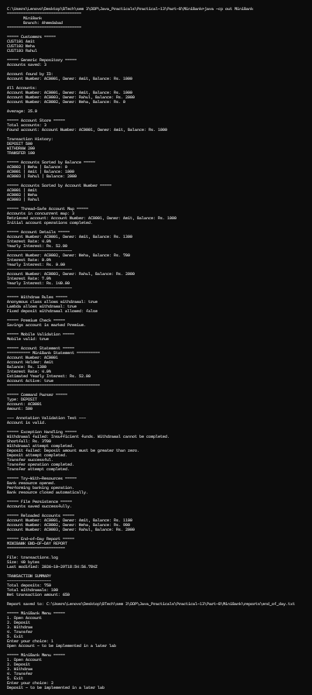
Learning Outcome:

Generic Containers — Learning Outcomes

Learned to create generic classes such as Box<T> and Pair<A, B> to store different types of data.
Understood how generics provide type safety and reduce the need for explicit type casting.
Practiced using getter and setter methods in generic classes.
Learned to write a generic method that returns the first element of an array of any type.
Understood how Java generics improve code reusability and reduce type-related errors.

Bounded Stats — Learning Outcomes

Learned to create a generic method using the bounded type parameter <N extends Number>.
Understood how to calculate the average of numeric arrays such as Integer[], Double[], and Long[].
Practiced converting numeric values to double using the doubleValue() method.
Learned how bounded type parameters restrict generic methods to specific types.
Understood why non-numeric types, such as String, are rejected at compile time because they do not extend Number.

