Practical-2

Aim: Part A — Practice Programs (Hour 1):
Work these in your lab-NN/ folder before the project: do the first one or two in the lab:

1. Smart thermostat (Thermostat.java, main in this file)
(a) Create class Thermostat with private String location, private int temperature, private static final int MIN=16 and MAX=30, and private static int activeCount=0.
(b) Constructor(location, startTemp): store location; set temperature to startTemp if it is within MIN..MAX else 22; increment activeCount.
(c) Constructor(location): chain with this(location, 22).
(d) raise(): if temperature < MAX add 1, else print “Already at maximum (30)”.
(e) lower(): if temperature > MIN subtract 1, else print “Already at minimum (16)”.
(f) Add getTemperature() (no setter) and static getActiveCount().
(g) In main: create two thermostats, call raise() 10 times then lower() 20 times in loops (printing the temperature each time), then print getActiveCount().

2. Cinema show (CinemaShow.java, main in this file)
(a) Create class CinemaShow with private String title, private int seatsAvailable, private final int capacity, and private static int totalBooked=0.
(b) Constructor(title, capacity): set both and seatsAvailable = capacity.
Constructor(title): chain with this(title, 100).
(c) book(int n): if n ≤ seatsAvailable, reduce seatsAvailable by n, add n to totalBooked, return true; else return false unchanged.
(d) cancel(int n): increase seatsAvailable by n but never above capacity.
(e) Add getSeatsAvailable() and static getTotalBooked().
(f) In main: run a sequence of book and cancel calls, printing the result and seats after each, then print getTotalBooked(). Expected output: booking more than available prints false and leaves seats unchanged; totalBooked equals the successful bookings.

Code:

1.
public class Thermostat {

private String location;
private int temperature;
private static final int MIN = 16;
private static final int MAX = 30;
private static int activeCount = 0;

public Thermostat(String location, int startTemp) {
this.location = location;

if (startTemp >= MIN && startTemp <= MAX) {
temperature = startTemp;
} else {
temperature = 22;
}

activeCount++;
}

public Thermostat(String location) {
this(location, 22);
}

public void raise() {
if (temperature < MAX) {
temperature++;
} else {
System.out.println("Already at maximum (30)");
}
}

public void lower() {
if (temperature > MIN) {
temperature--;
} else {
System.out.println("Already at minimum (16)");
}
}

public int getTemperature() {
return temperature;
}

public static int getActiveCount() {
return activeCount;
}

public static void main(String[] args) {

Thermostat t1 = new Thermostat("Living Room");
Thermostat t2 = new Thermostat("Bedroom", 25);

System.out.println("Initial Temperature: " + t1.getTemperature());

for (int i = 0; i < 10; i++) {
t1.raise();
System.out.println("Temperature: " + t1.getTemperature());
}

for (int i = 0; i < 20; i++) {
t1.lower();
System.out.println("Temperature: " + t1.getTemperature());
}

System.out.println("Active Thermostats: " + Thermostat.getActiveCount());
}
}

OUTPUT:
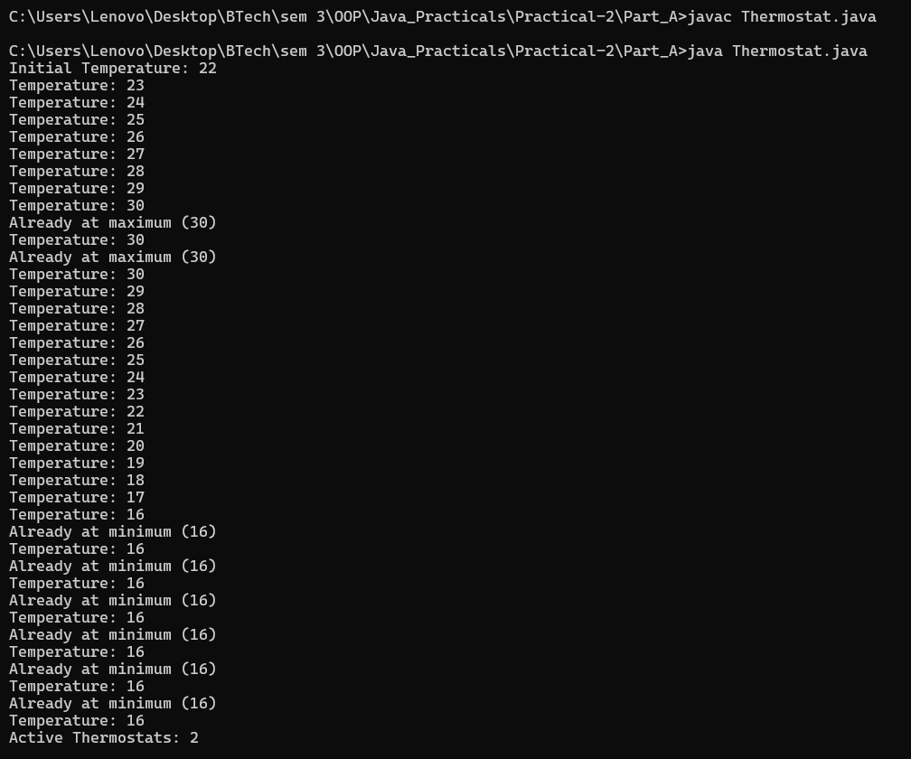

Code:

2.
public class CinemaShow {

private String title;
private int seatsAvailable;
private final int capacity;
private static int totalBooked = 0;
public CinemaShow(String title, int capacity) {
this.title = title;
this.capacity = capacity;
this.seatsAvailable = capacity;
}
public CinemaShow(String title) {
this(title, 100);
}
public boolean book(int n) {
if (n <= seatsAvailable) {
seatsAvailable -= n;
totalBooked += n;
return true;
} else {
return false;
}
}
public void cancel(int n) {
seatsAvailable += n;
if (seatsAvailable > capacity) {
seatsAvailable = capacity;
}
}
public int getSeatsAvailable() {
return seatsAvailable;
}
public static int getTotalBooked() {
return totalBooked;
}
public static void main(String[] args) {
CinemaShow show = new CinemaShow("Avengers", 100);
System.out.println("Book 20 seats: " + show.book(20));
System.out.println("Seats Available: " + show.getSeatsAvailable());
System.out.println("Book 50 seats: " + show.book(50));
System.out.println("Seats Available: " + show.getSeatsAvailable());
System.out.println("Book 40 seats: " + show.book(40));
System.out.println("Seats Available: " + show.getSeatsAvailable());
show.cancel(10);
System.out.println("After Cancel 10 seats:");
System.out.println("Seats Available: " + show.getSeatsAvailable());
System.out.println("Total Booked: " + CinemaShow.getTotalBooked());
}
}

OUTPUT:

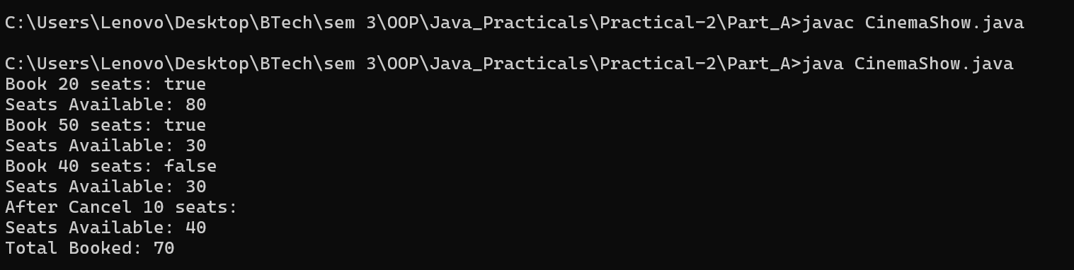

Part B — Project Work (Hour 2): MiniBank

AIM: In Practical 1 you built the empty menu shell. Now you create the data the bank works on — the Customer and Account classes. Using encapsulation, an account’s balance can change only through deposit() and withdraw(), never directly. These two classes are the foundation
every later lab extends.

1. Create a class named Customer with private fields name, email and mobile (all String) and a private final field customerId (String). Use a private static long field customerCounter and a private static method generateCustomerId() to create ids such as “CUST101”. Add a constructor and public getter methods.
2. Create a class named Account with private fields: a final String accountNumber, a String ownerName, a long balance (whole rupees) and a boolean active. Generate accountNumber with a private static counter (for example “AC0001”).
3. Add two constructors to Account: one taking ownerName and an opening balance; one taking only ownerName that calls the first using this(ownerName, 0).
4. Add a public method deposit(long amount) that adds amount to balance. Add a public method withdraw(long amount) that subtracts amount and returns true when the balance is sufficient, otherwise returns false without changing the balance. Add getter methods.
Do NOT add a public setter for balance.
- In main, create three Account objects inside an Account[] array, perform a few deposits and withdrawals, and print each balance.

Code:

import java.util.Scanner;
public class MiniBank {
// Record to store bank information
record BankInfo(String name, String branch) {}
// Enum for menu options
enum MenuOption {
OPEN_ACCOUNT,
DEPOSIT,
WITHDRAW,
TRANSFER,
EXIT
}
public static void main(String[] args) {
Scanner sc = new Scanner(System.in);
// Display application header
BankInfo bank = new BankInfo("MiniBank", "Ahmedabad");
System.out.println("================================");
System.out.println(" " + bank.name());
System.out.println(" Branch: " + bank.branch());
System.out.println("================================");
// Create Customer objects
Customer c1 = new Customer("Amit", "amit@gmail.com", "9876543210");
Customer c2 = new Customer("Neha", "neha@gmail.com", "9876543211");
Customer c3 = new Customer("Rahul", "rahul@gmail.com", "9876543212");
System.out.println("\n===== Customer Details =====");
System.out.println(c1.getCustomerId() + " " + c1.getName());
System.out.println(c2.getCustomerId() + " " + c2.getName());
System.out.println(c3.getCustomerId() + " " + c3.getName());
// Create three Account objects inside an array
Account[] accounts = {
new Account(c1.getName(), 1000),
new Account(c2.getName()),
new Account(c3.getName(), 2000)
};
// Perform deposits and withdrawals
accounts[0].deposit(500);
accounts[0].withdraw(200);
accounts[1].deposit(1000);
accounts[1].withdraw(300);
accounts[2].deposit(500);
accounts[2].withdraw(3000); // Insufficient balance
// Display account balances
System.out.println("\n===== Account Details =====");
for (Account account : accounts) {
System.out.println("Account Number: " + account.getAccountNumber());
System.out.println("Owner: " + account.getOwnerName());
System.out.println("Balance: Rs. " + account.getBalance());
System.out.println("Active: " + account.isActive());
System.out.println("----------------------------");
}
int choice;
// Display menu until the user selects EXIT
do {
System.out.println("\n===== MiniBank Menu =====");
System.out.println("1. Open Account");
System.out.println("2. Deposit");
System.out.println("3. Withdraw");
System.out.println("4. Transfer");
System.out.println("5. Exit");
System.out.print("Enter your choice: ");
choice = sc.nextInt();
if (choice < 1 || choice > 5) {
System.out.println("Invalid choice! Please try again.");
continue;
}
MenuOption option = MenuOption.values()[choice - 1];
String message = switch (option) {
case OPEN_ACCOUNT ->
"Open Account - to be implemented in a later lab";

case DEPOSIT ->
"Deposit - to be implemented in a later lab";
case WITHDRAW ->
"Withdraw - to be implemented in a later lab";

case TRANSFER ->
"Transfer - to be implemented in a later lab";
case EXIT ->
"Thank you for using MiniBank!";
};
System.out.println(message);
} while (choice != 5);
sc.close();
}
}
// Customer class
class Customer {
private String name;
private String email;
private String mobile;
private final String customerId;
private static long customerCounter = 100;
// Generate unique customer ID
private static String generateCustomerId() {
return "CUST" + (++customerCounter);
}
// Constructor
public Customer(String name, String email, String mobile) {
this.name = name;
this.email = email;
this.mobile = mobile;
this.customerId = generateCustomerId();
}
// Getter methods
public String getName() {
return name;
}
public String getEmail() {
return email;
}
public String getMobile() {
return mobile;
}
public String getCustomerId() {
return customerId;
}
}
// Account class
class Account {
private final String accountNumber;
private String ownerName;
private long balance;
private boolean active;
private static long accountCounter = 0;
// Generate unique account number
private static String generateAccountNumber() {
return String.format("AC%04d", ++accountCounter);
}
// Constructor with opening balance
public Account(String ownerName, long openingBalance) {
this.accountNumber = generateAccountNumber();
this.ownerName = ownerName;
this.balance = Math.max(0, openingBalance);
this.active = true;
}
// Constructor with default balance of zero
public Account(String ownerName) {
this(ownerName, 0);
}
// Deposit money
public void deposit(long amount) {
if (amount > 0 && active) {
balance += amount;
} else {
System.out.println("Invalid deposit amount or inactive account.");
}
}
// Withdraw money
public boolean withdraw(long amount) {
if (amount > 0 && active && balance >= amount) {
balance -= amount;
return true;
}
System.out.println("Withdrawal failed: insufficient balance or invalid amount.");
return false;
}
// Getter methods
public String getAccountNumber() {
return accountNumber;
}
public String getOwnerName() {
return ownerName;
}
public long getBalance() {
return balance;
}
public boolean isActive() {
return active;
}
}

OUTPUT:

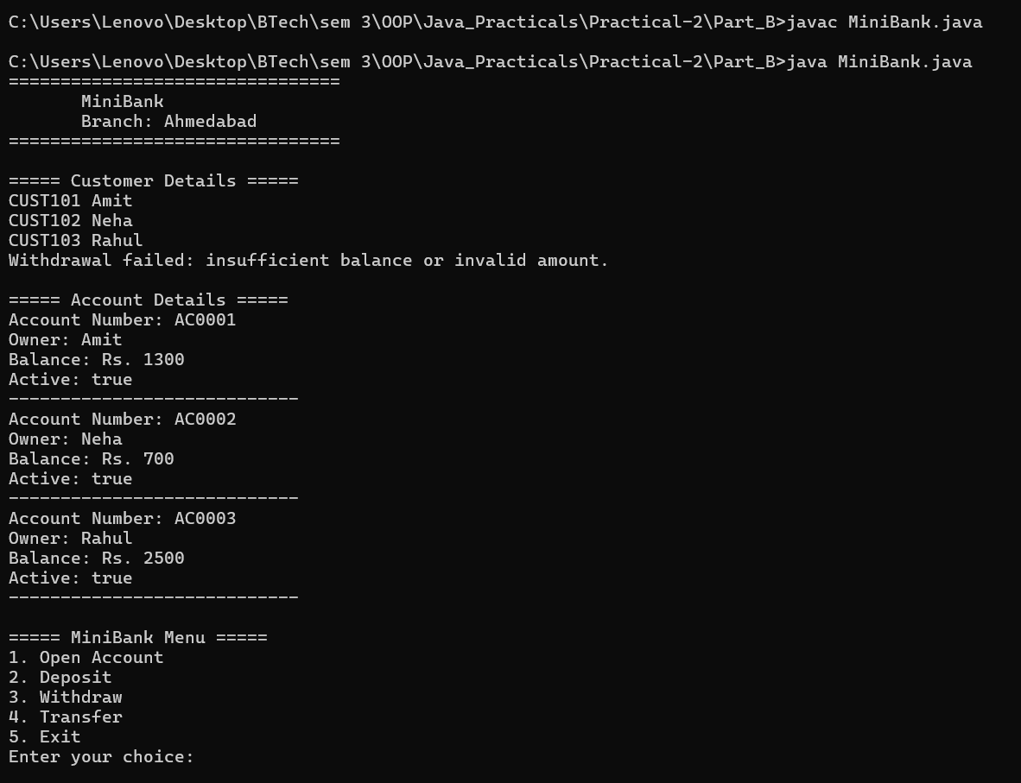

Learning Outcome:

Smart Thermostat — Learning Outcomes

Learned to create classes with private instance variables and static variables in Java.
Understood the use of constructors and constructor chaining using this().
Learned to use constants with static final and validate temperature limits.
Practiced implementing methods to raise and lower temperature with boundary checks.
Understood encapsulation and static methods for tracking the number of active thermostats.

Cinema Show — Learning Outcomes

Learned to create classes using private variables and final constants in Java.
Understood constructor overloading and constructor chaining using this().
Practiced booking and cancelling seats using methods and conditional statements.
Learned to prevent overbooking and ensure available seats never exceed the cinema capacity.
Understood the use of static variables and methods to track total successfully booked seats.

