Practical-3

Aim: Part A — Practice Programs (Hour 1)
Work these in your lab-NN/ folder before the project: do the first one or two in the lab:

1. Distinct points (Point.java + Driver.java with main)
(a) Create class Point with private int x, y and a constructor.
(b) Override toString() to return “(x, y)”.
(c) Override equals(Object) to be true when both x and y match, and hashCode() to agree (e.g. Objects.hash(x, y)).
(d) In Driver.main: build a Point[] with some repeated coordinates.
(e) Count distinct points: for each point, use equals() to check whether it already appeared earlier; count those that did not.
(f) Print “Distinct: N”.

2. Duplicate card check (Card.java + Driver.java)
(a) Create class Card with private String rank, suit and a constructor.
(b) Override toString() to return rank + “ of ” + suit (e.g. “Queen of Hearts”).
(c) Override equals()/hashCode() by rank + suit.
(d) In Driver.main: add cards to a Card[] one at a time; before adding each, use equals() to check it against the earlier cards.
(e) Print “Duplicate found: <card>” the first time a repeat appears.

Code:

- Driver.java
public class Driver {
public static void main(String[] args) {
Point[] p = {
new Point(1, 2),
new Point(3, 4),
new Point(1, 2),
new Point(5, 6),
new Point(3, 4)
};
int count = 0;
for (int i = 0; i < p.length; i++) {
boolean found = false;
for (int j = 0; j < i; j++) {
if (p[i].equals(p[j])) {
found = true;
break;
}
}
if (!found)
count++;
}
System.out.println("Distinct: " + count);
}
}

- Point.java
import java.util.Objects;
public class Point {
private int x;
private int y;
public Point(int x, int y) {
this.x = x;
this.y = y;
}
public String toString() {
return "(" + x + ", " + y + ")";
}
public boolean equals(Object obj) {
if (this == obj) return true;
if (!(obj instanceof Point)) return false;
Point p = (Point) obj;
return x == p.x && y == p.y;
}
public int hashCode() {
return Objects.hash(x, y);
}
}

OUTPUT:
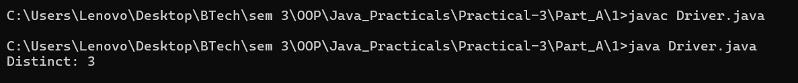

Code:
- Driver.java
public class Driver {
public static void main(String[] args) {
Card[] cards = {
new Card("Ace", "Spades"),
new Card("King", "Hearts"),
new Card("Queen", "Diamonds"),
new Card("Ace", "Spades")
};
for (int i = 0; i < cards.length; i++) {
for (int j = 0; j < i; j++) {
if (cards[i].equals(cards[j])) {
System.out.println("Duplicate found: " + cards[i]);
return;
}
}
}
}
}

- Card.java
import java.util.Objects;
public class Card {
private String rank;
private String suit;
public Card(String rank, String suit) {
this.rank = rank;
this.suit = suit;
}
public String toString() {
return rank + " of " + suit;
}
public boolean equals(Object obj) {
if (this == obj) return true;
if (!(obj instanceof Card)) return false;
Card c = (Card) obj;
return rank.equals(c.rank) && suit.equals(c.suit);
}
public int hashCode() {
return Objects.hash(rank, suit);
}
}

OUTPUT:

Part B — Project Work (Hour 2): MiniBank

AIM: In Practical 2 you created the Account and Customer classes. Here you make their objects behave correctly — they print as readable text (toString) and are compared by account number (equals/hashCode) — and you add a nested Address class. Correct equals/hashCode is essential because Practical 12 will store accounts in collections that rely on it.

1. In Account, override the toString() method to return a readable line containing accountNumber, ownerName and balance.
2. In Account, override equals(Object o) and hashCode() so that two accounts are equal when their accountNumber values are equal.
3. In Customer, add a public static nested class named Address with String fields line, city and pincode plus getters; add an Address field to Customer and a getAddress() method.
4. In Customer, add a clone() method (implement Cloneable) that returns a copy of the customer.
5. In main, print accounts using toString(), compare two Account objects with equals(), and use instanceof to check an object’s type.

Code:

import java.util.Scanner;
import java.util.Objects;
public class MiniBank {
// Record to store bank information
record BankInfo(String name, String branch) {}
// Enum for menu options
enum MenuOption {
OPEN_ACCOUNT,
DEPOSIT,
WITHDRAW,
TRANSFER,
EXIT
}
public static void main(String[] args) {
Scanner sc = new Scanner(System.in);
// Display application header
BankInfo bank = new BankInfo("MiniBank", "Ahmedabad");
System.out.println("================================");
System.out.println(" " + bank.name());
System.out.println(" Branch: " + bank.branch());
System.out.println("================================");
// Create Customer objects with addresses
Customer c1 = new Customer("Amit", "amit@gmail.com",
"9876543210",
new Customer.Address("ABC Road", "Ahmedabad", "380001"));
Customer c2 = new Customer("Neha", "neha@gmail.com",
"9876543211",
new Customer.Address("XYZ Road", "Surat", "395001"));
Customer c3 = new Customer("Rahul", "rahul@gmail.com",
"9876543212",
new Customer.Address("Main Road", "Vadodara", "390001"));
System.out.println("\n===== Customer Details =====");
System.out.println(c1.getCustomerId() + " " + c1.getName());
System.out.println(c2.getCustomerId() + " " + c2.getName());
System.out.println(c3.getCustomerId() + " " + c3.getName());
// Display nested Address details
Customer.Address address = c1.getAddress();
System.out.println("Address: " + address.getLine() + ", "
+ address.getCity() + ", " + address.getPincode());
// Clone a customer
Customer clonedCustomer = c1.clone();
System.out.println("\n===== Cloned Customer =====");
System.out.println(clonedCustomer.getCustomerId() + " "
+ clonedCustomer.getName());
// Create three accounts
Account[] accounts = {
new Account(c1.getName(), 1000),
new Account(c2.getName()),
new Account(c3.getName(), 2000)
};
// Perform deposits and withdrawals
accounts[0].deposit(500);
accounts[0].withdraw(200);
accounts[1].deposit(1000);
accounts[1].withdraw(300);
accounts[2].deposit(500);
accounts[2].withdraw(3000);
// Print accounts using toString()
System.out.println("\n===== Account Details =====");
for (Account account : accounts) {
System.out.println(account);
}
// Compare accounts using equals()
System.out.println("\n===== Account Comparison =====");
System.out.println("Account 1 equals Account 2: "
+ accounts[0].equals(accounts[1]));
System.out.println("Account 1 equals itself: "
+ accounts[0].equals(accounts[0]));
// Check object type using instanceof
System.out.println("\n===== Type Checking =====");
Object obj = accounts[0];
if (obj instanceof Account) {
System.out.println("The object is an Account.");
} else {
System.out.println("The object is not an Account.");
}
int choice;
// Display menu until EXIT is selected
do {
System.out.println("\n===== MiniBank Menu =====");
System.out.println("1. Open Account");
System.out.println("2. Deposit");
System.out.println("3. Withdraw");
System.out.println("4. Transfer");
System.out.println("5. Exit");
System.out.print("Enter your choice: ");
choice = sc.nextInt();
if (choice < 1 || choice > 5) {
System.out.println("Invalid choice! Please try again.");
continue;
}
MenuOption option = MenuOption.values()[choice - 1];
String message = switch (option) {
case OPEN_ACCOUNT ->
"Open Account - to be implemented in a later lab";
case DEPOSIT ->
"Deposit - to be implemented in a later lab";
case WITHDRAW ->
"Withdraw - to be implemented in a later lab";
case TRANSFER ->
"Transfer - to be implemented in a later lab";
case EXIT ->
"Thank you for using MiniBank!";
};
System.out.println(message);
} while (choice != 5);
sc.close();
}
}
// Customer class
class Customer implements Cloneable {
private String name;
private String email;
private String mobile;
private final String customerId;
private Address address;
private static long customerCounter = 100;
// Nested Address class
public static class Address {
private String line;
private String city;
private String pincode;
public Address(String line, String city, String pincode) {
this.line = line;
this.city = city;
this.pincode = pincode;
}
public String getLine() {
return line;
}
public String getCity() {
return city;
}
public String getPincode() {
return pincode;
}
}
// Generate customer ID
private static String generateCustomerId() {
return "CUST" + (++customerCounter);
}
// Constructor without address
public Customer(String name, String email, String mobile) {
this(name, email, mobile, null);
}
// Constructor with address
public Customer(String name, String email, String mobile,
Address address) {
this.name = name;
this.email = email;
this.mobile = mobile;
this.address = address;
this.customerId = generateCustomerId();
}
// Getter methods
public String getName() {
return name;
}
public String getEmail() {
return email;
}
public String getMobile() {
return mobile;
}
public String getCustomerId() {
return customerId;
}
public Address getAddress() {
return address;
}
// Clone customer
@Override
public Customer clone() {
try {
return (Customer) super.clone();
} catch (CloneNotSupportedException e) {
throw new AssertionError(e);
}
}
}
// Account class
class Account {
private final String accountNumber;
private String ownerName;
private long balance;
private boolean active;
private static long accountCounter = 0;
// Generate account number
private static String generateAccountNumber() {
return String.format("AC%04d", ++accountCounter);
}
// Constructor with opening balance
public Account(String ownerName, long openingBalance) {
this.accountNumber = generateAccountNumber();
this.ownerName = ownerName;
this.balance = Math.max(0, openingBalance);
this.active = true;
}
// Constructor with zero opening balance
public Account(String ownerName) {
this(ownerName, 0);
}
// Deposit money
public void deposit(long amount) {
if (amount > 0 && active) {
balance += amount;
} else {
System.out.println(
"Invalid deposit amount or inactive account.");
}
}
// Withdraw money
public boolean withdraw(long amount) {
if (amount > 0 && active && balance >= amount) {
balance -= amount;
return true;
}
System.out.println(
"Withdrawal failed: insufficient balance or invalid amount.");
return false;
}
// Getter methods
public String getAccountNumber() {
return accountNumber;
}
public String getOwnerName() {
return ownerName;
}
public long getBalance() {
return balance;
}
public boolean isActive() {
return active;
}
// Convert account details to readable text
@Override
public String toString() {
return "Account Number: " + accountNumber
+ ", Owner: " + ownerName
+ ", Balance: Rs. " + balance;
}
// Compare accounts by account number
@Override
public boolean equals(Object o) {
if (this == o) {
return true;
}
if (!(o instanceof Account)) {
return false;
}
Account account = (Account) o;
return accountNumber.equals(account.accountNumber);
}
// Generate hash code using account number
@Override
public int hashCode() {
return Objects.hash(accountNumber);
}
}

OUTPUT:

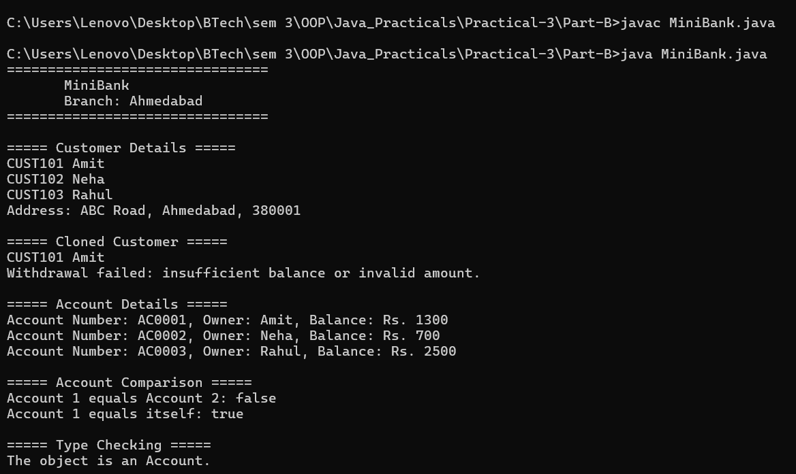
Learning Outcome:

Distinct Points — Learning Outcomes

Learned to create classes with private variables and constructors in Java.
Understood how to override toString() to display objects in a readable format.
Learned to override equals() and hashCode() to compare objects based on their coordinates.
Practiced using arrays and loops to identify and count distinct points.
Understood how to check object equality and avoid counting repeated coordinates.

Duplicate Card Check — Learning Outcomes

Learned to create a Card class with rank and suit attributes.
Understood how to override toString() to display card details clearly.
Learned to implement equals() and hashCode() based on rank and suit.
Practiced using arrays and loops to compare new cards with previously added cards.
Understood how to detect duplicate objects and display the first repeated card.

