Practical-5

AIM: Part A — Practice Programs (Hour 1) Work these in your lab-NN/ folder before the project: do the first one or two in the lab:

- Shape areas: an abstract Shape with abstract area(); subclasses Circle, Rectangle, Triangle. Put a mix in a Shape[] and loop once to print each area and the running total, tracking the largest — one loop handling every shape through polymorphism.

- Payroll: an abstract Employee with abstract monthlySalary(); FullTime (fixed), PartTime (hours × rate) and Intern (stipend), each calling super for the shared name/id. Loop a mixed array to print each salary and the total; use instanceof to add a note only for interns.

Code:

- Driver.java
public class Driver {
public static void main(String[] args) {
Shape[] shapes = {
new Circle(5),
new Rectangle(4, 6),
new Triangle(8, 5),
new Circle(3)
};
double total = 0;
double largest = 0;
for (Shape s : shapes) {
double a = s.area();
System.out.println("Area: " + a);
total += a;
if (a > largest) {
largest = a;
}
}
System.out.println("Total area: " + total);
System.out.println("Largest area: " + largest);
}
}

1.Shape.java
abstract class Shape {
abstract double area();
}

1.Circle.java
class Circle extends Shape {
double radius;
Circle(double radius) {
this.radius = radius;
}
@Override
double area() {
return Math.PI * radius * radius;
}
}

- Rectangle.java
class Rectangle extends Shape {
double length;
double width;
Rectangle(double length, double width) {
this.length = length;
this.width = width;
}
@Override
double area() {
return length * width;
}
}

- Triangle.java
class Triangle extends Shape {
double base;
double height;
Triangle(double base, double height) {
this.base = base;
this.height = height;
}
@Override
double area() {
return 0.5 * base * height;
}
}

OUTPUT:

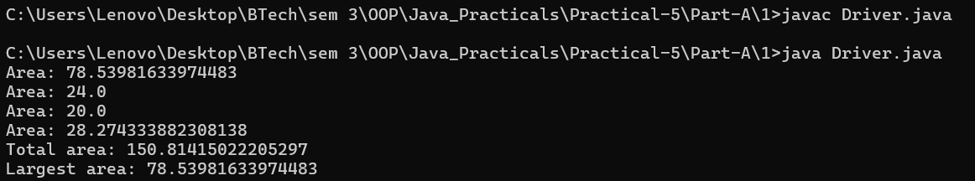

Code:

2.
abstract class Employee {
String name;
int id;
Employee(String name, int id) {
this.name = name;
this.id = id;
}
abstract double monthlySalary();
}
class FullTime extends Employee {
double fixedSalary;
FullTime(String name, int id, double fixedSalary) {
super(name, id);
this.fixedSalary = fixedSalary;
}
@Override
double monthlySalary() {
return fixedSalary;
}
}
class PartTime extends Employee {
int hours;
double rate;
PartTime(String name, int id, int hours, double rate) {
super(name, id);
this.hours = hours;
this.rate = rate;
}
@Override
double monthlySalary() {
return hours * rate;
}
}
class Intern extends Employee {
double stipend;
Intern(String name, int id, double stipend) {
super(name, id);
this.stipend = stipend;
}
@Override
double monthlySalary() {
return stipend;
}
}
public class Payroll {
public static void main(String[] args) {
Employee[] employees = {
new FullTime("Rahul", 101, 50000),
new PartTime("Priya", 102, 80, 300),
new Intern("Aarav", 103, 15000),
new FullTime("Neha", 104, 60000)
};
double total = 0;
for (Employee e : employees) {
double salary = e.monthlySalary();
System.out.println(
e.name + " (ID: " + e.id + ") Salary: Rs." + salary
);
if (e instanceof Intern) {
System.out.println(" Note: This employee is an intern.");
}
total += salary;
}
System.out.println("-------------------------");
System.out.println("Total Payroll: Rs." + total);
}
}

OUTPUT:

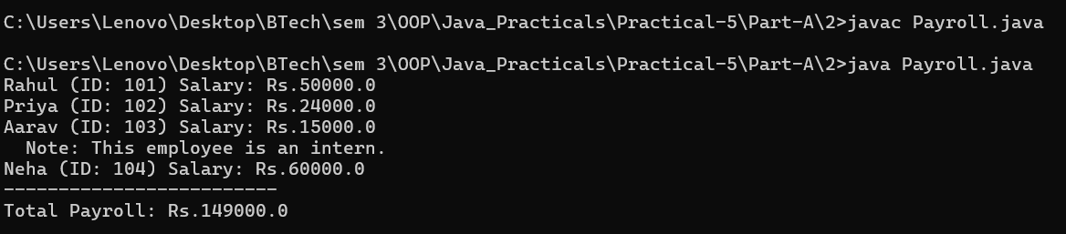

Part B — Project Work (Hour 2): MiniBank

AIM: A real bank has different account types. Building on the single Account class, this lab makes Account abstract and adds three subclasses — SavingsAccount, CurrentAccount and FixedDepositAccount — each with its own interest and withdrawal rules chosen automatically by polymorphism. This lets the rest of MiniBank treat every account through one common type.

1. Make Account an abstract class. Add two abstract methods: double interestRate() and boolean canWithdraw(long amount).
2. Create a class SavingsAccount that extends Account with a long field minBalance; interestRate() returns 4.0; canWithdraw() returns true only if the balance stays greater than or equal to minBalance.
3. Create a class CurrentAccount that extends Account with a long field overdraftLimit; interestRate() returns 0; canWithdraw() allows the balance to fall to minus overdraftLimit.
4. Create a class FixedDepositAccount that extends Account; interestRate() returns 7.0; canWithdraw() returns false (the deposit is locked).
5. Call super(...) from each subclass constructor to initialise the inherited fields.
6. In main, place objects of the three types in an Account[] array, loop through it and call interestRate() on each (this demonstrates run-time polymorphism); use a pattern instanceof check to handle one type specially.

Code:

import java.util.Scanner;
import java.util.Objects;
import java.util.regex.Pattern;
public class MiniBank {
record BankInfo(String name, String branch) {}
enum MenuOption {
OPEN_ACCOUNT, DEPOSIT, WITHDRAW, TRANSFER, EXIT
}
public static void main(String[] args) {
Scanner sc = new Scanner(System.in);
BankInfo bank = new BankInfo("MiniBank", "Ahmedabad");
System.out.println("================================");
System.out.println(" " + bank.name());
System.out.println(" Branch: " + bank.branch());
System.out.println("================================");
// Create customers
Customer c1 = new Customer(
"Amit", "amit@gmail.com", "9876543210",
new Customer.Address("ABC Road", "Ahmedabad", "380001"));
Customer c2 = new Customer(
"Neha", "neha@gmail.com", "9876543211",
new Customer.Address("XYZ Road", "Surat", "395001"));
Customer c3 = new Customer(
"Rahul", "rahul@gmail.com", "9876543212",
new Customer.Address("Main Road", "Vadodara", "390001"));
System.out.println("\n===== Customer Details =====");
System.out.println(c1.getCustomerId() + " " + c1.getName());
System.out.println(c2.getCustomerId() + " " + c2.getName());
System.out.println(c3.getCustomerId() + " " + c3.getName());
Customer.Address address = c1.getAddress();
System.out.println("Address: " + address.getLine() + ", "
+ address.getCity() + ", " + address.getPincode());
// Test cloning
Customer clonedCustomer = c1.clone();
System.out.println("\nCloned Customer: "
+ clonedCustomer.getCustomerId() + " "
+ clonedCustomer.getName());
// Create different account types in one Account array
Account[] accounts = {
new SavingsAccount(c1.getName(), 1000, 500),
new CurrentAccount(c2.getName(), 0, 2000),
new FixedDepositAccount(c3.getName(), 2000)
};
// Perform transactions
accounts[0].deposit(500);
accounts[0].withdraw(200);
accounts[1].deposit(1000);
accounts[1].withdraw(300);
accounts[2].deposit(500);
accounts[2].withdraw(100); // Not allowed for fixed deposit
// Display account details and interest rates
System.out.println("\n===== Account Details =====");
for (Account account : accounts) {
System.out.println(account);
System.out.println("Interest Rate: "
+ account.interestRate() + "%");
System.out.println("----------------------------");
}
// Demonstrate runtime polymorphism
System.out.println("\n===== Runtime Polymorphism =====");
for (Account account : accounts) {
System.out.println(account.getOwnerName()
+ " -> Interest: "
+ account.interestRate() + "%");
}
// Pattern matching with instanceof (Java 17+)
System.out.println("\n===== Type-Specific Check =====");
for (Account account : accounts) {
if (account instanceof SavingsAccount savingsAccount) {
System.out.println("Savings account minimum balance: Rs. "
+ savingsAccount.getMinBalance());
}
}
// Test equals()
System.out.println("\n===== Account Comparison =====");
System.out.println("Account 1 equals Account 2: "
+ accounts[0].equals(accounts[1]));
// Test instanceof
Object obj = accounts[0];
System.out.println("Is object an Account? "
+ (obj instanceof Account));
// Test validators
System.out.println("\n===== Validator Tests =====");
System.out.println("Valid Mobile: "
+ Validator.isValidMobile("9876543210"));
System.out.println("Invalid Mobile: "
+ Validator.isValidMobile("12345"));
System.out.println("Valid Email: "
+ Validator.isValidEmail("amit@gmail.com"));
System.out.println("Invalid Email: "
+ Validator.isValidEmail("amit@"));
System.out.println("Valid PAN: "
+ Validator.isValidPan("ABCDE1234F"));
System.out.println("Invalid PAN: "
+ Validator.isValidPan("ABC123"));
System.out.println("Valid IFSC: "
+ Validator.isValidIfsc("SBIN0001234"));
System.out.println("Invalid IFSC: "
+ Validator.isValidIfsc("SB123"));
// Test command parser
System.out.println("\n===== Command Parser =====");
Command command = CommandParser.parse("DEPOSIT AC0001 500");
System.out.println("Type: " + command.type());
System.out.println("Account Number: " + command.accountNumber());
System.out.println("Amount: " + command.amount());
// Test statement formatter
System.out.println("\n===== Account Statement =====");
System.out.println(
StatementFormatter.buildStatement(accounts[0]));
// Original menu
int choice;
do {
System.out.println("\n===== MiniBank Menu =====");
System.out.println("1. Open Account");
System.out.println("2. Deposit");
System.out.println("3. Withdraw");
System.out.println("4. Transfer");
System.out.println("5. Exit");
System.out.print("Enter your choice: ");
choice = sc.nextInt();
if (choice < 1 || choice > 5) {
System.out.println("Invalid choice! Please try again.");
continue;
}
MenuOption option = MenuOption.values()[choice - 1];
String message = switch (option) {
case OPEN_ACCOUNT ->
"Open Account - to be implemented in a later lab";
case DEPOSIT ->
"Deposit - to be implemented in a later lab";
case WITHDRAW ->
"Withdraw - to be implemented in a later lab";
case TRANSFER ->
"Transfer - to be implemented in a later lab";
case EXIT ->
"Thank you for using MiniBank!";
};
System.out.println(message);
} while (choice != 5);
sc.close();
}
}
// Customer class
class Customer implements Cloneable {
private String name;
private String email;
private String mobile;
private final String customerId;
private Customer.Address address;
private static long customerCounter = 100;
public static class Address {
private String line;
private String city;
private String pincode;
public Address(String line, String city, String pincode) {
this.line = line;
this.city = city;
this.pincode = pincode;
}
public String getLine() {
return line;
}
public String getCity() {
return city;
}
public String getPincode() {
return pincode;
}
}
private static String generateCustomerId() {
return "CUST" + (++customerCounter);
}
public Customer(String name, String email, String mobile) {
this(name, email, mobile, null);
}
public Customer(String name, String email, String mobile,
Customer.Address address) {
this.name = name;
this.email = email;
this.mobile = mobile;
this.address = address;
this.customerId = generateCustomerId();
}
public String getName() {
return name;
}
public String getEmail() {
return email;
}
public String getMobile() {
return mobile;
}
public String getCustomerId() {
return customerId;
}
public Customer.Address getAddress() {
return address;
}
@Override
public Customer clone() {
try {
return (Customer) super.clone();
} catch (CloneNotSupportedException e) {
throw new AssertionError(e);
}
}
}
// Abstract Account class
abstract class Account {
private final String accountNumber;
private String ownerName;
private long balance;
private boolean active;
private static long accountCounter = 0;
private static String generateAccountNumber() {
return String.format("AC%04d", ++accountCounter);
}
public Account(String ownerName, long openingBalance) {
this.accountNumber = generateAccountNumber();
this.ownerName = ownerName;
this.balance = Math.max(0, openingBalance);
this.active = true;
}
public Account(String ownerName) {
this(ownerName, 0);
}
// Abstract methods implemented by subclasses
public abstract double interestRate();
public abstract boolean canWithdraw(long amount);
// Deposit money
public void deposit(long amount) {
if (amount > 0 && active) {
balance += amount;
} else {
System.out.println(
"Invalid deposit amount or inactive account.");
}
}
// Withdraw money according to account-specific rules
public boolean withdraw(long amount) {
if (amount > 0 && active && canWithdraw(amount)) {
balance -= amount;
return true;
}
System.out.println(
"Withdrawal failed: account rules or balance limit.");
return false;
}
// Getter methods
public String getAccountNumber() {
return accountNumber;
}
public String getOwnerName() {
return ownerName;
}
public long getBalance() {
return balance;
}
public boolean isActive() {
return active;
}
@Override
public String toString() {
return "Account Number: " + accountNumber
+ ", Owner: " + ownerName
+ ", Balance: Rs. " + balance;
}
@Override
public boolean equals(Object o) {
if (this == o) {
return true;
}
if (!(o instanceof Account)) {
return false;
}
Account account = (Account) o;
return accountNumber.equals(account.accountNumber);
}
@Override
public int hashCode() {
return Objects.hash(accountNumber);
}
}
// SavingsAccount class
class SavingsAccount extends Account {
private long minBalance;
public SavingsAccount(String ownerName, long openingBalance,
long minBalance) {
super(ownerName, openingBalance);
this.minBalance = Math.max(0, minBalance);
}
@Override
public double interestRate() {
return 4.0;
}
@Override
public boolean canWithdraw(long amount) {
return amount > 0
&& getBalance() - amount >= minBalance;
}
public long getMinBalance() {
return minBalance;
}
}
// CurrentAccount class
class CurrentAccount extends Account {
private long overdraftLimit;
public CurrentAccount(String ownerName, long openingBalance,
long overdraftLimit) {
super(ownerName, openingBalance);
this.overdraftLimit = Math.max(0, overdraftLimit);
}
@Override
public double interestRate() {
return 0.0;
}
@Override
public boolean canWithdraw(long amount) {
return amount > 0
&& getBalance() - amount >= -overdraftLimit;
}
public long getOverdraftLimit() {
return overdraftLimit;
}
}
// FixedDepositAccount class
class FixedDepositAccount extends Account {
public FixedDepositAccount(String ownerName, long openingBalance) {
super(ownerName, openingBalance);
}
@Override
public double interestRate() {
return 7.0;
}
@Override
public boolean canWithdraw(long amount) {
return false;
}
}
// Validator class
class Validator {
private static final Pattern MOBILE_PATTERN =
Pattern.compile("[6-9][0-9]{9}");
private static final Pattern EMAIL_PATTERN =
Pattern.compile("^[A-Za-z0-9._%+-]+@[A-Za-z0-9.-]+\\.[A-Za-z]{2,}$");
private static final Pattern PAN_PATTERN =
Pattern.compile("[A-Z]{5}[0-9]{4}[A-Z]");
private static final Pattern IFSC_PATTERN =
Pattern.compile("[A-Z]{4}0[A-Z0-9]{6}");
public static boolean isValidMobile(String mobile) {
return mobile != null
&& MOBILE_PATTERN.matcher(mobile).matches();
}
public static boolean isValidEmail(String email) {
return email != null
&& EMAIL_PATTERN.matcher(email).matches();
}
public static boolean isValidPan(String pan) {
return pan != null
&& PAN_PATTERN.matcher(pan).matches();
}
public static boolean isValidIfsc(String ifsc) {
return ifsc != null
&& IFSC_PATTERN.matcher(ifsc).matches();
}
}
// Transaction types
enum TransactionType {
DEPOSIT, WITHDRAW, TRANSFER
}
// Command record
record Command(
TransactionType type,
String accountNumber,
long amount
) {}
// Command parser
class CommandParser {
public static Command parse(String line) {
String[] parts = line.trim().split("\\s+");
if (parts.length != 3) {
throw new IllegalArgumentException(
"Command must contain type, account number and amount.");
}
TransactionType type =
TransactionType.valueOf(parts[0].toUpperCase());
String accountNumber = parts[1];
long amount = Long.parseLong(parts[2]);
if (amount <= 0) {
throw new IllegalArgumentException(
"Amount must be positive.");
}
if (!accountNumber.matches("AC[0-9]{4}")) {
throw new IllegalArgumentException(
"Invalid account number.");
}
return new Command(type, accountNumber, amount);
}
}
// Statement formatter
class StatementFormatter {
public static String buildStatement(Account account) {
StringBuilder statement = new StringBuilder();
statement.append("========== MiniBank Statement ==========\n");
statement.append("Account Number: ")
.append(account.getAccountNumber()).append("\n");
statement.append("Account Holder: ")
.append(account.getOwnerName()).append("\n");
statement.append("Balance: Rs. ")
.append(account.getBalance()).append("\n");
statement.append("Interest Rate: ")
.append(account.interestRate()).append("%\n");
statement.append("Account Active: ")
.append(account.isActive()).append("\n");
statement.append("========================================");
return statement.toString();
}
}

OUTPUT:

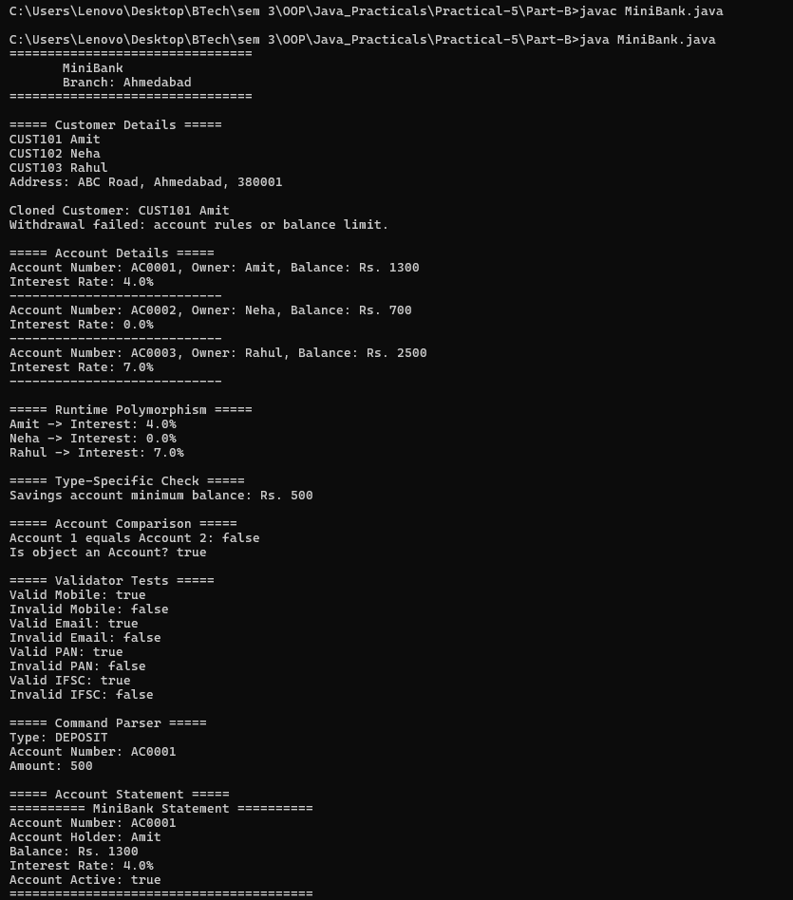
Learning Outcome:

Shape Areas — Learning Outcomes

Learned to create an abstract class with an abstract method and implement it in subclasses.
Understood inheritance and polymorphism using Shape, Circle, Rectangle, and Triangle.
Practiced storing different subclass objects in a single Shape[] array.
Learned to calculate individual areas, maintain a running total, and identify the shape with the largest area in one loop.
Understood how runtime polymorphism allows the same method call to calculate different shapes' areas.

Payroll — Learning Outcomes

Learned to create an abstract Employee class with shared name and ID fields.
Understood inheritance and method overriding by implementing monthlySalary() in different employee subclasses.
Practiced using super() to initialize common employee details in subclass constructors.
Learned to calculate individual salaries and total payroll using a mixed employee array.
Understood how to use instanceof to identify interns and display specific information based on employee type.

