Practical-6

Aim: Part A — Practice Programs (Hour 1). Work these in your lab-NN/ folder before the project: do the first one or two in the lab:

- Remote control: an interface Switchable with on()/off() and a default toggle(); Fan and Light implement it. Loop over a Switchable[] toggling each. Then add a functional interface that decides, given a device and an hour, whether it may switch on, and supply it once as an anonymous class and once as a lambda.

- Notification senders: a functional interface Notifier with send(String); make email and SMS senders as lambdas, hold them in an array, and broadcast one message through all. Add a marker interface Urgent and send twice for senders marked urgent.

Code:

- RemoteControl.java
interface Switchable {
void on();
void off();
default void toggle() {
on();
}
}
class Fan implements Switchable {
String name;
boolean isOn = false;
Fan(String name) {
this.name = name;
}
@Override
public void on() {
isOn = true;
System.out.println(name + " is ON");
}
@Override
public void off() {
isOn = false;
System.out.println(name + " is OFF");
}
}
class Light implements Switchable {
String name;
boolean isOn = false;
Light(String name) {
this.name = name;
}
@Override
public void on() {
isOn = true;
System.out.println(name + " is ON");
}
@Override
public void off() {
isOn = false;
System.out.println(name + " is OFF");
}
}
// Functional Interface
@FunctionalInterface
interface SwitchPolicy {
boolean maySwitchOn(Switchable device, int hour);
}
public class RemoteControl {
public static void main(String[] args) {
// Mixed array of devices
Switchable[] devices = {
new Fan("Fan"),
new Light("Light")
};
// Toggle each device
System.out.println("Toggling Devices:");
for (Switchable device : devices) {
device.toggle();
}
// Anonymous class
SwitchPolicy anonymousPolicy = new SwitchPolicy() {
@Override
public boolean maySwitchOn(Switchable device, int hour) {
return hour >= 6 && hour <= 22;
}
};
// Lambda
SwitchPolicy lambdaPolicy =
(device, hour) -> hour >= 8 && hour <= 20;

System.out.println("\nAnonymous Class Policy:");
int hour = 10;
for (Switchable device : devices) {
System.out.println(
"Can switch on at " + hour + ":00? "
+ anonymousPolicy.maySwitchOn(device, hour)
);
}
System.out.println("\nLambda Policy:");
for (Switchable device : devices) {
System.out.println(
"Can switch on at " + hour + ":00? "
+ lambdaPolicy.maySwitchOn(device, hour)
);
}
}
}

OUTPUT:

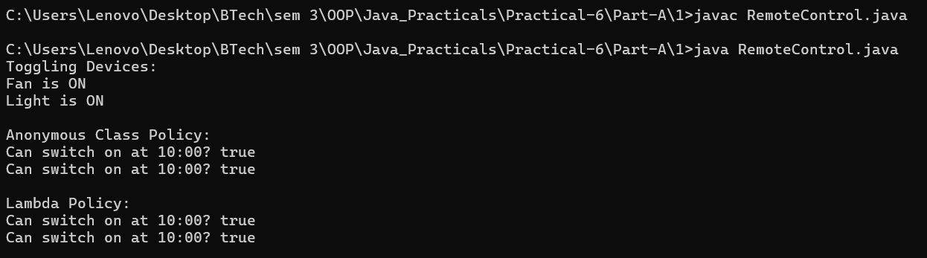

Code:

- NotificationDemo.java
@FunctionalInterface
interface Notifier {
void send(String message);
}
// Marker interface
interface Urgent {
}
// Email sender
class EmailNotifier implements Notifier, Urgent {
private final Notifier sender;
EmailNotifier(Notifier sender) {
this.sender = sender;
}
@Override
public void send(String message) {
sender.send(message);
}
}
// SMS sender
class SMSNotifier implements Notifier {
private final Notifier sender;
SMSNotifier(Notifier sender) {
this.sender = sender;
}
@Override
public void send(String message) {
sender.send(message);
}
}
public class NotificationDemo {
public static void main(String[] args) {
// Email as lambda
Notifier emailLambda =
message -> System.out.println("Email: " + message);
// SMS as lambda
Notifier smsLambda =
message -> System.out.println("SMS: " + message);
// Wrap them
Notifier email = new EmailNotifier(emailLambda);
Notifier sms = new SMSNotifier(smsLambda);
// Array containing both senders
Notifier[] notifiers = {
email,
sms
};
String message = "Exam starts at 10 AM.";
// Broadcast
for (Notifier notifier : notifiers) {
notifier.send(message);
// Send twice if marked Urgent
if (notifier instanceof Urgent) {
notifier.send(message);
}
}
}
}

OUTPUT:

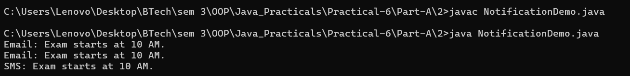

Part B — Project Work (Hour 2): MiniBank

AIM: With several classes now in place, this lab gives MiniBank a clean structure. You express account capabilities as interfaces, organise the code into model, util and service packages, and build a runnable JAR — the form in which the finished application will actually be delivered and run.

1. Create an interface named Transactable with methods void deposit(long amount) and boolean withdraw(long amount); make Account implement it.
2. Create an interface named InterestBearing with a default method double yearlyInterest() that uses interestRate() and the balance.
3. Create a functional interface named WithdrawRule with a single method boolean allow(Account account, long amount). Use it two ways in main: first with an anonymous class, then with a lambda expression.
4. Create a marker interface named Premium (an interface with no methods).
5. Move all classes into the packages model, util and service (add package statements and fix the import statements). Use one static import.
6. Build a runnable JAR file with a manifest whose Main-Class is the MiniBank class, and run it with the command java -jar.

Code:

import java.util.Scanner;
import model.*;
import util.StatementFormatter;
import service.CommandParser;
import static util.Validator.isValidMobile;
public class MiniBank {
public static void main(String[] args) {
Scanner sc = new Scanner(System.in);
BankInfo bank = new BankInfo("MiniBank", "Ahmedabad");
System.out.println("================================");
System.out.println(" " + bank.name());
System.out.println(" Branch: " + bank.branch());
System.out.println("================================");
// Create customers
Customer c1 = new Customer(
"Amit", "amit@gmail.com", "9876543210",
new Customer.Address(
"ABC Road", "Ahmedabad", "380001"));
Customer c2 = new Customer(
"Neha", "neha@gmail.com", "9876543211",
new Customer.Address(
"XYZ Road", "Surat", "395001"));
Customer c3 = new Customer(
"Rahul", "rahul@gmail.com", "9876543212",
new Customer.Address(
"Main Road", "Vadodara", "390001"));
System.out.println("\n===== Customers =====");
System.out.println(c1.getCustomerId() + " " + c1.getName());
System.out.println(c2.getCustomerId() + " " + c2.getName());
System.out.println(c3.getCustomerId() + " " + c3.getName());
// Create different account types
Account[] accounts = {
new SavingsAccount(c1.getName(), 1000, 500),
new CurrentAccount(c2.getName(), 0, 2000),
new FixedDepositAccount(c3.getName(), 2000)
};
accounts[0].deposit(500);
accounts[0].withdraw(200);
accounts[1].deposit(1000);
accounts[1].withdraw(300);
// Display accounts and interest
System.out.println("\n===== Account Details =====");
for (Account account : accounts) {
System.out.println(account);
System.out.println("Interest Rate: "
+ account.interestRate() + "%");
System.out.println("Yearly Interest: Rs. "
+ String.format("%.2f", account.yearlyInterest()));
System.out.println("----------------------------");
}
// 1. WithdrawRule using an anonymous class
WithdrawRule anonymousRule = new WithdrawRule() {
@Override
public boolean allow(Account account, long amount) {
return account.canWithdraw(amount);
}
};
// 2. WithdrawRule using a lambda expression
WithdrawRule lambdaRule =
(account, amount) -> account.canWithdraw(amount);
System.out.println("\n===== Withdraw Rules =====");
System.out.println("Anonymous class allows withdrawal: "
+ anonymousRule.allow(accounts[0], 500));
System.out.println("Lambda allows withdrawal: "
+ lambdaRule.allow(accounts[0], 500));
System.out.println("Fixed deposit withdrawal allowed: "
+ lambdaRule.allow(accounts[2], 100));
// Demonstrate marker interface
System.out.println("\n===== Premium Check =====");
if (accounts[0] instanceof Premium) {
System.out.println("Savings account is marked Premium.");
}
// Demonstrate static import
System.out.println("\n===== Mobile Validation =====");
System.out.println("Mobile valid: "
+ isValidMobile("9876543210"));
// Display statement
System.out.println("\n===== Account Statement =====");
System.out.println(StatementFormatter.buildStatement(accounts[0]));
// Parse a command
System.out.println("\n===== Command Parser =====");
try {
Command command =
CommandParser.parse("DEPOSIT AC0001 500");
System.out.println("Type: " + command.type());
System.out.println("Account: " + command.accountNumber());
System.out.println("Amount: " + command.amount());
} catch (IllegalArgumentException e) {
System.out.println("Command error: " + e.getMessage());
}
// Menu shell
int choice = 0;
do {
System.out.println("\n===== MiniBank Menu =====");
System.out.println("1. Open Account");
System.out.println("2. Deposit");
System.out.println("3. Withdraw");
System.out.println("4. Transfer");
System.out.println("5. Exit");
System.out.print("Enter your choice: ");
if (!sc.hasNextInt()) {
System.out.println("Please enter a number.");
sc.next();
continue;
}
choice = sc.nextInt();
if (choice < 1 || choice > 5) {
System.out.println("Invalid choice! Please try again.");
continue;
}
MenuOption option = MenuOption.values()[choice - 1];
String message = switch (option) {
case OPEN_ACCOUNT ->
"Open Account - to be implemented in a later lab";
case DEPOSIT ->
"Deposit - to be implemented in a later lab";
case WITHDRAW ->
"Withdraw - to be implemented in a later lab";
case TRANSFER ->
"Transfer - to be implemented in a later lab";
case EXIT ->
"Thank you for using MiniBank!";
};
System.out.println(message);
} while(choice != 5);
sc.close();
}
enum MenuOption {
OPEN_ACCOUNT, DEPOSIT, WITHDRAW, TRANSFER, EXIT
}
}

OUTPUT:

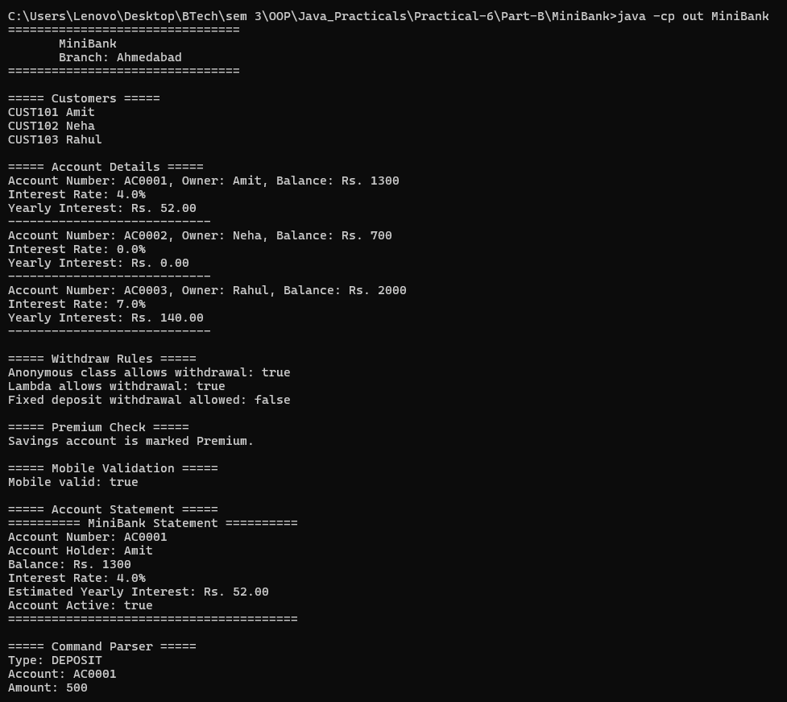
Learning Outcome:

Remote Control — Learning Outcomes

Learned to define and implement interfaces in Java using Switchable, Fan, and Light.
Understood how to use default methods such as toggle() to provide common functionality.
Practiced using an interface array to control multiple devices through polymorphism.
Learned to use functional interfaces with anonymous classes and lambda expressions to decide whether a device can switch on at a given hour.
Understood how interfaces and lambda expressions make code reusable, flexible, and easy to maintain.

Notification Senders — Learning Outcomes

Learned to create and use a functional interface Notifier with the send(String) method.
Understood how to implement email and SMS notifications using lambda expressions.
Practiced storing multiple notification senders in an array and broadcasting a common message.
Learned to use a marker interface Urgent to identify senders requiring special treatment.
Understood how to send urgent notifications twice while sending regular notifications once.

