Practical-7

Aim: Part A — Practice Programs (Hour 1). Work these in your lab-NN/ folder before the project: do the first one or two in the lab:

- Form validator: define @NotBlank and @MaxLength(int) for fields and annotate a SignupForm. Write a checker that uses reflection to read each field’s annotations and returns the list of validation errors for a given object.

- Mini test runner: define a @Run annotation and mark some no-arg methods of a class with it. Use reflection to find and invoke only the @Run methods and report how many ran — the idea behind how JUnit finds @Test methods.

Code:

1.FormValidator.java
import java.lang.annotation.*;
import java.lang.reflect.Field;
import java.util.ArrayList;
import java.util.List;
// Custom annotation: checks whether a field is blank
@Retention(RetentionPolicy.RUNTIME)
@Target(ElementType.FIELD)
@interface NotBlank {
}
// Custom annotation: checks maximum length
@Retention(RetentionPolicy.RUNTIME)
@Target(ElementType.FIELD)
@interface MaxLength {
int value();
}
// Signup form class
class SignupForm {
@NotBlank
@MaxLength(20)
String name;
@NotBlank
@MaxLength(30)
String email;
@NotBlank
@MaxLength(10)
String password;
SignupForm(String name, String email, String password) {
this.name = name;
this.email = email;
this.password = password;
}
}
// Validator class
class Validator {
public static List<String> validate(Object obj)
throws IllegalAccessException {
List<String> errors = new ArrayList<>();
Class<?> cls = obj.getClass();
for (Field field : cls.getDeclaredFields()) {
field.setAccessible(true);
Object value = field.get(obj);
// Check @NotBlank
if (field.isAnnotationPresent(NotBlank.class)) {
if (value == null ||
value.toString().trim().isEmpty()) {
errors.add(field.getName() + " cannot be blank");
}
}
// Check @MaxLength
if (field.isAnnotationPresent(MaxLength.class)) {
MaxLength max = field.getAnnotation(MaxLength.class);
if (value != null &&
value.toString().length() > max.value()) {
errors.add(field.getName()
+ " must not exceed "
+ max.value() + " characters");
}
}
}
return errors;
}
}
// Main class
public class FormValidator {
public static void main(String[] args)
throws IllegalAccessException {
SignupForm form = new SignupForm(
"",
"student@example.com",
"verylongpassword123"
);
List<String> errors = Validator.validate(form);
if (errors.isEmpty()) {
System.out.println("Form is valid");
} else {
System.out.println("Validation Errors:");

for (String error : errors) {
System.out.println(error);
}
}
}
}

OUTPUT:

Code:

2.MiniTest.java
import java.lang.annotation.*;
import java.lang.reflect.Method;
// Custom annotation
@Retention(RetentionPolicy.RUNTIME)
@Target(ElementType.METHOD)
@interface Run {
}
// Class containing test methods
class MyTests {
@Run
public void testAddition() {
System.out.println("Test Addition passed");
}
@Run
public void testSubtraction() {
System.out.println("Test Subtraction passed");
}
public void normalMethod() {
System.out.println("This method should not run");
}
@Run
public void testMessage() {
System.out.println("Test Message passed");
}
}
// Mini test runner
class MiniTestRunner {
public static int runTests(Object obj)
throws Exception {
int count = 0;
// Get all methods of the class
Method[] methods = obj.getClass().getDeclaredMethods();
for (Method method : methods) {
// Find only methods with @Run
if (method.isAnnotationPresent(Run.class)) {
// Check that the method has no parameters
if (method.getParameterCount() == 0) {
method.setAccessible(true);
method.invoke(obj);
count++;
}
}
}
return count;
}
}
// Main class
public class MiniTest {
public static void main(String[] args) throws Exception {
MyTests tests = new MyTests();
int total = MiniTestRunner.runTests(tests);
System.out.println("Total tests run: " + total);
}
}

OUTPUT:

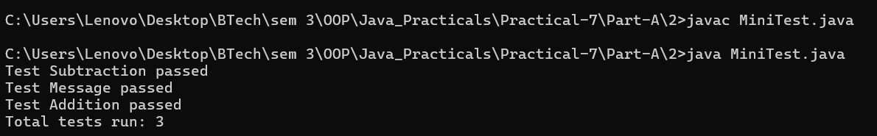

Part B — Project Work (Hour 2): MiniBank

AIM: Now that you are comfortable with classes and interfaces, you add metadata to MiniBank. You define custom annotations (@Id, @Positive, @MaxLength) and read them at run time with reflection to validate any object automatically — the same idea real frameworks use. The @Id marker will later identify each record in the generic repository you build in Practical 13.

1. Add the @Override annotation above every overridden method written so far (toString, equals, hashCode and the subclass methods). Add @FunctionalInterface above the WithdrawRule interface.
2. In a package named model.annotation, define three custom annotations: @Id (a marker, with @Target(FIELD) and @Retention(RUNTIME)); @Positive with a member String message() default “must be > 0”; and @MaxLength with a member int value().
3. Put @Id on the accountNumber field and @Positive on the balance field of Account.
4. Create a class named AnnotationValidator with a public static method String[] validate(Object obj) that uses reflection — getClass().getDeclaredFields(), field.isAnnotationPresent(...), field.setAccessible(true) and field.get(obj) — to check the @Positive and @MaxLength rules and return the error messages as a String[].
5. In main, create an Account with a negative balance and run
AnnotationValidator.validate() to print the error.

Code:

import java.util.Scanner;
import model.*;
import util.StatementFormatter;
import util.AnnotationValidator;
import service.CommandParser;
import static util.Validator.isValidMobile;
public class MiniBank {
public static void main(String[] args) {
Scanner sc = new Scanner(System.in);
BankInfo bank = new BankInfo("MiniBank", "Ahmedabad");
System.out.println("================================");
System.out.println(" " + bank.name());
System.out.println(" Branch: " + bank.branch());
System.out.println("================================");
// Create customers
Customer c1 = new Customer(
"Amit", "amit@gmail.com", "9876543210",
new Customer.Address(
"ABC Road", "Ahmedabad", "380001"));
Customer c2 = new Customer(
"Neha", "neha@gmail.com", "9876543211",
new Customer.Address(
"XYZ Road", "Surat", "395001"));
Customer c3 = new Customer(
"Rahul", "rahul@gmail.com", "9876543212",
new Customer.Address(
"Main Road", "Vadodara", "390001"));
System.out.println("\n===== Customers =====");
System.out.println(c1.getCustomerId() + " " + c1.getName());
System.out.println(c2.getCustomerId() + " " + c2.getName());
System.out.println(c3.getCustomerId() + " " + c3.getName());
// Create different account types
Account[] accounts = {
new SavingsAccount(c1.getName(), 1000, 500),
new CurrentAccount(c2.getName(), 0, 2000),
new FixedDepositAccount(c3.getName(), 2000)
};
// Perform initial account operations
accounts[0].deposit(500);
accounts[0].withdraw(200);
accounts[1].deposit(1000);
accounts[1].withdraw(300);
// Display accounts and interest
System.out.println("\n===== Account Details =====");
for (Account account : accounts) {
System.out.println(account);
System.out.println("Interest Rate: "
+ account.interestRate() + "%");
System.out.println("Yearly Interest: Rs. "
+ String.format("%.2f", account.yearlyInterest()));
System.out.println("----------------------------");
}
// WithdrawRule using an anonymous class
WithdrawRule anonymousRule = new WithdrawRule() {
@Override
public boolean allow(Account account, long amount) {
return account.canWithdraw(amount);
}
};
// WithdrawRule using a lambda expression
WithdrawRule lambdaRule =
(account, amount) -> account.canWithdraw(amount);
System.out.println("\n===== Withdraw Rules =====");
System.out.println("Anonymous class allows withdrawal: "
+ anonymousRule.allow(accounts[0], 500));
System.out.println("Lambda allows withdrawal: "
+ lambdaRule.allow(accounts[0], 500));
System.out.println("Fixed deposit withdrawal allowed: "
+ lambdaRule.allow(accounts[2], 100));
// Demonstrate marker interface
System.out.println("\n===== Premium Check =====");
if (accounts[0] instanceof Premium) {
System.out.println("Savings account is marked Premium.");
}
// Demonstrate static import
System.out.println("\n===== Mobile Validation =====");
System.out.println("Mobile valid: "
+ isValidMobile("9876543210"));
// Display statement
System.out.println("\n===== Account Statement =====");
System.out.println(
StatementFormatter.buildStatement(accounts[0]));
// Parse a command
System.out.println("\n===== Command Parser =====");
try {
Command command =
CommandParser.parse("DEPOSIT AC0001 500");
System.out.println("Type: " + command.type());
System.out.println("Account: " + command.accountNumber());
System.out.println("Amount: " + command.amount());
} catch (IllegalArgumentException e) {
System.out.println("Command error: " + e.getMessage());
}
// Annotation validation test
System.out.println("\n--- Annotation Validation Test ---");
String[] errors = AnnotationValidator.validate(accounts[0]);
if (errors.length == 0) {
System.out.println("Account is valid.");
} else {
for (String error : errors) {
System.out.println("Validation error: " + error);
}
}
// Negative balance validation test
System.out.println("\n--- Negative Balance Validation Test ---");
try {
Account invalidAccount =
new SavingsAccount("Test User", -100, 500);
String[] validationErrors =
AnnotationValidator.validate(invalidAccount);
if (validationErrors.length == 0) {
System.out.println("Account is valid.");
} else {
for (String error : validationErrors) {
System.out.println("Validation error: " + error);
}
}
} catch (IllegalArgumentException e) {
System.out.println(
"Account creation rejected: " + e.getMessage());
}
// Menu shell
int choice = 0;
do {
System.out.println("\n===== MiniBank Menu =====");
System.out.println("1. Open Account");
System.out.println("2. Deposit");
System.out.println("3. Withdraw");
System.out.println("4. Transfer");
System.out.println("5. Exit");
System.out.print("Enter your choice: ");
if (!sc.hasNextInt()) {
System.out.println("Please enter a number.");
sc.next();
continue;
}
choice = sc.nextInt();
if (choice < 1 || choice > 5) {
System.out.println("Invalid choice! Please try again.");
continue;
}
MenuOption option = MenuOption.values()[choice - 1];
String message = switch (option) {
case OPEN_ACCOUNT ->
"Open Account - to be implemented in a later lab";
case DEPOSIT ->
"Deposit - to be implemented in a later lab";
case WITHDRAW ->
"Withdraw - to be implemented in a later lab";
case TRANSFER ->
"Transfer - to be implemented in a later lab";
case EXIT ->
"Thank you for using MiniBank!";
};
System.out.println(message);
} while (choice != 5);
sc.close();
}
enum MenuOption {
OPEN_ACCOUNT, DEPOSIT, WITHDRAW, TRANSFER, EXIT
}
}

OUTPUT:

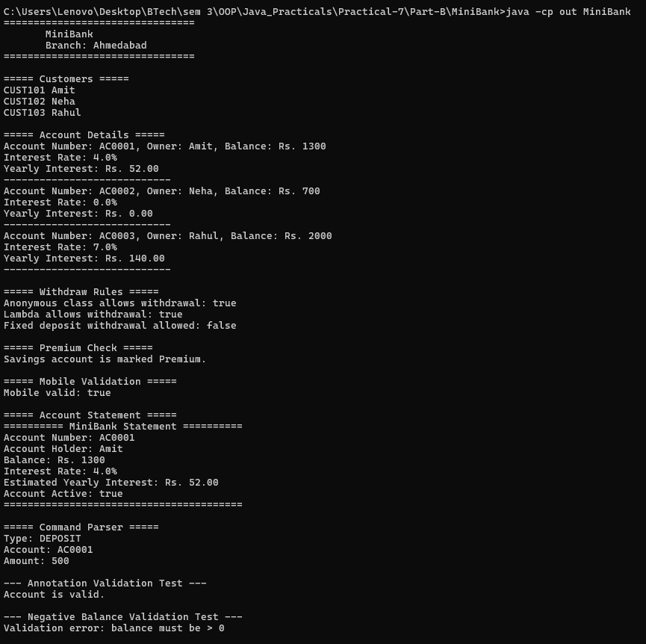
Learning Outcome:

Form Validator — Learning Outcomes

Learned to define custom annotations such as @NotBlank and @MaxLength in Java.
Understood how to apply annotations to class fields for input validation.
Learned to use reflection to inspect fields and read their annotations at runtime.
Practiced validating form data and collecting validation errors in a list.
Understood how to build a reusable validation system for checking user input.

2. Mini Test Runner — Learning Outcomes
Learned to define and use a custom @Run annotation in Java.
Understood how to identify annotated methods using reflection.
Practiced invoking selected no-argument methods dynamically at runtime.
Learned to count and report the number of test methods executed.
Understood the basic principle behind how testing frameworks like JUnit discover and execute annotated test methods.

