Practical-8

Aim: Part A — Practice Programs (Hour 1). Work these in your lab-NN/ folder before the project: do the first one or two in the lab:

- Guarded calculator: read two numbers and an operator; throw a custom DivideByZeroException and catch invalid-number input separately, printing a clear message each time; loop until a valid calculation succeeds and use finally to log each attempt.

- Stock issue: a Warehouse where issue(item, qty) throws a custom checked OutOfStockException carrying the shortfall, and InvalidQuantityException for qty ≤ 0. Process a list of requests, catching and reporting each failure without stopping the run.

Code:

- GuardedCalculator.java
import java.util.Scanner;
class DivideByZeroException extends Exception {
DivideByZeroException(String message) {
super(message);
}
}
public class GuardedCalculator {
public static void main(String[] args) {
Scanner sc = new Scanner(System.in);
boolean success = false;
while (!success) {
try {
System.out.print("Enter first number: ");
double num1 = Double.parseDouble(sc.nextLine());
System.out.print("Enter operator (+, -, *, /): ");
char operator = sc.nextLine().charAt(0);
System.out.print("Enter second number: ");
double num2 = Double.parseDouble(sc.nextLine());
double result;
switch (operator) {
case '+':
result = num1 + num2;
break;
case '-':
result = num1 - num2;
break;
case '*':
result = num1 * num2;
break;
case '/':
if (num2 == 0) {
throw new DivideByZeroException(
"Cannot divide by zero."
);
}
result = num1 / num2;
break;
default:
System.out.println("Invalid operator.");
continue;
}
System.out.println("Result = " + result);
success = true;
} catch (NumberFormatException e) {
System.out.println(
"Invalid number input. Please enter valid numbers."
);
} catch (DivideByZeroException e) {
System.out.println(
"Error: " + e.getMessage()
);
} finally {
System.out.println("Attempt logged.");
System.out.println("-------------------------");
}
}
System.out.println("Valid calculation completed.");
sc.close();
}
}

OUTPUT:

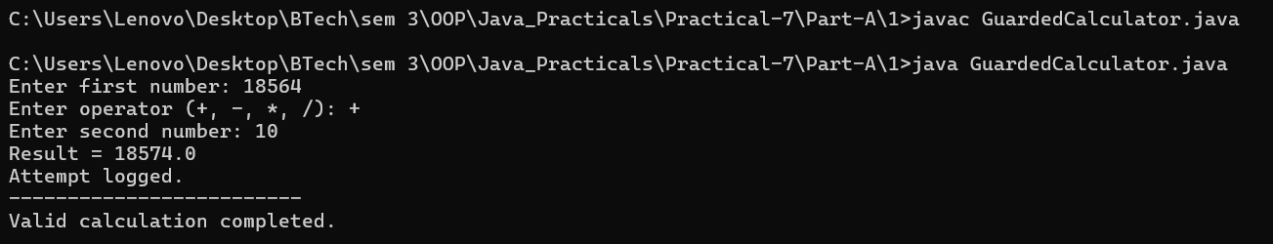

CODE:

2.StockIssue.java
class OutOfStockException extends Exception {
int shortfall;
OutOfStockException(int shortfall) {
super("Out of stock. Shortfall: " + shortfall);
this.shortfall = shortfall;
}
}
class InvalidQuantityException extends Exception {
InvalidQuantityException(String message) {
super(message);
}
}
class Warehouse {
private int stock;
Warehouse(int stock) {
this.stock = stock;
}
void issue(String item, int qty)
throws OutOfStockException, InvalidQuantityException {
if (qty <= 0) {
throw new InvalidQuantityException(
"Quantity must be greater than 0."
);
}
if (qty > stock) {
int shortfall = qty - stock;
throw new OutOfStockException(shortfall);
}
stock -= qty;
System.out.println(
"Issued " + qty + " units of " + item
);
System.out.println("Remaining stock: " + stock);
}
}
public class StockIssue {
public static void main(String[] args) {
Warehouse warehouse = new Warehouse(50);
String[] items = {
"Laptop",
"Mouse",
"Keyboard",
"Monitor",
"Printer"
};
int[] quantities = {
20,
40,
0,
60,
10
};
for (int i = 0; i < items.length; i++) {
System.out.println("\nRequest: "
+ items[i] + " - " + quantities[i]);
try {
warehouse.issue(items[i], quantities[i]);
} catch (InvalidQuantityException e) {
System.out.println(
"Invalid Quantity: " + e.getMessage()
);
} catch (OutOfStockException e) {
System.out.println(
"Out of Stock: " + e.getMessage()
);
System.out.println(
"Additional units needed: "
+ e.shortfall
);
}
}
System.out.println("\nAll requests processed.");
}
}

OUTPUT:

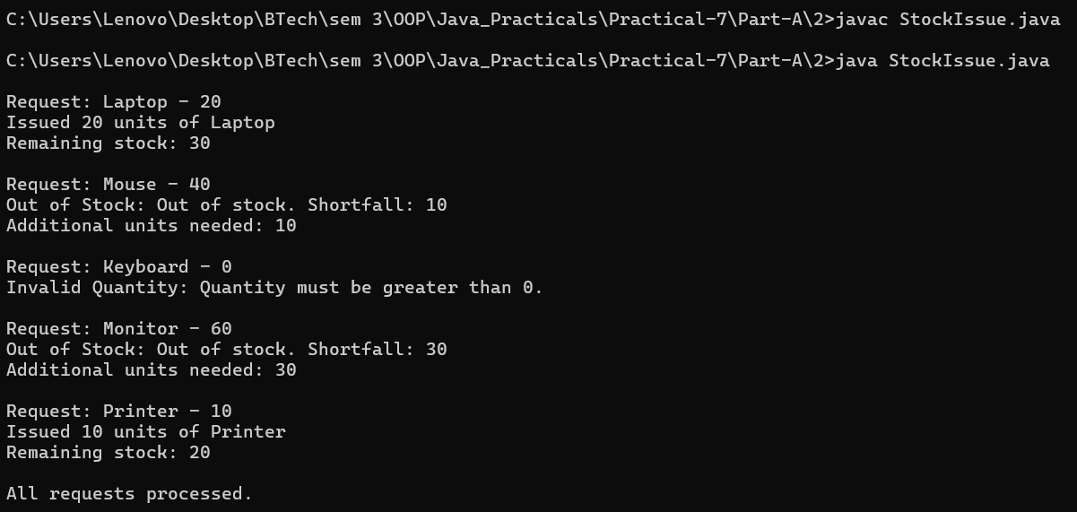

Part B — Project Work (Hour 2): MiniBank

AIM: Until now a failed withdrawal just returned false. In this lab you make MiniBank fault- tolerant: you replace those flags with a custom exception hierarchy so every failure is explicit and carries information (such as the shortfall). This is the Milestone 1 checkpoint, where the model, validation, annotations and error handling come together.

1. In a package named exception, create a checked base class BankException that extends Exception. Then create InsufficientFundsException, AccountNotFoundException and
InvalidAmountException, each extending BankException. Give InsufficientFundsException a long field shortfall.
2. Change withdraw(long amount) to declare throws InsufficientFundsException, InvalidAmountException; throw InsufficientFundsException when the balance is too low and InvalidAmountException when the amount is less than or equal to zero. Make deposit(long amount) throw InvalidAmountException for a non-positive amount.
3. Add a method transfer(Account to, long amount) that uses try, catch and finally and re-throws a BankException when needed.
4. In main, wrap the operations in try-catch blocks and print friendly messages; use a finally block; and show one try-with-resources example using a small AutoCloseable class that you create.

Code:

import java.util.Scanner;
import model.*;
import util.AnnotationValidator;
import util.StatementFormatter;
import util.BankResource;
import service.CommandParser;
import exception.BankException;
import exception.InsufficientFundsException;
import exception.InvalidAmountException;
import static util.Validator.isValidMobile;
public class MiniBank {
public static void main(String[] args) {
Scanner sc = new Scanner(System.in);
BankInfo bank = new BankInfo("MiniBank", "Ahmedabad");
System.out.println("================================");
System.out.println(" " + bank.name());
System.out.println(" Branch: " + bank.branch());
System.out.println("================================");
// Create customers
Customer c1 = new Customer(
"Amit", "amit@gmail.com", "9876543210",
new Customer.Address(
"ABC Road", "Ahmedabad", "380001"));
Customer c2 = new Customer(
"Neha", "neha@gmail.com", "9876543211",
new Customer.Address(
"XYZ Road", "Surat", "395001"));
Customer c3 = new Customer(
"Rahul", "rahul@gmail.com", "9876543212",
new Customer.Address(
"Main Road", "Vadodara", "390001"));
System.out.println("\n===== Customers =====");
System.out.println(c1.getCustomerId() + " " + c1.getName());
System.out.println(c2.getCustomerId() + " " + c2.getName());
System.out.println(c3.getCustomerId() + " " + c3.getName());
// Create different account types
Account[] accounts = {
new SavingsAccount(c1.getName(), 1000, 500),
new CurrentAccount(c2.getName(), 0, 2000),
new FixedDepositAccount(c3.getName(), 2000)
};
// Demonstrate deposit and withdrawal
try {
accounts[0].deposit(500);
accounts[0].withdraw(200);
accounts[1].deposit(1000);
accounts[1].withdraw(300);
} catch (BankException e) {
System.out.println(
"Bank operation error: " + e.getMessage());
} finally {
System.out.println(
"Initial account operations completed.");
}
// Display accounts and interest
System.out.println("\n===== Account Details =====");
for (Account account : accounts) {
System.out.println(account);
System.out.println("Interest Rate: "
+ account.interestRate() + "%");
System.out.println("Yearly Interest: Rs. "
+ String.format("%.2f",
account.yearlyInterest()));
System.out.println("----------------------------");
}
// WithdrawRule using an anonymous class
WithdrawRule anonymousRule = new WithdrawRule() {
@Override
public boolean allow(Account account, long amount) {
return account.canWithdraw(amount);
}
};
// WithdrawRule using a lambda expression
WithdrawRule lambdaRule =
(account, amount) -> account.canWithdraw(amount);
System.out.println("\n===== Withdraw Rules =====");
System.out.println("Anonymous class allows withdrawal: "
+ anonymousRule.allow(accounts[0], 500));
System.out.println("Lambda allows withdrawal: "
+ lambdaRule.allow(accounts[0], 500));
System.out.println("Fixed deposit withdrawal allowed: "
+ lambdaRule.allow(accounts[2], 100));
// Demonstrate marker interface
System.out.println("\n===== Premium Check =====");
if (accounts[0] instanceof Premium) {
System.out.println(
"Savings account is marked Premium.");
} else {
System.out.println(
"Savings account is not marked Premium.");
}
// Demonstrate static import
System.out.println("\n===== Mobile Validation =====");
System.out.println("Mobile valid: "
+ isValidMobile("9876543210"));
// Display statement
System.out.println("\n===== Account Statement =====");
System.out.println(
StatementFormatter.buildStatement(accounts[0]));
// Parse a command
System.out.println("\n===== Command Parser =====");
try {
Command command =
CommandParser.parse("DEPOSIT AC0001 500");
System.out.println("Type: " + command.type());
System.out.println("Account: "
+ command.accountNumber());
System.out.println("Amount: " + command.amount());
} catch (IllegalArgumentException e) {
System.out.println(
"Command error: " + e.getMessage());
}
// Annotation validation
System.out.println(
"\n===== Annotation Validation Test =====");
SavingsAccount testAccount =
new SavingsAccount("Test User", -500, 100);
String[] errors =
AnnotationValidator.validate(testAccount);
if (errors.length == 0) {
System.out.println("Account is valid.");
} else {
for (String error : errors) {
System.out.println(
"Validation Error: " + error);
}
}
// Custom exception handling: insufficient funds
System.out.println("\n===== Exception Handling =====");
try {
accounts[0].withdraw(5000);
} catch (InsufficientFundsException e) {
System.out.println(
"Withdrawal failed: " + e.getMessage());
System.out.println(
"Shortfall: Rs. " + e.getShortfall());
} catch (InvalidAmountException e) {
System.out.println(
"Invalid withdrawal: " + e.getMessage());
} finally {
System.out.println(
"Withdrawal attempt completed.");
}
// Invalid deposit test
try {
accounts[0].deposit(-100);
} catch (InvalidAmountException e) {
System.out.println(
"Deposit failed: " + e.getMessage());
} catch (BankException e) {
System.out.println(
"Bank error: " + e.getMessage());
} finally {
System.out.println("Deposit attempt completed.");
}
// Transfer test
try {
accounts[0].transfer(accounts[1], 200);
} catch (BankException e) {
System.out.println(
"Transfer failed: " + e.getMessage());
} finally {
System.out.println("Transfer attempt completed.");
}
// Try-with-resources demonstration
System.out.println("\n===== Try-With-Resources =====");
try (BankResource resource = new BankResource()) {
resource.performTask();
} catch (Exception e) {
System.out.println(
"Resource error: " + e.getMessage());
}
// Menu shell
int choice = 0;
do {
System.out.println("\n===== MiniBank Menu =====");
System.out.println("1. Open Account");
System.out.println("2. Deposit");
System.out.println("3. Withdraw");
System.out.println("4. Transfer");
System.out.println("5. Exit");
System.out.print("Enter your choice: ");
if (!sc.hasNextInt()) {
System.out.println("Please enter a number.");
sc.next();
continue;
}
choice = sc.nextInt();
if (choice < 1 || choice > 5) {
System.out.println(
"Invalid choice! Please try again.");
continue;
}
MenuOption option =
MenuOption.values()[choice - 1];
String message = switch (option) {
case OPEN_ACCOUNT ->
"Open Account - to be implemented in a later lab";
case DEPOSIT ->
"Deposit - to be implemented in a later lab";
case WITHDRAW ->
"Withdraw - to be implemented in a later lab";
case TRANSFER ->
"Transfer - to be implemented in a later lab";
case EXIT ->
"Thank you for using MiniBank!";
};
System.out.println(message);
} while (choice != 5);
sc.close();
}
enum MenuOption {
OPEN_ACCOUNT,
DEPOSIT,
WITHDRAW,
TRANSFER,
EXIT
}
}

OUTPUT:

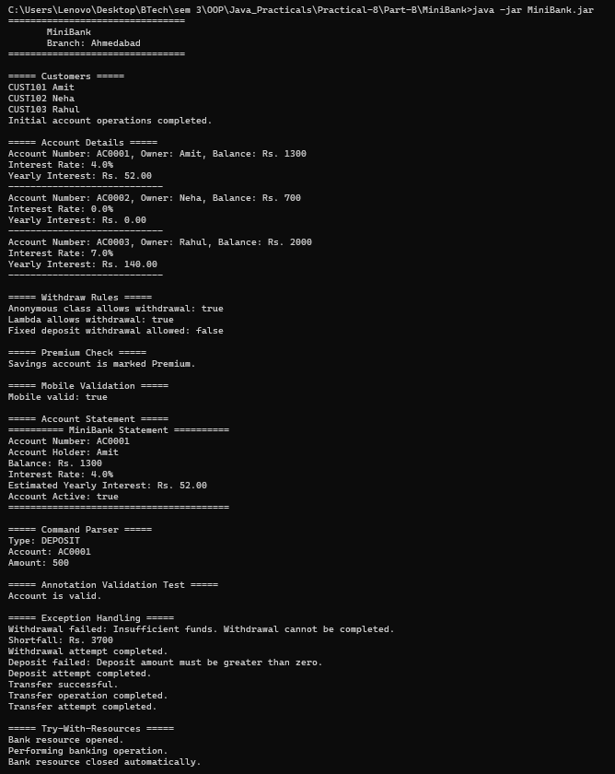
Learning Outcome:

Guarded Calculator — Learning Outcomes

Learned to create and use a custom exception, DivideByZeroException, in Java.
Understood how to handle invalid-number input separately using exception handling.
Practiced using try, catch, and finally blocks to manage errors and log every calculation attempt.
Learned to use loops to repeatedly accept input until a valid calculation succeeds.
Understood how exception handling improves program reliability and provides clear error messages to users.

Stock Issue — Learning Outcomes

Learned to create custom exceptions, OutOfStockException and InvalidQuantityException.
Understood how to implement checked exceptions to handle insufficient stock and invalid quantities.
Practiced validating stock requests before issuing items from a warehouse.
Learned to catch and report individual request failures without stopping the entire program.
Understood how exception handling helps maintain reliable inventory management and prevents invalid stock operations.

