Practical-9

Aim: Part A — Practice Programs (Hour 1). Work these in your lab-NN/ folder before the project: do the first one or two in the lab:

1. Counter race: several threads each increment a shared counter many times. Run it without synchronization to watch the total come out too low, then make the increment synchronized and confirm it is exactly right every run.

- Seat booking race: a shared seatsLeft of 5 with about 10 threads each trying to book one seat. Without synchronization show that more than 5 can succeed (oversell); with a synchronized book() exactly 5 do.

Code:

- CounterRace.java
class Counter {
private int count = 0;
// Without synchronization
public void increment() {
count++;
}
public int getCount() {
return count;
}
}
class MyThread extends Thread {
private Counter counter;
private int times;
MyThread(Counter counter, int times) {
this.counter = counter;
this.times = times;
}
public void run() {
for (int i = 0; i < times; i++) {
counter.increment();
}
}
}
public class CounterRace {
public static void main(String[] args) throws Exception {
int numberOfThreads = 10;
int incrementsPerThread = 100000;
Counter counter = new Counter();
MyThread[] threads = new MyThread[numberOfThreads];
for (int i = 0; i < numberOfThreads; i++) {
threads[i] = new MyThread(counter, incrementsPerThread);
threads[i].start();
}
for (int i = 0; i < numberOfThreads; i++) {
threads[i].join();
}
int expected = numberOfThreads * incrementsPerThread;
System.out.println("Expected count: " + expected);
System.out.println("Actual count: " + counter.getCount());
}
}

OUTPUT:

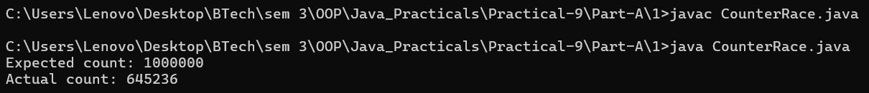

Code:

- SeatRace.java
class SeatBooking {
private int seatsLeft = 5;
private int booked = 0;
public void book(String name) {
if (seatsLeft > 0) {
// Small delay makes the race condition easier to observe
try {
Thread.sleep(10);
} catch (InterruptedException e) {
Thread.currentThread().interrupt();
}
seatsLeft--;
booked++;
System.out.println(name + " booked a seat");
} else {
System.out.println(name + " failed - no seats");
}
}
public int getBooked() {
return booked;
}
}
class BookingThread extends Thread {
private SeatBooking booking;
BookingThread(SeatBooking booking) {
this.booking = booking;
}
public void run() {
booking.book(Thread.currentThread().getName());
}
}
public class SeatRace {
public static void main(String[] args) throws Exception {
SeatBooking booking = new SeatBooking();
BookingThread[] threads = new BookingThread[10];
for (int i = 0; i < 10; i++) {
threads[i] = new BookingThread(booking);
threads[i].setName("Customer-" + (i + 1));
threads[i].start();
}
for (int i = 0; i < 10; i++) {
threads[i].join();
}
System.out.println("\nTotal successful bookings: "
+ booking.getBooked());
}
}

OUTPUT:
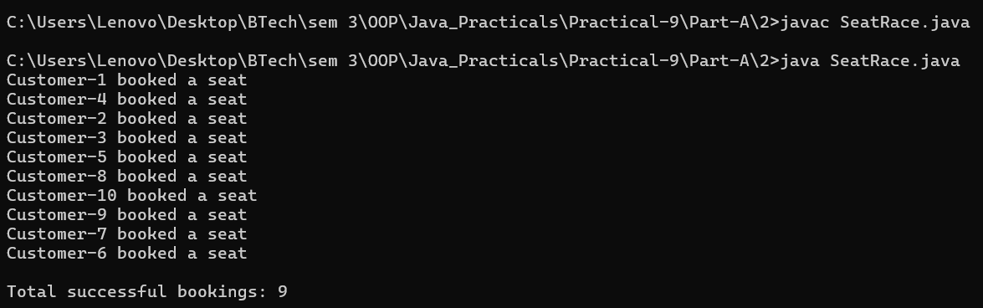

2.SeatRaceWithSynchornize.java
class SeatBooking {
private int seatsLeft = 5;
private int booked = 0;
public synchronized void book(String name) {
if (seatsLeft > 0) {
seatsLeft--;
booked++;
System.out.println(name + " booked a seat");
} else {
System.out.println(name + " failed - no seats");
}
}
public int getBooked() {
return booked;
}
}
class BookingThread extends Thread {
private SeatBooking booking;
BookingThread(SeatBooking booking) {
this.booking = booking;
}
public void run() {
booking.book(Thread.currentThread().getName());
}
}
public class SeatRaceWithSynchornize {
public static void main(String[] args) throws Exception {
SeatBooking booking = new SeatBooking();
BookingThread[] threads = new BookingThread[10];
for (int i = 0; i < 10; i++) {
threads[i] = new BookingThread(booking);
threads[i].setName("Customer-" + (i + 1));
threads[i].start();
}
for (int i = 0; i < 10; i++) {
threads[i].join();
}
System.out.println("\nTotal successful bookings: "
+ booking.getBooked());
}
}

OUTPUT:

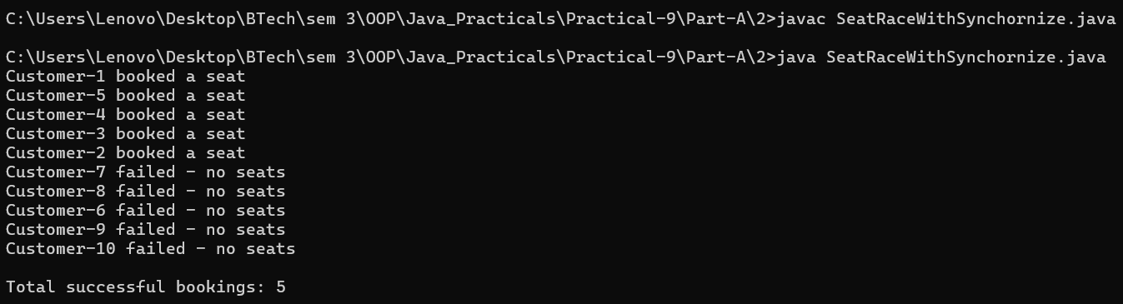

Part B — Project Work (Hour 2): MiniBank

AIM: A real bank serves many users at once. With the single-user logic working, this lab runs many threads against one account, lets you watch the balance come out wrong (a race condition), and then makes deposit and withdraw thread-safe with synchronization — protecting MiniBank’s shared data.

1. Create a class named AccountWorker that implements Runnable with fields Account account, int times and long amount; in run(), loop times times and call account.deposit(amount).
2. In main, create one account, start about 10 threads using AccountWorker, call join() on each, then print the final balance — it will be wrong because of the race condition.
3. Make deposit and withdraw synchronized (or use a synchronized block on a private lock object) and run the program again — the balance is now correct.
4. Print the thread names to observe the thread lifecycle.

Code:

import java.util.Scanner;

import model.*;
import util.AnnotationValidator;
import util.StatementFormatter;
import util.BankResource;
import service.CommandParser;
import exception.BankException;
import exception.InsufficientFundsException;
import exception.InvalidAmountException;
import static util.Validator.isValidMobile;
public class MiniBank {
public static void main(String[] args) {
Scanner sc = new Scanner(System.in);
BankInfo bank = new BankInfo("MiniBank", "Ahmedabad");
System.out.println("================================");
System.out.println(" " + bank.name());
System.out.println(" Branch: " + bank.branch());
System.out.println("================================");
// Create customers
Customer c1 = new Customer(
"Amit", "amit@gmail.com", "9876543210",
new Customer.Address(
"ABC Road", "Ahmedabad", "380001"));
Customer c2 = new Customer(
"Neha", "neha@gmail.com", "9876543211",
new Customer.Address(
"XYZ Road", "Surat", "395001"));
Customer c3 = new Customer(
"Rahul", "rahul@gmail.com", "9876543212",
new Customer.Address(
"Main Road", "Vadodara", "390001"));
System.out.println("\n===== Customers =====");
System.out.println(c1.getCustomerId() + " " + c1.getName());
System.out.println(c2.getCustomerId() + " " + c2.getName());
System.out.println(c3.getCustomerId() + " " + c3.getName());
// Create different account types
Account[] accounts = {
new SavingsAccount(c1.getName(), 1000, 500),
new CurrentAccount(c2.getName(), 0, 2000),
new FixedDepositAccount(c3.getName(), 2000)
};
// Demonstrate deposit and withdrawal
try {
accounts[0].deposit(500);
accounts[0].withdraw(200);
accounts[1].deposit(1000);
accounts[1].withdraw(300);
} catch (BankException e) {
System.out.println("Bank operation error: " + e.getMessage());
} finally {
System.out.println("Initial account operations completed.");
}
// Display accounts and interest
System.out.println("\n===== Account Details =====");
for (Account account : accounts) {
System.out.println(account);
System.out.println("Interest Rate: "
+ account.interestRate() + "%");
System.out.println("Yearly Interest: Rs. "
+ String.format("%.2f", account.yearlyInterest()));
System.out.println("----------------------------");
}
// WithdrawRule using an anonymous class
WithdrawRule anonymousRule = new WithdrawRule() {
@Override
public boolean allow(Account account, long amount) {
return account.canWithdraw(amount);
}
};
// WithdrawRule using a lambda expression
WithdrawRule lambdaRule =
(account, amount) -> account.canWithdraw(amount);
System.out.println("\n===== Withdraw Rules =====");
System.out.println("Anonymous class allows withdrawal: "
+ anonymousRule.allow(accounts[0], 500));
System.out.println("Lambda allows withdrawal: "
+ lambdaRule.allow(accounts[0], 500));
System.out.println("Fixed deposit withdrawal allowed: "
+ lambdaRule.allow(accounts[2], 100));
// Demonstrate marker interface
System.out.println("\n===== Premium Check =====");
if (accounts[0] instanceof Premium) {
System.out.println("Savings account is marked Premium.");
}
// Demonstrate static import
System.out.println("\n===== Mobile Validation =====");
System.out.println("Mobile valid: "
+ isValidMobile("9876543210"));
// Display statement
System.out.println("\n===== Account Statement =====");
System.out.println(StatementFormatter.buildStatement(accounts[0]));
// Parse a command
System.out.println("\n===== Command Parser =====");
try {
Command command =
CommandParser.parse("DEPOSIT AC0001 500");
System.out.println("Type: " + command.type());
System.out.println("Account: " + command.accountNumber());
System.out.println("Amount: " + command.amount());
} catch (IllegalArgumentException e) {
System.out.println("Command error: " + e.getMessage());
}
// Annotation validation
System.out.println("\n--- Annotation Validation Test ---");
SavingsAccount testAccount =
new SavingsAccount("Test User", -500, 100);
String[] errors = AnnotationValidator.validate(testAccount);
if (errors.length == 0) {
System.out.println("Account is valid.");
} else {
for (String error : errors) {
System.out.println("Validation Error: " + error);
}
}
// Custom exception handling: insufficient funds
System.out.println("\n===== Exception Handling =====");
try {
accounts[0].withdraw(5000);
} catch (InsufficientFundsException e) {
System.out.println("Withdrawal failed: " + e.getMessage());
System.out.println("Shortfall: Rs. " + e.getShortfall());
} catch (InvalidAmountException e) {
System.out.println("Invalid withdrawal: " + e.getMessage());
} finally {
System.out.println("Withdrawal attempt completed.");
}
// Invalid deposit test
try {
accounts[0].deposit(-100);
} catch (InvalidAmountException e) {
System.out.println("Deposit failed: " + e.getMessage());
} finally {
System.out.println("Deposit attempt completed.");
}
// Transfer test
try {
accounts[0].transfer(accounts[1], 200);
} catch (BankException e) {
System.out.println("Transfer failed: " + e.getMessage());
} finally {
System.out.println("Transfer attempt completed.");
}
// Try-with-resources demonstration
System.out.println("\n===== Try-With-Resources =====");
try (BankResource resource = new BankResource()) {
resource.performTask();
} catch (Exception e) {
System.out.println("Resource error: " + e.getMessage());
}
// Menu shell
int choice = 0;
do {
System.out.println("\n===== MiniBank Menu =====");
System.out.println("1. Open Account");
System.out.println("2. Deposit");
System.out.println("3. Withdraw");
System.out.println("4. Transfer");
System.out.println("5. Exit");
System.out.print("Enter your choice: ");
if (!sc.hasNextInt()) {
System.out.println("Please enter a number.");
sc.next();
continue;
}
choice = sc.nextInt();
if (choice < 1 || choice > 5) {
System.out.println("Invalid choice! Please try again.");
continue;
}
MenuOption option = MenuOption.values()[choice - 1];
String message = switch (option) {
case OPEN_ACCOUNT ->
"Open Account - to be implemented in a later lab";
case DEPOSIT ->
"Deposit - to be implemented in a later lab";
case WITHDRAW ->
"Withdraw - to be implemented in a later lab";
case TRANSFER ->
"Transfer - to be implemented in a later lab";
case EXIT ->
"Thank you for using MiniBank!";
};
System.out.println(message);
} while (choice != 5);
sc.close();
}
enum MenuOption {
OPEN_ACCOUNT, DEPOSIT, WITHDRAW, TRANSFER, EXIT
}
}

OUTPUT:

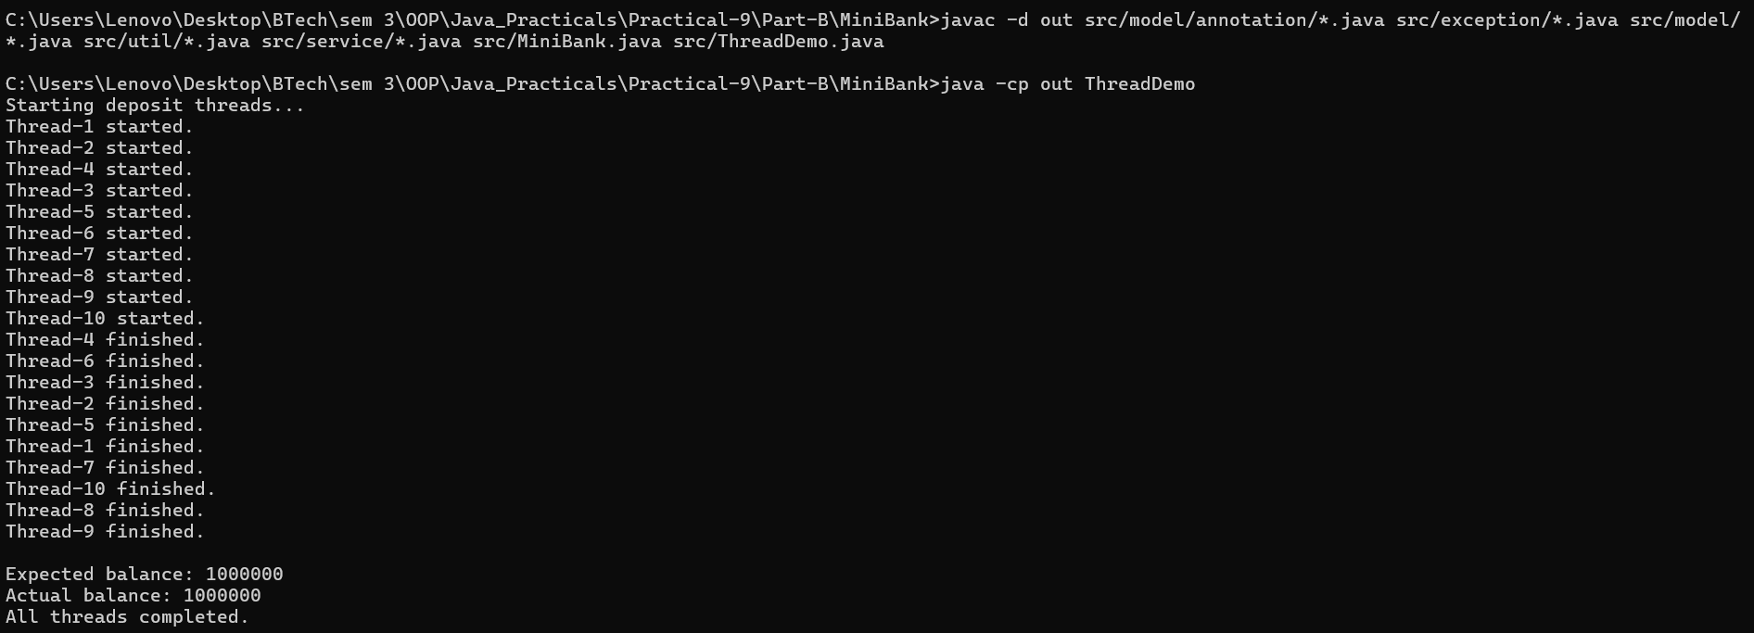
Learning Outcome:

Counter Race — Learning Outcomes

Learned to create and execute multiple threads in Java.
Understood race conditions when multiple threads access and modify a shared counter.
Observed how unsynchronized increments can produce incorrect results due to lost updates.
Learned to use the synchronized keyword to ensure thread-safe access to shared data.
Understood how synchronization ensures the final counter value is correct across repeated runs.

Seat Booking Race — Learning Outcomes

Learned to simulate concurrent seat booking using multiple threads.
Understood race conditions that can cause more seats to be booked than are available.
Practiced managing shared resources, such as the number of remaining seats, across threads.
Learned to use a synchronized book() method to prevent overselling and ensure only five bookings succeed.
Understood the importance of synchronization in maintaining data consistency and preventing resource conflicts in multithreaded applications.

