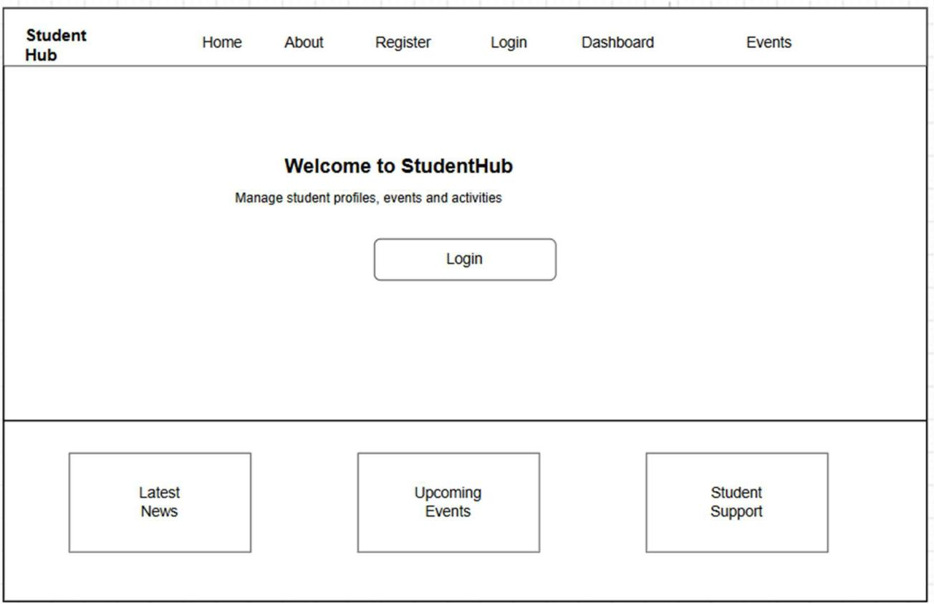
ITUE203 | WDF | D26IT132 PRACTICAL – 1
Problem Definition: Initiate the semester-long StudentHub portal by identifying the problemscope, user roles, key modules, navigation flow, and minimum 10 pages. Create a sitemap, low-fidelity wireframe, project folder structure, README file, and GitHub repository.

Code/Script/Task:

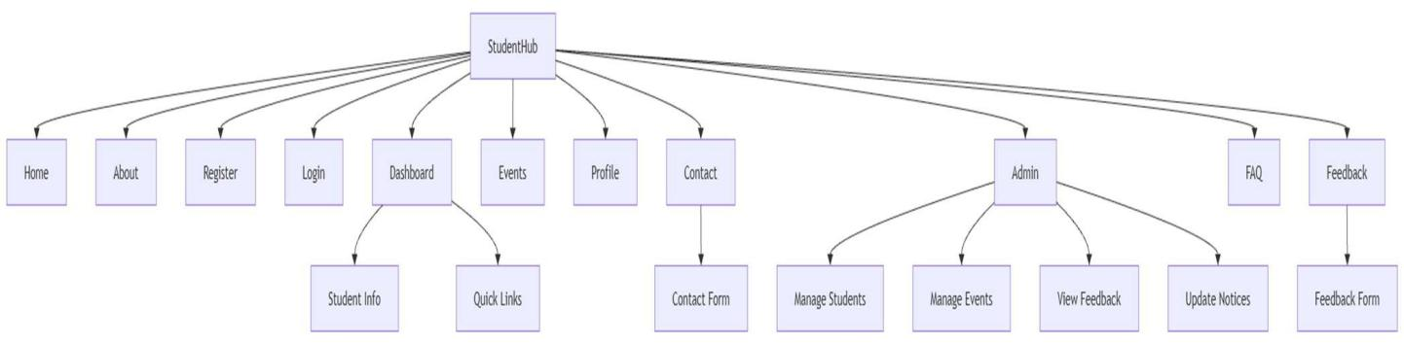
SiteMap:

Home_Page:

KDPIT | CSPIT

1 | Page

ITUE203 | WDF | D26IT132

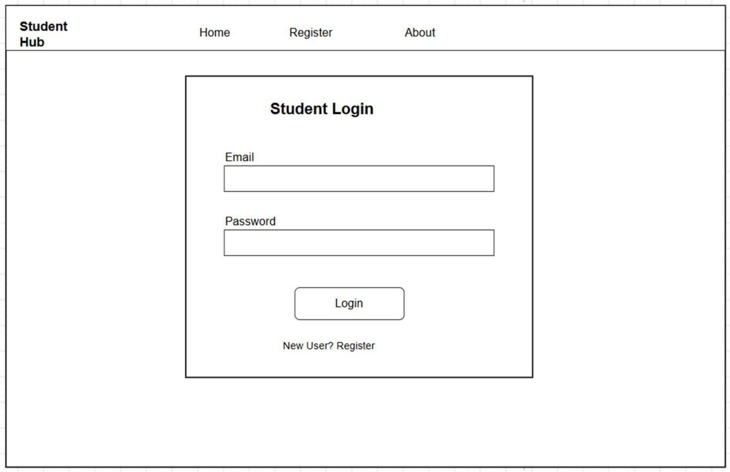
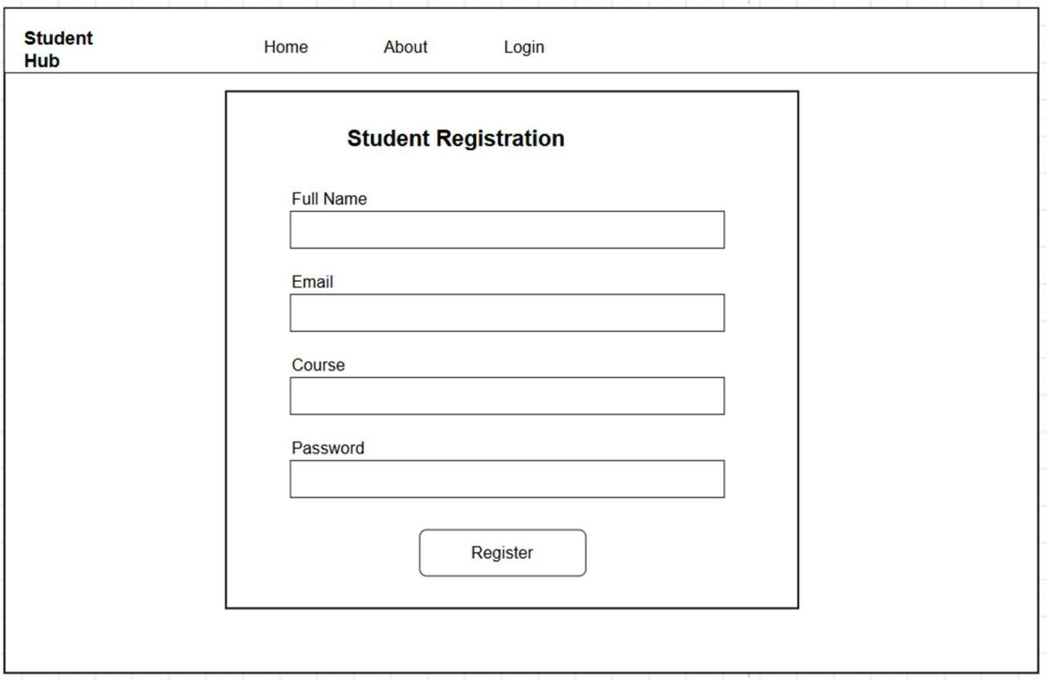
Login_page:

Register_page:

KDPIT | CSPIT

2 | Page

ITUE203 | WDF | D26IT132

About page:

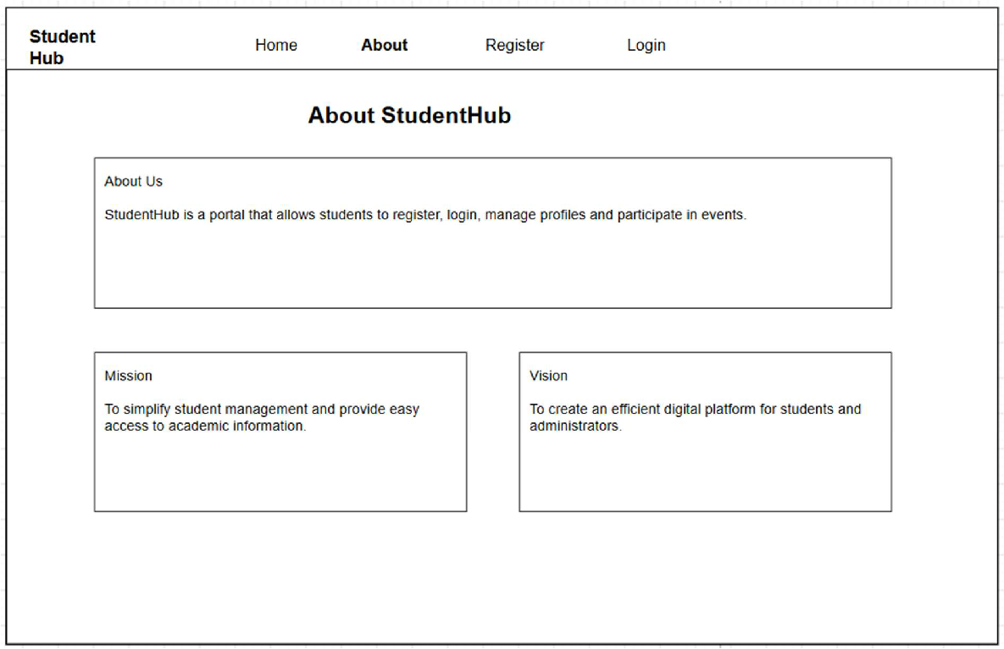

Question & Answer:

1. What is URL and parts of URL?
➢ A URL (Uniform Resource Locator) is the web address used to access a resource on the Internet. Its main parts are protocol, domain name, path, query string, and fragment.

2. How does HTML file processed in web browser?
➢ The browser requests the HTML file from the server, parses it, loads CSS/JavaScript, and renders the webpage for the user.

3. How will page navigation flow managed among all HTML pages?
➢ Page navigation is managed using HTML <a> (anchor) tags, allowing users to move between pages through the navigation menu.

4. How will GitHub commits be maintained after each practical?
➢ After each practical, changes will be committed with a meaningful message and pushed to GitHub to maintain version history and track progress.

KDPIT | CSPIT 3 | Page

ITUE203 | WDF | D26IT132

Conclusion / Learning Outcome:

Conclusion

Successfully designed the initial structure of the StudentHub website by creating the sitemap, low-fidelity wireframes, project folder structure, README file, and GitHub repository, establishing a strong foundation for further development.

Learning Outcomes
• Understood the website planning process, including sitemap creation and wireframing. • Learned to organize a web project, manage page navigation, and use GitHub for version control.

KDPIT | CSPIT 4 | Page

