PRACTICAL:10
AIM: Develop secure login and logout functionality using PHP sessions. Verify password using password_verify(), regenerate session ID after login, restrict dashboard access, implement role-based redirection, session timeout, and optional secure remember-me token.
INPUT:
process_login.php
<?php
error_reporting(E_ALL);
ini_set('display_errors', 1);
session_start();
require __DIR__ . "/db_connect_mysqli.php";
if ($_SERVER["REQUEST_METHOD"] !== "POST") {
header("Location: ../pages/login.html");
exit;
}
$email = trim($_POST["email"] ?? "");
$password = $_POST["password"] ?? "";
if (
$email === "" ||
$password === "" ||
!filter_var($email, FILTER_VALIDATE_EMAIL)
) {
header("Location: ../pages/login.html?error=1");
exit;
}
$sql = "SELECT id, name, email, password, role
FROM users
WHERE email = ?";
$stmt = $conn->prepare($sql);
$stmt->bind_param("s", $email);
$stmt->execute();
$result = $stmt->get_result();
$user = $result->fetch_assoc();
if (
!$user ||
!password_verify($password, $user["password"])
) {
$stmt->close();
$conn->close();
header("Location: ../pages/login.html?error=1");
exit;
}
// Regenerate session ID after successful authentication.
if (!session_regenerate_id(true)) {
die("Unable to establish a secure session.");
}
// Store authenticated user details.
$_SESSION["user_id"] = $user["id"];
$_SESSION["user_name"] = $user["name"];
$_SESSION["user_email"] = $user["email"];
$_SESSION["user_role"] = $user["role"];
$_SESSION["last_activity"] = time();
// Record last login.
$update = $conn->prepare(
"UPDATE users SET last_login = NOW() WHERE id = ?"
);
$update->bind_param("i", $user["id"]);
$update->execute();
$update->close();
$stmt->close();
$conn->close();
// Redirect based on role.
if ($user["role"] === "admin") {
header("Location: ../page/admin_dashboard.php");
exit;
}
if ($user["role"] === "student") {
header("Location: ../page/student_dashboard.php");
exit;
}
// Deny any unexpected role.
$_SESSION = [];
session_destroy();
header("Location: ../page/login.html?error=1");
exit;
?>

logout.php
<?php
session_start();
// Remove session data.
$_SESSION = [];
// Expire the session cookie.
if (ini_get("session.use_cookies")) {
$params = session_get_cookie_params();
setcookie(
session_name(),
"",
[
"expires" => time() - 42000,
"path" => $params["path"],
"domain" => $params["domain"],
"secure" => $params["secure"],
"httponly" => $params["httponly"],
"samesite" => $params["samesite"] ?? "Lax"
]
);
}
// Destroy the session.
session_destroy();
// Return to login.
header("Location: ../page/login.html?logout=1");
exit;
?>

student_dashboard.php
<?php
error_reporting(E_ALL);
ini_set('display_errors', 1);
require __DIR__ . '/../php/session_guard.php';
require_role('student');
?>
<!DOCTYPE html>
<html lang="en">
<head>
<meta charset="UTF-8">
<meta name="viewport" content="width=device-width, initial-scale=1.0">
<title>Student Dashboard - StudentHub</title>
</head>
<body>
<h1>Student Dashboard</h1>
<p>
Welcome,
<?= htmlspecialchars($_SESSION['user_name'], ENT_QUOTES, 'UTF-8') ?>!
</p>
<p>You have logged in successfully as a student.</p>
<a href="../php/logout.php">Logout</a>
</body>
</html>

Student.php
<?php
error_reporting(E_ALL);
ini_set('display_errors', 1);
require __DIR__ . '/../php/session_guard.php';
require_role('admin');
?>
<!DOCTYPE html>
<html lang="en">
<head>
<meta charset="UTF-8">
<meta name="viewport" content="width=device-width, initial-scale=1.0">
<title>Admin Dashboard - StudentHub</title>
</head>
<body>
<h1>Admin Dashboard</h1>
<p>
Welcome,
<?= htmlspecialchars($_SESSION['user_name'], ENT_QUOTES, 'UTF-8') ?>!
</p>
<p>You have logged in successfully as an administrator.</p>
<a href="../php/logout.php">Logout</a>
</body>
</html>

OUTPUT:
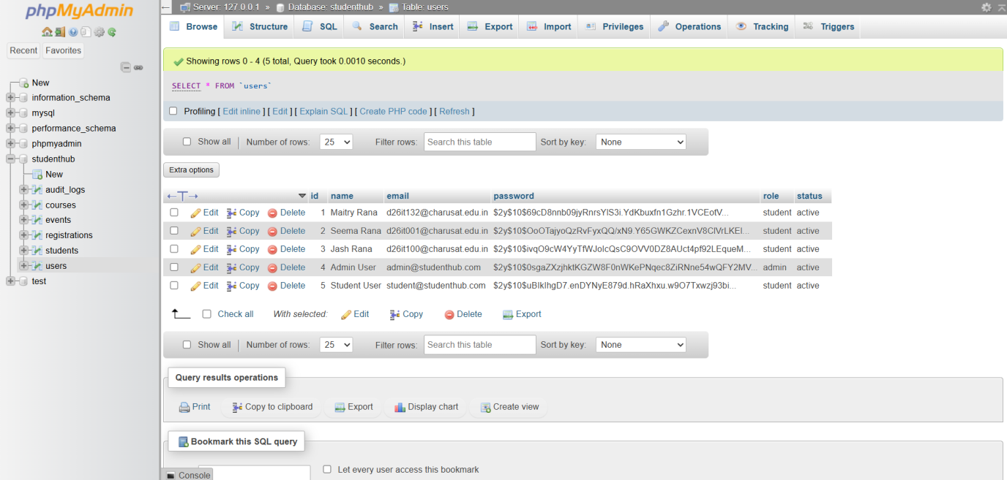
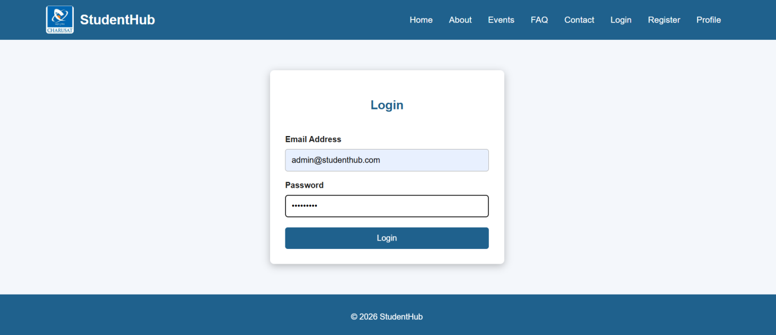
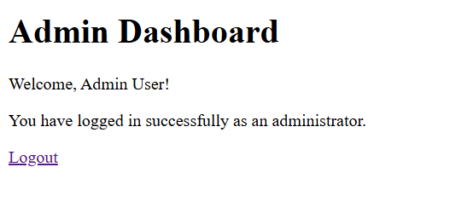
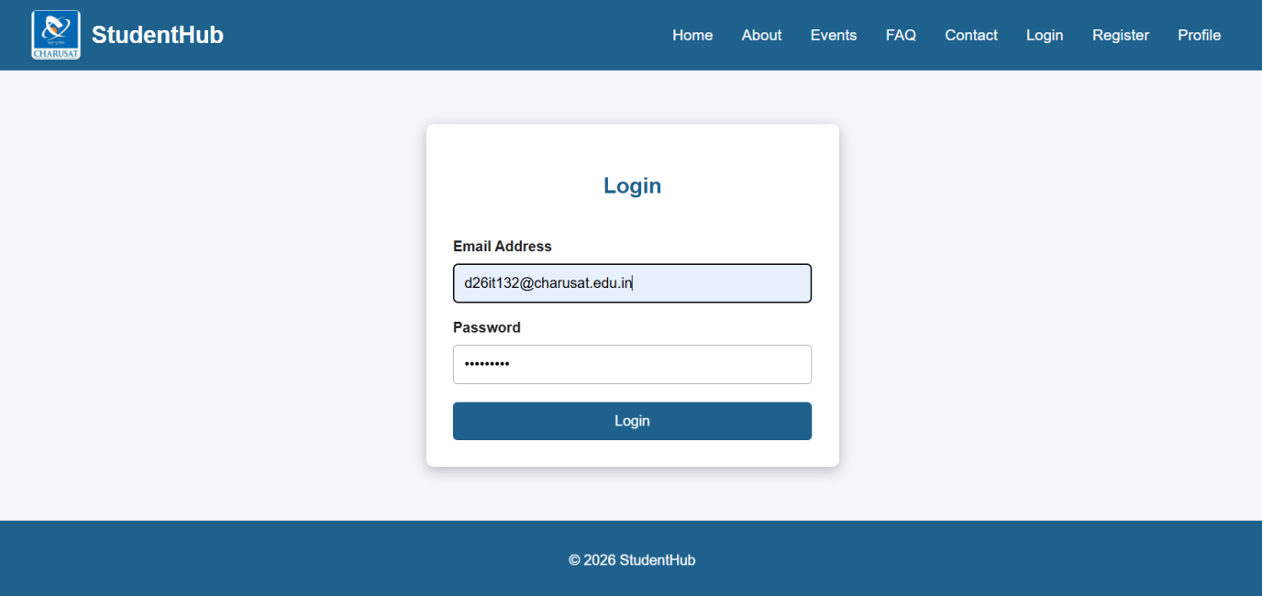
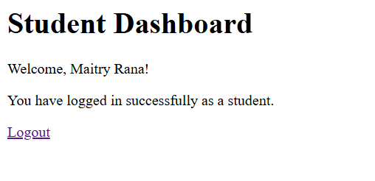

Key Questions / Analysis / Interpretation
1. Are sessions started and destroyed securely?
Yes, sessions are started securely, the session ID is regenerated after login, and the session and cookie are cleared during logout.
2. Is password_verify() used correctly?
Yes, password_verify() checks the entered password against the hashed password stored in the database.
3. Is unauthorized dashboard access blocked?
Yes, unauthorized users are redirected to the login page, and users with the wrong role receive an access-denied message.
4. Is session timeout implemented?
Yes, the session expires after a specified period of inactivity and redirects the user to the login page.
5. Are admin and student users redirected to appropriate dashboards?
Yes, admin users are redirected to admin.php, while student users are redirected to student.php, according to their assigned roles.

Learning Outcome:
The practical helped me learn how to implement secure login and logout functionality using PHP sessions. I learned to verify passwords using password_verify(), regenerate session IDs after login, and protect dashboards from unauthorized access. I also understood how to implement role-based access control for admin and student users, manage session timeouts, and destroy sessions securely during logout. This practical improved my understanding of web application security and user authentication.

