PRACTICAL:11
AIM: Create a student management module to add, view, edit, delete, search and filter student records. All database operations must use MYSQLi statements and clear success/failure messages.
INPUT:
Create a student_crud folder and in that contain this all files
db.php
<?php
session_start();
require_once __DIR__ . "/db_connect_mysqli.php";
// StudentHub Practical 11: Student Management CRUD
// Check login
if (!isset($_SESSION["user_id"])) {
header("Location: ../page/login.html");
exit;
}
// Only admins can manage student records
if (
!isset($_SESSION["user_role"]) ||
$_SESSION["user_role"] !== "admin"
) {
header("Location: ../page/student_dashboard.php");
exit;
}
// 15-minute inactivity timeout
$timeout = 900;
if (
isset($_SESSION["last_activity"]) &&
(time() - $_SESSION["last_activity"] > $timeout)
) {
$_SESSION = [];
session_destroy();
header("Location: ../page/login.html?timeout=1");
exit;
}
$_SESSION["last_activity"] = time();
// Check database connection
if (!isset($conn) || !($conn instanceof mysqli)) {
http_response_code(500);
exit("Database connection is unavailable. Check db_connect_mysqli.php.");
}
// Create CSRF token
if (empty($_SESSION["csrf_token"])) {
$_SESSION["csrf_token"] = bin2hex(random_bytes(32));
}
// Escape output
function h($value): string
{
return htmlspecialchars((string)$value, ENT_QUOTES, "UTF-8");
}

// Redirect after successful operation
function redirectWithStatus(string $status): void
{
header(
"Location: student_management.php?status=" .
rawurlencode($status)
);
exit;
}
// Load courses for the dropdown
$courses = [];
$courseResult = $conn->query(
"SELECT course_id, course_name
FROM courses
ORDER BY course_name"
);
if ($courseResult) {
while ($courseRow = $courseResult->fetch_assoc()) {
$courses[] = $courseRow;
}
$courseResult->free();
}
$error = "";
// Handle form submissions
if ($_SERVER["REQUEST_METHOD"] === "POST") {
// Verify CSRF token
$postedToken = $_POST["csrf_token"] ?? "";
if (
!is_string($postedToken) ||
!hash_equals($_SESSION["csrf_token"], $postedToken)
) {
http_response_code(403);
exit("Invalid request token. Refresh the page and try again.");
}
$action = $_POST["action"] ?? "";
// ADD OR UPDATE
if ($action === "add" || $action === "update") {
$id = filter_var(
$_POST["id"] ?? null,
FILTER_VALIDATE_INT
);
$name = trim((string)($_POST["name"] ?? ""));
$email = trim((string)($_POST["email"] ?? ""));
$mobile = trim((string)($_POST["mobile"] ?? ""));
$courseId = filter_var(
$_POST["course_id"] ?? null,
FILTER_VALIDATE_INT
;
$year = filter_var(
$_POST["year"] ?? null,
FILTER_VALIDATE_INT
);
$gender = trim((string)($_POST["gender"] ?? ""));
// Confirm the selected course exists
$selectedCourse = null;
foreach ($courses as $courseOption) {
if (
$courseId !== false &&
(int)$courseOption["course_id"] === (int)$courseId
) {
$selectedCourse = $courseOption;
break;
}
}
// Validate input
if ($name === "" || mb_strlen($name) > 100) {
$error = "Enter a student name (maximum 100 characters).";
} elseif (
!filter_var($email, FILTER_VALIDATE_EMAIL) ||
strlen($email) > 150
) {
$error = "Enter a valid email address (maximum 150 characters).";
} elseif ($mobile === "" || strlen($mobile) > 15) {
$error = "Enter a mobile number of up to 15 characters.";
} elseif (!$courseId || !$selectedCourse) {
$error = "Select a valid course.";
} elseif ($year === false || $year < 1 || $year > 10) {
$error = "Enter a valid academic year.";
} elseif (
!in_array($gender, ["Male", "Female", "Other"], true)
) {
$error = "Select a valid gender.";
} elseif ($action === "update" && (!$id || $id < 1)) {
$error = "Invalid student ID.";
} else {
// INSERT: use course_id because the students table
// does not have a course column.
if ($action === "add") {
$stmt = $conn->prepare(
"INSERT INTO students
(name, email, mobile, year, gender, course_id)
VALUES (?, ?, ?, ?, ?, ?)"
);
if (!$stmt) {
$error = "Unable to prepare the add operation: "
. $conn->error;
} else {
$stmt->bind_param(
"sssisi",
$name,
$email,
$mobile,
$year,
$gender,
$courseId
);
if ($stmt->execute()) {
$stmt->close();
redirectWithStatus("added");
}
if ($stmt->errno === 1062) {
$error = "A student with that email already exists.";
} else {
$error = "Unable to add student: " . $stmt->error;
}
$stmt->close();
}
} else {
// UPDATE student details
$stmt = $conn->prepare(
"UPDATE students
SET name = ?,
email = ?,
mobile = ?,
year = ?,
gender = ?,
course_id = ?
WHERE id = ?"
);
if (!$stmt) {
$error = "Unable to prepare the update operation: "
. $conn->error;
} else {
$stmt->bind_param(
"sssisii",
$name,
$email,
$mobile,
$year,
$gender,
$courseId,
$id
);
if ($stmt->execute()) {
$stmt->close();
redirectWithStatus("updated");
}
if ($stmt->errno === 1062) {
$error = "A student with that email already exists.";
} else {
$error = "Unable to update student: " . $stmt->error;
}
$stmt->close();
}
}
}
// DELETE
} elseif ($action === "delete") {
$id = filter_var(
$_POST["id"] ?? null,
FILTER_VALIDATE_INT
);
if (!$id || $id < 1) {
$error = "Invalid student ID.";
} else {
$stmt = $conn->prepare(
"DELETE FROM students WHERE id = ?"
);
if (!$stmt) {
$error = "Unable to prepare the delete operation: "
. $conn->error;
} else {
$stmt->bind_param("i", $id);
if (
$stmt->execute() &&
$stmt->affected_rows > 0
) {
$stmt->close();
redirectWithStatus("deleted");
}
$error = "Student was not deleted. The record may no longer exist.";
$stmt->close();
}
}
} else {
$error = "Unknown action.";
}
}
// SEARCH AND PAGINATION
$search = trim((string)($_GET["q"] ?? ""));
$perPage = 10;
$page = filter_var(
$_GET["page"] ?? 1,
FILTER_VALIDATE_INT
);
$page = ($page && $page > 0) ? $page : 1;
$students = [];
$totalRecords = 0;
$like = "%" . $search . "%";
// Count matching records
if ($search !== "") {
$countStmt = $conn->prepare(
"SELECT COUNT(*) AS total
FROM students s
LEFT JOIN courses c ON s.course_id = c.course_id
WHERE s.name LIKE ?
OR s.email LIKE ?
OR c.course_name LIKE ?"
);
if ($countStmt) {
$countStmt->bind_param(
"sss",
$like,
$like,
$like
);
if ($countStmt->execute()) {
$countResult = $countStmt->get_result();
$countRow = $countResult->fetch_assoc();
$totalRecords = (int)($countRow["total"] ?? 0);
$countResult->free();
} else {
$error = "Unable to count matching records: "
. $countStmt->error;
}
$countStmt->close();
} else {
$error = "Unable to prepare record count: " . $conn->error;
}
} else {
$countResult = $conn->query(
"SELECT COUNT(*) AS total FROM students"
);
if ($countResult) {
$countRow = $countResult->fetch_assoc();
$totalRecords = (int)($countRow["total"] ?? 0);
$countResult->free();
} else {
$error = "Unable to count student records: " . $conn->error;
}
}
$totalPages = max(1, (int)ceil($totalRecords / $perPage));
$page = min($page, $totalPages);
$offset = ($page - 1) * $perPage;
// Fetch student records and get course names from courses table
if ($search !== "") {
$stmt = $conn->prepare(
"SELECT
s.id,
s.name,
s.email,
s.mobile,
c.course_name AS course,
s.year,
s.gender,
s.course_id
FROM students s
LEFT JOIN courses c ON s.course_id = c.course_id
WHERE s.name LIKE ?
OR s.email LIKE ?
OR c.course_name LIKE ?
ORDER BY s.id ASC
LIMIT ? OFFSET ?"
);
if ($stmt) {
$stmt->bind_param(
"sssii",
$like,
$like,
$like,
$perPage,
$offset
);
}
} else {
$stmt = $conn->prepare(
"SELECT
s.id,
s.name,
s.email,
s.mobile,
c.course_name AS course,
s.year,
s.gender,
s.course_id
FROM students s
LEFT JOIN courses c ON s.course_id = c.course_id
ORDER BY s.id ASC
LIMIT ? OFFSET ?"
);
if ($stmt) {
$stmt->bind_param("ii", $perPage, $offset);
}
}
// Execute student records query
if ($stmt) {
if ($stmt->execute()) {
$result = $stmt->get_result();
while ($row = $result->fetch_assoc()) {
$students[] = $row;
}
$result->free();
} else {
$error = "Unable to load student records: " . $stmt->error;
}
$stmt->close();
} elseif ($error === "") {
$error = "Unable to prepare the student records query: "
. $conn->error;
}
// Success messages
$statusMessages = [
"added" => "Student added successfully.",
"updated" => "Student updated successfully.",
"deleted" => "Student deleted successfully."
];
$status = (string)($_GET["status"] ?? "");
$successMessage = $statusMessages[$status] ?? "";
// Load selected student for editing
$editStudent = null;
$editId = filter_var(
$_GET["edit"] ?? null,
FILTER_VALIDATE_INT
);
if ($editId && $editId > 0) {
$stmt = $conn->prepare(
"SELECT
s.id,
s.name,
s.email,
s.mobile,
c.course_name AS course,
s.year,
s.gender,
s.course_id
FROM students s
LEFT JOIN courses c ON s.course_id = c.course_id
WHERE s.id = ?"
);
if ($stmt) {
$stmt->bind_param("i", $editId);
if ($stmt->execute()) {
$result = $stmt->get_result();
$editStudent = $result->fetch_assoc() ?: null;
$result->free();
}
$stmt->close();
}
}
?>
<!DOCTYPE html>
<html lang="en">
<head>
<meta charset="UTF-8">
<meta name="viewport" content="width=device-width, initial-scale=1.0">
<title>StudentHub - Student Management</title>
<link rel="stylesheet" href="../CSS/style.css">
<style>
/* Student Management Header */
.dashboard-header {
display: flex;
justify-content: space-between;
align-items: center;
gap: 20px;
padding: 24px 35px;
margin-bottom: 25px;
background: linear-gradient(135deg, #123b72, #2563a6);
color: #ffffff;
border-radius: 14px;
box-shadow: 0 6px 18px rgba(18, 59, 114, 0.18);
}
.dashboard-header h1 {
margin: 0 0 6px;
font-size: 30px;
font-weight: 700;
letter-spacing: 0.5px;
color: #ffffff;
}
.dashboard-header p {
margin: 0;
font-size: 15px;
color: #e0ecff;
}
.dashboard-header .dashboard-logout {
display: inline-block;
padding: 10px 20px;
background: #ffffff;
color: #174ea6;
text-decoration: none;
font-weight: 600;
border-radius: 8px;
transition: background 0.2s ease, transform 0.2s ease;
}
.dashboard-header .dashboard-logout:hover {
background: #e0ecff;
transform: translateY(-2px);
}
.dashboard-header .dashboard-logout:focus-visible {
outline: 3px solid #facc15;
outline-offset: 3px;
}
@media (max-width: 600px) {
.dashboard-header {
padding: 20px;
flex-direction: column;
align-items: flex-start;
}
.dashboard-header h1 {
font-size: 25px;
}
.dashboard-header .dashboard-logout {
align-self: flex-start;
}
}
.crud-form {
display: grid;
grid-template-columns: repeat(2, minmax(0, 1fr));
gap: 16px;
}
.crud-form label {
display: block;
font-weight: 600;
margin-bottom: 6px;
}
.crud-form input,
.crud-form select {
width: 100%;
box-sizing: border-box;
padding: 11px 12px;
border: 1px solid #cbd5e1;
border-radius: 7px;
font: inherit;
}
.crud-form .full-width {
grid-column: 1 / -1;
}
.crud-form button,
.search-form button,
.action-button {
border: 0;
border-radius: 7px;
padding: 10px 15px;
background: #174ea6;
color: white;
cursor: pointer;
text-decoration: none;
display: inline-block;
font: inherit;
}
.secondary-button {
background: #64748b !important;
}
.search-form {
display: flex;
flex-wrap: wrap;
gap: 10px;
margin-bottom: 20px;
}
.search-form input {
flex: 1;
min-width: 200px;
padding: 10px 12px;
border: 1px solid #cbd5e1;
border-radius: 7px;
font: inherit;
}
.crud-table {
width: 100%;
border-collapse: collapse;
min-width: 900px;
}
.crud-table th,
.crud-table td {
padding: 11px 12px;
text-align: left;
border-bottom: 1px solid #e2e8f0;
}
.crud-table th {
background: #edf3fc;
color: #174ea6;
}
.crud-table tr:hover td {
background: #f8fbff;
}
.action-cell {
white-space: nowrap;
}
.delete-form {
display: inline;
}
.delete-button {
background: #b42318;
border: 0;
border-radius: 7px;
color: white;
padding: 9px 12px;
cursor: pointer;
font: inherit;
}
.notice {
padding: 12px 15px;
border-radius: 8px;
margin: 12px 0;
}
.notice-success {
background: #e8f7ee;
color: #17663a;
border: 1px solid #b8e3c8;
}
.notice-error {
background: #fff0f0;
color: #a61b1b;
border: 1px solid #f2c2c2;
}
@media (max-width: 650px) {
.crud-form {
grid-template-columns: 1fr;
}
.crud-form .full-width {
grid-column: auto;
}
}
</style>
</head>
<body>
<main class="dashboard-page">
<header class="dashboard-header">
<div>
<h1>StudentHub</h1>
<p>Student Management</p>
</div>
<a class="dashboard-logout" href="logout.php">Logout</a>
</header>
<section class="dashboard-welcome">
<h2>Manage Students</h2>
<p>Add, view, edit, delete, and search student records.</p>
<p>
Total matching records:
<strong><?php echo $totalRecords; ?></strong>
</p>
</section>
<?php if ($successMessage !== ""): ?>
<div class="notice notice-success" role="status">
<?php echo h($successMessage); ?>
</div>
<?php endif; ?>
<?php if ($error !== ""): ?>
<div class="notice notice-error" role="alert">
<?php echo h($error); ?>
</div>
<?php endif; ?>
<section class="dashboard-info">
<h2><?php echo $editStudent ? "Edit Student" : "Add Student"; ?></h2>
<?php if (!$courses): ?>
<div class="notice notice-error">
No courses were found in the courses table.
Add a course before adding student records.
</div>
<?php endif; ?>
<form class="crud-form" method="post" action="student_management.php">
<input
type="hidden"
name="csrf_token"
value="<?php echo h($_SESSION["csrf_token"]); ?>"
>
<input
type="hidden"
name="action"
value="<?php echo $editStudent ? "update" : "add"; ?>"
>
<?php if ($editStudent): ?>
<input
type="hidden"
name="id"
value="<?php echo (int)$editStudent["id"]; ?>"
>
<?php endif; ?>
<div>
<label for="name">Student name</label>
<input
id="name"
name="name"
maxlength="100"
required
value="<?php echo h($editStudent["name"] ?? ""); ?>"
>
</div>
<div>
<label for="email">Email</label>
<input
id="email"
name="email"
type="email"
maxlength="150"
required
value="<?php echo h($editStudent["email"] ?? ""); ?>"
>
</div>
<div>
<label for="mobile">Mobile</label>
<input
id="mobile"
name="mobile"
maxlength="15"
required
value="<?php echo h($editStudent["mobile"] ?? ""); ?>"
>
</div>
<div>
<label for="course_id">Course</label>
<select id="course_id" name="course_id" required>
<option value="">Select course</option>
<?php foreach ($courses as $courseOption): ?>
<option
value="<?php echo (int)$courseOption["course_id"]; ?>"
<?php
echo (
isset($editStudent["course_id"]) &&
(int)$editStudent["course_id"] ===
(int)$courseOption["course_id"]
) ? "selected" : "";
?>
>
<?php echo h($courseOption["course_name"]); ?>
</option>
<?php endforeach; ?>
</select>
</div>
<div>
<label for="year">Academic year</label>
<input
id="year"
name="year"
type="number"
min="1"
max="10"
required
value="<?php echo h($editStudent["year"] ?? "1"); ?>"
>
</div>
<div>
<label for="gender">Gender</label>
<select id="gender" name="gender" required>
<option value="">Select gender</option>
<?php foreach (["Male", "Female", "Other"] as $genderOption): ?>
<option
value="<?php echo h($genderOption); ?>"
<?php
echo (
($editStudent["gender"] ?? "") ===
$genderOption
) ? "selected" : "";
?>
>
<?php echo h($genderOption); ?>
</option>
<?php endforeach; ?>
</select>
</div>
<div class="full-width">
<button type="submit" <?php echo !$courses ? "disabled" : ""; ?>>
<?php echo $editStudent ? "Save Changes" : "Add Student"; ?>
</button>
<?php if ($editStudent): ?>
<a
class="action-button secondary-button"
href="student_management.php"
>
Cancel Edit
</a>
<?php endif; ?>
</div>
</form>
</section>
<section class="dashboard-info">
<h2>Student Records</h2>
<form class="search-form" method="get" action="student_management.php">
<input
type="search"
name="q"
value="<?php echo h($search); ?>"
placeholder="Search by name, email, or course"
aria-label="Search students"
>
<button type="submit">Search</button>
<a
class="action-button secondary-button"
href="student_management.php"
>
Clear
</a>
</form>
<div style="overflow-x:auto;">
<table class="crud-table">
<thead>
<tr>
<th>ID</th>
<th>Name</th>
<th>Email</th>
<th>Mobile</th>
<th>Course</th>
<th>Year</th>
<th>Gender</th>
<th>Actions</th>
</tr>
</thead>
<tbody>
<?php if (!$students): ?>
<tr>
<td colspan="8">No student records found.</td>
</tr>
<?php else: ?>
<?php foreach ($students as $student): ?>
<tr>
<td><?php echo (int)$student["id"]; ?></td>
<td><?php echo h($student["name"]); ?></td>
<td><?php echo h($student["email"]); ?></td>
<td><?php echo h($student["mobile"]); ?></td>
<td><?php echo h($student["course"] ?? ""); ?></td>
<td><?php echo h($student["year"]); ?></td>
<td><?php echo h($student["gender"]); ?></td>
<td class="action-cell">
<a
class="action-button"
href="student_management.php?edit=<?php echo (int)$student["id"]; ?>"
>
Edit
</a>
<form
class="delete-form"
method="post"
action="student_management.php"
onsubmit="return confirm('Are you sure you want to delete this student record?');"
>
<input
type="hidden"
name="csrf_token"
value="<?php echo h($_SESSION["csrf_token"]); ?>"
>
<input
type="hidden"
name="action"
value="delete"
>
<input
type="hidden"
name="id"
value="<?php echo (int)$student["id"]; ?>"
>
<button
class="delete-button"
type="submit"
>
Delete
</button>
</form>
</td>
</tr>
<?php endforeach; ?>
<?php endif; ?>
</tbody>
</table>
</div>
<div style="display:flex; justify-content:center; align-items:center; gap:15px; margin-top:20px; flex-wrap:wrap;">
<?php if ($page > 1): ?>
<a
class="action-button secondary-button"
href="?page=<?php echo $page - 1; ?>&amp;q=<?php echo urlencode($search); ?>"
>
Previous
</a>
<?php endif; ?>
<span>
Page <?php echo $page; ?> of <?php echo $totalPages; ?>
</span>
<?php if ($page < $totalPages): ?>
<a
class="action-button"
href="?page=<?php echo $page + 1; ?>&amp;q=<?php echo urlencode($search); ?>"
>
Next
</a>
<?php endif; ?>
</div>
</section>
</main>
</body>
</html>

OUTPUT:
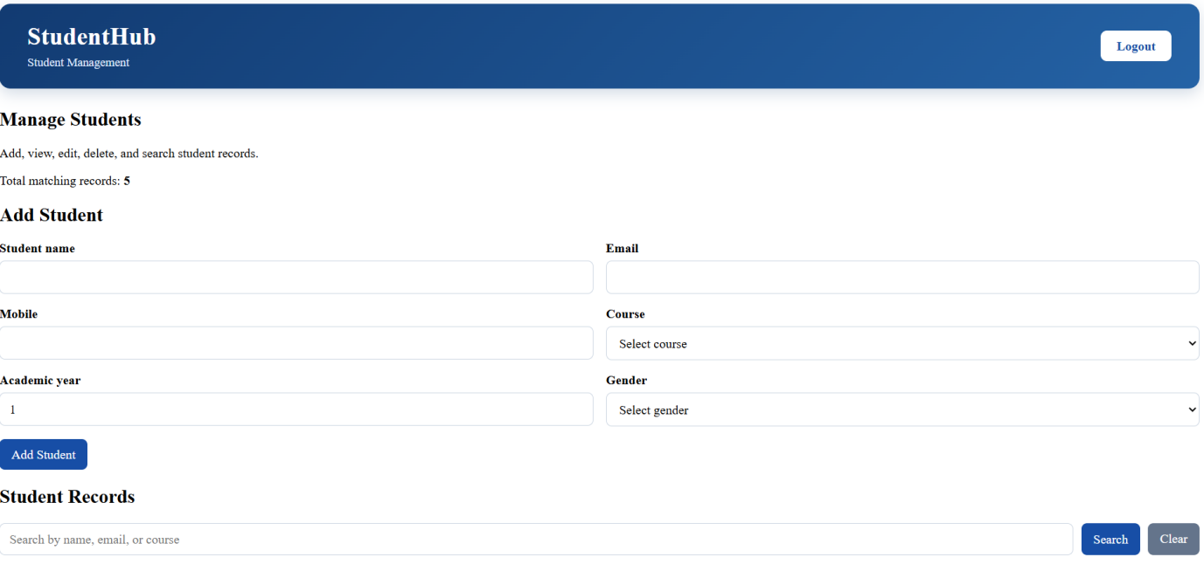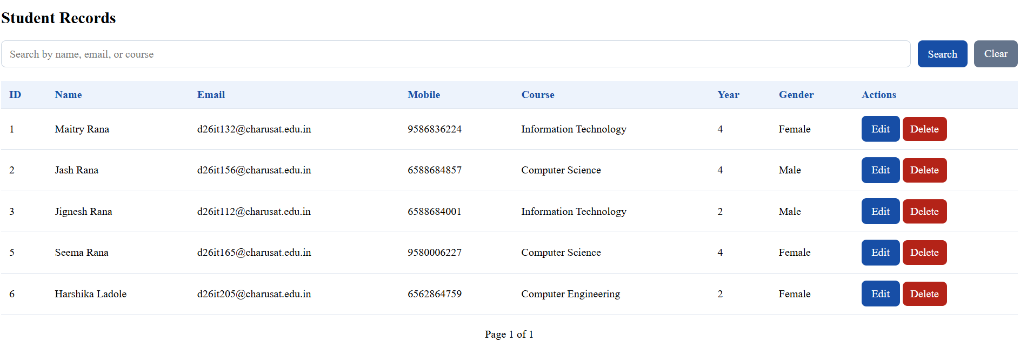

Key Questions / Analysis/ Interpretation
1. Are SELECT, INSERT, UPDATE, and DELETE operations working?
Yes. All four are working, and every query uses MySQLi prepared statements.
Operation | File | Query | Evidence (screenshot)
SELECT | index.php | SELECT id,name,email,phone,course,year FROM students WHERE status='active' ... LIMIT ? OFFSET ? | List page with 20+ records
INSERT | add.php | INSERT INTO students (name,email,phone,course,year) VALUES (?,?,?,?,?) | “Student added successfully” message
UPDATE | edit.php | UPDATE students SET name=?,email=?,phone=?,course=?,year=? WHERE id=? | “Student updated successfully” message
DELETE | delete.php | UPDATE students SET status='deleted' WHERE id=? (soft delete) | “Student deleted successfully” message and phpMyAdmin showing status = deleted

2. Is search by name/email/course implemented?
Yes. index.php uses one search box with this query:
Sql WHERE status='active' AND (name LIKE ? OR email LIKE ? OR course LIKE ?)
The search text is wrapped as %text%, so partial matches work. For example, “shah” finds Aarav Shah and Myra Shah. It also works together with the Course filter, Year filter and Sort, and it keeps working across pages and in the CSV export.

3. Are delete operations confirmed before execution?
Yes. Each Delete button is inside a form with this check:
Html onsubmit="return confirm('Are you sure you want to delete this student?');"
The browser shows a popup. If the user clicks Cancel, the form does not submit and nothing changes. If the user clicks OK, delete.php runs.

