PRACTICAL:12
AIM: Develop event management functionality for admin users. Admin can add, view, update, delete, and upload event posters with file type and file size validation.
INPUT:
Events.php
<?php
session_start();

// Admin access check
if (
!isset($_SESSION['user_id']) ||
!isset($_SESSION['user_role']) ||
$_SESSION['user_role'] !== 'admin'
) {
header("Location: ../pages/login.html");
exit;
}
require_once __DIR__ . "/db_connect_mysqli.php";
// Fetch events in ascending ID order
$sql = "SELECT * FROM events ORDER BY id ASC";
$result = $conn->query($sql);
if (!$result) {
die("Unable to retrieve events.");
}
$message = $_GET['message'] ?? '';
$type = $_GET['type'] ?? 'success';
$messages = [
'added' => 'Event added successfully.',
'updated' => 'Event updated successfully.',
'deleted' => 'Event deleted successfully.',
'invalid' => 'Invalid event details or poster file.',
'failed' => 'Operation failed. Please try again.',
'notfound' => 'Event not found.',
'uploadfailed'=> 'Poster upload failed.',
'dbfailed' => 'Database operation failed.'
];
?>
<!DOCTYPE html>
<html lang="en">
<head>
<meta charset="UTF-8">
<meta name="viewport" content="width=device-width, initial-scale=1.0">
<title>StudentHub - Event Management</title>
<link rel="stylesheet" href="../CSS/events_admin.css">
</head>
<body>
<header class="admin-header">
<div>
<h1>StudentHub</h1>
<p>Event Management Dashboard</p>
</div>
<a href="../php/student_management.php" class="home-btn">Student Management</a>
<a class="home-btn" href="logout.php">Logout</a>
</header>
<main class="container">
<div class="page-heading">
<div>
<h2>Manage Events</h2>
<p>Add, view, edit and delete events.</p>
</div>
<a href="add_event.php" class="btn btn-primary">
+ Add New Event
</a>
</div>
<?php if (isset($messages[$message])): ?>
<div class="alert <?= $type === 'error'
? 'alert-error'
: 'alert-success' ?>">
<?= htmlspecialchars($messages[$message]) ?>
</div>
<?php endif; ?>
<div class="table-wrapper">
<table>
<thead>
<tr>
<th>ID</th>
<th>Poster</th>
<th>Event Name</th>
<th>Date</th>
<th>Venue</th>
<th>Category</th>
<th>Status</th>
<th>Actions</th>
</tr>
</thead>
<tbody>
<?php if ($result->num_rows > 0): ?>
<?php while ($event = $result->fetch_assoc()): ?>
<tr>
<td><?= (int) $event['id'] ?></td>
<td>
<?php if (!empty($event['poster'])): ?>
<img
class="poster-preview"
src="../uploads/event_posters/<?= rawurlencode(basename($event['poster'])) ?>"
alt="Event poster">
<?php else: ?>
<span>No poster</span>
<?php endif; ?>
</td>
<td>
<?= htmlspecialchars($event['event_name']) ?>
</td>
<td>
<?= htmlspecialchars($event['event_date']) ?>
</td>
<td>
<?= htmlspecialchars($event['venue']) ?>
</td>
<td>
<?= htmlspecialchars($event['category'] ?? '') ?>
</td>
<td>
<span class="status <?= $event['status'] === 'Open'
? 'open'
: 'closed' ?>">
<?= htmlspecialchars($event['status']) ?>
</span>
</td>
<td class="actions">
<a
class="btn btn-edit"
href="edit_event.php?id=<?= (int) $event['id'] ?>">
Edit
</a>
<form
action="delete_event.php"
method="POST"
onsubmit="return confirm('Are you sure you want to delete this event?');">
<input
type="hidden"
name="id"
value="<?= (int) $event['id'] ?>">
<button type="submit" class="btn btn-delete">
Delete
</button>
</form>
</td>
</tr>
<?php endwhile; ?>
<?php else: ?>
<tr>
<td colspan="8" class="empty">
No events found. Click Add New Event to create one.
</td>
</tr>
<?php endif; ?>
</tbody>
</table>
</div>
</main>
</body>
</html>

OUTPUT:
The admin@studenthub.com is the admin
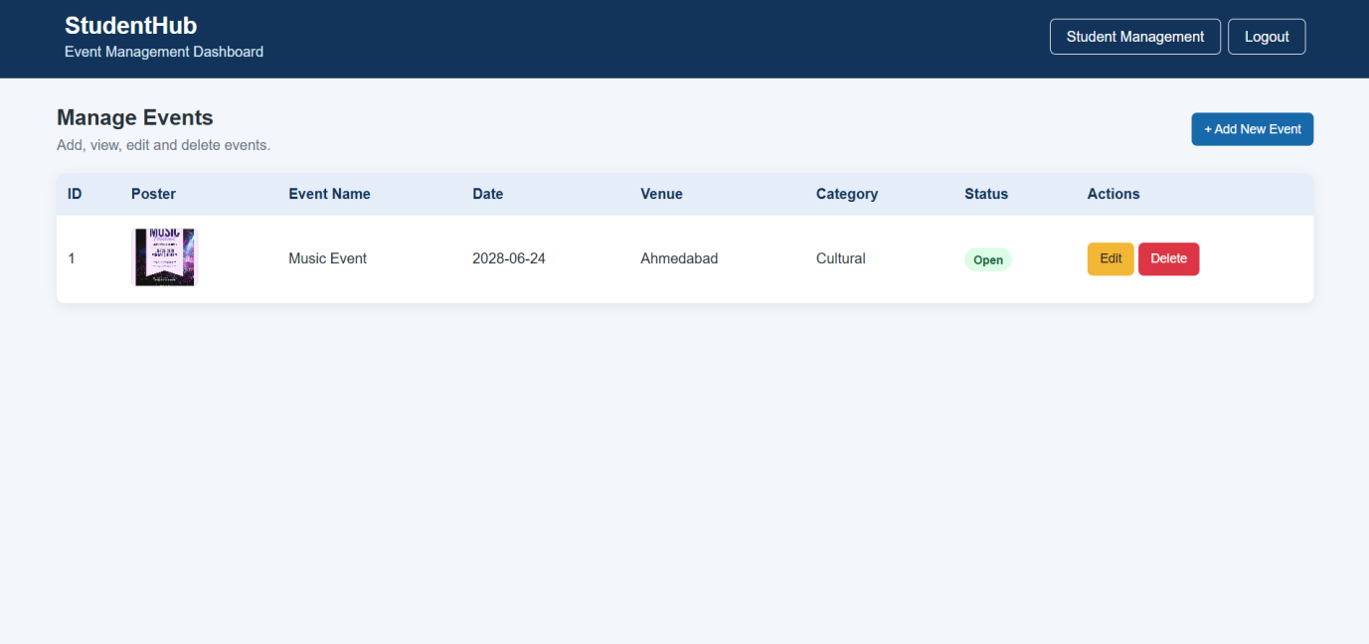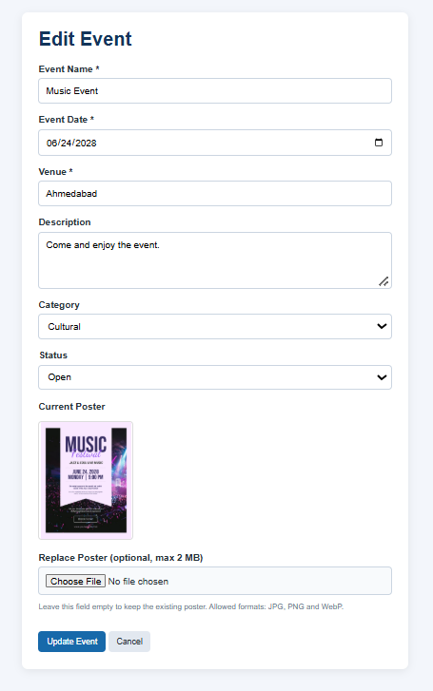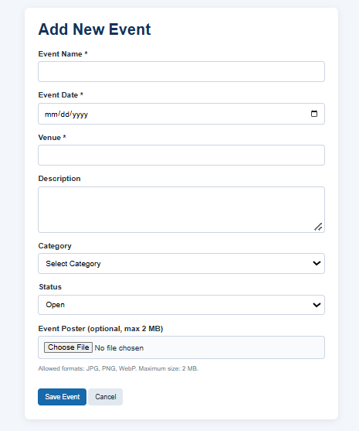

Key Questions / Analysis / Interpretation
- Are add, update, and delete functionalities implemented correctly?
Yes, the system supports adding, editing, and deleting events through the admin Manage Events page.
- Is the UI linked with the database correctly?
Yes, the PHP interface is connected to the MySQL database. Events added by the admin are displayed on the existing Events page.
- Are poster uploads validated for type and size?
Yes, poster uploads are validated for file type (JPEG, PNG, and WEBP) and file size (maximum 2 MB).
- Are success and failure messages displayed?
Yes, success and failure messages are provided to inform the admin about event operations and errors.

