PRACTICAL:13
AIM: Create simple PHP JSON API endpoints for events or students and consume them using Fetch API. Perform list, add, update, and delete operations asynchronously without full page reload.
INPUT:
api.php
<?php
header("Content-Type: application/json; charset=UTF-8");
require_once __DIR__ . "/db_connect_mysqli.php";
function sendResponse($status, $data)
{
http_response_code($status);
echo json_encode($data);
exit;
}
if (!isset($conn) || !($conn instanceof mysqli)) {
sendResponse(500, [
"success" => false,
"message" => "MySQLi connection is not available."
]);
}
$method = $_SERVER["REQUEST_METHOD"];
// READ AND SEARCH STUDENTS
if ($method === "GET") {
$search = trim($_GET["search"] ?? "");
if ($search !== "") {
$sql = "SELECT id, name, email, mobile, course_id, year, gender
FROM students
WHERE name LIKE ? OR email LIKE ?
ORDER BY id ASC";
$stmt = $conn->prepare($sql);
if (!$stmt) {
sendResponse(500, [
"success" => false,
"message" => "Failed to prepare search query."
]);
}
$searchTerm = "%" . $search . "%";
$stmt->bind_param("ss", $searchTerm, $searchTerm);
} else {
$sql = "SELECT id, name, email, mobile, course_id, year, gender
FROM students
ORDER BY id ASC";
$stmt = $conn->prepare($sql);
if (!$stmt) {
sendResponse(500, [
"success" => false,
"message" => "Failed to prepare query."
]);
}
}
if (!$stmt->execute()) {
sendResponse(500, [
"success" => false,
"message" => "Failed to fetch students."
]);
}
$result = $stmt->get_result();
$students = [];
while ($row = $result->fetch_assoc()) {
$students[] = $row;
}
sendResponse(200, [
"success" => true,
"data" => $students
]);
}
// READ JSON DATA FOR POST, PUT AND DELETE
$input = json_decode(file_get_contents("php://input"), true);
if (!is_array($input)) {
sendResponse(400, [
"success" => false,
"message" => "Invalid JSON data."
]);
}
// ADD STUDENT
if ($method === "POST") {
$name = trim($input["name"] ?? "");
$email = trim($input["email"] ?? "");
$mobile = trim($input["mobile"] ?? "");
$courseId = trim((string)($input["course_id"] ?? ""));
$year = trim((string)($input["year"] ?? ""));
$gender = trim($input["gender"] ?? "");
if (
$name === "" ||
$email === "" ||
$mobile === "" ||
$courseId === "" ||
$year === "" ||
$gender === ""
) {
sendResponse(400, [
"success" => false,
"message" => "Please fill in all fields."
]);
}
if (!filter_var($email, FILTER_VALIDATE_EMAIL)) {
sendResponse(400, [
"success" => false,
"message" => "Please enter a valid email address."
]);
}
if (!ctype_digit($courseId) || (int)$courseId < 1) {
sendResponse(400, [
"success" => false,
"message" => "Course ID must be a positive number."
]);
}
if (!ctype_digit($year) || (int)$year < 1) {
sendResponse(400, [
"success" => false,
"message" => "Year must be a positive number."
]);
}
if (!preg_match('/^[0-9]{10,15}$/', $mobile)) {
sendResponse(400, [
"success" => false,
"message" => "Mobile must contain 10 to 15 digits."
]);
}
if (!in_array($gender, ["Male", "Female", "Other"], true)) {
sendResponse(400, [
"success" => false,
"message" => "Please select a valid gender."
]);
}
// Check for duplicate email
$check = $conn->prepare(
"SELECT id FROM students WHERE email = ?"
);
$check->bind_param("s", $email);
$check->execute();
$checkResult = $check->get_result();
if ($checkResult->num_rows > 0) {
sendResponse(409, [
"success" => false,
"message" => "This email is already registered."
]);
}
$sql = "INSERT INTO students
(name, email, mobile, course_id, year, gender)
VALUES (?, ?, ?, ?, ?, ?)";

$stmt = $conn->prepare($sql);
if (!$stmt) {
sendResponse(500, [
"success" => false,
"message" => "Failed to prepare insert query."
]);
}
$courseId = (int)$courseId;
$year = (int)$year;
$stmt->bind_param(
"sssiis",
$name,
$email,
$mobile,
$courseId,
$year,
$gender
);
if ($stmt->execute()) {
sendResponse(201, [
"success" => true,
"message" => "Student added successfully.",
"id" => $conn->insert_id
]);
}
if ($stmt->errno === 1062) {
sendResponse(409, [
"success" => false,
"message" => "This email is already registered."
]);
}
sendResponse(500, [
"success" => false,
"message" => "Failed to add student."
]);
}
// UPDATE STUDENT
if ($method === "PUT") {
$id = filter_var(
$input["id"] ?? null,
FILTER_VALIDATE_INT
);
if (!$id || $id < 1) {
sendResponse(400, [
"success" => false,
"message" => "A valid student ID is required."
]);
}
$name = trim($input["name"] ?? "");
$email = trim($input["email"] ?? "");
$mobile = trim($input["mobile"] ?? "");
$courseId = trim((string)($input["course_id"] ?? ""));
$year = trim((string)($input["year"] ?? ""));
$gender = trim($input["gender"] ?? "");
if (
$name === "" ||
$email === "" ||
$mobile === "" ||
$courseId === "" ||
$year === "" ||
$gender === ""
) {
sendResponse(400, [
"success" => false,
"message" => "Please fill in all fields."
]);
}
if (!filter_var($email, FILTER_VALIDATE_EMAIL)) {
sendResponse(400, [
"success" => false,
"message" => "Please enter a valid email address."
]);
}
if (!ctype_digit($courseId) || (int)$courseId < 1) {
sendResponse(400, [
"success" => false,
"message" => "Course ID must be a positive number."
]);
}
if (!ctype_digit($year) || (int)$year < 1) {
sendResponse(400, [
"success" => false,
"message" => "Year must be a positive number."
]);
}
if (!preg_match('/^[0-9]{10,15}$/', $mobile)) {
sendResponse(400, [
"success" => false,
"message" => "Mobile must contain 10 to 15 digits."
]);
}
if (!in_array($gender, ["Male", "Female", "Other"], true)) {
sendResponse(400, [
"success" => false,
"message" => "Please select a valid gender."
]);
}
// Check whether the student exists
$check = $conn->prepare(
"SELECT id FROM students WHERE id = ?"
);
$check->bind_param("i", $id);
$check->execute();
if ($check->get_result()->num_rows === 0) {
sendResponse(404, [
"success" => false,
"message" => "Student not found."
]);
}
// Check duplicate email belonging to another student
$checkEmail = $conn->prepare(
"SELECT id FROM students WHERE email = ? AND id != ?"
);
$checkEmail->bind_param("si", $email, $id);
$checkEmail->execute();
if ($checkEmail->get_result()->num_rows > 0) {
sendResponse(409, [
"success" => false,
"message" => "This email belongs to another student."
]);
}
$sql = "UPDATE students
SET name = ?, email = ?, mobile = ?,
course_id = ?, year = ?, gender = ?
WHERE id = ?";
$stmt = $conn->prepare($sql);
if (!$stmt) {
sendResponse(500, [
"success" => false,
"message" => "Failed to prepare update query."
]);
}
$courseId = (int)$courseId;
$year = (int)$year;
$stmt->bind_param(
"sssiisi",
$name,
$email,
$mobile,
$courseId,
$year,
$gender,
$id
);
if ($stmt->execute()) {
sendResponse(200, [
"success" => true,
"message" => "Student updated successfully."
]);
}
sendResponse(500, [
"success" => false,
"message" => "Failed to update student."
]);
}
// DELETE STUDENT
if ($method === "DELETE") {
$id = filter_var(
$input["id"] ?? null,
FILTER_VALIDATE_INT
);
if (!$id || $id < 1) {
sendResponse(400, [
"success" => false,
"message" => "A valid student ID is required."
]);
}
$stmt = $conn->prepare(
"DELETE FROM students WHERE id = ?"
);
if (!$stmt) {
sendResponse(500, [
"success" => false,
"message" => "Failed to prepare delete query."
]);
}
$stmt->bind_param("i", $id);
if (!$stmt->execute()) {
sendResponse(500, [
"success" => false,
"message" => "Failed to delete student."
]);
}
if ($stmt->affected_rows === 0) {
sendResponse(404, [
"success" => false,
"message" => "Student not found."
]);
}
sendResponse(200, [
"success" => true,
"message" => "Student deleted successfully."
]);
}
// UNSUPPORTED METHOD
header("Allow: GET, POST, PUT, DELETE");
sendResponse(405, [
"success" => false,
"message" => "Method not allowed."
]);
?>

OUTPUT:
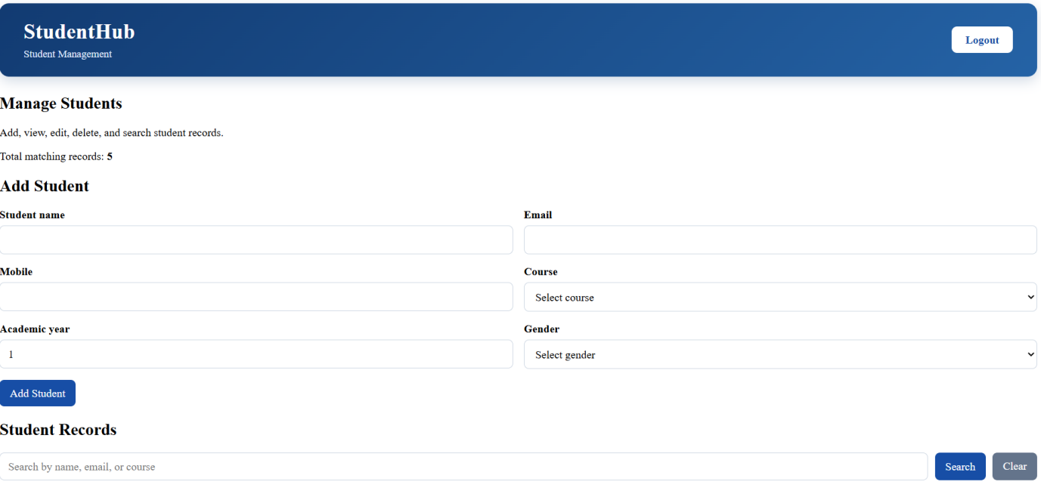
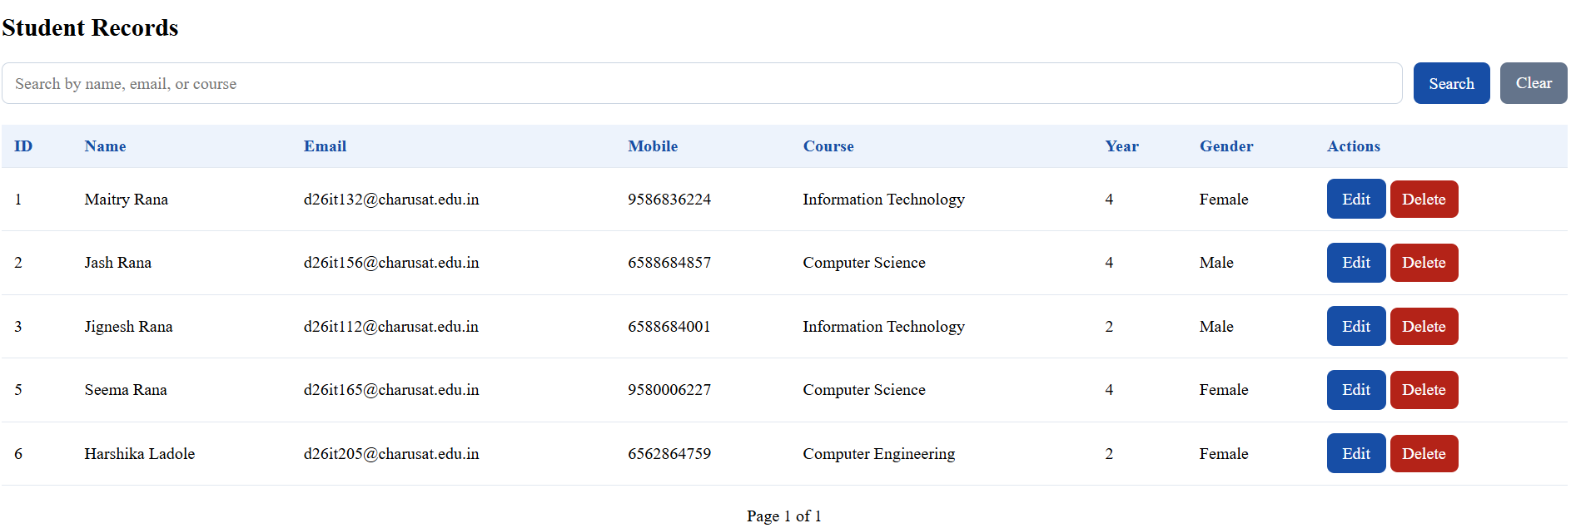

Its automatically add on the CSV also
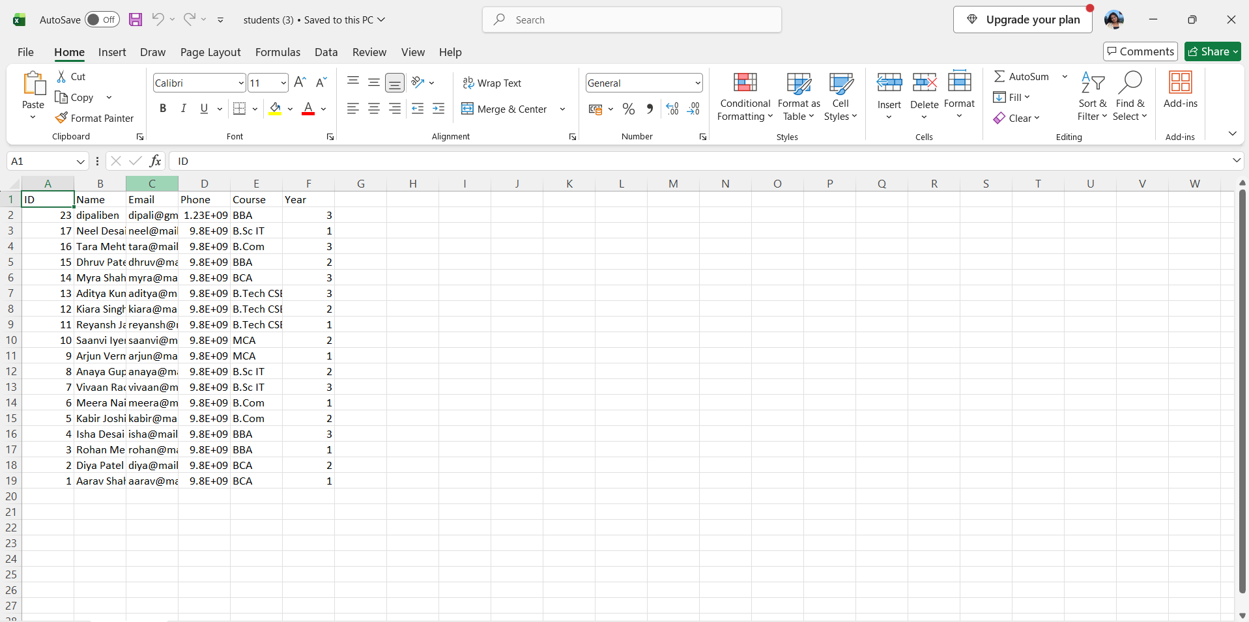

Key Questions / Analysis/ Interpretation
- Do PHP endpoints return valid JSON responses?
Yes, the PHP API endpoint returns valid JSON responses. The api.php file sets the appropriate Content-Type header to application/json and returns a structured response containing success, message, and data. The API was tested successfully and returned the student records from the database in JSON format.
2. Are GET and POST requests handled properly?
Yes, the API is designed to handle GET and POST requests properly. The GET request retrieves all active student records or fetches a specific student using their ID. The POST request adds a new student to the database after validating the submitted information and checking for duplicate email addresses. The API also returns appropriate HTTP status codes and messages for successful operations and errors.

3.Are loading, success, and error states shown on the frontend?
Yes, the frontend displays loading, success, and error states when communicating with the PHP API. While student data is being fetched, a “Loading students...” message appears. When the data loads successfully, the student records are displayed along with a message showing the number of students found. If an error occurs, an error message informs the user that the records could not be loaded. These states provide clear feedback about the progress and result of the operation.

4. Is input validation performed before database operations?
Yes, input validation is performed in the PHP API before inserting or updating student records. The API checks that the name is not empty, the email address is valid, the phone number contains exactly 10 digits, the course is selected from the allowed courses, and the year is between 1 and 4. It also checks for duplicate email addresses. Invalid data is rejected with an appropriate error response, helping maintain data accuracy and consistency in the database.

