PRACTICAL:14

Aim: Develop an admin dashboard that displays user statistics, student count, event count and latest registrations. Restrict access to admin users only and show dynamic menu options based on role.

Input:
audit_log.php
<?php

function logAudit($conn, $userId, $action, $details = "")
{
$ipAddress = $_SERVER["REMOTE_ADDR"] ?? "Unknown";
$sql = "INSERT INTO audit_logs
(user_id, action, details, ip_address)
VALUES (?, ?, ?, ?)";
$stmt = $conn->prepare($sql);
if (!$stmt) {
return false;
}
$stmt->bind_param(
"isss",
$userId,
$action,
$details,
$ipAddress
);
$result = $stmt->execute();
$stmt->close();
return $result;
}
?>

Dynamic_menu.php
<?php

if (session_status() === PHP_SESSION_NONE) {
session_start();
}
$role = $_SESSION["role"] ?? "";
$menus = [
"admin" => [
["Dashboard", "admin_dashboard.php"],
["Students", "student_management.php"],
["Manage Users", "admin_users.php"],
["Audit Logs", "audit_logs.php"],
["Home", "../page/index.html"]
],
"student" => [
["Home", "../page/index.html"],
["Profile", "../page/profile.html"],
["Events", "../page/events.html"],
["Dashboard", "../page/dashboard.html"]
],
"staff" => [
["Home", "../page/index.html"],
["Students", "student_management.php"],
["Events", "../page/events.html"]
]
];
$menuItems = $menus[$role] ?? [];
?>
<nav class="admin-nav" aria-label="Main navigation">
<?php foreach ($menuItems as $item): ?>
<a href="<?= htmlspecialchars(
$item[1],
ENT_QUOTES,
"UTF-8"
) ?>">
<?= htmlspecialchars(
$item[0],
ENT_QUOTES,
"UTF-8"
) ?>
</a>
<?php endforeach; ?>
<?php if ($role !== ""): ?>
<a href="logout.php">Logout</a>
<?php endif; ?>
</nav>

OUTPUT:
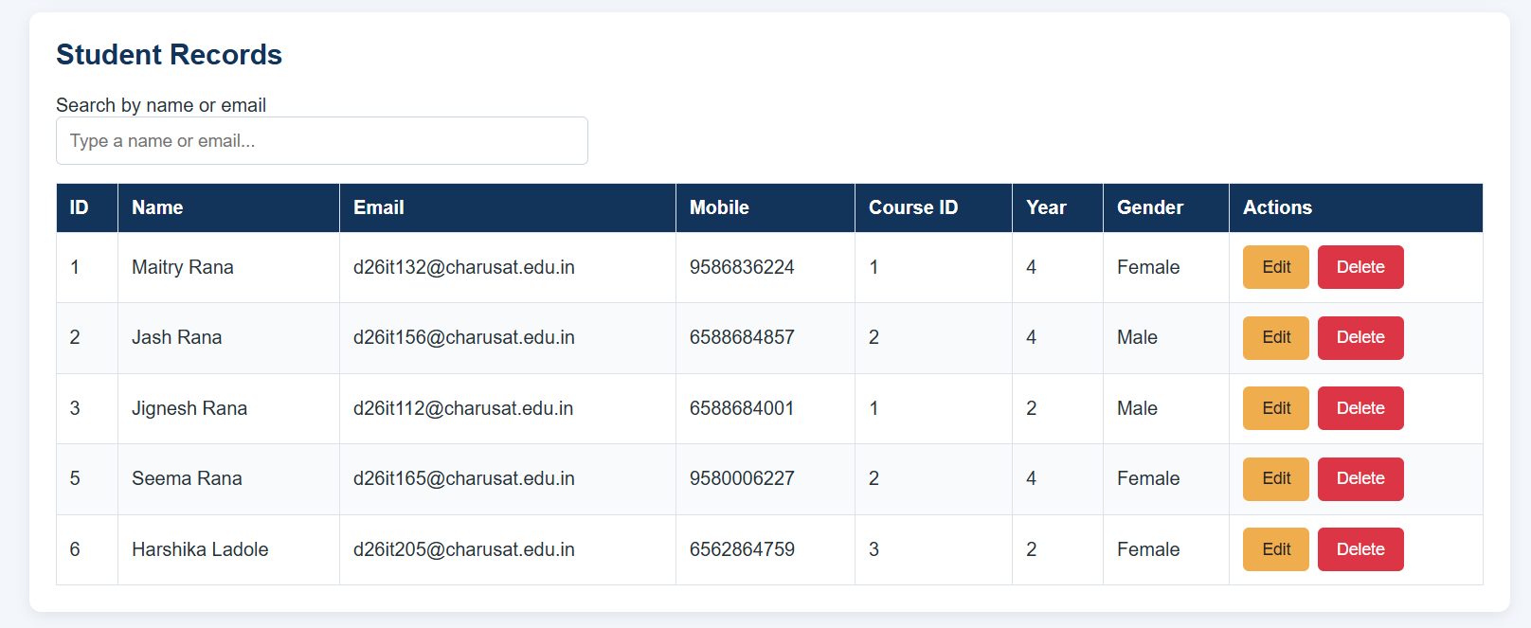
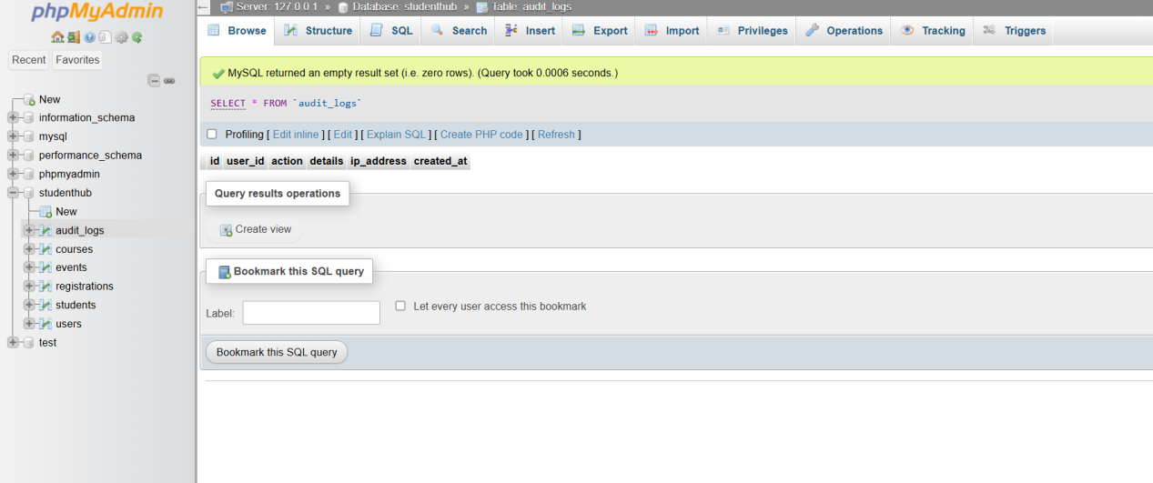

Key Questions / Analysis/ Interpretation

1. Are dashboard values loaded dynamically from the database?
Yes, dashboard values are loaded dynamically from the database using SQL queries to display student counts, event counts, and recent registrations.
2. Is access restricted to admin users?
Yes, access is restricted to admin users by checking their session and role before displaying the dashboard.
3. Are role-based menus working?
Yes, role-based menus display different options depending on the logged-in user's role, such as Admin or Student.
4. Are important admin actions recorded in audit_logs?
Yes, important admin actions, such as login, insertion, updating, and deletion of records, are recorded in the audit_logs table for tracking and security.

