Practical-2

Problem Definition: Develop static HTML5 skeletons for at least 10 StudentHub pages such as Home, About, Register, Login, Dashboard, Events, Profile, Contact,
Admin, FAQ, and Feedback. Use semantic tags and accessibility-friendly
structure.

Code/Task/Script:

HTML(index.html):
<!DOCTYPE html>
<html lang="en">
<head>
<meta charset="UTF-8">
<meta name="viewport" content="width=device-width, initial-scale=1.0">
<title>StudentHub - Home</title>
<link rel="stylesheet" href="style.css">
</head>

<body>
<a href="#main-content" class="skip-link">Skip to main content</a>
<header>
<h1>StudentHub</h1>
<p>Student Information and Learning Portal</p>
</header>
<nav aria-label="Main Navigation">
<ul>
<li><a href="index.html">Home</a></li>
<li><a href="about.html">About</a></li>
<li><a href="register.html">Register</a></li>
<li><a href="login.html">Login</a></li>
<li><a href="dashboard.html">Dashboard</a></li>
<li><a href="events.html">Events</a></li>
<li><a href="profile.html">Profile</a></li>
<li><a href="contact.html">Contact</a></li>
<li><a href="faq.html">FAQ</a></li>
<li><a href="assignment.html">Assignments</a></li>
<li><a href="achievement.html">Achievements</a></li>
<li><a href="feedback.html">Feedback</a></li>
<li><a href="admin.html">Admin</a></li>
</ul>
</nav>
<main id="main-content">
<section>
<h2>Welcome to StudentHub</h2>
<p>
StudentHub is a student portal where students can access
assignments, events, achievements, profiles and other
academic information.
</p>
</section>
<section>
<h2>Student Services</h2>
<div class="card-container">
<article class="card">
<h3>Assignments</h3>
<p>View your academic assignments and deadlines.</p>
<a href="assignment.html">View Assignments</a>
</article>
<article class="card">
<h3>Events</h3>
<p>Check upcoming college events and activities.</p>
<a href="events.html">View Events</a>
</article>
<article class="card">
<h3>Achievements</h3>
<p>View and manage your academic achievements.</p>
<a href="achievement.html">View Achievements</a>
</article>
</div>
</section>
<aside>
<h2>Important Notice</h2>
<p>Registration for the upcoming student activities is open.</p>
</aside>
</main>
<footer>
<p>&copy; 2026 StudentHub. All rights reserved.</p>
</footer>
</body>
</html>

Output:
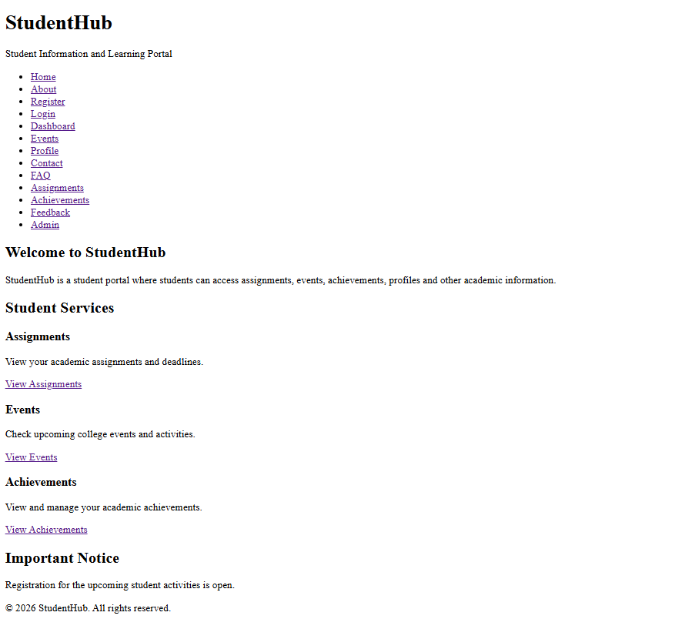

Question & Answer:

1. Are semantic tags such as header, nav, main, section, article, aside, and
footer used properly?
Ans: Check whether semantic tags are used correctly to organize the webpage.
<header> – Contains the website title, logo, or introductory content.
<nav> – Contains navigation links.
<main> – Contains the main content of the page.
<section> – Groups related content.
<article> – Contains independent content, such as a blog post.
<aside> – Contains related or additional information.
<footer> – Contains copyright information and footer links.
Expected result: Semantic tags are used appropriately to make the website structure meaningful and easy to understand.

2. Are form labels, headings, image alt text, and navigation links
accessible?
Ans: Check whether the website is accessible to all users.
Form labels: Every input field should have a properly associated <label>.
Headings: Use headings in a logical order, such as <h1>, <h2>, and <h3>.
Image alt text: Add meaningful alt text to informative images.
Navigation links: Use descriptive link text and ensure links are keyboard-accessible.
Expected result: Users, including those using screen readers or keyboards, can understand and navigate the website easily.

- Is the page structure consistent across all pages?
Ans: Check whether all website pages follow a similar layout.
Keep the header and navigation menu consistent across pages.
Use a similar content layout and styling.
Maintain consistent fonts, colors, spacing, and footer design.
Ensure navigation links work correctly between pages.

Conclusion: The StudentHub project successfully demonstrates the basic structure of at least 10 HTML5 web pages using semantic tags and accessibility-friendly elements. These pages provide a consistent layout, easy navigation, and a user-friendly foundation for developing a complete student portal.

