PRACTICAL:3
Problem Definition:
Design responsive layouts for Home, About, Registration, Dashboard, and Events pages using CSS Grid and Flexbox. Optional to use CSS framework such as Bootstrap or Tailwind.

HTML(index.html):
<!DOCTYPE html>
<html lang="en">
<head>
<meta charset="UTF-8">
<meta name="viewport" content="width=device-width, initial-scale=1.0">
<title>StudentHub - Home</title>
<link rel="stylesheet" href="../CSS/index.css">
</head>
<body>
<header>
<nav class="navbar" aria-label="Main navigation">
<a href="index.html" class="logo-link">
<img src="../IMAGES/charusat_logo.jpg" alt="StudentHub Logo" class="logo-image">
<span class="logo-text">StudentHub</span>
</a>

<button id="menuButton" class="hamburger" type="button" aria-expanded="false" aria-label="Open navigation menu">
☰
</button>
<ul id="navigationMenu" class="navigation-menu">
<li><a href="index.html" aria-current="page">Home</a></li>
<li><a href="admin.html" >Admin</a></li>
<li><a href="faq.html" >FAQ</a></li>
<li><a href="contact.html" >Contact</a></li>
<li><a href="dashboard.html" >Dashboard</a></li>
<li><a href="login.html" >Login</a></li>
<li><a href="register.html" >Register</a></li>
<li><a href="profile.html">Profile</a></li>
</ul>
</nav>
</header>
<main>
<section class="hero">
<div class="hero-overlay">
<h1>Welcome to Student Hub</h1>
<p>Your one-stop platform for student information, college events and activities.</p>
<a href="about.html" class="hero-button">Learn More</a>
</div>
</section>
<section class="slider-section">
<h2>StudentHub Highlights</h2>
<div class="slider">
<article class="slide active">
<img src="../IMAGES/library.jpg" alt="CSPIT Campus" class="slide-image">
<div class="slide-overlay">
<div class="slide-content">
<h3>Student Resources</h3>
<p>Access useful information, student resources and important college updates.</p>
</div>
</div>
</article>
</div>
<section class="features">
<h2>StudentHub Features</h2>
<article class="feature-card">
<div class="feature-icon">🎓</div>
<h3>Student Achievement</h3>
<p>With their hardwork, they get the result.</p>
<a href="achievement.html">Explore</a>
</article>
<article class="feature-card">
<div class="feature-icon">🎉</div>
<h3>College Events</h3>
<p>Stay updated with workshops, cultural events and college activities.</p>
<a href="events.html">View Events</a>
</article>
<article class="feature-card">
<div class="feature-icon">💬</div>
<h3>Student Feedback</h3>
<p>Share your suggestions and help us improve StudentHub.</p>
<a href="feedback.html">Give Feedback</a>
</article>
</section>
</main>
<footer>
<p>&copy; 2026 StudentHub</p>
</footer>
<script src="../JS/index.js"></script>
</body>
</html>

OUTPUT:
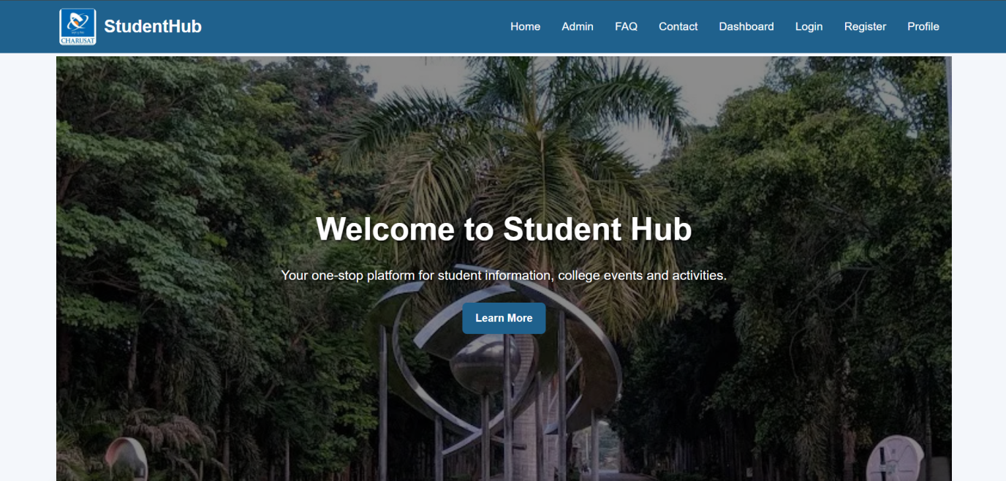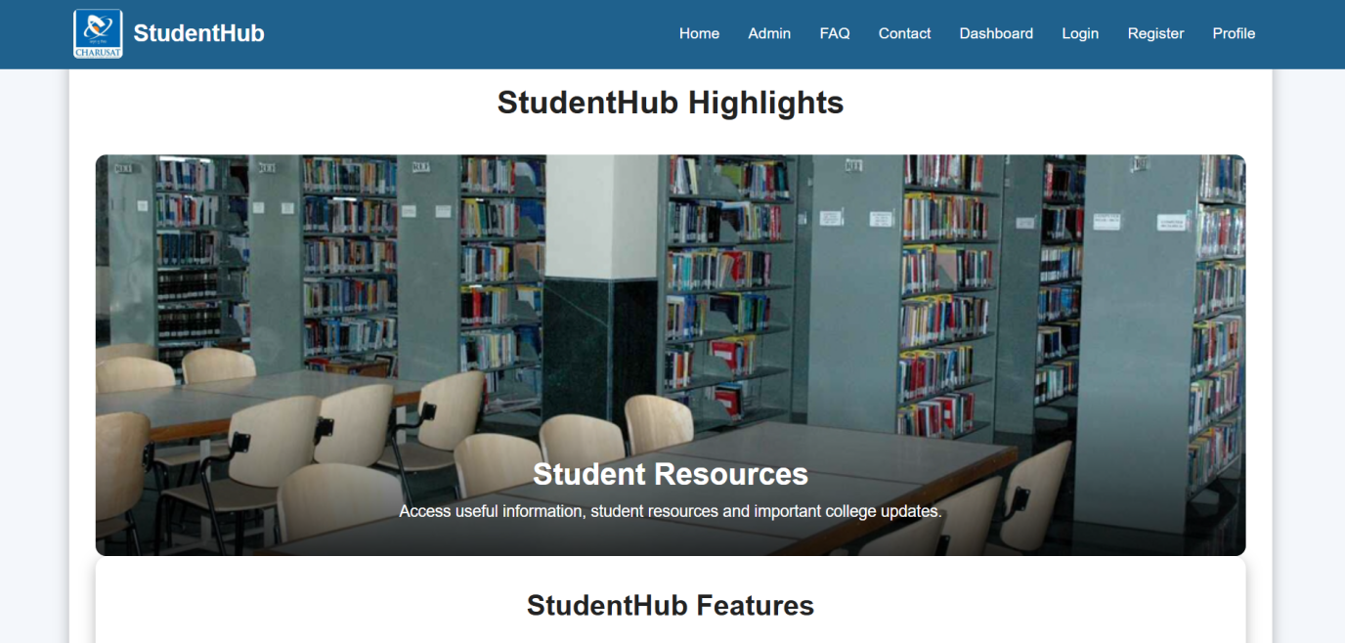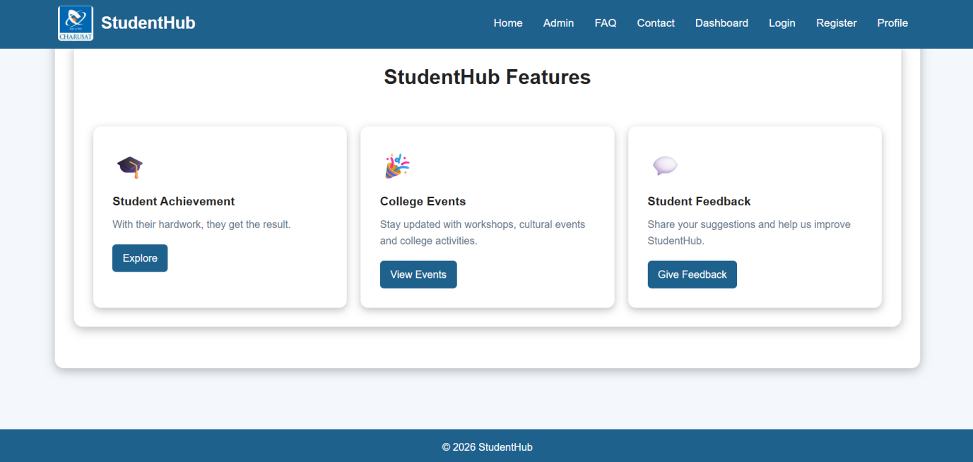

Key Question/Analysis/Interpretation:
- How does the layout adapt for mobile, tablet, and desktop screens?
The layout is designed to be responsive using the viewport meta tag and flexible CSS properties. Navigation items can wrap onto multiple lines on smaller screens, while the main content uses a maximum width and automatically adjusts according to the available screen size. Additional media queries can be added for more advanced mobile, tablet, and desktop layouts.
- Which layout technique is used and why?
The layout primarily uses CSS Flexbox, especially for the navigation menu. Flexbox allows navigation links and other elements to align easily and wrap when there is limited screen space, making it suitable for responsive layouts.
- Are typography, spacing, colors, and contrast readable?
Yes. A clear font style, readable font size, sufficient spacing, and proper line height are used to improve readability. The dark header and footer backgrounds with light text provide good visual contrast, while consistent margins and padding create a clean layout.
- Is the framework used consistently without unnecessary inline CSS?
Yes. The website uses an external style.css file for styling instead of unnecessary inline CSS. This keeps the code clean, improves consistency across all pages, and makes the website easier to maintain. In this implementation, no CSS framework is required; standard HTML5 and CSS are used consistently.

Conclusion
The responsive StudentHub website was successfully designed with a flexible and user-friendly layout. CSS Flexbox was used to organize and align page elements effectively across different screen sizes. Proper typography, spacing, colors, and contrast improved readability and usability. Consistent use of external CSS helped maintain clean, organized, and reusable code. Overall, this practical provided a strong foundation in responsive web design, CSS layout techniques, and consistent styling practices.

