PRACTICAL:4
AIM: Add dynamic UI components such as collapsible FAQ, modal popup, image/content slider, notification banner, hamburger menu, and light/dark theme switcher using JavaScript.
INPUT:
index.js:
const themeToggle = document.getElementById("themeToggle");

// Load the saved theme when the page opens
const savedTheme = localStorage.getItem("studentHubTheme");
if (savedTheme === "dark") {
document.body.classList.add("dark-mode");
}
function updateThemeButton() {
const isDark = document.body.classList.contains("dark-mode");
themeToggle.textContent = isDark ? "☀️ Light Mode" : "🌙 Dark Mode";
themeToggle.setAttribute(
"aria-label",
isDark ? "Switch to light mode" : "Switch to dark mode"
);
}
// Set the correct button text on page load
updateThemeButton();
// Switch between light and dark mode
themeToggle.addEventListener("click", function () {
document.body.classList.toggle("dark-mode");
const isDark = document.body.classList.contains("dark-mode");
localStorage.setItem(
"studentHubTheme",
isDark ? "dark" : "light"
);
updateThemeButton();
});

OUTPUT:
1.Dark View:
When you click on the moon icon, the page will switch to dark mode.
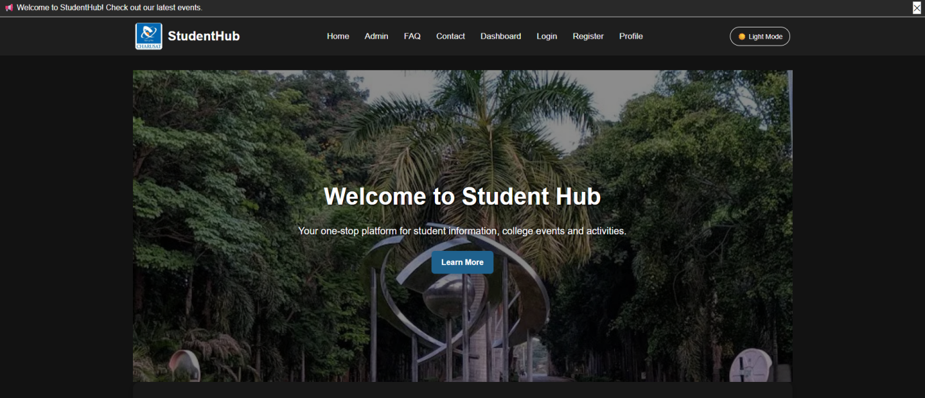

2.Light view:
When you click on the Sun icon, the page will switch to dark mode.
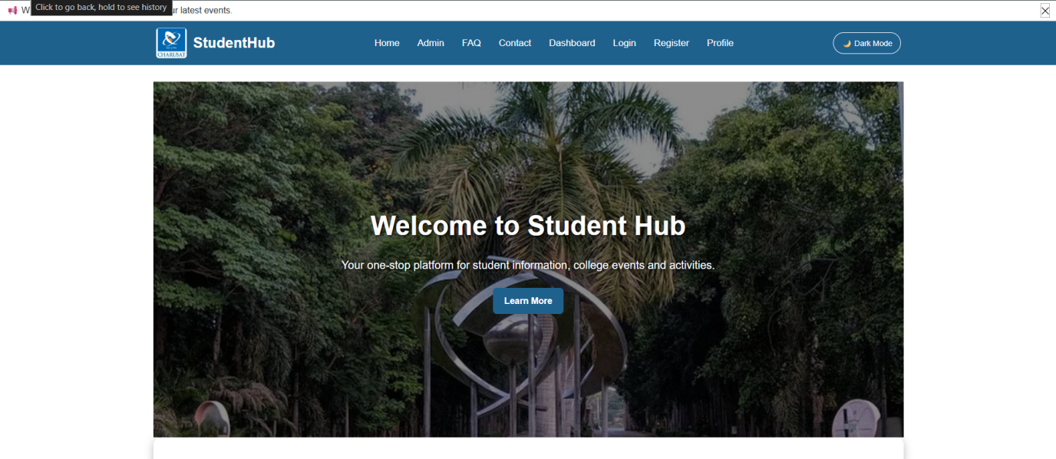

Key Questions / Analysis/ Interpretation:
- How are DOM elements selected and modified?
DOM elements are selected using JavaScript methods such as document.querySelector(), document.getElementById(), or document.querySelectorAll(). For example, the moon icon can be selected using document.querySelector(".theme-toggle"). Once the element is selected, JavaScript can modify its appearance or behavior using properties.
- Are event listeners attached correctly?
Yes, event listeners should be attached to the appropriate interactive elements. For example, an event listener can be added to the moon icon using addEventListener("click", function() { ... }). When the user clicks the icon, the function executes and changes the page from light mode to dark mode or vice versa.
- Is localStorage used for remembering theme choice?
Yes, localStorage can be used to remember the user's preferred theme. When the user selects dark mode, JavaScript can save the choice using localStorage.setItem(). When the page is loaded again, the saved value can be retrieved using localStorage.getItem(). If the saved preference is "dark", the dark-mode class can automatically be applied to the page.
- Does interactivity improve usability without breaking accessibility?
Yes. The dark-mode toggle improves usability by allowing users to choose an appearance that is more comfortable for them, especially in low-light environments. However, the toggle should also be designed with accessibility in mind. The moon icon should preferably be a real <button> element so that it can be operated using both a mouse and a keyboard. It should also have a meaningful accessible name, such as aria-label="Toggle dark mode".

Conclusion/ Learning Outcome:
In conclusion, Dynamic UI components were successfully added to the StudentHub project using JavaScript, including a collapsible FAQ, modal popup, image slider, notification banner, hamburger menu, and light/dark theme switcher. These features improve interactivity, accessibility, and the overall user experience of the website.

