PRACTICAL:5
AIM: Create a student registration form with HTML5 input types and JavaScript validation for name, email, mobile number, password, confirm password, course, year, gender, and terms acceptance. Use Regular Expression for validations.
INPUT:
Register.html
<!DOCTYPE html>
<html lang="en">
<head>
<meta charset="UTF-8">
<meta name="viewport" content="width=device-width, initial-scale=1.0">
<title>StudentHub - Register</title>
<link rel="stylesheet" href="../CSS/register.css">
</head>
<body>
<header>
<nav class="navbar" aria-label="Main navigation">
<a href="index.html" class="logo-link">
<img src="../IMAGES/charusat_logo.jpg" alt="StudentHub Logo" class="logo-image">
<span class="logo-text">StudentHub</span>
</a>
<button id="menuButton" class="hamburger" type="button" aria-expanded="false" aria-label="Open navigation menu">
☰
</button>
<ul id="navigationMenu" class="navigation-menu">
<li><a href="index.html" aria-current="page">Home</a></li>
<li><a href="about.html" >About</a></li>
<li><a href="events.html" >Events</a></li>
<li><a href="faq.html" >FAQ</a></li>
<li><a href="contact.html" >Contact</a></li>
<li><a href="login.html" >Login</a></li>
<li><a href="register.html" >Register</a></li>
<li><a href="profile.html">Profile</a></li>
</ul>
</nav>
</header>
<main>
<section>
<h2>Create Student Account</h2>
<form id="registerForm">
<!-- Full Name -->
<label for="name">Full Name</label>
<input type="text" id="name" name="name" placeholder="Enter full name">
<!-- Email -->
<label for="email">Email Address</label>
<input type="email" id="email" name="email" placeholder="Enter email address">
<!-- Student ID -->
<label for="studentid">Student ID</label>
<input type="text" id="studentid" name="studentid" placeholder="Enter studentID">
<!-- Mobile Number -->
<label for="number">Mobile Number</label>
<input
type="tel"
id="number"
name="number"
placeholder="Enter 10-digit mobile number"
maxlength="10"
>
<!-- Course -->
<label for="course">Course</label>
<select id="course" name="course">
<option value="">Select Course</option>
<option value="it">Information Technology</option>
<option value="cs">Computer Science</option>
<option value="ce">Computer Engineering</option>
</select>
<!-- Password -->
<label for="password">Password</label>
<input
type="password"
id="password"
name="password"
placeholder="Enter password"
>
<!-- Recheck Password -->
<label for="recheckPassword">Recheck Password</label>
<input
type="password"
id="recheckPassword"
name="recheckPassword"
placeholder="Re-enter password"
>
<!-- Submit Button -->
<button type="submit">Register</button>
</form>
</section>
</main>
<footer>
<p>&copy; 2026 StudentHub</p>
</footer>
<script src="../JS/register.js"></script>
</body>
</html>

Register.css
/* Register Page CSS */
* {
box-sizing: border-box;
}
body {
font-family: Arial, Helvetica, sans-serif;
background: #f4f7fb;
color: #222;
line-height: 1.6;
min-height: 100vh;
margin: 0;
}
header {
background: #1f618d;
color: #fff;
position: sticky;
top: 0;
z-index: 1000;
}
.navbar {
max-width: 1400px;
margin: auto;
padding: 0px 30px;
display: flex;
align-items: center;
justify-content: space-between;
gap: 20px;
background: transparent;
}
.logo-link {
display: flex;
align-items: center;
gap: 12px;

color: #fff;
text-decoration: none;
}
.logo-image {
width: 55px;
height: 55px;
object-fit: contain;
background: #fff;
border-radius: 6px;
}
.logo-text {
font-size: 26px;
font-weight: bold;
}
.navigation-menu {
list-style: none;
display: flex;
align-items: center;
gap: 4px;
}
.navigation-menu li {
list-style: none;
}
.navigation-menu a {
display: block;
color: #fff;
text-decoration: none;
padding: 10px 14px;
border-radius: 7px;
font-size: 17px;
}
.navigation-menu a:hover{
background: #2574a9;
}
.theme-button {
background: #fff;
color: #1f618d;
border: none;
padding: 10px 15px;
border-radius: 7px;
cursor: pointer;
font-size: 15px;
font-weight: bold;
}
.hamburger {
display: none;
background: none;
border: none;
color: #fff;
font-size: 28px;
cursor: pointer;
}
/* Skip Link */
.skip-link {
position: absolute;
left: -999px;
}
.skip-link:focus {
left: 10px;
top: 10px;
background-color: #000;
color: white;
padding: 10px;
}
form {
display: flex;
flex-direction: column;
}
label {
margin-top: 15px;
margin-bottom: 6px;
font-weight: bold;
}
input,
select {
width: 100%;
padding: 12px;
border: 1px solid #aaa;
border-radius: 5px;
font-size: 16px;
}
button {
margin-top: 25px;
padding: 12px;
background-color: #1f618d;
color: white;
border: none;
border-radius: 5px;
font-size: 16px;
cursor: pointer;
}
button:hover {
background-color: #10364d;
}
footer {
background-color: #1f618d;
color: white;
text-align: center;
padding: 15px;
}
@media (max-width: 600px) {
nav ul {
flex-direction: column;
}
nav a {
text-align: center;
}
main {
margin: 10px;
padding: 10px;
}
}
main {
max-width: 650px;
margin: 30px auto;
padding: 20px;
}
section {
background-color: white;
padding: 30px;
border-radius: 8px;
box-shadow: 0 4px 15px rgba(0, 0, 0, 0.2);
}
section h2 {
text-align: center;
color: #1f618d;
}

OUTPUT:
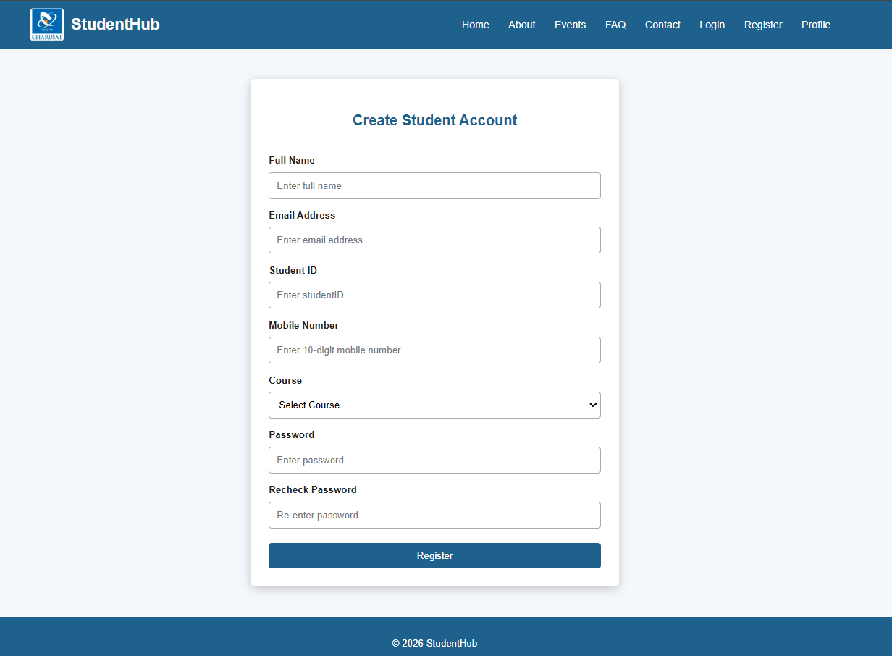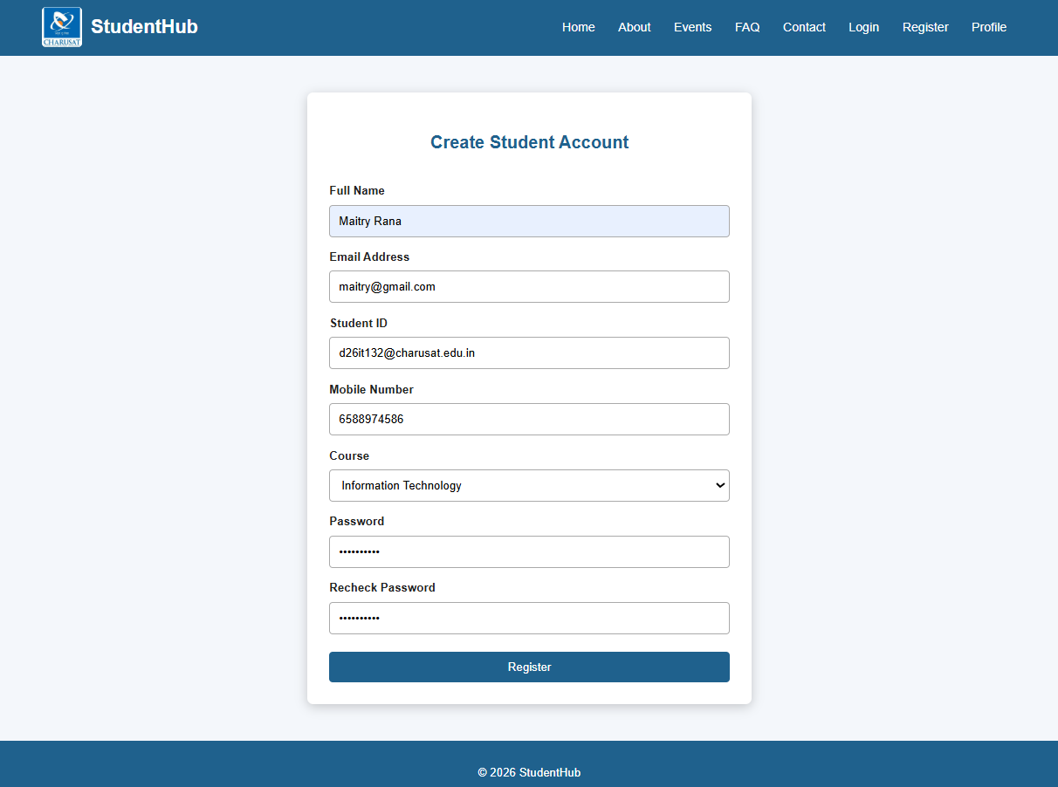
Key Questions / Analysis / Interpretation:
- Are correct input types and attributes used?
Yes, the form should use appropriate HTML input types and attributes for each field. For example, type="email" should be used for email addresses, type="password" for passwords, and type="text" for names or usernames. Attributes such as required, placeholder, minlength, maxlength, and autocomplete can also be used where appropriate.
- Are validation errors displayed near the relevant fields?
Yes, validation errors should be displayed close to the field where the problem occurs. For example, if the email address is invalid, an error message such as “Please enter a valid email address” should appear directly below or beside the email input. This makes it easy for users to understand what needs to be corrected.
- Is password strength checked?
Yes, password strength should be checked to encourage users to create secure passwords. The validation can check requirements such as minimum length, uppercase and lowercase letters, numbers, and special characters. A password-strength indicator can also provide immediate feedback, such as Weak, Medium, or Strong.
- Is the form accessible using keyboard and screen-reader-friendly labels?
Yes, the form should be designed so that users can navigate and complete it using only the keyboard. Each input should have a properly associated <label> so that screen readers can identify what information is required. Keyboard focus should also be clearly visible, and the fields should follow a logical tab order. Validation messages should be accessible to screen readers as well.
Conclusion/Learning Outcome:
Overall, a well-designed form should combine proper input types, clear validation, password-strength checking, and accessibility features. These practices make the form easier to understand, safer to use, and accessible to a wider range of users.

