PRACTICAL:6

AIM:Display event lists, student profiles, notices, or FAQs from external JSON files using Fetch API. Implement dynamic rendering, search, filter, sorting, and pagination.
INPUT:
Events.json

[
{
"title": "AI and Machine Learning Workshop",
"category": "Workshop",
"description": "Discover artificial intelligence concepts and explore real-world machine learning applications.",
"date": "20 November 2026",
"venue": "Seminar Hall"
},
{
"title": "Project Exhibition",
"category": "Innovation",
"description": "Present creative projects, demonstrate your ideas, and learn from other student innovators.",
"date": "23 November 2026",
"venue": "Innovation Centre"
},
{
"title": "Sports Day",
"category": "Sports",
"description": "Participate in athletic activities and cheer for your friends in exciting sports competitions.",
"date": "25 October 2026",
"venue": "College Ground"
},
{
"title": "Badminton Championship",
"category": "Sports",
"description": "Show your speed, focus, and teamwork in the campus badminton championship.",
"date": "28 November 2026",
"venue": "Indoor Sports Hall"
},
{
"title": "Cultural Festival",
"category": "Cultural",
"description": "Celebrate student talent through music, dance, drama, and creative performances.",
"date": "5 November 2026",
"venue": "College Campus"
},
{
"title": "Dance and Music Night",
"category": "Cultural",
"description": "Enjoy energetic dance performances, live music, and entertainment by student artists.",
"date": "30 November 2026",
"venue": "Main Auditorium"
},
{
"title": "Photography Competition",
"category": "Creativity",
"description": "Capture memorable campus moments and express your creativity through photography.",
"date": "2 December 2026",
"venue": "College Campus"
},
{
"title": "Career Guidance Seminar",
"category": "Career",
"description": "Explore career opportunities, industry trends, and useful strategies for professional growth.",
"date": "4 December 2026",
"venue": "Seminar Hall"
},
{
"title": "Mock Interview Session",
"category": "Career",
"description": "Practice interview questions and improve your communication and confidence.",
"date": "9 December 2026",
"venue": "Placement Cell"
},
{
"title": "Green Campus Drive",
"category": "Social",
"description": "Join fellow students in planting trees and promoting environmental awareness.",
"date": "12 December 2026",
"venue": "College Campus"
},
{
"title": "Student Club Meetup",
"category": "Student Life",
"description": "Meet club members, discover new interests, and participate in collaborative activities.",
"date": "14 December 2026",
"venue": "Student Activity Centre"
},
{
"title": "Startup Idea Challenge",
"category": "Innovation",
"description": "Share your business ideas, develop creative solutions, and learn about entrepreneurship.",
"date": "16 December 2026",
"venue": "Conference Room"
}
]

faq.json

{
"faqs": [
{
"id": 1,
"question": "How can I register?",
"answer": "Open the Register page and fill in the required information.",
"category": "Account"
},
{
"id": 2,
"question": "How can I log in to StudentHub?",
"answer": "Open the Login page and enter your registered email address and password.",
"category": "Account"
},
{
"id": 3,
"question": "How can I update my profile?",
"answer": "Open the Profile page to view your student information.",
"category": "Account"
},
{
"id": 4,
"question": "What can I access from the student dashboard?",
"answer": "The dashboard provides an overview of pending assignments, upcoming events, and student achievements.",
"category": "Dashboard"
},
{
"id": 5,
"question": "How can I view upcoming college events?",
"answer": "Open the Events page to view upcoming technical, cultural, and sports events.",
"category": "Events"
},
{
"id": 6,
"question": "How can I check my pending assignments?",
"answer": "Visit the Assignments section to view assignment details, deadlines, and completion status.",
"category": "Assignments"
},
{
"id": 7,
"question": "How can I contact StudentHub support?",
"answer": "Visit the Contact page and submit the form with your name, email address, and message.",
"category": "Support"
},
{
"id": 8,
"question": "What should I do if I forget my password?",
"answer": "Use the password recovery option if available. Otherwise, contact the website administrator.",
"category": "Account"
},
{
"id": 9,
"question": "Is StudentHub accessible on mobile devices?",
"answer": "StudentHub supports mobile devices when its responsive layout is implemented correctly.",
"category": "General"
},
{
"id": 10,
"question": "Can I participate in college events?",
"answer": "Check the Events page for details and follow the registration instructions for each event.",
"category": "Events"
},
{
"id": 11,
"question": "Why is my student information not displayed?",
"answer": "Check your information. If the problem continues, contact the website administrator.",
"category": "Support"
},
{
"id": 12,
"question": "What is the purpose of StudentHub?",
"answer": "StudentHub provides a centralized platform for student information, academic resources, college events, and achievements.",
"category": "General"
}
]
}

OUTPUT:
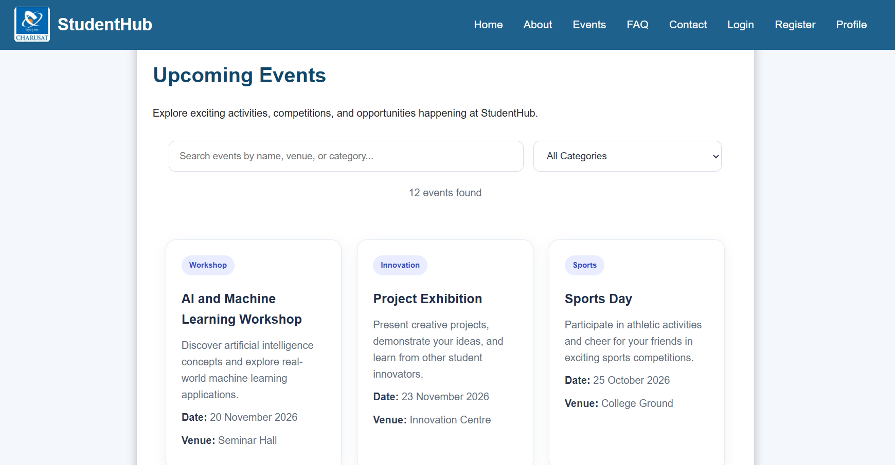
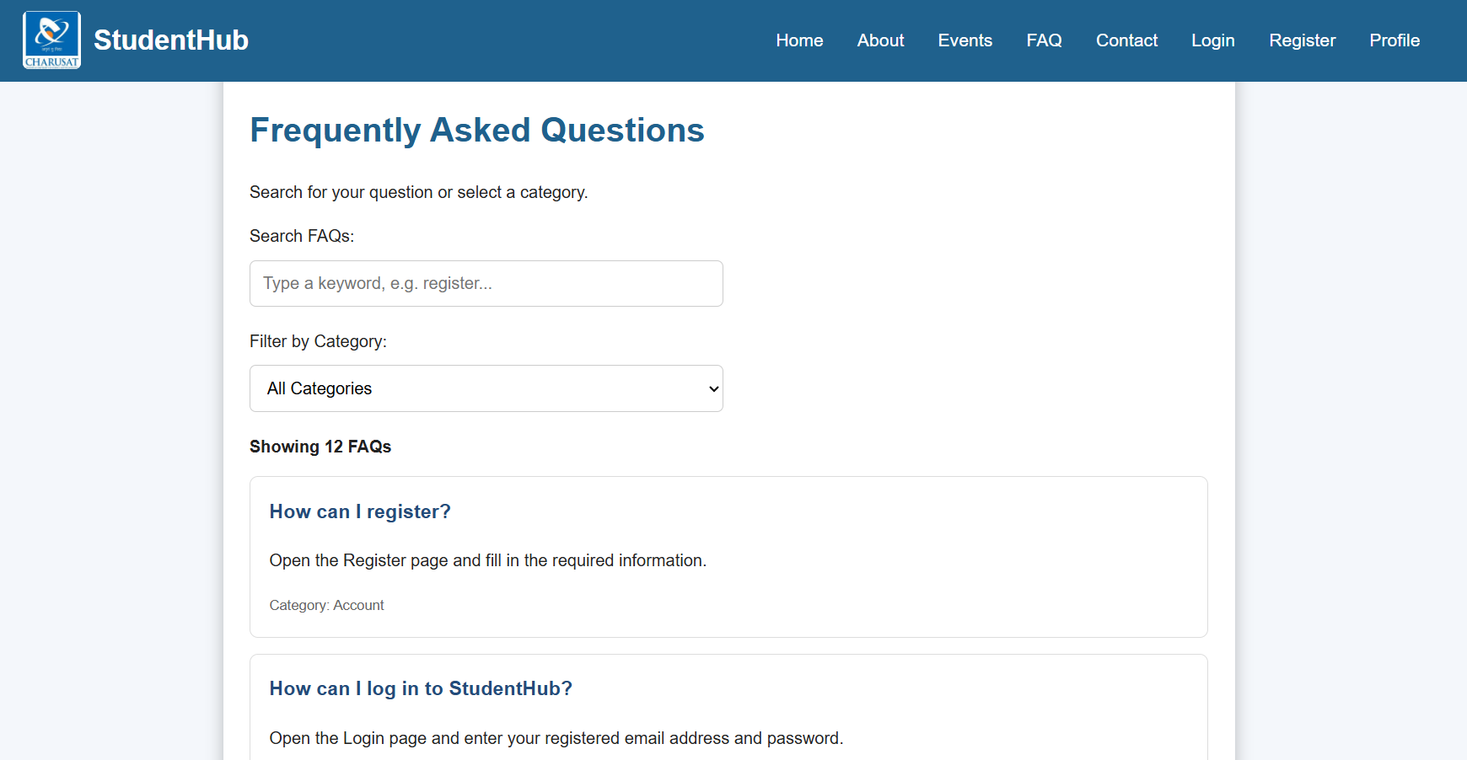

Key Questions / Analysis / Interpretation:

1. How is JSON fetched, parsed, and rendered?
JSON data is fetched from an API or a local JSON file using JavaScript's fetch() method. The response is converted into a JavaScript object using .json() and displayed dynamically on the webpage using DOM manipulation.

2. Which array methods are used for search, filter, sort, and pagination?
Search: includes() or find()
Filter: filter()
Sort: sort()
Pagination: slice()
These methods help display relevant data, organize records, and show a limited number of items per page.

3. How are loading and error states handled?
A loading message or spinner is displayed while data is being fetched. The try...catch block handles errors, and finally can hide the loading indicator after the operation finishes. The response.ok property is checked to detect HTTP errors.

4. How is modularity maintained in JavaScript files?
Modularity is maintained by dividing code into separate files based on functionality, such as data fetching, search, filtering, and UI rendering. JavaScript export and import statements allow functions and variables to be reused across files, making the code easier to maintain and debug.

Conclusion:
JSON handling, array methods, loading and error management, and JavaScript modules help make the StudentHub project dynamic, efficient, and maintainable. These techniques improve data presentation, code organization, and the overall user experience.

