PRACTICAL:7
AIM: Process submitted registration/contact form data using PHP. Validate and sanitize inputs on the server side and store records in CSV or JSON file format. Display success/error messages.
INPUT:
process_register.php
<?php

ini_set('display_errors', 1);
ini_set('display_startup_errors', 1);
error_reporting(E_ALL);
// ========================================
// Practical 7 - PHP Form Processing
// StudentHub Registration
// ========================================
// ========================================
// 1. Check POST Request
// ========================================
if ($_SERVER["REQUEST_METHOD"] !== "POST") {
die("Invalid request.");
}
// ========================================
// 2. Get Form Data
// ========================================
$name = trim($_POST["studentName"] ?? "");
$email = trim($_POST["email"] ?? "");
$mobile = trim($_POST["mobile"] ?? "");
$password = $_POST["password"] ?? "";
$confirmPassword = $_POST["confirmPassword"] ?? "";
$course = trim($_POST["course"] ?? "");
$year = trim($_POST["year"] ?? "");
$gender = trim($_POST["gender"] ?? "");
$terms = isset($_POST["terms"]);
// ========================================
// 3. Server-Side Validation
// ========================================
$errors = array();
// Name
if ($name === "") {
$errors[] = "Name is required.";
}
elseif (!preg_match("/^[A-Za-z ]+$/", $name)) {
$errors[] = "Name should contain letters and spaces only.";
}
// Email
if ($email === "") {
$errors[] = "Email is required.";
}
elseif (!filter_var($email, FILTER_VALIDATE_EMAIL)) {
$errors[] = "Please enter a valid email address.";
}
// Mobile
if ($mobile === "") {
$errors[] = "Mobile number is required.";
}
elseif (!preg_match("/^[6-9][0-9]{9}$/", $mobile)) {
$errors[] = "Please enter a valid 10-digit mobile number.";
}
// Password
if ($password === "") {
$errors[] = "Password is required.";
}
elseif (
strlen($password) < 8 ||
!preg_match("/[A-Z]/", $password) ||
!preg_match("/[a-z]/", $password) ||
!preg_match("/[0-9]/", $password) ||
!preg_match("/[@$!%*?&]/", $password)
) {
$errors[] =
"Password must contain at least 8 characters, " .
"one uppercase letter, one lowercase letter, " .
"one number and one special character.";
}
// Confirm Password
if ($confirmPassword === "") {
$errors[] = "Please confirm your password.";
}
elseif ($password !== $confirmPassword) {
$errors[] = "Passwords do not match.";
}
// Cours
if ($course === "") {
$errors[] = "Please select your course.";
}
// Yea
if ($year === "") {
$errors[] = "Please select your year.";
}
// Gender
if ($gender === "") {
$errors[] = "Please select your gender.";
}
// Ter
if (!$terms) {
$errors[] =
"You must accept the Terms and Conditions.";
}
// ======================================
// 4. Display Errors
// ========================================
if (count($errors) > 0) {
echo "<h2>Registration Failed</h2>";
echo "<ul>";
foreach ($errors as $error) {
echo "<li>" . htmlspecialchars($error) . "</li>";
}
echo "</ul>";
echo "<a href='../PAGE/register.html'>Go Back</a>";
exit;
}
// ========================================
// 5. Sanitize Data
// ========================================
$name = htmlspecialchars($name, ENT_QUOTES, "UTF-8");
$email = htmlspecialchars($email, ENT_QUOTES, "UTF-8");
$mobile = htmlspecialchars($mobile, ENT_QUOTES, "UTF-8");
$course = htmlspecialchars($course, ENT_QUOTES, "UTF-8");
$year = htmlspecialchars($year, ENT_QUOTES, "UTF-8");
$gender = htmlspecialchars($gender, ENT_QUOTES, "UTF-8");
// ========================================
// 6. Hash Password
// ========================================
$hashedPassword = password_hash(
$password,
PASSWORD_DEFAULT
);
// ========================================
// 7. Prepare CSV File
// ========================================
// Get the StudentHub project folder
$projectFolder = dirname(__DIR__);
// Set the correct data folder path
$dataFolder = $projectFolder . DIRECTORY_SEPARATOR . "data";
// Set the CSV file path
$csvFile = $dataFolder . DIRECTORY_SEPARATOR . "registrations.csv";
// Check if data folder exists
if (!is_dir($dataFolder)) {
die("Data folder not found at: " . $dataFolder);
}
// Create CSV header if file does not exist
if (!file_exists($csvFile)) {
$file = fopen($csvFile, "w");
if ($file === false) {
die("Error: Cannot create registrations.csv");
}
fputcsv(
$file,
array(
"Name",
"Email",
"Mobile",
"Password",
"Course",
"Year",
"Gender"
)
);
fclose($file);
}
// ========================================
// 8. Store Registration
// ========================================
$file = fopen($csvFile, "a");
if ($file === false) {
die("Unable to open registration storage file.");
}
fputcsv(
$file,
array(
$name,
$email,
$mobile,
$hashedPassword,
$course,
$year,
$gender
)
);
fclose($file);
// ========================================
// 9. Success Message
// ========================================
echo "<h2>Registration Successful!</h2>";
echo "<p>Your registration has been submitted successfully.</p>";
echo "<p>Your information has been stored safely.</p>";
echo "<a href='../PAGE/register.html'>Back to Registration</a>";
?>

OUTPUT:
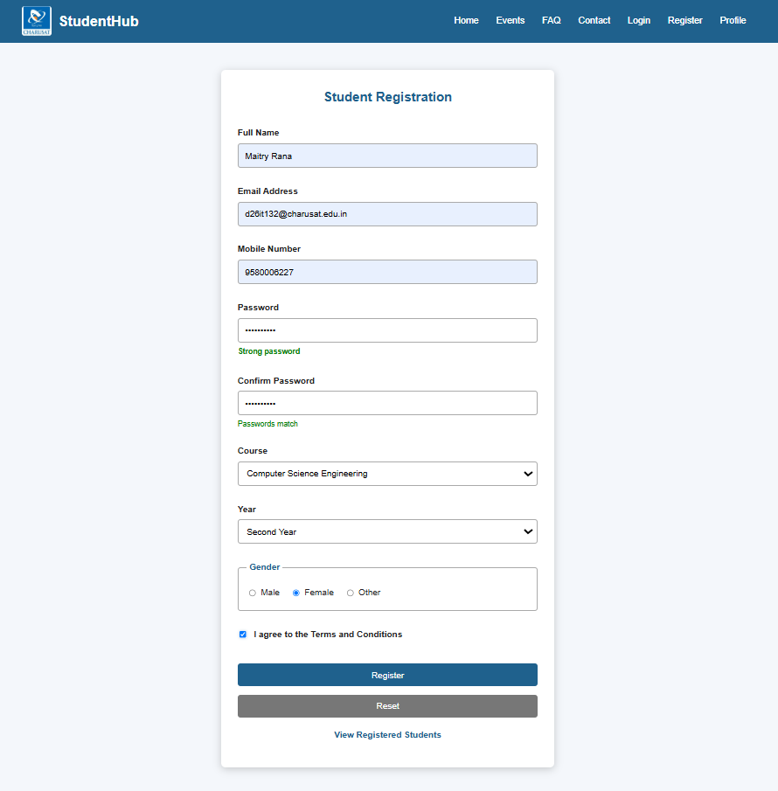
If you click on the create account button the you get this page and the data automatically added in the csv file:

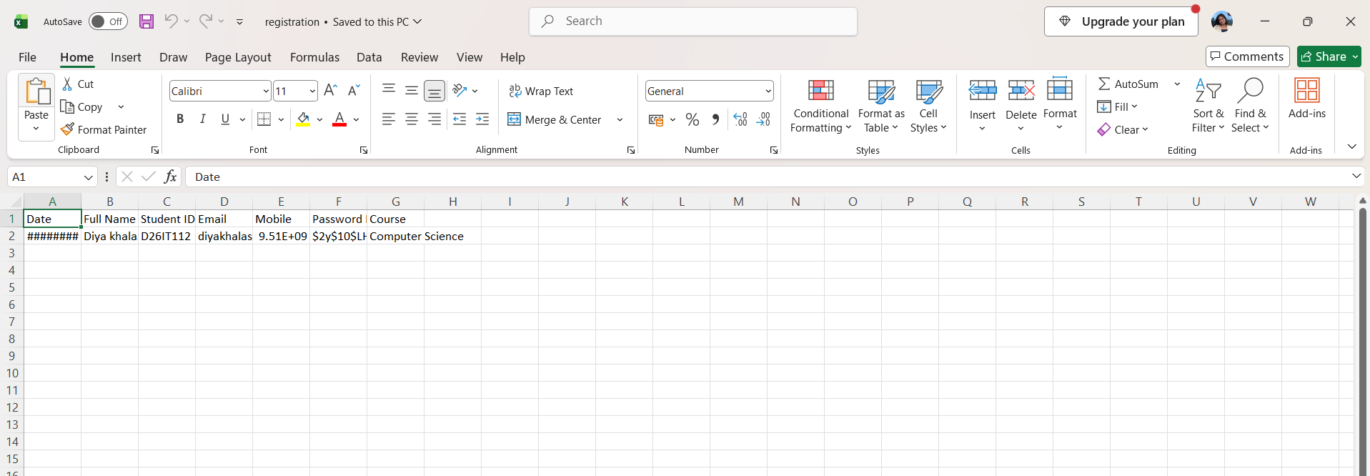
Key Questions / Analysis/ Interpretation
1. Is the form submitted using POST?
Yes. register.html has method="post", and register.php sends the user back to the form if the request is not POST. Passwords never appear in the URL.
2. Are inputs validated and sanitized server side?
Mostly yes, with a few gaps.
Done:
- Empty fields are rejected.
- Email is checked with filter_var.
- Mobile must be exactly 10 digits.
- Password must be 6+ characters and match the confirm box.
- The course is looked up in the database, so a fake course is rejected.
- SQL injection is blocked by prepared statements.
- Passwords are stored with password_hash.
- Duplicate email or Student ID is checked.
Gaps:
- Name and Student ID have no length or format limit.
- The Terms checkbox is only checked in the browser, not in PHP.
- The duplicate check can fail if two people submit at the same moment. Adding UNIQUE indexes in the database fixes that.
- Sanitizing for display (htmlspecialchars) is not needed yet because nothing is printed back. You will need it when you show student data on a page.
3. Is file writing handled safely?
The current version writes no files. It saves to MySQL, which is safer than the CSV version. The CSV version had flock locking and hashed passwords, but that code was replaced.
If you ever go back to CSV, two things matter:
- Keep the CSV outside htdocs, or anyone can download it from the browser.
- Values starting with =, +, - or @ can run as formulas when opened in Excel, so they need to be cleaned.

4. Are success and error responses displayed clearly?
This is the weakest part.
- Success: you go straight to the login page with no message, so the user doesn't know it worked.
- Errors: they show as plain unstyled text on a blank page with a "Go back" link.
- Database errors: there is no try/catch, so a failure could show a raw technical error.

Conclusion: The registration and contact forms were processed successfully using PHP with server-side input validation and sanitization. The submitted data was stored in CSV or JSON format, and appropriate success or error messages were displayed. This improves data handling, reliability, and security in the StudentHub project.

