PRACTICAL:8
AIM: Design the database for StudentHub with students, events and registrations. Create PHP database connection using MYSQL statements.
INPUT:
process_registration.php

<?php
require __DIR__ . "/db_connect.php";
if ($_SERVER["REQUEST_METHOD"] !== "POST") {
header("Location: ../pages/register.html");
exit;
}
$name = trim($_POST["name"] ?? "");
$email = trim($_POST["email"] ?? "");
$mobile = trim($_POST["mobile"] ?? "");
$course_id = $_POST["course_id"] ?? "";
$year = $_POST["year"] ?? "";
$gender = strtolower(trim($_POST["gender"] ?? ""));
$password = $_POST["password"] ?? "";
$confirmPassword = $_POST["confirmPassword"] ?? "";
$terms = isset($_POST["terms"]);
// Validate the form data
if (
$name === "" ||
!filter_var($email, FILTER_VALIDATE_EMAIL) ||
!preg_match('/^[0-9]{10}$/', $mobile) ||
!ctype_digit((string)$course_id) ||
!in_array((int)$course_id, [1, 2, 3], true) ||
!ctype_digit((string)$year) ||
(int)$year < 1 ||
(int)$year > 4 ||
!in_array($gender, ["male", "female", "other"], true) ||
!$terms
) {
exit("Invalid input. Please go back and check the form.");
}
try {
$sql = "INSERT INTO students
(name, email, mobile, course_id, year, gender)
VALUES
(:name, :email, :mobile, :course_id, :year, :gender)";
$stmt = $pdo->prepare($sql);
$stmt->execute([
":name" => $name,
":email" => $email,
":mobile" => $mobile,
":course_id" => (int)$course_id,
":year" => (int)$year,
":gender" => ucfirst($gender)
]);
echo "<h2>Registration Successful!</h2>";
echo "<p>Student data has been saved to MySQL.</p>";
echo "<br>";
echo '<a href="view_students_db.php">View Registered Students</a>';
} catch (PDOException $e) {
if ($e->getCode() === "23000") {
exit("Unable to register the student. Check the email, selected course, and database constraints.");
}
exit("Unable to save student data. Check your database table and column names.");
}
?>
view_register.php

<?php
require __DIR__ . "/db_connect.php";
$sql = "SELECT students.id,
students.name,
students.email,
students.mobile,
students.year,
students.gender,
courses.course_name
FROM students
LEFT JOIN courses
ON students.course_id = courses.course_id
ORDER BY students.id ASC";
$stmt = $pdo->query($sql);
$students = $stmt->fetchAll();
function h($value) {
return htmlspecialchars(
(string)$value,
ENT_QUOTES,
"UTF-8"
);
}
?>
<!DOCTYPE html>
<html lang="en">
<head>
<meta charset="UTF-8">
<meta name="viewport" content="width=device-width, initial-scale=1.0">
<title>Registered Students - StudentHub</title>
<style>
body {
font-family: Arial, sans-serif;
margin: 30px;
background: #f4f6f9;
}
h2 {
text-align: center;
color: #23395d;
}
.top-link {
display: inline-block;
margin-bottom: 20px;
text-decoration: none;
background: #23395d;
color: white;
padding: 10px 15px;
border-radius: 5px;
}
.table-container {
overflow-x: auto;
background: white;
padding: 15px;
border-radius: 8px;
}
table {
width: 100%;
border-collapse: collapse;
background: white;
}
th, td {
border: 1px solid #ccc;
padding: 10px;
text-align: left;
}
th {
background: #23395d;
color: white;
}
tr:nth-child(even) {
background: #f2f2f2;
}
.update-btn,
.delete-btn {
display: inline-block;
padding: 7px 10px;
border: none;
border-radius: 4px;
color: white;
text-decoration: none;
cursor: pointer;
font-size: 14px;
}
.update-btn {
background: #16803c;
}
.delete-btn {
background: #c62828;
}
.delete-form {
display: inline;
}
.empty-message {
text-align: center;
padding: 20px;
}
</style>
</head>
<body>
<h2>Registered Students</h2>
<p>
<a class="top-link" href="../page/register.html">
+ Register Another Student
</a>
</p>
<?php if (count($students) > 0): ?>
<div class="table-container">
<table>
<thead>
<tr>
<th>ID</th>
<th>Name</th>
<th>Email</th>
<th>Mobile</th>
<th>Course</th>
<th>Year</th>
<th>Gender</th>
<th>Actions</th>
</tr>
</thead>
<tbody>
<?php foreach ($students as $student): ?>
<tr>
<td><?= h($student["id"]) ?></td>
<td><?= h($student["name"]) ?></td>
<td><?= h($student["email"]) ?></td>
<td><?= h($student["mobile"]) ?></td>
<td><?= h($student["course_name"] ?? "Not assigned") ?></td>
<td><?= h($student["year"]) ?></td>
<td><?= h($student["gender"]) ?></td>
<td>
<a
class="update-btn"
href="update_student_db.php?id=<?= (int)$student["id"] ?>">
Update
</a>
<form
class="delete-form"
action="delete_student_db.php"
method="POST"
onsubmit="return confirm('Are you sure you want to delete this student?');">
<input
type="hidden"
name="id"
value="<?= (int)$student["id"] ?>">
<button
type="submit"
class="delete-btn">
Delete
</button>
</form>
</td>
</tr>
<?php endforeach; ?>
</tbody>
</table>
</div>
<?php else: ?>
<p class="empty-message">
No registered students found.
</p>
<?php endif; ?>
</body>
</html>
OUTPUT:
Students
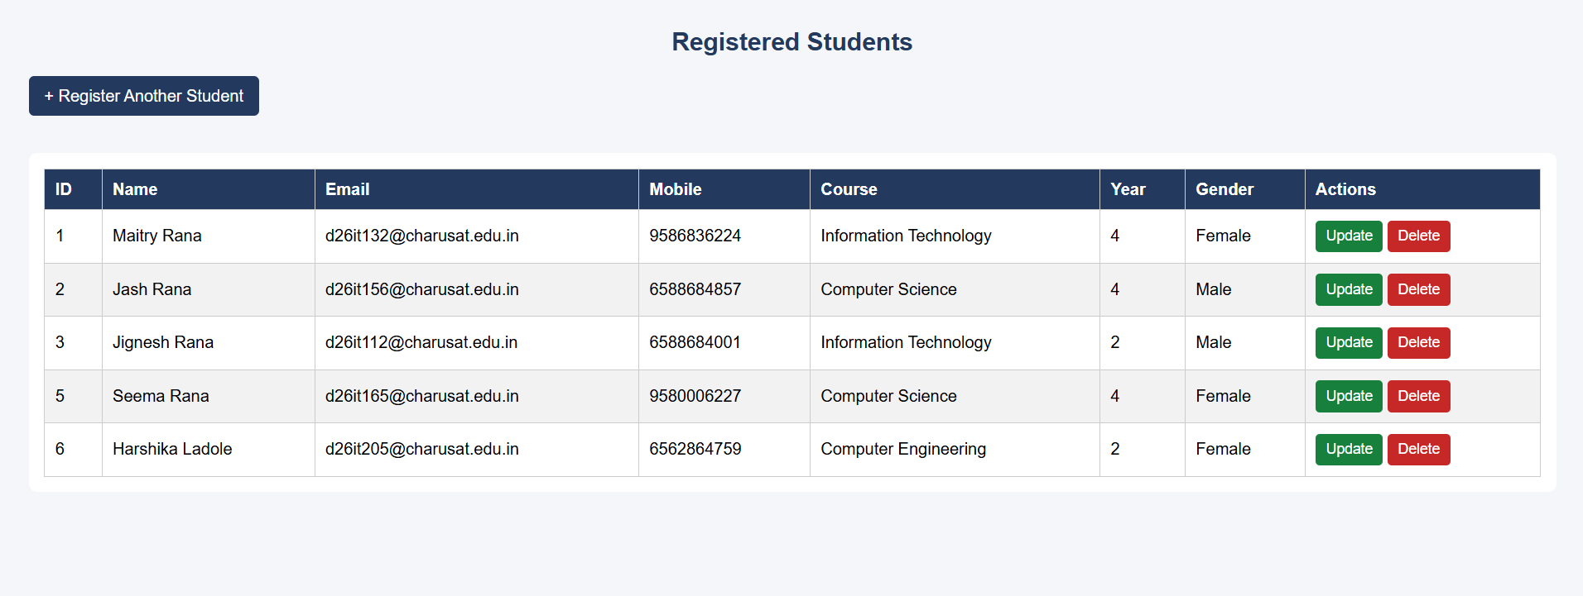
Key Questions / Analysis/ Interpretation:
1. Is the schema normalized properly?
Mostly yes. It is close to 3rd normal form.
- courses is a separate table, so course names are not repeated in every student row.
- students and events each hold only facts about themselves.
- registrations is a link table. One student can join many events and one event can have many students, and this table handles that many-to-many relationship.
2. Are primary keys and foreign keys correctly defined?
Yes.
Table | Primary key | Foreign keys
courses | course_id | none
students | student_id | course_id → courses
events | event_id | none
registrations | registration_id | student_id → students, event_id → events
- The tables use InnoDB, which is needed for foreign keys to work.
- UNIQUE (student_id, event_id) in registrations stops the same student joining the same event twice.
3. Is the database connection handled securely?
I can't fully say yet, because I haven't seen the code in db_connect.php. Sir provided it, and I only know these facts:
- Sir's PHP files use PDO with prepared statements, which protects against SQL injection. That part is good.
- The connection test shows it works.

