PRACTICAL:9

AIM: Implement secure user registration by inserting user details into MySQL using MYSQLi. Validate input on frontend and backend, check duplicate email/username, hash passwords using password_hash(), and display appropriate messages.

db_connect_mysqli.php
<?php
$host = "localhost";
$username = "root";
$password = "";
$dbname = "studenthub";
$conn = new mysqli(
$host,
$username,
$password,
$dbname
);
if ($conn->connect_error) {
die("Database connection failed.");
}
$conn->set_charset("utf8mb4");
?>

process_user_registration.php
<?php
require __DIR__ . "/db_connect_mysqli.php";
if ($_SERVER["REQUEST_METHOD"] !== "POST") {
exit("Please submit the registration form.");
}
// Get form data
$name = trim($_POST["name"] ?? "");
$email = trim($_POST["email"] ?? "");
$password = $_POST["password"] ?? "";
$confirmPassword = $_POST["confirmPassword"] ?? "";
// Server-side validation
if (
$name === "" ||
$email === "" ||
$password === "" ||
$confirmPassword === ""
) {
exit("All fields are required.");
}
if (strlen($name) > 100) {
exit("Name must not exceed 100 characters.");
}
if (!filter_var($email, FILTER_VALIDATE_EMAIL)) {
exit("Please enter a valid email address.");
}
if (strlen($email) > 255) {
exit("Email address is too long.");
}
if (strlen($password) < 6) {
exit("Password must contain at least 6 characters.");
}
if ($password !== $confirmPassword) {
exit("Passwords do not match.");
}
// Check whether the email already exists
$check_sql = "SELECT id FROM users WHERE email = ?";
$check_stmt = $conn->prepare($check_sql);
$check_stmt->bind_param("s", $email);
$check_stmt->execute();
$check_stmt->store_result();
if ($check_stmt->num_rows > 0) {
$check_stmt->close();
$conn->close();
exit("This email is already registered.");
}
$check_stmt->close();
// Hash the password before saving
$hashed_password = password_hash(
$password,
PASSWORD_DEFAULT
);
// Insert the user using a prepared statement
$sql = "INSERT INTO users (name, email, password)
VALUES (?, ?, ?)";
$stmt = $conn->prepare($sql);
$stmt->bind_param(
"sss",
$name,
$email,
$hashed_password
);
if ($stmt->execute()) {
echo "<h2>Registration Successful!</h2>";
echo "<p>User registered securely using MySQLi.</p>";
echo '<a href="../pages/register_user.html">
Register Another User</a>';
} else {
// Error code 1062 means a duplicate-key violation
if ($stmt->errno == 1062) {
echo "This email is already registered.";
} else {
echo "Registration failed. Please try again.";
}
}
$stmt->close();
$conn->close();
?>

OUTPUT:
Frontend
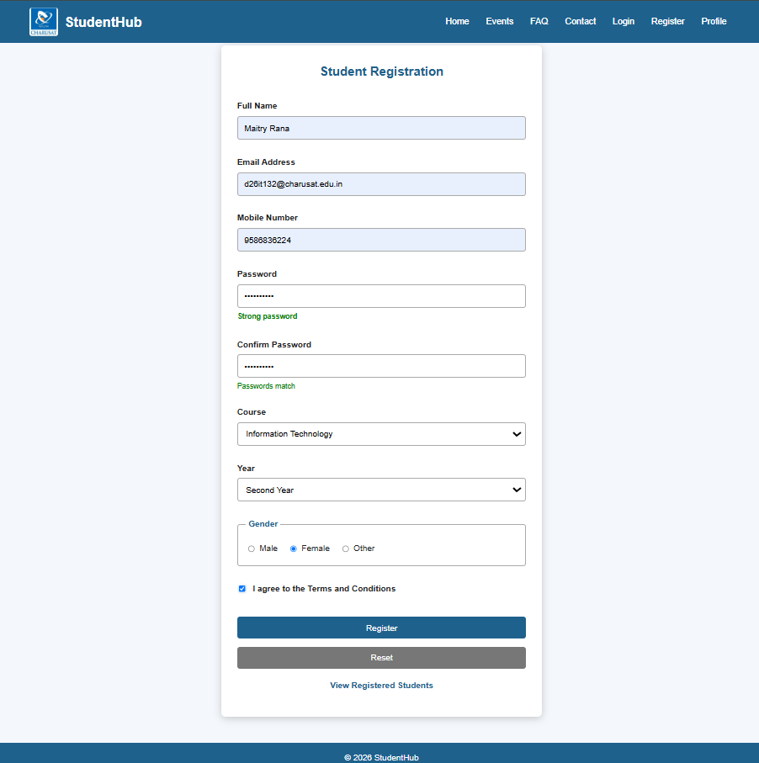

Backend
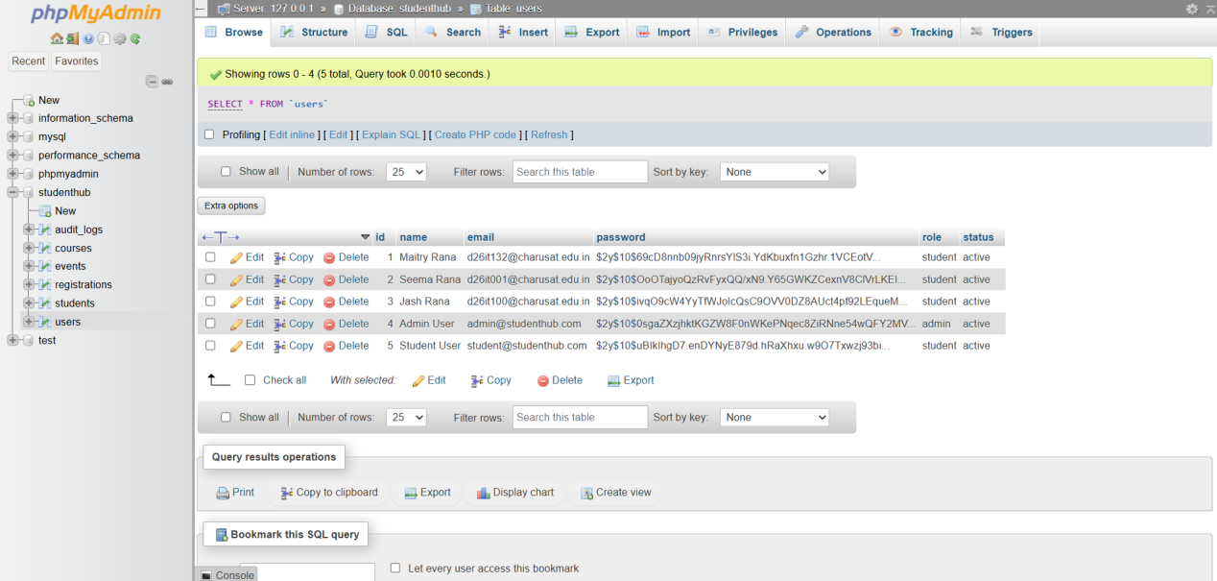

As you can see above, in table the password is stored in hash value by applying hash( ).

Key Questions / Analysis/ Interpretation:

1. Is password_hash() used before storing passwords?
Yes, password_hash() should be used to securely hash passwords before storing them in a file or database. Passwords should never be stored as plain text.

2. Is duplicate email/username checked?
Yes, the system should check whether an email address or username already exists before registering a new user. If a duplicate is found, an appropriate error message should be displayed.

3. Are frontend and backend validations consistent?
Yes, frontend validation using HTML5 and JavaScript should match backend validation using PHP. However, backend validation is essential because frontend checks can be bypassed.

Conclusion: Proper password hashing, duplicate checking, and consistent validation improve the security and reliability of the StudentHub registration system and help protect user information.

