SwISTrack 2.2.0

SwISTrack has been enhanced since the last official release (2.0.1) by the possibility to count the number of objects in user specified regions of interest (ROI). ROI can have arbitrary shape and number, and can be conveniently supplied by a b/w image.


Figure 1: With a mask image, an arbitrary number of ROIs can be supplied to SwISTrack

During tracking, the ROIs are highlighted and the number of objects currently within the ROI are displayed.

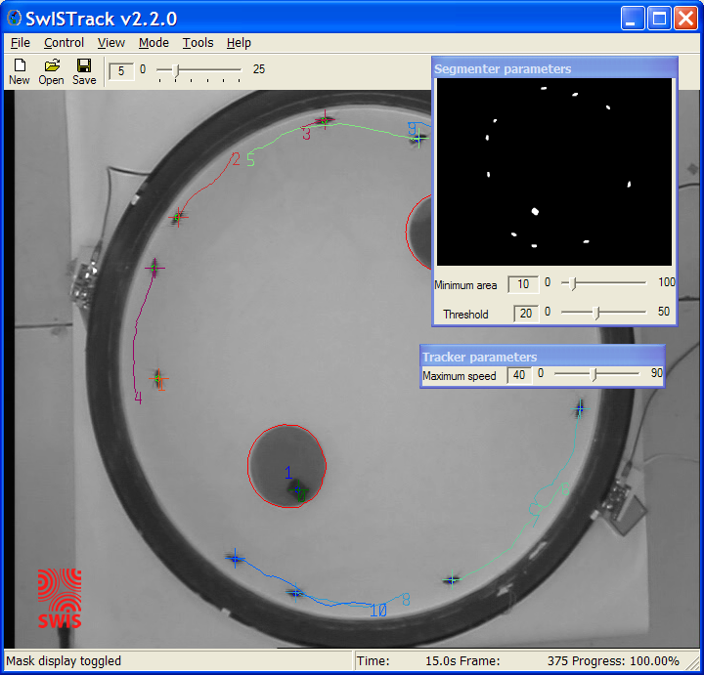
Figure 2: The ROIs as specified in Fig. 1 are highlighted by a red circle, while the number of objects is displayed in the center

Additional features of SwISTrack 2.2.0 are
- Coverage Visualization added (only for demo purposes) [v2.1.1]
- IEEE1394 Cameras (Firewire) are now directly supported for real-time tracking (requires the CMU 1394 camera driver) [v2.1.0]
- Background can be estimated from the video itself (only for demo purposes) [v2.1.0]
- the possibility to export video data with overlaid trajectory data with frame rate reduced up to 1Hz (a 180min experiment at 30Hz can be stored as a 6min video) [v2.0.1].

Identified problems and future work
- Improvement of multi-target tracking (enhanced data-association)
- Enhanced error handling inside SwISTrack allowing for faster error reporting, debugging and bugfixing

