# Assignment

This first assignment will be described in multiple parts: a) loading data, b) mean and median steps taken daily, c) average daily activity pattern, d) imputation of missing values, and e) differences in activity pattern between weekends and weekdays.

## Loading Data

Source Dataset: activity.csv (2/11/2014 10:08AM)

[Activity monitoring data](https://d396qusa40orc.cloudfront.net/repdata%2Factivity.zip)

Three variables are included in the activity monitoring dataset: 1. **steps** taken in a 5-minute interval (missing values are coded as NA), 2. **date** on which a measurement was taken in YYYY-MM-DD format, and 3. **interval** in which a measurement was taken.

## Interpretation of Results

Descriptive statistics, means and medians, for non-missing daily steps (excluding missing values) and total daily steps (including missing values) are lower when 2,304 missing values are imputed as zeroes.

|  |  |  |
| --- | --- | --- |
| Number of Observations | Mean Daily Steps | Median Daily Steps |
| Non-missing 15,264 | 10,766 | 10,765 |
| Missing 2,304 |  |  |
| Total 17,568 | 9,354 | 10,400 |

Since 11,014 of the non-missing values equal zero, the total number of zero step counts is 13,318.

## List of Figures

Histograms for the mean number of steps taken daily allow graphical comparison of frequency distributions excluding and including (imputed) missing values.

Time series of mean number of steps taken per five-minute interval allow graphical comparison of time series for weekend

* Rplot1. Histogram of total number of steps taken daily excluding missing values
* Rplot2. Time series of mean number of steps taken per five-minute interval averaged over days,
* Rplot3. Histogram of total number of steps taken daily including imputed missing values,
* Rplot4. Multiple time series of mean number of steps taken per five-minute interval averaged over weekends or weekdays.

setwd("C:/Users/d2i2k/RepData_PeerAssessment1")  
ActivityData <- read.csv("activity.csv", header=TRUE)   
x <- tapply(ActivityData$steps,INDEX=ActivityData$date,FUN=sum,na.rm=TRUE)  
y <- subset(x, x>0)

**Rplot1. Histogram of total number of steps taken daily (excluding missing values)** 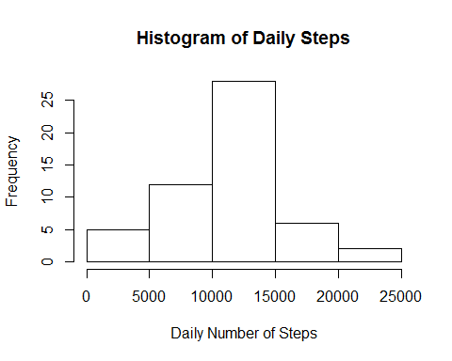

**Mean and median number of steps taken daily (excluding missing values)**

summary(y)

## Min. 1st Qu. Median Mean 3rd Qu. Max.   
## 41 8840 10800 10800 13300 21200

x <- tapply(ActivityData$interval,INDEX=ActivityData$interval,FUN=mean,na.rm=TRUE)  
y <- tapply(ActivityData$steps,INDEX=ActivityData$interval,FUN=mean,na.rm=TRUE)  
xy <- cbind(x,y)

**Rplot2. Time series of mean steps taken per five-minute interval averaged over days** 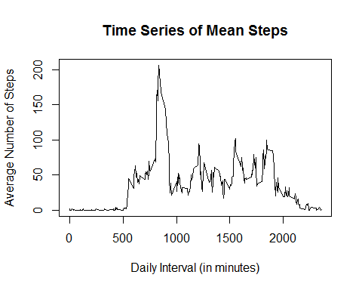

**Maximum number of steps taken per five-minute interval (peak activity equals 206 steps during the 104th five-minute interval @ 835 minutes)**

which.max(y)

## 835   
## 104

### Strategy for data imputation of missing values as zeroes

setwd("C:/Users/d2i2k/RepData_PeerAssessment1")  
ActivityData <- read.csv("activity.csv", header=TRUE)   
x <- is.na(ActivityData$steps)  
x.sub <- subset(x,x="TRUE")  
length(x.sub)

## [1] 2304

y <- ifelse(is.na(ActivityData$steps),0,ActivityData$steps)  
z <- data.frame(y,ActivityData$date)  
w <- tapply(z$y,INDEX=z$ActivityData.date,FUN=sum,na.rm=TRUE)

**Rplot3. Histogram of total number of steps taken daily (including imputed missing values)** 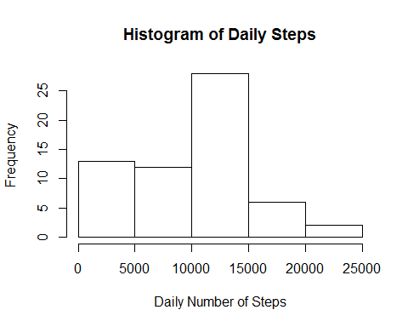

**Mean and median number of steps taken daily (including imputed missing values)**

summary(w)

## Min. 1st Qu. Median Mean 3rd Qu. Max.   
## 0 6780 10400 9350 12800 21200

### Repeat strategy for data imputation of missing values as zeroes

x <- ifelse(is.na(ActivityData$steps), 0, ActivityData$steps) # 17,568 row vector  
y <- ActivityData$interval # 17,568 row vector

### Factor variable for weekends (Sat-Sun) versus week days (Mon-Fri)

library(chron)  
w <- is.weekend(ActivityData$date) # 17,568 row vector  
xyw <- data.frame(x,y,w) # 17,568 row by 3 column array  
xyw1 <- subset(xyw,w=="TRUE") # 4,608 row by 3 column array for weekends  
x <- tapply(xyw1$x,INDEX=xyw1$y,FUN=mean,na.rm=TRUE) # 288 row vector of steps  
y <- tapply(xyw1$y,INDEX=xyw1$y,FUN=mean,na.rm=TRUE) # 288 row vector of intervals  
z <- vector(mode = "character",length=288) # 288 row vector of weekends  
 for (i in 1:288) {z[i] <- "Weekend"}  
xy1 <- cbind(as.data.frame(x),as.data.frame(y),as.data.frame(z)) # 288 row by 3 column array for weekends  
  
xyw2 <- subset(xyw,w=="FALSE") # 4,608 row by 3 column array for weekdays  
x <- tapply(xyw2$x,INDEX=xyw2$y,FUN=mean,na.rm=TRUE) # 288 row vector of steps  
y <- tapply(xyw2$y,INDEX=xyw2$y,FUN=mean,na.rm=TRUE) # 288 row vector of intervals  
z <- vector(mode = "character",length=288) # 288 row vector of weekdays  
 for (i in 1:288) {z[i] <- "Weekday"}  
xy2 <- cbind(as.data.frame(x),as.data.frame(y),as.data.frame(z)) # 288 row by 3 column array for weekdays  
  
xy <- rbind(xy1,xy2) # 576 row by 3 column array

**Rplot4. Multiple time series of mean steps taken per five-minute interval averaged over weekends or weekdays** 