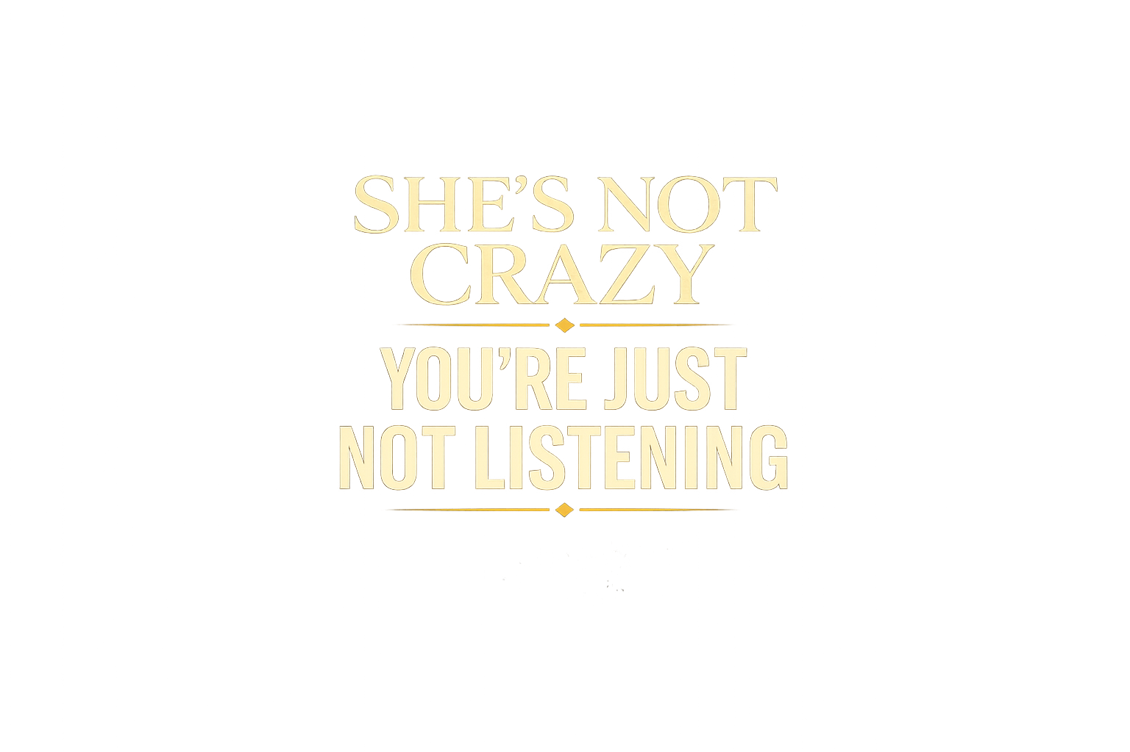
She’s Not Crazy, You’re Just Not Listening
A Practical Guide to Hearing Her, Repairing Conflict, and Rebuilding Connection
Austin D. Howell
First Edition
Part 1

Copyright
She’s Not Crazy, You’re Just Not Listening
A Practical Guide to Hearing Her, Repairing Conflict, and Rebuilding Connection
Copyright © 2026 Austin D. Howell. All rights reserved.
No part of this publication may be reproduced, distributed, stored in a retrieval system, or transmitted in any form or by any means, including electronic, mechanical, photocopying, recording, scanning, or otherwise, without the prior written permission of the copyright holder, except for brief quotations used in reviews, criticism, scholarship, or other uses permitted under applicable copyright law.
This book is provided for educational and informational purposes only. It is not intended as, and should not be relied upon as, therapy, mental health treatment, medical advice, diagnosis, treatment, legal advice, or financial advice. Reading this book does not create a therapist-client, doctor-patient, attorney-client, or fiduciary relationship of any kind.
The material in this book is designed to support reflection, communication, and relationship skill-building. It is not a substitute for qualified professional care. If you are experiencing abuse, coercion, threats, severe mental distress, self-harm risk, trauma symptoms, or an unsafe relationship environment, seek appropriate licensed or emergency support in your jurisdiction.
Some examples, dialogues, and scenarios in this book are fictionalised, composite, or adapted for clarity and privacy. Any resemblance to specific persons or events is coincidental or has been materially altered.
The author disclaims liability for any loss, harm, damage, or adverse outcome arising directly or indirectly from the use or application of the information contained in this book.
Author: Austin D. Howell
Title: She’s Not Crazy, You’re Just Not Listening
Subtitle: A Practical Guide to Hearing Her, Repairing Conflict, and Rebuilding Connection
Edition: First Edition
Publication Year: 2026

Dedication
For everyone who has ever tried to explain their hurt clearly and still felt unseen.
For the partners who are tired of repeating themselves, and for the partners who want to do better but were never taught how.
Table of Contents
Copyright 2
Dedication 3
Contents 5
Quick Start Guide 6
Introduction 9
Part I — Foundation 15
Chapter 1: The Language Beneath the Words — Understanding Emotional Intelligence 17
Chapter 2: Recognising and Regulating Your Emotions 33
Chapter 3: Active Listening — Hearing Beyond Words 48
Chapter 4: Establishing Healthy Boundaries 67
Chapter 5: Navigating Conflict Without Damage 84
Chapter 6: The Art of Apology and Repair 102
Chapter 7: Emotional Intimacy and Vulnerability 124
Chapter 8: Physical Intimacy and Connection 149
Chapter 9: Quality Time and Presence 169
Chapter 10: Your 8-Week Foundation Action Plan 192
Companion Resources 209
Resources and Further Support 210
Acknowledgements 211
About the Author 212

Quick Start Guide
If you do not want to read this book cover to cover before making changes, start here.
The goal is simple: interrupt the most damaging patterns first, create more safety, and establish a rhythm of better responses.

Your First 48 Hours

Step 1: Stop trying to solve everything at once
Choose one recurring pain point.
Examples:
- the same argument keeps repeating
- one of you feels unheard
- boundaries are vague and resentment is rising

Step 2: Name the pattern without blame
Use this formula:
When X happens, we usually end up in Y, and the result is Z.
Examples:
- When one of us brings up a complaint, the other explains too quickly, and we both end up more frustrated.
The purpose is description, not accusation.

Step 3: Pick one stabilising tool
Use one of these immediately:
- a 20-minute pause before continuing a heated conversation
- one daily 10-minute check-in without phones
- one boundary stated clearly and calmly
- one repair attempt after conflict
- one appreciation spoken aloud each day for seven days

Step 4: Use a script, not improvisation
Do not rely on emotional fluency in the exact moment you are most activated.
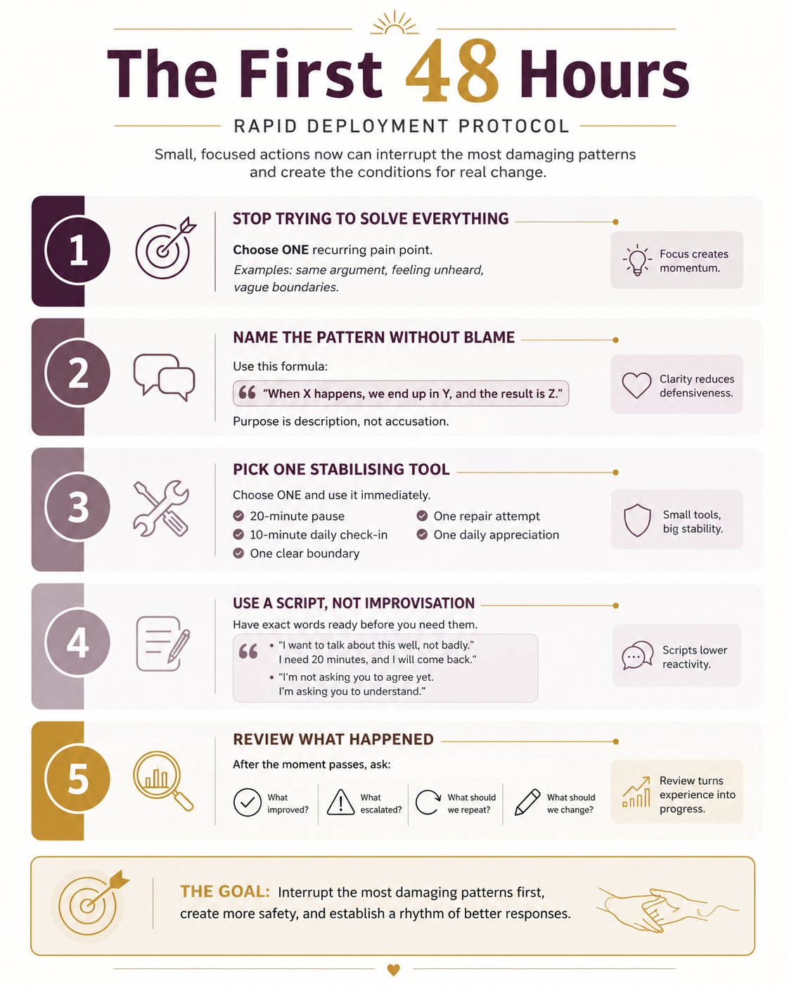
Figure: Your First 48 Hours at a Glance

“I want to talk about this well, not badly. I need 20 minutes, and I will come back.”
“I am not asking you to agree yet. I am asking you to understand what this felt like for me.”

Step 5: Review what happened
After the moment passes, ask:
- What improved?
- What escalated?
- What should we repeat?
- What should we change next time?

Best Starting Chapters by Problem
Problem | Start here
Conflict | Chapters 1, 3, 5, and 6
Distance | Chapters 1, 7, 8, and 9
Resentment | Chapters 2, 4, 5, and 6
Feeling unheard | Chapters 1, 2, 3, and 6

The Minimum Viable Rhythm
For two weeks, do this:
- one 10-minute daily check-in
- one weekly review conversation
- one repair attempt after conflict
- one appreciation each day
- no major conflict by text when avoidable
That alone can change a great deal.

Introduction

Why relationships can feel so hard, even when the love is real
You did not pick up this book because relationships are simple.
You picked it up because something in the connection has become difficult to ignore. Maybe you and your partner keep having the same argument in slightly different clothes. Maybe one of you feels unheard and the other feels chronically misunderstood. Maybe you love each other, but the relationship has become heavier than it used to be: more reactive, more distant, more effortful, less warm.
That experience is common. It is also deeply discouraging.
Many couples are not failing because they do not care. They are struggling because they were never given a practical language for emotional life together. They were taught how to work, perform, achieve, solve, endure, and stay busy. They were not taught how to recognise activation before it becomes escalation, how to listen without defending, how to repair after harm, how to ask clearly for what they need, or how to sustain warmth once the novelty of early love gives way to the ordinary pressures of adult life.
Love matters. But love, by itself, is not a communication system, a repair strategy, a boundary structure, a stress-regulation plan, or a shared operating rhythm. A relationship becomes stronger not when two people care in theory, but when one or both people develop the skills, habits, and language that allow care to be felt in practice.
That is what this book is for.

Who this book is for
This is a practical relationship playbook written primarily for the partner who has been told, in one form or another, you are not really listening.
In many heterosexual relationships, that reader will often be a man. The title reflects that reality directly. This book is therefore not positioned as a neutral, abstract overview of relationships in general. It is aimed at the partner being asked to grow emotionally, listen more accurately, repair more cleanly, and show up with greater steadiness, accountability, and care.
It is also for the partner who has been saying, in one form or another, “Something is not working, and I am tired of carrying it alone.”
That does not mean the material is useful only to men. Anyone who recognises themselves in these patterns can use it. But the centre of gravity is deliberate: this book is written toward the partner whose defensiveness, emotional distance, poor listening, weak repair, or inconsistent follow-through has been wearing the relationship down.
It is especially for readers who recognise one or more of the following:
- repeated fights without real resolution
- chronic defensiveness
- distance after conflict
- difficulty naming feelings or needs
- uneven emotional labour
- intimacy that feels inconsistent, pressured, or thin
- unclear boundaries with family, work, phones, money, or time
- a growing fear that the relationship is being worn down by ordinary life
And it is for the partner who has heard some version of, “You’re not really listening,” and wants to respond with more than guilt, argument, shutdown, or short-lived effort.
Some readers will arrive here feeling unseen. Others will arrive feeling blamed, confused, or overwhelmed by the emotional complexity of the relationship. Both experiences matter. Both can be addressed honestly. This book is written to reduce that distance without softening the need for accountability.

What “crazy” actually means in this book
The title uses the word crazy because many people have heard it, feared it, or used softer versions of it without naming what was really happening.
In this book, crazy is not a diagnosis. It is not a description of a partner’s worth, character, or mental health. It is treated as a low-resolution label: a blunt word people often reach for when they do not yet have the skill, patience, or emotional vocabulary to understand the signal being sent.
A low-resolution label collapses useful information.

Examples:
Low-resolution label | Higher-resolution read
“She’s crazy.” | “I do not understand the emotional signal yet.”
“She’s too emotional.” | “Her intensity is exceeding my current listening capacity.”
“She’s overreacting.” | “I have not understood why this matters so much to her.”
“She’s fine.” | “Her words say fine, but her body may be signalling shutdown.”
“She’s dramatic.” | “I stopped listening accurately and started judging the delivery.”
This distinction matters because labels end curiosity. Accurate listening reopens it.
The goal of this book is to help you move from low-resolution labels to high-resolution understanding: from dismissal to signal detection, from defensiveness to curiosity, and from vague blame to practical repair.

What this book is
This book is a training manual for becoming safer, clearer, and more trustworthy inside a relationship.
It is designed to help readers move from vague frustration to clear patterns, from recurring conflict to better repair, and from “we keep talking but nothing changes” to more grounded, repeatable progress. It treats relationship skill as something learnable rather than mystical. It assumes that many painful patterns improve once they are named accurately and practised differently.
The core premise is simple: most relational pain becomes easier to change once it becomes easier to name.
When you can identify what is actually happening, such as defensiveness, flooding, misattunement, avoidance, unclear boundaries, invisible labour, unresolved resentment, or mismatched support needs, you gain leverage. You stop treating every painful moment as a brand-new crisis and start recognising patterns that can be interrupted, understood, and replaced.
This book is built around practical transformation rather than abstract inspiration. It aims to help you:
- understand what keeps going wrong
- respond more skilfully when it does
- reduce preventable damage
- build a relationship that feels safer, clearer, warmer, and more resilient over time
This volume is Part I: Foundation. It builds the essential skills: emotional awareness, regulation, listening, boundaries, repair, intimacy, and presence. It also stands on its own as a complete and usable foundation for meaningful relational change.
Part II extends that work into the deeper pressures of long-term partnership, including support under strain, differences in values and needs, and the more complex patterns that emerge once the basics are no longer the main barrier.

What this book is not
This book is not therapy.
It is not a substitute for medical care, legal advice, crisis intervention, or qualified trauma treatment. It does not diagnose you, your partner, or your relationship. It does not assume that every relationship should be preserved at any cost. And it does not ask the more self-aware partner to carry the entire burden of change.
Where professional support is appropriate, this book should function as a bridge, not a replacement.
It is also not a book about winning arguments, controlling a partner, or becoming emotionally fluent for appearance alone. The goal is not to sound evolved. The goal is to become more trustworthy, more accurate, more regulated, and more capable of real partnership.
You and your partner may be coming to this book from different sides of the same pattern. One of you may be exhausted from not feeling heard. The other may be realising, perhaps too late, that care without skill is not enough.

If you are the partner who feels unheard
You may have spent a long time trying to explain what is missing.
You may have said that the issue is not only the dishes, the tone, the lateness, the screen time, the forgotten promise, or the argument itself. The issue is what those moments come to mean when they happen often enough: I am alone in this. I am not being taken seriously. I have to translate my pain into something simpler before it can even be received.
That kind of exhaustion changes a person. It often produces cycles of pleading, over-explaining, withdrawing, exploding, and then feeling guilty for having any needs at all.
This book is written to validate that pattern without trapping you in it. You should not have to become your partner’s full-time interpreter, therapist, or project manager in order to be loved well. A healthier partnership requires a more shared burden of awareness, responsibility, and repair.

If you are the partner being asked to grow
You may care deeply and still be getting it wrong.
You may believe you are listening because you are present for the words while missing the emotional meaning underneath them. You may move too quickly to explanations, solutions, or self-defence because those responses feel productive, while emotional attunement feels vague, exposing, or difficult to measure.
None of that makes you evil. It does make growth necessary.
This book is not here to flatter you, and it is not here to humiliate you. It is here to make you more capable. It asks for emotional precision, better listening, cleaner apologies, stronger follow-through, and more willingness to stay in difficult moments without turning them into self-protection exercises.

How to use this book
Do not treat this book like a motivational speech.
Treat it like a training manual.
Read with a pen. Mark your patterns. Notice where you get defensive. Use the scripts. Try the exercises. Repeat what works. Review what fails. Come back to the material after real conversations, not only before them.
You do not need to apply everything at once. In fact, you should not. Work one pattern at a time. Build one reliable improvement before chasing ten. Progress in relationships is often less dramatic than people expect, but more powerful than they realise. A cleaner tone. A better pause. A more believable apology. A conversation that does not collapse into the usual cycle. These moments matter because they change what the relationship starts to expect.
Trust is rebuilt through repeated evidence.

What this book is trying to change
By the end of this book, the goal is not perfection. The goal is a measurable shift in how you function inside the relationship.
That may look like:
- less escalation
- faster recovery after conflict
- more accurate listening
- clearer boundaries
- less emotional guesswork
- more honest intimacy
- stronger support during stress
- a deeper sense that the relationship is becoming safer rather than more exhausting
You do not need a flawless relationship to build a better one.
You need clearer patterns, better tools, more honesty, and enough repeated effort for change to become believable.
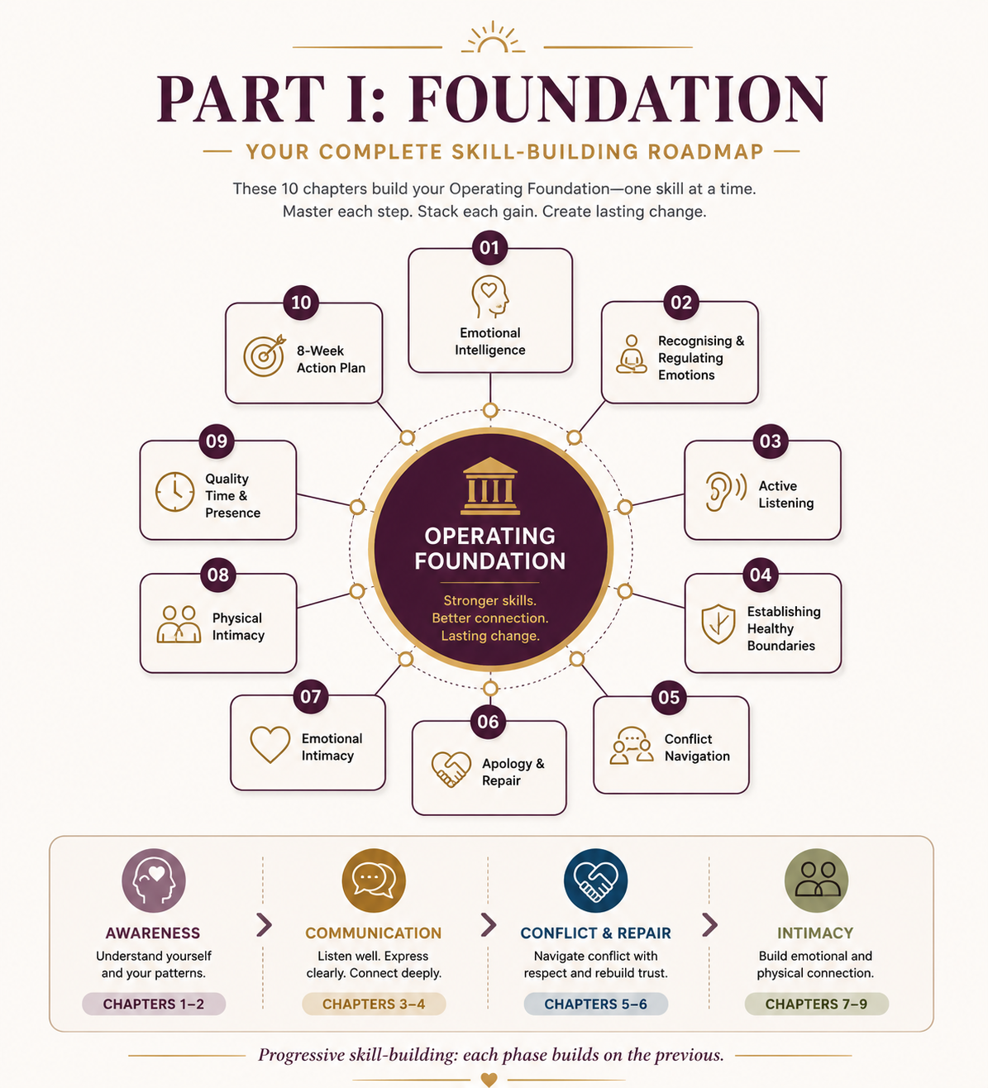
Part I Overview: The Foundation Skills

Part I — Foundation



Chapter 1: The Language Beneath the Words — Understanding Emotional Intelligence

Purpose
Build the emotional awareness and response skills that make every later chapter more usable.

Why This Chapter Comes First
Most relationship problems begin with missed signals.
One person feels hurt, flooded, lonely, irritated, dismissed, embarrassed, overwhelmed, or shut out. The other person notices only fragments of that experience, or notices it too late. By the time the emotional reality becomes visible, it often shows up as tone, withdrawal, criticism, silence, sharpness, distance, defensiveness, or a fight that seems to have arrived out of nowhere.
If you cannot identify what is happening inside you, you will struggle to regulate it. If you cannot read what is happening inside your partner with reasonable accuracy, you will keep responding to the wrong problem. And if you cannot do either of those things under stress, every later skill — communication, repair, boundaries, intimacy, and conflict resolution — becomes much harder to apply when it matters most.
Emotional intelligence is not a soft extra. It is the operating foundation beneath everything else.
If you apply this chapter well, you should see three early changes:
- less escalation,
- more accurate understanding,
- faster recovery after misattunement.
That is why this chapter comes first.

The Core Tool
Use this sequence:
Notice → Name → Normalise → Navigate

Notice
Notice what changed in you, in your partner, or in the room.

Name
Name the feeling as precisely as you can.

Normalise
Normalise the fact that the feeling exists without shaming it.

Navigate
Choose the next response that reduces damage and increases clarity.
If you remember nothing else from this chapter, remember that sequence.

What Emotional Intelligence Actually Means
Emotional intelligence is the ability to notice, understand, regulate, and respond to emotions — your own and someone else’s — in ways that increase clarity rather than damage.
It is not the same as being emotional. It is not the same as being agreeable. It is not the same as having good intentions.
A person can care deeply and still be emotionally unintelligent in practice. They can love their partner and still miss cues, escalate quickly, defend automatically, dismiss pain, or retreat into silence because they do not yet have the skill to stay connected under emotional load.
At its simplest, emotional intelligence asks four questions:
- 1. What am I feeling?
- 2. Why am I feeling it?
- 3. What is this feeling pushing me to do?
- 4. What would be the wiser response here?
That sounds straightforward until stress enters the room. Under pressure, many people lose precision. “I’m annoyed” may actually mean ashamed. “I’m fine” may actually mean hurt and trying not to need anything. “I’m angry” may actually mean afraid, embarrassed, unimportant, or overwhelmed.
The more accurately you can answer those questions, the better your later choices tend to become.

High EI vs. Low EI in Practice
Low emotional intelligence in practice often looks like:
- misreading tone,
- reacting before checking,
- defending before understanding,
- using vague labels as if they were precise enough,
- assuming intent instead of asking.
High emotional intelligence in practice often looks like:
- noticing shifts earlier,
- naming feelings more precisely,
- checking interpretations before treating them as fact,
- responding in ways that reduce damage,
- repairing sooner when something goes wrong.
A quick contrast makes the difference clearer.
Low EI: hears, “You seem distant lately,” and answers, “That’s ridiculous. I’ve just been busy.”
High EI: hears the same sentence and answers, “You may be picking up on something real. Say more.”
This is where emotional intelligence matters most: not in calm theory, but in messy real time.

Evidence and Limits
This chapter uses evidence-informed guidance, not fixed rules about men, women, or couples.
Across relationship science, emotion regulation research, and communication theory, a few broad patterns show up repeatedly: people tend to do better in close relationships when they identify internal states more accurately, regulate activation before reacting, listen for emotional meaning as well as literal content, and repair ruptures before resentment hardens. Research on emotional granularity, affect labelling, misattunement and repair, and emotion regulation points in the same broad direction: when people can name internal states more accurately, they tend to respond with more flexibility and less collateral damage.
Those patterns are useful, but they are not universal laws. Test them against real behaviour in your relationship.
A few guardrails matter here:
- emotional awareness is learnable, but progress is rarely linear,
- intention and impact are not the same thing,
- emotional precision is more useful than broad labels like fine, stressed, or angry,
- stronger skill does not remove the need for accountability, boundaries, or outside support when self-guided work is no longer enough.
If conversations regularly involve intimidation, coercion, threats, chronic contempt, panic, dissociation, severe shutdown, or trauma responses that make connection unsafe or impossible, use this chapter as support around higher-level care, not as a substitute for it.

The Four Pillars of Emotional Intelligence

1. Self-Awareness
Self-awareness is the ability to identify your internal state while it is happening, not three hours later when the damage is already done.
It includes:
- naming feelings more accurately,
- noticing body signals,
- recognising your triggers,
- understanding your recurring interpretations,
- distinguishing between the event itself and the meaning your nervous system assigned to it.
Without self-awareness, you will tend to confuse reaction with truth.

2. Self-Regulation
Self-regulation is the ability to stay connected to your feelings without handing them the steering wheel.
It does not mean suppression. It means you can feel something strongly without immediately turning it into volume, withdrawal, contempt, fixing, blame, or escape.
Self-regulation lets you pause long enough to choose a response you are less likely to regret.

3. Social Awareness
Social awareness is the ability to read another person with increasing accuracy.
It means noticing emotional cues beyond literal words:
- tone,
- pace,
- posture,
- facial change,
- eye contact,
- breath,
- energy shift,
- the difference between what is being said and what is being signalled.
This is not mind-reading. It is informed observation plus curiosity.

4. Relationship Management
Relationship management is what happens when the first three capacities begin working together.
You notice yourself. You notice the other person. You regulate enough to stay constructive. Then you respond in a way that protects connection.
This is the pillar people usually want first, but it cannot be built well without the others.
In sequence, the pillars work like this: you notice yourself, steady yourself, read the other person more accurately, and then respond in ways that protect connection.
EI Flow: Notice self → steady self → read other → respond well.

In Real Time
When pressure rises, the sequence becomes practical:
- 1. notice your state,
- 2. slow the reaction,
- 3. read the other person,
- 4. respond with care.
That is the operating rhythm beneath the rest of the book.

The Hidden Problem: Low Emotional Vocabulary
Many adults have an emotional vocabulary that is far thinner than they realise.
They can identify a few broad states:
- angry,
- stressed,
- fine,
- frustrated,
- tired.
But broad labels are blunt instruments. They do not create enough clarity to guide wise responses.
For example, “angry” might actually mean:
- disrespected,
- cornered,
- ashamed,
- helpless,
- anxious,
- overloaded,
- dismissed,
- disappointed.
Those are not interchangeable.
If you mislabel your experience, you often mishandle it. You may seek control when what you need is reassurance. You may attack when what you need is space. You may withdraw when what you need is language. You may try to fix your partner when what they actually need is validation and steadiness.
Increasing emotional precision is therefore one of the fastest ways to reduce unnecessary conflict.

A Quick Feelings Bank
Use these as starter categories when your first answer is too vague. Start by choosing one word from each family that fits you most often under stress.

Anger Family
- irritated
- resentful
- disrespected
- cornered
- frustrated
- bitter

Fear Family
- anxious
- unsafe
- uncertain
- overwhelmed
- pressured
- on edge

Shame Family
- embarrassed
- exposed
- inadequate
- foolish
- rejected
- not enough

Sadness Family
- disappointed
- lonely
- hurt
- let down
- heavy
- unseen

Disconnection Family
- dismissed
- ignored
- unimportant
- misunderstood
- far away
- emotionally alone
The goal is not to choose the perfect word every time. The goal is to become more precise than fine, bad, stressed, or angry.

Low-Resolution and High-Resolution Reads
A useful way to think about emotional accuracy is the difference between low-resolution and high-resolution reads.
A low-resolution read gives you a label but not enough information to respond wisely.
A high-resolution read gives you more usable data: what happened, what it meant, what feeling was activated, what need may be underneath it, and what response would reduce damage.
Examples:
Low-resolution read | High-resolution read
“I’m angry.” | “I feel dismissed and overloaded.”
“I’m stressed.” | “I feel pressured, uncertain, and under-supported.”
“You’re being dramatic.” | “I am struggling to understand the level of hurt underneath this reaction.”
“Nothing is wrong.” | “Something is active, but I do not yet feel ready to name it.”
This is not about using perfect language. It is about upgrading the resolution enough to stop responding to the wrong problem.
When you notice yourself reaching for a blunt label, treat it as a signal. It usually means the moment needs more accuracy, not more certainty.

The “I’m Fine” Problem
One of the most common relational failures is not dramatic cruelty. It is low-resolution emotional reading.
A partner says, “I’m fine.” The words are neutral. The body is not.
The jaw is tighter. The eye contact is gone. The room feels colder. The answers are shorter. The pace is different.
Someone with low emotional awareness hears the sentence and moves on. Someone with stronger awareness notices the mismatch and becomes curious.
That curiosity can prevent hours of avoidable damage.
The goal is not interrogation. The goal is gentle checking rather than forced emotional extraction.
Low-resolution read: “She said she’s fine, so she’s fine.” Higher-resolution read: “The words say fine, but the body may be signalling shutdown. I should check gently before assuming.”
Try:
“I hear you saying you’re fine. I may be wrong, but something feels a little different. Do you want space, support, or should I simply stay close and not push?”

When “Crazy” Becomes a Zero-Resolution Label
The harshest form of low-resolution listening is the word crazy or its softer relatives: dramatic, too sensitive, too emotional, overreacting.
Those words usually do not clarify the problem. They end the conversation by making the speaker the problem.

A better approach is to translate the label into a more honest self-report:
Label you may be tempted to use | More accountable translation
“You’re being crazy.” | “I am overwhelmed and I do not yet understand what you are trying to tell me.”
“You’re too sensitive.” | “This matters to you more than I expected, and I need to understand why.”
“You’re overreacting.” | “Your reaction is bigger than my current understanding of the event.”
“You’re dramatic.” | “I am reacting to the delivery instead of listening for the hurt.”
Every time you replace a dismissive label with a more accurate read, you create a chance for repair.
This does not mean every reaction is automatically fair, accurate, or well-expressed. It means you cannot respond wisely until you understand what the reaction is carrying.

Worked Example: Dinner Went Quiet
Marcus and Elena had both had long days. During dinner, Elena became unusually quiet. Marcus noticed the shift but told himself not to “make a thing out of nothing.” He assumed she was tired.
After dinner, he started scrolling through his phone. Elena became colder. When he finally asked what was wrong, she said, “Nothing.” He believed her again. Two hours later, they were in a fight that appeared to be about dishes, but was actually about something much older: Elena felt invisible when her emotional state changed and Marcus responded as if presence were optional.
The next week, they tried a different approach.
When Marcus noticed the shift, he said:
“I may be wrong, but you seem quieter than usual and a little shut down. I don’t want to assume. Are you tired, upset, or just low-capacity?”
Elena exhaled and said, “Honestly? I’m hurt. You cancelled on lunch again and acted like it was no big deal.”
The problem was not solved instantly. But it became visible sooner, and because it became visible sooner, it caused less secondary damage.
That is emotional intelligence in practice: notice the cue, check the read, avoid certainty, and name more than one possible explanation.

Worked Example: The False Alarm
Priya came home distracted after a difficult workday. She answered Daniel’s first question briefly and went quiet while putting her things down. Daniel immediately assumed she was angry with him. This is a classic distorted-assumption pattern: personalisation — treating incomplete or neutral data as if it must be about you.
Within minutes, he became tense, defensive, and preoccupied with figuring out what he had done wrong.
Instead of checking his assumption, he said:
“If you’re upset with me, just say it.”
Priya, already drained, snapped back. Now they were both activated — one because she was overloaded, the other because he had mistaken distance for accusation.
Later, they tried it differently.
Daniel said:
“You seem far away. I’m noticing I’m starting to assume it’s about me, but I may be wrong. Are you upset with me, or are you just carrying a lot from the day?”
Priya said, “It’s not you. I’m cooked. I need ten quiet minutes before I can talk normally.”
That second version prevented a completely avoidable fight.
Emotional intelligence is not only about noticing pain accurately. It is also about not manufacturing threat out of incomplete data.

Worked Example: Misreading Yourself
Alicia left a work meeting telling herself she was angry. She replayed the conversation all the way home and kept thinking about how dismissive her manager had sounded. By the time she walked through the door, she was tense, sharp, and ready to unload.
When her partner asked what was wrong, she said, “I’m just annoyed. Leave it.”
But when she slowed down and looked more carefully, annoyed was not the most accurate word. She was embarrassed. She had been corrected publicly, and what she was calling anger was partly a cover for feeling exposed and not good enough.
That shift mattered.
Once she named the feeling more accurately, her response changed from aggression to honesty. Instead of staying sharp, she said:
“I thought I was angry, but I think I’m actually embarrassed. I felt exposed in that meeting, and I’m carrying that home.”
That answer created room for support instead of conflict.
Accurately reading yourself is often the difference between discharging emotion and actually dealing with it.

What Gets in the Way
Even people who agree with these tools often struggle to use them consistently. The problem is not always resistance. Often, it is speed, habit, and emotional overload.
A few common blockers are:
- moving too fast to interpretation,
- confusing certainty with accuracy,
- low emotional vocabulary,
- assuming your first reaction is the full truth,
- taking another person’s state personally too quickly,
- treating emotional skill as optional until conflict becomes expensive,
- shame around naming feelings at all,
- family conditioning that punished emotional expression,
- over-intellectualising instead of feeling and naming,
- speed, fatigue, or stress load that reduce curiosity,
- fear that naming an emotion will make it bigger or more real.
Awareness gets easier with repetition. So does repair. But neither becomes reliable by accident.

If You Miss the Signal
You will miss signals sometimes. Everyone does.
The goal is not perfect emotional reading. The goal is earlier correction.
When you realise you missed something, do not double down. Restart.
Try:
“I think I missed what was happening for you. Let me slow down and try again.”
That sentence protects far more connection than pretending you already understood.

Scripts

Script 1 — Checking the Read
“I may be wrong, but you seem quieter and more shut down than usual. Are you tired, upset, or just low-capacity?”

Script 2 — Naming Your Own State
“I’m noticing I’m not just annoyed. I think I’m actually feeling dismissed and a bit embarrassed.”

Script 3 — Correcting an Assumption
“I’m starting to tell myself a story about what this means. Before I run with that, can I check whether I’m reading it right?”

Script 4 — Restarting After a Miss
“I think I responded to the wrong thing. Let me try to understand what was actually happening for you.”

7-Day Starter Plan

Day 1 — Build a Feelings List
Write down ten emotions you commonly feel but rarely name with precision.

Day 2 — Notice Body Signals
Track where emotions show up first in your body: jaw, chest, stomach, shoulders, breath, energy, voice.

Day 3 — Check One Assumption
In one conversation, ask yourself: What do I know, and what am I assuming?

Day 4 — Use One Read-Check Question
Try: “I may be wrong, but…” before treating your interpretation as fact.

Day 5 — Upgrade One Emotion Word
Replace a vague word like fine, bad, stressed, or angry with something more specific.

Day 6 — Notice One Mismatch
Catch one moment where the words and the body do not match.

Day 7 — Review the Pattern
Ask:
- What emotions do I identify fastest?
- Which ones do I miss or flatten?
- Where do I tend to assume rather than check?
- What helped me become more accurate this week?

Growing Strength Indicators
You are getting better at this if you can increasingly say yes to the following:
- I notice emotional shifts earlier.
- I use more precise feeling words.
- I check assumptions more often instead of treating them as facts.
- I notice the difference between an event and the meaning I assigned to it.
- I read emotional cues with more curiosity and less certainty.
- I correct myself sooner after a misread.
- I respond to the actual problem more often than to my first story about it.

Not-Yet Indicators
More work is needed if the following stay common:
- I treat my first interpretation as the truth.
- I use broad labels like fine or angry for almost everything.
- I notice emotional reality only after tone has already changed.
- I assume another person’s state is about me without checking.
- I confuse reaction with accuracy.
- I miss the body-language mismatch when someone says they are “fine.”
- I get more certain under stress, not more curious.

QR Worksheet: Emotional Awareness Map
Slug: ch01-emotional-awareness-map

Scan or visit: https://shesnotcrazybook.com/ws/ch01-emotional-awareness-map

Use the worksheet to record:
- event,
- body cue,
- first interpretation,
- more accurate interpretation,
- primary feeling,
- secondary feeling,
- what I assumed,
- what I checked,
- what I would do differently next time.
The goal is accuracy, not performance.

Practical Application Checklist
Use this chapter well if you can increasingly do the following:
- notice emotional shifts earlier,
- name feelings more precisely,
- distinguish the event from the meaning you assigned to it,
- track your own body cues,
- read another person’s cues with curiosity rather than certainty,
- ask before assuming,
- correct emotional misreads sooner.

Referral Note
This chapter is for self-guided skill-building. It is not enough for every situation.
Use this material as support around higher-level care, not as a substitute for it, if conversations regularly involve:
- intimidation,
- coercion,
- threats,
- chronic contempt,
- panic,
- dissociation,
- severe shutdown,
- trauma responses that make connection unsafe or impossible.
Better awareness is valuable. It is not a treatment for abuse, coercive control, or serious instability.

Recap
Emotional intelligence is not about sounding insightful. It is about becoming more accurate.
Remember the sequence:
Notice → Name → Normalise → Navigate
Notice the shift. Name the feeling. Normalise the fact of it. Navigate the next response with more care.
That is how emotional life becomes more workable instead of more chaotic.
Awareness does not solve everything. But without it, the rest of the book becomes much harder to use well.
Awareness is the first step. Regulation is what keeps awareness from collapsing under pressure.
Do this today: The next time you notice a change in tone, pace, or energy, do not assume. Ask one clean question before you respond.

See Also
- Chapter 2: Recognising and Regulating Your Emotions
- Chapter 3: Active Listening — Hearing Beyond Words
- Chapter 6: The Art of Apology and Repair

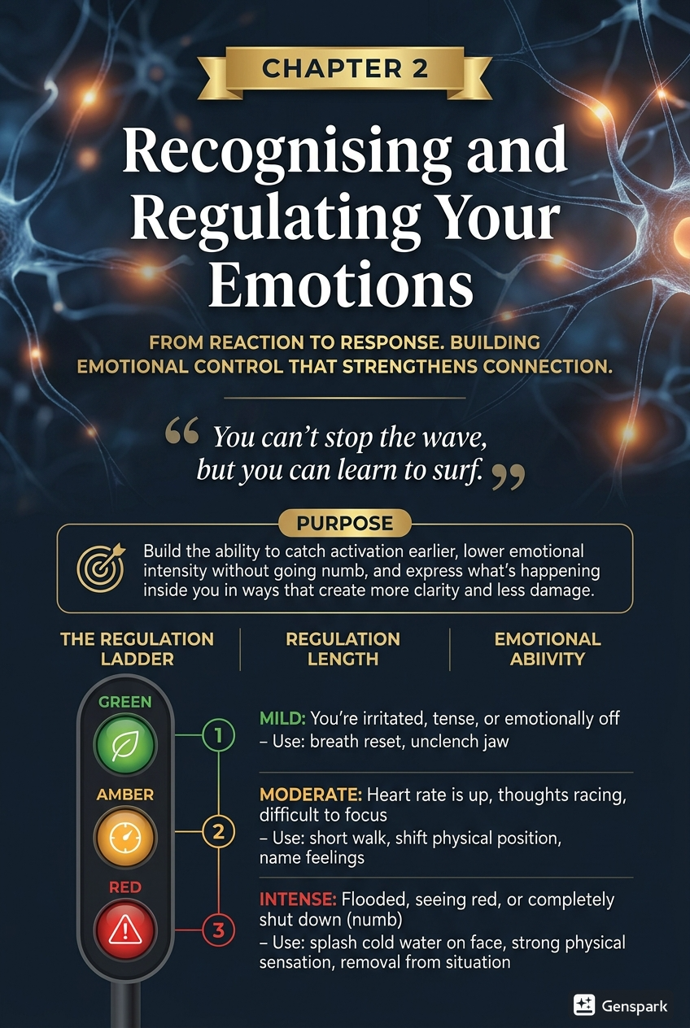

Chapter 2: Recognising and Regulating Your Emotions

Purpose
Build the ability to catch activation earlier, lower emotional intensity without going numb, and express what is happening inside you in ways that create more clarity and less damage.

Why This Chapter Comes Next
Chapter 1 focused on emotional awareness. That is necessary, but it is not sufficient.
You can identify that you are angry, hurt, ashamed, overloaded, anxious, or shut down and still handle that emotional reality badly. You can still become sharp, defensive, sarcastic, withdrawn, controlling, passive, or unreachable. Recognition without regulation often produces better vocabulary with the same damage.
This chapter is about what happens after recognition.
If you apply it well, you should see a few early changes:
- less escalation,
- fewer impulsive responses,
- clearer expression of what is actually wrong,
- faster returns to steadiness after stress.
That changes the climate of a relationship.

The Core Tool
Use this sequence:
Pause → Locate → Lower → Link

Pause
Do not let your first impulse become your first behaviour.

Locate
Identify what you are feeling, where it is showing up in your body, and what triggered it.

Lower
Bring the intensity down enough to think, not just react.

Link
Return to language, contact, and the next constructive step.
This is regulation in practice: not denial, not suppression, and not pretending nothing happened. Regulation is the ability to stay connected to reality without being governed by the hottest part of your nervous system.

Regulation Is Not Suppression
This distinction matters.
Suppression says:
- I should not feel this.
- I need to shut this down.
- If I ignore it, it will stop affecting me.
Regulation says:
- This is real.
- It is here.
- I do not need to obey it immediately.
- I can choose what I do next.
Suppressed emotion usually leaks out indirectly through tone, distance, sarcasm, shutdown, or resentment. Regulation is different. It allows feeling without letting feeling run the room.

Regulation Is Not Compliance
Regulation does not mean making yourself smaller so someone else can stay comfortable. It does not mean softening legitimate protest into silence. It does not mean surrendering boundaries, excusing harm, or becoming easier to ignore.
Good regulation makes you more accurate, not more compliant. It helps you say what is true with more steadiness and less collateral damage.

The Physiology of Emotion
Emotion is not only a thought. It is a body event.
Before you explain yourself, justify yourself, or argue with your partner, your body often shifts first:
- your jaw tightens,
- your breath shortens,
- your chest hardens,
- your stomach drops,
- your shoulders rise,
- your voice changes,
- your attention narrows,
- and your mind starts scanning for disrespect, danger, rejection, blame, or proof.
This is why people say, “I just snapped.” Usually, something happened before the snap. It happened quickly.
Under stress, accuracy often drops. You become more certain and less correct. You become more reactive and less curious. You start responding not just to the present moment, but to the meaning your nervous system assigned to it.
That is why regulation has to begin in the body, not only in the argument.

Catch the Shift Earlier
Most people try to regulate too late. They wait until they are already flooded.
A better strategy is to learn your early signs.
For some people, activation begins as:
- talking faster,
- interrupting,
- repeating the same point,
- needing immediate understanding,
- mentally building a case,
- losing warmth in the voice,
- preparing rebuttals while the other person is still speaking.
For others, it begins as:
- going quiet,
- going blank,
- wanting to leave,
- feeling emotionally far away,
- dropping eye contact,
- a heaviness in the body,
- the thought, “I cannot do this.”
Ask yourself:
- What happens in my body before I get sharp?
- What happens in my mind before I get defensive?
- What happens in my behaviour before I shut down?
- What does my partner probably notice before I do?
If you catch the shift one minute earlier, you often prevent thirty minutes of avoidable damage.

Triggers: The Present Moment Is Not Always the Whole Story
A trigger is not just something that annoys you. It is a present event that carries extra charge because of what it touches underneath.
The visible event may be small. The meaning may be large.
- A forgotten text may feel like abandonment.
- A harsh tone may feel like disrespect.
- A correction in front of others may feel like humiliation.
- A partner’s withdrawal may feel like rejection.
- A request for space may feel like danger.
This does not make your feelings fake. It means the intensity may be coming from more than one layer at once.
A useful question is:
What happened, and what did it come to mean to me?
Those are not identical.

Trigger Mapping
When a reaction feels bigger than the visible event, map it.
Use this structure:
Event → Interpretation → Emotion → Impulse
Example:
- Event: My partner corrected me in front of someone else.
- Interpretation: She thinks I am incompetent.
- Emotion: Shame, anger.
- Impulse: Shut down, retaliate, become cold.
Or:
- Event: He did not respond for hours.
- Interpretation: I am not important.
- Emotion: Anxiety, hurt, resentment.
- Impulse: Send a sharp message, withdraw, act like I do not care.
Mapping the sequence reduces confusion. It helps you stop treating impulse as destiny.

The Regulation Ladder
Not every emotional moment requires the same intervention. Use the least disruptive tool that works.

Green: Mild Activation
You are irritated, tense, or emotionally off, but still able to think.
Use:
- one slower breath,
- unclench your jaw,
- lower your voice,
- ask one clarifying question,
- name what is happening cleanly.
Example:
“I’m noticing I’m getting defensive. Let me slow down and make sure I understand what you mean.”

Yellow: Moderate Activation
You can still speak, but your thinking is narrowing and your tone is likely deteriorating.
Use:
- a brief pause,
- both feet on the floor,
- a longer exhale,
- no absolute language,
- a clean statement of your state before continuing.
Example:
“I want to stay in this conversation, but I’m getting too activated to do it well. Give me ten minutes, and I’ll come back.”

Red: Flooded
Your body is hot, your mind is racing or blank, and useful conversation is no longer happening.
Use:
- stop the exchange,
- separate temporarily,
- regulate physically,
- return at a specific time,
- do not use the pause as punishment.
Example:
“I’m flooded. I do not trust myself to speak well right now. I’m taking twenty minutes, and I will come back at 7:40.”
The return matters. A pause without return often feels like abandonment. A pause with clear re-entry is regulation.

60-Second Reset
Use this when you feel yourself starting to speed up, harden, or shut down.
- 1. Put both feet on the floor.
- 2. Drop your shoulders.
- 3. Inhale gently through your nose for a count of 4.
- 4. Exhale slowly for a count of 6 to 8.
- 5. Repeat for 5 rounds.
- 6. At the end, name one feeling as precisely as you can.
Example:
“I’m feeling more hurt than angry.”
This is not magic. It is a fast way to interrupt acceleration.

Optional Variation: Physiological Sigh
- 1. Take a normal inhale.
- 2. Add one small extra inhale on top.
- 3. Exhale slowly and fully.
- 4. Repeat 2 to 3 times.
Use this when your body feels especially tight or overloaded.

One-Minute Mindfulness Scan
Use this when you need clarity before language.
Ask:
- 1. What am I feeling?
- 2. Where is it showing up in my body?
- 3. What story am I telling about this?
- 4. What response would reduce damage right now?
Do not try to answer perfectly. Aim for more accuracy than your first impulse.

Grounding in Real Time
Grounding is a way of telling your body it does not need to stay at full alarm.
Useful grounding methods include:

Longer Exhale
Breathe out more slowly than you breathed in.

Contact With the Body
Feel your feet. Relax your hands. Drop your shoulders. Unclench your mouth.

Sensory Orientation
Name a few things you can see, hear, or physically feel.

Movement
Walk briefly. Stretch. Step outside. Splash cool water on your face.

Accurate Self-Talk
Not:
“This is stupid.”
“I should be over this.”
Instead:
“I’m activated.”
“This feels bigger than the moment.”
“I need to steady first.”

Time Containment
Do not tell yourself, “We’ll never fix this.” Tell yourself, “I need to get through the next ten minutes cleanly.”
Grounding is not the whole job. It is what makes the rest of the job possible.

Healthy Expression vs. Emotional Dumping
Once intensity lowers, expression matters.
Healthy expression is honest, bounded, and accountable. It names experience without turning experience into a weapon.
It sounds like:
“I felt dismissed when that happened.”
“I’m more hurt than angry.”
“I noticed I started assuming the worst.”
“I need a slower conversation so I can stay present.”
“When you walked away mid-sentence, I felt shut out.”
Unhealthy expression often looks like:
- accusation disguised as honesty,
- using emotion as proof,
- volume instead of clarity,
- contempt,
- mind-reading,
- dragging old material into the current moment without structure,
- saying, “I’m just being real,” when you are actually dumping emotional charge onto someone.
Suppression is not healthy. Dumping is not healthy either.
The target is clean expression.
Clean expression usually includes:
- 1. what happened,
- 2. what you felt,
- 3. what meaning you made of it,
- 4. what you need now.
Example:
“When the conversation ended that abruptly, I felt dismissed and shut out. I started telling myself that nothing I said mattered. I do not want to stay in that story. I need us to come back and finish this more calmly.”

Worked Example: Full Sequence in Motion
Jordan walks into the kitchen and says, “Did you pay that bill yet?”
Sam has already had a hard day. The question lands as criticism.

What Happens Internally
- Trigger: the question about the bill.
- Body cue: chest tightens, jaw sets.
- Interpretation: “I’m being treated like I’m irresponsible.”
- Emotion: shame, irritation.
- Impulse: snap back — “Why do you always ask like that?”

Old Pattern
Sam snaps. Jordan gets defensive. The conversation turns into a fight about tone, respect, and who is always carrying everything.

New Pattern
Sam notices the body cue and uses the core tool.
Pause Sam does not answer immediately.
Locate Sam identifies the feeling: “I’m feeling ashamed and defensive.”
Lower Sam does one 60-second reset and relaxes his jaw.
Link Sam says:
“That question landed badly for me because I’m already feeling behind. I heard criticism in it, even if that wasn’t your intent. I did pay it. Can we restart that a little softer?”

Outcome
The moment does not disappear, but it stays workable. The feeling becomes visible sooner, so it causes less secondary damage.
That is emotional regulation in practice.

What Not to Do During a Pause
A pause can be useful or destructive. The difference is how you use it.
Do not:
- storm off without a return time,
- text-argue during the break,
- rehearse a prosecution brief,
- use the pause as punishment,
- disappear for hours without explanation,
- come back only when you feel ready to win.
A pause is for steadiness, not leverage.

Co-Regulation Without Outsourcing Responsibility
You are responsible for your own regulation, but relationships can still help or hinder steadiness.
A supportive partner cannot do your regulating for you, but they can make it easier or harder for you to stay constructive.
Examples of helpful requests:
“I can settle faster if we lower our voices.”
“Please do not follow me while I’m taking a short pause.”
“I need you to let me finish one sentence before responding.”
“I want to come back to this, but I need ten minutes first.”
That is not helplessness. It is clear communication about conditions that support better functioning.

If You Handle It Badly
You will not do this perfectly. No one does.
When you handle emotion badly, recover quickly.
- 1. Name it.
- 2. Own it specifically.
- 3. Describe the impact without self-protective editing.
- 4. Repair what you can.
- 5. Make the next better behaviour visible.
Example:
“I got flooded and sharp. You were trying to talk to me, and I answered with defensiveness. That likely felt dismissive and unfair. I’m sorry. I want to restart this more slowly and address the actual issue.”
That is stronger than either collapse or denial.

Scripts

Script 1 — Early Regulation
“I’m noticing I’m getting activated. I want to stay accurate, not reactive. Give me a minute to slow down.”

Script 2 — Time-Out With Return
“I’m too activated to do this well right now. I’m taking twenty minutes to settle, and I will come back at 8:15.”

Script 3 — Clean Expression
“What happened was small on the surface, but it hit something bigger in me. I felt hurt and unimportant, and I need to talk about that without us turning it into a fight.”

Script 4 — Re-Entry After Pause
“I’ve settled enough to try again. Let me say what I think happened, then you can tell me what I missed.”

7-Day Starter Plan

Day 1 — Body Cues Inventory
Write down how activation shows up in your body.

Day 2 — Trigger Map One Recent Event
Use: Event → Interpretation → Emotion → Impulse.

Day 3 — Practice the Pause Script
Use it once before you are fully flooded.

Day 4 — Do the 60-Second Reset
Use it before replying in one mildly activating moment.

Day 5 — Separate Event From Interpretation
In one difficult moment, ask: “What happened, and what did I make it mean?”

Day 6 — Express One Feeling Cleanly
Use the four-part structure: what happened, what I felt, what meaning I made of it, and what I need.

Day 7 — Review the Week
Ask:
- What triggered me most?
- Which tool helped most?
- Where did I escalate?
- Where did I recover better than usual?
- What will I repeat next week?

Growing Strength Indicators
You are getting better at this if you can increasingly say yes to the following:
- I notice activation in my body before my tone fully changes.
- I can ask for a pause without disappearing.
- I can separate event from interpretation at least some of the time.
- I can lower intensity before trying to solve the issue.
- I can express hurt without turning it into attack.
- I return from pauses when I said I would.
- I recover faster after a poorly handled moment.

Not-Yet Indicators
More work is needed if the following stay common:
- I confuse suppression with self-control.
- I treat every strong feeling as proof.
- I pause, but do not return.
- I rehearse my defence during every break.
- I wait too long to speak, then overflow.
- I use “honesty” to justify emotional dumping.
- I am often surprised by my own escalation.

QR Worksheet: Trigger Map + Regulation Ladder
Slug: ch02-trigger-map-regulation-ladder

Scan or visit: https://shesnotcrazybook.com/ws/ch02-trigger-map-regulation-ladder
Use the worksheet to record:
- event,
- body cues,
- primary feeling,
- secondary feeling,
- interpretation or story,
- impulse,
- activation level: green / yellow / red,
- regulation tool used,
- repair or re-entry sentence,
- outcome.
The goal is pattern visibility, not perfection.

Practical Application Checklist
Use this chapter well if you can increasingly do the following:
- catch activation before your tone hardens,
- identify body signs earlier,
- distinguish the event from the story about the event,
- ask for a pause without abandoning the conversation,
- ground before continuing,
- express hurt without weaponising it,
- notice when you are suppressing instead of regulating,
- repair more quickly after a miss.

Referral Note
This chapter is for self-guided skill-building. It is not enough for every situation.
Use this material as support around higher-level care, not as a substitute for it, if conversations regularly involve:
- intimidation,
- coercion,
- threats,
- chronic contempt,
- surveillance,
- panic,
- dissociation,
- self-harm threats,
- substance-driven volatility,
- emotional shutdown so severe that re-entry is repeatedly impossible.
Better regulation is valuable. It is not a treatment for abuse, coercive control, or serious instability.

Recap
Recognising emotion is only the first half of the work.
The second half determines whether emotion becomes clarity or damage.
The goal is not to feel less. The goal is to handle what you feel more skillfully.
Remember the sequence:
Pause → Locate → Lower → Link
Pause before impulse. Locate the feeling and trigger. Lower the intensity. Link back to truth, language, and connection.
That is how emotion stops being something that merely happens to the relationship and becomes something you can work with inside it.
Regulation is what makes listening possible when the conversation starts to matter.
Do this today: The next time you feel yourself speed up, harden, or go blank, do one 60-second reset before you say another sentence.

See Also
- Chapter 1: The Language Beneath the Words: Understanding Emotional Intelligence
- Chapter 3: Active Listening — Hearing Beyond Words
- Chapter 7: Emotional Intimacy and Vulnerability

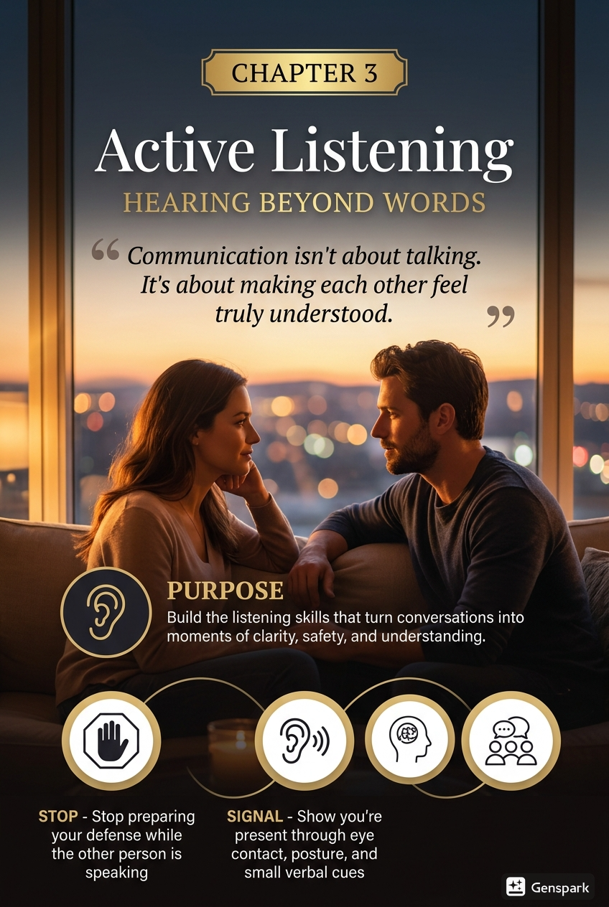

Chapter 3: Active Listening — Hearing Beyond Words

Purpose
Build the listening skills that turn conversations from reactive exchanges into moments of clarity, safety, and understanding.

Why This Chapter Comes Next
Chapter 1 focused on emotional awareness. Chapter 2 focused on recognising activation and regulating it before it becomes damage.
This chapter depends on both.
You cannot listen well if you cannot notice emotional shifts. You cannot listen well if you are too activated to stay open. And you cannot build trust if your partner has to fight through your defensiveness just to get a basic point across.
Many relationship problems are not caused by a total absence of talking. They are caused by talking that does not actually produce understanding.
People speak. Words are exchanged. Explanations are offered. Solutions are proposed. But one or both partners leave the conversation feeling:
- unseen,
- corrected too quickly,
- emotionally alone,
- misunderstood,
- or forced to repeat themselves until their tone hardens.
That is not a communication failure in the narrow sense. It is a listening failure.
If you apply this chapter well, you should see several early changes:
- less interruption,
- less defensive rebuttal,
- fewer circular arguments,
- more accurate understanding,
- and more moments when one person can say, “Yes, that is what I meant.”
That sentence matters more than people realise. It is one of the clearest signs that connection is increasing.

What Active Listening Actually Means
Active listening is the deliberate practice of understanding the other person’s content, emotion, and underlying need before moving into explanation, problem-solving, or response.
It is not the same as silence. It is not the same as waiting your turn. It is not the same as collecting evidence for your defence. It is not the same as nodding while mentally preparing a correction.
Active listening means you are doing at least five things at once:
- hearing the literal words,
- noticing the emotional tone,
- tracking what matters most to the speaker,
- checking your assumptions,
- and staying open long enough to reflect back what you understood.
Listening is therefore not passive. It is skilled attention.

Signal Reception Model
For the rest of this chapter, think of listening as signal reception.
Your partner is not only sending words. They may also be sending emotional data through tone, pace, repetition, hesitation, silence, body language, and the specific thing they keep coming back to.
Good listening means receiving five layers before responding:
- 1. Content: What did they literally say?
- 2. Feeling: What emotion is present or implied?
- 3. Meaning: What does this seem to mean to them?
- 4. Need: What are they asking for directly or indirectly?
- 5. Check: What should I confirm before assuming?
Most listening failures happen because someone responds to layer one while the relationship problem is happening at layers two through five.

The Core Tool
Use this sequence:
Stop → Signal → Say Back → Search → Support

Stop
Stop preparing your defence while the other person is still speaking.

Signal
Show that you are present through eye contact, body orientation, stillness, and brief verbal cues.

Say Back
Reflect the message in your own words before you add your own point.

Search
Check for the feeling, concern, or need underneath the words.

Support
Respond in the form that is most useful right now: validation, clarification, accountability, comfort, or only then a solution.
This is the practical shape of listening that helps rather than aggravates.

Hearing vs. Listening
Hearing is physical. Listening is relational.
You can hear every word and still miss the conversation.
For example, a partner says:
“I’m tired of being the one who has to remember everything.”
A hearing-only response might be:
“That’s not true. I remembered the appointment last week.”
A listening response might be:
“You’re feeling like the mental load is falling heavily on you, and you’re worn out by having to keep track of things all the time. Is that right?”
The second response may not solve the issue. But it does something essential first: it makes the other person feel more accurately received.
That changes what becomes possible next.

The Pitfalls of Passive Listening
Passive listening often looks calm from the outside and disconnected on the inside.
The listener is technically quiet, but not truly engaged. They may be:
- waiting for their turn to talk,
- listening only for mistakes,
- offering minimal acknowledgements without tracking feeling,
- looking calm while mentally closing down,
- or appearing polite while emotionally absent.
This creates a familiar experience for the speaker: “You were there for the words, but not for me.”
Passive listening is dangerous because it can be mistaken for patience. It can sound polite while still being emotionally absent. In reality, it often delays the same misunderstanding that active listening would have exposed and corrected much earlier.
A useful check is this:
Am I trying to understand, or am I just not interrupting?

Why Listening Breaks Down
Most poor listening is not caused by indifference. It is caused by pressure.
People stop listening well when:
- they feel accused,
- they hear a complaint as a verdict on their character,
- they become preoccupied with proving good intent,
- they are embarrassed,
- they feel rushed,
- they assume they already know what the other person means,
- or they are more committed to being right than being accurate.
A common internal shift sounds like this:
“That is not what I meant.”
“That is unfair.”
“I need to explain.”
“I am being blamed.”
“I know where this is going.”
Once that shift happens, attention narrows. Curiosity drops. Listening becomes self-protection.
This is why Chapter 2 matters. Regulation makes listening possible under pressure.

The Three Listening Targets
When someone is speaking about something emotionally important, listen for three layers.

1. Content
What happened? What are the facts, sequence, and visible details?

2. Feeling
How did it land emotionally? What is the speaker likely feeling: hurt, frustration, loneliness, fear, resentment, embarrassment, disappointment, or overwhelm?

3. Need
What matters most underneath this? Do they need reassurance, accountability, partnership, repair, clarity, support, rest, respect, follow-through, or simply to be understood before anything else?
Most listeners stay stuck at the content layer. But the emotional and relational meaning often lives in the other two.

Listening to Understand, Not to Respond
One of the most common mistakes in conflict is answering too soon.
A partner says something painful or inconvenient. The listener moves immediately into one of the following:
- correction,
- explanation,
- defence,
- counterexample,
- solution,
- or counter-complaint.
This creates a predictable experience for the speaker: they feel they have to work harder to get the first layer of understanding before the conversation can move anywhere useful.
Listening to understand means delaying your answer long enough to confirm the other person’s reality as they experienced it.
That does not require full agreement. It does require accurate reception.
You can disagree with a conclusion and still understand the experience. You can have had good intentions and still listen seriously to negative impact.
A useful internal rule is this:
Understanding first. Response second.

Verbal Listening Skills
These are the core language habits that improve listening quickly.

Paraphrasing
Repeat the message in your own words.
Examples:
“What I’m hearing is…”
“So for you, the issue is not only the plan changing. It’s that you felt left out of the decision.”
“It sounds like you’re less angry about the event itself and more hurt by what it meant.”
Paraphrasing is useful because it reveals misunderstanding early.

Clarifying
Ask a question to sharpen understanding.
Examples:
“When you say unsupported, what did that look like in that moment?”
“Was the hardest part the tone, the timing, or the fact that it kept happening?”
“Do you want me to understand, help solve, or both?”
Clarifying prevents you from filling in gaps with assumption.

Reflecting Feeling
Name the emotional layer, not just the facts.
Examples:
“That sounds lonely.”
“You seem more disappointed than angry.”
“I can hear how exhausting that’s been for you.”
This is often the point where someone finally feels heard.

Summarising
Pull several strands together at the end.
Example:
“So the pattern for you is this: when plans change at the last minute and I do not communicate clearly, you end up feeling unimportant and stuck carrying the consequences. You want more predictability and more follow-through from me.”
A good summary turns a messy conversation into something workable.

Do Not Paraphrase Mechanically
Paraphrasing is for accuracy, not performance. If it sounds scripted, shorten it and make it warmer. The goal is to help the other person feel understood, not to recite a formula.
Natural language usually works better than textbook language.
Instead of:
“What I am hearing is that your affective state was negatively impacted by my behavioural inconsistency.”
Try:
“You felt let down because I said I would do it and then I didn’t.”

Non-Verbal Listening Skills
Listening is not only verbal.
A person can say the correct sentence with the wrong body.
Common non-verbal signs of poor listening include:
- looking away constantly,
- checking the phone,
- crossing the arms and leaning back with contempt,
- sighing loudly,
- eye-rolling,
- smirking,
- pacing while the other person is still speaking,
- or acting visibly impatient.
These behaviours communicate:
“Hurry up.”
“I already disagree.”
“Your experience is inconvenient.”
“This is a performance, not a conversation.”
Helpful non-verbal listening usually includes:
- facing the speaker,
- steady but not aggressive eye contact,
- less movement,
- a calmer face,
- brief acknowledgements,
- and enough stillness that the other person does not have to compete with your body for space.

Timing and Environment Matter
Listening quality also depends on setting.
Where possible:
- do not keep a phone in your hand,
- avoid doorway conversations for important topics,
- do not attempt serious listening while multitasking,
- and sit down where both faces are visible.
Your body and environment should support the conversation, not compete with it.

Validation Is Not Agreement
This distinction is essential.
Many people resist listening because they confuse validation with surrender.
Validation means:
- I can see how that landed that way for you.
- I can understand why you felt that.
- Given your experience, that reaction makes sense.
Validation does not mean:
- you are objectively right about every detail,
- my intentions do not matter,
- I agree with every conclusion,
- or I am admitting total blame.
Validation is about acknowledging the internal logic of the other person’s experience.

Quick Contrast
Validation is | Validation is not
“I can see why that hurt.” | “You are right about every detail.”
“That makes sense from your side.” | “My intentions do not matter.”
“I understand your experience.” | “I accept total blame.”
Without validation, many conversations stall. With validation, difficult truths become easier to discuss without escalating immediately.

The Fixing Reflex
A major listening problem in close relationships is the urge to solve before the other person feels understood.
This happens especially when the listener experiences pain as a task.
The internal sequence often goes like this:
“There is a problem.”
“I need to fix it.”
“If I offer a solution, I am helping.”
“If my solution is rejected, I feel useless or criticised.”
But many emotional conversations are not asking for immediate fixing. They are asking for attunement first.
A partner may need:
- presence,
- empathy,
- accurate reflection,
- or accountability,
before any solution can land.
A useful question is:
“Do you want understanding, problem-solving, or both?”
That one question can save an enormous amount of frustration.

Common Listening Errors
These are the mistakes most likely to damage understanding.

Interrogating Instead of Understanding
Too many questions, asked too sharply, can feel like cross-examination rather than care.

One-Upping
Responding to someone’s pain with a story that centres your own pain.

Defensive Corrections
Focusing on minor factual inaccuracies to avoid the emotional point.

Mind-Reading
Assuming you already know what the other person means.

Premature Reassurance
Saying “It’s fine,” “Don’t worry,” or “You’re overthinking it” before understanding the actual concern.

Switching to Yourself Too Fast
Turning the conversation into your explanation before the speaker feels received.

Listening Only for Fault
Scanning the conversation for unfairness toward you instead of for what your partner is trying to convey.
These habits are common. They are also trainable.

Worked Example: From Defensiveness to Understanding
Leah says:
“I feel like I always have to chase you for the small things.”
Ben immediately feels accused. His first impulse is:
“That’s not true. I did the groceries and the school pickup.”
That is the old pattern. He hears complaint as total condemnation and responds with evidence.

What Active Listening Looks Like Instead
Stop Ben notices the urge to defend and does not speak immediately.
Signal He turns toward Leah, puts his phone down, and stays still.
Say Back He says:
“You feel like the follow-up is falling on you too often.”
Search He adds:
“Is it mainly about the tasks, or more about feeling alone in carrying them?”
Leah says:
“Both. But mostly it’s that I do not feel like I can trust things to stay on your radar unless I keep holding them there.”
Support Ben responds:
“That makes sense. You want more reliability so you do not have to manage both the task and the reminder system. I can see how exhausting that would be.”
Now the conversation can move into accountability and planning.
Nothing magical happened. Leah simply did not have to battle through his defence to reach the point.

Compare the Difference: Bad Version vs. Better Version

Version A — Rebuttal, Fixing, Minimising
Speaker: “I felt embarrassed when you joked about me in front of your friends.”
Listener: “I was only joking. You know I didn’t mean anything by it. You’re being too sensitive. Next time I just won’t joke at all.”
What went wrong:
- intent replaced impact,
- sensitivity was used as dismissal,
- the speaker’s feeling was not reflected,
- and the solution came before understanding.

Version B — Reflect, Clarify, Validate, Then Respond
Speaker: “I felt embarrassed when you joked about me in front of your friends.”
Listener: “It landed as exposing rather than funny, especially because it happened publicly. Is that the main part?”
Speaker: “Yes. I felt small.”
Listener: “I can see why that would hurt. I want to take that more seriously. I’m sorry. Next time I’ll keep that kind of joke off you, especially in public.”
What changed:
- the feeling was reflected,
- the impact was taken seriously,
- validation came before defence,
- and the response included behavioural change.

Mini-Case: The Silent Shutdown
Nadia raises a concern about how tense dinner felt with the children. Omar says nothing for several seconds, then shrugs and says, “I don’t know what you want me to say.”
Nadia experiences this as withdrawal and indifference. Omar experiences it as overload.
A better listening move for Omar would be:
“I’m feeling a bit flooded, but I want to understand. Let me try to say back what I think you mean before I respond.”
Then:
“You’re saying the issue isn’t just dinner. It’s that when I go cold, the whole house feels tense and you feel left holding the emotional weight. Is that close?”
That answer does not require Omar to have perfect language. It requires willingness and structure.

Mini-Case: When Listening Looks Too Thin
Tara tells Daniel she felt embarrassed when he joked about her in front of friends. Daniel replies, “I said sorry. What else do you want?”
Technically, he addressed the event. Relationally, he skipped the experience.
A more active listening response would be:
“You felt exposed, and because it happened publicly it hit harder than I realised. You want me to take that kind of thing more seriously and not hide behind humour. Is that right?”
That response makes repair more believable.

Listening Must Lead Somewhere
Being heard matters, but listening is not the final goal. If the same issue is understood accurately five times and nothing changes, listening starts to feel performative.
Good listening should feed repair, follow-through, and reliability. It should make better behaviour more likely, not simply make painful conversations sound more polished.
Understanding builds trust. Changed behaviour protects it.

When You Are the Speaker
Listening improves faster when both people know how to make themselves easier to hear.
If you are bringing up something important, try to:
- speak from specifics rather than global attacks,
- separate one issue from five older issues,
- name what you felt,
- say what mattered most,
- and avoid forcing the listener to guess what kind of response you need.
Helpful openings include:
“I want to talk about one specific thing.”
“I’m not asking you to agree with everything. I’m asking you to understand how it landed.”
“Before we solve it, can you say back what you think I mean?”
“I need empathy first, then we can talk solutions.”
Active listening is a shared skill, even if one person is currently better at it than the other.

If You Notice Yourself Getting Defensive
Use this reset:
- 1. Pause.
- 2. Relax your body.
- 3. Tell yourself: “Understanding first.”
- 4. Reflect back one thing you heard.
- 5. Ask one clarifying question.
Example:
“I can feel myself wanting to explain, but let me make sure I understand first. What hurt most about that moment for you?”
That one sentence often changes the direction of the whole interaction.

Listening Drill: The Two-Minute Reflection
Use this once a day for one week.
- 1. One person speaks for up to two minutes about a small but real experience.
- 2. The listener does not interrupt.
- 3. The listener reflects back:
- the content,
- the feeling,
- and the likely need.
- 1. The speaker responds only with:
“Yes, that’s right,” or
“Almost — the main part you missed was…”
- 1. Switch roles.
Keep the first week small. Do not start with your hardest unresolved conflict.
This drill builds accuracy before pressure.
Minimum Viable Listening Rhythm
Use this for two weeks before judging whether your listening is improving.
- one 10-minute distraction-free daily check-in,
- one two-minute reflection drill each day,
- one weekly communication review,
- and one partner feedback form at the end of each week.
Listening improves through repetition and correction, not insight alone.

Scripts

Script 1 — Basic Reflection
“Let me say back what I think I’m hearing before I respond.”

Script 2 — Feeling Reflection
“It sounds like this landed as hurtful and dismissive, not just frustrating.”

Script 3 — Clarifying the Need
“Do you need understanding right now, problem-solving, or both?”

Script 4 — If You Feel Defensive
“I can feel myself wanting to explain, but I want to understand first. What part mattered most to you?”

Script 5 — Summary Check
“So the pattern for you is this: when this keeps happening, you end up feeling alone and overburdened. Is that accurate?”

7-Day Starter Plan

Day 1 — Catch Interruptions
Notice how often you interrupt, rehearse, or defend internally while someone is still speaking.

Day 2 — Use One Reflection Sentence
Say: “Let me say back what I think I heard.”

Day 3 — Listen for Feeling, Not Only Facts
In one conversation, name the likely feeling underneath the words.

Day 4 — Ask the Need Question
Use: “Do you need understanding, problem-solving, or both?”

Day 5 — Put the Phone Away Completely
During one meaningful conversation, remove obvious distractions.

Day 6 — Summarise Before Responding
Offer a short summary before giving your own point.

Day 7 — Review the Pattern
Ask:
- When do I listen best?
- When do I become defensive fastest?
- What kinds of topics collapse my curiosity?
- What listening move helped most this week?

Growing Strength Indicators
You are getting better at this if you can increasingly say yes to the following:
- I interrupt less.
- I can reflect back what I heard before giving my own view.
- I notice the feeling underneath the facts more often.
- I can validate without feeling like I am surrendering.
- I ask more clarifying questions and make fewer assumptions.
- People correct me less often when I summarise what they meant.
- Conversations resolve faster because understanding arrives sooner.

Not-Yet Indicators
More work is needed if the following stay common:
- I listen mainly for mistakes or unfairness.
- I treat my explanation as more urgent than the other person’s experience.
- I offer solutions before understanding the emotional point.
- I use silence as shutdown rather than attention.
- I paraphrase mechanically, but the speaker still feels missed.
- I become impatient when someone needs emotional language before practical language.
- I assume I know what they mean before they finish saying it.

QR Worksheet: Listening Accuracy Check
Slug: ch03-listening-accuracy-check

Scan or visit: https://shesnotcrazybook.com/ws/ch03-listening-accuracy-check
Use the worksheet to record:
- topic of conversation,
- what was said,
- what I assumed too early,
- what feeling I identified,
- what need I identified,
- reflection sentence used,
- clarifying question used,
- whether the speaker felt understood,
- what I would do differently next time.
The goal is accuracy, not performance.

Partner Feedback Form — Listening Accuracy Check
Ask your partner to complete this briefly after one meaningful conversation each week.
Rate each statement from 1 to 5.
- 1. I felt heard in this conversation.
- 2. My feelings were reflected accurately.
- 3. My partner interrupted or defended too quickly.
- 4. My partner seemed present rather than distracted.
- 5. I felt more understood by the end than I did at the beginning.
Then complete these prompts:
- The part you understood best was:
- The part you missed was:
- Next time I need more:
- One thing that helped was:
Use the feedback for correction, not self-punishment.

Practical Application Checklist
Use this chapter well if you can increasingly do the following:
- stop preparing your defence while the other person is still speaking,
- reflect back the message before responding,
- listen for content, feeling, and need,
- validate without assuming that validation equals agreement,
- delay fixing until understanding has landed,
- reduce non-verbal signs of impatience or contempt,
- ask clarifying questions instead of mind-reading,
- and summarise difficult conversations in a way the other person recognises as accurate.

Referral Note
This chapter is for relational skill-building. It is not enough for every situation.
Listening skills do not require staying in conversations that are unsafe, degrading, or coercive.
Use this material as support around higher-level care, not as a substitute for it, if conversations regularly involve:
- intimidation,
- coercion,
- threats,
- chronic contempt,
- deliberate humiliation,
- repeated reality distortion,
- panic,
- dissociation,
- or emotional shutdown so severe that meaningful conversation cannot be sustained.
Better listening is valuable. It is not a treatment for abuse, coercive control, or serious instability.

Recap
Active listening is not waiting quietly for your turn. It is the disciplined practice of understanding before responding.
Remember the sequence:
Stop → Signal → Say Back → Search → Support
Stop the rush to defend. Signal presence. Say back what you heard. Search for the feeling and need underneath the words. Support in the form that is actually useful.
That is how conversations move from “we talked” to “I felt understood.”
Listening does not solve every problem. But without it, even good intentions rarely land well.
Better listening makes healthier boundaries easier to discuss, because people defend less when they feel understood first.
Do this today: In your next meaningful conversation, ask one clarifying question before offering any explanation.

See Also
- Chapter 2: Recognising and Regulating Your Emotions
- Chapter 4: Establishing Healthy Boundaries
- Chapter 6: The Art of Apology and Repair

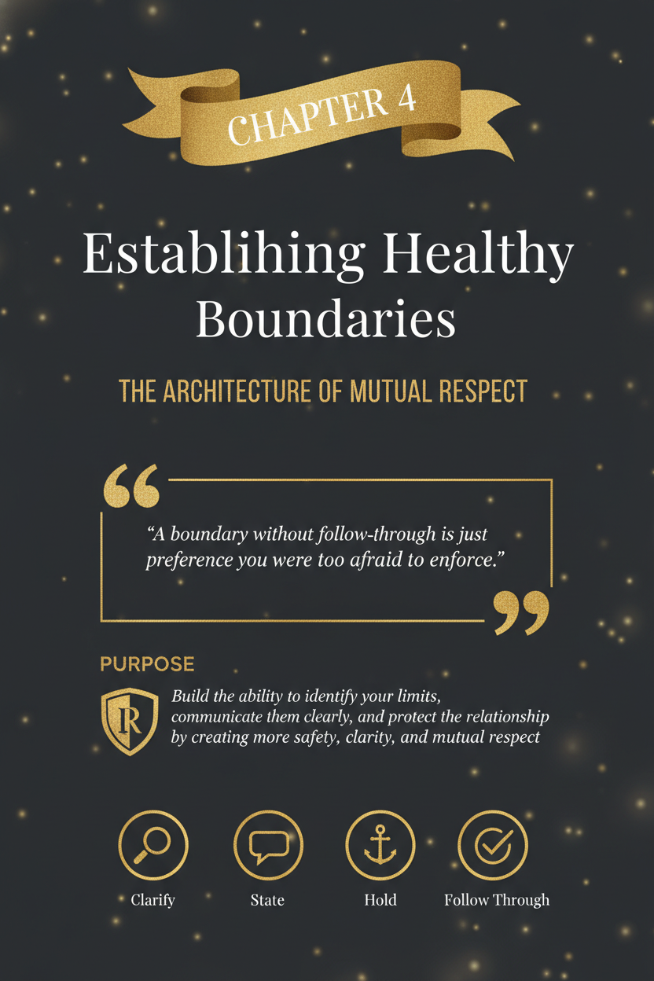

Chapter 4: Establishing Healthy Boundaries

Purpose
Build the ability to identify your limits, communicate them clearly, and protect the relationship by creating more safety, clarity, and mutual respect.

Why This Chapter Comes Next
Chapter 1 focused on emotional awareness. Chapter 2 focused on regulation. Chapter 3 focused on listening.
This chapter depends on all three.
You cannot set a healthy boundary well if you do not know what you are feeling, cannot regulate your delivery, or cannot listen to the other person’s response without collapsing, attacking, or over-explaining.
Many people think boundaries are mainly about saying no. They are not.
Boundaries define what protects trust, dignity, energy, time, and emotional safety in a relationship. They help answer questions like:
- What is okay for me?
- What is not okay for me?
- What do I need to stay open instead of resentful?
- What happens if this line keeps being crossed?
Without boundaries, relationships often become confusing and expensive. People over-accommodate, under-say, over-function, guess, resent, and finally explode. Then everyone acts surprised when the problem was visible much earlier.
If you apply this chapter well, you should see several early changes:
- less resentment,
- less confusion about expectations,
- fewer repeated violations,
- clearer requests,
- more self-respect in the way you relate.
That is not distance. That is structure.

What a Boundary Actually Is
A boundary is a clear statement of what you will allow, what you will not allow, and what you will do to protect the line if needed.
It is not a punishment. It is not a threat. It is not silent resentment. It is not controlling another person’s inner world.
A healthy boundary usually has three parts:
- 1. the limit,
- 2. the reason or value underneath it,
- 3. the action you will take if the limit is not respected.
For example:
“I’m willing to continue this conversation, but I’m not willing to be shouted at. If voices stay raised, I’m going to pause and come back later.”
That is a boundary.
It names the line. It names the condition. It names the response.

Preference, Request, Boundary, or Ultimatum?
Many people use the word boundary for several different things. That creates confusion.
Here is a cleaner distinction:
Type | Example | Meaning
Preference | “I’d rather talk earlier in the day.” | Desirable, but not required.
Request | “Can you text me if you’ll be late?” | A clear ask, but no enforcement is built in.
Boundary | “If you’re going to be late, I need a text. If I don’t get one, I’m not waiting to eat.” | A limit plus a self-protective action.
Ultimatum | “Do this or I’m done.” | A high-stakes final line.
Not every preference needs to become a boundary. Not every request needs a consequence. And not every boundary needs to sound like a final warning.
Using the right category helps you stay clearer and less dramatic.

Boundaries Are Not Control
This distinction matters because people often confuse the two.
A boundary says:
- This is what I will participate in.
- This is what I will not participate in.
- This is what I will do if the line is crossed.
Control says:
- You are not allowed to feel that.
- You must behave exactly how I prefer.
- I will manage your choices instead of my own participation.
A boundary is about your behaviour and your limits. A controlling move is about dominating the other person’s behaviour.
Compare the difference.
Boundary:
“If we are discussing something important, I need you not to walk away mid-sentence. If you need a pause, say that clearly, and I’ll respect it.”
Control:
“You are never allowed to leave the room when I’m talking.”
The first sets terms for mutual respect. The second treats access as ownership.

The Core Tool
Use this sequence:
Clarify → State → Hold → Follow Through

Clarify
Get clear about what the actual limit is.

State
Say it directly and specifically.

Hold
Do not over-explain, argue it into the ground, or apologise for having it.

Follow Through
If the line is crossed, do what you said you would do.
Boundaries fail most often at the fourth step.

Why People Struggle With Boundaries
Many people do not struggle because they are weak. They struggle because boundaries trigger fear.
Common fears include:
- fear of conflict,
- fear of abandonment,
- fear of seeming selfish,
- fear of being misunderstood,
- fear of being “too much,”
- fear that if you set a limit, you will have to enforce it.
Some people were raised in families where boundaries were mocked, punished, ignored, or treated as betrayal. Others learned to stay likable by staying available. Others confuse patience with self-erasure.
The result is often the same: they tolerate too much for too long, then speak only when full of resentment.
That usually makes the boundary sound harsher than it needed to sound earlier.
A late boundary often sounds like an explosion. An earlier boundary often sounds like clarity.

Signs You Need a Boundary
You probably need a boundary when:
- you keep saying yes when you mean no,
- you feel resentful after agreeing,
- you keep over-explaining your discomfort,
- the same issue keeps happening and “being patient” is not changing it,
- you dread certain conversations because the pattern is predictable,
- your time, energy, or dignity are repeatedly overrun,
- you keep hoping someone will “just know” without being told.
Resentment is often delayed boundary information.
It is rarely the first sign. It is usually what happens after many earlier signs were ignored.

Types of Boundaries
Not all boundaries are the same. A healthy relationship often needs several kinds.

Emotional Boundaries
Protect your inner life.
Examples:
- not taking responsibility for another person’s feelings instead of your own,
- not accepting contempt as normal,
- not staying in conversations that become degrading,
- not forcing emotional closeness on demand.

Time Boundaries
Protect attention, energy, and rhythm.
Examples:
- not having serious conversations at midnight,
- protecting decompression time after work,
- not making every request urgent by default.

Communication Boundaries
Protect the tone and form of engagement.
Examples:
- no name-calling,
- no shouting,
- no disappearing without a return plan,
- no major conflict by text when avoidable.

Physical Boundaries
Protect space, body autonomy, and safety.
Examples:
- respecting touch preferences,
- not blocking exits,
- not crowding during conflict,
- asking before moving into physically intimate repair.

Digital Boundaries
Protect privacy, attention, and trust.
Examples:
- expectations around phone use,
- device privacy,
- response-time assumptions,
- when not to continue conflict through messages.

Relational Boundaries
Protect the structure of the partnership itself.
Examples:
- what stays private versus shared with others,
- how in-laws are handled,
- what counts as respectful repair,
- how decisions get made.

Internal Boundaries
Not all boundaries are aimed outward. Some of the most important boundaries are with yourself.
Internal boundaries help you stop abandoning your own limits before anyone else has to cross them.
Examples include:
- not re-entering an argument when you are already flooded,
- not checking your phone repeatedly for reassurance,
- not saying yes just to avoid discomfort,
- not continuing to explain a boundary once it has already been stated clearly,
- not staying in conversations that are no longer constructive.
Internal boundaries often determine whether external boundaries hold.

Good Boundaries Are Clear, Specific, and Behavioural
Weak boundaries are often vague.
Examples:
“I need more respect.”
“I need space.”
“You need to do better.”
Those are emotionally understandable, but behaviourally unclear.
Stronger boundaries sound like this:
“If you need space, say that directly instead of going silent for hours.”
“I’m not available for conversations where I’m being mocked.”
“After 10 p.m., I’m not having heavy conflict conversations unless it is urgent.”
“If plans change, I need to be told before the last minute whenever possible.”
The more observable the behaviour, the more usable the boundary.

Weak Boundary vs. Strong Boundary
Weak boundary:
“I just need more respect.”
Stronger boundary:
“If you start mocking me during conflict, I’m ending the conversation and coming back later.”
The first communicates pain. The second communicates a usable limit.

The Structure of a Good Boundary Statement
A clean boundary usually includes:
- 1. the behaviour,
- 2. the effect,
- 3. the limit,
- 4. the follow-through.
Example:
“When I’m interrupted repeatedly, I stop being able to think clearly. I need us to take turns and let each other finish. If that keeps happening, I’m going to pause the conversation and come back later.”
You do not always need every part every time. But this structure helps keep boundaries direct and non-chaotic.

Self-Respect and Boundary Tone
A healthy boundary does not need a hostile tone to be real.
Many people unconsciously believe a boundary only counts if it sounds forceful enough to prove seriousness. Usually the opposite is true. Boundaries are strongest when they are calm, specific, and repeatable.
This does not mean soft to the point of collapse. It means steady.
Steady sounds like:
- clear,
- brief,
- behavioural,
- unhooked from drama,
- consistent over time.
A boundary stated calmly and enforced consistently is usually stronger than one delivered with theatrical intensity and no follow-through.

Worked Example: The Late-Night Conflict Loop
Jenna and Miles kept having major conversations after 11 p.m. Both were tired. Both were more reactive. The same arguments escalated because neither had enough capacity left to do them well.
Jenna kept telling herself they just needed to “try harder” to communicate. In reality, they needed a boundary.
The new boundary sounded like this:
“I’m willing to discuss hard things with you, but not late at night when we’re both already depleted. After 10 p.m., unless something is truly urgent, I want us to pause and come back the next day.”
Miles resisted at first. He said it felt like avoidance.
Jenna held the line:
“It’s not avoidance. It’s structure. I want us to do this better, not just longer.”
The issue did not disappear overnight. But the quality of conflict improved because the timing improved.
That is what a useful boundary often does: it changes the conditions so the relationship can function more intelligently.

Worked Example: When the Boundary Is Too Vague
Noah kept saying, “I just need more respect.” His partner, Leah, genuinely did not know what he meant in practice. To her, it sounded like a complaint without instruction.
When he finally got more specific, the issue became workable:
“When I’m still speaking and you laugh or cut in, I feel dismissed. I need you to let me finish my thought before responding. If that keeps happening, I’m going to stop the conversation and come back later.”
The emotional truth had been there all along. But the boundary only became usable when the behaviour became specific.

What Happens When a Boundary Is Tested
Most meaningful boundaries will be tested.
Not always because the other person is malicious. Sometimes because:
- they are used to the old pattern,
- they do not like losing easy access,
- they assume you will bend again,
- or they are uncomfortable with change.
This is where many people abandon the boundary too early.
They state it clearly, the other person pushes back, and they immediately move into:
- over-explaining,
- defending,
- apologising,
- softening it beyond usefulness,
- or not following through.
That teaches the relationship that the boundary is negotiable under pressure.
The more stable move is to restate the line, keep the tone calm, reduce extra explanation, and follow through if needed.

Responding to Boundary Pushback
Common pushback sounds like:
“You’re overreacting.”
“You’re too sensitive.”
“So now I have to walk on eggshells?”
“That’s just how I am.”
“You always make everything a big deal.”
A useful response is not to debate your right to have the boundary.
Try:
“You do not have to agree with the boundary for it to be real.”
Or:
“I’m not asking you to like this limit. I’m telling you what I need in order to stay in this conversation well.”
Or:
“You can disagree, but I’m still going to hold the line.”
Clarity is often more effective than persuasion.

Choosing a Good Consequence
A good follow-through is:
- immediate enough to connect to the issue,
- proportionate to the behaviour,
- behavioural rather than theatrical,
- enforceable by you,
- designed to protect clarity, not create fear.
Poor follow-through often sounds inflated, vague, punishing, or impossible to carry out.
Better follow-through usually sounds smaller and more realistic.
Inflated:
“If you interrupt me again, I’m done with this relationship.”
More usable:
“If the interruptions keep happening, I’m going to pause and come back when we can actually take turns.”
The goal is not to scare the other person into obedience. The goal is to protect the line in a way you can actually sustain.

Follow-Through Is What Makes a Boundary Real
A boundary without follow-through is often just a request with frustrated energy behind it.
This is not about punishment. It is about credibility.
If you say:
“If the shouting continues, I’m going to pause this conversation,”
then the shouting continues and you stay, the relationship learns that the line does not hold under pressure.
Follow-through can be small and still matter.
Examples:
- ending the conversation for now,
- leaving the room,
- not replying immediately to aggressive messages,
- refusing to continue a mocking exchange,
- declining a plan you already said you were not available for.
Follow-through does not need to be dramatic. It needs to be real.

Boundaries and Repair
Good boundaries do not make repair less likely. They make real repair more likely.
Why? Because repair works best when both people know:
- what crossed a line,
- why it mattered,
- and what needs to change next time.
A relationship with no boundaries often confuses repair with relief. People calm down, but nothing becomes clearer.
A relationship with better boundaries can say:
“That crossed a line.”
“This is why it mattered.” “This is what needs to happen differently next time.”
That is repair with structure.

Boundary Mistakes to Avoid

Waiting Too Long
The longer you wait, the more likely the boundary comes out as accumulated resentment.

Over-Explaining
Too much explanation often weakens clarity and invites argument about your reasons instead of engagement with the limit.

Making the Boundary Global
Avoid “always” and “never” language unless it is truly warranted.

Using a Boundary as a Threat
A boundary should protect clarity, not create fear for leverage.

Naming a Consequence You Will Not Enforce
Do not promise a response you already know you will not follow through on.

Confusing Discomfort With Wrongness
A boundary can feel uncomfortable and still be necessary.

If You Are the One Hearing a Boundary
Receiving a boundary well is also a relationship skill.
A useful response sounds like:
“I hear the line.”
“I may not like it, but I understand what you’re asking.”
“Say more about what would help.”
“That makes sense.”
“I can work with that.”
An unhelpful response sounds like:
“So I’m just the bad guy now?”
“You’re too much.”
“That’s ridiculous.”
“You’re making problems where there aren’t any.”
You do not need to love a boundary immediately to respect it.

Boundary Drill: The One-Sentence Limit
Use this once a day for one week.
Take one recurring frustration and reduce it to a single behavioural sentence.
Examples:
“If you need space, say that directly instead of disappearing.”
“I’m not available for mocking or name-calling.”
“After 10 p.m., I’m not doing heavy conflict conversations.”
The goal is not perfection. The goal is specificity.
Minimum Viable Boundary Rhythm
Use this for two weeks before judging whether your boundaries are improving.
- one resentment check each day,
- one boundary sentence practice each day,
- one follow-through review each week,
- and one conversation about what is and is not working.
Boundaries become more natural through repetition, not one emotionally intense moment of clarity.

Scripts

Script 1 — Basic Boundary
“I’m not okay with being spoken to like that. If it continues, I’m going to pause this conversation.”

Script 2 — Time Boundary
“I want to talk about this, but not when we’re both depleted. Let’s come back to it tomorrow at a better time.”

Script 3 — Digital Boundary
“I’m not going to keep arguing about this by text. I’m open to talking about it properly later.”

Script 4 — Repeated Interruption Boundary
“I want to hear you, and I want to finish my sentence too. If we keep interrupting, I’m going to slow this down and take turns.”

Script 5 — Pushback Response
“You do not have to agree with the boundary for it to be real.”

7-Day Starter Plan

Day 1 — Name One Resentment
Write down one place where resentment keeps building. Ask: What boundary information is inside this resentment?

Day 2 — Make It Behavioural
Turn one vague complaint into one specific line.

Day 3 — Shorten the Explanation
State the limit in two or three sentences, not ten.

Day 4 — Add Follow-Through
Decide what you will actually do if the line is crossed.

Day 5 — Practise Calm Delivery
Say the boundary out loud once when you are not activated.

Day 6 — Hold One Small Line
Enforce one low-stakes boundary without apologising for having it.

Day 7 — Review the Pattern
Ask:
- Where do I collapse most quickly?
- Which boundary is easiest for me to state?
- Which one is hardest?
- What kind of pushback hooks me fastest?
- What helped me stay clearer this week?

Growing Strength Indicators
You are getting better at this if you can increasingly say yes to the following:
- I know the difference between a limit and a complaint.
- I can state a boundary more clearly and briefly.
- I do not over-explain as quickly as I used to.
- I can tolerate some discomfort without abandoning the line.
- I follow through more consistently.
- I feel less resentment after clear communication.
- I can hear another person’s boundary without treating it as rejection.

Not-Yet Indicators
More work is needed if the following stay common:
- I wait until I am resentful before saying anything.
- My boundaries are too vague to be usable.
- I confuse boundaries with controlling other people.
- I soften the line as soon as there is pushback.
- I threaten consequences I do not enforce.
- I apologise for every limit I set.
- I call something a boundary when it is actually unspoken resentment.

QR Worksheet: Boundary Builder
Slug: ch04-boundary-builder

Scan or visit: https://shesnotcrazybook.com/ws/ch04-boundary-builder
Use the worksheet to record:
- the recurring issue,
- what line is being crossed,
- what value is being protected,
- the specific behaviour,
- the boundary statement,
- the follow-through,
- the pushback I expect,
- the calm response I will use,
- the outcome.
The goal is clarity, not hardness.

Practical Application Checklist
Use this chapter well if you can increasingly do the following:
- identify where resentment is signalling a missing limit,
- make boundaries behavioural and specific,
- state a limit calmly and clearly,
- distinguish boundaries from control,
- reduce over-explaining,
- hold the line when there is mild pushback,
- follow through on what you said you would do,
- and respond to another person’s boundary without unnecessary defensiveness.

Referral Note
This chapter is for relational skill-building. It is not enough for every situation.
Boundaries are especially important in difficult relationships, but they are not a substitute for a safety plan, legal protection, or specialised support when there is abuse, coercive control, stalking, intimidation, financial entrapment, or fear.
Use this material as support around higher-level care, not as a substitute for it, if the relationship regularly involves:
- threats,
- chronic contempt,
- retaliation for limits,
- stalking or surveillance,
- coercion,
- blocked exits,
- physical intimidation,
- severe emotional instability that makes follow-through unsafe.
Better boundaries are valuable. They are not a treatment for abuse or coercive control.

Recap
A boundary is not a punishment. It is a structure that protects dignity, clarity, and trust.
Remember the sequence:
Clarify → State → Hold → Follow Through
Clarify the line. State it clearly. Hold it without over-explaining. Follow through if needed.
That is how relationships become less confusing and less resentment-driven.
Boundaries do not create distance by default. Healthy boundaries make closeness safer.
Healthy boundaries can be revised when trust, context, and capacity change. The goal is not rigidity. The goal is clarity.
Boundaries do not eliminate conflict. They make conflict less chaotic and more repairable.
Do this today: Name one recurring frustration and turn it into one clean behavioural boundary sentence.

See Also
- Chapter 2: Recognising and Regulating Your Emotions
- Chapter 3: Active Listening — Hearing Beyond Words
- Chapter 6: The Art of Apology and Repair

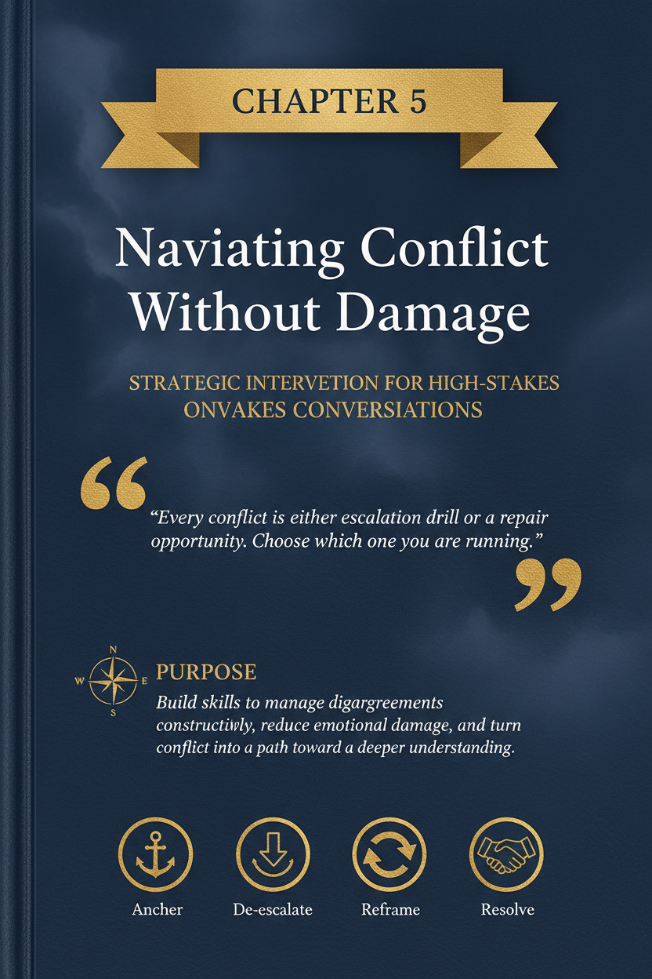

Chapter 5: Navigating Conflict Without Damage

Purpose
Build the skills to handle disagreement without turning conflict into disrespect, shutdown, or unnecessary relational damage.

Why This Chapter Comes Next
Chapter 1 focused on emotional awareness. Chapter 2 focused on regulation. Chapter 3 focused on listening. Chapter 4 focused on boundaries.
This chapter depends on all four.
You cannot navigate conflict well if you cannot recognise what you are feeling, regulate your activation, listen without moving straight into defence, or hold clear boundaries around what is and is not acceptable.
Conflict is inevitable in close relationships. The question is not whether you will disagree. The question is whether those disagreements will bring you closer or push you apart.
Many couples do not fail because they argue. They fail because their arguments become:
- repetitive,
- disrespectful,
- flooded,
- avoidant,
- or structurally unsolvable.
If you apply this chapter well, you should see several early changes:
- less escalation,
- fewer circular arguments,
- more clarity about what the conflict is really about,
- more productive repair after rupture,
- and more agreements that actually hold.
Conflict handled well does not weaken connection. It often strengthens it.

Conflict Is Not the Enemy
Conflict is not proof that the relationship is broken. It is proof that two real people have different needs, expectations, sensitivities, histories, capacities, and priorities.
Healthy relationships do not avoid conflict completely. They learn how to move through it without turning difference into contempt, defensiveness, or emotional injury.
Conflict becomes dangerous when it turns into:
- combat instead of problem-solving,
- scorekeeping instead of understanding,
- character attack instead of issue focus,
- or chronic avoidance instead of honest engagement.
The goal is not zero conflict. The goal is conflict without unnecessary damage.

Healthy Conflict vs. Destructive Conflict
Healthy conflict | Destructive conflict
issue-focused | contemptuous or humiliating
bounded and respectful | chaotic or intimidating
emotionally honest | manipulative or reality-distorting
recoverable | repeated without repair
reality-based | driven by coercion, fear, or chronic shutdown
Not all conflict is equal. Some conflict stretches a relationship. Some conflict corrodes it.

The Core Tool
Use this sequence:
Slow → Name → Listen → Solve → Seal

Slow
Reduce speed, volume, and reactivity before the conflict outruns your skill.

Name
Name the real issue and the emotional layer underneath it.

Listen
Let each person feel accurately heard before trying to win, fix, or close.

Solve
Focus on the smallest workable solution, not total victory.

Seal
End with clarity: what was understood, what changes next, and when you will revisit if needed.
This is how conflict stops being a free-for-all and becomes a structured conversation.

Common Conflict Patterns
Many arguments are not actually new. They are familiar patterns wearing new clothes.

Criticism vs. Defence
One person raises a complaint harshly. The other responds by explaining, deflecting, or counter-attacking.

Pursue vs. Withdraw
One person pushes harder for engagement. The other shuts down, goes quiet, or leaves. The more one pursues, the more the other withdraws.

Fix vs. Feel
One person wants emotional understanding first. The other wants to solve the issue immediately. Both feel unsupported.

Issue Stacking
A current disagreement becomes a container for five older grievances that were never resolved.

Scorekeeping
The conversation turns into who has done more, failed more, tried more, or hurt more.

Tone Drift
The issue changes because tone becomes the new issue.
Pattern recognition matters because most couples waste energy arguing about the surface event while ignoring the recurring structure underneath it.

Know Your Conflict Style
Different people default to different conflict styles under pressure.
Common styles include:
- Escalating: louder, faster, more forceful,
- Avoiding: delaying, minimising, changing the subject,
- Defending: explaining intention before hearing impact,
- Over-accommodating: agreeing too quickly to end discomfort,
- Analysing: intellectualising instead of staying with the emotional point,
- Shutting down: going blank, cold, or unreachable.
No style is automatically wise just because it is familiar.
A useful question is:
What do I tend to do when conflict starts to feel emotionally expensive?
That answer often tells you more than the conflict topic itself.

Solvable vs. Perpetual Conflicts
Not every conflict should be approached the same way.

Solvable Conflicts
These are usually practical, logistical, or structural.
Examples:
- chores,
- schedules,
- routines,
- shared roles,
- money systems,
- planning problems.
These conflicts often improve through clearer agreements, better systems, and more follow-through.

Perpetual or Manageable Conflicts
These are often rooted in temperament, personality, family culture, pace, preference, or sensitivity differences.
Examples:
- one person wants more processing time,
- one person wants more spontaneity,
- one person is more socially open than the other,
- one person needs more reassurance,
- one person prefers more structure.
These conflicts may never disappear completely. The goal is not fantasy closure. The goal is better navigation, less damage, and more realistic accommodation.
That distinction matters. If you try to solve a perpetual difference like a spreadsheet problem, you often create more frustration instead of less.

What Conflict Is Usually Really About
Most recurring conflict is not only about the visible issue.
The dishes may be about shared load. The lateness may be about respect. The silence may be about abandonment. The phone may be about attention. The tone may be about dignity.
If you only argue about the surface event, you often miss the underlying meaning.
A useful shift is this:
- What happened?
- What did it mean to each of us?
- What need was threatened?
That moves the conversation from accusation to understanding.

The Fair Fighting Rules
Conflict becomes less destructive when both people agree to a few rules before they need them.

Stay on One Issue
Do not turn one conflict into a container for everything unresolved.

No Name-Calling
Contempt does not clarify. It corrodes.

No Mind-Reading
Say what you observed and what you felt. Do not announce the other person’s motives as fact.

No Absolute Language
Use fewer “always” and “never” claims unless they are actually true.

No Public Humiliation
Do not continue sensitive conflict in front of children, friends, family, or strangers.

No Major Conflict by Text When Avoidable
Text is a poor place for emotionally loaded repair.

No Blocked Exits or Cornering
If someone needs a pause, the pause must be possible.

No Weaponising Vulnerability
Do not use previously shared pain as ammunition.

Use Time-Outs With Return
Pausing is fair. Disappearing is not.
Fair fighting does not mean conflict feels pleasant. It means the conflict remains workable.

De-Escalation Techniques
When conflict starts to speed up, the first job is not resolution. It is stabilisation.
Useful de-escalation moves include:

Lower the Pace
Speak more slowly. Use fewer words. Let silence do some work.

Lower the Volume
Raised voices rarely create better comprehension.

Name the State
Try:
“I’m getting activated and I want to do this well.”

Shorten the Target
Instead of solving the whole relationship, solve the next ten minutes.

Take a Structured Pause
Try:
“I need twenty minutes to settle, and I will come back at 7:40.”

Validate One Thing First
Validation lowers threat even before agreement exists.

Sit Beside the Problem, Not Inside It
Treat the conflict as something both of you are facing, not as proof that one of you must lose.
De-escalation is not avoidance. It is what makes actual resolution possible.

When to Pause vs. When to Continue
Continue if both people are still able to:
- listen,
- reflect,
- stay on one issue,
- and remain basically respectful.
Pause if either person is:
- flooded,
- contemptuous,
- repetitive,
- incoherent,
- or no longer engaging the issue in good faith.
The best pause comes early enough to protect the conversation, not so late that it only interrupts damage already done.

Use “I” Statements Without Turning Them Into Disguised Blame
“I” statements help when they reduce accusation.
Helpful:
“I felt dismissed when the plan changed and I found out late.”
Less helpful:
“I feel like you never care about anyone but yourself.”
That second example starts with “I feel,” but it is still an attack.
A clean structure sounds like:
- what happened,
- what I felt,
- what meaning I made of it,
- what I need now.
For example:
“When dinner changed at the last minute, I felt frustrated and unimportant. I made it mean my time wasn’t being considered. Next time I need earlier notice if possible.”
That is clearer and easier to work with.

Worked Example: The Real Conflict Beneath the Dishes
Ava says:
“You never help unless I ask three times.”
Marcus hears accusation and starts defending himself:
“That’s not true. I helped yesterday.”
The old pattern begins.
But when they slow down, the real issue becomes clearer.
Ava is not only talking about dishes. She is talking about mental load and feeling alone in carrying the relationship’s invisible work.
A better version sounds like this:
“The dishes are part of it, but the bigger issue is that I feel like I have to manage the whole system. I don’t want help only after prompting. I want more shared ownership.”
Marcus responds:
“So the issue is less this one task and more that you feel like the manager by default. That makes sense. Let’s figure out what shared ownership actually looks like.”
Now the problem is finally the real problem.

Worked Example: Escalation vs. Structure

Version A — Combat
Speaker: “You ignored my message for hours.”
Listener: “I was working. Not everything is about you.”
Speaker: “See? This is exactly the problem. You always make me feel stupid for caring.”
Listener: “Because you’re dramatic.”
The topic is now lost. Tone has taken over.

Version B — Conflict Without Damage
Speaker: “When I didn’t hear back for hours, I felt brushed aside.”
Listener: “You felt unimportant in that moment?”
Speaker: “Yes. I know you were working, but it hit me that way.”
Listener: “I can understand that. I wasn’t ignoring you, but I can see why it landed badly. Next time I can send a quick heads-up if I’m going dark for a while.”
What changed:
- less defensiveness,
- clearer emotional meaning,
- no name-calling,
- specific future adjustment.
That is conflict moved back into structure.

Worked Example: A Conflict That Should Not Be Solved Immediately
Rae and Daniel start a serious conversation at 11:20 p.m. about family plans. Within minutes, both are sharper than usual. Rae is repeating herself. Daniel is half-listening and rubbing his face. Neither is processing well.
The issue is real. The timing is bad.
Instead of forcing closure, Rae says:
“This matters, and I don’t want to do it badly. We’re both too depleted to solve it well tonight.”
Daniel answers:
“Agreed. Let’s pause and pick it up tomorrow at 6:30. I’m not brushing it off. I just don’t think we can do it cleanly right now.”
They do not finish the conflict that night. But they do close it with structure:
- the issue is acknowledged,
- the pause is mutual,
- the return time is set,
- reassurance is given.
Not every conflict needs immediate resolution. Some need a safer window.

Looping Conflicts
A looping conflict is an argument that feels different on the surface but keeps following the same structure underneath.
It often sounds like:
“We’ve already talked about this.”
“We keep ending up here.”
“This is the same fight again.”
“Nothing changes even when we discuss it.”
Loops happen when:
- the deeper issue is never named,
- the same pattern keeps replaying,
- the conversation ends without a usable agreement,
- or the agreement is made but not revisited.

How to Interrupt a Loop
- 1. stop and name the loop,
- 2. identify the deeper issue,
- 3. ask what is still unresolved,
- 4. make one specific next-step agreement,
- 5. revisit later if needed rather than pretending it is settled.
Try:
“I think we’re back in the same loop. Let’s stop arguing about the surface version and name what keeps not getting resolved.”
Naming the loop is often the first moment the conflict becomes different.

Finding Win-Win Solutions
Not every conflict has a perfect solution. But many conflicts improve when both people move from positions to needs.
A position sounds like:
“I want you to stop asking so many questions.”
A need sounds like:
“I want to feel trusted when I’m already trying.”
A position sounds like:
“I want to talk right now.”
A need sounds like:
“I want reassurance that this matters and won’t be avoided.”
Once needs are visible, solutions become easier.
Try this process:
- 1. each person states the issue,
- 2. each person names the need underneath it,
- 3. brainstorm more than one possible solution,
- 4. choose the smallest workable next step,
- 5. agree on who will do what,
- 6. revisit if needed.
Win-win does not mean both people get everything. It means neither person has to disappear for the solution to work.
A workable agreement can be revised if it stops fitting reality. The goal is not perfection. The goal is better functioning.

When You Need a Pause
A pause can protect the conflict or damage it.
A good pause:
- is named clearly,
- happens before total flooding,
- includes a return time,
- and is used to regulate, not rehearse a better attack.
Try:
“I want to keep going, but not like this. I need twenty minutes, and I’ll come back at 8:10.”
A bad pause sounds like:
- storming off,
- going silent for hours,
- refusing to say when you will return,
- or continuing the conflict through hostile text.
The pause only helps if the reconnection is real.

Conflict Mistakes to Avoid

Solving Too Early
If the feeling is not understood yet, the solution usually does not land.

Focusing on the Smallest Inaccuracy
Minor factual correction is often used to avoid the larger emotional point.

Bringing in the Entire Relationship
Keep the conflict proportionate to the actual issue.

Demanding Immediate Resolution
Some conflicts need a second conversation, not a forced same-night ending.

Confusing Intensity With Honesty
Louder is not truer.

Treating Pauses as Abandonment or Punishment
The quality of the pause matters.

Forgetting to Close the Loop
If nothing is agreed, the conflict often simply waits to happen again.

If You Are the One Raising the Issue
Make yourself easier to hear.
That does not mean making yourself smaller. It means being clearer.
Helpful moves:
- raise one issue at a time,
- use specifics,
- name the feeling underneath the frustration,
- ask for the kind of response you need,
- stay close to the actual event.
Example:
“I’m not trying to start a fight. I want to talk about one thing that’s been sitting with me and get to a cleaner solution.”
That kind of opening helps reduce immediate defensiveness.

Conflict Resolution Toolkit
Use this toolkit when a disagreement starts to slide.
- one slower breath,
- one feeling word,
- one reflection sentence,
- one clarifying question,
- one boundary if tone deteriorates,
- one pause with a return time if flooded,
- one specific next-step agreement before ending.
The goal is not to use every tool every time. The goal is to stop having no tools at all.

Role-Play Suggestions
Use these for structured practice when the relationship is calm.

Role-Play 1 — Late Reply, Calm Repair
One person raises concern about delayed communication. The other practises listening, naming the emotional meaning, and agreeing on a future adjustment.

Role-Play 2 — Interruption Boundary
One person keeps interrupting. The other practises stating a boundary calmly and slowing the conversation down without attacking.

Role-Play 3 — Time-Out With Return
Both partners practise pausing a rising conflict and re-entering at the agreed time.
Keep role-plays short. The aim is skill rehearsal, not theatre.
Minimum Viable Conflict Rhythm
Use this for two weeks before judging whether conflict is improving.
- one conflict review each week,
- one deliberate de-escalation practice,
- one repair attempt after rupture,
- and one agreement check-back.
Conflict gets cleaner through repetition, reflection, and follow-through, not through one impressive conversation.

Scripts

Script 1 — Slowing the Conflict
“I want to talk about this, but not in a way that makes it worse. Let’s slow down.”

Script 2 — Naming the Real Issue
“The surface issue is small, but what it brought up for me is bigger.”

Script 3 — De-Escalation
“I’m getting activated. I want to keep this constructive, so I need to lower the temperature first.”

Script 4 — Win-Win Framing
“Let’s figure out what would work for both of us instead of arguing for total victory.”

Script 5 — Closing the Loop
“Before we stop, let’s make sure we’re clear on what we each understood and what changes next.”

7-Day Starter Plan

Day 1 — Notice Your Conflict Style
Write down what you tend to do first under conflict: escalate, explain, avoid, shut down, fix, or appease.

Day 2 — Catch One Pattern
Notice one recurring pattern: criticism/defence, pursue/withdraw, tone drift, or issue stacking.

Day 3 — Use One “I” Statement Cleanly
Raise one issue without accusation.

Day 4 — Validate Before Solving
In one disagreement, reflect the other person’s feeling before offering your point.

Day 5 — Practise a Pause With Return
Use a structured pause before flooding.

Day 6 — Name the Underlying Need
Ask: What is this conflict really about underneath the surface event?

Day 7 — Review the Week
Ask:
- What pattern showed up most often?
- Where did we escalate fastest?
- What helped de-escalate?
- Did we actually close the loop?
- What will we repeat next week?

Growing Strength Indicators
You are getting better at this if you can increasingly say yes to the following:
- I recognise common conflict patterns sooner.
- I can stay on one issue longer.
- I interrupt less and reflect more.
- I can de-escalate before the conflict gets out of hand.
- I can name the emotional meaning under the surface issue.
- I look for workable solutions instead of total victory.
- We leave more conflicts with clarity than confusion.

Not-Yet Indicators
More work is needed if the following stay common:
- every disagreement turns into character judgment,
- tone becomes the whole conflict,
- we keep stacking unresolved issues,
- I push for resolution when I am too activated to think clearly,
- I use pauses badly or do not return,
- I care more about being right than being accurate,
- we finish arguments without any clear next step.

QR Worksheet: Conflict Map
Slug: ch05-conflict-map

Scan or visit: https://shesnotcrazybook.com/ws/ch05-conflict-map
Use the worksheet to record:
- the trigger,
- the visible issue,
- the deeper meaning,
- each person’s likely need,
- the conflict pattern that appeared,
- where escalation began,
- what de-escalation tool was used,
- the agreement reached,
- what still needs repair.
The goal is pattern visibility, not perfect conflict.

Practical Application Checklist
Use this chapter well if you can increasingly do the following:
- recognise your conflict style,
- identify recurring conflict patterns,
- stay on one issue at a time,
- use fair fighting rules consistently,
- de-escalate before the argument outruns your skill,
- listen for the emotional meaning under the surface issue,
- seek workable solutions rather than total victory,
- and close the loop with a clear next step.

Referral Note
This chapter is for relational skill-building. It is not enough for every situation.
Conflict skills do not require staying in interactions that are unsafe, degrading, coercive, or physically intimidating.
Use this material as support around higher-level care, not as a substitute for it, if the relationship regularly involves:
- threats,
- intimidation,
- chronic contempt,
- blocked exits,
- stalking or surveillance,
- retaliation for speaking up,
- coercive control,
- physical aggression,
- severe emotional instability that makes safe conflict impossible.
Better conflict skills are valuable. They are not a treatment for abuse or coercive control.

Conflict Is Not Finished When the Argument Stops
A conflict is not finished just because the volume dropped or the conversation ended.
A conflict is finished when one of two things happens:
- genuine clarity is reached,
- or meaningful repair begins.
If the argument stops but the injury remains unaddressed, the conflict usually returns in another form.
That is why conflict and repair belong together. The end of a disagreement should move toward understanding, accountability, reconnection, or a clear plan for what happens next.
That is also why Chapter 6 matters.

Recap
Conflict is not the enemy. Damage is.
Remember the sequence:
Slow → Name → Listen → Solve → Seal
Slow the conflict. Name the real issue. Listen before you try to win. Solve for the smallest workable next step. Seal the conversation with clarity.
That is how disagreement becomes less destructive and more revealing.
Good conflict does not mean no pain, no friction, or no strong feeling. It means the relationship survives the honesty.
Do this today: In your next disagreement, name the deeper issue underneath the surface complaint before you try to solve it.

See Also
- Chapter 2: Recognising and Regulating Your Emotions
- Chapter 3: Active Listening — Hearing Beyond Words
- Chapter 6: The Art of Apology and Repair

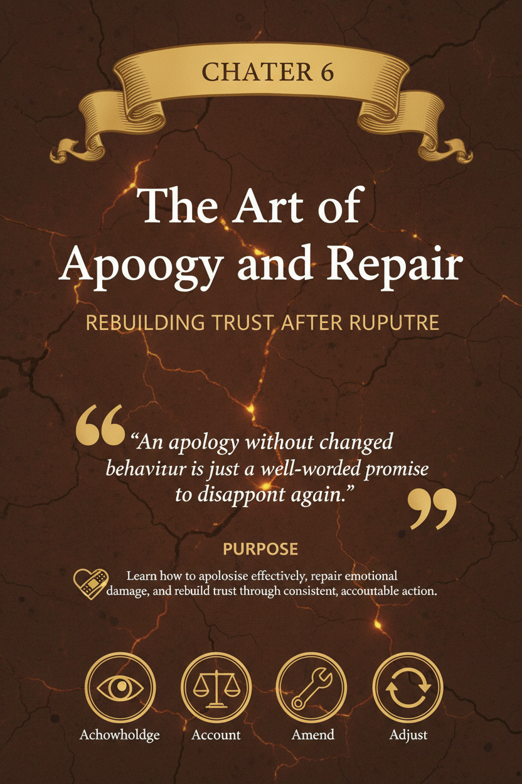

Chapter 6: The Art of Apology and Repair

Purpose
Build the ability to repair relational ruptures cleanly, apologise without defensiveness, and translate remorse into visible change that can actually rebuild trust.

Why This Chapter Comes Next
Chapter 1 built emotional awareness. Chapter 2 built regulation. Chapter 3 built listening. Chapter 4 built boundaries. Chapter 5 built conflict skills.
This chapter depends on all five.
You cannot repair well if you cannot recognise what happened, regulate your urge to defend yourself, listen to the impact of your behaviour, respect boundaries around timing and tone, or stay steady enough to take responsibility without turning the conversation into self-protection.
Conflict and repair belong together.
A disagreement is not finished just because the room is quiet. Many couples stop at the end of the argument and mistake that for resolution. It is not. If the injury remains unaddressed, the conflict usually returns in another form: colder tone, sharper defensiveness, less trust, more distance, more scorekeeping, and less generosity.
Repair is the bridge between rupture and reconnection.
If you apply this chapter well, you should start to see:
- faster recovery after conflict,
- fewer fake apologies,
- less lingering resentment,
- more believable accountability,
- clearer prevention steps,
- and more trust in the relationship’s ability to survive honesty.

Learning Objectives
By the end of this chapter, you should be able to:
- distinguish apology from actual repair,
- name the specific behaviour that caused harm,
- validate impact without moving too quickly into defence,
- recognise weak, diluted, or performative apologies,
- create one visible repair step that reduces recurrence,
- and understand why forgiveness, reconciliation, and trust rebuild happen on different timelines.

The First Distinction That Changes Everything

Ending the Argument Is Not the Same as Repair
An argument can end because:
- one person shut down,
- one person gave up,
- both people got exhausted,
- time ran out,
- or one person decided to “move on” without addressing impact.
None of that is repair.
Repair begins when someone becomes more committed to truth and reconnection than to self-protection.
That usually sounds like:
“You’re right. Let me name what I did.”
“I can see how that landed.”
“I don’t want to defend myself before I understand the damage.”
“I handled that badly.”
“Here is what I will do differently next time.”
The hurt person is rarely looking only for the words I’m sorry. They are looking for evidence that reality has been seen, responsibility has been taken, and the same injury is less likely to repeat.

Apology vs Repair vs Forgiveness vs Reconciliation vs Trust Rebuild
This distinction needs to stay clean.
Concept | What it is | What it is not
Apology | Verbal acknowledgement of harm and responsibility | Instant repair
Repair | Actions that reduce damage, restore safety, and address the rupture | Emotional theatre
Forgiveness | A personal release process that may happen over time | Denial of harm
Reconciliation | Renewed closeness, openness, or partnership after rupture | Automatic entitlement
Trust rebuild | Repeated evidence over time that the pattern is changing | Reward for one good conversation
A good apology matters. Repair matters more. Trust rebuild matters longest.
That order protects reality.

The Core Tool
Use this sequence:
Name → Validate → Own → Amend → Ask

Name
Say clearly what you did.
Not the vague category.
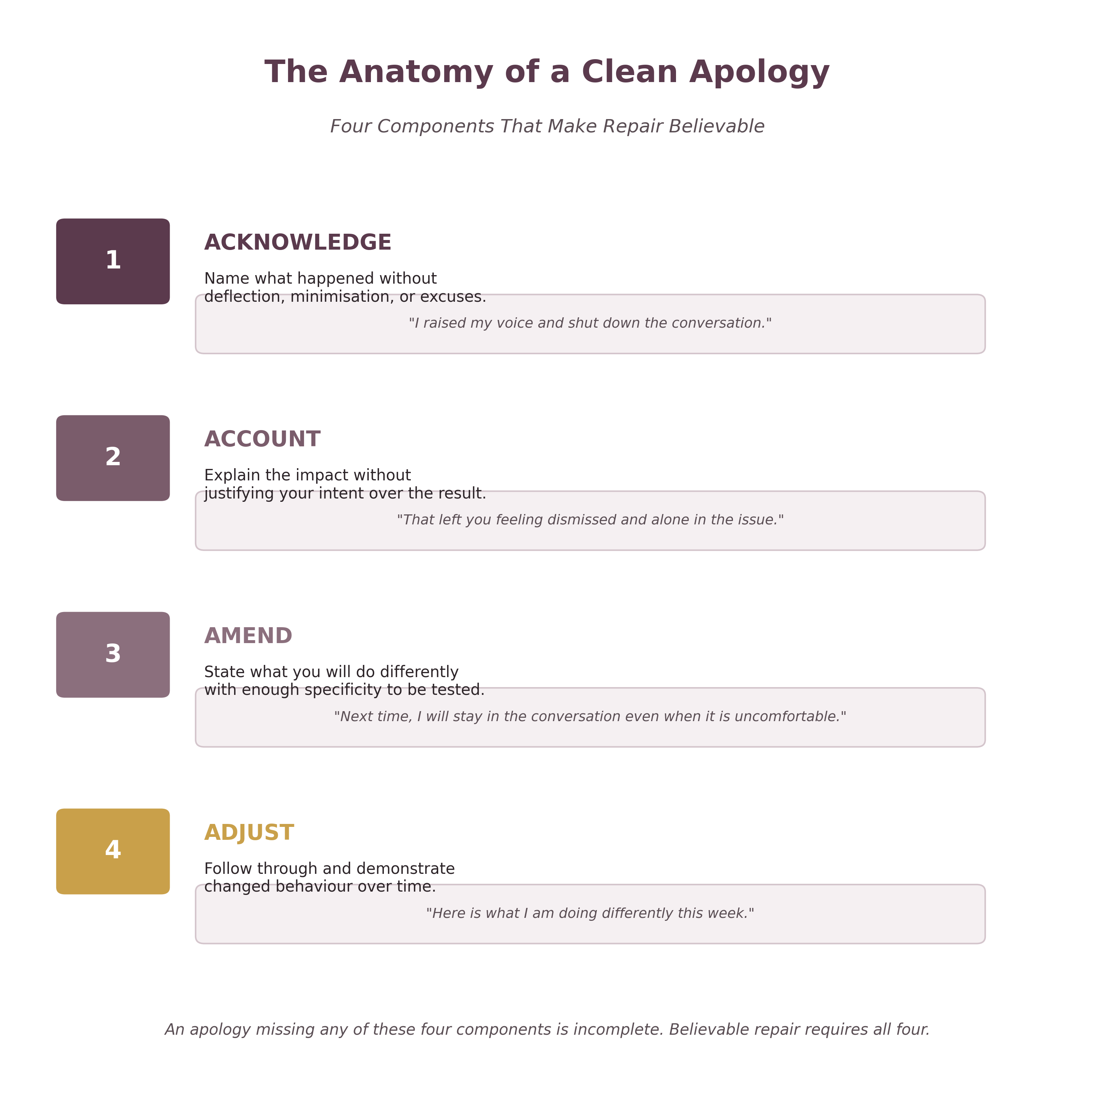
The Clean Apology Framework
Not the version that protects your image.
Bad:
“I’m sorry for everything.”
Better:
“I’m sorry I raised my voice, interrupted you twice, and then walked away without telling you I needed a pause.”
Specificity builds credibility.

Validate
Name the likely impact without arguing with it.
Bad:
“I’m sorry you took it that way.”
Better:
“I can see that made you feel dismissed and alone.”
Validation does not require full agreement about every detail. It requires seriousness about the other person’s experience.

Own
Take responsibility without excuse, dilution, or equal-blame bargaining.
Bad:
“I’m sorry, but you were doing it too.”
Better:
“That was my behaviour. I chose it. It was not okay.”
Ownership is where many apologies fail.

Amend
State what will change in behaviour, structure, or rhythm.
Bad:
“I’ll try to do better.”
Better:
“Next time I feel myself getting that activated, I’m going to call a 20-minute pause before my tone changes.”
Change must be visible. Otherwise, the apology becomes emotional performance.

Ask
Make room for the other person’s needs without demanding reassurance.
Examples:
“Is there anything else you need me to understand about how that landed?”
“What would feel repairing right now?”
“Do you need space, a fuller conversation, or one concrete next step from me?”
Ask with openness, not strategy.

What a Genuine Apology Actually Does
A genuine apology does five things:
- names the behaviour,
- validates the impact,
- takes responsibility,
- states a change,
- and makes room for the other person’s needs.
It does not ask for instant absolution.
It says, in effect:
I see what happened. I see my part in it. I see how it affected you. I am not asking you to ignore that. I am trying to make safety and truth more possible from here.

Regulate Before Repairing
This is where Chapter 2 matters again.
Many people know they need to apologise but try to do it while still flooded, ashamed, defensive, or half-committed to arguing their case. That usually produces a pseudo-apology.

Regulate Before Repairing Means:
- do not apologise while still flooded,
- do not disappear indefinitely,
- do not convert guilt into dramatic self-condemnation,
- do not use delay as avoidance,
- return with clarity, not collapse.
A cleaner version sounds like:
“I’m too defensive right now to apologise well, and I don’t want to do this badly. Give me 20 minutes to settle, and I will come back.”
Or:
“I need a little time to think so I can take proper responsibility, but I’m not disappearing from this. I’ll come back tonight.”
A pause without return feels like abandonment. A pause with clear re-entry is regulation.

Self-Repair Matters Too
If you are the one who caused harm, your first internal tasks are to:
- lower activation,
- stop rehearsing your defence,
- separate shame from accountability,
- and return ready to tell the truth.
Remorse is useful. Collapse is not.
If your apology turns into “I’m the worst person alive,” the hurt person now has to manage your shame on top of their own pain. That is not repair. That is burden transfer.

Intention and Impact
One of the biggest obstacles to repair is the belief that good intention should cancel bad impact.
It does not.
You may not have meant to humiliate, dismiss, frighten, ignore, pressure, embarrass, or abandon your partner. If that is how it landed, that reality still matters.
Intent answers one question:
What was I trying to do?
Impact answers another:
What happened on the receiving end?
Repair requires respect for both, but impact usually needs to be addressed first.
Why? Because a hurt person who is still trying to get you to acknowledge reality cannot meaningfully receive your explanation yet. If you move too quickly to intent, they often hear:
“My self-image matters more than your experience.”
“Your pain is inconvenient.”
“I need you to know I’m a good person before I know what happened to you.”
A better order is:
- 1. acknowledge what happened,
- 2. validate the impact,
- 3. own your part,
- 4. then explain context only if it helps without erasing responsibility.
For example:
“I didn’t mean to dismiss you, but I can see that I did. I interrupted, corrected your tone, and moved to solutions before understanding you. I can see why that felt lonely and frustrating. That part is on me.”
That lands very differently from:
“I wasn’t dismissing you. I was just trying to help.”
Address impact first. Explain intent later, and only in ways that clarify without erasing responsibility.

Why Apologies Fail
Most failed apologies break down in predictable ways.

Vague Apology
“Sorry about before.”
This sounds like the speaker wants closure without precision.

Defensive Apology
“I’m sorry, but you were yelling too.”
This is not repair. It is shared-blame negotiation.

Impact-Denying Apology
“I’m sorry you feel that way.”
This distances the speaker from responsibility.

Self-Centred Apology
“I feel like the worst person in the world.”
Now the hurt person has to comfort you.

Urgency Apology
“I said I’m sorry. What more do you want?”
This reveals that the apology was mainly a bid to stop discomfort.

Promise-Only Apology
“It won’t happen again.”
Without acknowledgement, validation, ownership, and structure, this is thin.
A weak apology usually tries to escape shame faster than it tries to repair harm.

Repeated Minor Ruptures Matter Too
Repair is not only for visible blowups.
Many relationships corrode through accumulation:
- distracted listening,
- lateness,
- dismissive tone,
- screen absorption,
- forgotten follow-through,
- sarcasm,
- low-grade defensiveness,
- emotional absenteeism,
- repeated “small” letdowns that never get named.
The problem is not always one dramatic event. Sometimes it is the steady drip of minor injuries that teach the other person, over time, that they cannot count on warmth, steadiness, or accurate care.
A strong relationship repairs both major ruptures and repeated micro-ruptures.
A simple apology after a small miss can prevent a larger conflict later:
“I was half-listening just then and made you repeat yourself. That was dismissive. I’m sorry. Say it again—I want to actually hear you.”
That kind of fast, clean repair has major long-term value.

Remorse vs Repair
Remorse is internal. Repair is relational.
You can feel terrible and still not repair well.
A person may cry, feel guilty, hate what happened, and genuinely wish they had handled it differently. None of that automatically repairs anything. Internal regret matters, but the relationship cannot build trust from feelings it cannot see.
Repair requires movement.
It usually includes some combination of:
- clear acknowledgement,
- listening to impact,
- changed behaviour,
- restitution where appropriate,
- and tolerance for the fact that trust may return more slowly than regret.
This is why many hurt partners say:
“You say sorry, but nothing changes.”
“You feel bad, but I still carry the impact.”
“The apology sounded good, but I don’t trust it yet.”
Those responses are not cruelty. They are often evidence that the relationship has seen emotion without enough change.
Remorse matters. Repair proves it.

Credible Repair vs Performative Repair
This is one of the most important distinctions in the chapter.

Signs Repair Is Credible
- specificity increases,
- defensiveness decreases,
- behaviour changes before the next rupture,
- accountability remains present even when forgiveness is not immediate,
- the same harm becomes less frequent and less intense,
- repair attempts happen earlier,
- structural changes hold without repeated prompting.

Signs Repair Is Performative
- quick tears without clear ownership,
- repeated “I said sorry” pressure,
- minimising impact,
- pushing for fast forgiveness,
- improved language with unchanged behaviour,
- apologising beautifully while resisting real change,
- making the hurt person manage the apologiser’s shame.
Use these five questions as a quick repair test:
- 1. Did the apology name the behaviour clearly?
- 2. Did it take responsibility without dilution?
- 3. Was the impact treated seriously?
- 4. Is there a concrete change attached?
- 5. Does behaviour improve over time without repeated prompting?
If most answers are no, the repair is weak no matter how emotionally intense it sounded.

Repair Attempt vs Premature Smoothing
A repair attempt is meant to restore honesty and safety. Premature smoothing is meant to end discomfort before the truth has fully landed.
Examples of premature smoothing:
“Can we just move on?”
“You know I didn’t mean it.”
“Let’s not ruin the whole day.”
“I already said sorry, so why are we still here?”
Examples of actual repair attempts:
“Let me restart that—I got defensive.”
“You’re right. I’m focused on my intent, not your impact.”
“I can hear this still hasn’t landed. Let me stay with it.”
“What part still feels unresolved?”
Do not confuse fast emotional smoothing with repair.

Repair Attempts During Conflict
Not all repair happens after the rupture. Some repair attempts happen inside the conflict itself.
These smaller moves matter because they stop further damage from accumulating.
Examples:
“You’re right. Let me restart that.”
“I’m getting defensive. Slow me down.”
“That came out harsher than I meant. Let me try again.”
“I’m arguing with your tone because I don’t want to face the point.”
“We’re off track. The issue matters more than my pride.”
Many couples miss small repair windows repeatedly. The result is that manageable conflict hardens into distrust. Early repair attempts keep the rupture from deepening.

Making Amends and Preventing Recurrence
The strongest apology is not eloquent. It is useful.
Useful apologies reduce the odds of recurrence.
Ask:
- What exactly happened?
- What pattern was underneath it?
- What was I protecting?
- What should happen earlier next time?
- What structure would make repetition less likely?

Amends Are Not Only Material
Many readers hear “make amends” and think of gifts, flowers, treats, or symbolic gestures.
Sometimes that can be part of repair. Usually it is not enough.
Relational amends are often behavioural, structural, or practical.
Examples:
- initiating the hard follow-up conversation instead of waiting to be chased,
- correcting a public misstatement,
- taking over the burden created by your mistake,
- putting agreements into writing, a calendar, or reminders,
- creating a repeatable check-in,
- changing your response timing,
- reducing screen use in key conversations,
- following through on a promise without needing repeated prompting.
Repair gets stronger when it becomes operational.
For example:
Injury: You shouted during conflict. Pattern underneath it: You stayed in the conversation after you were already flooded. Repair plan: You agree on an earlier pause threshold and a return time.
Or:
Injury: You forgot something important repeatedly. Pattern underneath it: You relied on memory instead of structure. Repair plan: Shared calendar, alerts, and an explicit follow-through check.
Or:
Injury: You disappeared after conflict. Pattern underneath it: You use silence to regulate but do not signal the pause. Repair plan: You send: “I need an hour to settle. I’m not abandoning this. I’ll return at 8:30.”

Family-of-Origin and Apology Style
Some people come from families where apology was normal, direct, and safe.
Others come from families where:
- apology meant weakness,
- accountability led to humiliation,
- nobody apologised unless forced,
- emotional harm was minimised,
- or “moving on” mattered more than truth.
If apologising feels unusually hard, awkward, exposing, or shame-heavy, that may be part of the reason.
That context can explain difficulty. It does not remove responsibility.
Part of adulthood is outgrowing apology habits that damage closeness.

Worked Examples

Example 1 — The Raised Voice
Nina brings up feeling unsupported. Eli becomes defensive, raises his voice, and says:
“Nothing I do is ever enough for you.”
Nina goes quiet. The conversation ends coldly.
A weak apology sounds like:
“Sorry, I was stressed.”
That may be true, but it is too thin.
A better repair sounds like:
“I’m sorry I raised my voice and made the conversation feel unsafe. You were trying to tell me something important, and I turned it into defence. I can see how that would feel intimidating and lonely. That was my behaviour, and it was not okay. Next time I notice myself getting that activated, I’m going to call a pause before the volume rises. If you’re up for it, I’d like to come back and hear what you were trying to tell me.”
What changed:
- specific behaviour named,
- impact validated,
- responsibility taken,
- future change made visible,
- conversation reopened.

Example 2 — The Forgotten Promise
Amira asks Jay to handle a task that matters to her. He agrees. He forgets. She ends up carrying it again.
Jay says:
“I said I was sorry.”
Amira is still upset.
Why? Because the issue is not only the forgotten task. It is the meaning:
- I can’t rely on you.
- I keep carrying the mental load.
- Your apology costs you less than your forgetfulness costs me.
A better repair sounds like:
“I’m sorry I told you I’d handle it and then didn’t. That left you carrying the burden again, and I can see why that feels exhausting and unfair. I should not have agreed casually and then left it to memory. I’ve put it in the calendar now, set reminders, and I’m going to message you when it’s done rather than assume it will happen. Is there anything else I need to repair here besides the task itself?”

Example 3 — Public Embarrassment
During dinner with friends, Sara makes a cutting joke about Malik. Everyone laughs. Malik laughs too, then becomes distant.
Later, Sara says:
“I was just joking.”
That centres intent and ignores impact.
A better repair sounds like:
“I’m sorry I made that joke about you in front of everyone. I can see how that would feel exposing and disrespectful, especially because it put pressure on you to laugh along. I crossed a line there. I don’t want to use humour at your expense. Next time, if I’m unsure, I won’t say it. If you want, I’m willing to acknowledge it directly and clean it up instead of pretending it was harmless.”

Example 4 — The Verbally Skilled but Weak Apology
Leah is articulate, reflective, and emotionally fluent. After hurting Ben, she says:
“I can see that my nervous system went into an old protective pattern that shaped my relational response. I hate that my dysregulation had collateral impact on your attachment system.”
This sounds intelligent. It may even sound deep.
But Ben still feels untouched by it.
Why? Because the apology stayed abstract. It protected image through language. It described mechanisms without plainly owning behaviour.
A stronger version sounds like:
“I spoke to you coldly, rolled my eyes, and made you feel small when you were trying to be honest with me. I was defensive and I hid inside big words instead of just admitting that. I’m sorry. That was unfair and disrespectful. Next time I notice myself doing that, I’m going to slow down and name the actual feeling instead of turning it into analysis.”
Clarity beats eloquence.

Example 5 — The Apology Lands, but Trust Is Still Rebuilding
Tara found out that Ben had hidden an important financial problem for several weeks because he did not want to “stress her out.” When the truth came out, she felt shocked, shut out, and less secure.
Ben apologised more cleanly this time:
“I’m sorry I hid this from you. I told myself I was protecting you, but what I actually did was remove your right to know what was happening. I can see why that would make you feel shut out and less safe with me. That was dishonest. From now on, if something affects both of us, I will tell you early instead of waiting until I feel forced. I’ve already written out the numbers, the overdue items, and the next steps so we can look at them together. I know that doesn’t restore trust instantly, but I want to earn it back honestly.”
Tara responded:
“I appreciate that you’re being direct now. The apology helps. I’m not ready to act like trust is back yet, because this changed how safe I feel with information. I need consistency for a while before this feels repaired.”
This is a realistic middle ground.
The apology lands. The relationship does not need to pretend nothing happened. Repair begins. Trust is still rebuilding.
That is often what healthy realism looks like after meaningful rupture.

If You Are the One Receiving the Apology
Receiving an apology also takes skill.
You are not obligated to:
- forgive instantly,
- minimise your hurt,
- reassure the other person,
- or declare closure before you actually feel safe.
You are allowed to say:
“I appreciate the apology, but I’m not ready to move past it yet.”
“I need more specificity.”
“I heard the words. I need to see the change.”
“I need time before I can talk about forgiveness.”
“I’m open to repair, but I need consistency, not just insight.”
A strong apology does not require immediate emotional relief on the receiving end.
Sometimes the most honest response is:
“Thank you for saying that clearly. I need some time for it to land.”
That is not rejection. That is pacing.

When Apologies Are Not Enough
Some injuries are too large, too repeated, or too structurally dangerous to be handled by apology alone.
Apologies are not enough when the relationship includes patterns such as:
- chronic lying,
- repeated betrayal,
- coercion,
- intimidation,
- contempt,
- surveillance,
- threats,
- financial control,
- physical aggression,
- blocked exits,
- repeated verbal degradation,
- or ongoing harm followed by repeated remorse with no durable change.
In those cases, the issue may not be poor repair. It may be safety, instability, or coercive dynamics.
Better language cannot fix a structure that remains unsafe.
An apology also may not be enough after serious rupture unless it is paired with stronger accountability, such as:
- transparency agreements,
- written commitments,
- outside support,
- changed routines,
- clear boundaries,
- documented follow-through,
- or meaningful consequences if the behaviour repeats.
Do not assign a chapter the job of replacing safety.

Trust Rebuilds More Slowly Than Regret
Trust rarely returns at the speed of remorse.
The person who caused the harm may feel sorry quickly. The person who absorbed the harm may need far longer to feel safe again. That difference is normal.
The apologising partner often thinks:
- I admitted it.
- I said sorry.
- I’m trying.
The hurt partner often thinks:
- The apology matters.
- The injury still lives in my body.
- I need evidence before I relax.
Trust rebuilds through consistency, predictability, reduced defensiveness, follow-through, and time. If you want trust back, build evidence more than explanation.
Minimum Viable Repair Rhythm
If repair is weak in your relationship, start here:
- 1. Return within a reasonable window
Do not leave rupture unaddressed indefinitely.
- 1. Use a clean apology
Name, Validate, Own, Amend, Ask.
- 1. Identify the pattern underneath the incident
Do not treat every injury as random.
- 1. Make one concrete change visible
Not “I’ll do better.” Something observable.
- 1. Revisit briefly
Ask:
“Did the repair land at all?”
“What still feels unresolved?”
“What would help rebuild trust from here?”
Repair becomes more believable when it is a short sequence, not one speech.

Good Apology Checklist
A strong apology is:
- specific,
- impact-aware,
- ownership-based,
- change-linked,
- non-demanding.
If one of those five is missing, the repair usually weakens.

Fast Repair Rule
- Say what you did.
- Name what it caused.
- Own your part.
- State what changes.
- Do not demand instant relief.
Use this when emotions are high and you need a clean repair path without over-talking.

Scripts

Script 1 — Clean Apology
When to use: when you can clearly see your part. What it does: names the behaviour, validates impact, and opens the door to repair.
“I’m sorry I \[specific behaviour\]. I can see that it made you feel \[likely impact\], and I understand why. That was my responsibility, and I handled it badly. Next time I’m going to \[specific change\]. Is there anything else you need me to understand or repair?”

Script 2 — Restart During Conflict
When to use: when you realise you are actively making things worse. What it does: interrupts damage before the rupture deepens.
“Let me stop. I’m getting defensive, and I can hear that I’m no longer listening well. I don’t want to keep handling this badly. Can I restart and try to understand what this felt like for you?”

Script 3 — Delayed but Responsible Apology
When to use: when you needed time to regulate before returning. What it does: separates pause from avoidance.
“I needed time to settle so I didn’t give you a defensive apology. I’m back now, and I want to say this clearly. I was wrong to \[specific behaviour\]. I can see the impact that had on you, and I want to take responsibility for it properly.”

Script 4 — Making Amends
When to use: when words alone are too thin. What it does: attaches the apology to visible change.
“I know the apology matters, but I also know words are not enough here. Here is what I’m changing: \[specific behaviour/system change\]. I’ll show you through consistency, not just promises.”

Script 5 — Receiving Without Pretending
When to use: when the apology is meaningful but you are not ready for instant closure. What it does: keeps honesty intact without closing the door to repair.
“Thank you for saying that clearly. I appreciate the ownership. I’m not ready to move on as if it’s fully repaired yet, but I do want to keep moving in that direction. What matters most to me now is seeing the change hold.”

7-Day Starter Plan

Day 1 — Audit Your Last Three Apologies
For each one, ask:
- Was it specific?
- Did I validate impact?
- Did I own it without defending?
- Did I state a change?
- Did I make room for the other person?

Day 2 — Spot One Pseudo-Apology Habit
Notice which one is most common for you:
- vagueness,
- defensiveness,
- over-explaining,
- asking for fast closure,
- or promising change without structure.

Day 3 — Practise Specific Acknowledgement
Take one old sentence like “Sorry about earlier” and rewrite it with behavioural precision.

Day 4 — Practise Impact Language
Add one sentence that names how the behaviour likely landed.

Day 5 — Build One Prevention Step
Choose one recurring pattern and decide what will happen earlier next time.

Day 6 — Make One Small Repair Attempt Faster
Do not wait for a perfect moment. When you notice a miss, address it sooner.

Day 7 — Review the Pattern
Ask:
- What apology habit weakens repair most for me?
- Do I try to escape shame too quickly?
- What helps me stay accountable without collapsing?
- What kind of repair lands best in this relationship?

Reflection Questions
- 1. What do I find hardest in apologising: specificity, validation, ownership, change, or patience?
- 2. When I hurt someone, what am I most tempted to protect?
- 3. Do I want forgiveness more quickly than I want understanding?
- 4. What repeated harm in my relationship has been apologised for more than it has been repaired?
- 5. What would make my apologies more trustworthy over the next month?
- 6. Did I grow up around apology habits that made accountability feel unsafe, weak, or humiliating?
- 7. What structural change would reduce the chance of repeating the same rupture?

Practical Application Checklist
Use this chapter well if you can increasingly do the following:
- recognise when repair is needed,
- distinguish apology from actual repair,
- apologise with specificity,
- validate impact without debating it,
- take responsibility without dilution,
- make one visible prevention step,
- respect the other person’s pace,
- and treat trust as something rebuilt through evidence.

QR Worksheet: Repair Builder
Slug: ch06-repair-builder

Scan or visit: https://shesnotcrazybook.com/ws/ch06-repair-builder
Title: Apology and Repair Map
Use it for:
- post-conflict review,
- repeated micro-ruptures,
- missed repairs,
- weekly relationship review.
Prompts:
- What happened?
- What did I do specifically?
- What was the likely impact?
- What am I tempted to defend?
- What responsibility is actually mine?
- What apology sentence needs to be said?
- What change will reduce recurrence?
- What might the other person need now?
- What follow-up check-in is needed?
Output: A one-page repair plan that separates behaviour, impact, responsibility, amends, and next-step structure.

Recap
Apology is not surrender. It is accountability in service of connection.
Remember the sequence:
Name → Validate → Own → Amend → Ask
Name what you did. Validate the impact. Own your part. Amend through visible change. Ask what is needed without demanding instant closure.
A real apology does not erase the past. It makes a different future more believable.

Bridge to Chapter 7
Repair is not only about reducing damage.
Done well, it creates the conditions for deeper vulnerability. When people learn that truth can be spoken, harm can be named, accountability can be tolerated, and connection can survive honesty, emotional intimacy becomes safer.
That is where the next chapter begins.

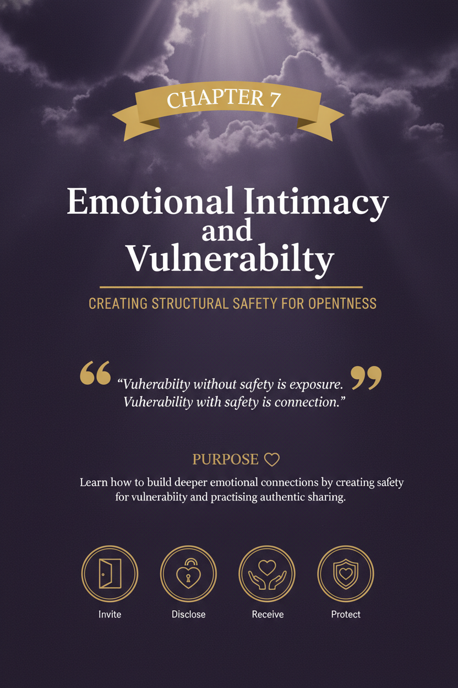

Chapter 7: Emotional Intimacy and Vulnerability

Purpose
Build the ability to create emotional closeness through honesty, openness, steadiness, and repeated moments of safe connection.

Why This Chapter Comes Next
Chapter 1 built emotional awareness. Chapter 2 built regulation. Chapter 3 built listening. Chapter 4 built boundaries. Chapter 5 built conflict skills. Chapter 6 built apology and repair.
This chapter depends on all six.
Emotional intimacy does not grow only from love, attraction, or time spent together. It grows when people feel increasingly safe to reveal what is true inside them without expecting ridicule, punishment, correction, withdrawal, or emotional abandonment.
That means intimacy is not only about chemistry. It is about conditions.
If emotional awareness is weak, people cannot name what is real. If regulation is weak, vulnerability gets overwhelmed by defensiveness or shutdown. If listening is weak, disclosure feels exposed rather than received. If boundaries are weak, openness gets confused with overexposure or emotional dumping. If conflict and repair are weak, people stop bringing their deeper selves forward because experience has taught them that honesty is costly.
Repair makes vulnerability safer. Vulnerability makes intimacy deeper.
That is why this chapter belongs here.
If you apply it well, you should start to see:
- more emotional openness,
- less guarded communication,
- more honesty without immediate escalation,
- deeper warmth and trust,
- stronger connection during ordinary moments,
- and a relationship that feels less like coordination and more like closeness.

Learning Objectives
By the end of this chapter, you should be able to:
- distinguish emotional intimacy from emotional intensity,
- understand why vulnerability is necessary but needs pacing,
- recognise common barriers to closeness,
- create conditions that make disclosure safer,
- respond to your partner’s vulnerability without flattening or hijacking it,
- distinguish healthy openness from dependency dynamics,
- and build repeatable habits that deepen emotional connection over time.

Fast Intimacy Framework
- Honesty: Say something more real than your protective default.
- Pacing: Share in a way the relationship can actually hold.
- Reception: Listen before correcting, fixing, or defending.
- Protection: Do not weaponise what was shared.
- Follow-up: Come back later so care becomes continuity.
Use this when you want a quick check for whether a conversation is likely to deepen closeness or accidentally shut it down.

What Emotional Intimacy Actually Is
Emotional intimacy is the experience of being known with honesty and received with care.
It includes:
- sharing your inner world with increasing truth,
- being able to name feelings, needs, fears, hopes, and disappointments,
- trusting that what matters to you will not be casually dismissed,
- and experiencing your partner as emotionally reachable rather than merely physically present.
Emotional intimacy is not:
- constant disclosure,
- emotional fusion,
- dramatic confession without containment,
- forced transparency,
- or permanent agreement.
Two people can spend years together and still have low emotional intimacy.
They may:
- manage the household well,
- coordinate parenting well,
- handle logistics competently,
- sleep in the same bed,
- and still feel emotionally far apart.
Why? Because emotional intimacy is not produced automatically by proximity. It grows through repeated moments of truth that are received with care.
Intimacy does not eliminate privacy. It reduces concealment where concealment damages closeness.

Emotional Intimacy vs. Emotional Intensity
This distinction matters.
Some relationships feel emotionally charged but are not emotionally intimate.
They have:
- constant volatility,
- high-conflict chemistry,
- fast closeness after rupture,
- urgent emotional exchanges,
- dramatic reassurance cycles,
- and the feeling of “so much emotion” without much true safety.
That is intensity.
Emotional intimacy is different.
It tends to feel more like:
- steadiness,
- honesty,
- warmth,
- emotional permission,
- safety around truth,
- and depth without chaos.
Intensity can feel powerful because it is activating. Intimacy feels different because it is regulating.
A useful test is this:
Do we feel closer because we know each other more honestly, or because our nervous systems keep getting jolted into contact?
One builds trust. The other often builds dependence without safety.

Common Forms of Pseudo-Intimacy
Not all closeness is genuine intimacy.
Some patterns create the feeling of depth while quietly avoiding real safety.
Common forms include:
- only feeling close after fights,
- oversharing early to force a sense of specialness,
- bonding mainly through crisis,
- confusing being needed with being known,
- using sex to bypass emotional distance,
- mistaking mutual pain exposure for actual emotional trust,
- and living in a loop where rupture creates reunion but steadiness feels flat.
Pseudo-intimacy often feels intense, urgent, or unusually revealing. What it lacks is stability. If closeness exists only after rupture, only during crisis, or only when boundaries blur, the relationship may be bonded but not yet safe.

Why Vulnerability Matters
Vulnerability is the act of revealing something real that could be dismissed, misunderstood, or unmet.
Examples include:
“I felt hurt when that happened.”
“I’m more insecure than I’ve been admitting.”
“I’m afraid I matter less to you than other things.”
“I want more closeness, but I feel embarrassed asking.”
“I’m ashamed of how much this affects me.”
“I don’t feel as strong as I’m trying to look.”
Without vulnerability, intimacy stays shallow.
A relationship can still function without it. It can be polite, practical, efficient, loyal, and even long-lasting. But without vulnerability, it often remains emotionally undernourished.
People start living side by side rather than deeply together.
Vulnerability is what lets another person meet the real you instead of only the managed version.
That is why it matters.

Why Vulnerability Feels Risky
Vulnerability is valuable precisely because it involves risk.
People tend to protect themselves when past experience has taught them that openness leads to:
- criticism,
- minimisation,
- dismissal,
- advice instead of understanding,
- ridicule,
- unwanted fixing,
- weaponisation later,
- or silence that feels like abandonment.
Some people grew up in homes where feelings were mocked or ignored. Some learned that only anger was allowed. Some learned to stay useful instead of honest. Some learned to perform strength because revealing need felt dangerous.
So when a partner says, “Just be open with me,” that request may sound simple to the person asking and dangerous to the person receiving it.
That does not mean vulnerability is impossible. It means intimacy needs conditions, not slogans.

The Core Tool
Use this sequence:
Notice → Share → Receive → Protect → Repeat

Notice
Notice what is true inside you before it hardens into distance, resentment, or defensive tone.
Ask:
- What am I actually feeling?
- What am I needing?
- What am I afraid to say?
- What story am I already telling myself?

Share
Say something more honest than your usual protective version.
Not everything. Not all at once. Just something more real.

Receive
If you are the listener, receive the disclosure before evaluating, correcting, or solving.

Protect
Treat what was shared with care. Do not mock it, minimise it, debate it too quickly, or weaponise it later.
Vulnerability offered in good faith should invite closeness, not serve as moral leverage in later conflict.

Repeat
Intimacy grows by repetition, not one breakthrough conversation.
This is the practical rhythm of emotional closeness.

The Conditions That Make Vulnerability Safer
People open up more when certain conditions are present.

1. Regulation
If one or both people are highly activated, vulnerability is more likely to be mishandled.
Honesty lands best when the nervous system is not already preparing for threat.

2. Attention
Half-listening kills intimacy.
Phones, multitasking, distracted eye contact, rushed replies, and performative nodding all teach the speaker that what they are revealing is not actually being held.

3. Non-Punitive Listening
If disclosure is consistently met with correction, blame, or a lecture, people stop bringing depth.

4. Boundaries
Vulnerability is not the same as flooding the other person with unprocessed emotional material at any time, in any tone, with no regard for their capacity.
Healthy intimacy requires honesty and containment.

5. Repair History
If the relationship has a history of poor repair, each new disclosure carries more risk. If the relationship has a history of clean repair, openness becomes more believable.

6. Predictability
When a person can reasonably predict that their inner world will be met with care rather than chaos, they speak more freely.
Intimacy becomes easier when honesty is less costly and reception becomes more predictable.

Common Barriers to Emotional Intimacy
Most intimacy problems are not caused by lack of care. They are caused by repeated barriers that quietly block access.

Defensive Listening
One person shares something vulnerable. The other hears complaint, accusation, or judgment and moves straight into self-protection.

Over-Fixing
The listener tries to solve the problem before receiving the emotion.
This often sounds useful and lands as distance.

Emotional Minimalism
One or both partners rely on narrow language:
“I’m fine.”
“It’s whatever.”
“I’m just tired.”
“It’s not a big deal.”
This low-resolution emotional language makes closeness harder.

Chronic Performance of Strength
Some people protect themselves by staying composed, competent, funny, sexual, useful, or productive while hiding grief, fear, shame, tenderness, or need.
That can look strong from the outside and lonely from the inside.

Fear of Need
People often fear that naming need will make them look weak, needy, demanding, or unattractive.
The result is often indirect behaviour:
- resentment instead of request,
- withdrawal instead of disclosure,
- sarcasm instead of hurt,
- anger instead of fear.

Emotional Weaponisation
If one partner later uses vulnerability against the other, intimacy degrades quickly.
Very few people keep sharing honestly once that has happened enough times.

Vulnerability Is Not Emotional Dependence
This distinction protects the relationship.
Healthy vulnerability says:
“This is true for me.”
“I want you closer to my inner world.”
“Your support matters.”
“I want honesty and connection.”
Emotional dependence says:
“You must regulate me constantly.”
“If you are not always reassuring me, I cannot settle.”
“Your role is to make my inner life manageable for me.”
“If you step back, I lose emotional footing completely.”
A partner can be a source of support without becoming a substitute for self-regulation, reflection, friendship, purpose, or professional help.
Intimacy deepens through mutual support, not emotional captivity.
Reassurance is not the problem. Endless reassurance-seeking without internal work is different. So are repeated testing, panic-driven over-disclosure, or making one partner responsible for keeping the other emotionally stable at all times.
Closeness requires support. It does not require fusion.

The Difference Between Honesty and Emotional Dumping
This distinction protects both people.
Honesty sounds like:
“I want to tell you something that feels vulnerable.”
“I’m noticing I feel more hurt than I expected.”
“This is hard to say, but I want you to know what’s real for me.”
Emotional dumping sounds like:
- unloading without timing,
- using rawness as permission for disrespect,
- speaking without self-awareness,
- flooding the other person without regard for their capacity,
- demanding instant emotional labour.
Vulnerability is not licence to become uncontained.
Healthy intimacy requires:
- honesty,
- pacing,
- context,
- and respect for timing.
A useful sentence is:
“I want to share something real, but I want to do it in a way that helps us feel closer, not flooded.”
That keeps intimacy from turning into emotional spillage.

How to Share More Honestly
Many people do not need more emotion. They need more precision.
A strong vulnerability statement often includes:
- 1. what happened,
- 2. what you felt,
- 3. what meaning you made of it,
- 4. what you need or hope for now.
For example:
“When you went quiet after I brought that up, I felt anxious and a little ashamed. I started telling myself I had already ruined the conversation. What I need right now is not fixing. I need to know whether you’re still with me.”
Or:
“I’m realising I’ve been acting irritated, but underneath that I feel lonely. I miss feeling close to you, and I’ve been embarrassed to say that directly.”
Those statements create more connection than:
“You never care.”
“Whatever.”
“You’re impossible to talk to.”
Precision reduces distortion. Distortion blocks intimacy.

How to Receive Vulnerability Well
If someone shares something soft, exposed, or emotionally costly, your first task is not interpretation. It is care.
A strong receiving response usually includes:
- attention,
- non-defensive listening,
- emotional acknowledgement,
- and patience before problem-solving.
Helpful responses sound like:
“Thank you for telling me that.”
“I can hear that this cost you something to say.”
“That makes sense.”
“I’m glad you told me.”
“Tell me a little more.”
“I want to understand before I respond.”
Unhelpful receiving responses sound like:
“That’s not what happened.”
“You’re overthinking it.”
“Why didn’t you just say something sooner?”
“You shouldn’t feel that way.”
“Here’s what you need to do.”
“So now I’m the bad guy?”
The quality of reception shapes the future of disclosure.
When people are received well, they usually share more accurately next time.

Reopening After Bad Reception
Many people want more intimacy but are recovering from a history in which honesty was mishandled.
If prior openness led to dismissal, ridicule, minimisation, defensiveness, silence, betrayal, or later weaponisation, do not force yourself into instant full exposure.
A wiser approach is to:
- start with lower-risk truths,
- name the old pattern directly,
- watch how your partner responds over time,
- avoid confusing one good conversation with full safety,
- and build trust gradually through repeated good reception.
A useful sentence is:
“I want to be more open with you, but I’m doing that carefully because this hasn’t always felt safe for me. I need us to build this steadily.”
That is not withholding. That is paced honesty.
Trust often reopens in layers.

The Intimacy Ladder
Not every disclosure needs to be deep immediately.
Emotional intimacy often grows best in graduated layers.

Level 1 — Surface Reality
“I had a hard day.”
“I’m tired.”
“I feel a bit off.”

Level 2 — Named Emotion
“I felt disappointed after that conversation.”
“I’m more anxious than I realised.”

Level 3 — Personal Meaning
“Part of why that hit so hard is that I already felt insecure.”
“I made that mean I wasn’t important.”

Level 4 — Exposed Need
“I need reassurance, and I feel embarrassed admitting that.”
“I want more closeness, but I’m afraid of looking needy.”

Level 5 — Deeper Truth
“I’m scared that if I show you how much this matters to me, you’ll pull away.”
“I’m carrying shame I haven’t known how to talk about.”
You do not force Level 5 all the time.
The goal is not maximum exposure. The goal is increasing honesty with appropriate pacing.

Intimacy Requires Reciprocity
Intimacy weakens when one person does most of the revealing and the other mostly observes, analyses, or receives.
Different temperaments are normal. Different disclosure styles are normal. Different pacing is normal.
Permanent one-sidedness is not intimacy.
The more verbal partner should not become the sole emotional carrier of the relationship. The more guarded partner does not need to become identical in style, but they do need to become increasingly reachable over time.
Mutuality may not look symmetrical in every conversation. It should still become believable across the relationship as a whole.
A useful question is:
Are both of us becoming more knowable, or is only one of us doing most of the emotional work?

Intimacy Is Built in Small Moments
Many people think intimacy is built mainly in major conversations.
Sometimes it is.
More often, it is built in ordinary moments such as:
- how you greet each other,
- whether you notice emotional shifts,
- how quickly you become distracted,
- whether you ask a second question,
- how you respond when your partner looks off,
- whether you follow up on something important,
- and how much tenderness exists in everyday tone.
Intimacy does not grow only through confession. It grows through accurate attention.
Examples:
“You got quiet just then. What happened inside?”
“You seem heavier tonight. Want company, space, or both?”
“You told me that mattered today. How did it go?”
“You don’t have to be polished with me. What’s actually going on?”
These moments teach the nervous system that the relationship is emotionally inhabited, not merely managed.

Follow-Up Builds Trust
Receiving vulnerability well in the moment matters. Remembering it later matters too.
Follow-up turns care into continuity.
Examples:
“You mentioned that conversation mattered today. How did it go?”
“You said you were feeling overwhelmed yesterday. How are you now?”
“I’ve been thinking about what you told me.”
“You seemed more hopeful after we talked. Is that still true?”
When a person sees that what they shared was remembered, intimacy deepens. It teaches them that their inner world does not disappear the moment the conversation ends.

The Role of Masculinity, Shame, and Guardedness
Many men have been taught to perform steadiness without learning how to communicate vulnerability.
That often creates a painful pattern:
- distress is converted into silence,
- fear becomes irritation,
- shame becomes defensiveness,
- tenderness becomes joking,
- and need becomes withdrawal.
This does not mean men do not feel deeply. It often means they were not taught how to stay connected while feeling deeply.
The result is that a partner may interpret guardedness as indifference when what is actually present is fear, inarticulacy, or shame.
That does not excuse emotional unavailability. It does explain why growth often feels awkward before it feels natural.
A useful sentence for the more guarded partner is:
“I’m not great at saying this cleanly yet, but I want to be more honest than usual.”
That creates room for imperfect vulnerability.

What Kills Intimacy Over Time
Emotional intimacy rarely disappears all at once.
It usually erodes through repeated, ordinary failures such as:
- distracted presence,
- unresolved resentment,
- low-grade contempt,
- repeated broken follow-through,
- harsh tone,
- avoidance of important conversations,
- using busyness as emotional camouflage,
- turning every vulnerable moment into problem-solving,
- and letting repair happen too slowly or not at all.
A relationship can survive a lot of imperfection. What it struggles to survive is chronic emotional thinness plus poor repair.
People do not only need love. They need to feel felt.

Worked Examples

Example 1 — The Useful Admission
Maya has been snappy all week. Jordan assumes she is annoyed with him.
Instead of continuing the pattern, Maya says:
“I want to say this more honestly than I have been. I’ve seemed irritated, but underneath that I feel overwhelmed and a little alone. I think I’ve been hoping you’d notice without me having to say it.”
Jordan responds:
“Thank you for telling me directly. I can hear that you’ve been carrying a lot. Tell me what has felt most lonely.”
What helped:
- the speaker named the deeper feeling,
- the listener did not defend,
- and the conversation moved toward emotional reality instead of tone-policing.

Example 2 — The Poor Reception
Levi says:
“I’ve been feeling insecure lately, and I hate admitting that.”
Nora replies:
“Why? You’ve got nothing to be insecure about. You’re being ridiculous.”
Her intent is reassurance.
His experience is dismissal.
A better response would have been:
“Thanks for telling me. What’s been bringing that up for you?”
Reassurance can help. Premature reassurance often flattens the disclosure before it is understood.

Example 3 — The Guarded Partner
Tina wants Darren to share more. Darren goes quiet whenever conversations become emotionally loaded.
Instead of saying, “You never open up,” Tina says:
“I don’t need a perfect answer. I just want something more real than ‘I’m fine.’ What’s one thing that’s harder than you’ve been letting on?”
Darren says:
“Honestly, I’ve been feeling like I’m failing at everything lately, and I don’t really know how to talk about that without feeling weak.”
That is a meaningful turning point.
Not because everything is solved, but because something true entered the room.

Example 4 — The Over-Fixer
Sofia says:
“I’ve been missing you, even when we’re together.”
Ethan quickly responds:
“Okay, then let’s schedule more date nights, maybe Thursdays and Sundays. We can fix this.”
The plan may be useful later. It is too early at first.
A better first response is:
“That hurts to hear, but I’m glad you told me. Say more about what feels missing.”
Understanding must come before solutions if intimacy is the goal.

Example 5 — A Small Daily Moment
Priya notices that Sam is quieter than usual after a family call.
Instead of asking, “What’s wrong?” in a sharp tone, she says:
“You seem heavier after that call. Want to talk, or do you want me to just sit with you for a minute?”
Sam says:
“Just sit with me first.”
That moment is small.
It is also intimacy.

Example 6 — Different Desired Depth
Elena likes frequent deep conversations and often wants to process the relationship at night. Marcus cares about closeness too, but he gets overloaded by high-frequency emotional processing and does better with fewer, more intentional check-ins.
At first, Elena experiences him as unavailable. Marcus experiences her as relentless.
A better conversation sounds like:
Elena: “Depth matters to me. When we stay only practical for too long, I start to feel alone.”
Marcus: “I do want that with you. I just don’t do it well when it happens every night or when I’m already depleted. I’d rather do it properly than badly.”
Elena: “Okay. I don’t need constant depth. I need a more reliable rhythm.”
Marcus: “Then let’s build one. Two proper check-ins a week, and shorter connection moments on the other days.”
The solution is not deciding who is “too much” or “too avoidant.” It is building a rhythm that respects both nervous systems while protecting closeness.

Example 7 — Better, Not Perfect
Rhea tells Malik:
“I’ve been feeling more distant from you than I want to admit.”
Malik’s first instinct is to explain how busy and stressed he has been. He starts to do that, then catches himself and says:
“I can feel myself wanting to defend first. Let me slow down. I don’t want to miss what you’re actually telling me. Say a little more about what has felt distant.”
Rhea replies:
“Thank you. I’m not saying you don’t care. I’m saying I haven’t felt emotionally close lately.”
Malik responds:
“That makes sense. I’m glad you said it before it got worse.”
This is not perfect reception. He still moved toward defence first.
But he noticed it, corrected course, and became reachable.
That matters.
Many meaningful improvements in intimacy do not begin with flawless vulnerability. They begin with catching an old pattern early enough to choose a better response.

If You Are the More Open Partner
If you tend to be more emotionally expressive, you may feel lonely carrying the relational depth.
Common mistakes here include:
- over-explaining because you fear being missed,
- pushing for disclosure when the other person is not regulated,
- turning vulnerability into interrogation,
- measuring love only by verbal fluency.
Your task is not to shrink your depth.
It is to pair honesty with pacing.
You are allowed to want more emotional closeness. You are also wise to avoid dragging it into existence through pressure alone.
Useful sentences include:
“I want more honesty between us, not a perfect speech.”
“Take your time, but don’t disappear.”
“I’m not asking you to be polished. I’m asking you to be real.”
“I want connection, not a forced answer.”

If You Are the More Guarded Partner
If emotional openness feels awkward, exposing, or unnatural, start smaller.
You do not need to become a different personality.
You do need to become more reachable.
Try:
- naming one feeling more precisely,
- sharing the meaning under your irritation,
- saying when something feels hard to admit,
- telling your partner what kind of response would help,
- staying in the conversation a little longer before shutting down.
Examples:
“I’m more embarrassed than angry.”
“I do have something to say, but it’s taking me a minute.”
“I feel exposed saying this, so don’t rush me.”
“I’m not trying to avoid you. I’m trying not to say this badly.”
Intimacy often begins where performance relaxes.

Emotional Safety Rules
Agree on a few relational rules that make vulnerability easier to risk.

No Mocking
Do not make tenderness pay for showing up.

No Immediate Cross-Examination
Curiosity is good. Interrogation is not.

No Weaponising Later
Do not store disclosures for future ammunition.

No Forced Timing
Make room for “I want to answer this well, but I need a minute.”

No Problem-Solving Too Early
First understand. Then help.

No Major Vulnerability Conversations by Text When Avoidable
Emotionally important conversations usually need tone, pacing, and presence.
These rules reduce the emotional cost of honesty.
Minimum Viable Intimacy Rhythm
If the relationship feels emotionally thin, start here:
- 1. One daily 10-minute check-in
No phones. No multitasking. No logistics for the first few minutes.
- 1. One second question
When your partner says something real, ask one more caring question before moving on.
- 1. One honest sentence a day
Say one thing that is slightly more real than your default setting.
- 1. One warm follow-up
Come back later to something your partner shared earlier.
- 1. One clean repair after emotional mishandling
If vulnerability is received badly, address it quickly.
That rhythm alone can significantly deepen a relationship.

Fast Intimacy Check
- Is this honest?
- Is this paced?
- Is this safe enough?
- Is this being received?
- Will we follow up?
Use this when you want closeness without rushing into exposure, pressure, or over-talking.

Intimacy Warning Signs
More work is needed if these patterns remain common:
“I’m fine” is the main emotional language,
- one person carries nearly all emotional disclosure,
- vulnerable moments are met with fixing or defence,
- honesty regularly leads to escalation,
- both people feel lonely while technically together,
- emotional conversations happen only during conflict,
- tenderness feels rarer than tension,
- there is strong loyalty but low felt closeness.
These signs do not mean the relationship is doomed. They do mean intimacy needs intentional work.

Scripts

Script 1 — Naming Something Real
When to use: when you want to share more honestly than usual. What it does: turns vague mood into relationally usable truth.
“I want to say something a little more honestly than I usually do. What’s true is that I’ve been feeling \[emotion\], and I think underneath that is \[deeper meaning\]. I’m not saying this to blame you. I’m saying it because I want us to feel closer, not further apart.”

Script 2 — Receiving Vulnerability Well
When to use: when your partner shares something exposed or emotionally costly. What it does: helps them feel received before you respond with your own view.
“Thank you for telling me that. I can hear this matters. Let me make sure I understand what you’re saying before I respond.”

Script 3 — Asking for Emotional Presence
When to use: when you need closeness more than solutions. What it does: reduces misunderstanding about what kind of support you need.
“I’m not asking you to fix this right now. I’m asking you to stay with me in it for a minute and understand what it feels like from my side.”

Script 4 — Slowing Down a Guarded Moment
When to use: when you want to open up but feel exposed or inarticulate. What it does: buys time without disappearing.
“I do have something real to say, but I need a minute to find the words. I’m not shutting down. I just want to say it in a way that’s true.”

Script 5 — Repairing a Bad Reception
When to use: when someone’s vulnerability was mishandled. What it does: restores safety after dismissal, fixing, or defensiveness.
“You shared something real with me, and I handled it badly. I moved too quickly into \[defence/fixing/minimising\], and I can see how that would make it harder to open up again. I’m sorry. If you want to try again, I want to receive it better.”

7-Day Starter Plan

Day 1 — Notice Your Default Protection Style
Ask:
- Do I minimise?
- Do I joke?
- Do I fix?
- Do I go quiet?
- Do I get irritated instead of honest?

Day 2 — Expand One Feeling
Replace a vague phrase like “I’m stressed” with something more precise:
- disappointed,
- lonely,
- ashamed,
- anxious,
- overwhelmed,
- unimportant.

Day 3 — Share One Honest Sentence
Say one thing that is slightly more vulnerable than your default.

Day 4 — Ask One Better Question
Instead of “What’s wrong?” try:
“What happened inside when that happened?”
“What feels hardest about this?”
“What do you most need me to understand?”

Day 5 — Practise Receiving
When your partner shares something real, do not fix it first. Reflect it back first.

Day 6 — Follow Up on Something Important
Return later to something they shared earlier in the week.

Day 7 — Review the Pattern
Ask:
- What makes vulnerability feel safer with us?
- What makes it feel expensive?
- Where do we go shallow by habit?
- What one change would deepen closeness next week?

Reflection Questions
- 1. What do I usually protect instead of reveal?
- 2. What feelings are hardest for me to name directly?
- 3. When my partner becomes vulnerable, do I tend to listen, fix, defend, or withdraw?
- 4. What helps me feel emotionally safe in a relationship?
- 5. What makes openness feel risky for me?
- 6. Where have I confused emotional intensity with emotional closeness?
- 7. What small daily habit would help us feel more emotionally connected?

Practical Application Checklist
Use this chapter well if you can increasingly do the following:
- recognise the difference between intensity and intimacy,
- name more precise emotions,
- share something real without overloading the conversation,
- receive vulnerability without flattening it,
- create safer conditions for honesty,
- follow up on emotionally important moments,
- repair bad receptions quickly,
- distinguish support from dependency,
- and build closeness through consistency rather than dramatic breakthroughs.

QR Worksheet: Intimacy and Vulnerability Builder
Slug: ch07-intimacy-vulnerability-builder

Scan or visit: https://shesnotcrazybook.com/ws/ch07-intimacy-vulnerability-builder
Title: Emotional Intimacy Map
Use it for:
- individual reflection,
- couple check-ins,
- rebuilding closeness after distance,
- identifying barriers to vulnerability.
Prompts:
- What do I most often hide?
- What do I most want understood?
- What helps me feel safe enough to share?
- What makes me shut down or protect myself?
- How do I usually respond when my partner opens up?
- What intimacy habit do we already do well?
- What intimacy habit is missing?
- What one practical change would make honesty easier this week?
Output: A one-page map of vulnerability patterns, intimacy barriers, and one next-step closeness practice.

Recap
Emotional intimacy is not produced automatically by love, attraction, or time.
It grows when people are increasingly able to tell the truth about their inner world and trust that truth will be received with care.
Remember the sequence:
Notice → Share → Receive → Protect → Repeat
Notice what is true. Share it with more honesty. Receive it with care. Protect what was shared. Repeat the process in small, steady ways.
Intimacy is built through repeated moments in which honesty becomes safer, reception becomes steadier, and closeness becomes more believable.

Bridge to Chapter 8
Emotional intimacy and physical intimacy are related, but they are not the same.
Many couples struggle because they try to use physical closeness to compensate for emotional distance, or they expect emotional closeness to appear automatically through physical contact alone. When emotional closeness is thin, physical connection is often pressured, misread, avoided, or used compensatorily.
The next chapter explores how physical intimacy, consent, desire, affection, and embodied connection work best when safety, honesty, and attunement are already growing.
That is where we go next.

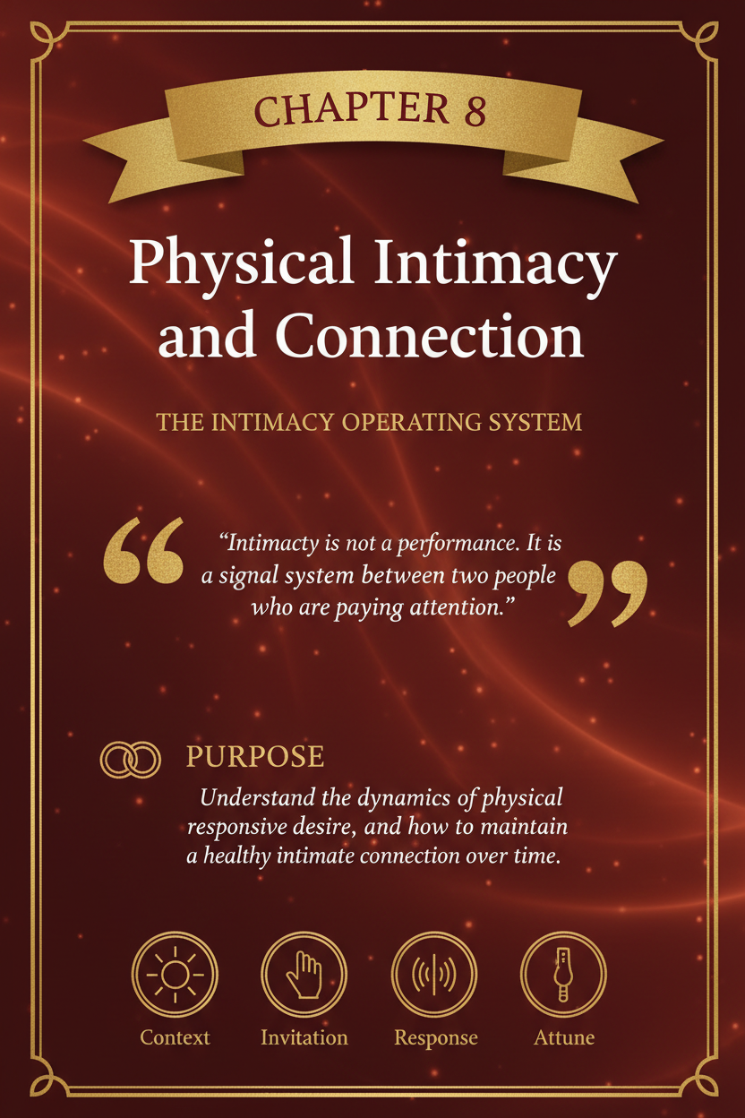

Chapter 8: Physical Intimacy and Connection

Purpose
Build the attitudes, language, and habits that make physical intimacy feel safe, mutual, wanted, and emotionally connected rather than pressured, confusing, avoidant, or transactional.

Why This Chapter Comes Next
Chapter 7 focused on emotional intimacy and vulnerability.
This chapter depends on it.
Physical intimacy does not sit in a separate category from the rest of the relationship. It is shaped by the same patterns already covered in this book:
- whether each partner feels heard,
- whether conflict gets repaired,
- whether boundaries are respected,
- whether resentment is addressed,
- whether affection feels safe,
- and whether closeness is something both people can enter honestly.
Many couples describe a physical intimacy problem as if it exists on its own. Often it does not. Often the physical difficulty is downstream of emotional misattunement, repeated defensiveness, unresolved conflict, unequal load, chronic stress, or affection that has become too loaded with expectation.
That is why this chapter belongs here.
If you apply it well, you should begin to see:
- less pressure around physical connection,
- more honest conversation about comfort, desire, and pacing,
- more affectionate contact outside sexual moments,
- less personalization of every mismatch,
- and a clearer path toward rebuilding closeness when life or conflict has thinned it out.
The goal is not performance.
The goal is connection.

Physical Intimacy Is Broader Than Sex
When people hear the phrase physical intimacy, they often think only of sex.
That is too narrow.
Physical intimacy includes the full range of safe, wanted physical closeness that helps partners feel connected in their bodies as well as their minds:
- holding hands,
- greeting hugs,
- leaning into each other,
- cuddling,
- kissing,
- affectionate touch,
- resting together,
- sensual closeness,
- and sexual connection.
These forms of touch do not all carry the same meaning, and they should not all be treated as steps toward the same outcome.
One of the quickest ways to make touch feel tense is to make every affectionate moment feel like a prelude to sex. When every hug feels like an opening move, a hug stops being restful. It becomes strategic. The body starts bracing.
Healthy physical intimacy works better when there is room for:
- touch that comforts,
- touch that reassures,
- touch that expresses affection,
- touch that reconnects,
- and touch that becomes sexual only when both people genuinely want that.
That distinction matters.

The Real Problem Is Often Not Desire Alone
Couples often describe physical distance in simple terms:
“We barely touch anymore.”
“We are never on the same page.”
“I feel rejected all the time.”
“I feel pressured all the time.”
Those statements are real, but they usually sit on top of deeper layers:
- unresolved resentment,
- emotional disconnection,
- poor repair after conflict,
- pressure or obligation,
- stress and exhaustion,
- body shame,
- fear of rejection,
- unclear boundaries,
- or different meanings attached to affection and sex.
If you treat physical intimacy as a stand-alone problem, you often miss the actual causes.
A more useful question is not only:
How often are we connecting physically?
It is also:
What has made physical connection easier or harder between us lately?
That question opens the door to reality instead of blame.

A Practical Triage Order
When physical intimacy has become painful, sparse, loaded, or conflictual, do not try to fix everything at once.
Use this order.

1. Rule out conditions that make rebuilding unsafe
Do not push for more physical intimacy first if the relationship currently includes:
- coercion,
- fear,
- intimidation,
- unresolved betrayal,
- active abuse,
- ongoing contempt,
- severe shutdown,
- or a crisis that makes honest closeness unavailable.

2. Reduce pressure and restore safety
Make honesty safer than compliance.
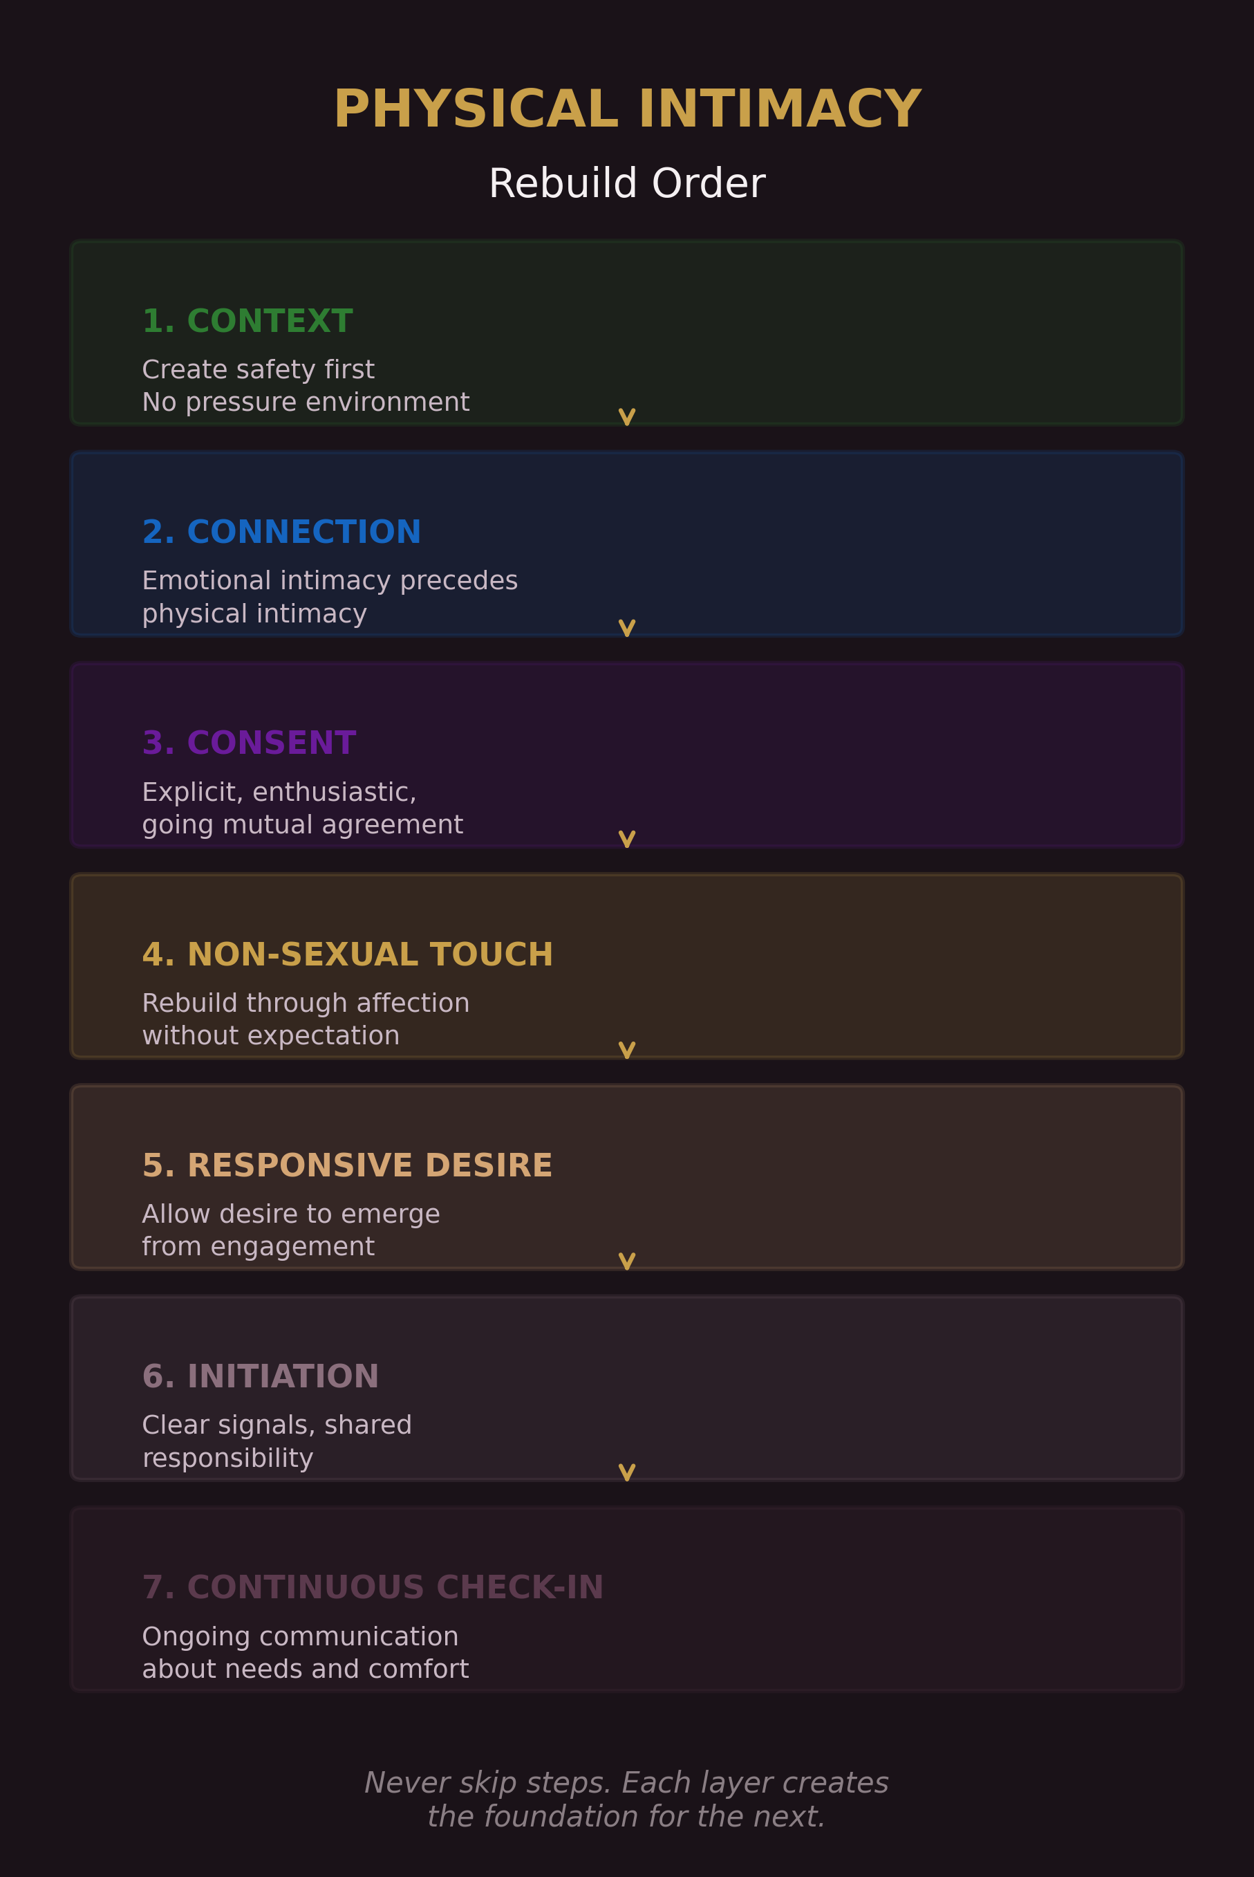
Physical Intimacy Rebuild Order
Restore physical warmth that does not demand escalation.

4. Reopen communication
Talk clearly about comfort, desire, pacing, boundaries, and what has been difficult.

5. Rebuild sexual connection gradually
Move at the pace the relationship can honestly hold.
This sequence matters because many couples try to start at step five and then wonder why the body does not cooperate.

The Core Tool
Use this sequence:
Soften → Signal → Check → Connect → Review

Soften
Reduce pressure, entitlement, urgency, and assumption.

Signal
Show warmth and interest clearly rather than through sulking, passive pressure, or mind-reading.

Check
Check for willingness, comfort, timing, and emotional state.

Connect
Choose the form of physical closeness that fits the moment rather than the form that proves a point.

Review
Talk afterward, outside the moment, about what helped, what did not, and what each partner needs more or less of.
This keeps physical intimacy from becoming a silent battlefield.

Emotional Safety Comes First
A body does not relax on command.
If someone feels tense, resentful, wary, dismissed, rushed, overworked, or emotionally alone, physical openness often drops. This is not stubbornness. It is often nervous-system reality.
When the relationship has been cold, defensive, conflict-heavy, or transactional, physical intimacy may begin to feel less like closeness and more like demand.
Emotional safety in this chapter means:
- your no is respected,
- your yes matters,
- you do not have to manage the other person’s reaction for them,
- affection is not constantly converted into expectation,
- conflict is not ignored and then bypassed through physical initiation,
- your body is treated as yours,
- and closeness feels mutual rather than extracted.
Many people want the reassurance of physical connection while neglecting the emotional conditions that make that connection possible.
That usually fails.
You cannot stay defensive for days, leave hurt unaddressed, make affection feel loaded, and then expect the body to feel open because enough time has passed.
The body often keeps the score that the mind tries to skip.

Responsive and Spontaneous Desire
One of the most useful distinctions in this area is the difference between spontaneous desire and responsive desire.

Spontaneous desire
This is desire that appears more suddenly or with less need for emotional or environmental build-up.

Responsive desire
This is desire that emerges in response to context: feeling safe, feeling wanted without pressure, relaxing, receiving affectionate touch, being emotionally connected, and having space to arrive gradually.
Neither pattern is better.
But partners often get into trouble when they assume desire should look the same in both people.
A common mismatch sounds like this:
- one partner feels desire first and seeks physical closeness to create connection,
- the other often needs connection, safety, and the right conditions before desire becomes accessible.
If neither person understands this difference, they misread each other.
One feels rejected. The other feels pressured. Both feel alone.
A more useful frame is:
- some people need less runway,
- some people need more runway,
- and stress, conflict, fatigue, resentment, health, and life load can all change how much runway is needed.
That reduces unnecessary shame.
It also reduces the false belief that desire is always a referendum on love.
Often it is a referendum on context.

Non-Sexual Touch Is Foundational
Non-sexual touch matters because it:
- lowers threat,
- builds familiarity,
- communicates warmth,
- creates connection without pressure,
- and helps partners feel chosen in ordinary life.
Examples include:
- greeting hugs,
- a hand on the back,
- sitting with legs touching,
- cuddling without agenda,
- holding hands during a walk,
- a kiss on the forehead,
- or checking in with gentle touch during a hard day.
These moments are small, but they accumulate.
They tell the body:
This relationship contains touch that is caring, not extracting.
For many couples, restoring physical closeness begins not with sex, but with rebuilding safe, affectionate contact.

Touch Without Agenda
A useful rule is this:
Not every touch is a bid for more.
If one partner cannot relax into a hug because they are constantly evaluating whether it will become an unwanted escalation, the hug stops being restful. It becomes management work.
Touch without agenda means:
- affection that is offered freely,
- no scorekeeping if it does not lead elsewhere,
- no passive punishment because a partner wanted comfort but not sex,
- and no resentment because affection remained affection.
This does not mean sexual initiation is wrong.
It means physical warmth should not collapse into pressure by default.
When affectionate touch can exist without hidden demands, both trust and desire usually have better conditions in which to grow.

Consent Is Not a Technicality
Consent is not a box to tick.
It is the relational foundation that makes physical intimacy humane.
Healthy consent is:
- freely given,
- reversible,
- informed,
- enthusiastic,
- and specific.
It is ongoing, not permanent. It can change mid-moment. It matters in long-term relationships just as much as in new ones.
A prior yes does not guarantee a current yes. Silence is not clarity. Compliance is not enthusiasm. Wearing someone down is not mutuality. Sulking after a no is not neutral. It teaches the body that honesty has a cost.
A person should be able to say:
“Not tonight.”
“I want closeness, but not sex.”
“Slow down.”
“That does not feel good.”
“I am not there yet.”
“Can we just hold each other?”
And those boundaries should be met with steadiness rather than punishment.
If a partner cannot say no safely, their yes becomes unreliable.
That is not intimacy. That is pressure.

Safety Is More Than Consent Language
Consent matters, but safety is broader.
A person may technically say yes while still feeling:
- emotionally cornered,
- scared of conflict,
- guilty for disappointing their partner,
- responsible for regulating the other person’s self-worth,
- or disconnected from their own body.
So do not ask only:
Was consent present?
Also ask:
Was the atmosphere safe enough for honesty?
Safety increases when:
- refusals are tolerated without drama,
- initiation is clear rather than manipulative,
- both partners can slow things down,
- feedback is welcomed rather than treated as an insult,
- and past hurts are not bypassed just because physical closeness is desired.

Resentment Makes the Body Cautious
One of the most common but least discussed blocks to physical intimacy is unresolved resentment.
When resentment is building, touch may start to feel:
- obligatory,
- emotionally false,
- poorly timed,
- or disconnected from the actual state of the relationship.
A partner may think:
You want access to my body, but you have not really dealt with the ways I have been carrying this relationship alone.
Or:
You want closeness now, but you were unavailable when I needed care, accountability, or repair.
That does not mean resentment should be weaponized.
It means it should be taken seriously.
If one partner feels overloaded, unappreciated, or emotionally abandoned, physical closeness often becomes harder—not because attraction vanished, but because trust and goodwill were quietly worn down.
Do not only ask whether desire has dropped.
Also ask:
- What has been left unresolved?
- What has not been repaired?
- What has become silently expensive?

The Mental Load and Physical Availability
A person carrying excessive invisible labor often has less room for desire.
If one partner is constantly tracking:
- chores,
- appointments,
- family logistics,
- emotional tone,
- planning,
- reminders,
- and everyone else’s needs,
that person may not experience the relationship as a place of rest.
They may experience it as another site of work.
Physical closeness becomes harder when one partner feels they are carrying the relational system, the household system, or the emotional system alone.
So when physical intimacy drops, do not only ask about attraction.
Also ask:
- Are we sharing responsibility fairly?
- Is resentment building?
- Is one person always “on”?
- Has ordinary life drained the room that desire needs?
Sometimes the most meaningful precondition for intimacy is not a sexual strategy.
It is load-sharing that makes a partner feel partnered again.

Communication About Physical Needs
Many couples talk less clearly about physical intimacy than about almost anything else.
They hint. They wait. They guess. They resent. They personalize. They hope the other person will somehow know.
That approach produces confusion quickly.
Physical intimacy usually improves when partners can discuss:
- what helps each person feel open,
- what turns them off emotionally or physically,
- what kind of affection they want more of,
- what makes them feel pressured,
- how initiation lands,
- how stress affects desire,
- what boundaries matter,
- what reassurance they need,
- and how to reconnect after difficult seasons.
These conversations usually work best outside the heat of the moment.
Not during a fight. Not in the middle of rejection. Not only when one partner is already hurt.
Use a calm structure:
- 1. What helps me feel close.
- 2. What makes closeness harder for me.
- 3. What I want more of.
- 4. What I want less of.
- 5. What would make this feel safer and more mutual.
That keeps the conversation concrete.

Invitation vs. Pressure
A helpful distinction is this:
Invitation | Pressure
warm | loaded
clear | indirect or manipulative
easy to decline | costly to decline
responsive to timing | entitled to timing
accepts honesty | punishes honesty
interested in connection | interested in getting a yes
Poor initiation often includes:
- sulking,
- guilt,
- repeated pushing after uncertainty,
- sudden escalation from no contact,
- scorekeeping,
- or acting wounded before the other person has even answered.
Better initiation feels more like:
- warmth before the ask,
- attention to context,
- an invitation rather than a demand,
- and steadiness if the answer is no or not now.
A healthy initiation posture says:
I want closeness with you, and your honesty is welcome.
That honesty is what keeps future closeness possible.

How to Receive a No Without Creating Damage
A refusal is not always rejection of you as a person.
It may reflect fatigue, stress, unresolved tension, body discomfort, timing, emotional state, or simply a genuine lack of readiness in that moment.
When you hear no, do this:
- stay calm,
- do not punish,
- do not withdraw in protest,
- do not argue the person out of their boundary,
- and do not turn honesty into a debt.
If genuine, you can offer alternate closeness:
“Would a cuddle feel okay?”
“Do you want to just lie together for a bit?”
“Thanks for being honest.”
If there is a larger pattern causing pain, discuss it later in a calm conversation.
Do not force the larger conversation in the exact moment of disappointment.
That usually converts honesty into danger.

Physical Intimacy After Conflict
One of the most damaging patterns is trying to use physical intimacy as a shortcut around unresolved rupture.
Sometimes both partners genuinely want physical closeness after conflict. Sometimes that can be healing.
But often it fails because the emotional repair has not actually happened.
Ask:
- Has the issue really been addressed?
- Has impact been acknowledged?
- Is resentment still active?
- Does physical closeness feel comforting, or does it feel like an attempt to skip repair?
For many people, physical intimacy lands best after emotional repair, not instead of it.

Body Image, Confidence, and Self-Consciousness
Physical intimacy is shaped not only by the relationship, but by how each person feels in their own body.
Low body confidence can make someone:
- avoid touch,
- rush through intimacy,
- stay mentally absent,
- resist exposure,
- feel easily ashamed,
- or expect rejection before it happens.
Answer that with sensitivity, not pressure.
That means:
- do not use vulnerability as a joke target,
- do not compare your partner to others,
- give specific appreciation rather than generic flattery,
- respect preferences around pacing and exposure,
- and make the moment feel emotionally kind rather than evaluative.
A body is more likely to open where it feels safe from criticism.

Rebuilding Physical Intimacy After Distance
When physical intimacy has been strained for a while, many couples make the mistake of trying to jump straight back to where they used to be.
That usually adds more pressure.
A better path is gradual.

Stage 1: Restore safety
- lower pressure,
- improve repair,
- make honesty safer.

Stage 2: Restore affectionate touch
- more hand-holding,
- greeting and goodbye warmth,
- cuddling,
- non-sexual contact.

Stage 3: Restore conversation
- discuss what has been difficult,
- name what each person misses,
- clarify what helps each person feel open.

Stage 4: Restore lightness
- flirt again,
- create playfulness,
- spend time together that is not purely logistical.

Stage 5: Rebuild sexual connection gradually
- at the pace the relationship can honestly support,
- with active check-ins,
- without treating every step as a test of whether the relationship is okay.
Rebuilding is usually less about forcing chemistry and more about removing threat.

When Outside Support Is Appropriate
This chapter is educational. It is not a substitute for qualified medical or therapeutic care.
Seek appropriate support when physical intimacy is being affected by issues such as:
- persistent pain,
- erectile difficulties,
- postpartum recovery,
- medication side effects,
- sudden or lasting libido changes,
- trauma symptoms,
- severe anxiety,
- depression,
- hormonal concerns,
- betrayal trauma,
- or relationship dynamics that no longer feel safe enough for self-guided repair.
Professional support is not a sign of failure. It is often the clearest way forward when the issue is larger than communication alone.

Scripts

Script 1: Talking About Pressure Without Attack
“I want to talk about something sensitive in a careful way. Lately, physical closeness has started to feel pressured for me, and that makes me pull back more. I’m not saying I don’t want connection. I’m saying I need it to feel safer, slower, and less loaded. I want us to build that together.”

Script 2: Naming Rejection Without Blame
“I want to be honest without making this heavier. I’ve been feeling rejected and unsure how to talk about it well. I don’t want to pressure you, and I also don’t want to keep silently building resentment. Can we talk about what helps you feel open and what has been making connection harder lately?”

Script 3: Asking for More Non-Sexual Touch
“I’d like more affection between us that doesn’t automatically need to lead anywhere. Things like hugging, cuddling, holding hands, and small touches during the day help me feel connected. I think that would make us feel closer overall.”

Script 4: Consent and Check-In in the Moment
“I want to check in rather than assume. Does this feel good? Do you want to keep going, slow down, or stop? I’m okay with honesty.”

Script 5: Receiving Difficult Feedback Well
“Thank you for telling me directly. I want to understand what has been feeling pressured or difficult for you before I respond. I’m listening.”

Script 6: Rebuilding After a Dry Season
“I don’t think we need to fix everything tonight. I think we need to start rebuilding connection in smaller, safer ways. I’d rather create something honest and mutual than try to force us back to what we used to be.”

Reflection Questions
- 1. What makes physical closeness feel safest for me?
- 2. What makes it harder for me to relax into touch or intimacy?
- 3. Do I offer affection freely in ordinary life, or mostly when I want more?
- 4. How safe is honesty in our relationship when one person is not in the mood?
- 5. Do I personalize every mismatch, or can I stay curious about context?
- 6. What role do stress, resentment, exhaustion, or unequal load play in our physical distance?
- 7. What kind of touch helps me feel connected even when sex is not on the table?
- 8. Have we clearly discussed what initiation, refusal, pacing, and consent should look like between us?
- 9. What would rebuilding physical intimacy slowly and safely look like for us?
- 10. Is there anything here that now needs qualified outside support rather than guesswork?

Practice: The Physical Connection Reset
Use this for two weeks.

Daily
- Give one affectionate gesture with no agenda.
- Notice whether touch in the relationship feels warm, pressured, absent, or mixed.
- Say one specific appreciation about your partner’s presence, care, or physical warmth if genuine.

Three Times This Week
Spend 10 minutes together without screens and with some form of gentle contact, if welcome:
- sit close,
- hold hands,
- rest against each other,
- or cuddle briefly.
No pressure for it to become more.

Once This Week
Have one calm conversation using these prompts:
- What helps you feel close to me physically?
- What makes physical connection harder for you lately?
- What kind of affection do you want more of?
- What would make initiation feel clearer and safer?
- What should we stop doing because it adds pressure?

If Intimacy Has Become Strained
Do not set a performance target first. Set a safety target first.
Examples:
“No sulking after a no.”
“More non-sexual touch.”
“No major conflict by text before bed.”
“One honest check-in instead of silent guessing.”
“We repair tension before trying to bypass it physically.”

QR Worksheet: Physical Intimacy Map
Slug: ch08-physical-intimacy-map

Scan or visit: https://shesnotcrazybook.com/ws/ch08-physical-intimacy-map
Complete separately, then compare.

Green: Reliably Helps Closeness for Me

Amber: Depends on Context, Timing, or Emotional State

Red: Reliably Closes Me Down Quickly

I Feel Most Physically Open When:

I Feel Least Physically Open When:

Touch That Feels Connecting to Me:

Touch That Feels Loaded, Pressured, or Difficult for Me:

What I Want More Of:

What I Want Less Of:

What Makes Initiation Easier for Me:

What Makes Refusal Safer for Me:

One Thing We Can Try This Week:

One Thing We Need to Stop Doing:

A Simple Model to Remember
Better conditions for physical intimacy usually require five things:
Safety + Warmth + Honesty + Freedom to Decline + Shared Load
If several of those are missing, desire often becomes harder to access and physical closeness becomes easier to misread.

Chapter Recap
Physical intimacy is healthiest when it grows from safety, honesty, warmth, and mutuality rather than pressure or assumption.
Key points:
- Physical intimacy is broader than sex.
- Emotional safety often shapes physical openness.
- Desire can be spontaneous or responsive.
- Non-sexual touch builds trust and lowers pressure.
- Consent must be active, ongoing, and safe to withdraw.
- Resentment and unequal load can make the body cautious.
- Honest communication about touch, desire, and pressure is essential.
- Rebuilding physical intimacy usually works better gradually than forcefully.
- Some situations require qualified outside support rather than self-guided repair alone.
Physical intimacy cannot be sustainably extracted from a relationship that feels emotionally unsafe.
But when safety, respect, affection, honesty, and shared effort are present, the body often becomes less guarded and more available for real connection.

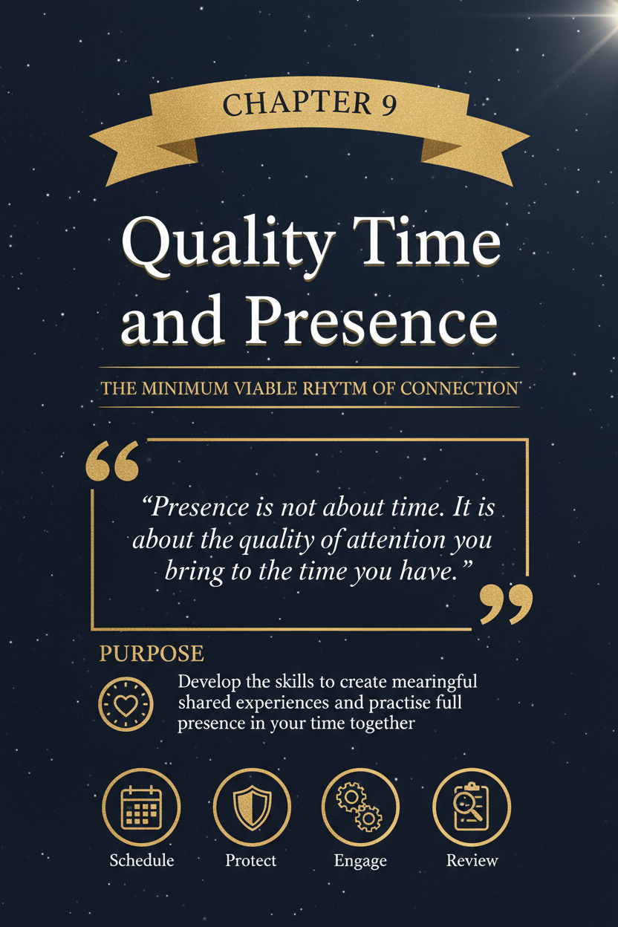

Chapter 9: Quality Time and Presence

Purpose
Build the habits of attention, shared rhythm, and intentional presence that help a relationship feel warm, chosen, and emotionally alive rather than merely managed.

Why This Chapter Comes Next
Chapter 7 focused on emotional intimacy and vulnerability. Chapter 8 focused on physical intimacy and connection.
This chapter depends on both.
Emotional intimacy deepens when people feel genuinely attended to. Physical intimacy often becomes easier when the relationship contains enough warmth, safety, and ordinary closeness outside moments of pressure. Quality time is one of the main ways that warmth is maintained.
Many couples do not lose connection only through one major rupture. More often, they lose it gradually through divided attention, task-only conversation, chronic distraction, exhaustion, unresolved resentment, and the quiet habit of giving each other what is left over instead of something protected.
That is why this chapter belongs here.
If you apply it well, you should begin to see:
- more warmth in ordinary moments,
- less parallel living,
- more felt connection during everyday life,
- fewer complaints that sound like “we’re together, but not really together,”
- more shared rituals that protect closeness,
- and a relationship that feels less like logistics and more like partnership.
The goal is not constant togetherness.
The goal is meaningful presence.

Learning Objectives
By the end of this chapter, you should be able to:
- distinguish proximity from presence,
- understand why quality time is not only about hours spent together,
- recognize common ways couples become emotionally thin while still functioning,
- identify different forms of quality time,
- create small rituals of connection that are realistic and repeatable,
- reduce distraction without turning the relationship into another performance task,
- understand how unresolved hurt can flatten otherwise well-planned time together,
- and rebuild shared presence when the relationship has become overly practical, rushed, or distant.

What Quality Time Actually Is
Quality time is not simply being in the same room.
It is the experience of shared attention.
It happens when both people can feel, in a clear and believable way:
- you are here,
- you are not half somewhere else,
- I do not have to compete with everything else for your attention,
- and this moment matters enough to be entered on purpose.
Quality time can include:
- meaningful conversation,
- shared activity,
- play,
- affection,
- quiet companionship,
- a walk,
- cooking together,
- a check-in at the end of the day,
- a ritual around coffee, dinner, or bedtime,
- or sitting side by side and actually being with each other rather than only beside each other.
It is not one specific format.
It is relational presence with some degree of intentionality.

Proximity Is Not Presence
Many couples spend large amounts of time together without feeling connected.
They may be:
- watching separate screens,
- talking only about tasks,
- coordinating children,
- managing bills,
- discussing who is doing what tomorrow,
- correcting small logistics,
- or sitting close while mentally elsewhere.
That is proximity.
It may still matter. Shared life is built through ordinary co-presence. But proximity alone does not reliably produce emotional nourishment.
Presence is different.
Presence means:
- your attention is not fragmented,
- your body language is open enough to signal receptivity,
- your partner does not have to drag you into the moment,
- and the interaction contains some real contact rather than only parallel activity.
A relationship can be starved even while the calendar is full.

The Quiet Drift Into Parallel Living
Most disconnection is not dramatic at first.
It often begins as:
- long workdays,
- constant phone use,
- children or caregiving strain,
- unfinished conflict,
- tiredness,
- overstimulation,
- or the assumption that the relationship will “be fine” if nothing catastrophic is happening.
Then the pattern hardens.
The relationship becomes efficient but thin.
People still do things together, but the shared life starts sounding like this:
“Did you pay that?”
“What time is pickup?”
“Can you grab milk?”
“I’m tired.”
“We’ll talk later.”
“I’m listening.”
- while not really listening.
Eventually, one or both partners stop asking for more because asking starts to feel embarrassing, needy, repetitive, or pointless.
That is how warmth fades without a clean event to blame.

Attention Is an Emotional Signal
Attention is not neutral.
Where your attention goes, your partner draws conclusions.
Repeated divided attention can communicate:
I’m not really available,
- the relationship lives in leftover time,
- other inputs reach me more easily than you do,
- and I am physically present but not relationally accessible.
Repeated intentional attention communicates something very different:
- you matter,
- I want to know your world,
- we still belong to each other inside ordinary life,
- and I am willing to protect some space for us.
This is one reason that distraction lands so strongly in relationships. People are not only reacting to a phone, a laptop, or a television. They are reacting to what repeated inattention comes to mean.

The Core Tool
Use this sequence:
Pause → Protect → Tune In → Share → Repeat

Pause
Shift out of task mode long enough to actually arrive.
Do not move straight from stress, screens, or logistics into half-present contact and call it connection.

Protect
Remove what predictably divides attention.
Put the phone away. Turn the television off. Step out of multitasking. Create even ten minutes that are not being competed for.

Tune In
Notice what each of you is bringing into the moment.
Ask:
- How are you arriving?
- What kind of contact is realistic right now?
- Do we need conversation, comfort, laughter, quiet, or simple closeness?

Share
Enter one real moment together.
That may be:
- a conversation,
- a walk,
- a check-in,
- a meal,
- a game,
- affection,
- a shared task done with warmth,
- or honest quiet.

Repeat
Connection strengthens through rhythm more than intensity.
One meaningful pattern done consistently will usually help more than occasional grand gestures that cannot be sustained.

Failure Modes of Quality Time
Many couples believe they are investing in quality time when they are mostly investing in appearances, co-location, or structure without true presence.
Common distortions include:

Task-Only Time
You are doing life together but not emotionally meeting each other inside it. You may be efficient, responsible, and coordinated while still feeling lonely.

Screen-Adjacent Time Mistaken for Connection
You are near each other, maybe even touching, but each person’s attention is elsewhere. The room is shared; the moment is not.

Entertainment Mistaken for Intimacy
Watching something together, going out, or filling time with stimulation can be enjoyable. But enjoyment does not always equal emotional contact. A date can still feel flat if neither person is emotionally reachable.

Scheduled Time Without Arrival
Time is set aside, but one or both people stay mentally at work, in conflict, on the phone, or inside unfinished stress. The block exists. Presence never fully arrives.

Quality Time Used as Repair Avoidance
A dinner, outing, or affectionate evening is sometimes used to smooth over unresolved hurt rather than address it. This may look nice from the outside while feeling emotionally thin on the inside.
The key distinction is simple:
Quality time is not just time allocated. It is time actually inhabited.

Quality Time Is Not the Same as Emotional Labour
This section matters because “let’s spend more quality time together” can quietly become another burden placed on the more relationally aware partner.
Quality time is not fully repairing if one partner must always:
- notice the drift,
- raise the issue,
- plan the date,
- schedule the check-in,
- protect the time,
- bring the emotional intention,
- and rescue the interaction when it goes flat.
When that happens, time together can start to feel less like care and more like management.
A healthier pattern looks more shared.
That means both partners increasingly help carry:
- initiation,
- planning,
- attention,
- follow-through,
- and emotional hosting.
The point is not perfect equality in every week. The point is that connection should not depend almost entirely on one person’s vigilance.
If one partner is always the cruise director, therapist, scheduler, and atmosphere manager, quality time itself becomes another invisible labor load.

Not All Quality Time Looks the Same
One of the most common mistakes is assuming quality time means the same thing to both people.
It does not.
For some people, quality time means:
- eye contact,
- talking deeply,
- undivided conversation,
- a date,
- or an emotional check-in.
For others, it means:
- doing something side by side,
- building, cooking, walking, driving, or working together,
- affectionate silence,
- shared novelty,
- or simply being unhurried in the same space.
Neither preference is automatically better.
The problem starts when one partner offers connection in a form that feels natural to them and assumes it should land equally well for the other person.
A useful question is:
When do you feel most connected to me?
Not:
Why aren’t you satisfied with what I already do?
That shift creates much better information.

Five Common Quality Time Styles
These categories are not rigid. Most people want more than one.

1. Conversational Presence
Feeling close through uninterrupted conversation, curiosity, and emotional exchange.
Mismatch friction: one partner feels starved without deeper verbal contact, while the other thinks shared activity already counts as togetherness.

2. Shared Activity
Feeling close through doing something together: walking, cooking, training, errands, projects, games.
Mismatch friction: one partner feels bonded through doing, while the other feels unseen unless there is direct emotional attention.

3. Quiet Companionship
Feeling close through calm, unpressured togetherness without needing constant verbal depth.
Mismatch friction: one partner experiences this as peaceful connection, while the other experiences it as emotional absence unless something more explicit happens.

4. Play and Novelty
Feeling close through humor, surprise, exploration, dates, new places, or new experiences.
Mismatch friction: one partner wants freshness and energy; the other may prefer familiarity and low-demand connection.

5. Ritual Time
Feeling close through repeated, predictable moments that create continuity: morning coffee, evening check-in, Friday takeout, Sunday walk.
Mismatch friction: one partner relies on ritual for safety and steadiness, while the other resists routine because they fear it will feel mechanical or boring.
Couples often improve quickly when they stop arguing abstractly about “quality time” and identify which forms matter most to each person.

Time Does Not Need to Be Long to Be Meaningful
Quality time is not only about large blocks of time.
Longer time helps, but smaller moments matter more than people think when they are:
- intentional,
- consistent,
- and emotionally available.
Examples:
- a real goodbye in the morning,
- a six-minute check-in after work,
- ten undistracted minutes before bed,
- a walk around the block,
- a hug that lasts long enough to feel settling,
- one meal eaten without screens,
- a genuine “How are you, really?” with time to answer.
A relationship can be weakened by chronic inattention and strengthened by repeated small moments of real contact.
Do not underestimate the cumulative effect of micro-connection.

Rituals Stabilise Connection. Novelty Reanimates It.
Rituals matter because they reduce decision fatigue.
Without rituals, connection often depends on:
- energy,
- mood,
- memory,
- initiative,
- luck,
- or whichever partner is already carrying the emotional load.
With rituals, connection becomes easier to maintain because it is expected rather than improvised.
Healthy rituals can be simple:
- a check-in after work,
- coffee together in the morning,
- a walk after dinner,
- a phone-free meal,
- a weekly date at home,
- a bedtime conversation,
- a shared playlist on drives,
- a Sunday planning and appreciation check-in.
A good ritual is not elaborate.
It is repeatable.
But consistency alone is not always enough.
Rituals stabilise connection. Novelty reanimates it.
Strong relationships usually need both:
- rituals to protect safety, continuity, and shared rhythm,
- novelty to protect freshness, play, and the sense that the relationship is still alive rather than only maintained.
Novelty does not need to mean something expensive or dramatic. It may be:
- trying a new walk route,
- cooking something different,
- going somewhere unplanned,
- asking new questions,
- changing the usual date format,
- or laughing together in a way that interrupts predictability.
A good rule is this:
Use ritual to protect the bond. Use novelty to refresh the bond.

Transition Moments Matter More Than People Think
Many relationships lose warmth in the transitions.
Examples:
- how you greet each other,
- how you reconnect after work,
- how you part in the morning,
- how you shift from parent mode to partner mode,
- how you return after conflict,
- and how you close the day.
These moments are small, but they shape the emotional climate.
A poor transition often sounds like:
- walking in while still on your phone,
- offering no greeting,
- leading with a complaint,
- leading with logistics,
- giving distracted half-contact,
- or dropping into cold silence.
A better transition can be very simple:
- greet first,
- make eye contact,
- touch if welcome,
- ask one real question,
- do not begin with correction or demand,
- and let the other person arrive before you turn them into a task partner.
Repeated warm transitions create safety.
Repeated flat or hostile transitions create distance faster than many people realize.

Script: Post-Work Transition
“I want to reconnect well, but I need ten minutes to decompress so I can actually be present. After that, I want to hear how your day was and be with you properly.”
This works better than either of the common extremes:
- collapsing into total emotional unavailability,
- or forcing immediate closeness while still dysregulated and distracted.

Shared Time Cannot Be Only Task Time
Many couples spend most of their shared time inside:
- chores,
- parenting,
- money,
- repairs,
- decisions,
- scheduling,
- and problem-solving.
Those things matter. Real partnership includes them.
But if the relationship contains only operational time, warmth thins out quickly.
A relationship needs some moments where the point is not only maintenance.
That does not always require expensive dates or elaborate plans.
It does require at least some time where the relationship is allowed to feel alive rather than only managed.

Presence Under Stress
It is easy to be present when things are easy.
The relationship feels safest when presence survives ordinary discomfort.
Real presence under stress often looks like:
- staying in the room without dominating it,
- not immediately turning the moment into a solution project,
- not escaping into screens, chores, sarcasm, or emotional distance,
- offering one sentence of validation before responding,
- asking whether your partner wants comfort, listening, or problem-solving,
- lowering your pace rather than overpowering the moment,
- and remaining reachable even if you need a pause.
Presence under stress does not mean saying the perfect thing.
It means your partner does not have to chase you through defensiveness, avoidance, or contempt just to feel that you are still there.
A useful sentence is:
“I’m here. I may not have the full answer yet, but I want to understand what this is like for you.”
That sentence often does more for connection than a rushed explanation.

Quality Time Cannot Replace Repair
This point needs to stay clear.
Quality time does not reliably land when resentment is untreated.
If one partner is still carrying unresolved hurt, a dinner, walk, movie night, or date may look cosmetically nice while feeling emotionally flat from the inside. The activity may still matter. But it often will not restore closeness on its own.
Repair and quality time are allies.
Neither fully substitutes for the other.
When hurt is active:
- quality time may feel staged,
- affection may feel loaded,
- conversation may stay careful and shallow,
- and one or both partners may leave the moment thinking, “That was nice, but it didn’t really touch the problem.”
This does not mean you should avoid all shared time until everything is perfectly resolved.
It means you should stop expecting protected time to erase injuries that still need direct attention.
A better frame is:
- use repair to clear what is blocking connection,
- use quality time to strengthen what repair made more possible.

Anti-Performative Warning
Some readers will turn this chapter into a checklist and then wonder why the relationship still feels thin.
Quality time is not something you perform to earn credit, avoid harder conversations, or prove that you “did the right thing.”
It only becomes restorative when:
- attention is genuine,
- presence is believable,
- follow-through is credible,
- and the interaction is not secretly being used as emotional cover for what still needs to be said.
A technically correct date night with emotionally absent energy will often land worse than a short, honest, fully present conversation.
The goal is not theatre.
The goal is contact.

Mini Case Vignette 1: Together, but on Separate Screens
Marcus and Elena spent nearly every evening in the same room. From the outside, it looked like plenty of time together. They ate on the couch, watched shows, scrolled, exchanged a few updates about work, and went to bed. But Elena increasingly felt lonely. When she brought it up, Marcus felt confused and defensive. In his mind, they were together constantly.
The real issue was not the quantity of time. It was attention fragmentation.
Their evenings contained proximity but very little arrival. Marcus was often half on his phone. Elena stopped initiating conversation because she felt she had to compete for attention. Both gradually adapted to a thinner version of connection and then began interpreting the other person’s withdrawal personally.
Their first useful shift was not a major date night. It was much smaller. They created a 20-minute device-free transition after dinner three times a week. No television. No phones. No logistics for the first few minutes. Just arrival, conversation, and contact.
The change was not dramatic at first. It was credible. Within a few weeks, both felt less emotionally outsourced from the relationship. The important part was not novelty. It was that shared attention became visible again.

Mini Case Vignette 2: Date Night Flattened by Unresolved Hurt
Nina and Jordan knew they needed more quality time, so they began scheduling Friday date nights. On paper, this was a good move. In practice, the evenings often felt strained. They could laugh a little, eat, and sometimes enjoy themselves, but there was a recurring flatness underneath it. Nina kept leaving with the feeling that something essential remained untouched. Jordan felt frustrated that his effort did not seem to count.
What was blocking them was not the format. It was untreated resentment.
Jordan had been repeatedly unreliable about follow-through at home, and Nina was carrying the bulk of planning, reminders, and emotional coordination. Date night felt nice on the surface, but it also felt like a temporary performance layered over a relationship burden that still lived in the background.
Their progress began when they stopped expecting date night to do repair work it could not do. They used one calm conversation to name the load imbalance directly, created one concrete household change, and agreed that dates were meant to support connection, not replace accountability.
Once the resentment started being addressed, the same Friday night structure began to land differently. Nothing glamorous changed. What changed was that the relationship stopped asking curated time to cover for unresolved injury.

Conversation That Deepens Connection
Not every connected conversation needs to be heavy.
But quality time becomes thinner when every conversation stays at one of two extremes:
- pure logistics,
- or sudden emotionally loaded dumping because nothing smaller has been maintained.
A healthier range includes:
- practical talk,
- light talk,
- affectionate talk,
- reflective talk,
- future talk,
- memory talk,
- gratitude,
- humor,
- and occasional deeper vulnerability.
Useful prompts include:
- What took the most out of you today?
- What felt good today?
- What has been sitting on you lately?
- Where have we felt most connected this week?
- What would help you feel more supported right now?
- What are you looking forward to together?
Quality time is often improved less by cleverness than by better questions and more patience.

Screens, Divided Attention, and Relational Erosion
Technology is not the enemy. But unmanaged distraction is expensive.
The issue is not that screens exist.
The issue is repeated partial presence.
A phone in hand during a sensitive conversation often communicates:
- this is not fully important,
- I may leave the moment at any second,
- you do not have my whole attention,
- and the conversation is competing rather than protected.
This matters especially when one partner is already feeling:
- lonely,
- dismissed,
- under-prioritized,
- or exhausted from carrying connection alone.
Digital boundaries help when they are clear and mutual.
Examples:
- no phones during dinner,
- phones away for the first ten minutes after reconnecting,
- no scrolling during check-ins,
- no major relational conflict by text when avoidable,
- and one protected block each week for uninterrupted time.
The point is not moral purity.
The point is protecting attention where attention is needed.

When One Partner Wants More Time Than the Other
This is common.
One person feels deprived. The other feels pressured. Both often become inaccurate about each other.
The deprived partner may think:
- You never make time for us.
- I always come last.
- If I do not ask, nothing happens.
The pressured partner may think:
- Nothing I do is enough.
- I’m already here all the time.
- You are turning closeness into another demand.
Usually, the real problem is not only quantity.
It is mismatch plus poor translation.
Questions that help:
- What counts as quality time to each of us?
- How much do we each realistically need to stay connected?
- What forms are easiest for each of us to give and receive?
- What gets in the way repeatedly?
- What is one rhythm we could sustain without resentment?
Aim for honest negotiation, not vague guilt.

Quality Time After Disconnection
When a relationship has gone thin, do not try to manufacture instant depth.
That usually feels forced.
A better sequence is:

1. Reduce obvious drains
Lower distraction, sarcasm, chronic criticism, and avoidable multitasking.

2. Restore small rituals
Bring back simple forms of predictable connection.

3. Rebuild ordinary warmth
Add more greeting, more appreciation, more soft contact, and more unpressured moments.

4. Reopen conversation
Talk about how the relationship has been feeling without turning the conversation into a trial.

5. Add shared experience
Do something together that is not only functional.

6. Increase depth gradually
Let deeper emotional contact return through repeated safety, not demand.
Many couples sabotage reconnection by expecting one date, one conversation, or one weekend away to reverse months of thin contact.
Reconnection usually works better as accumulation.

Different Social and Energy Profiles
Do not assume low energy means low love.
Some people recharge through quiet. Some through activity. Some through conversation. Some need decompression before they can be present. Some want connection first and decompress later.
This is why timing matters.
A useful shift is to ask:
- When are you most available for real connection?
- What helps you arrive?
- What drains you before you even begin?
- What kind of time feels restorative rather than demanding?
Quality time improves when it is designed with reality in mind.

Presence Is Also About Follow-Through
Nothing drains connection faster than repeated symbolic effort without reliable continuity.
Examples:
- promising a date and not planning it,
- saying “we should spend more time together” without creating structure,
- offering attention only after conflict,
- starting strong for two days and disappearing again,
- or expecting praise for occasional effort while the overall pattern remains thin.
Warmth builds when presence becomes dependable.
Dependable presence does not have to be constant.
It does have to become credible.

When Outside Support May Be Appropriate
This chapter is educational. It is not a substitute for qualified therapeutic or clinical support.
Seek outside support when chronic disconnection appears tied to issues such as:
- severe burnout,
- depression,
- compulsive screen use,
- substance misuse,
- trauma symptoms,
- long-term avoidance,
- repeated contempt,
- unresolved betrayal,
- coercive dynamics,
- or a relationship climate that no longer feels emotionally safe enough for self-guided repair.
Sometimes the issue is not scheduling.
Sometimes it is a larger wound that protected time alone cannot repair.

Scripts

Script 1: Asking for More Presence Without Attack
“I want to talk about something that feels small on the surface but important underneath. Lately, I’ve been missing your actual presence, not just time in the same room. I know life has been full, and I’m not trying to criticise you. I’m trying to say I miss feeling connected to you. Can we talk about what kind of time would help us feel more together again?”

Script 2: Naming Divided Attention Carefully
“I want to say this without making it bigger than it needs to be. When we’re talking and your attention keeps going to your phone, I start to feel less important and less willing to open up. I’m not asking for perfection. I’m asking for some moments that feel protected and undivided.”

Script 3: Creating a Small Weekly Ritual
“I don’t think we need some huge overhaul right now. I think we need one thing we can actually sustain. Could we choose one protected block each week that’s just for us, even if it’s simple? A walk, dinner, coffee, anything that feels real and repeatable.”

Script 4: Explaining What Quality Time Means to You
“When I say I want more quality time, I don’t only mean more hours near each other. I mean I want some time where we’re actually with each other—talking, laughing, checking in, doing something shared, or just being present without everything else pulling at us.”

Script 5: Checking In Before Shared Time
“Before we jump into the evening, what do you have capacity for tonight? Do you want conversation, quiet, a walk, a meal together, or just ten real minutes before we both decompress?”

Script 6: Rebuilding After a Disconnected Season
“I don’t think we need to force instant depth. I think we need to start showing up for each other more consistently in smaller ways. I’d rather rebuild something honest than keep pretending we feel close when we’ve both been stretched thin.”

Script 7: Post-Work Transition
“I care about reconnecting well. I’m too depleted to be fully present this exact minute, and I don’t want to give you leftovers and call it connection. Give me ten minutes to decompress, and then I want to hear about your day properly.”

Reflection Questions
- 1. When do I feel most connected to my partner?
- 2. What usually gets in the way of real presence between us?
- 3. Do I confuse time near each other with time meaningfully spent together?
- 4. What kind of quality time matters most to me: conversation, activity, quiet companionship, novelty, or ritual?
- 5. Do I know what kind of quality time matters most to my partner?
- 6. How often are screens, fatigue, or logistics swallowing our best shared time?
- 7. Who usually notices the drift and initiates repair, time protection, or reconnection?
- 8. Has quality time quietly become another invisible labour load for one of us?
- 9. What transition moment in our day needs the most improvement?
- 10. Are we trying to use planned time to cover unresolved hurt that still needs direct repair?
- 11. What is one small repeatable pattern that would make our relationship feel more alive this week?
- 12. Where do we need more ritual, and where do we need more novelty?

Practice: The Presence Reset
Use this for two weeks.

Daily
- Create one moment of real, eye-contacted presence, even if brief.
- Put one obvious distraction away during one interaction that matters.
- Offer one specific sign of interest, warmth, or curiosity.

Three Times This Week
Spend at least 10–20 minutes together in one of these forms:
- walking,
- talking without screens,
- sharing a meal attentively,
- sitting together in intentional quiet,
- or doing a small activity side by side with warmth.
The goal is not performance.
The goal is contact.

Once This Week
Have one calm conversation using these prompts:
- When do you feel most connected to me?
- What gets in the way of that lately?
- What kind of time feels most meaningful to you?
- What is one small ritual we could protect this week?

If the Relationship Has Become Thin
For one week, prioritise these three things:
- greet each other properly,
- protect one phone-free block,
- and ask one real question each day that is not logistical.
Do not try to fix everything.
Rebuild contact first.

QR Worksheet: Quality Time and Presence Audit
Slug: ch09-quality-time-presence-audit

Scan or visit: https://shesnotcrazybook.com/ws/ch09-quality-time-presence-audit
What makes me feel most connected:
What makes me feel least connected even when we are technically together:
The forms of quality time that matter most to me are:
The forms of quality time I think matter most to my partner are:
The biggest distractions or drains on our shared attention are:
One daily transition we need to improve is:
One small ritual we could realistically protect is:
One form of novelty that would refresh us without overwhelming us is:
One thing I want more of:
One thing I want less of:
One conversation we need to have about time, attention, or priorities is:
One concrete change we can test this week is:
How many times this week did we protect device-free attention?
What ritual did we actually complete?

A Simple Model to Remember
Quality time is not measured only by hours. It is measured by attention, intention, and whether the moment feels genuinely shared.

Chapter Recap
- Proximity is not the same as presence.
- Quality time means shared attention, not only shared space.
- Task-only time, screen-adjacent time, and entertainment without emotional contact are common substitutes for real connection.
- Quality time is weakened when one partner must carry all the planning, prompting, and emotional hosting.
- Small rituals often protect connection better than occasional grand gestures.
- Rituals stabilise connection. Novelty reanimates it.
- Different people experience quality time differently; ask rather than assume.
- Warm transitions, protected attention, and repeatable rituals create disproportionate benefit.
- Real presence under stress means staying reachable without immediately escaping, solving, or hardening.
- Quality time cannot reliably replace repair when resentment is still active.
- Reconnection usually works through accumulation, not one dramatic fix.
- Meaningful presence is one of the clearest ways love becomes believable.
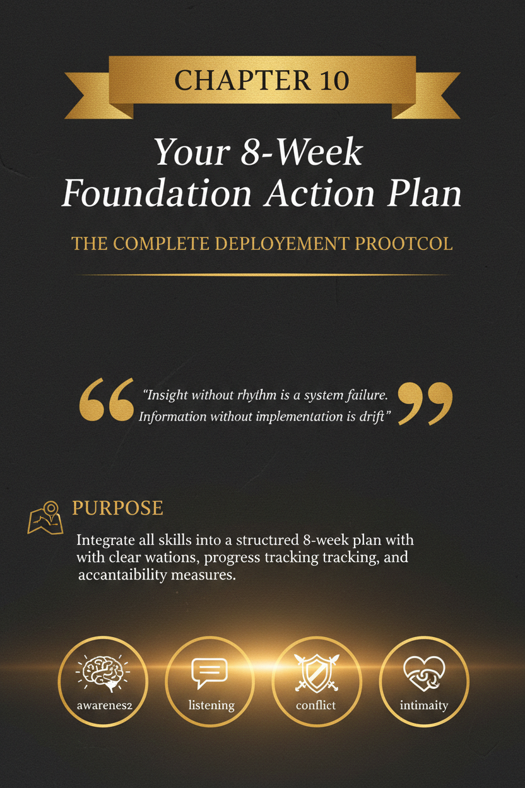

Chapter 10: Your 8-Week Foundation Action Plan

Purpose
Translate the first nine chapters into consistent behaviour so the relationship changes in practice, not only in theory.

Opening Vignette
A common pattern looks like this:
After a hard conversation, someone says, “I know what I need to do differently.” They mean it. For two or three days, they listen better, pause sooner, and try harder. Then work gets heavy, stress rises, timing goes bad, and the old reflexes return: defensiveness, impatience, distraction, shutdown, or the sense that the relationship is slipping back into the same familiar groove.
Nothing stalled because the insight was fake. It stalled because the insight was not yet attached to a rhythm.
That is the gap this chapter closes.
It takes good intentions, turns them into weekly structure, and gives change a better chance of surviving ordinary life.

Why This Chapter Comes Next
Chapters 1 through 9 built the foundations:
- emotional awareness,
- regulation,
- listening,
- boundaries,
- conflict skills,
- apology and repair,
- emotional intimacy,
- physical intimacy,
- and quality time.
Those skills matter. But insight alone does not reliably change a relationship.
Many people can explain what healthy communication looks like and still fail to do it when tired, triggered, embarrassed, distracted, or under pressure. That is not always because they do not care. Often, it is because they do not yet have a repeatable structure for applying what they have learned.
That is what this chapter is for.
This chapter turns the first nine chapters into a rhythm.
Not a performance. Not a personality transplant. Not an unrealistic reboot.
A rhythm.
In practical terms, that rhythm is the Minimum Viable Rhythm: the smallest repeatable structure that keeps change alive when motivation drops.
Insight without rhythm usually becomes drift. A strong conversation can create hope, but only repeated behaviour makes that hope believable. The purpose of this chapter is to turn the previous chapters into visible evidence: small actions, repeated often enough that the relationship begins to trust them.
A relationship usually improves when healthier responses become easier to access, easier to repeat, and easier to review. This eight-week plan is designed to do exactly that.
If you apply it well, you should begin to see:
- less guesswork,
- less decision fatigue,
- more consistent effort,
- faster recovery after mistakes,
- stronger follow-through,
- and a clearer path from intention to trust.
The goal is not perfection by week eight.
The goal is to become more reliable.

Learning Objectives
By the end of this chapter, you should be able to:
- convert relational insight into daily and weekly practices,
- build a simple review rhythm that reduces drift,
- focus on one skill at a time without losing sight of the whole picture,
- recognise setbacks without turning them into collapse,
- identify what is working and repeat it,
- and carry the strongest foundations of Part I into the more advanced work that follows.

What This Chapter Actually Is
This chapter is an implementation chapter.
It is not here to give you a fresh theory of love.
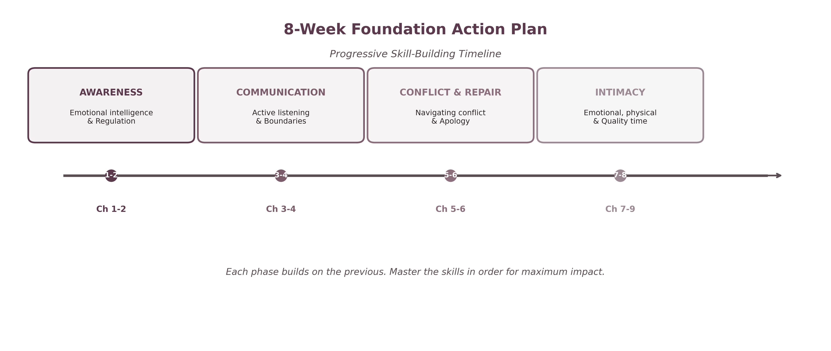
The 8-Week Foundation Timeline
That matters because many relationships do not stay stuck for lack of information. They stay stuck because:
- insight is irregular,
- effort is reactive,
- repair happens only after damage,
- progress is not reviewed,
- and good intentions disappear under stress.
A structured plan helps because it reduces the mental load of deciding what to work on each day. It replaces vague self-promises with visible behaviours.
You do not need to wake up each morning asking:
- What should I focus on today?
- Am I working on too much?
- How do I know whether anything is changing?
The plan answers those questions for you.

The Core Tool
Use this sequence:
Focus → Practice → Track → Review → Adjust

Focus
Choose the one skill the week is organised around.
Do not try to improve everything at once.

Practice
Use a few concrete behaviours every day rather than occasional bursts of insight.

Track
Log what you did, what you missed, and what triggered difficulty.
Use a notebook, worksheet, notes app, spreadsheet, or companion tracker.

Review
Take one protected block each week to review what is improving, what is failing, and what needs correction.

Adjust
Make the next week more realistic, not more dramatic.
This is how behavioural change becomes sustainable.

Ground Rules
Before you begin, keep these rules in front of you.

1. Consistency beats intensity
Ten workable minutes repeated honestly will usually do more than one grand gesture followed by five empty days.

2. One week, one primary focus
All the skills remain relevant, but each week has one lead skill. Let it lead.

3. Do not use the plan as self-punishment
This is not a scoreboard for shame. It is a structure for learning.

4. Missed days do not invalidate the week
A missed day is information, not failure.

5. Repair counts as progress
If you catch yourself, own it, and correct course sooner than before, that is progress.

6. Your partner is not your compliance officer
This plan is for your growth. Do not ask the hurt partner to manage your consistency for you.

7. Better is the target, not flawless
You are building credibility, not pretending to be transformed overnight.

Before You Start
Do these five things first.

1. Choose one tracking method
Use one place only:
- notebook,
- printed worksheet,
- notes app,
- spreadsheet,
- or companion app.
Do not scatter the process across five systems.

2. Pick your weekly review time
Use the same day each week if possible. Friday works well because it lets you review before the next week begins.

3. Tell your partner what you are doing
Keep it simple.
You are not asking them to praise you in advance. You are letting them know you are trying to create a steadier pattern.

4. Choose realistic daily minimums
Do not set goals so ambitious that they disappear by day three.

5. Define what a setback looks like
Know your common failure modes:
- defensiveness,
- forgetting,
- impatience,
- overwhelm,
- all-or-nothing thinking,
- trying to move too fast,
- asking for credit too early.
Anticipated setbacks are easier to manage than surprising ones.

What to Expect Across the Eight Weeks
Progress usually does not feel smooth.

Weeks 1–2: Awareness phase
You may feel:
- awkward,
- self-conscious,
- slower than usual,
- more aware of your own gaps,
- tempted to perform insight instead of building it.
This is normal.
You are interrupting automatic behaviour. That often feels clumsy before it feels natural.

Weeks 3–4: Friction phase
Once boundaries and conflict structure enter the picture, old patterns often become more visible.
You may notice:
- more discomfort around limits,
- more temptation to defend,
- resistance to follow-through,
- impatience that the relationship is not improving fast enough.
This is also normal.

Weeks 5–6: Depth phase
Repair and intimacy work often bring deeper material to the surface:
- old hurts,
- unspoken fears,
- shame,
- longing,
- and the recognition that some previous apologies were incomplete.
Do not confuse depth with regression.

Weeks 7–8: Integration phase
You begin practising warmth, touch, presence, and rhythm more intentionally.
At this point, progress may look like:
- less pressure,
- more ordinary kindness,
- more believable consistency,
- and a stronger sense that change is becoming lived rather than announced.

The Weekly Structure
Each week uses the same basic frame:
- one primary theme,
- daily minimum behaviours,
- one midweek check,
- one Friday review, or your chosen weekly review day,
- and one reset for the next week.
Keep the structure stable even as the content changes.

Simple Weekly Scorecard
If you want a tighter way to track consistency, use this simple scale for each daily minimum:
- 0 = missed
- 1 = attempted
- 2 = completed cleanly
Do not use the score to shame yourself. Use it to spot patterns.
A week full of 1s may still be meaningful progress if the previous version of you was not attempting the skill at all.

Week 1: Emotional Intelligence and Regulation

Aim
Notice your internal state earlier and reduce reactivity before it becomes damage.

Daily Minimums
- Name your emotional state at least once in real time.
- Notice one body signal linked to activation.
- Use one regulation tool before responding when activated.
- Share one honest feeling during the week rather than hiding behind “fine.”

Good Weekly Targets
These are directional targets, not pass-fail rules.
- complete daily emotion tracking,
- practise one breath or grounding exercise each day,
- identify your three most common triggers,
- make one clean vulnerability statement.

Focus Question
What happens in me before I become sharp, cold, defensive, or unavailable?

Common Failure Mode
Waiting until you are already flooded.

Better Response
Catch the shift earlier. A one-minute pause is more effective than a forty-minute apology later.

Week 2: Active Listening

Aim
Listen to understand before you explain, fix, or correct.

Daily Minimums
- Use at least one reflective response each day.
- Ask one clarifying question before offering your view.
- Do not give unsolicited advice during emotionally loaded moments.
- Repair one past moment of dismissiveness if relevant.

Good Weekly Targets
These are directional targets, not pass-fail rules.
- three strong reflective listening moments,
- one conversation where you say back the feeling accurately,
- zero interruptions during one full check-in,
- one “Do you want understanding, help, or both?” question.

Focus Question
Did my partner feel more accurately received after talking to me?

Common Failure Mode
Listening only long enough to prepare your defence.

Better Response
Delay explanation. Understanding first. Response second.

Week 3: Boundaries

Aim
Create clearer lines around respect, time, tone, and participation.

Daily Minimums
- Notice one moment where you want to over-accommodate or overrun.
- State one preference or limit clearly instead of hinting.
- Respect one stated boundary without arguing with it.
- Review whether your follow-through matched your words.

Good Weekly Targets
These are directional targets, not pass-fail rules.
- set one new boundary,
- clarify one old unclear boundary,
- enforce one limit consistently,
- reduce one resentment-producing pattern.

Focus Question
Where am I becoming resentful because I am being unclear, inconsistent, or avoidant?

Common Failure Mode
Calling something a boundary without following through.

Better Response
A boundary is not only a statement. It is a statement plus action.

Week 4: Conflict Skills

Aim
Reduce escalation and make disagreement more structured, respectful, and repairable.

Daily Minimums
- Stay on one issue at a time.
- Use one soft start-up instead of an attack.
- Call a pause before flooding if needed.
- Make at least one repair attempt during or after tension.

Good Weekly Targets
These are directional targets, not pass-fail rules.
- one soft start-up,
- three repair attempts across the week,
- one twenty-minute pause used properly,
- one structured revisit after a hard conversation.

Focus Question
What pattern do we fall into fastest when conflict starts?

Common Failure Modes
- criticism,
- defensiveness,
- tone drift,
- issue stacking,
- pursue-withdraw loops.

Better Response
Slow the conversation down before trying to solve it.

Week 5: Apology and Repair

Aim
Move from vague remorse to specific accountability and visible change.

Daily Minimums
- Notice one defensive impulse and interrupt it.
- If harm occurs, name it specifically.
- Validate impact before explaining intent.
- Follow through on one repair commitment.

Good Weekly Targets
These are directional targets, not pass-fail rules.
- complete one overdue apology,
- make one repair attempt without self-protection,
- ask what would feel repairing,
- track whether promised change actually happened.

Focus Question
Am I trying to look better, or am I trying to repair well?

Common Failure Mode
Apologising in a way that still asks the hurt person to carry your shame, excuse you, or reassure you.

Better Response
Name. Validate. Own. Amend. Ask.

Week 6: Emotional Intimacy

Aim
Create more honesty, depth, and emotional safety without flooding the relationship.

Daily Minimums
- Share one thing more honest than your usual protective version.
- Ask one question that invites depth rather than logistics.
- Respond to one vulnerable moment with curiosity, not correction.
- Protect what is shared.

Good Weekly Targets
These are directional targets, not pass-fail rules.
- use one daily vulnerability prompt,
- share one fear,
- disclose one need cleanly,
- ask one deep question and stay present for the answer.

Focus Question
What am I reluctant to say because I fear being misunderstood, judged, or unmet?

Common Failure Mode
Trying to create intimacy through intensity rather than steadiness.

Better Response
Depth grows through repeated safe moments, not one dramatic disclosure.

Week 7: Physical Intimacy and Connection

Aim
Reduce pressure and rebuild physical closeness as mutual, safe, and emotionally connected.

Daily Minimums
- Offer one affectionate touch that does not carry demand.
- Notice whether touch feels warm, pressured, avoidant, or disconnected.
- Ask rather than assume when closeness matters.
- Respect the answer without sulking, bargaining, or withdrawing.

Good Weekly Targets
These are directional targets, not pass-fail rules.
- increase non-sexual affection,
- have one honest conversation about comfort, pacing, or desire,
- create one unpressured physical ritual,
- reduce one pattern that makes touch feel loaded.

Focus Question
Does physical contact in this relationship feel safe, mutual, and unpressured?

Common Failure Mode
Treating all touch as a pathway to one outcome.

Better Response
Let touch mean comfort, reassurance, affection, or playfulness too. Pressure narrows closeness. Safety broadens it.

Week 8: Quality Time and Presence

Aim
Protect attention and create a warmer, more believable rhythm of connection.

Daily Minimums
- create one short phone-free moment of genuine presence,
- ask one non-logistical question,
- offer one appreciation,
- protect one small ritual of connection.

Good Weekly Targets
These are directional targets, not pass-fail rules.
- one protected block of shared time,
- one planned shared activity,
- one honest conversation about how the relationship has been feeling,
- one decision about which ritual to keep after the eight weeks end.

Focus Question
Are we mainly near each other, or are we actually with each other?

Common Failure Mode
Expecting one date or one “good night” to reverse weeks or months of thin contact.

Better Response
Think accumulation. Warmth rebuilds through repeated ordinary moments that are actually inhabited.

Your Friday Review
Set aside 20 to 30 minutes each week.
Do not use this review to accuse, grandstand, or perform repentance. Use it to tell the truth and make the next week more workable.

Review These Questions
- What went well this week?
- Where did I actually follow through?
- Where did I miss, avoid, or defend?
- What triggered the hardest moments?
- What helped most?
- What pattern repeated?
- What should I keep?
- What should I stop?
- What should I adjust next week?

Review the Week in Behavioural Terms
Do not review only by feeling.
Review by what actually happened:
- Did I pause sooner?
- Did I reflect before responding?
- Did I hold the boundary?
- Did I repair the harm?
- Did I create more warmth?
- Did I keep the ritual?
Behavioural review protects against self-deception.

When the Week Went Poorly
If the week went badly, do not restart the entire process in a dramatic way.
Do this instead:
- name what failed,
- reduce the scope,
- repair what needs repairing,
- continue into the next week with a cleaner target.
A bad week is not a ruined plan. It is useful data.

Worked Example: A Bad Week Corrected
Bad week:
You planned to practise listening, but by Tuesday you were tired, defensive, and interrupting again. By Thursday, you had stopped tracking altogether. By Friday, the temptation was to say the plan was not working.
Corrected week:
Instead of quitting, you tell the truth. You note that the daily target was too ambitious for the week you were having. You reduce the minimum to one reflective response per day, restart the tracker, and repair the moment where you became dismissive. The next week is smaller, but cleaner.
That is still progress.
The point is not uninterrupted execution. The point is faster course correction.

The Minimum Viable Version of the Plan
If life is unusually full, keep the skeleton:
- one daily emotional check,
- one listening effort,
- one moment of warmth,
- one weekly review,
- one repair attempt when needed.
The perfect plan done for four days is less useful than the simpler plan done for eight weeks.

Signs the Plan Is Working
Success is not only “we never argue.” That is too crude.
Better signs include:
- you catch activation earlier,
- conversations become less circular,
- repair happens sooner,
- apologies sound cleaner,
- boundaries become clearer,
- affection feels less pressured,
- attention feels more believable,
- your partner no longer has to work as hard to feel received,
- effort becomes more consistent after the immediate crisis passes.
Those are meaningful shifts.

Transitioning Out of Week Eight
At the end of the eight weeks, do not drop the whole structure just because the formal plan is complete.
Instead, keep three things:

1. One weekly review rhythm
Even a short review prevents drift.

2. Two daily anchor behaviours
Choose the two most useful behaviours from the plan and keep them.
Examples:
- reflective listening,
- one appreciation,
- one protected check-in,
- one pause before reacting,
- one moment of affectionate contact,
- one clear boundary expression.

3. One monthly deeper reset
Use it to review patterns, goals, and what the relationship needs next.
This is how the plan stops being a chapter and becomes a practice.

Scripts

Script 1: Telling Your Partner You’re Starting the Plan
“I want to do this differently, not just talk about doing it differently. I’m starting an eight-week plan to make the things I’ve been learning more consistent in real life. I’m not asking you to manage it for me. I just want you to know I’m taking it seriously.”

Script 2: Naming a Miss Without Defending
“I missed that this week. I got reactive and slipped back into old habits. I’m not saying that to excuse it. I’m saying it because I want to name it cleanly and correct it instead of pretending I’m doing better than I am.”

Script 3: Friday Review Invitation
“Can we take twenty minutes to review the week? I don’t want this to become a blame session. I want to look honestly at what helped, what didn’t, and what would make next week more workable.”

Script 4: Recommitting After a Setback
“I’m disappointed in how I handled that, but I don’t want to turn that disappointment into quitting. I want to repair what needs repairing, get specific about what failed, and keep going more honestly.”

Checklist
Before moving into Part II, ask:
- Can I identify my state faster than before?
- Can I regulate sooner than before?
- Can I listen longer before defending?
- Can I state boundaries more clearly?
- Can I handle conflict with less damage?
- Can I apologise more specifically?
- Can I be more emotionally open without flooding?
- Can I make physical closeness feel safer and less pressured?
- Can I protect time and attention more consistently?
- Can I review progress without collapsing or pretending?
If the answer is “more than before,” the foundation is working.

QR Worksheet: 8-Week Foundation Tracker
Slug: ch10-foundation-tracker

Scan or visit: https://shesnotcrazybook.com/ws/ch10-foundation-tracker
Title: 8-Week Foundation Tracker
Suggested sections:
- daily behaviour log,
- trigger notes,
- Friday review prompts,
- week-by-week scorecard,
- post-week-eight carry-forward plan.

Recap
The first nine chapters gave you the tools. This chapter gives you the rhythm.
Relationships rarely change because one conversation was impressive. They change because better behaviours become more regular, more credible, and easier to trust.
That is the point of this plan.
Not intensity. Not image. Not temporary effort.
Repetition. Review. Repair. Warmth. Follow-through.
That is how change starts feeling real.
And that is what prepares you for Part II: not just stronger intentions, but a stronger behavioural base for handling deeper partnership challenges with more steadiness and less drift.

Companion Resources
Use the companion resource hub for worksheet downloads, chapter tools, and reader bonuses. Every chapter worksheet also has its own short URL for easy access from the paperback or eBook.
Reader hub: https://shesnotcrazybook.com/worksheets
https://shesnotcrazybook.com/ws/ch01-emotional-awareness-map
https://shesnotcrazybook.com/ws/ch02-trigger-map-regulation-ladder
https://shesnotcrazybook.com/ws/ch03-listening-accuracy-check
https://shesnotcrazybook.com/ws/ch04-boundary-builder
https://shesnotcrazybook.com/ws/ch05-conflict-map
https://shesnotcrazybook.com/ws/ch06-repair-builder
https://shesnotcrazybook.com/ws/ch07-intimacy-vulnerability-builder
https://shesnotcrazybook.com/ws/ch08-physical-intimacy-map
https://shesnotcrazybook.com/ws/ch09-quality-time-presence-audit
https://shesnotcrazybook.com/ws/ch10-foundation-tracker

Resources and Further Support
This book is educational and practical. It is not therapy, diagnosis, legal advice, medical advice, or crisis intervention.
If there is immediate danger, contact emergency services in your jurisdiction. If coercion, stalking, threats, self-harm risk, or abuse are present, prioritise safety and seek qualified local support before using relationship repair exercises.
For ongoing support, consider a licensed relationship counsellor, trauma-informed therapist, domestic and family violence service, GP, legal aid service, or crisis support service appropriate to your location.

Acknowledgements
This book was built on a simple conviction: many relationships do not fail because love is absent, but because the skills required to protect love were never clearly taught.
Thank you to the readers who are willing to confront painful patterns honestly rather than hide behind pride, blame, or defensiveness. Thank you to the people who keep asking for healthier ways to communicate, repair, and reconnect. Your honesty is what makes work like this matter.
Thank you also to the clinicians, researchers, educators, and thinkers whose work on communication, emotional regulation, attachment, conflict repair, and relational safety helped shape the practical direction of this book. While this is not a clinical text, it was written with respect for the growing body of work that treats relationship skill as something that can be learned, practised, and strengthened over time.
And finally, thank you to the people who know firsthand how exhausting it is to feel unheard, and to those who have found the courage to learn how to listen better. This book is for both.

About the Author
Austin D. Howell is a writer, systems-minded strategist, and digital product builder based in Perth, Western Australia. His work focuses on practical frameworks that help people think more clearly, communicate more effectively, and build stronger structures in both life and work.
He wrote this book to bring that same systems-minded approach to relationships, turning recurring emotional friction into patterns that can be named, understood, and improved in practice.
In this book, he translates emotionally charged patterns into usable tools for listening, regulation, repair, boundaries, intimacy, and long-term partnership. His aim is not to offer abstract inspiration, but to create practical guidance that readers can apply in real conversations and real relationships.

