**Design Document**

**Major Modules:**

Server Socket:

JSON

Client Socket:

JSON

Server Proxy:

Apache

UI / GUI:

Android with

XML and Java

Database:

MySQL

Database Proxy:

MySQL Proxy

Business Logic: PHP or Python

**Class Diagrams**

Client side Android Class Diagram:

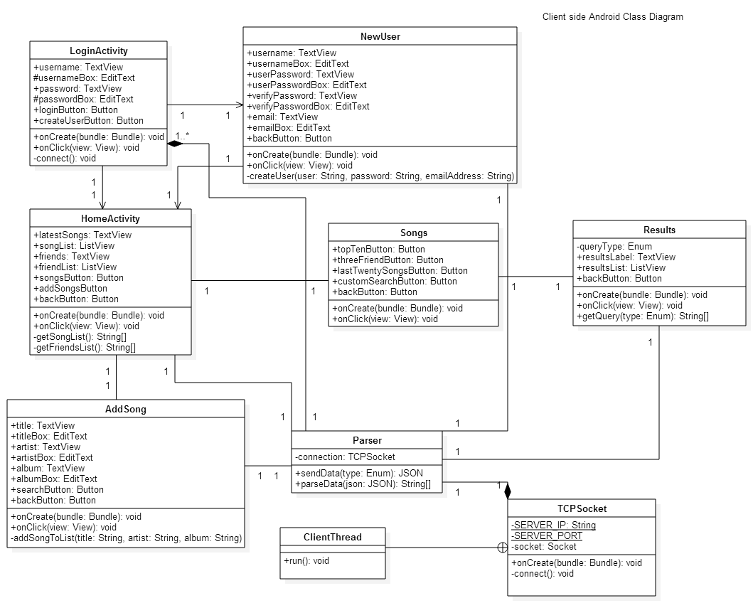

Server side Database Class Diagram:



**Sequence Diagrams**

Login Client Side Sequence:

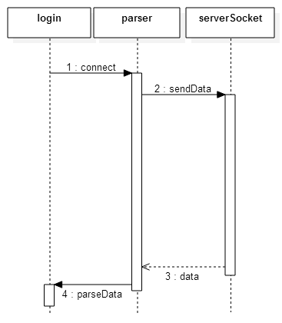

Login Server Side Sequence:



New User Client Side Sequence:

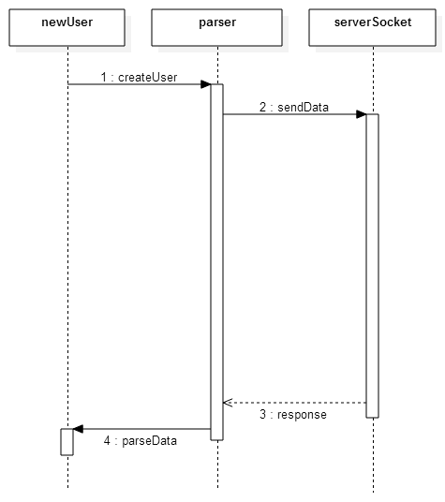

New User Server Side Sequence:



Home Client Side Sequence:

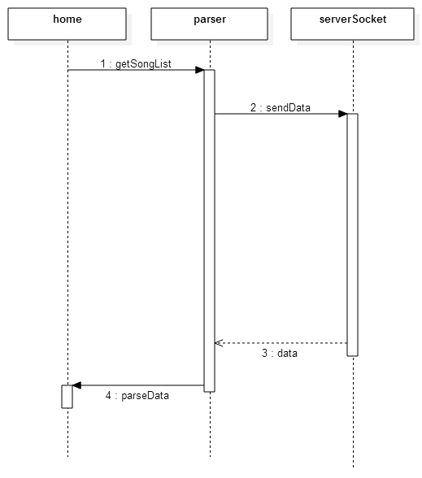

Home Server Side Sequence:



Home Client Side Sequence (continue):

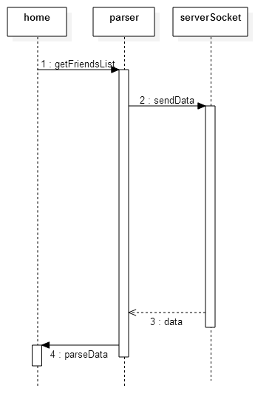

Home Server Side Sequence (continue):



Add Song Client Side Sequence:

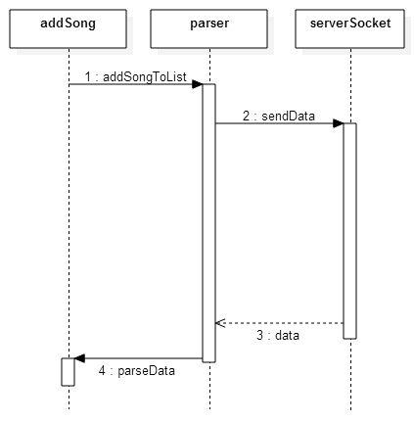

Add Song Server Side Sequence:



Result Client Side Sequence:

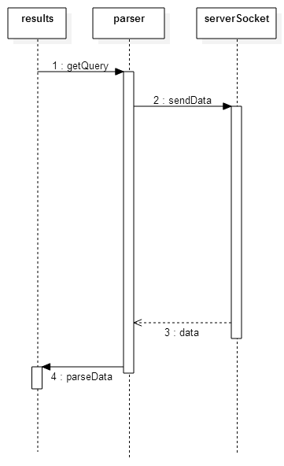

Result Server Side Sequence:

