**HW1 (Due on Sept. 8, 6pm in class) and Project Overview**

**1a) C/C++ using Dev-C++**

**Source code:**

#include <stdio.h>

#include <iostream>

main(){

printf("Hello ACS560!\n");

std::cout<<" \nPress any key to continue\n";

std::cin.ignore();

return 0;

}//end main

**Screenshot:**

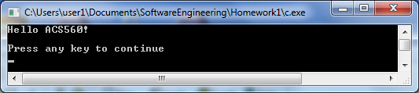

**1b) Java using Eclipse**

**Source code:**

**public** **class** HW1 {

**public** **static** **void** main(String[] args) {

System.*out*.println("Hellow ACS560!");

}//end main method

}//end class

**Screenshot:**

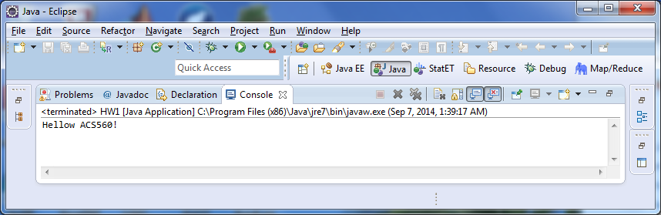

**1c) Python using python shell**

**Source code:**

print "Hello ACS560!"

**Screenshot:**

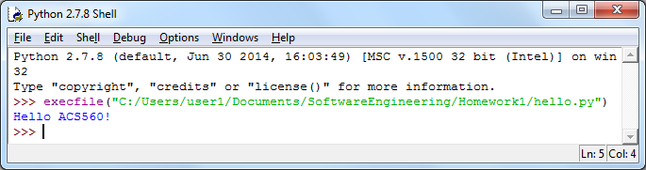

**1d) C# using Microsoft Virtual Studio**

**Source code:**

namespace hello

{

class Program

{

static void Main(string[] args)

{

Console.WriteLine("Hello ACS560!\n");

// Keep the console window open in debug mode.

Console.WriteLine("Press any key to exit.");

Console.ReadKey();

}

}

}

**Screenshot:**

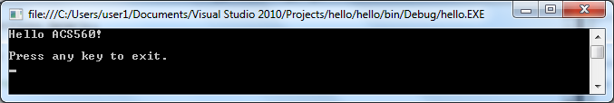

**1e) HTML using Notepad**

**Source code:**

<!DOCTYPE HTML>

<html>

<header><title>HW1</title></header>

<body>

Hello ACS560!

</body>

</html>

**Screenshot:**

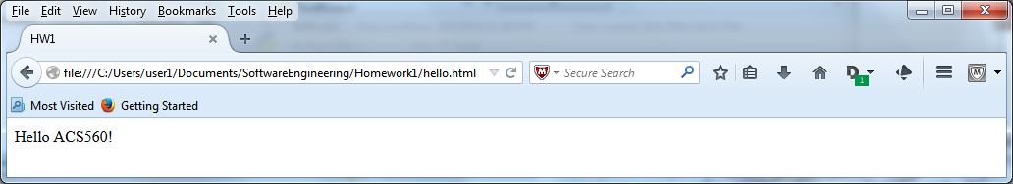

**1f) JavaScript using Notepad**

**Source code:**

<!DOCTYPE HTML>

<html>

<header><title>HW1</title></header>

<body>

<h1>JavaScript HW1 Example</h1>

<script>

alert("Hello ACS560!")

</script>

</body>

</html>

**Screenshot:**

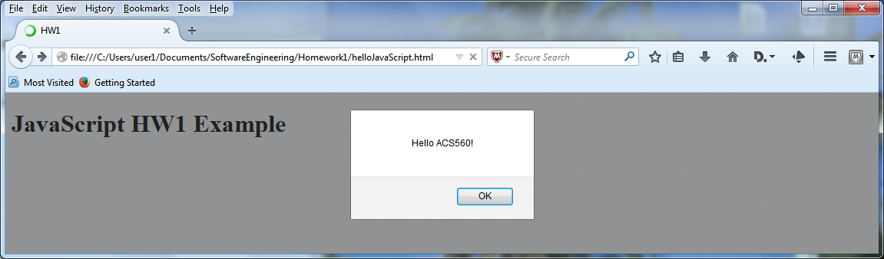

**1g) Go (Golang) using Notepad; http://golang.org/**

**Source code:**

package main

import "fmt"

func main() {

fmt.Printf("Hello ACS560!\n")

}//end func main

**Screenshot:**

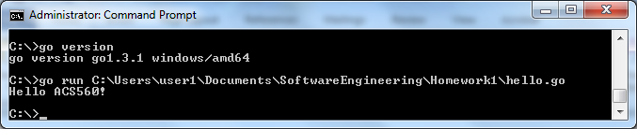

**1h) Shell Script using gedit and a Ubuntu virtual machine**

**Source code:**

#!/bin/bash

# shell script

echo "Hello ACS560!"

**Screenshot:**

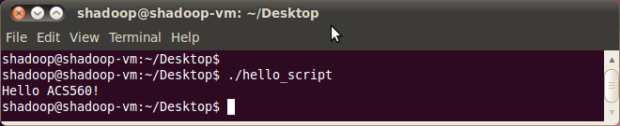

**2) Original file under Linux (Ubuntu)**

**Screenshot:**

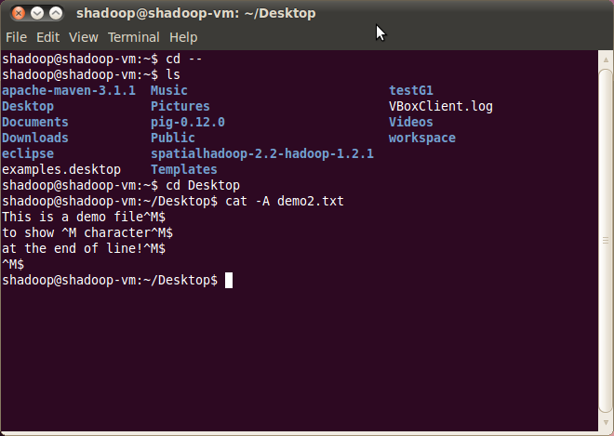

**1st Method under Ubuntu flip (i.e. dos2Unix)**

**Screenshot:**

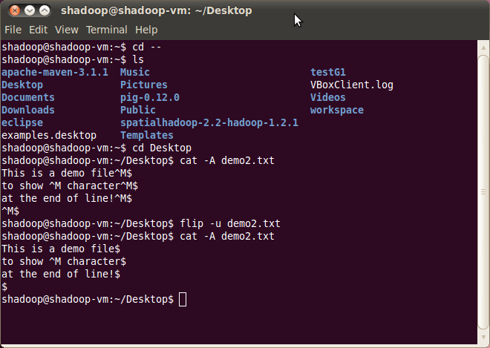

**2nd Method under Ubuntu use tr—translate or delete characters**

**(tr -d '\15\32' < winfile.txt > unixfile.txt)**

**Screenshot:**

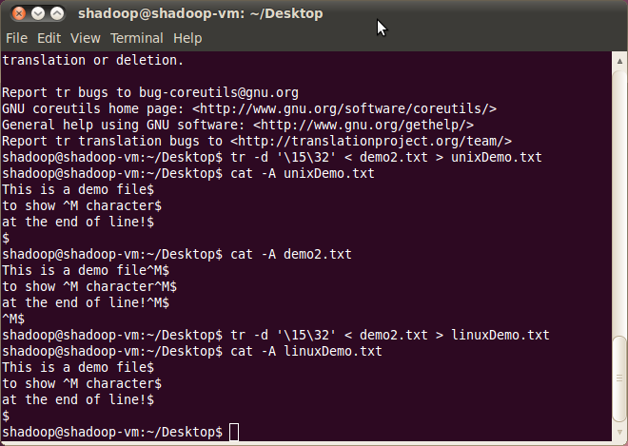

**3a) HTML problem using a Notepad:**

**Source code:**

<!DOCTYPE html>

<html>

<head>

<style>

table, th, td {

border: 1px solid black;

}

th, td {

padding: 5px;

}

</style>

</head>

<body>

<table style="width:100%">

<tr>

<th>Semester</th>

<th>Course</th>

</tr>

<tr>

<td>Fall 2014</td>

<td>Software Engineering</td>

</tr>

<tr>

<td>Fall 2014</td>

<td>Cloud Computing</td>

</tr>

<tr>

<td>Fall 2014</td>

<td>Research Assistant</td>

</tr>

</table>

</body>

</html>

**Screenshot:**

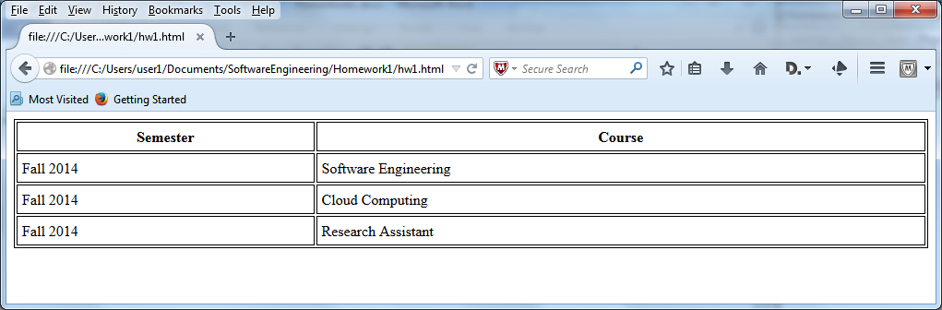

**3b) HTML problem using favorite programming language:**

**Source code:**

**import** java.io.BufferedWriter;

**import** java.io.FileWriter;

**import** java.io.IOException;

**public** **class** HTML {

// Field

**private** StringBuilder sb = **new** StringBuilder();

**public** HTML() {

}// end constructor

**public** **void** addRow(String col1, String col2, String type) {

sb.append("<tr>" + "<" + type + ">" + col1 + "</" + type + ">" + "<"

+ type + ">" + col2 + "</" + type + ">" + "</tr>");

}// end addRow method

**public** **void** buildHTML() {

FileWriter fstream = **null**;

BufferedWriter out = **null**;

String[] stringArray = **new** String[6];

stringArray[0] = "Semester";

stringArray[1] = "Course";

stringArray[2] = "Fall 2014";

stringArray[3] = "Software Engineering";

stringArray[4] = "Cloud Computing";

stringArray[5] = "Research Assistant";

sb.append("<!DOCTYPE html>");

sb.append("<html>");

sb.append("<head>");

sb.append("<style>");

sb.append("table, th, td { border: 1px solid black; } th, td { padding: 5px; }");

sb.append("</style>");

sb.append("</head>");

sb.append("<body>");

sb.append("<table style=\"width:100%\">");

addRow(stringArray[0], stringArray[1], "th");

addRow(stringArray[2], stringArray[3], "td");

addRow(stringArray[2], stringArray[4], "td");

addRow(stringArray[2], stringArray[5], "td");

sb.append("</table>");

sb.append("</body>");

sb.append("</html>");

**try** {

fstream = **new** FileWriter(

"C:/Users/user1/Documents/SoftwareEngineering/Homework1/hw1.html");

out = **new** BufferedWriter(fstream);

out.write(sb.toString());

out.close();

} **catch** (IOException e) {

e.printStackTrace();

}// end try catch

}// end buildHTML method

**public** **static** **void** main(String[] args) {

HTML myHTML = **new** HTML();

myHTML.buildHTML();

}// end main method

}// end HTML class

**Screenshot:**

