**TECNOLÓGICO DE MONTERREY, BOOTCAMP FULLSTACK WEB DEVELOPER**

FINAL PROJECT

TITLE: **RECOV.MX**

DESCRIPTION: App solution for management of debt recovery on mortgage sector.

The platform has great potential and it’s value is related to banking industry from micro credits, group credits, consumer credits and mortgage. All those credits have to be managed to recover due payments

**Description of roles:**

As a solo project i will be covering all the tasks involved in the project

Scheduled tasks for the project:

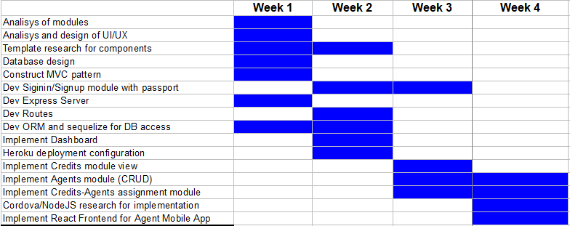

UI/UX interfaces:

* **Login**

Login form for access to the platform

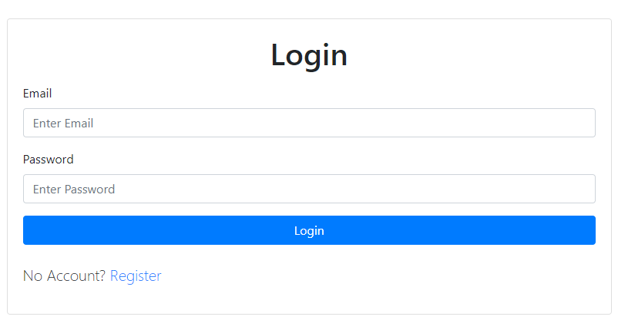

* **User registration**

Interface for the registration of a new user of the platform

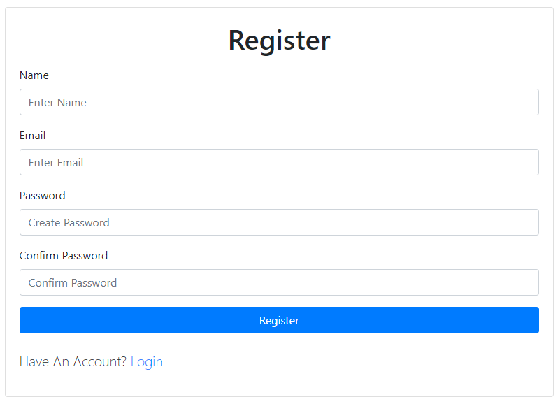

* **Dashboard**

Main form for displaying information related to credits. Summary of number of credits, new credits, total and pending debts. Graphic representation of the overall status of the credits

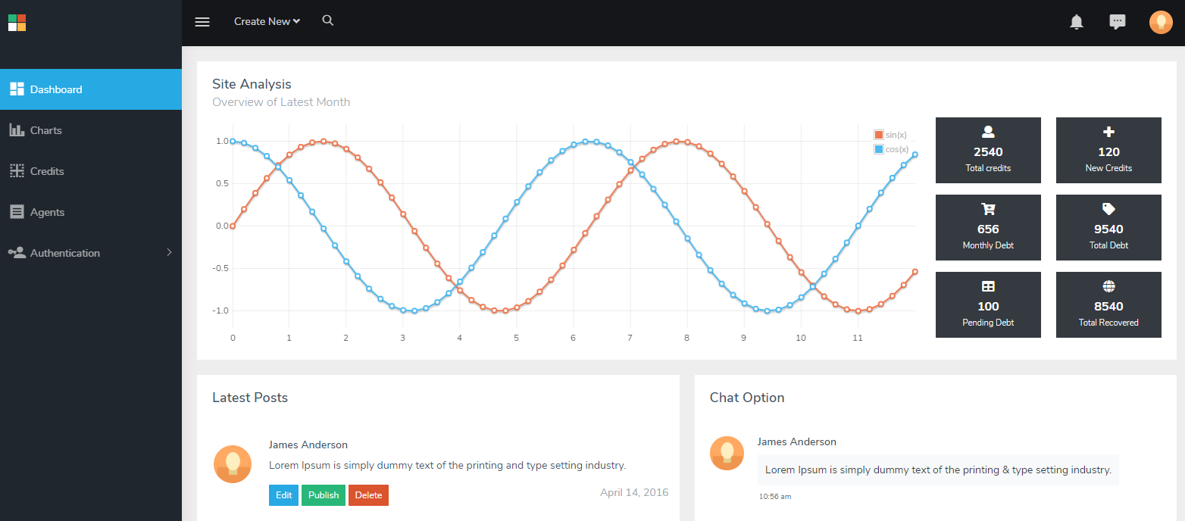

* **Credits**

Data related to credits, Credit number, name of the owner, date of the credit, total debt, total payments

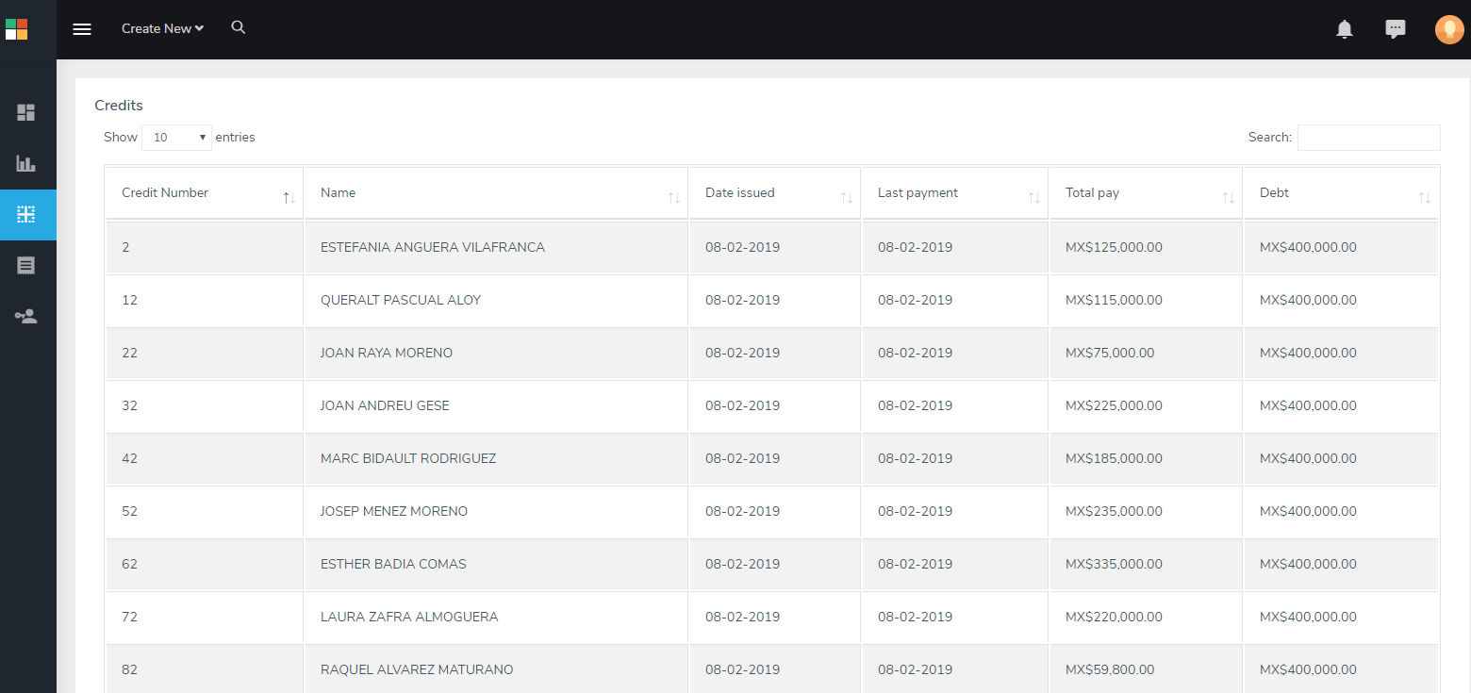

* **Agents**

Data related to the field agents that make visits for recovery of due payments

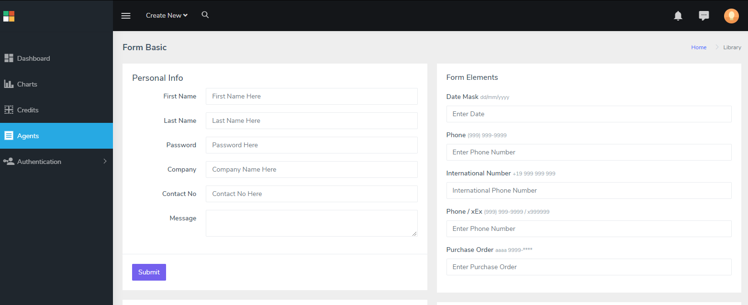

Confidential

July, 2019