Reference-supported evaluation of ECG-ICG B- and X-point localisation across physiological conditions

Research Question 1
Which B- and X-point localisation approaches are reference-supported, and what factors contribute to their variability and failure?

Main finding
B- and X-point reliability depended on the exact definition, reference provenance, failure burden, retained-beat coverage, condition and waveform context. HeartCycle ECHO comparisons identified low central errors for B8 and X12, but other definitions had smaller signed bias, different tails or different failure burdens. X-point common-valid coverage was substantially lower than B coverage. Matched condition changes and morphology effects were method-specific, so the evidence does not support one universal B or X detector.

Aim and objectives
- Evaluate all 10 B and 13 X definitions against ECHO or expert annotations where available.
- Quantify signed error, extreme tails, same-beat disagreement and common-valid coverage.
- Compare valid, missed and invalid detections and reconcile failures to verified execution paths.
- Estimate matched rest-to-exercise and baseline-to-workload changes within participants.
- Test sharpness, slope, amplitude, signal-to-noise ratio, competing features and beat variability against error, failure and disagreement.
Each conclusion below is linked to an in-document figure and numerical table. Accuracy, agreement, failure and morphology are kept as separate outcomes.

Datasets references and evaluation
HeartCycle provides independent ECHO valve-event measurements. ReBeat provides expert ICG B/X annotations. IITB has no independent B/X reference and therefore supports failure and disagreement analyses only. The datasets were not pooled into a single accuracy estimate.
Dataset | Participants | Condition | Beats | Reference | Comparable evidence
HeartCycle | 17 | Overall | 1,706 | ECHO AVO for B; ECHO AVC for X | Strict common reference: B 986; X 371
IITB-ICG | 18 matched | Rest / post-exercise | 2,022 / 1,737 | No independent B/X reference | Matched failure and disagreement
ReBeatICG | 24 matched | Baseline / cognitive workload | 8,403 / 8,492 | Expert ICG B/X annotations | Strict common reference: B 967/838; X 511/433

Table 1. Dataset, reference provenance and comparable samples. ReBeat counts are baseline/workload.

Evaluation rules
- Reference error used strict all-method common-reference beats and is reported as participant median absolute error, signed bias and P90/P95 absolute error.
- Failure used attempted detections: (missed + invalid) / attempted. Upstream ineligibility remained separate.
- Disagreement used all-method common-valid beats. A smaller retained-beat range cannot be called better reliability when failures exclude difficult beats.
- Matched condition estimates used the same participants, participant-level changes and clustered bootstrap intervals.
- Morphology categories were outcome-blind within-participant median splits. They are exploratory strata, not physiological or clinical thresholds.
No approved timing-error tolerance exists. Tolerance exceedance was therefore not calculated. Physical dZ/dt calibration remains unverified, so amplitude-related results retain dataset-specific units.

Frozen localisation definitions
The frozen method set covers local extrema, derivative extrema and crossings, amplitude thresholds, adaptive rules and one heart-rate formula. No definition or parameter was changed for this report.
B | Frozen rule
B1 | Last qualifying local minimum before C
B2 | Last downward third-derivative zero crossing
B3 | Maximum third derivative
B4 | Backward 45% C-amplitude crossing
B5 | Backward 25% C-amplitude crossing
B6 | Maximum second derivative
B7 | Last upward second-derivative zero crossing
B8 | R + 0.55 x (C - R)
B9 | Last upward baseline-plus-10% crossing
B10 | Backward 15% C-amplitude crossing

X | Frozen rule
X1 | First local minimum after C
X2 | Absolute dZ/dt minimum
X3 | First upward third-derivative zero crossing
X4 | Minimum third derivative with strict C < X < next R rule
X5 | First descending 45% global-minimum threshold
X6 | First descending 25% global-minimum threshold
X7 | First upward second-derivative zero crossing
X8 | First post-minimum second-derivative maximum
X9 | Minimum second derivative
X10 | Heart-rate-adjusted Weissler formula
X11 | Halfway C-to-global-minimum downward crossing
X12 | Absolute minimum in C-to-0.4RR window
X13 | First descending 15% global-minimum threshold

Table 2. Condensed descriptions of the 23 frozen definitions. Exact implementation parameters remain unchanged in the verified source.
All 23 methods appear in the reference tables where a reference exists, in the five-context detection tables, in the definition-wise disagreement figures and in the complete morphology screen.

Reference accuracy B point
HeartCycle B timings were compared with ECHO AVO. ReBeat B timings were compared with expert ICG labels. The two references answer different questions and are shown separately.
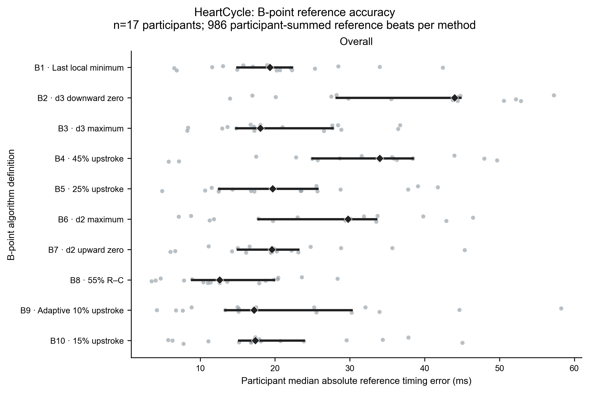 | 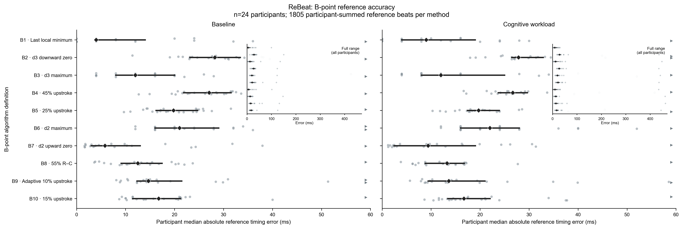
Figure 2A. Participant-level B reference correspondence for all B1-B10 definitions. Each point is one participant median; intervals summarise participants.
Method | HeartCycle ECHO | ReBeat baseline | ReBeat workload
B1 | 19.3 / -4.7 / 45.7 / 63.5 | 4.0 / -4.0 / 40.0 / 52.0 | 9.0 / -4.0 / 44.0 / 56.6
B2 | 44.0 / 38.7 / 58.8 / 65.4 | 28.2 / 27.6 / 45.4 / 56.3 | 27.8 / 28.3 / 52.7 / 66.7
B3 | 18.0 / 14.7 / 39.7 / 48.8 | 12.0 / 8.0 / 52.0 / 76.0 | 12.0 / 4.0 / 60.0 / 80.0
B4 | 34.0 / 31.3 / 47.6 / 52.6 | 27.1 / 26.4 / 37.8 / 44.0 | 26.7 / 26.9 / 45.7 / 60.1
B5 | 19.7 / 19.7 / 39.9 / 45.1 | 19.8 / 18.6 / 31.5 / 38.9 | 19.7 / 20.4 / 38.9 / 49.3
B6 | 29.8 / 25.8 / 46.8 / 52.2 | 21.0 / 20.0 / 40.0 / 72.0 | 22.0 / 20.0 / 44.0 / 72.0
B7 | 19.6 / -7.5 / 45.1 / 61.2 | 5.8 / -3.0 / 40.6 / 52.3 | 9.4 / -3.2 / 41.4 / 55.9
B8 | 12.6 / 11.5 / 29.5 / 34.2 | 12.5 / -11.0 / 24.8 / 30.1 | 13.2 / -10.0 / 25.0 / 36.9
B9 | 17.2 / -5.8 / 45.7 / 57.7 | 14.7 / 0.8 / 55.7 / 82.2 | 13.6 / 5.2 / 56.9 / 75.1
B10 | 17.4 / 11.8 / 38.2 / 44.6 | 16.8 / 13.9 / 30.8 / 41.0 | 16.7 / 16.1 / 37.8 / 47.3

Table 3. B reference metrics in ms, shown as median absolute error / signed median / P90 / P95. HeartCycle: n=17, 986 strict common-reference beats. ReBeat: n=24, 967 baseline and 838 workload beats.
B8 had the lowest observed HeartCycle participant median absolute error (12.59 ms), but it was late by +11.47 ms. B9 had a smaller signed bias (-5.82 ms) and a wider P95 tail (57.73 ms). ReBeat expert-label patterns differed, confirming that the reference type changes the comparison. These are descriptive all-method results, not a paired superiority ranking.

Reference accuracy X point
HeartCycle X timings were compared with ECHO AVC. ReBeat X timings were compared with expert ICG labels. X common-reference samples were smaller than B samples because every X definition had to be valid on the same referenced beat.
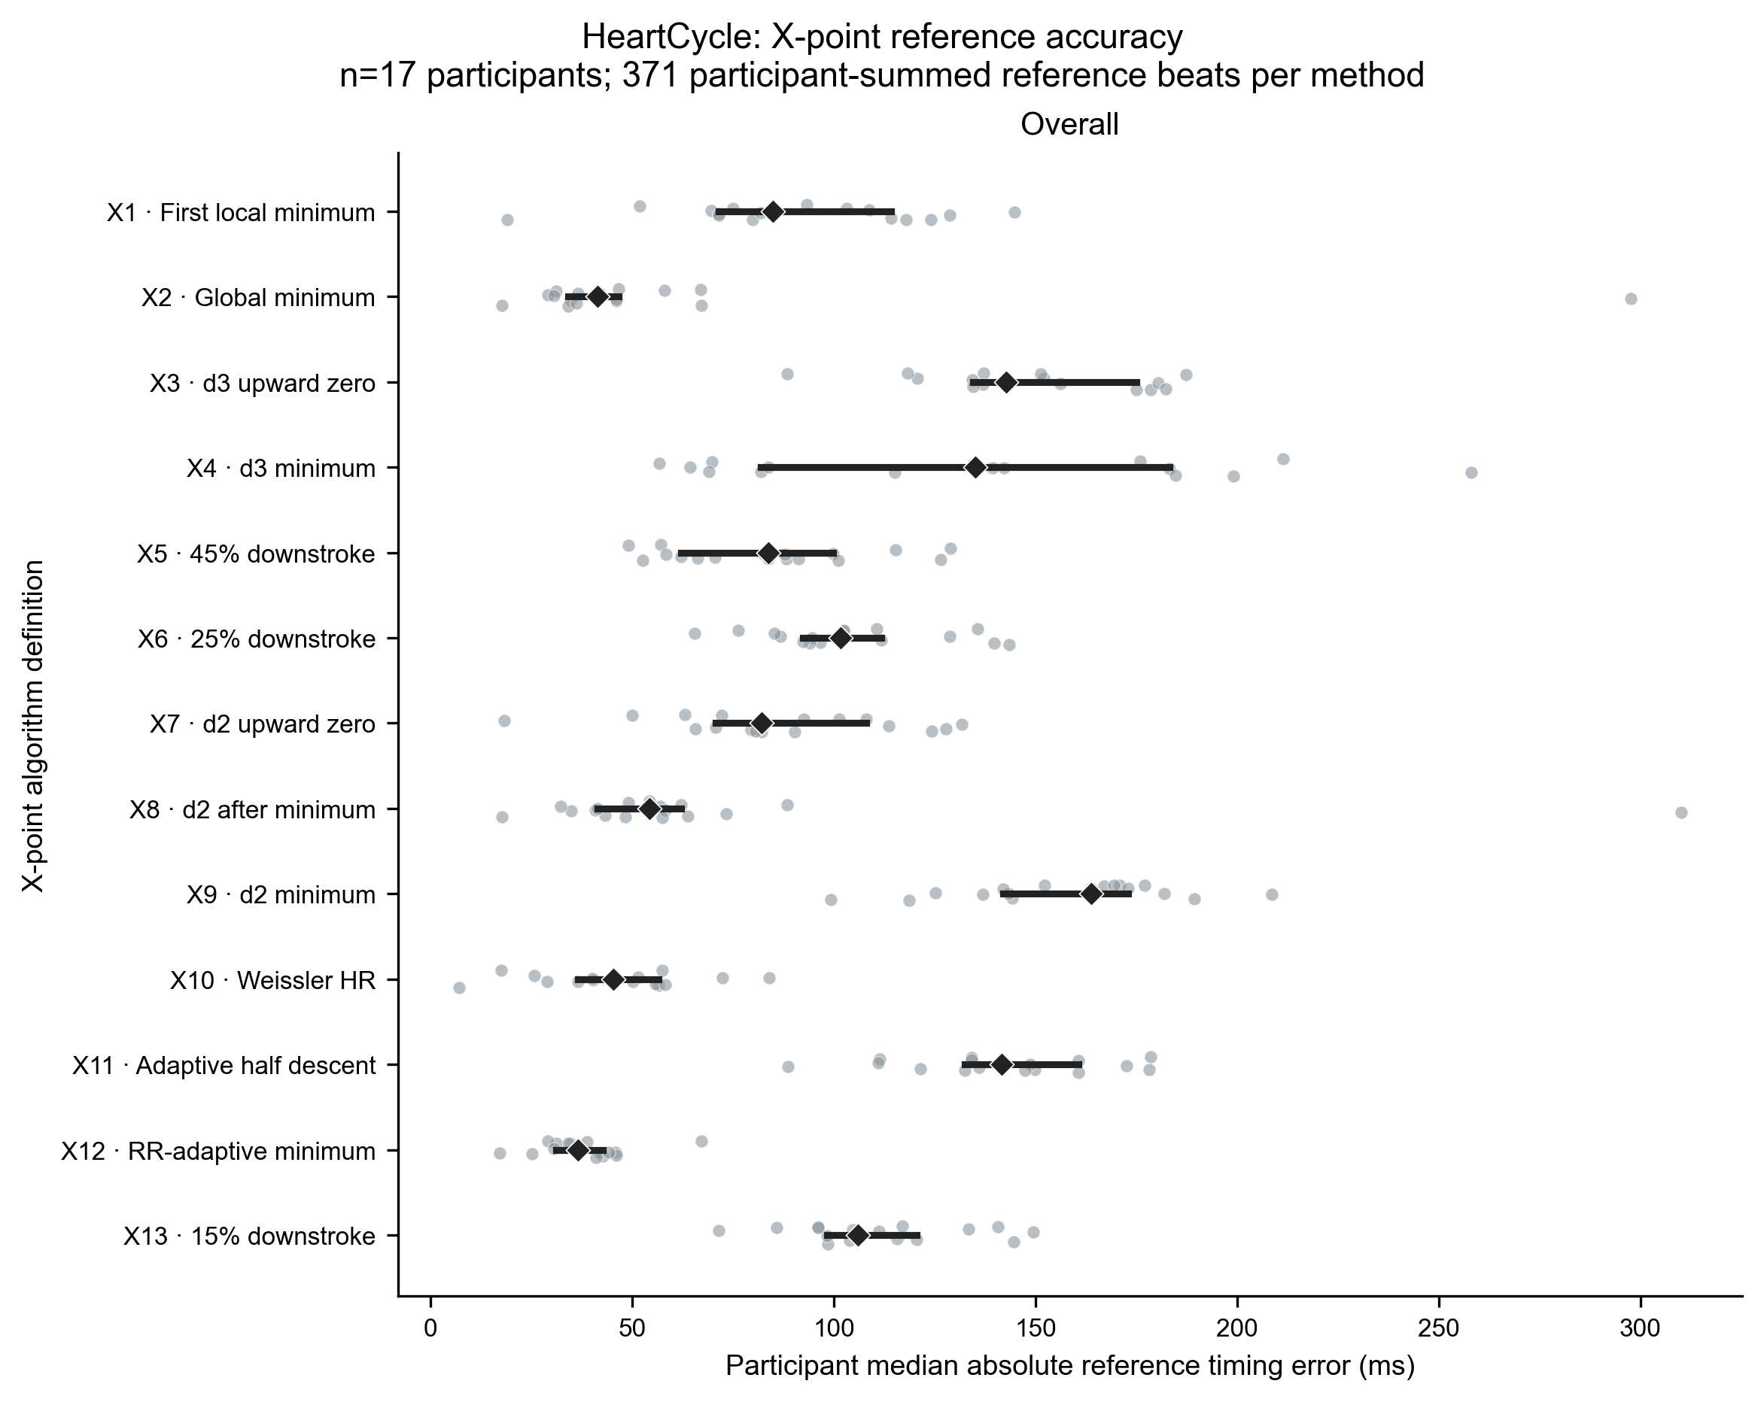 | 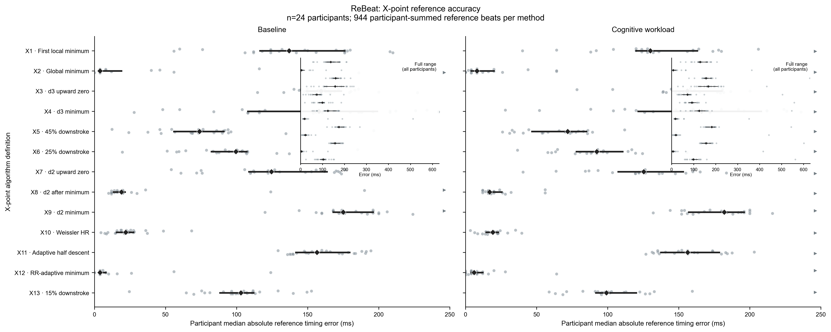
Figure 2B. Participant-level X reference correspondence for all X1-X13 definitions. B and X use different physiological events and are not combined.
Method | HeartCycle ECHO | ReBeat baseline | ReBeat workload
X1 | 85.0 / -94.3 / 156.1 / 174.2 | 137.0 / -144.0 / 208.0 / 220.0 | 130.0 / -148.0 / 216.0 / 248.0
X2 | 41.5 / 38.8 / 379.2 / 409.4 | 4.0 / -4.0 / 248.0 / 386.0 | 8.0 / -4.0 / 271.2 / 373.6
X3 | 142.7 / -144.7 / 188.6 / 194.7 | 159.5 / -161.4 / 201.0 / 209.6 | 156.0 / -159.1 / 210.6 / 227.7
X4 | 135.2 / 66.1 / 351.4 / 498.7 | 158.0 / 24.0 / 332.0 / 422.0 | 166.0 / -24.0 / 361.6 / 448.0
X5 | 83.8 / -88.4 / 131.8 / 142.7 | 73.9 / -78.6 / 125.2 / 148.4 | 71.9 / -68.3 / 123.5 / 155.1
X6 | 101.6 / -102.4 / 145.2 / 152.4 | 99.5 / -97.9 / 142.7 / 164.4 | 92.3 / -89.9 / 143.0 / 164.7
X7 | 82.1 / -84.2 / 138.0 / 147.0 | 124.5 / -137.2 / 186.1 / 196.8 | 125.3 / -136.5 / 190.8 / 216.8
X8 | 54.4 / 53.6 / 393.5 / 422.8 | 19.0 / 12.0 / 268.0 / 392.0 | 17.0 / 12.0 / 279.2 / 381.6
X9 | 163.9 / -145.7 / 209.4 / 219.7 | 175.0 / -168.0 / 236.0 / 340.0 | 182.0 / -164.0 / 224.0 / 313.6
X10 | 45.4 / 44.0 / 71.2 / 81.4 | 22.1 / 16.9 / 43.4 / 53.2 | 19.2 / 15.0 / 45.7 / 63.5
X11 | 141.7 / -139.6 / 180.3 / 184.5 | 156.5 / -156.6 / 195.3 / 203.5 | 156.3 / -155.6 / 198.2 / 209.7
X12 | 36.6 / 31.7 / 68.1 / 78.9 | 4.0 / -4.0 / 60.0 / 84.0 | 6.0 / -4.0 / 68.0 / 120.0
X13 | 105.9 / -109.5 / 150.6 / 155.1 | 103.1 / -104.2 / 151.8 / 168.5 | 99.1 / -98.0 / 153.7 / 172.4

Table 4. X reference metrics in ms, shown as median absolute error / signed median / P90 / P95. HeartCycle: n=17, 371 strict common-reference beats. ReBeat: n=24, 511 baseline and 433 workload beats.
X12 had the lowest observed HeartCycle median absolute error (36.55 ms; signed +31.68 ms; P95 78.94 ms). X2 had a similar central error (41.45 ms) but P95 409.40 ms. X3 and X9 were systematically early. ReBeat X2 and X12 both had 4.00 ms baseline median absolute error against expert labels, again showing that expert-label agreement is not equivalent to ECHO valve-event correspondence.

Signed B timing-error distributions
Signed error is detected time minus reference time. Negative values are early and positive values are late. Common bins and scales were used within the B comparison.
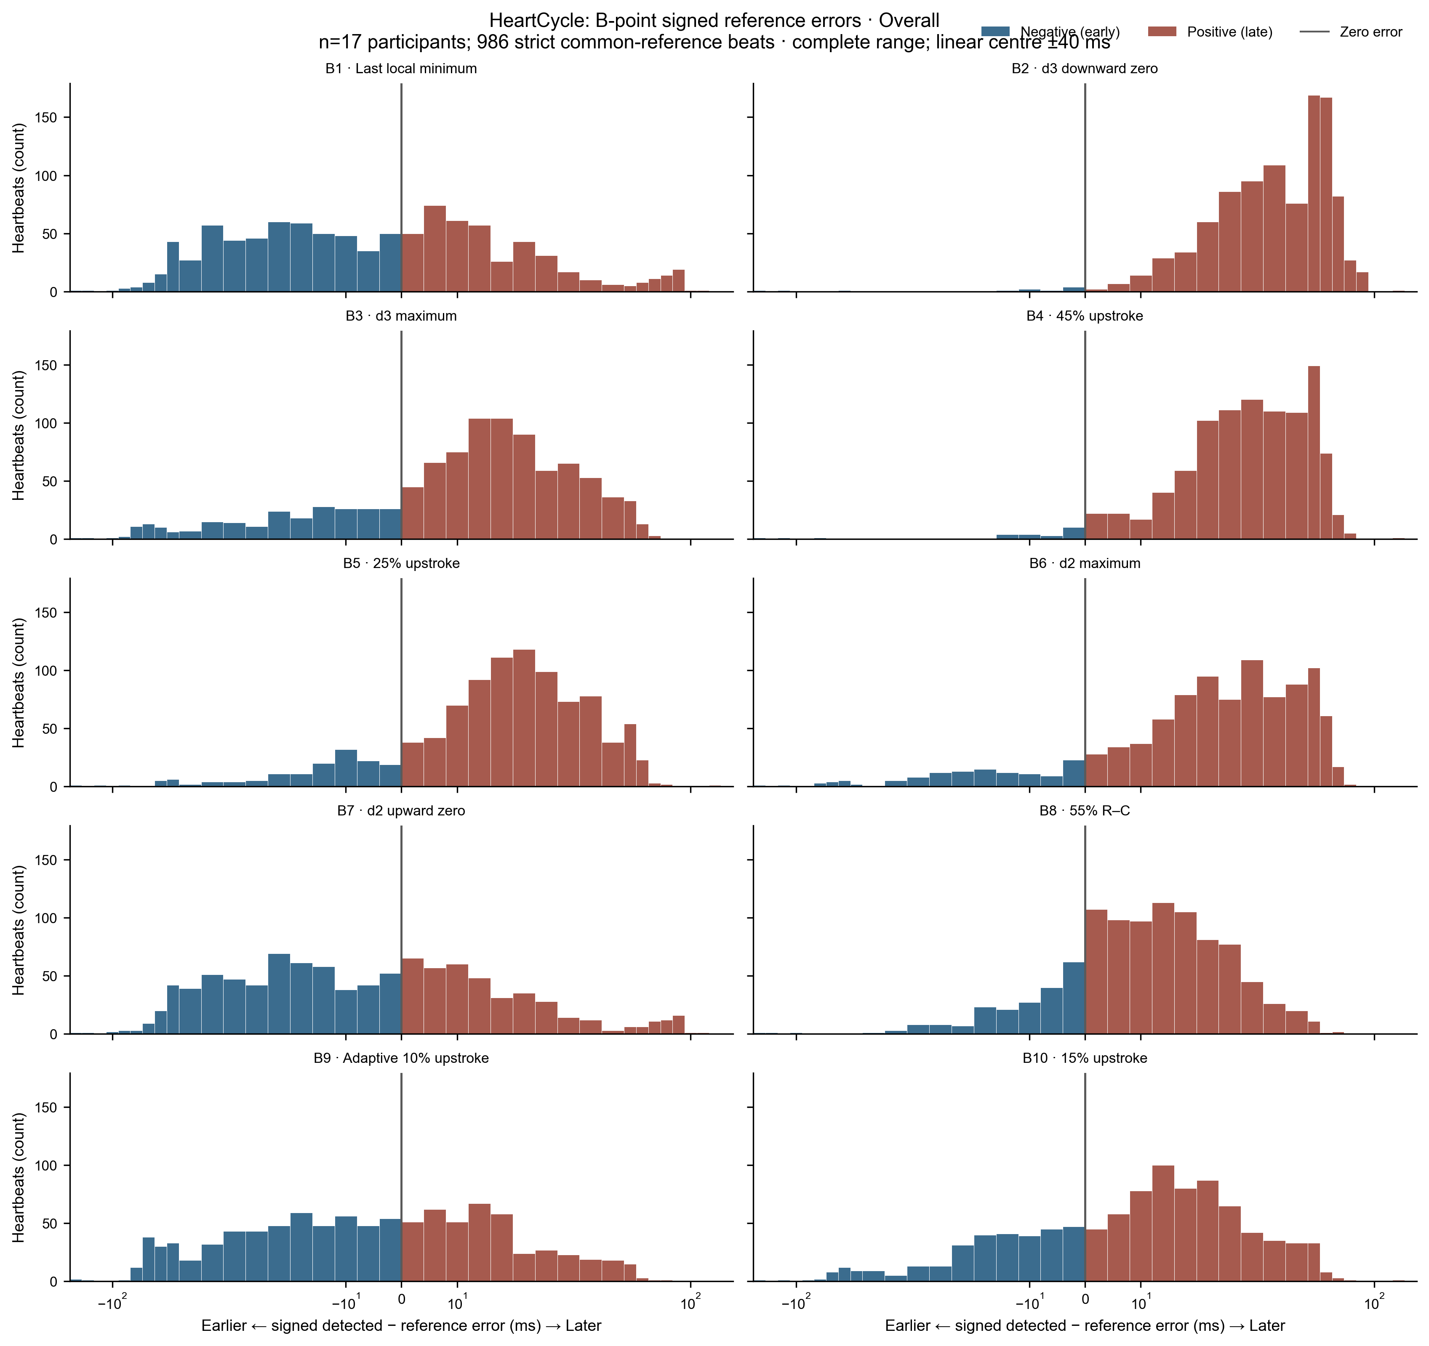
Figure 3A. HeartCycle signed B timing errors against ECHO AVO on 986 strict common-reference beats from 17 participants. The neutral line is zero; negative and positive errors are visually separated.
The distributions support the numerical values in Table 3. B8 combined the lowest observed central absolute error with a positive bias; B9 was closer to zero in signed bias but had a broader upper tail; B2 was later and had a larger central error. No tolerance percentage is shown because no clinical or analytical threshold was approved.

Signed X timing-error distributions
The X distributions show why a central error alone is insufficient. Early systematic shifts and occasional large late errors can produce similar medians with very different tails.
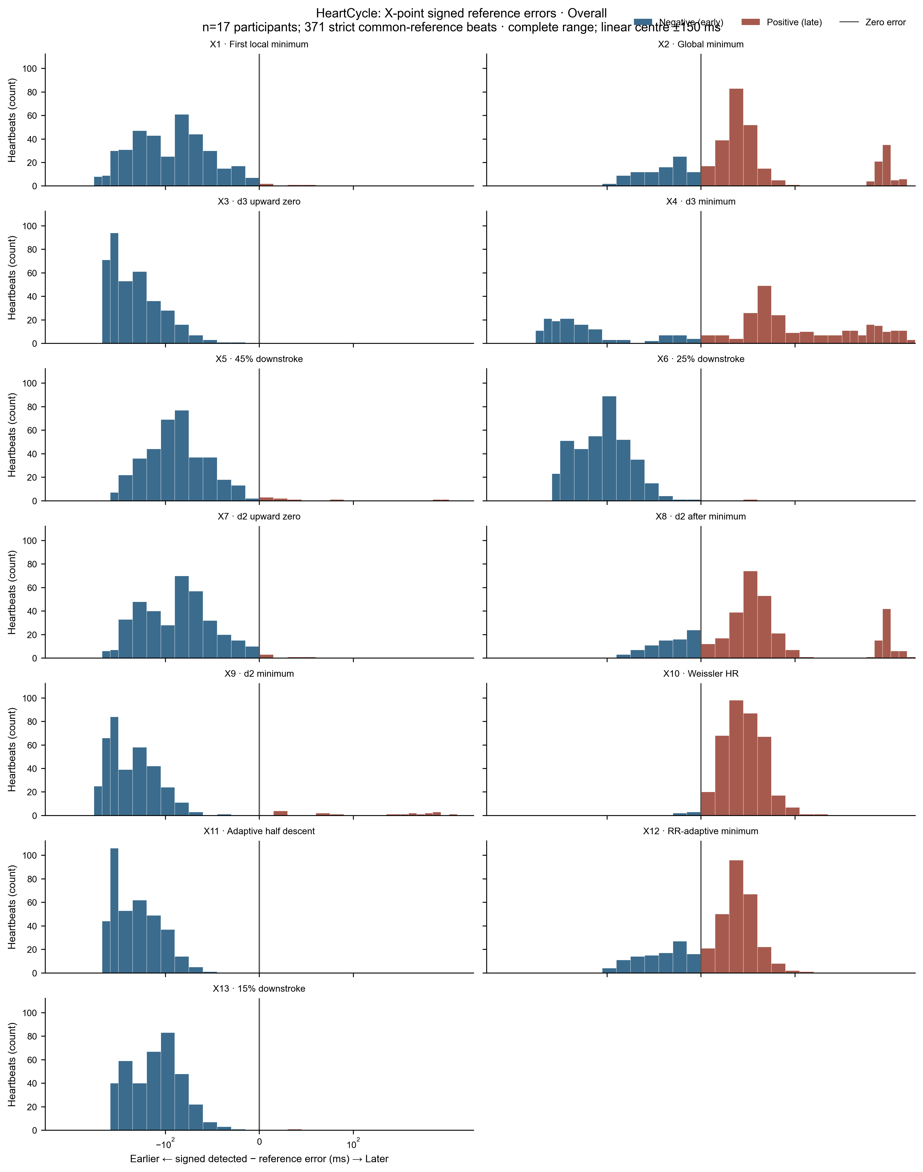
Figure 3B. HeartCycle signed X timing errors against ECHO AVC on 371 strict common-reference beats from 17 participants.
X3 and X9 had signed medians of -144.72 and -145.73 ms. X2 and X8 contained large late tails, with P95 values of 409.40 and 422.85 ms. X12 had a smaller P95 of 78.94 ms. The plots and Table 4 establish timing correspondence on retained reference beats; they do not show failure frequency.

Detection success and failure B point
Failure is missed plus invalid detections divided by attempted detections. Table 5 reports every B definition in all five dataset-condition contexts. Each cell is valid/missed/invalid/attempted followed by the failure rate.
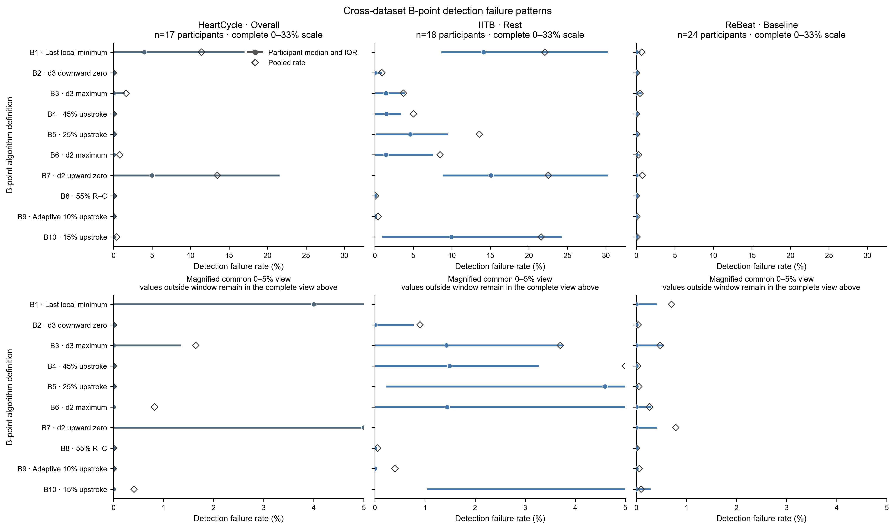
Figure 4A. Dataset-specific B failure patterns. Datasets and conditions remain separate; bars do not imply a pooled acquisition or cohort effect.
B | HeartCycle | IITB rest | IITB post | ReBeat base | ReBeat workload
B1 | 1510/195/0/1705 (11.4%) | 1557/441/0/1998 (22.1%) | 1144/579/0/1723 (33.6%) | 8343/59/0/8402 (0.7%) | 8368/122/0/8490 (1.4%)
B2 | 1705/0/0/1705 (0.0%) | 1980/18/0/1998 (0.9%) | 1701/22/0/1723 (1.3%) | 8399/3/0/8402 (0.0%) | 8483/7/0/8490 (0.1%)
B3 | 1677/0/28/1705 (1.6%) | 1924/17/57/1998 (3.7%) | 1621/22/80/1723 (5.9%) | 8362/3/37/8402 (0.5%) | 8439/7/44/8490 (0.6%)
B4 | 1705/0/0/1705 (0.0%) | 1898/98/2/1998 (5.0%) | 1683/38/2/1723 (2.3%) | 8400/2/0/8402 (0.0%) | 8482/8/0/8490 (0.1%)
B5 | 1705/0/0/1705 (0.0%) | 1727/263/8/1998 (13.6%) | 1634/85/4/1723 (5.2%) | 8398/3/1/8402 (0.0%) | 8477/13/0/8490 (0.2%)
B6 | 1691/0/14/1705 (0.8%) | 1829/17/152/1998 (8.5%) | 1654/22/47/1723 (4.0%) | 8380/3/19/8402 (0.3%) | 8446/7/37/8490 (0.5%)
B7 | 1475/212/18/1705 (13.5%) | 1548/436/14/1998 (22.5%) | 1133/571/19/1723 (34.2%) | 8336/54/12/8402 (0.8%) | 8347/127/16/8490 (1.7%)
B8 | 1705/0/0/1705 (0.0%) | 1997/0/1/1998 (0.1%) | 1721/0/2/1723 (0.1%) | 8402/0/0/8402 (0.0%) | 8489/0/1/8490 (0.0%)
B9 | 1705/0/0/1705 (0.0%) | 1990/0/8/1998 (0.4%) | 1712/0/11/1723 (0.6%) | 8397/0/5/8402 (0.1%) | 8484/0/6/8490 (0.1%)
B10 | 1698/4/3/1705 (0.4%) | 1567/420/11/1998 (21.6%) | 1538/177/8/1723 (10.7%) | 8394/7/1/8402 (0.1%) | 8474/16/0/8490 (0.2%)

Table 5. Complete B detection status evidence. V/M/I/A = valid/missed/invalid/attempted. Rates use attempted detections; upstream-ineligible records are excluded from A.
B1 produced 1,144 valid and 579 missed detections from 1,723 post-exercise attempts. B7 produced 1,133 valid, 571 missed and 19 invalid detections from the same 1,723 attempts. Other B rules often failed less, but lower failure did not guarantee lower reference error or smaller disagreement.

Detection success and failure X point
Table 6 reports every X definition in the same five contexts. The complete counts prevent a low-error retained subset from being interpreted without its failure burden.
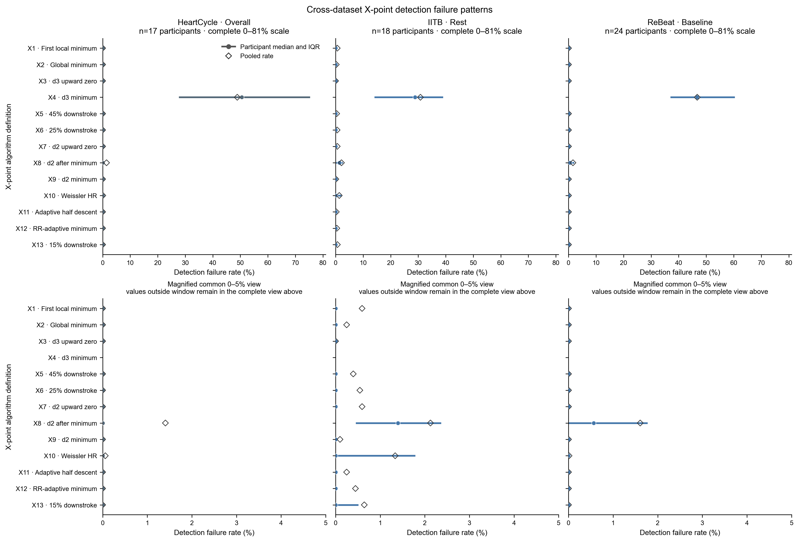
Figure 4B. Dataset-specific X failure patterns for all thirteen definitions. Reference accuracy and operational failure remain separate outcomes.
X | HeartCycle | IITB rest | IITB post | ReBeat base | ReBeat workload
X1 | 1706/0/0/1706 (0.0%) | 2010/12/0/2022 (0.6%) | 1728/9/0/1737 (0.5%) | 8403/0/0/8403 (0.0%) | 8492/0/0/8492 (0.0%)
X2 | 1706/0/0/1706 (0.0%) | 2017/0/5/2022 (0.2%) | 1731/0/6/1737 (0.3%) | 8403/0/0/8403 (0.0%) | 8492/0/0/8492 (0.0%)
X3 | 1706/0/0/1706 (0.0%) | 2022/0/0/2022 (0.0%) | 1734/3/0/1737 (0.2%) | 8403/0/0/8403 (0.0%) | 8492/0/0/8492 (0.0%)
X4 | 872/0/834/1706 (48.9%) | 1399/0/623/2022 (30.8%) | 1035/0/702/1737 (40.4%) | 4476/0/3927/8403 (46.7%) | 4664/0/3828/8492 (45.1%)
X5 | 1706/0/0/1706 (0.0%) | 2014/8/0/2022 (0.4%) | 1725/12/0/1737 (0.7%) | 8403/0/0/8403 (0.0%) | 8492/0/0/8492 (0.0%)
X6 | 1706/0/0/1706 (0.0%) | 2011/11/0/2022 (0.5%) | 1724/13/0/1737 (0.7%) | 8403/0/0/8403 (0.0%) | 8492/0/0/8492 (0.0%)
X7 | 1706/0/0/1706 (0.0%) | 2010/12/0/2022 (0.6%) | 1728/9/0/1737 (0.5%) | 8403/0/0/8403 (0.0%) | 8492/0/0/8492 (0.0%)
X8 | 1682/24/0/1706 (1.4%) | 1979/43/0/2022 (2.1%) | 1693/44/0/1737 (2.5%) | 8268/135/0/8403 (1.6%) | 8240/252/0/8492 (3.0%)
X9 | 1706/0/0/1706 (0.0%) | 2020/0/2/2022 (0.1%) | 1734/0/3/1737 (0.2%) | 8403/0/0/8403 (0.0%) | 8492/0/0/8492 (0.0%)
X10 | 1705/1/0/1706 (0.1%) | 1995/25/2/2022 (1.3%) | 1718/16/3/1737 (1.1%) | 8402/1/0/8403 (0.0%) | 8489/3/0/8492 (0.0%)
X11 | 1706/0/0/1706 (0.0%) | 2017/5/0/2022 (0.2%) | 1731/6/0/1737 (0.3%) | 8403/0/0/8403 (0.0%) | 8492/0/0/8492 (0.0%)
X12 | 1706/0/0/1706 (0.0%) | 2013/0/9/2022 (0.4%) | 1729/0/8/1737 (0.5%) | 8403/0/0/8403 (0.0%) | 8492/0/0/8492 (0.0%)
X13 | 1706/0/0/1706 (0.0%) | 2009/13/0/2022 (0.6%) | 1724/13/0/1737 (0.7%) | 8403/0/0/8403 (0.0%) | 8492/0/0/8492 (0.0%)

Table 6. Complete X detection status evidence. V/M/I/A = valid/missed/invalid/attempted.
HeartCycle X4 had 834 invalid detections in 1,706 attempts (48.89%). X8 missed 24 of 1,706 attempts. X4 remained failure-prone across datasets, but the magnitude cannot be attributed to physiology because acquisition, cohort and processing differ.

Verified operational failure mechanisms
The hierarchy assigned one primary reason per failed or ineligible record only after the frozen execution path was verified. Acquisition warnings remained contextual QC flags and were not counted as algorithmic causes.
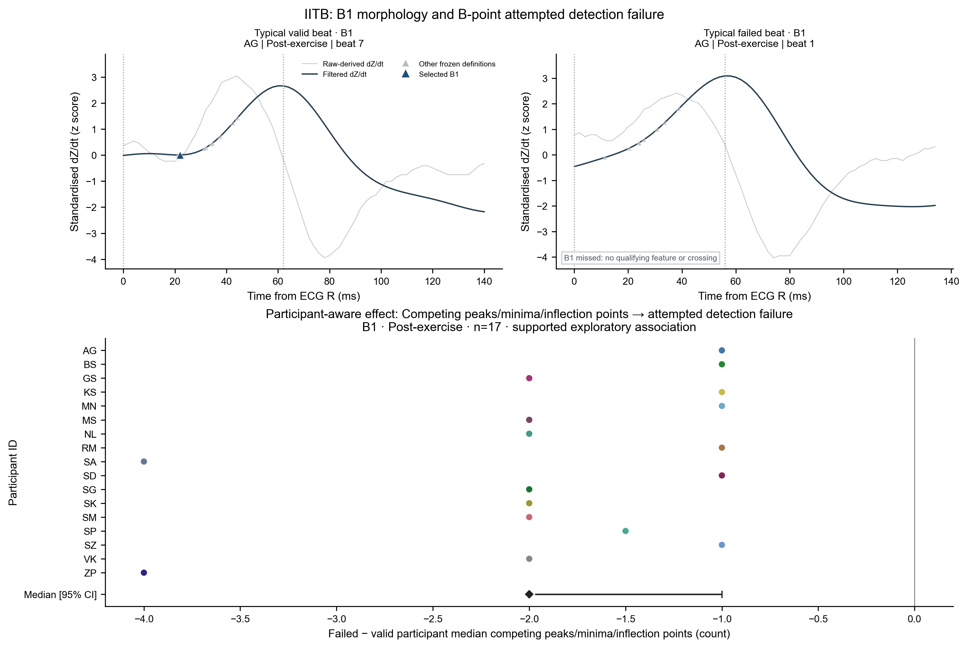 | 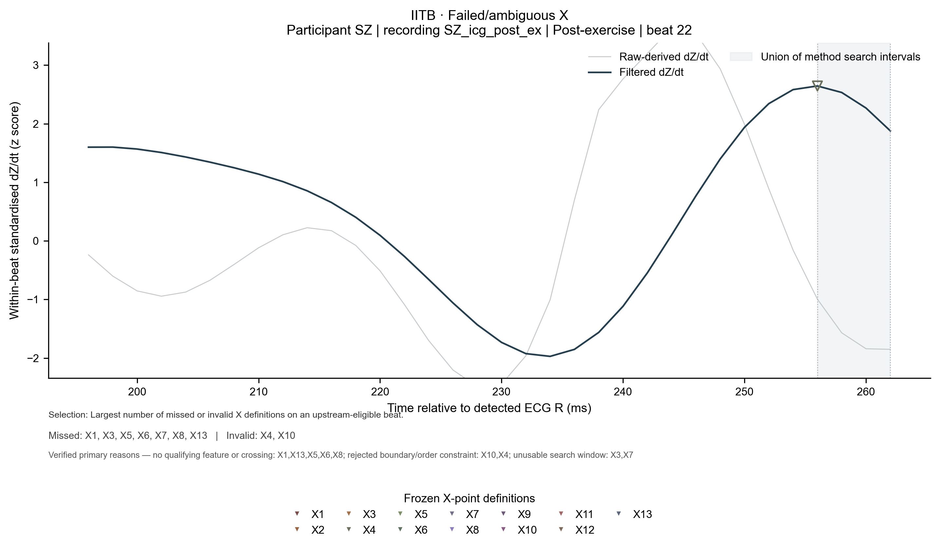
Figure 6A and Figure 1A. Actual waveforms supporting the B1 and X4/X8 execution-path findings. The B1 panel shows a no-qualifying-minimum miss. The X panel identifies missed and invalid definitions on the same beat.
Method | Context | Observed burden | Frozen rule | Verified primary path
B1 | IITB post | 579 M / 1,723 | Last qualifying local minimum | 579 no qualifying minima
B7 | IITB post | 571 M + 19 I / 1,723 | Last upward d2 zero crossing | 564 no crossing; 7 short windows; 19 order rejects
X4 | HeartCycle | 834 I / 1,706 | Minimum d3; require C < X < next R | Boundary/order rejection
X8 | HeartCycle | 24 M / 1,706 | First d2 maximum after global minimum | No qualifying post-minimum maximum

Table 7. Method-specific failure burden, frozen rule and verified execution path. Table 5 provides the full B1/B7 counts and Table 6 the full X4/X8 counts across contexts.
Across 514,280 method-beat records, 15,788 were failed or upstream-ineligible: 466 upstream dependency/ineligibility, 182 unusable windows, 4,520 no qualifying feature/crossing and 10,620 boundary/order rejections. Counts reconciled exactly with the original statuses; no record remained unresolved. These are software-operational mechanisms, not physiological causes.

Same-beat B timing variability
Definition-wise disagreement is the participant median absolute difference from the other-method median on all-method common-valid beats. It measures method consistency, not reference accuracy.
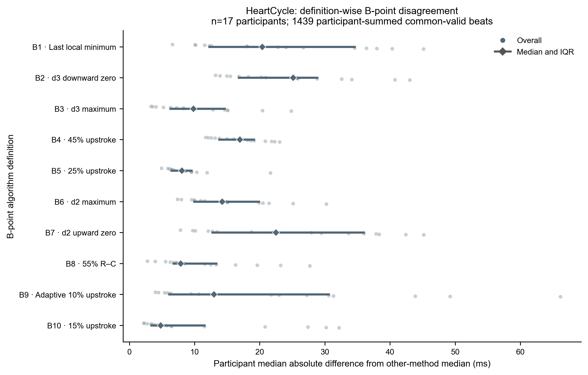
Figure 5A. HeartCycle definition-wise B disagreement on the same common-valid beats.
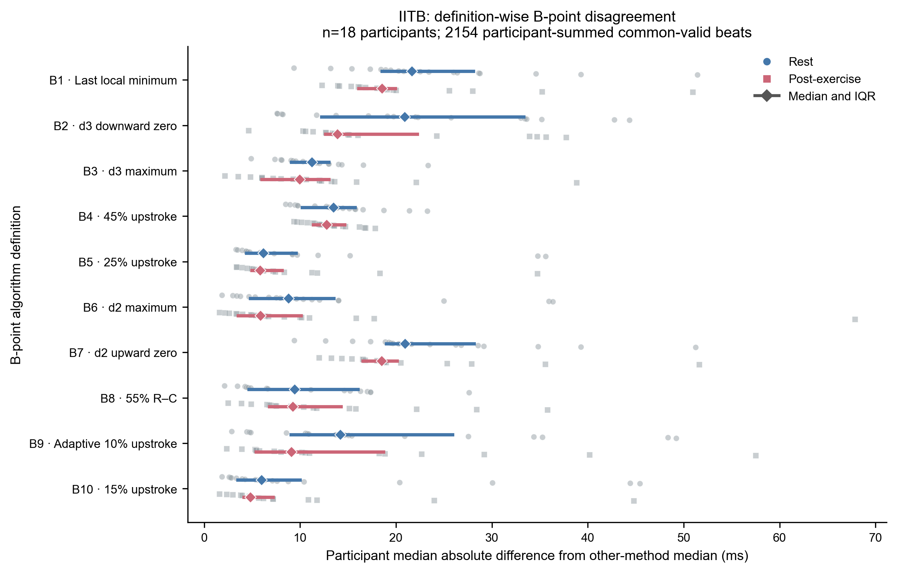 | 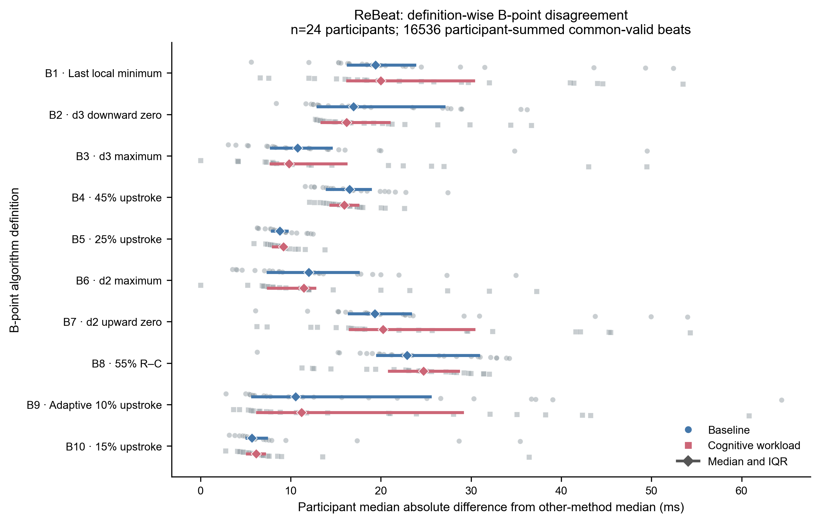
Figure 5B. B disagreement across matched IITB and ReBeat conditions. Each point is one participant summary; condition symbols are not reference errors.
B disagreement was definition-dependent in every dataset. IITB all-method B range changed by -3.82 ms after exercise, but its 95% interval (-12.36 to +2.43 ms) included zero. This does not support a general improvement in B reliability.

Same-beat X timing variability and coverage
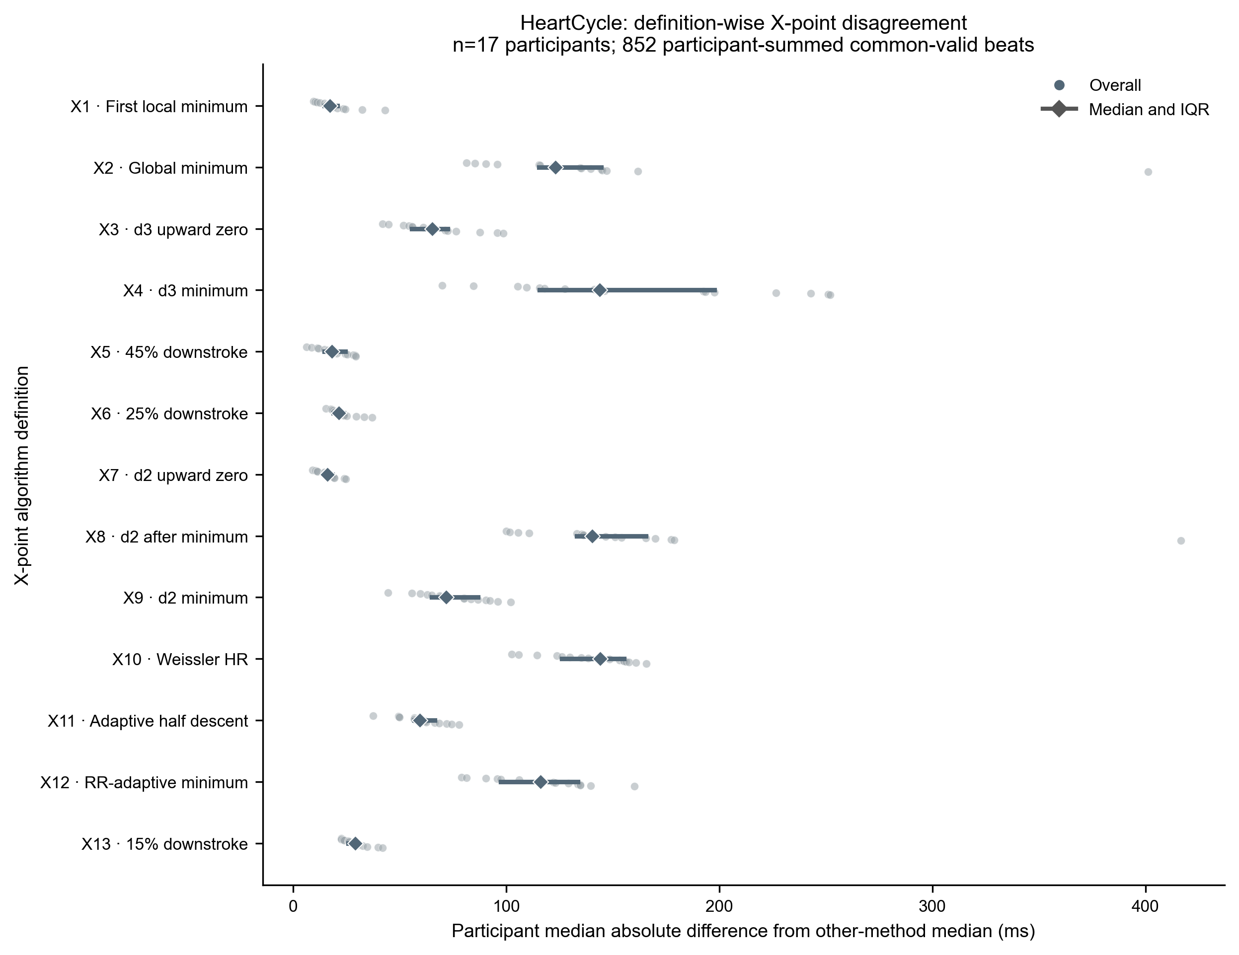
Figure 5C. HeartCycle definition-wise X disagreement on 852 all-method common-valid beats.
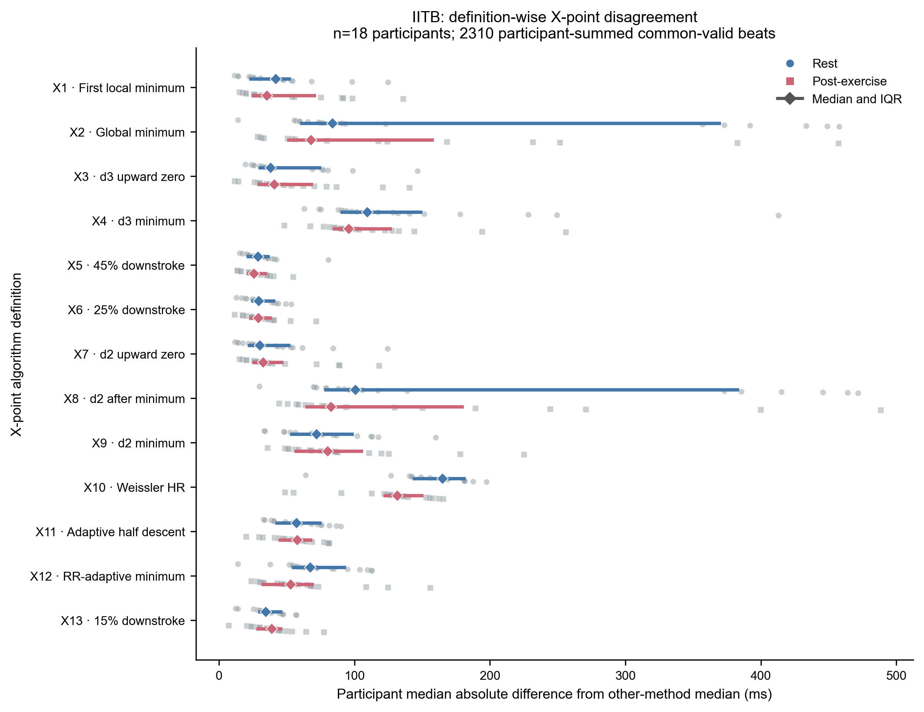 | 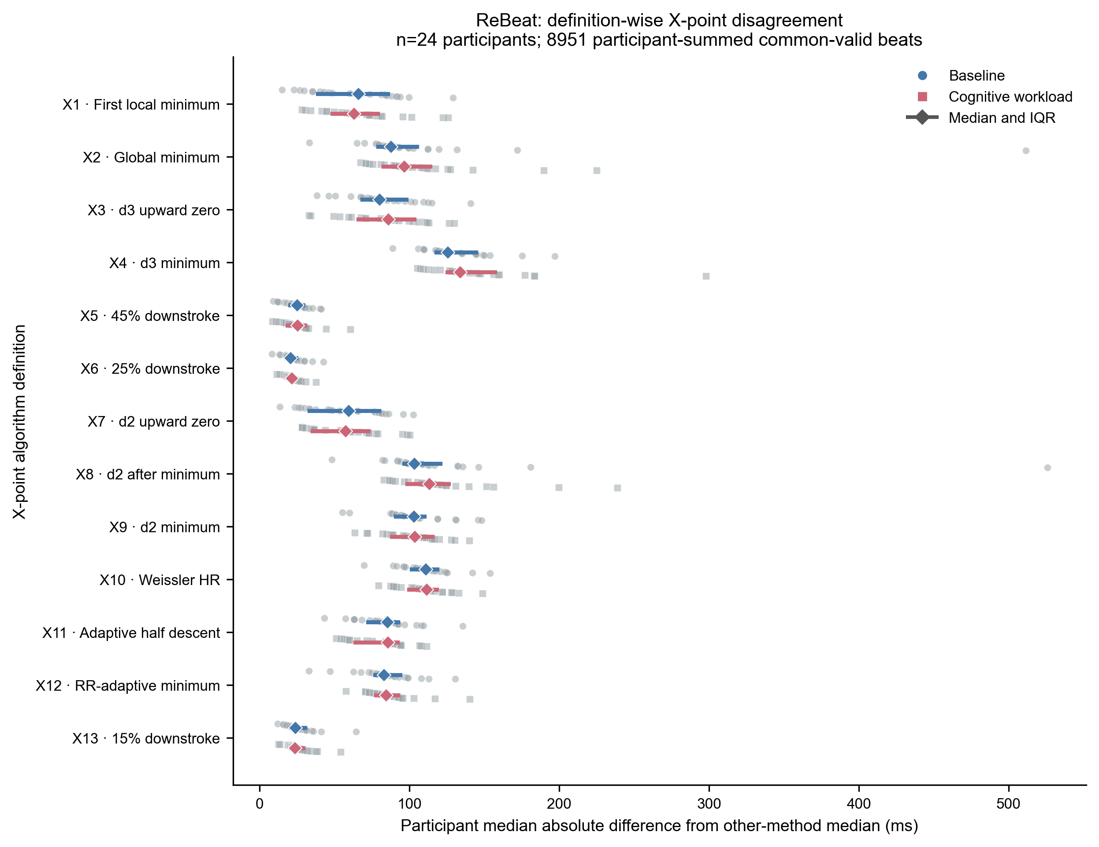
Figure 5D. X disagreement across matched conditions. The plotted samples exclude beats on which any X method failed.
Dataset/condition | B common-valid | B range ms | X common-valid | X range ms
HeartCycle overall | 1439/1705 | 57.8 | 852/1706 | 259.5
IITB rest | 1152/1998 | 58.7 | 1329/2022 | 263.7
IITB post | 1002/1723 | 49.2 | 981/1737 | 247.7
ReBeat baseline | 8275/8402 | 54.1 | 4401/8403 | 235.4
ReBeat workload | 8261/8490 | 58.3 | 4550/8492 | 252.0

Table 8. Common-valid coverage and participant median all-method range. Range summaries use only beats valid for every definition.
HeartCycle X had an approximately 260 ms participant-median all-method range, but only 852 of 1,706 attempts were common-valid. The strict ECHO AVC comparison used 371 of 691 reference-eligible beats, a different restriction. Lower disagreement among retained beats must therefore be interpreted with excluded failures.

Matched physiological-condition comparisons
IITB compares rest with post-exercise in 18 participants. ReBeat compares baseline with cognitive workload in 24 participants. Positive changes mean the stress condition was higher.
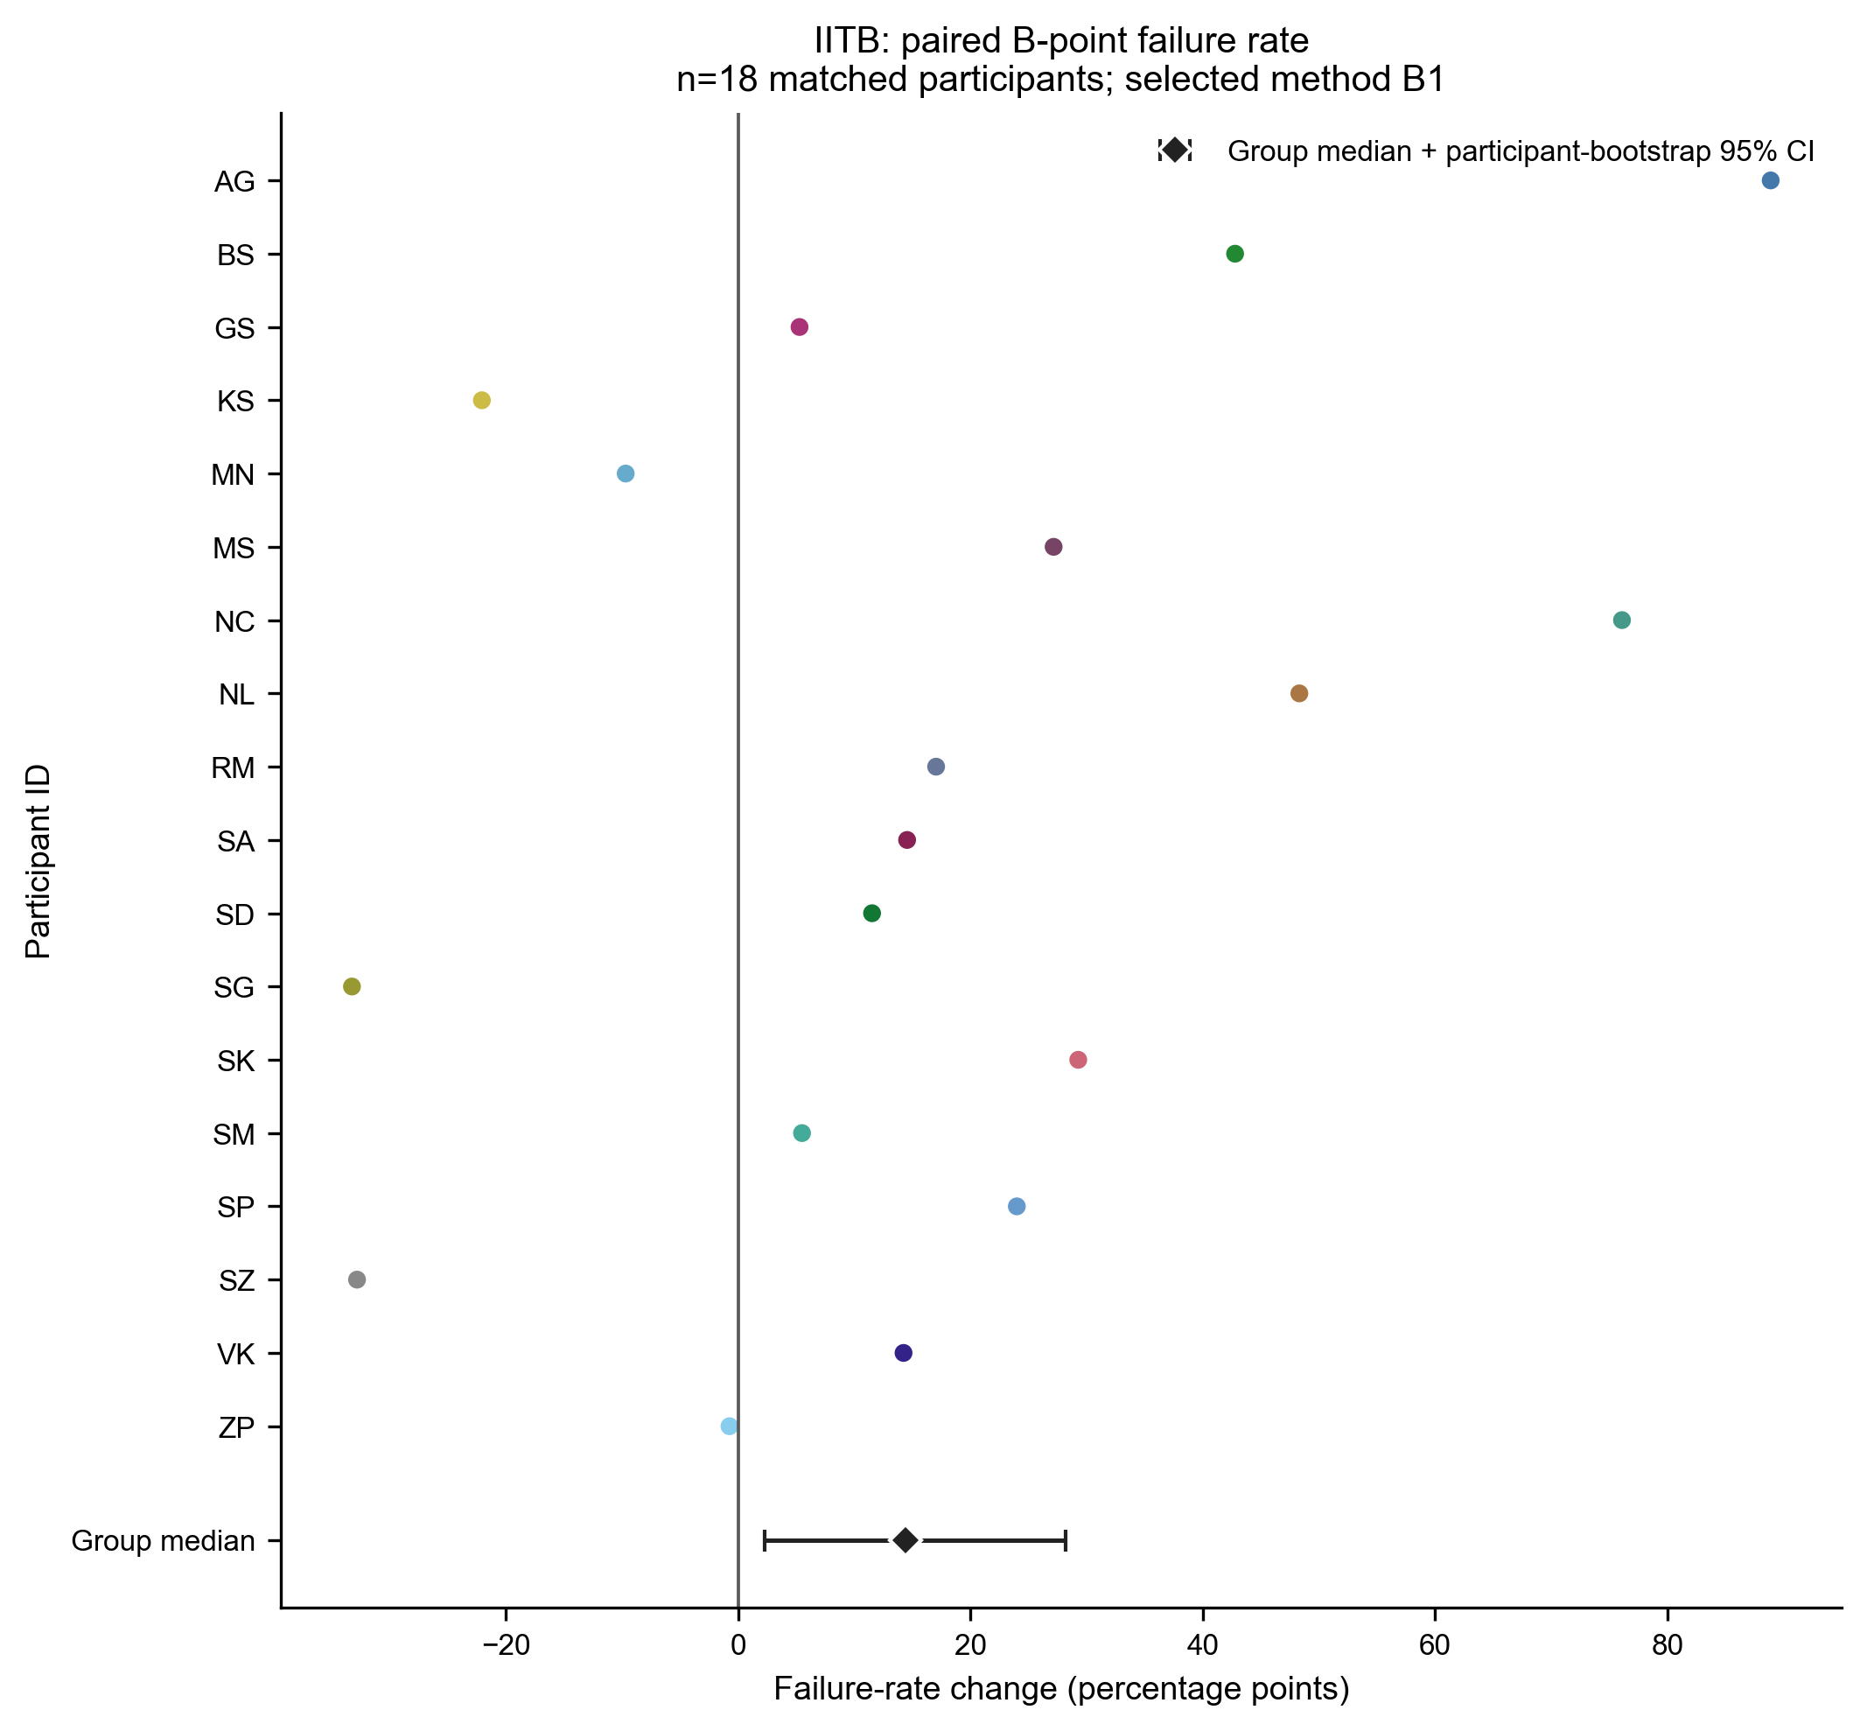 | 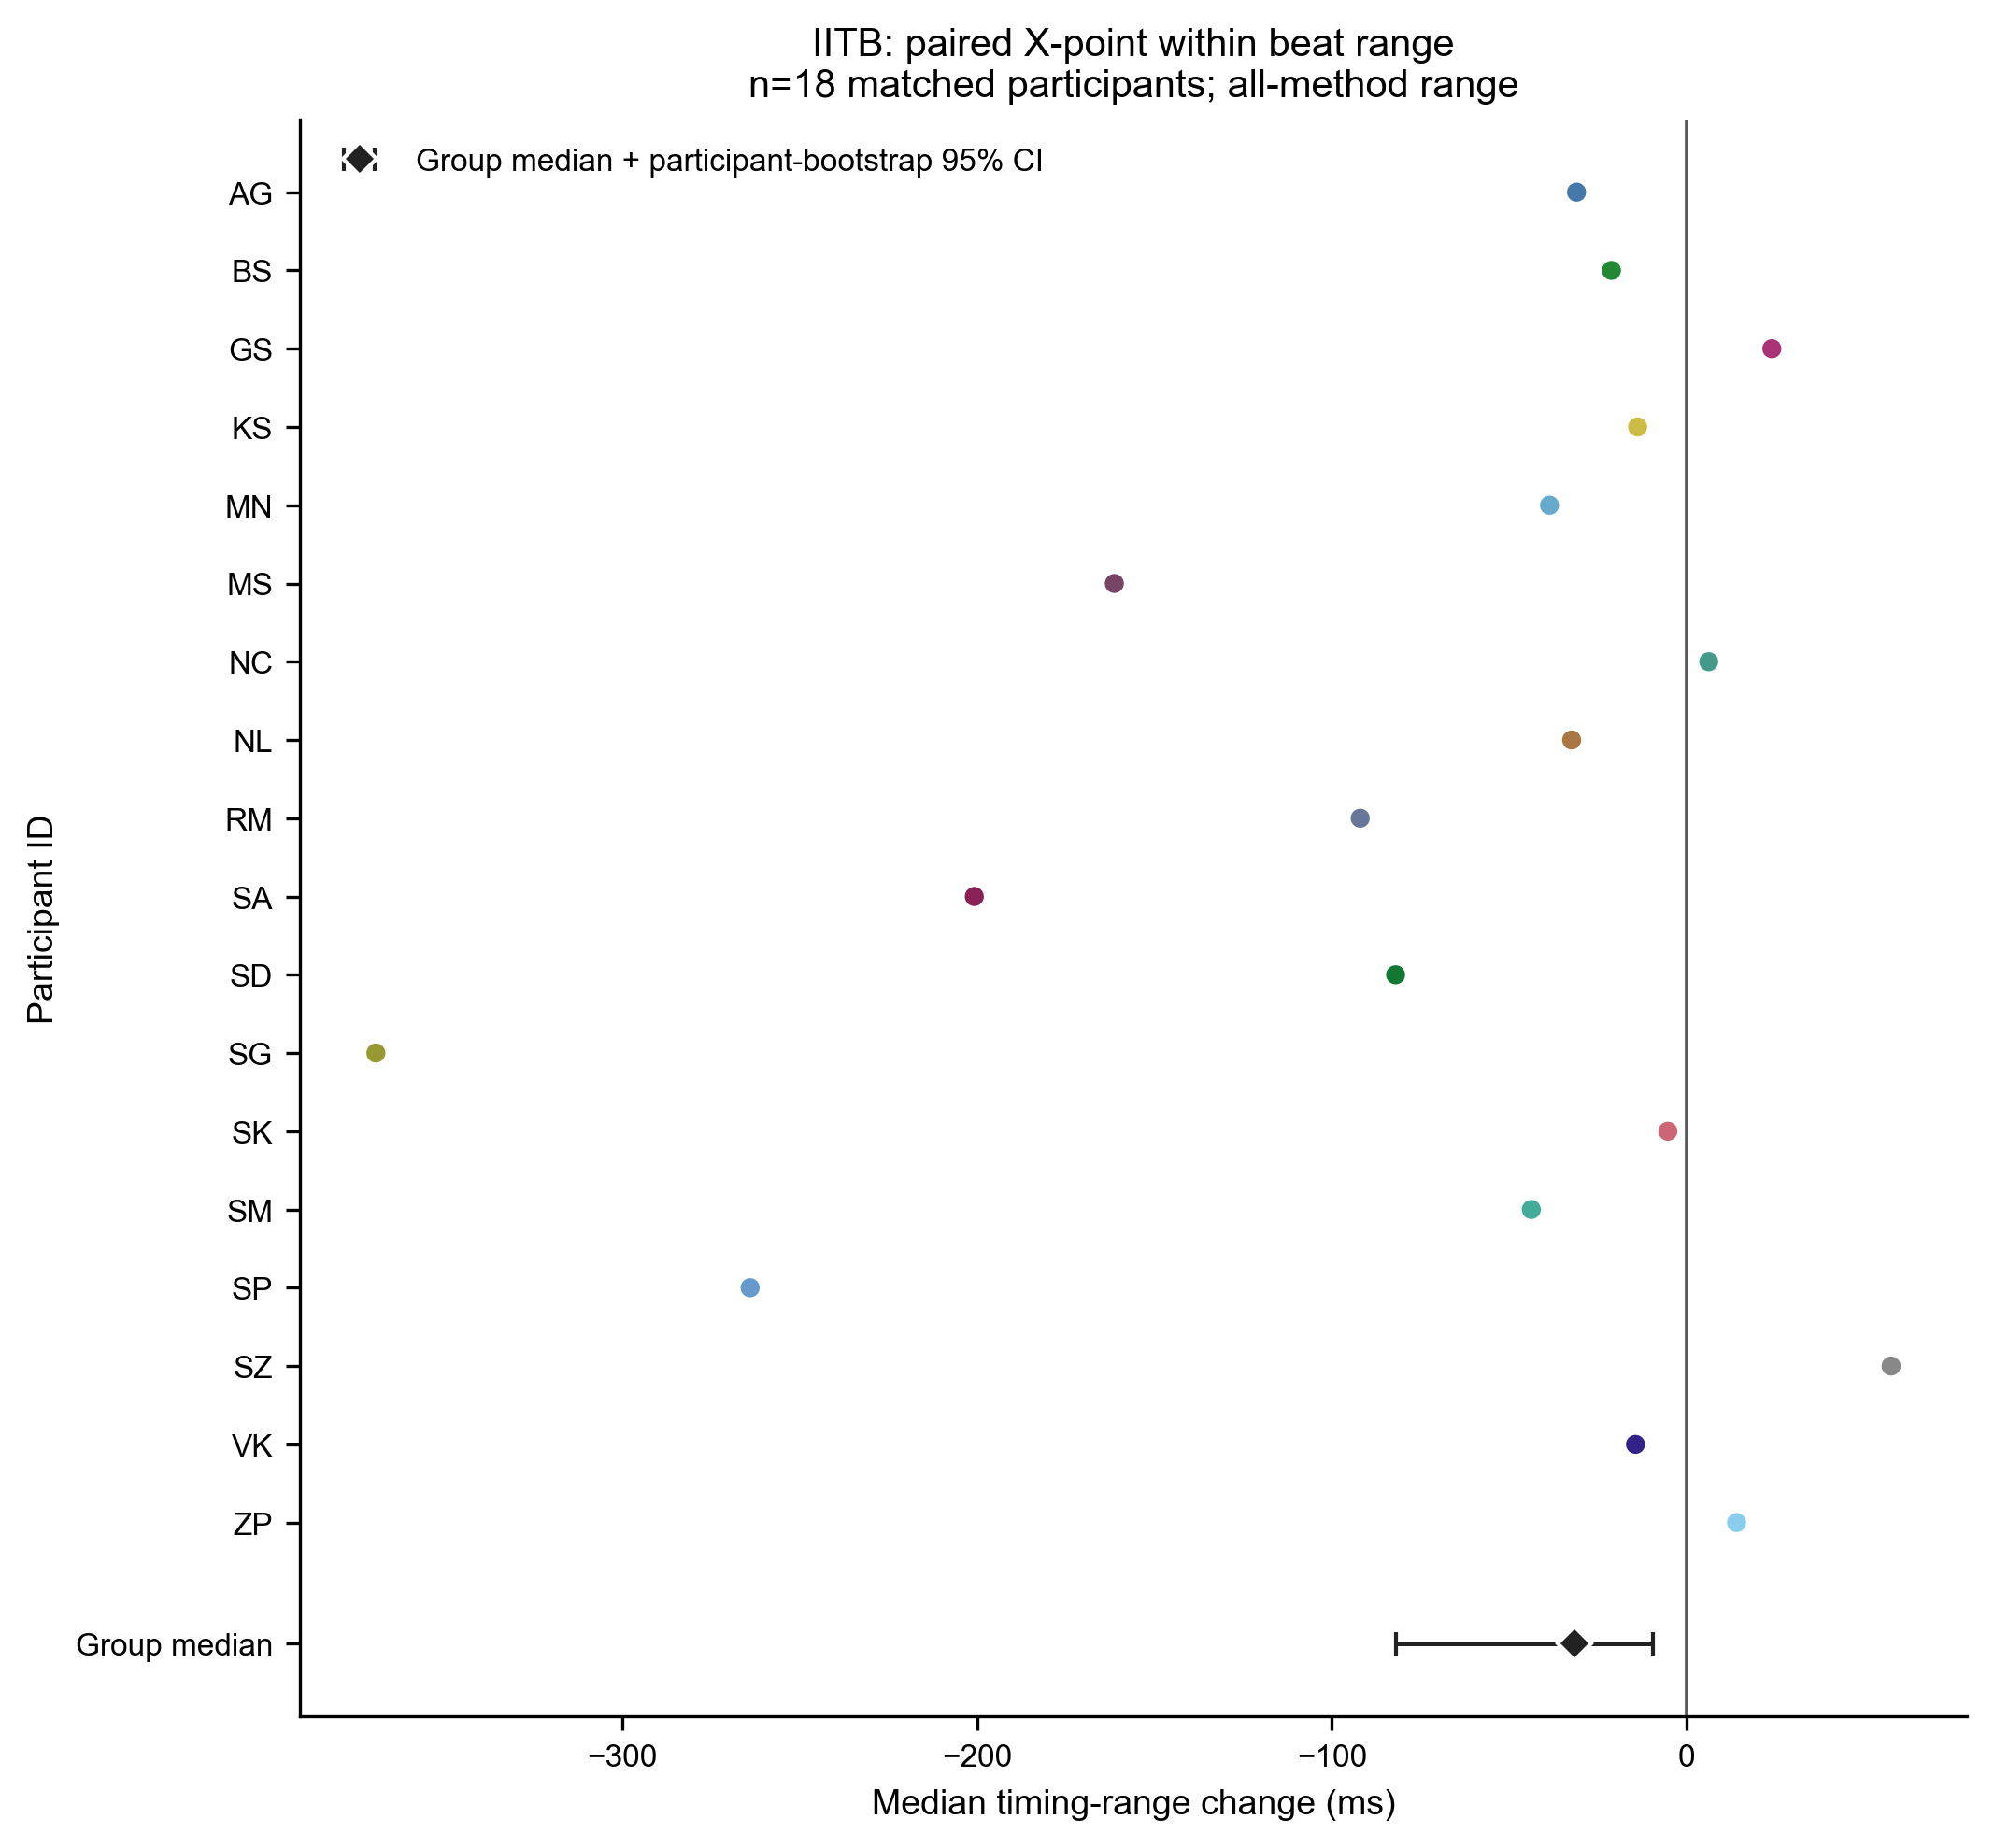
Figure 7A. Matched IITB changes in operational failure and retained-beat disagreement.
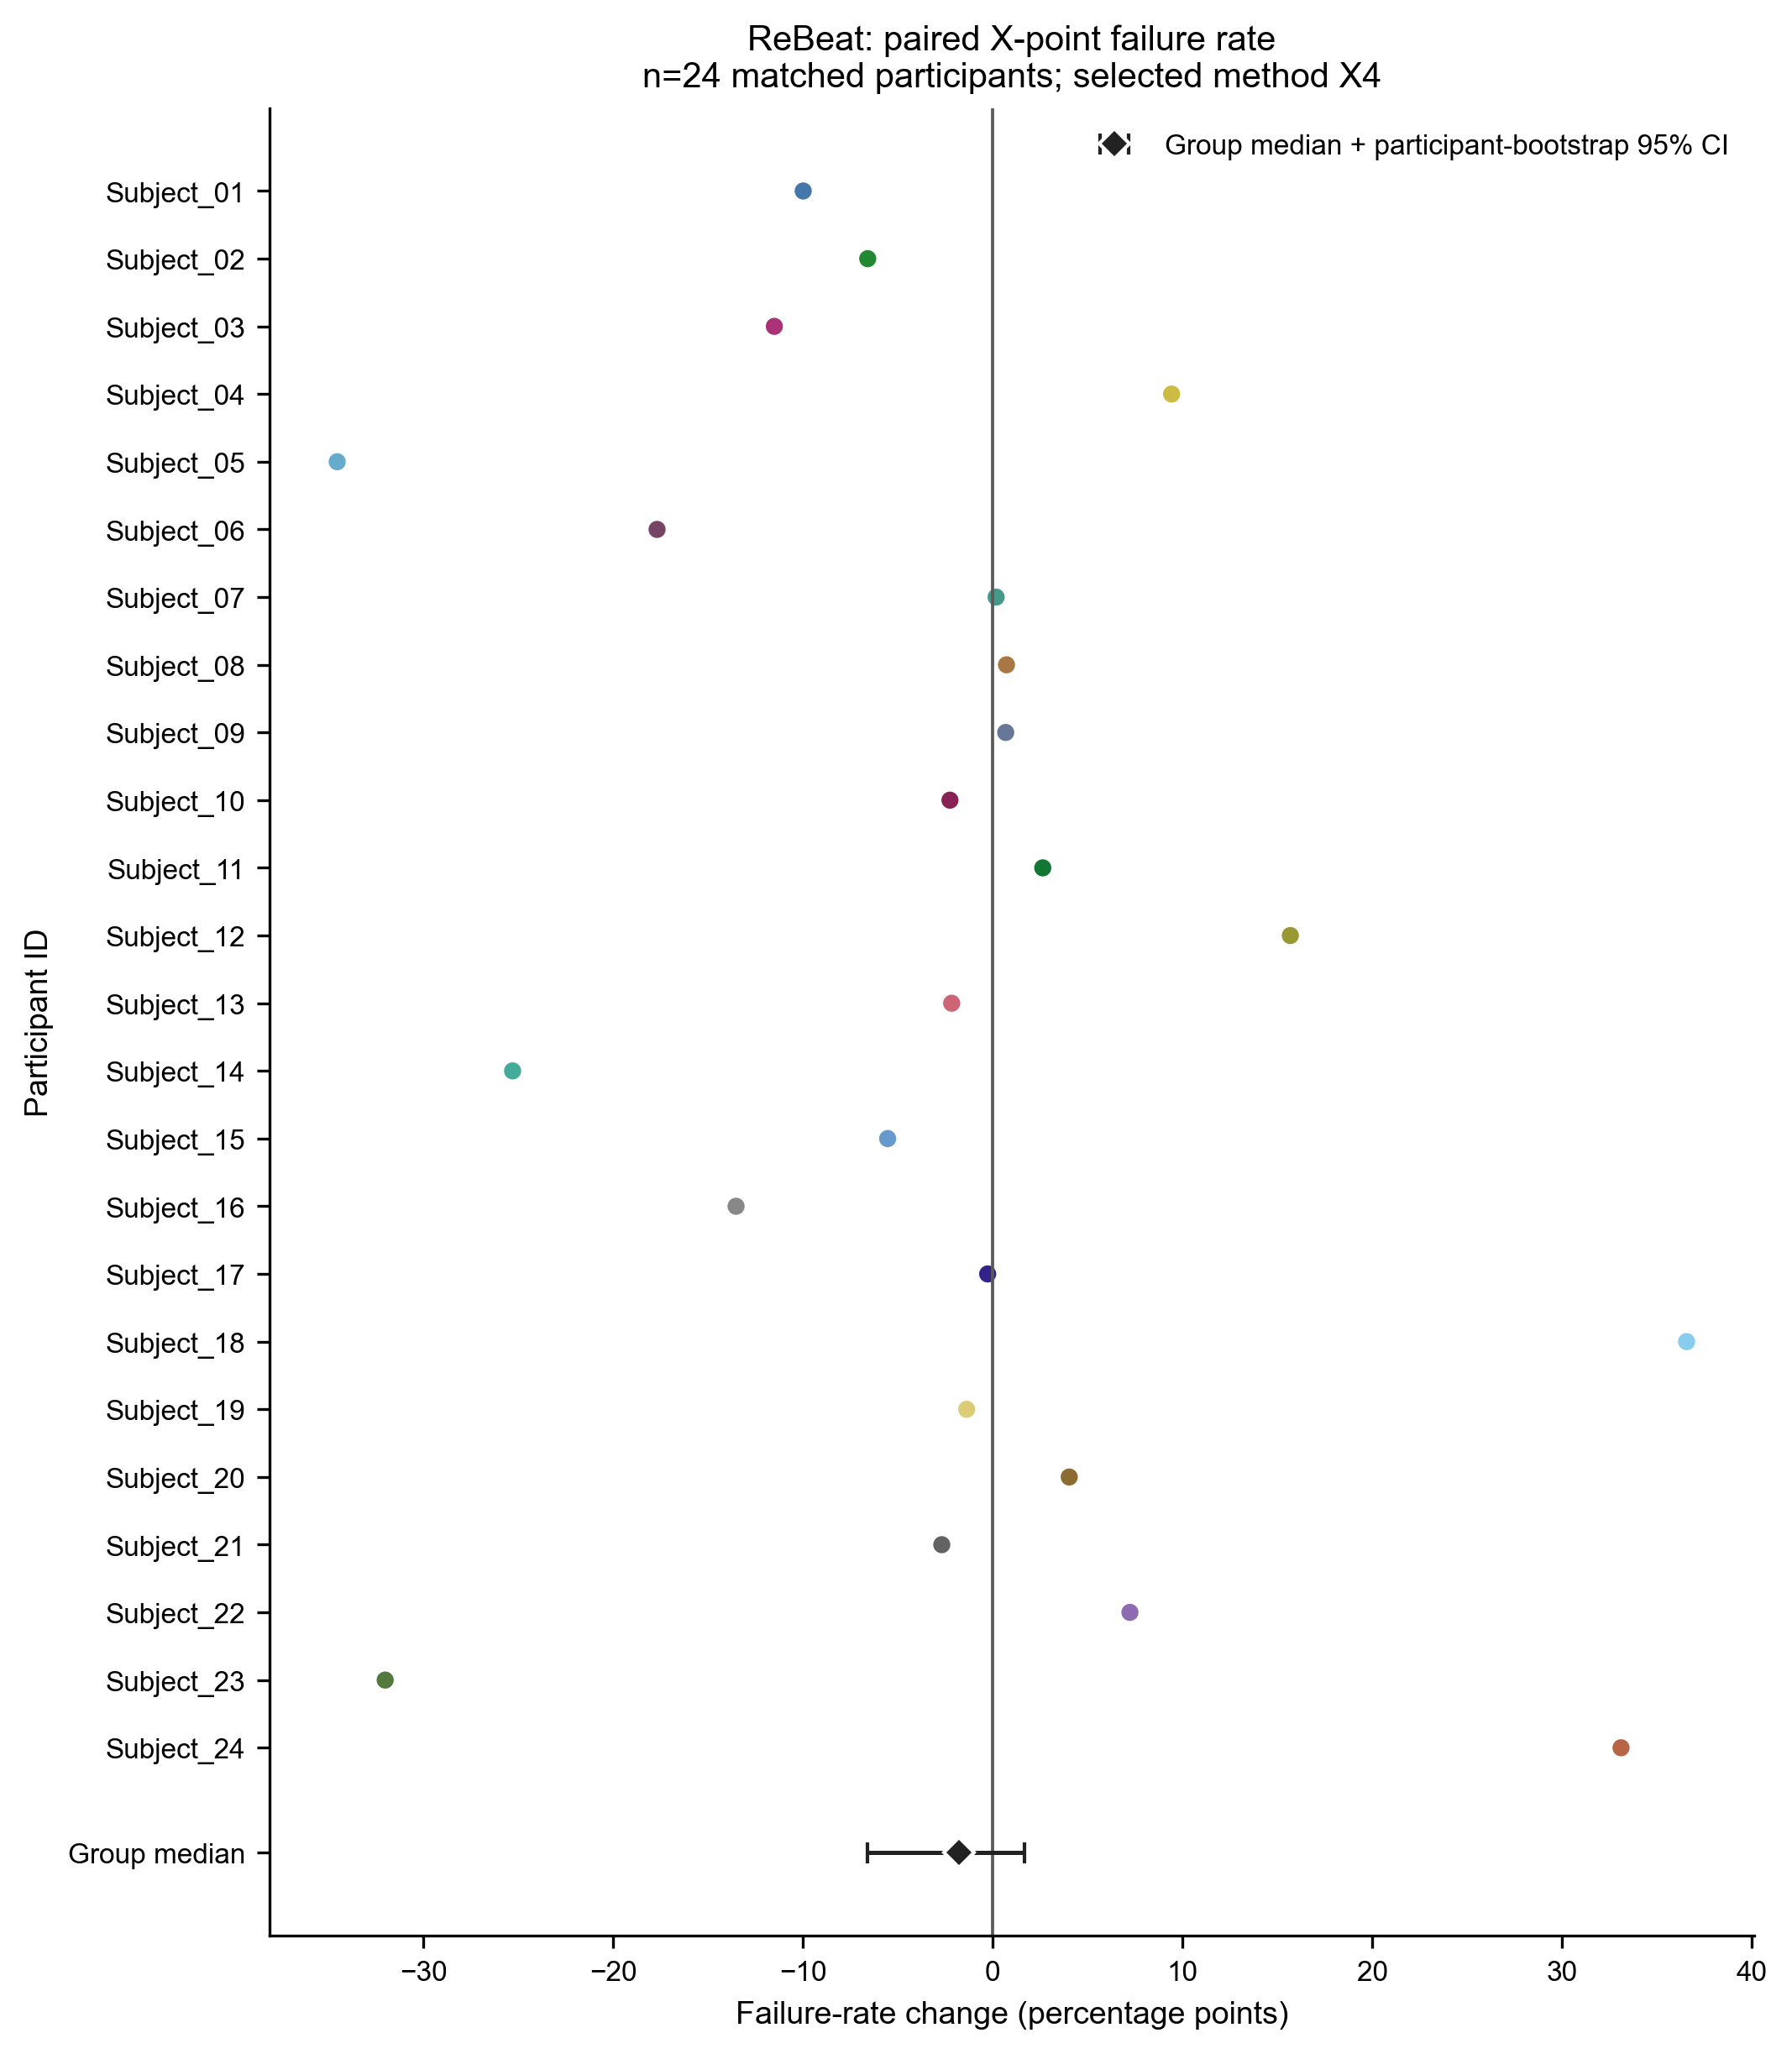 | 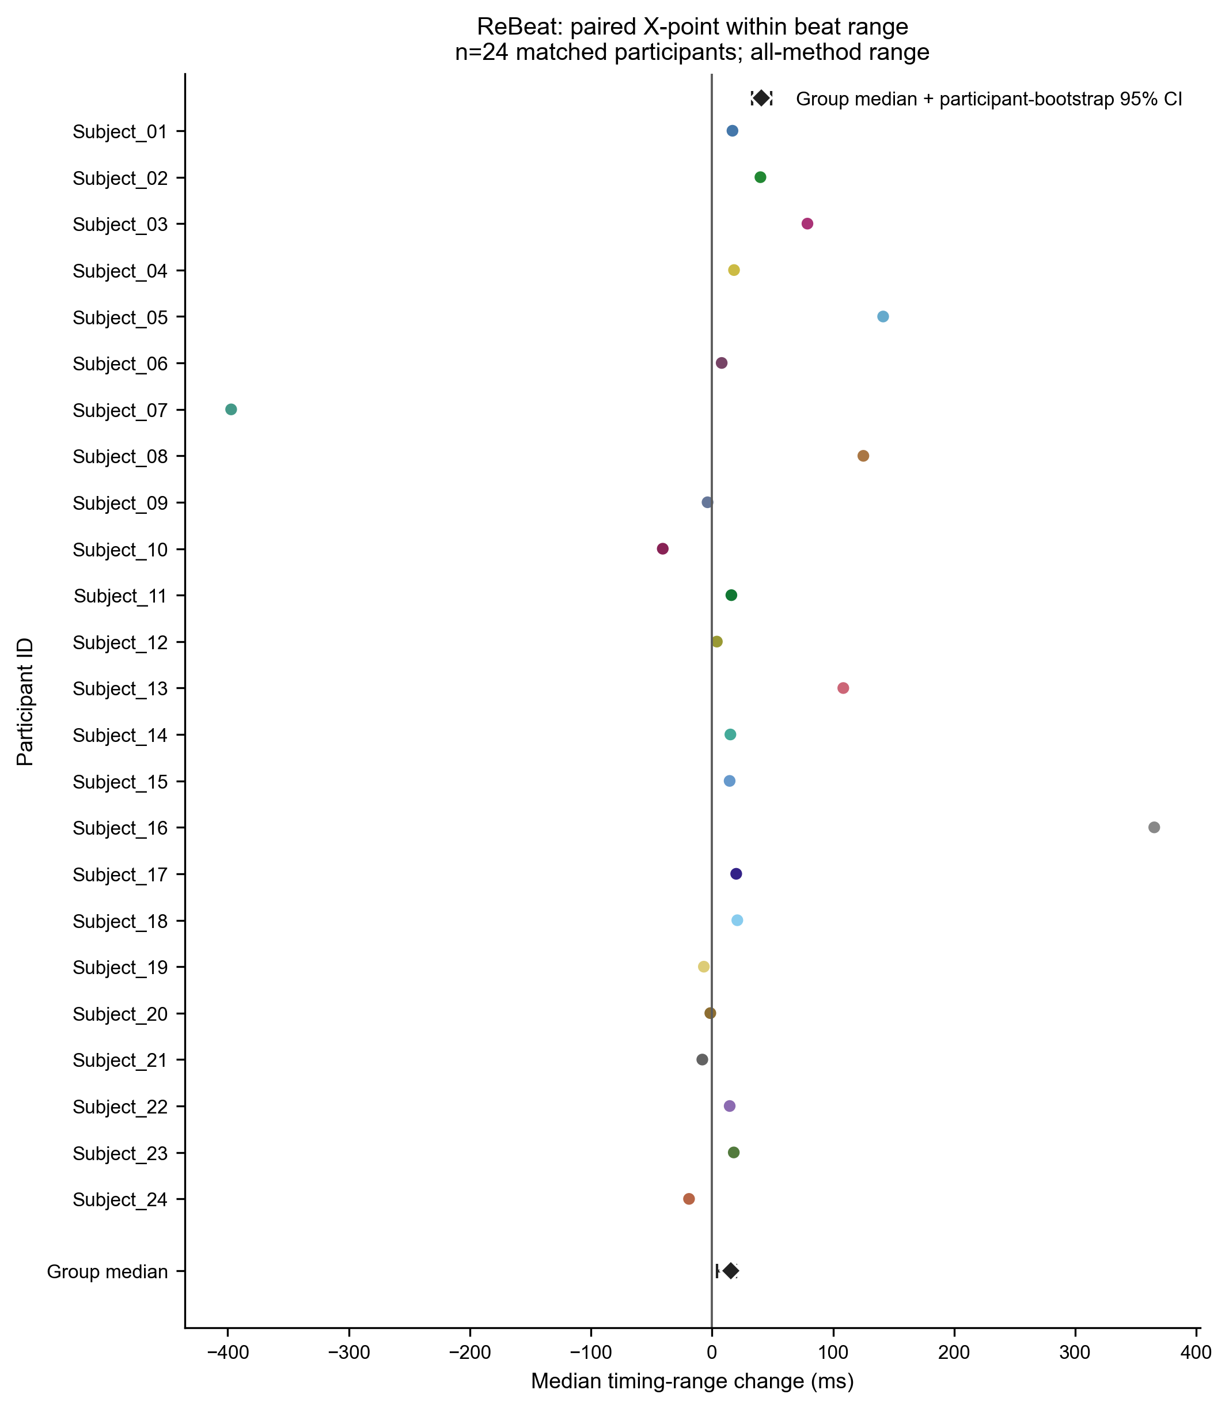
Figure 7B. Matched ReBeat changes in X failure and disagreement.
Matched outcome | N | Median change | 95% bootstrap interval | +/-/0 participants
IITB B1 failure pp | 18 | +14.40 | +2.27 to +28.22 | 13/5/0
IITB B7 failure pp | 18 | +14.40 | +2.27 to +29.56 | 13/5/0
IITB B range ms | 18 | -3.82 | -12.36 to +2.43 | 6/12/0
IITB X range ms | 18 | -31.70 | -82.02 to -9.53 | 4/14/0
IITB X4 failure pp | 18 | +7.73 | -5.09 to +19.82 | 12/6/0
ReBeat B range ms | 24 | +0.86 | -0.41 to +2.05 | 16/8/0
ReBeat X range ms | 24 | +15.59 | +4.00 to +20.00 | 17/7/0
ReBeat X8 failure pp | 24 | +0.63 | +0.01 to +1.62 | 17/5/2

Table 9. Matched participant effects. IITB: post-exercise minus rest. ReBeat: workload minus baseline.
IITB B1/B7 failure increased by 14.40 percentage points. IITB X range decreased by 31.70 ms, but this success-only result occurred alongside failures and is not improved reliability. ReBeat X range increased by 15.59 ms and X8 failure increased by 0.63 percentage points. All 23 ReBeat matched expert-reference median-error intervals included zero, so the data do not support a general condition-related accuracy shift.

Continuous waveform morphology and quality
The continuous screen included 1,794 feature-method-outcome tests and 23,631 participant effects. Reference-error analyses used strict common-reference valid beats; failure analyses compared failed with valid attempted beats; disagreement analyses used common-valid beats.
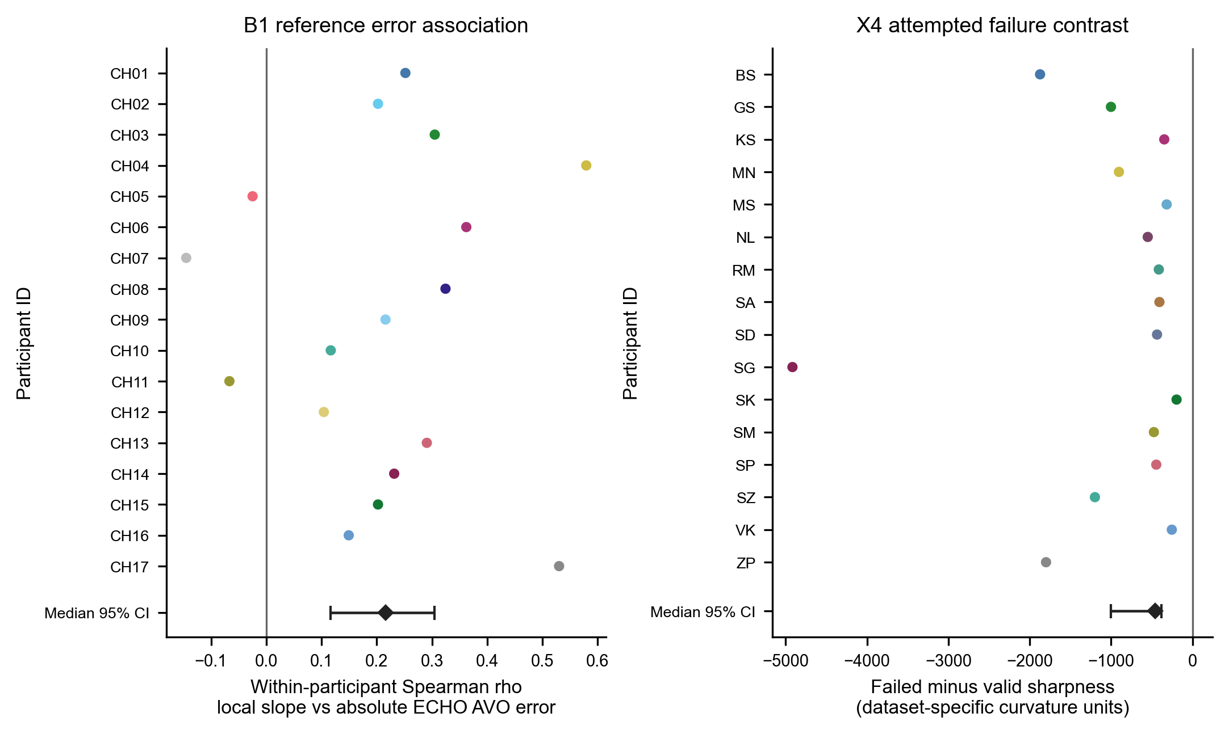
Figure 6B. Participant-aware continuous effects. HeartCycle B1 slope versus absolute ECHO AVO error is shown beside IITB post-exercise X4 failed-minus-valid sharpness.
Feature | Ref supported | Failure supported | Disagreement supported | Inspectible example
Sharpness | 12/69 | 10/115 | 21/115 | IITB post X4 failure: -460 units [-1,002, -381], q=.0053, n=16
Slope | 8/69 | 10/115 | 22/115 | HeartCycle B1 abs error: rho .216 [.117, .305], q=.0237, n=17
Amplitude | 7/69 | 8/115 | 15/115 | ReBeat baseline X4 failure feature effect +.062 [.050, .092], q=.00054, n=24
SNR | 5/69 | 7/115 | 18/115 | ReBeat baseline X4 failure feature effect +.375 [.146, .514], q=.0020, n=24
Competing features | 10/69 | 7/115 | 26/115 | IITB post B1 failed-valid -2 [-2, -1], q=.0040, n=17
Beat variability | 0/69 | 6/115 | 7/115 | No supported reference-error effect; IITB X3 condition rho .397, p=.111, q=.960

Table 10. Six-feature continuous morphology evidence. Fractions are supported tests / estimable tests after multiplicity control.
The remaining 1,595 continuous rows were unsupported. Sharpness and slope recurred in selected results, but amplitude, SNR and competing-feature directions varied by method and outcome. X8 had a verified no-feature failure path, yet no continuous X8 failure-related morphology association survived correction. The associations are participant-aware and exploratory, not causal mechanisms.

Categorical waveform morphology and quality
Each beat was assigned to a lower or higher within-participant feature stratum without using detector outcomes. Exact median ties and unavailable feature values were excluded and retained in the denominator audit.
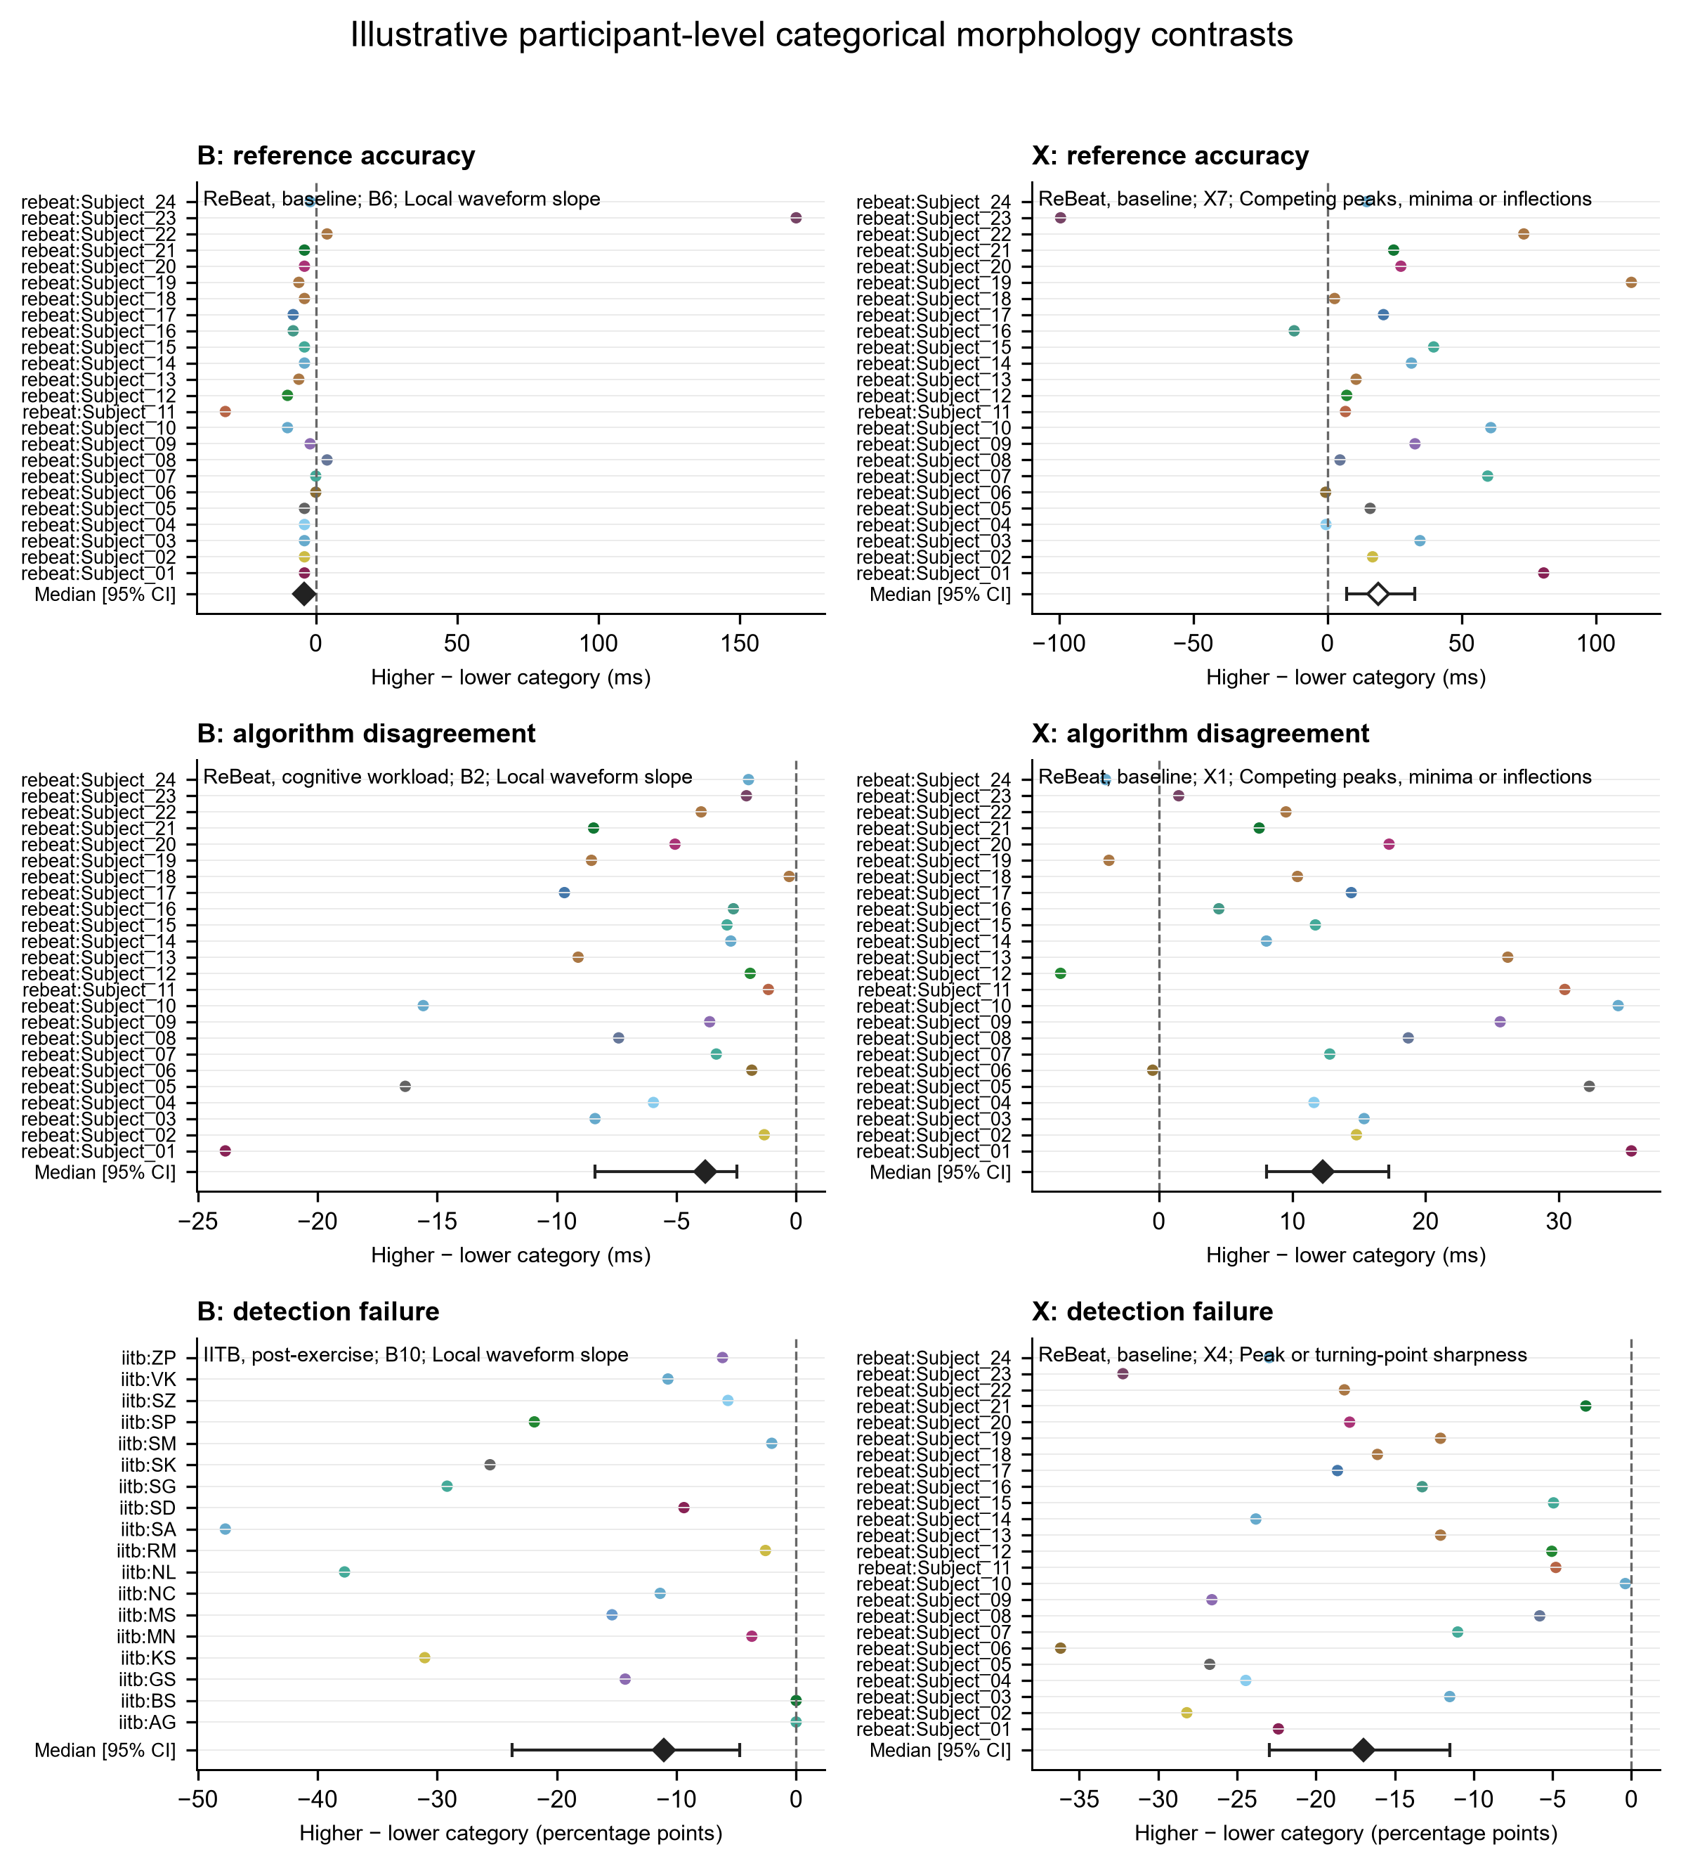
Figure 6C. Selected higher-minus-lower categorical contrasts for reference error, failure and peer disagreement. Each point is one participant effect with a bootstrap interval.
Feature | Method/outcome | Higher - lower | 95% interval | Evidence
Sharpness | ReBeat X4 failure | Baseline: -16.98 pp | -22.96 to -11.52 | n=24; q=.00022
Slope | ReBeat B6 abs expert error | -4.00 ms | -5.00 to -4.00 | n=24; q=.0287
Amplitude | ReBeat workload X4 failure | +10.53 pp | +5.66 to +14.65 | n=24; q=.00069
SNR | ReBeat baseline X4 failure | +9.36 pp | +4.00 to +14.36 | n=24; q=.00122
Competing features | ReBeat baseline X1 disagreement | +12.27 ms | +8.06 to +17.26 | n=24; q=.00282
Beat variability | IITB post X8 failure | +1.88 pp | +0.52 to +2.85 | n=18; q=.0186

Table 11. Selected categorical effects covering all six features. The full 2,208-row analysis contained 118 supported comparisons; three B absolute-error contrasts and no X absolute-error contrasts survived correction.
Ninety-three results were supported in both continuous and categorical analyses and all 93 agreed in direction. This is internal consistency within the same data, not independent validation. No single feature explained every failure or disagreement pattern, and these participant-relative categories are not physiological thresholds.

Real waveform evidence for disagreement and failure
Population statistics establish how often a result occurred. These recorded beats show what the frozen definitions did on the underlying signal. They are explanatory cases, not prevalence estimates.
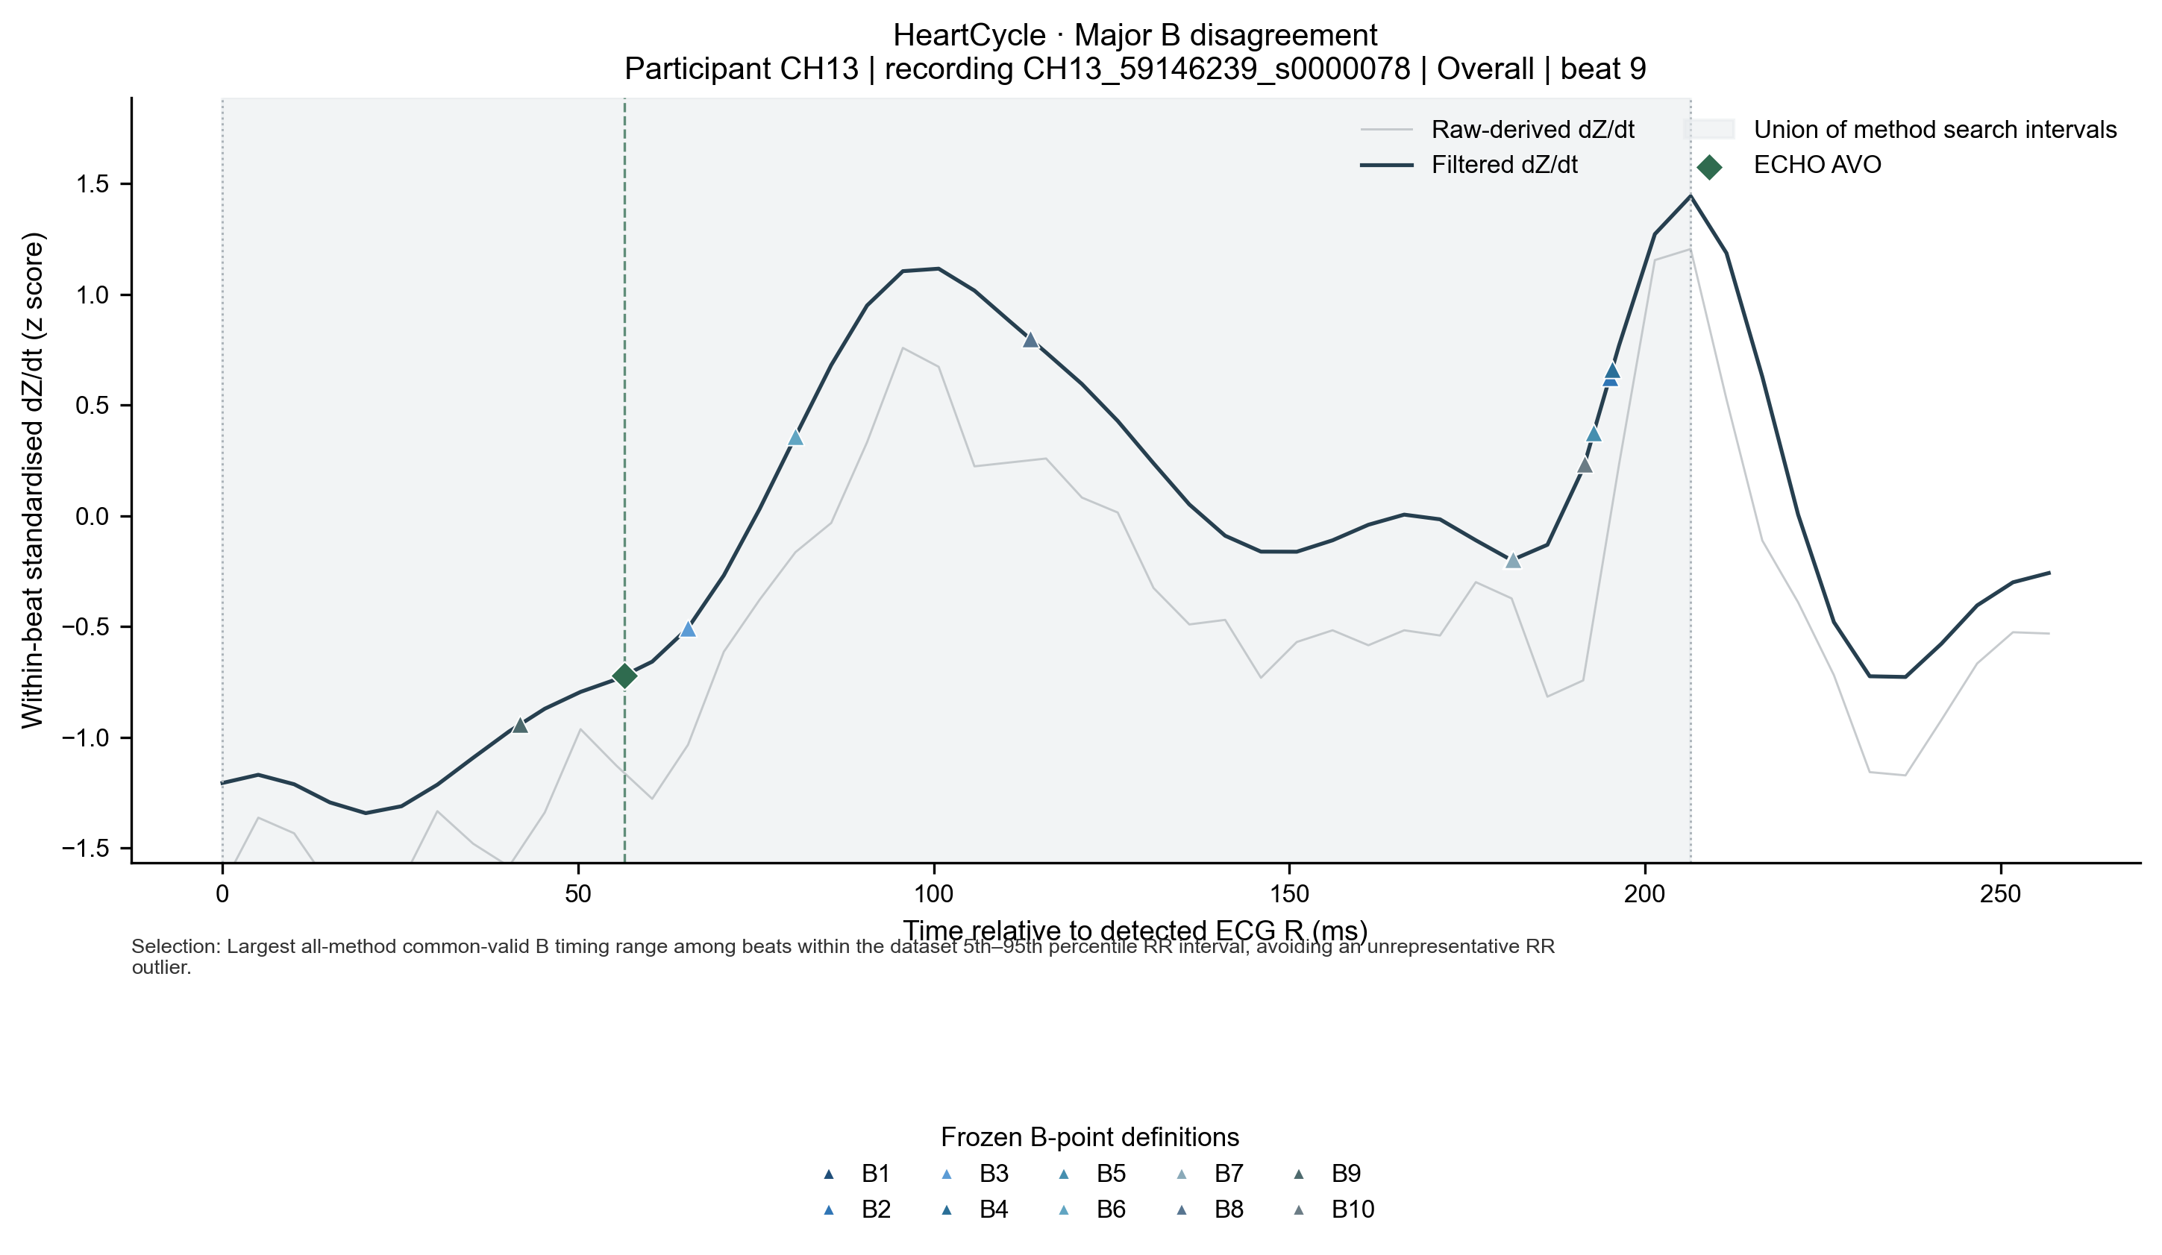 | 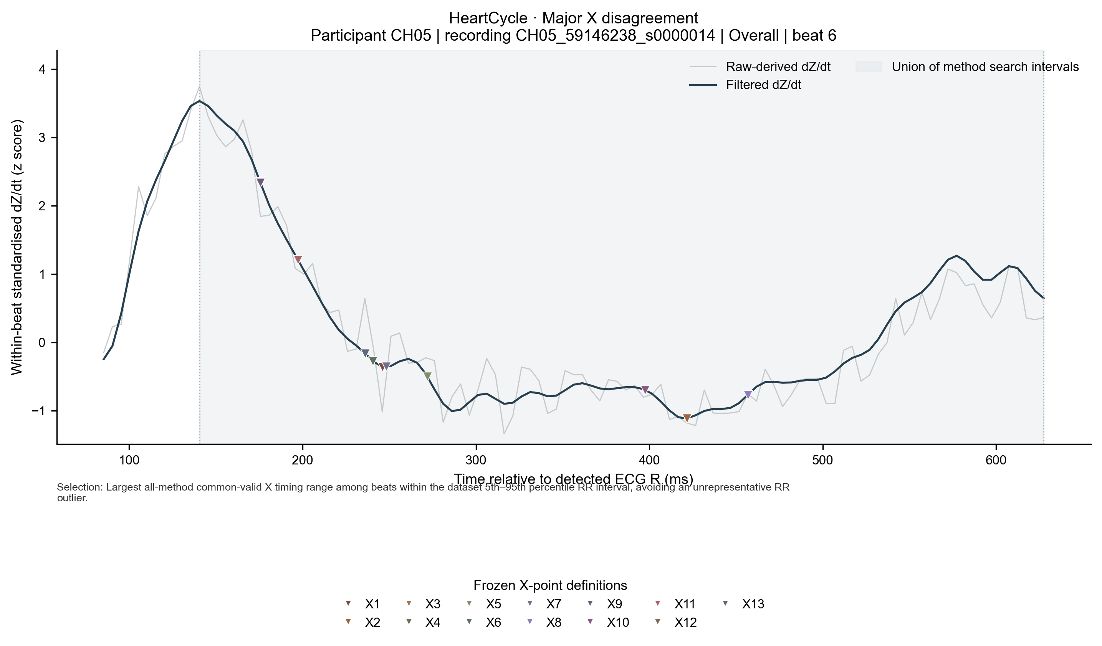
Figure 1B. Same-beat B and X disagreement examples selected reproducibly within the central RR distribution. B range was 153.49 ms; X range was 833.46 ms.
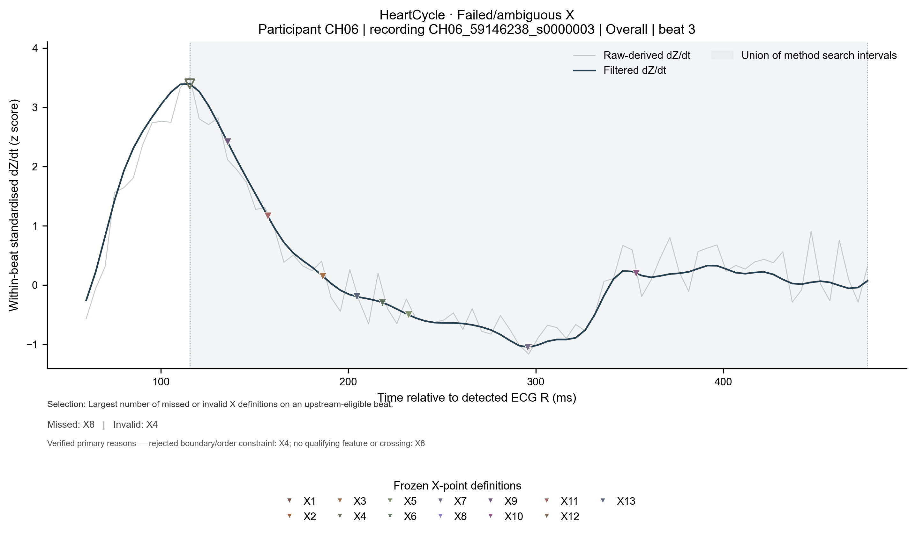
Figure 1C. HeartCycle failed/ambiguous X example. X4 was invalid because its selected minimum violated strict ordering; X8 missed because no qualifying post-minimum maximum was found.
The cases support the mechanism descriptions in Table 7 and the population burdens in Tables 5-6. A waveform can explain an execution path, but it cannot establish that the same visual feature caused failures across participants.

Paired algorithm agreement and cross-dataset interpretation
Bland-Altman analyses were limited to justified related pairs on identical valid beats: B4 versus B5 and X5 versus X6. Agreement between methods is not independent physiological accuracy.
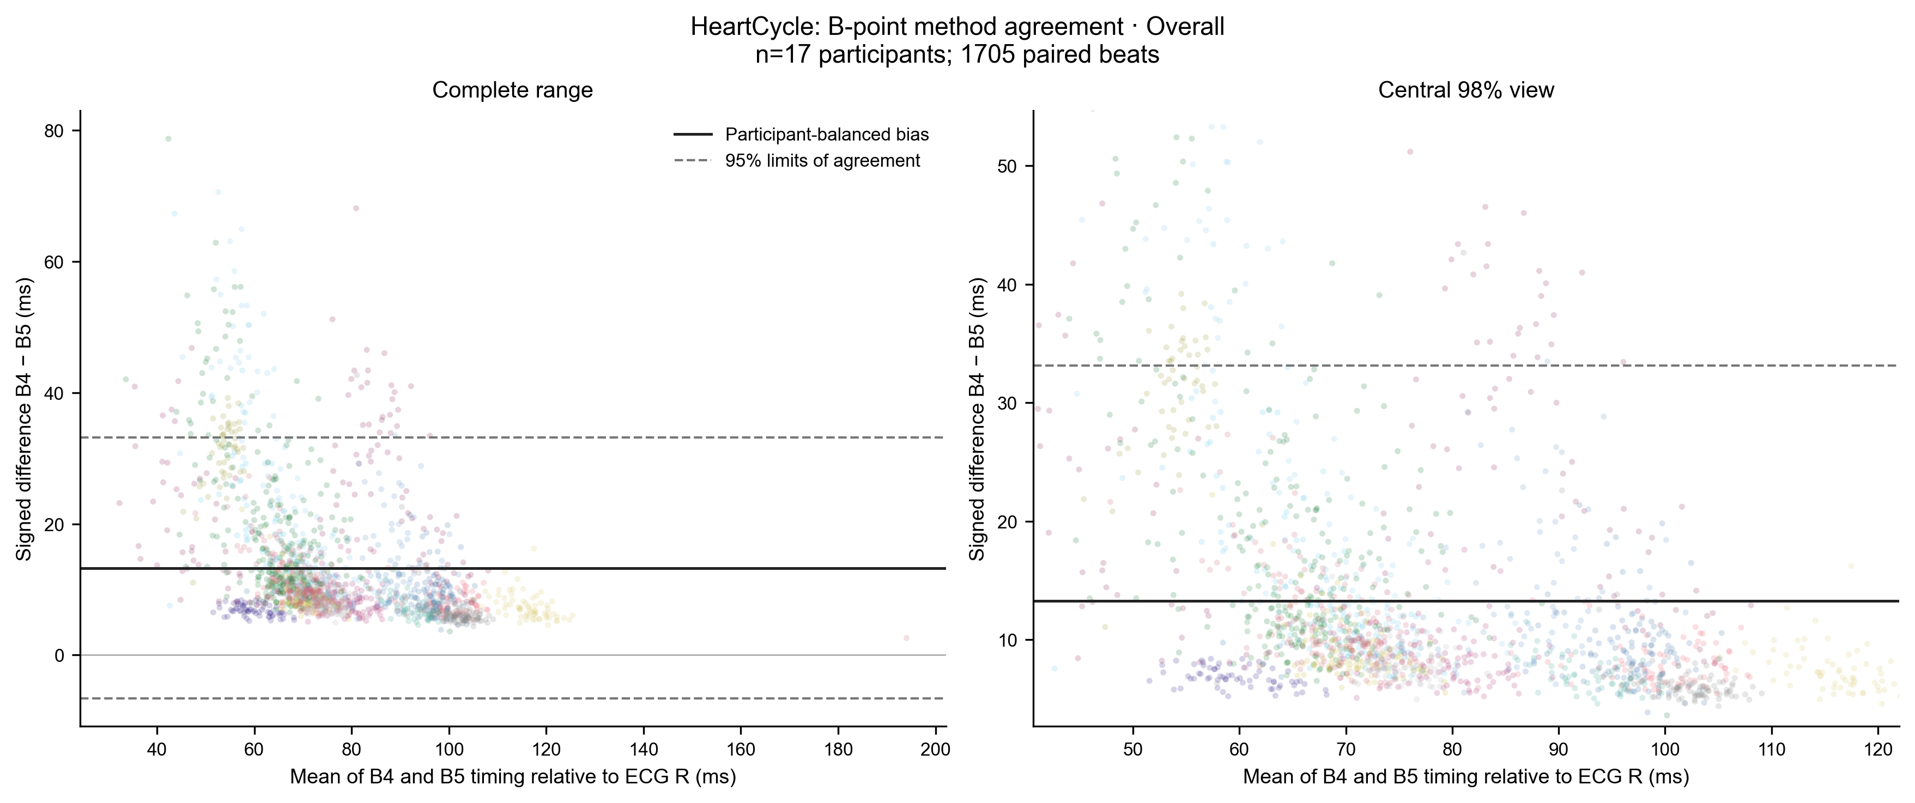 | 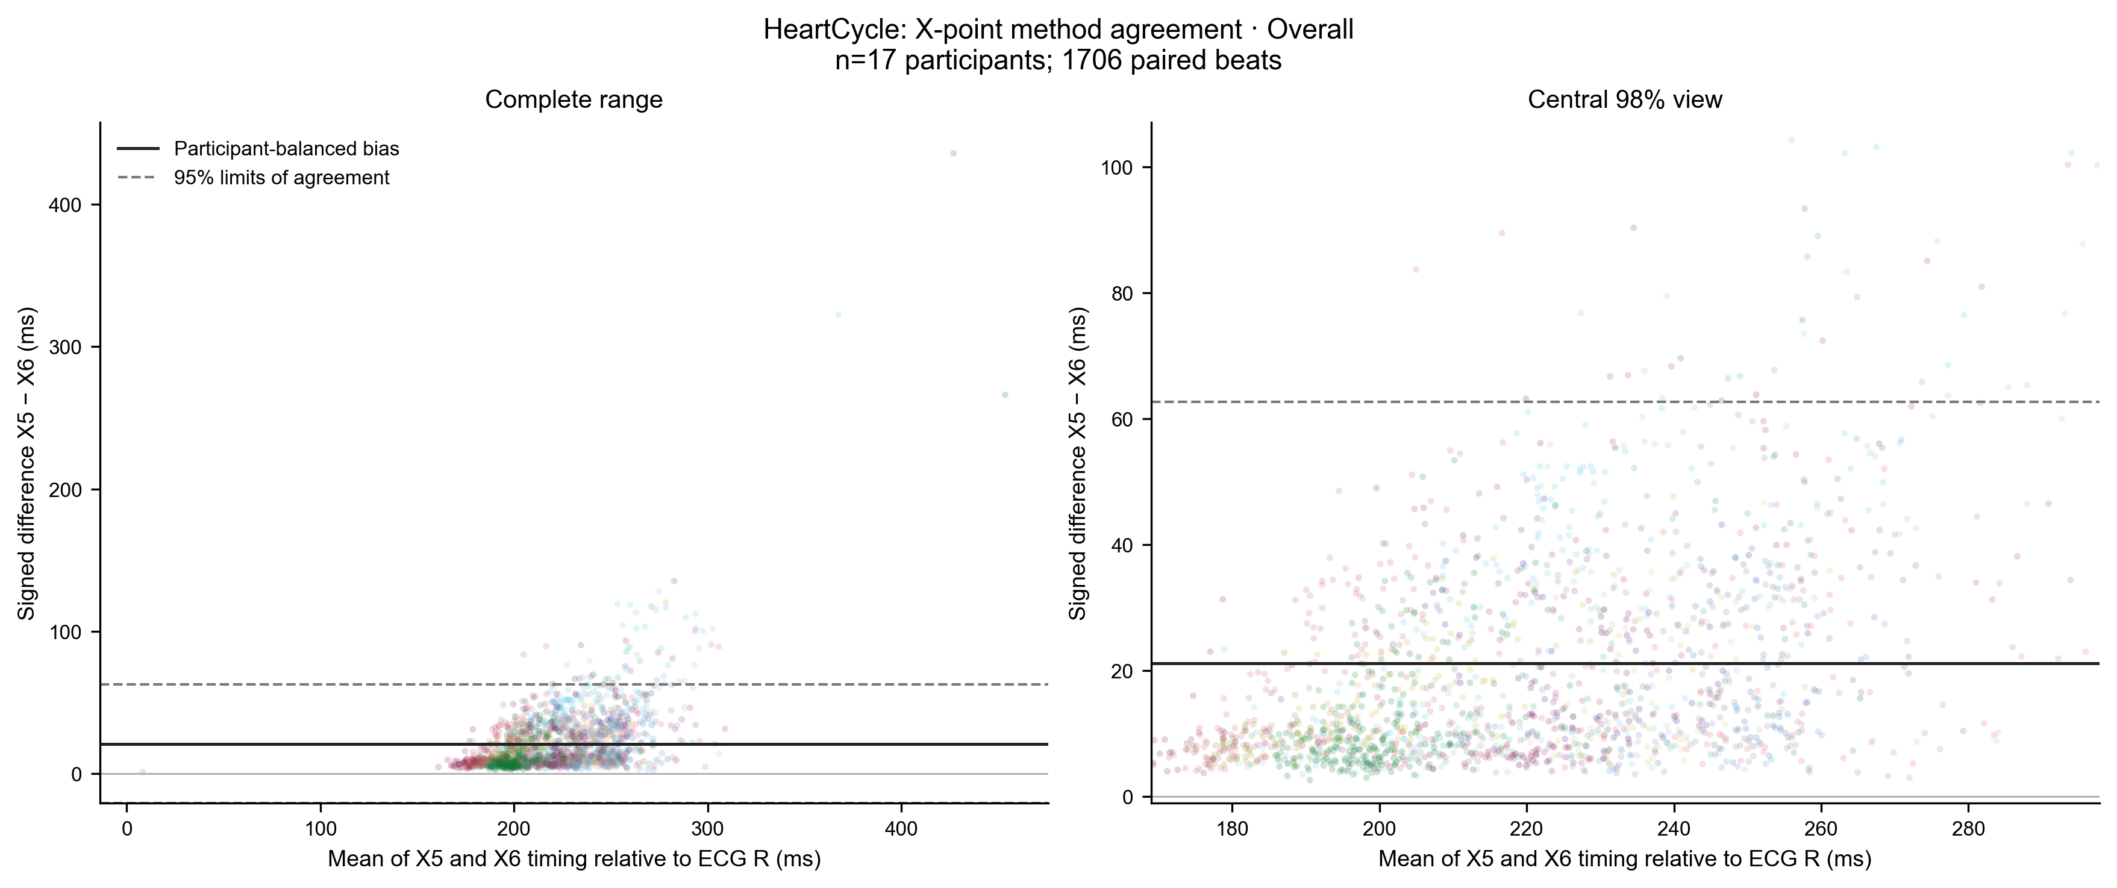
Figure 9. HeartCycle participant-balanced Bland-Altman evidence. Horizontal lines show bias and limits of agreement.
Dataset/condition/pair | N | Beats | Bias ms | Bias 95% CI | Limits ms
HeartCycle overall B4-B5 | 17 | 1705 | +13.28 | +9.96 to +17.05 | -6.60 to +33.16
HeartCycle overall X5-X6 | 17 | 1706 | +21.10 | +17.90 to +24.47 | -20.43 to +62.63
IITB normal B4-B5 | 18 | 1727 | +13.33 | +10.06 to +17.21 | -16.27 to +42.93
IITB normal X5-X6 | 18 | 2011 | +32.64 | +22.04 to +45.60 | -111.36 to +176.64
IITB post_exercise B4-B5 | 18 | 1634 | +11.20 | +8.59 to +15.14 | -12.43 to +34.82
IITB post_exercise X5-X6 | 18 | 1724 | +23.61 | +17.37 to +30.49 | -77.88 to +125.11
ReBeat baseline B4-B5 | 24 | 8398 | +9.14 | +7.48 to +11.31 | -6.98 to +25.26
ReBeat baseline X5-X6 | 24 | 8403 | +22.27 | +18.86 to +25.95 | -42.64 to +87.17
ReBeat cognitive_workload B4-B5 | 24 | 8477 | +8.80 | +7.22 to +10.84 | -7.82 to +25.41
ReBeat cognitive_workload X5-X6 | 24 | 8492 | +25.27 | +20.47 to +30.42 | -61.89 to +112.44

Table 12. Participant-balanced paired-method agreement across all available datasets and conditions.
HeartCycle B4-B5 bias was +13.28 ms (95% CI 9.96 to 17.05; limits -6.60 to +33.16). X5-X6 bias was +21.10 ms (17.90 to 24.47; limits -20.43 to +62.63). Related threshold rules were therefore not interchangeable. Cross-dataset recurrence of a failure pattern is an operational warning, not evidence that a cohort or condition caused it.

Claim to figure and table verification matrix
Each substantive conclusion is paired with a displayed figure and numerical table. N and beat counts describe the actual comparison set, not the full raw dataset.
Scientific claim | Dataset/condition | Methods | Figure | Table | Participants/beats | Effect/rate | Uncertainty | Limitation
B reference correspondence differs by definition | HeartCycle; ReBeat | B1-B10 | 2A | 3 | 17/986; 24/967,838 | B8 HC MedAE 12.59 ms | P95 34.21 ms | ECHO and expert labels differ
X reference correspondence and tails differ | HeartCycle; ReBeat | X1-X13 | 2B, 3B | 4 | 17/371; 24/511,433 | X12 HC MedAE 36.55 ms | P95 78.94 ms | Strict common-reference subset
B and X failure burdens are method-specific | All contexts | B1-B10; X1-X13 | 4A-4B | 5-6 | 17-24; all attempts | Exact V/M/I/A rates | Participant plots in figures | Failure is not timing error
B1/B7, X4 and X8 have verified paths | IITB post; HC | B1,B7,X4,X8 | 1A, 6A | 7 | 17-18; 1,706/1,723 | B1 579; B7 590 failures; X4 48.89% | Exact reconciliation | Operational, not physiological
X retained-beat disagreement is large and selective | All datasets | X1-X13 | 5C-5D | 8 | 17-24; common-valid | HC median range about 260 ms | Coverage 852/1,706 | Complete-case selection
Condition changes are outcome-specific | IITB; ReBeat | All; focal rows | 7A-7B | 9 | 18; 24 matched | B1 +14.40 pp; X range +15.59 ms | Bootstrap intervals | No causal isolation
All six morphology features show mixed support | All datasets | B1-B10; X1-X13 | 6B | 10 | 10-24 per effect | 23631 participant effects | BH q and bootstrap CI | Exploratory associations
Categorical effects do not define thresholds | All datasets | B1-B10; X1-X13 | 6C | 11 | Up to 24 paired | 118/2208 supported | Bootstrap CI and q | Internal, not external validation
Waveforms explain cases, not prevalence | HeartCycle; IITB | All markers | 1A-1C | 7-8 | Single beats plus population tables | Ranges 153.49/833.46 ms | Population uncertainty elsewhere | Case-study limit
Related pairs are not interchangeable | All datasets | B4-B5; X5-X6 | 9 | 12 | 17-24; paired beats | HC biases +13.28/+21.10 ms | Bias CI and limits | Agreement is not accuracy

Table 13. Final claim-to-evidence traceability. Every direct RQ1 conclusion on the next page maps to at least one figure and one numerical table in this report.

Integrated findings limitations and direct answer

Direct answer to RQ1
1. Reference correspondence. HeartCycle B8 and X12 had the lowest observed participant median absolute errors in their point-specific ECHO comparisons, but signed bias, tails and failures differed across methods. ReBeat expert labels produced different patterns. Figures 2A-2B and Tables 3-4 provide the all-method evidence; no paired result establishes universal superiority.
2. Timing variability and coverage. Definitions differed on identical beats, especially for X. Figure 5 and Table 8 show both the range and the common-valid denominator. HeartCycle X retained 852 of 1,706 beats, so lower disagreement on retained beats cannot be separated from excluded failures.
3. Failure mechanisms. Figures 1 and 4 and Tables 5-7 show method-specific burdens and execution paths. X4 repeatedly violated its strict ordering rule, B1/B7 often lacked a qualifying feature or crossing, and X8 sometimes lacked the required post-minimum maximum. These are verified software paths, not physiological causes.
4. Condition sensitivity. Figure 7 and Table 9 support increased IITB B1/B7 failure and increased ReBeat X disagreement. IITB has no independent timing reference, and all ReBeat matched expert-error intervals included zero. The evidence therefore does not support a general condition-related loss of timing accuracy.
5. Morphology and quality. Figure 6 and Tables 10-11 cover all six predefined characteristics. Sharpness and slope recurred in selected results, while amplitude, SNR, competing features and beat variability were method- and outcome-dependent. Most tests were unsupported, and no association establishes physiological causation.

Implications for PEP and LVET
PEP inherits B timing error. LVET inherits B and X timing errors and their covariance. Later interval analyses should report the exact fiducial definitions, reference provenance, valid coverage, signed bias, tails and condition-specific failure, rather than relying on a single median error.

Limitations
IITB has no independent B/X timing reference. ReBeat expert annotations are not interchangeable with ECHO valve events. Strict reference and common-valid analyses are selected subsets, especially for X. No approved clinical timing tolerance exists. Physical dZ/dt calibration remains unverified. Dataset comparisons are confounded by acquisition, cohort and processing. Morphology analyses are exploratory and do not define causal mechanisms or fixed physiological thresholds.

Scientific contribution
The study evaluates 10 B and 13 X definitions across independent ECHO events, expert labels, matched conditions, reconciled failures, same-beat disagreement and six waveform characteristics. Its contribution is a reproducible account of method-specific reliability boundaries. It does not nominate one universal detector. The verified numerical outputs and 73 accepted evidence panels remain unchanged; this report consolidates the evidence needed to inspect the conclusions directly.

