Introduction and P1 research purpose
RQ1 asks which B- and X-point localisation approaches are supported by available references and what contributes to their variability and failure. The answer is conditional: no single definition is reliable across every reference type, dataset and physiological condition.
HeartCycle B8 had the lowest observed B-point median absolute ECHO AVO error, while X12 combined a relatively low ECHO AVC median error with a smaller tail than several alternatives. These are reference-specific observations, not evidence of universal superiority. ReBeat expert annotations produced different patterns and are not equivalent to independent ECHO valve events. Coverage changes the interpretation: X4 failed on 48.89% of HeartCycle attempts and on about 31–47% of IITB and ReBeat attempts. IITB B1/B7 failure increased after exercise even though complete-case timing disagreement decreased.
The all-method morphology analysis linked waveform sharpness, slope, amplitude, signal quality, competing features and beat-to-beat variability to reference error, failure or disagreement in specific method-dataset combinations. The effects were heterogeneous and exploratory. They support operational reliability boundaries, not physiological causation.

What P1 establishes
- Reference correspondence, failure burden, disagreement and pairwise agreement are separate outcomes and must not be collapsed into one score.
- HeartCycle B8 had the lowest observed participant median absolute B error, 12.59 ms, with signed median +11.47 ms and P95 34.21 ms; no paired superiority test was claimed.
- HeartCycle X12 had the lowest observed participant median absolute X error, 36.55 ms; X2 had a similar median but a 409.40 ms P95 tail.
- Common-valid X analyses retained only 371 of 691 HeartCycle reference-eligible beats, so lower disagreement among retained beats cannot be interpreted as improved reliability.
- Frozen failure paths are reproducible. For X4, a third-derivative minimum at C is rejected by the strict C < X < next-R rule.
- The contribution beyond earlier B-only rankings is the combined B/X reference audit, denominator-complete failure analysis, matched-condition analysis and six-feature morphology evidence.
Scope: 10 frozen B definitions and 13 frozen X definitions across HeartCycle, IITB-ICG and ReBeatICG. Canonical algorithms and calculations were not changed during this consolidation.

Datasets references algorithms and methods
The analysis used strict common samples for reference comparisons, participant-level summaries for inference and separate failure denominators. A failed detection was never assigned a numerical timing error. ECHO AVO and AVC are valve-event measurements; ReBeat labels are expert ICG annotations; IITB has no independent B/X timing reference.
Dataset | Conditions | Participants | Beats | Reference | Permitted claim
HeartCycle | Overall | 17 | 1,706 | ECHO AVO and AVC | Reference correspondence, failure and disagreement
IITB-ICG | Rest and post-exercise | 18 matched | 2,022 / 1,737 | None | Failure and disagreement only
ReBeatICG | Baseline and cognitive workload | 24 matched | 8,403 / 8,492 | Expert ICG; 1,842 matched rows | Expert-label correspondence, failure and disagreement

Frozen definitions and statistics
The B catalogue covers local minima, second- and third-derivative rules, amplitude thresholds and an R-to-C proportional rule. The X catalogue covers post-C minima, derivative extrema and crossings, downstroke thresholds, an RR-adaptive minimum and a metadata-gated Weissler formula. Exact parameters and implementation versions are in the canonical registry. All 23 definitions remain represented in the 115-row supplementary results table.
- Accuracy: participant median absolute detected-minus-reference timing error, signed error and P90/P95 absolute error on identical common-reference beats.
- Failure: missed plus invalid detections divided by attempted detections; upstream ineligibility is reported separately.
- Disagreement: within-beat all-method timing range and definition-specific distance from the peer median on common-valid beats.
- Condition change: stress minus baseline/rest for matched participants, with participant-bootstrap 95% intervals.
- Morphology: six predeclared features, participant-aware effects and within-family Benjamini-Hochberg labels; strata were defined without access to outcomes.
- Agreement: participant-balanced Bland-Altman bias and limits for related method pairs B4/B5 and X5/X6.

Audit outcome
The 115 result rows, 514,280 method-beat records, reference formulas, common sets and denominators reconcile. Nineteen regression tests pass. No defect was found in the canonical calculations. The scientific completion adds a matched ReBeat expert-reference condition comparison, feature-specific synthesis of the full morphology screen, explicit X4 logic and an unavailable physiologically-implausible field. No clinical timing tolerance was invented.

Reference accuracy and error distributions
Question: which definitions correspond most closely to the available reference events, and is performance consistent across participants? HeartCycle comparisons use 17 participants and strict common-reference samples of 986 B beats and 371 X beats. ReBeat expert comparisons use uniquely matched annotation rows and are interpreted separately.
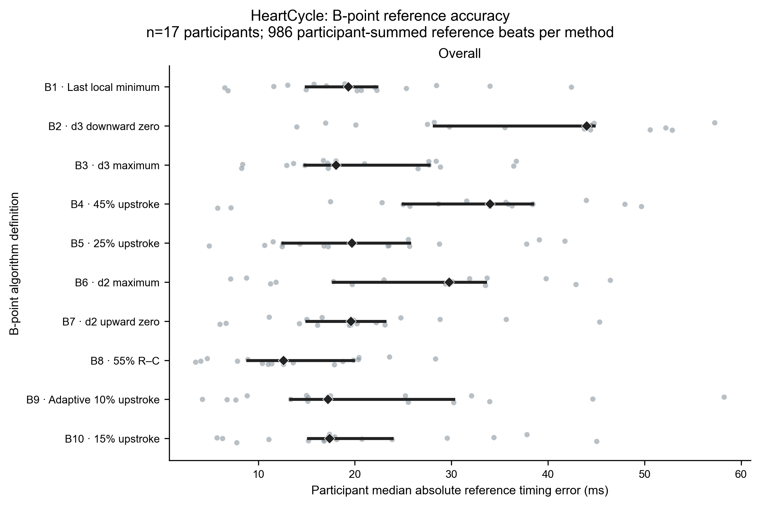
Figure 2A. HeartCycle B-point reference accuracy. Each grey point is one participant's median absolute detected-minus-ECHO AVO error; black diamonds and bars show the across-participant median and IQR. B8 had the lowest observed participant median absolute error, 12.59 ms. B9 showed less signed bias (-5.82 ms) but a wider P95 tail of 57.73 ms. No paired inferential comparison established universal superiority.
X result. X12 had the lowest participant median absolute ECHO AVC error (36.55 ms; signed median +31.68 ms; P95 78.94 ms). X2 had a 41.45 ms median but a 409.40 ms P95. The full X panel and ReBeat B/X panels remain in the supplementary collection. ReBeat baseline participant medians were 4.00 ms for B1, 5.80 ms for B7 and 4.00 ms for X12/X2, but these are expert-annotation comparisons.

Signed error distributions and tails
Median absolute error alone hides whether a definition is systematically early or late and whether a small number of beats produces extreme error. Signed error is detected time minus reference time. Negative values are early and positive values are late. All X algorithms below use the same 371 strict common-reference HeartCycle beats and common scales.
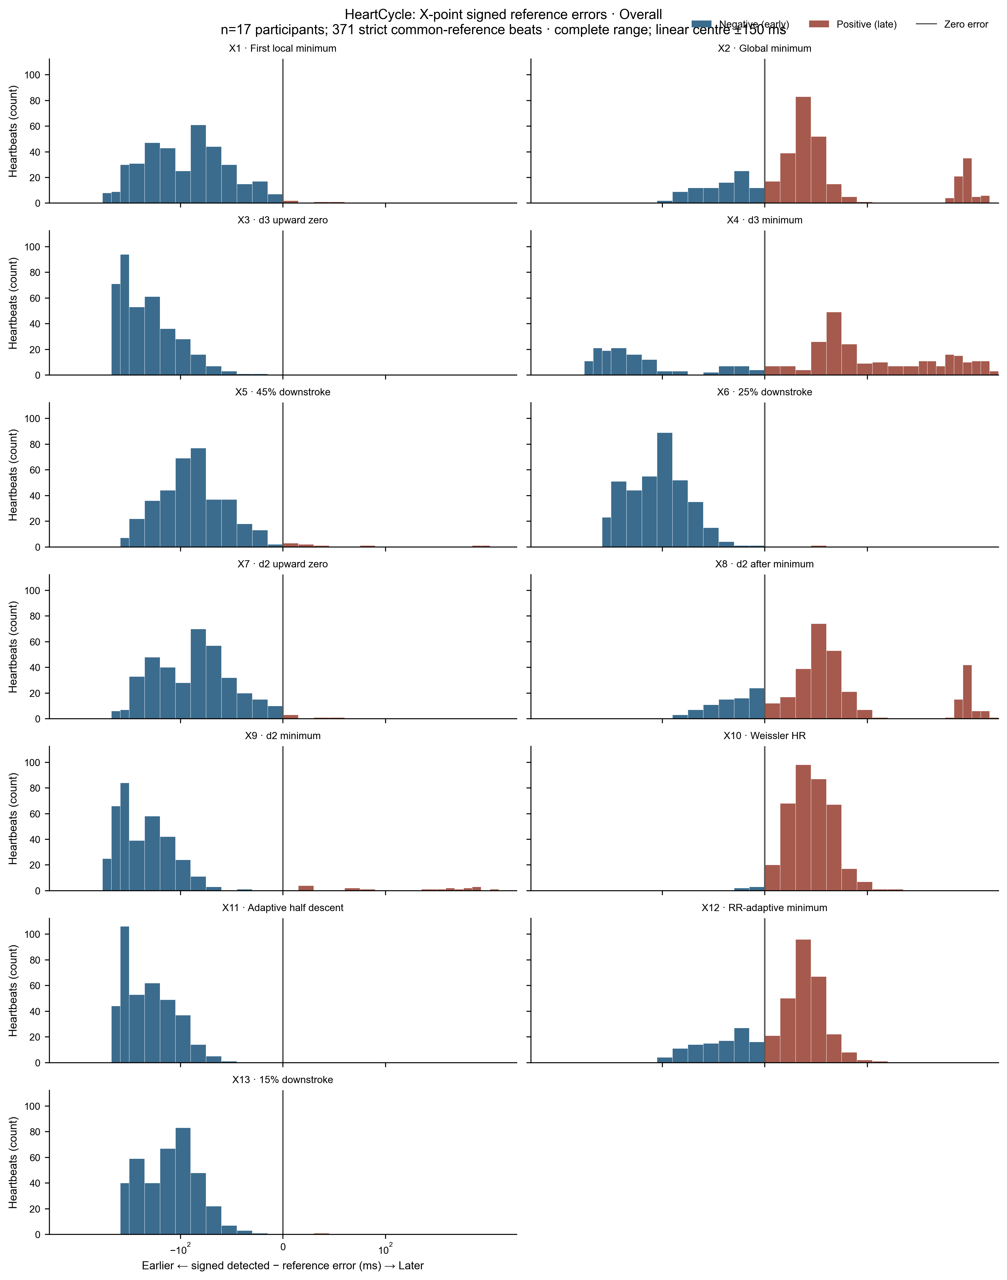
Figure 3. HeartCycle X-point signed errors against ECHO AVC. The common binning separates early and late detection while retaining complete tails. X3 and X9 were systematically early (signed medians -144.72 and -145.73 ms). X2 and X8 contain late tail clusters despite moderate central errors. X12 combined the lowest observed participant median absolute error with a smaller P95 than X2. No tolerance-exceedance percentage is shown because no clinical or analytical threshold was approved.
B distributions were narrower but still definition-dependent. B8 combined a +11.47 ms signed median with a 34.21 ms P95; B2 had a 44.01 ms participant median absolute error and 65.41 ms P95. This changes the decision from choosing a method by mean error to evaluating central correspondence, direction, tails and failure together.

Detection success failure and variability
Question: how often does each frozen definition fail, and what recorded rule produced the failure? Failure is missed plus invalid divided by attempted detections. Upstream-ineligible records are separate and do not inflate the attempted-failure denominator.
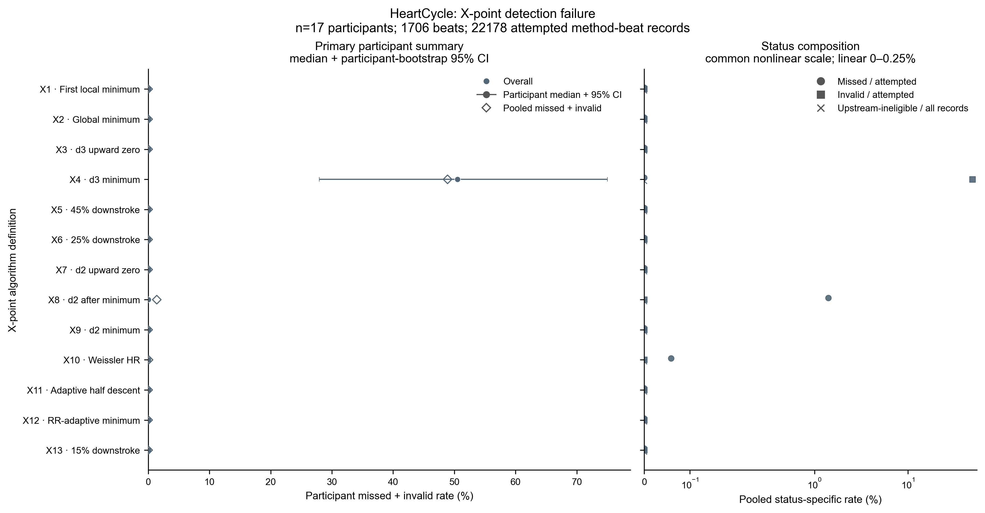
Figure 4. HeartCycle X-point failure. Each method's participant-median failure and bootstrap interval are shown with pooled status composition. X4 was invalid on 834 of 1,706 attempts (48.89%); X8 missed 24 of 1,706 attempts (1.41%). The result establishes operational dependability, not timing accuracy.
Method/context | Attempted failure | Verified primary reason | Interpretation
HeartCycle B1 | 195/1,705 (11.44%) | No qualifying local minimum | Failure burden accompanies otherwise moderate ECHO error
HeartCycle B7 | 230/1,705 (13.49%) | No crossing: 212; boundary/order: 18 | Highest HeartCycle B failure
HeartCycle X4 | 834/1,706 (48.89%) | X sample not strictly between C and next R | Minimum can be at C and is then rejected

Across all datasets, 15,788 of 514,280 method-beat rows were failed or upstream-ineligible. The mutually exclusive primary reasons were 466 upstream dependency/ineligibility, 182 unusable windows, 4,520 no qualifying feature or crossing and 10,620 rejected boundary/order constraints. Unresolved count: zero. These are verified software execution paths, not physiological causes.

Algorithm disagreement and complete case coverage
Question: how far apart are definitions on the same beat and participant? The outcome is timing disagreement, not ground-truth error. Common-valid analysis includes only beats where every method in the point-type comparison produced a valid result.
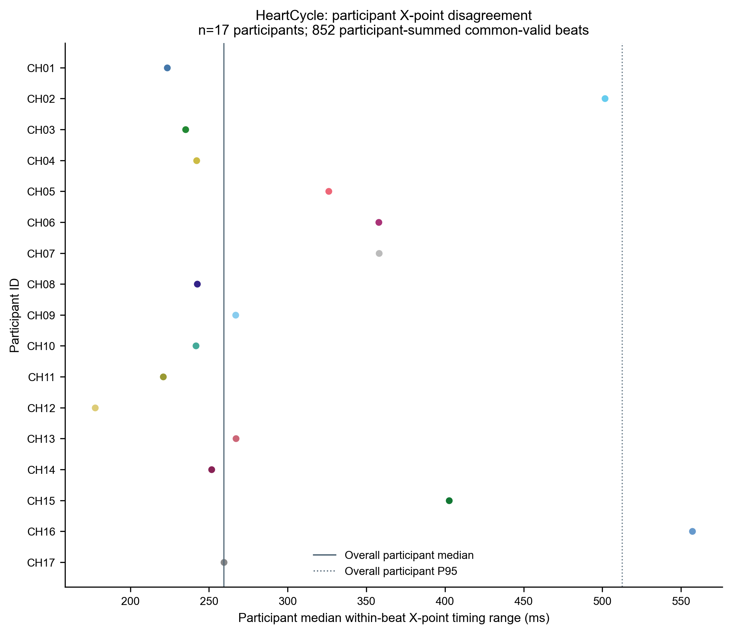
Figure 5. HeartCycle participant X-point disagreement. Each coloured dot is one participant's median within-beat timing range across all 13 X definitions. The overall participant median was about 260 ms, with strong heterogeneity. Only 852 of 1,706 beats were common-valid for this all-method display, so the plotted distribution is a success-only subset.
Dataset/condition | B common-valid | X common-valid | Interpretation
HeartCycle overall | 1,439/1,705 | 852/1,706 | X coverage is 49.9%
IITB rest | 1,152/1,998 | 1,329/2,022 | Different eligible denominators
IITB post-exercise | 1,002/1,723 | 981/1,737 | Failure increased while retained-beat range fell
ReBeat baseline | 8,275/8,402 | 4,401/8,403 | X coverage is 52.4%
ReBeat cognitive | 8,261/8,490 | 4,550/8,492 | X coverage is 53.6%

IITB post-exercise participant-median all-method range changed by -3.82 ms for B and -31.70 ms for X. Because failures increased at the same time, the smaller retained-beat range cannot be called improved reliability. ReBeat X range increased by 15.59 ms (95% bootstrap interval 4.00 to 20.00; 17 of 24 participants increased).

Physiological condition sensitivity
Matched detector analyses used the same 18 IITB participants at rest and post-exercise and the same 24 ReBeat participants at baseline and cognitive workload. IITB has no independent B/X reference. ReBeat expert-reference change was estimable for 22 participants represented in both conditions, with different beats recorded in each condition.
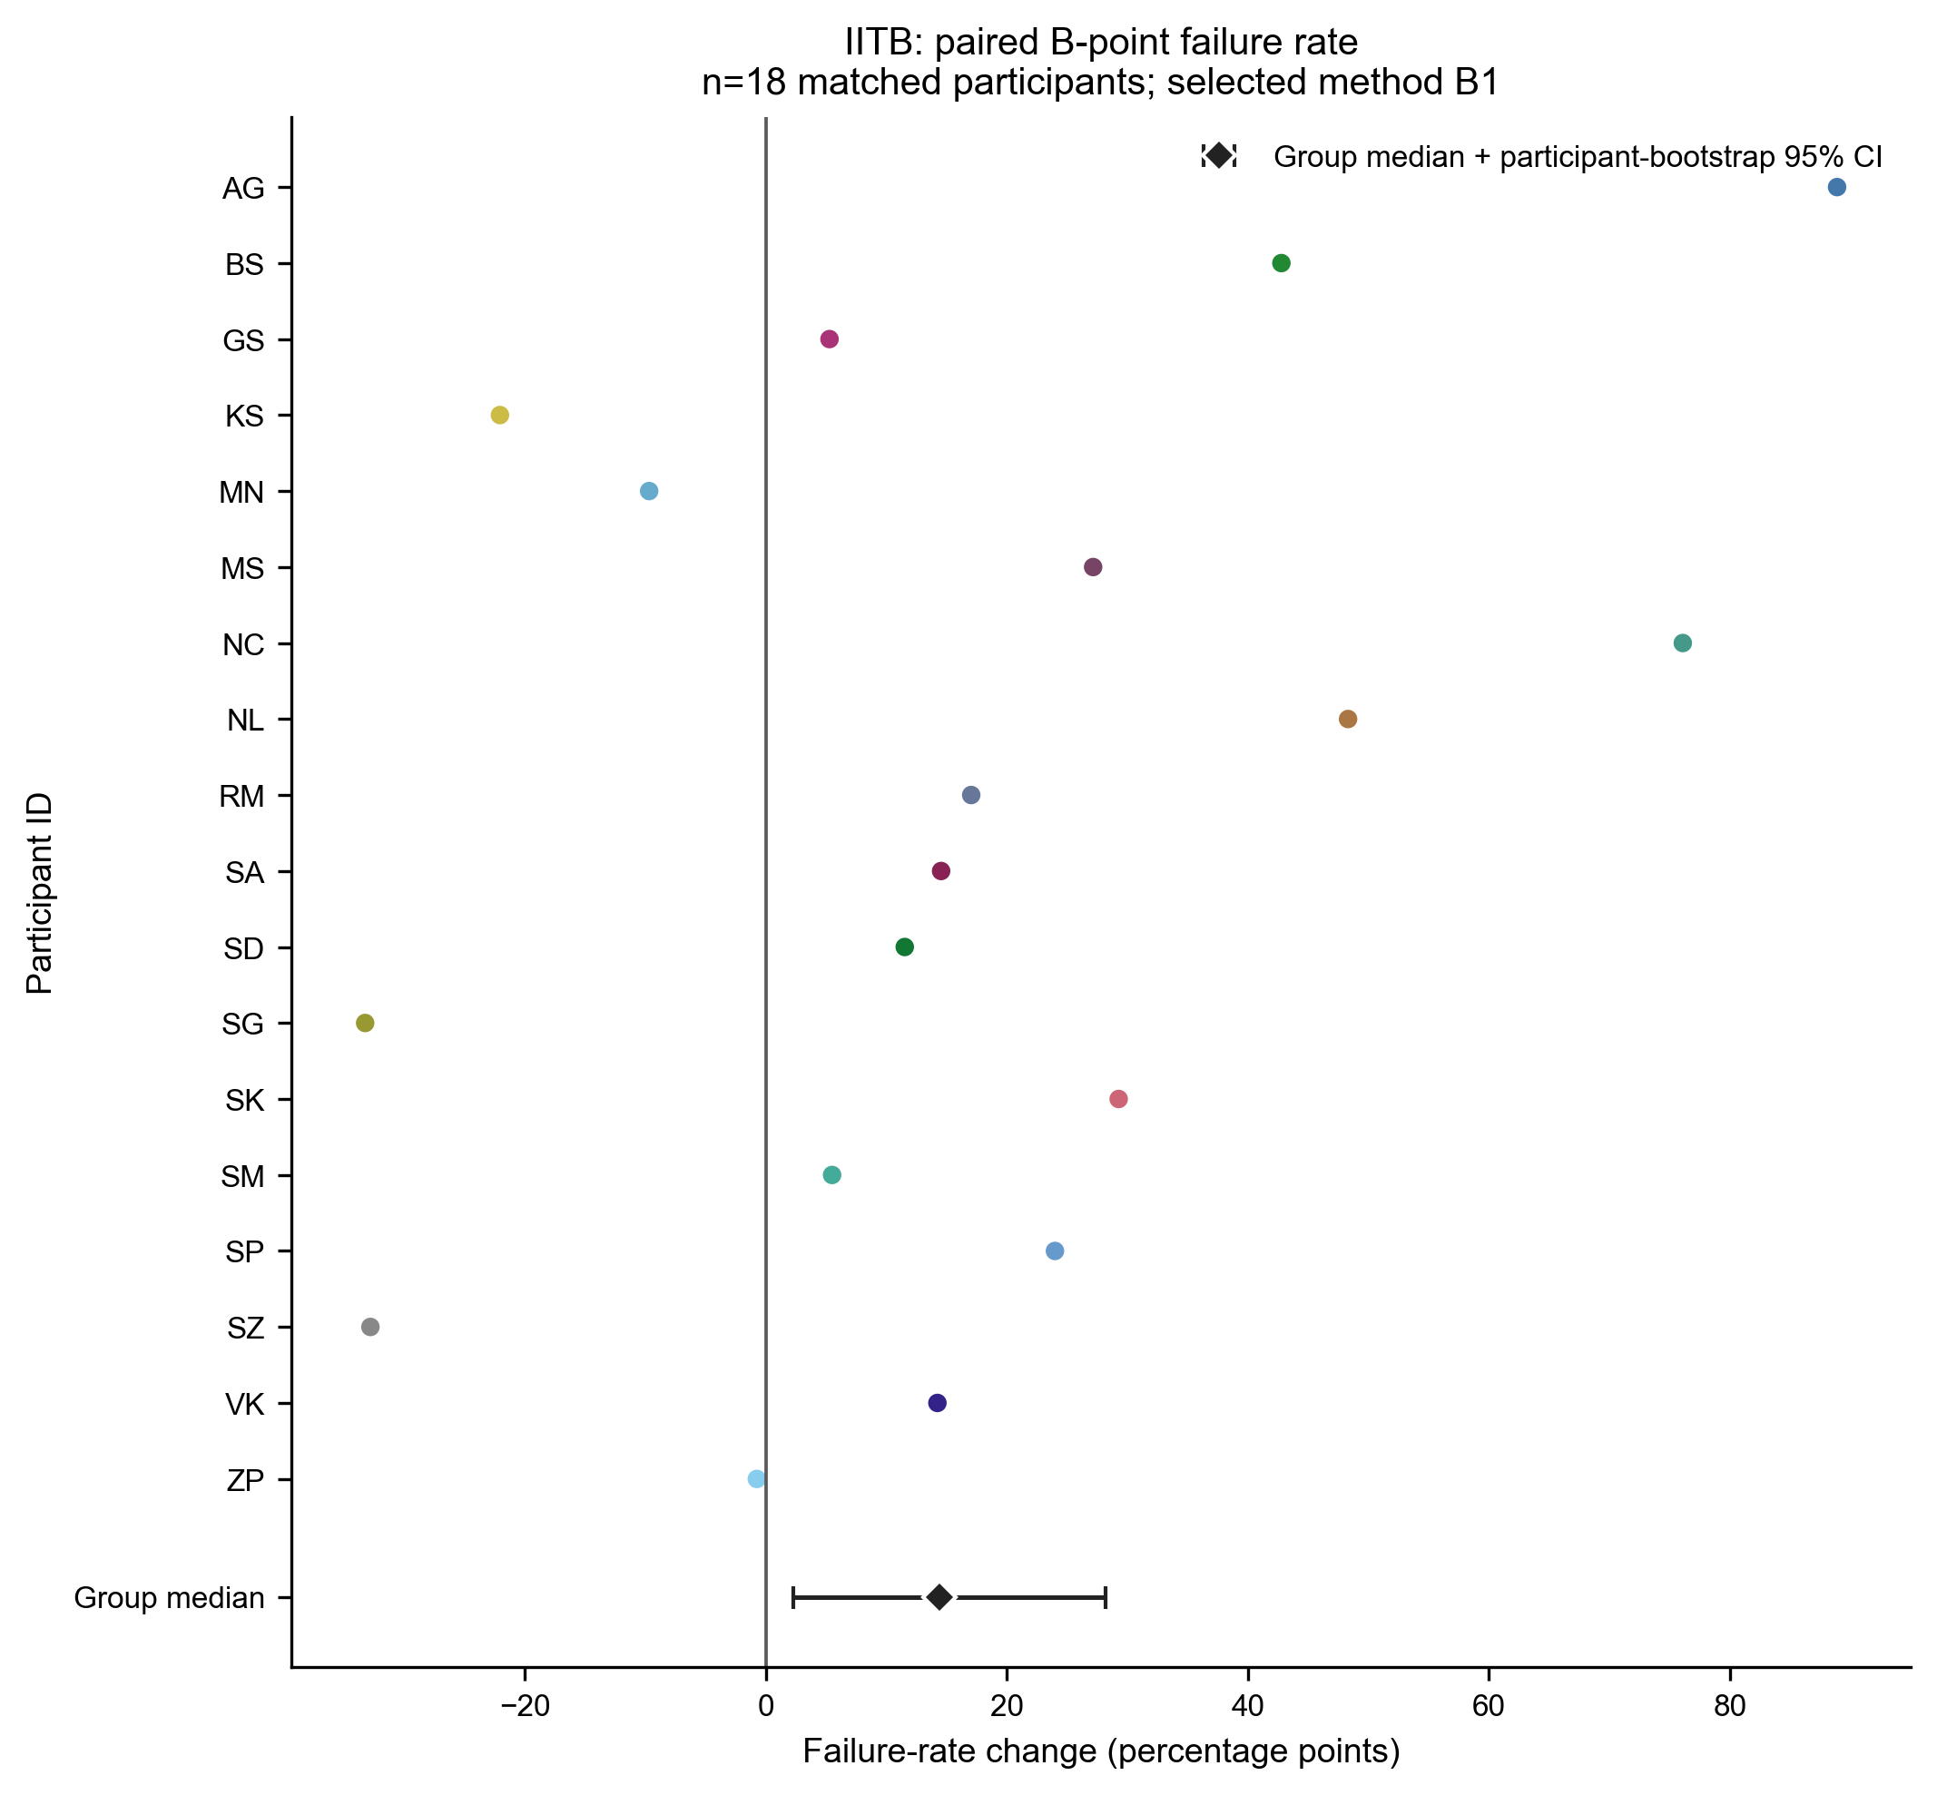
Figure 7. IITB paired B1 failure change. Each point is post-exercise minus rest for one participant; the diamond and interval show the median and participant-bootstrap 95% interval. B1 increased by 14.40 percentage points (95% interval 2.28 to 28.22). B7 showed the same median increase with a similar interval. This establishes condition sensitivity in detection success, not reference timing accuracy.
Matched outcome | Median change | 95% interval or direction | Conclusion
IITB B1 failure | +14.40 points | 2.28 to 28.22 | Supported increase
IITB X4 failure | +7.73 points | -5.09 to 19.82 | Direction uncertain
IITB RR interval | -177 ms | Post-exercise minus rest | Strong condition change
ReBeat X8 failure | +0.63 points | 0.01 to 1.62 | Small supported increase
ReBeat X range | +15.59 ms | 4.00 to 20.00 | 17/24 increased
ReBeat B1 expert MAE | +2.00 ms | -2.00 to 4.00 | No consistent median change
ReBeat X12 expert MAE | 0.00 ms | 0.00 to 4.00 | No consistent median change

Every one of the 23 ReBeat participant-median absolute expert-reference error intervals included zero, so the available annotations do not establish a consistent workload-related median accuracy change. Figure 8 aligns failure patterns across datasets without pooling. X4 is failure-prone in every dataset, but cohort, equipment, preprocessing and morphology are confounded, so the magnitude cannot be attributed to disease or a single physiological mechanism.

Waveform morphology and failure investigation
All six prespecified features were evaluated against strict common-reference absolute error, attempted detection failure and method-specific peer disagreement for every applicable B and X definition. The 1,794 tests produced 23,631 participant effects. The table reports multiplicity-controlled exploratory support as positive/negative effects; the sign describes the measured association or failed-minus-valid contrast, not whether a waveform is physiologically better.
Feature | Reference error | Failure | Peer disagreement | Observed pattern
Sharpness | 12/69 (2+/10-) | 10/115 (0+/10-) | 21/115 (6+/15-) | Supported failure contrasts consistently had lower failed-beat sharpness; other outcomes remained method-specific
Local slope | 8/69 (3+/5-) | 10/115 (0+/10-) | 22/115 (6+/16-) | Supported failure contrasts consistently had lower failed-beat slope; reference-error directions were mixed
Amplitude | 7/69 (6+/1-) | 8/115 (2+/6-) | 15/115 (12+/3-) | Mostly positive reference-error and disagreement effects; failure was not a uniform low-amplitude pattern
Signal-to-noise ratio | 5/69 (3+/2-) | 7/115 (7+/0-) | 18/115 (12+/6-) | Supported failure effects were positive, contradicting a simple low-SNR explanation
Competing features | 10/69 (5+/5-) | 7/115 (0+/7-) | 26/115 (13+/13-) | Directions were mixed or counterintuitive; more counted features did not consistently mean worse reliability
Beat-to-beat variability | 0/69 | 6/115 (5+/1-) | 7/115 (6+/1-) | No supported reference-error association; selected failure and disagreement effects were mainly positive

Support was uneven: HeartCycle contributed 13 B and one X association, IITB 42 B and seven X associations, and ReBeat 81 B and 55 X associations. This distribution, the mixed directions and the 1,595 unsupported rows rule out a universal morphology threshold. HeartCycle X12 competing-feature evidence did not survive correction, and beat-to-beat variability had no supported reference-error association for any method.
Outcome definitions matter. Error effects are within-participant correlations on valid strict common-reference beats. Failure effects compare the participant median feature on failed and valid attempted beats without assigning timing errors to failures. Peer-disagreement effects use common-valid beats and therefore remain sensitive to exclusion of difficult X beats.

Selected participant aware effects and operational interpretation
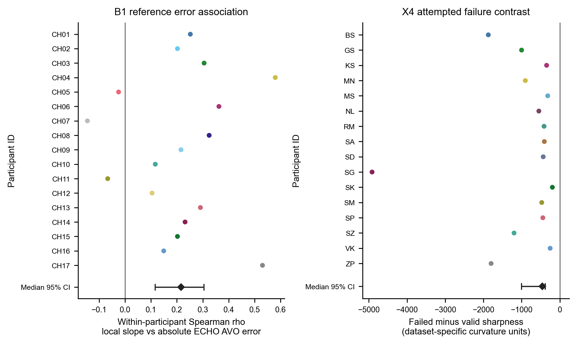
Figure 6. Selected method-specific morphology effects. Left: HeartCycle B1 local slope versus absolute ECHO AVO error, one within-participant Spearman coefficient per participant (median rho 0.216, 95% bootstrap interval 0.117 to 0.305; q=0.0237; n=17). Right: IITB post-exercise X4 failed-minus-valid sharpness (median -460 dataset-specific curvature units, interval -1,002 to -381; q=0.00525; n=16). Diamonds and bars show the participant median and interval. These associations identify reliability boundaries but do not prove causation.
B1 searches for the last qualifying local minimum; B7 searches for the last second-derivative upward crossing. Their IITB post-exercise failures were dominated by no qualifying feature or crossing. B1 had 579 misses. B7 had 571 misses, comprising 564 no-crossing records and seven search windows with fewer than two samples, plus 19 order-invalid detections. Both participant-median failure rates increased by 14.40 percentage points. Failed beats had fewer counted competing features (median failed-minus-valid contrast -2; q=0.00396; n=17), while the change in competing-feature count correlated negatively with the change in failure (rho -0.82; q=0.0035; n=18). That direction is counterintuitive and does not establish a morphology mechanism.
X4 searches for the third-derivative minimum in a slice that includes C, then requires X to be strictly after C. Every recorded X4 failure was an order rejection because the minimum occurred at the excluded boundary. Lower failed-beat sharpness was reproducible in IITB post-exercise and ReBeat, but ReBeat failures also had higher amplitude and SNR and lower slope. The software mechanism is therefore established, while the physiological explanation remains multifactorial. X8 provides a contrast: its misses reflect absence of a qualifying post-minimum second-derivative maximum, but no failure-related morphology association survived correction; only selected disagreement associations were supported.

Real waveform examples and paired agreement
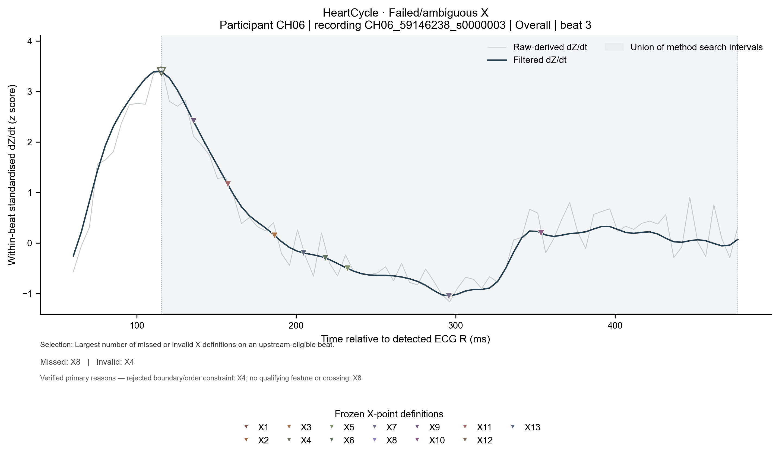
Figure 1. HeartCycle failed or ambiguous X example selected after the full comparison. All markers belong to the same real beat. X4 was invalid because its selected sample did not satisfy strict C < X < next R; X8 missed because no qualifying post-minimum second-derivative maximum was found. The panel explains an execution path but is not population-level evidence. Clean, major-B and major-X cases for all datasets remain in the supplement.
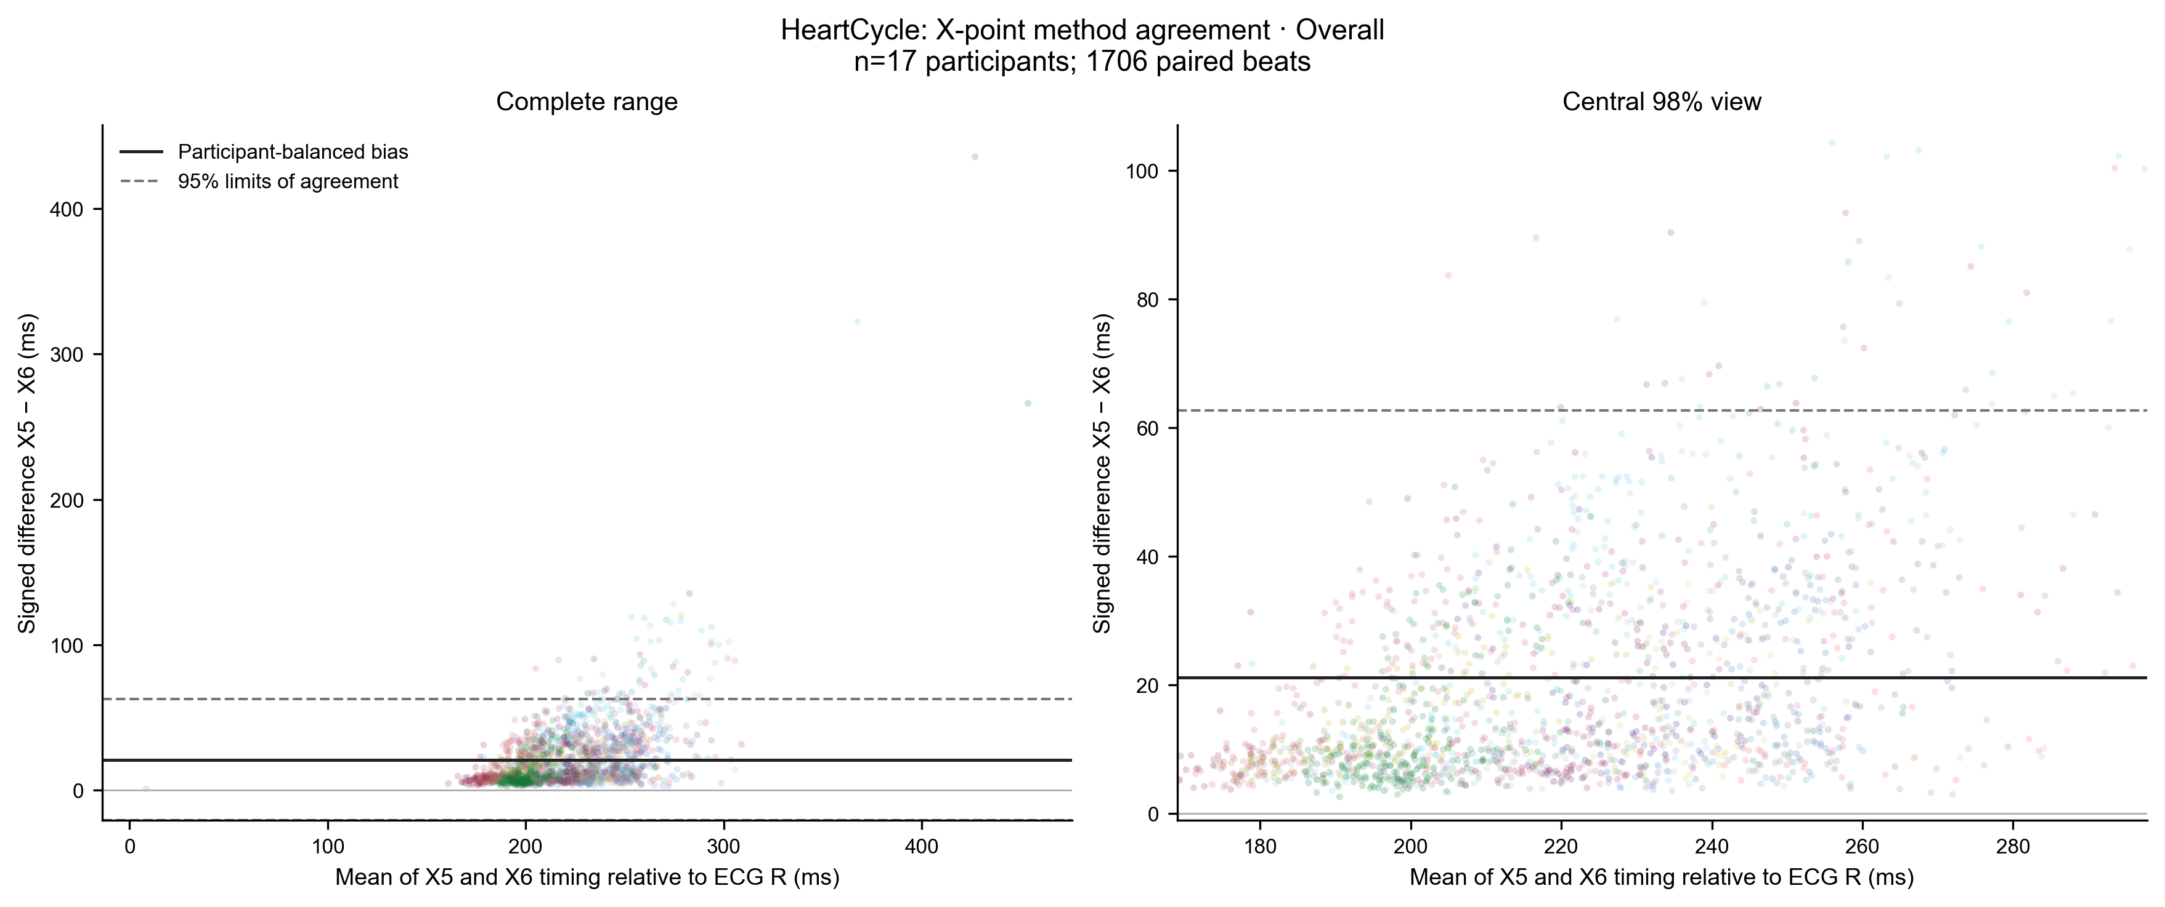
Figure 9. HeartCycle X5 versus X6 agreement. Each point is a paired beat; the solid line is participant-balanced bias and dashed lines are limits of agreement. X5-X6 bias was +21.10 ms with limits -20.43 to +62.63 ms (17 participants; 1,706 beats). The related threshold methods are not interchangeable. Agreement between algorithms does not establish physiological accuracy.

Integrated P1 findings and discussion
The evidence defines reliability profiles rather than a leaderboard. B8 had the lowest observed HeartCycle ECHO AVO median error and no failures there. B1/B7 had low ReBeat expert-label median errors but larger and condition-sensitive failure burdens. X12 combined a relatively low median error with a smaller HeartCycle tail than X2, while X4 exposed a boundary problem that removed 31–49% of attempted beats across datasets. These differences depend on reference provenance, tails, coverage, participant variation, condition and waveform context.
Claim | Evidence | Boundary
B8 had the lowest observed HeartCycle ECHO B median error | Figures 2–3; strict common sample | Descriptive comparison; HeartCycle ECHO only
X12 combined a low X median with a smaller tail than X2 | Figures 2–3; ECHO and expert tables | Reference types remain separate
X4 is operationally unreliable | Figure 4; exact failure records | Does not determine physiological correctness
IITB B1/B7 failure increases after exercise | Figure 7; matched n=18 | No independent IITB reference
ReBeat cognitive X disagreement increases | Figures 5 and 7; +15.59 ms | Success-only common-valid subset
ReBeat median expert-reference change is uncertain | Matched n=22; all 23 intervals include zero | Different beats; expert ICG reference
Morphology effects are method and outcome specific | Figure 6; 1,794-test screen | Exploratory and non-causal
X5 and X6 are not interchangeable | Figure 9; bias and limits | Agreement is not accuracy
Dataset differences cannot be disease effects | Figure 8; comparability audit | Acquisition and cohort confounding

Contribution beyond prior work
Árbol et al. compared three B algorithms against two scorers and documented large differences in missed cycles. Forouzanfar et al. developed a morphology-aware B detector and evaluated rest and post-exercise data. Karpiel et al. assessed B, C and X detections against expert labels in a clinical pilot. P1 does not repeat a single B ranking. It combines 10 B and 13 X definitions with independent ECHO evidence where available, expert-label evidence kept separate, exact failure-path reconciliation, matched condition changes, denominator-aware disagreement and an all-method six-feature morphology screen.
For downstream work, PEP inherits B timing error and LVET inherits both B and X error and their covariance. A low median error can coexist with severe tails, and a high-failure method can look stable on retained beats. P1 supports reporting the exact definition, reference type, coverage, signed bias, tails and condition-specific behaviour before calculating PEP or LVET.

Limitations outstanding validation and conclusion

Established findings
- HeartCycle B8 and X12 had the lowest observed participant median absolute errors within their point-specific strict common-reference comparisons; paired superiority was not established.
- Failure burdens and mechanisms differ sharply by method; X4 repeatedly selects an inadmissible boundary sample.
- Exercise and cognitive workload change failure or disagreement for selected methods within matched participants.
- Specific morphology features are associated with selected reference errors, failures and peer disagreement, but effects are heterogeneous.

What remains uncertain
- IITB has no independent B/X timing reference. ReBeat expert ICG labels are not interchangeable with ECHO valve events.
- Common-valid analyses are success-only and particularly selective for X. Physical dZ/dt calibration is unverified.
- No approved clinical timing tolerance exists. Morphology associations are exploratory and do not prove physiological causation.
- The frozen detector, execution and filter source files are now packaged under src/variability_analysis and match the recorded SHA-256 hashes exactly.
- Fresh raw-data replays reproduced the stored R, next-R, C and all canonical 10 B and 13 X detection outputs. An isolated Python 3.12 environment without system site packages reproduced all 84 IITB/ReBeat recordings and the full HeartCycle pipeline; raw datasets remain external.

Direct answer to RQ1
HeartCycle B8 and X12 had the lowest observed median absolute errors against their respective ECHO events, while ReBeat expert annotations produced a different pattern. None is universally reliable. Method-specific failures, selective complete-case coverage, participant heterogeneity and condition changes determine when a timing estimate is dependable. Sharpness and slope often tracked failure or disagreement, but amplitude, SNR and competing-feature directions were inconsistent. The code-based failure mechanisms are reproducible; the waveform associations do not yet establish causal physiology.

Reproducibility
The analytical package contains preprocessing, alignment, validation, statistics, morphology, figure-generation and report scripts, plus README, requirements and 23 passing tests. The evidence package includes the 115-row results table, all 1,794 morphology tests, 690 failure-reason rows, 672 condition-morphology tests, matched ReBeat expert-reference changes, plotting data, audit logs and the complete Figure 1 to 9 inventory. The three frozen upstream implementation files are now packaged and hash-verified. A full raw replay still requires the external raw datasets at the configured read-only paths.

