MNR

Mitchell Saunders

Nicholas Saunders

Ramon Lucindo

CST 363, Fall 2019 A

Project Part 1

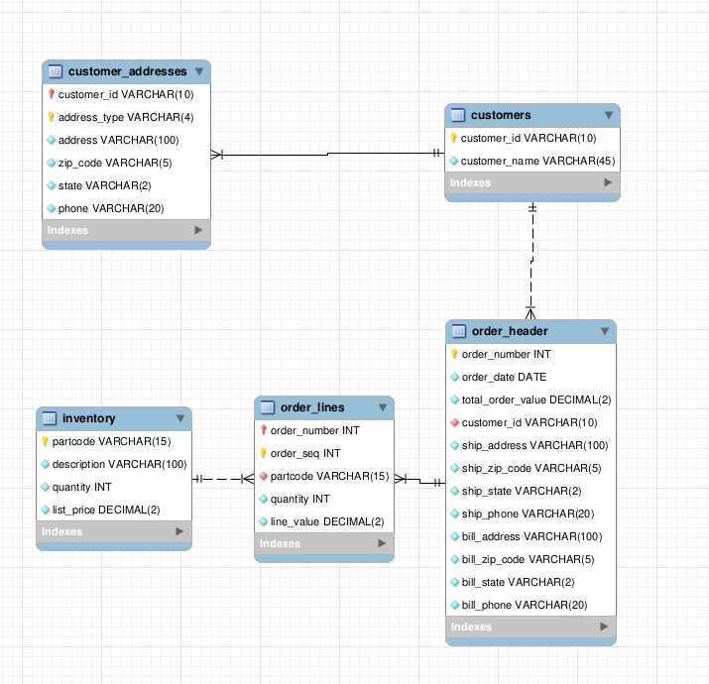

MNR Canine Goods is a wholesaler that specializes in non-GMO and locally grown ingredients for varied and carefully crafted canine edibles. The database design is intended for the Customer Service Representatives, who then will fill out orders from customers who order through the phone directly. This database is made in such a way that the Customer Service Representatives are able to view inventory, create orders, and view invoices. This web interface is intended to be used by the CSR and not by customers. The database is able to manage MNR Canine Goods’ inventory, and able to generate invoices with proper billing and shipping addresses.

Normalization design decisions:

Table breakdown:

* Inventory: 3NF
* Customers: 3NF
* Order_header: 3NF
  + The ship_address, bill_address and like fields appear to depend on the customer_id. The purpose of those fields are to store the customer address information at the time of order creation (in case of future customer address changes). So these fields do actually completely depend on the order_number field.
* Order_Lines: 1NF
  + Not in 3NF because of use of composite primary key. Use of composite primary key is to facilitate intuitive future joins and use data from both tables.
* Customer_addresses: 1NF
  + Not in 3NF because of use of composite primary key. Use of composite primary key is to facilitate intuitive future joins and use data from both tables.