**Nordic Blockchain**

**Luca Francioni, 240068**

**Supervisor: Michael Viuff**

**[Number of characters]**

**ICT Engineering**

**7th Semester**

**21/01/2019**

Version: August, 2018

Template responsible: dans@via.dk

**Table of content**

Preface iii

1 Introduction 1

2 Group Description 2

3 Project Initiation 3

4 Project Description 4

5 Project Execution 5

6 Personal Reflections 6

7 Supervision 7

8 Conclusions 8

Appendices

# Preface

The project is an embryonal stage of a bigger picture full of possibilities and customizable components, it will require a lot of work to make something like this usable to a full potential in a bank system with thousands if not millions of operations per hour; in the while, the idea is move the first step into this technology proposing something different and to appreciate the innovation concept behind software engineering.

# Introduction

The Nordic Blockchain project is being developed single-handedly by the only group member (Luca Francioni), as such, the choice of the model for the process report is the Kanban Model; for reasons of simplicity, easy handling, faster maintain and update while also being simple to interpret.

# Group Description

* **Luca Francioni**

ICT Embedded Engineering student in VIA University College, 7th semester.

Born and grown up in Italy, in 1994 and moved to Denmark.

Various independent FOSS projects focused on IT Security, video games and OS manipulation; passionate about reverse engineering and moderately experienced low-level developer and applied cryptography.

# Project Initiation

By suddenly finding myself without a group, I had the freedom to choose a topic that I’m interested in without external influence: blockchains.

The blockchain topic is very widely applicable into different contexts and systems, but the idea of applying it to the banking context came out by the necessity of a bank transfer that took 5 days to be completed and noticed how a faster transfer is also a more expensive fee being applied.

I was very cautious with the planning of the documentation, as I knew the workload as a single member would be a lot different from the original impression, therefore I tried to define as much as possible the time dedicated to each individual phase of the project development, but at the same time leaving certain areas under “pending review and update” since I knew they’d be changed frequently.

I used Kanban model to plan ahead my work, as it is simple and fast to update and keep track of while working on the rest of the project, avoiding forgetting steps or details during the process.

# Project Description

The problem definition was initially defined with a vague goal of creation of a blockchain that can handle secure transactions but was not well defining the goal of the project and what would define the project completed.

As such, the problem definition has been reworked during the first weeks of development, redefining the goal integrally and better describing what is that the project premise is being built with.

The goal is now realistic as I chosen to only work towards the base structure of the blockchain, the transaction system and the steps involved to make a transaction reach the dedicated nodes (the most important requirement) and the correct functioning of it.

As such, I believe the project can be completed within the time limit and by following the planning done should only improve the progress.

# Project Execution

Being alone, approaching the project from an organization point is a lot easier as I did not have to organize workload for members and rely on their seriousness with the matter, but the downside is the increased workload for me.

To organize myself and to dedicate the proper workload while keeping the focus on the functional requirements without losing myself into unnecessary functionalities I choose to use Kanban’s model.

Kanban is extremely simple and helped me significantly to keep track of to-dos, I’ve chosen to record a weekly log, that would keep track of stuff to do, being done and done already.

Every last day of the working week (Friday), I would examine my “done” increment and verify that I didn’t go out of focus, that I dealt with the task properly and that would also be coherent to the original design to the best extent; by comparing my requirements and/or design with the implementation.

To identify “criticality” of the elements during planning and process management, the red color is used for “essential”, the yellow color and its different graduations for “moderately important” (the darker, the most) and the green for lesser or minor priority tasks that may require lesser time of completion.

The blue tasks instead are “special”: a task that must be done before the others in the same “doing” section, this has been used to mark “sprints planning” session.

The following is the weekly log of the operations being coordinated and dealt with:

**Week 4**

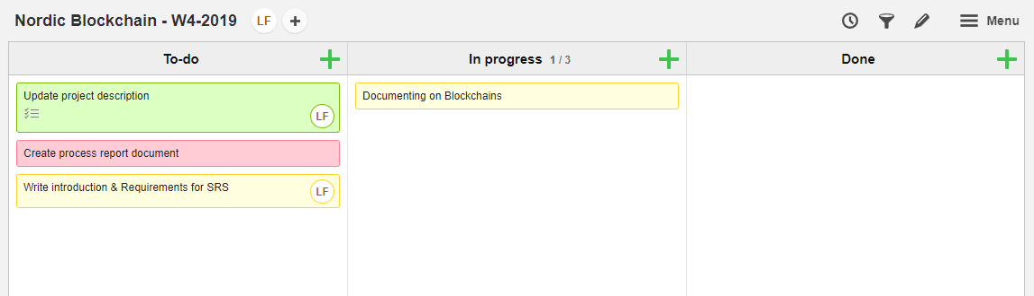

The embryonal stage of the project, after the creation of the project description and the first steps into the requirements identification.

**Week 5**

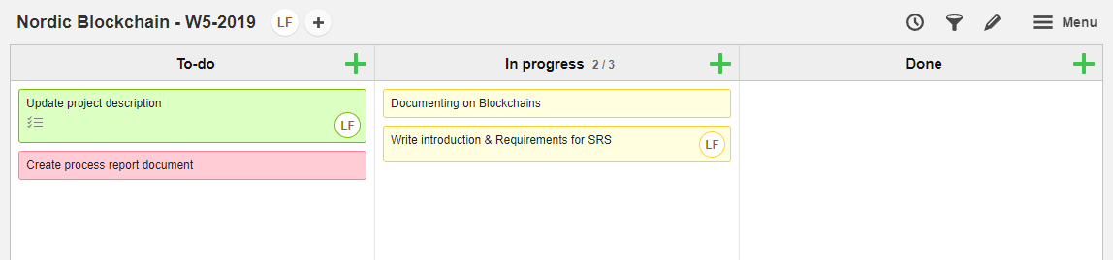

The first days, before understanding how to achieve something, I had to document myself into blockchains in details and understanding current designs and generic concepts.

**Week 6**

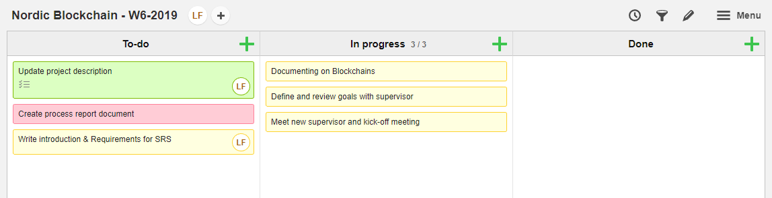

Michael has been assigned to me, we had to have a meeting and discuss how to proceed into the bachelor project writings.

**Week 7**

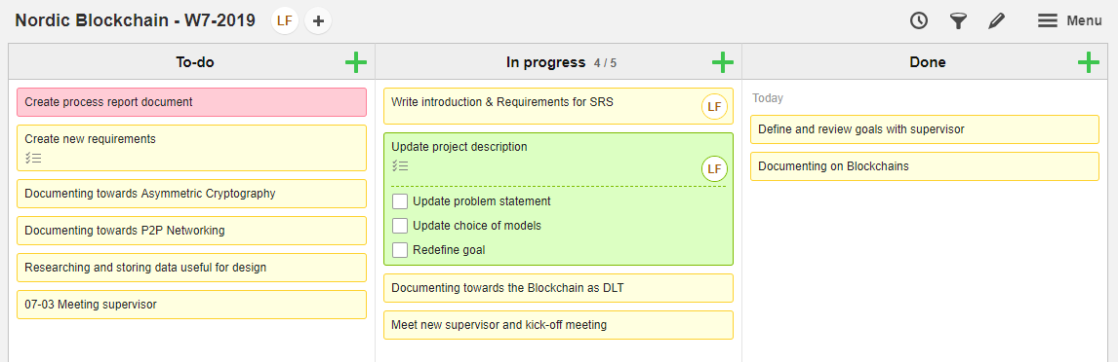

After the first meeting, the picture of writing the BPR became much clearer and more tasks could be created in the Kanban model, the project description should’ve been updated to better fit the goal of my project and the various mutations after I documented myself deeply into blockchains.

**Week 8**

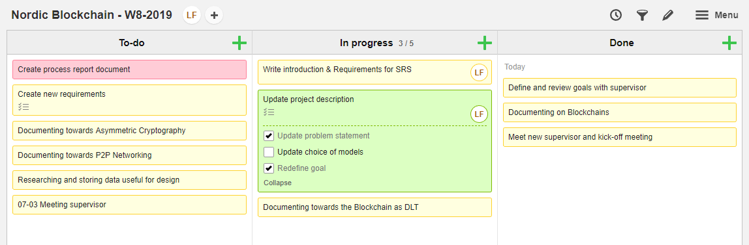

I changed the problem statement slightly, to better center the concept of the problem I was trying to solve.

**Week 9**

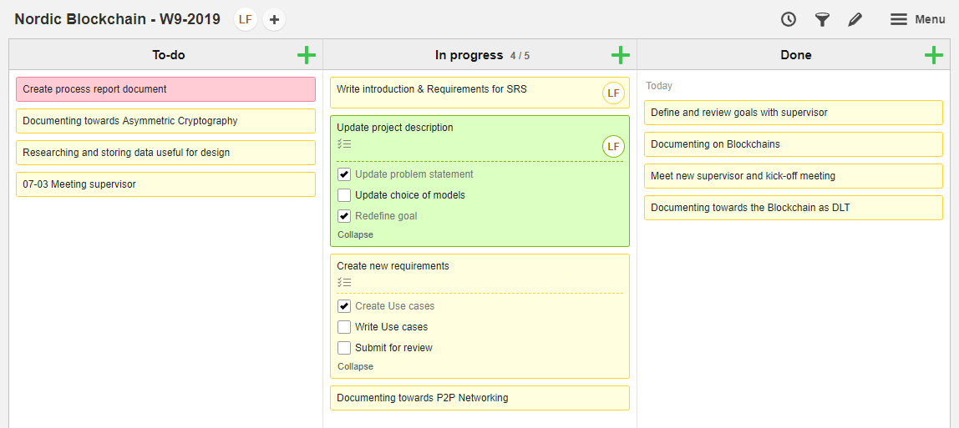

Therefore, the first requirements and UML graphics started to pop out, since I figured out what a stakeholder wants from this and he wants something to happen, when clicking or interacting with something else.

**Week 10**

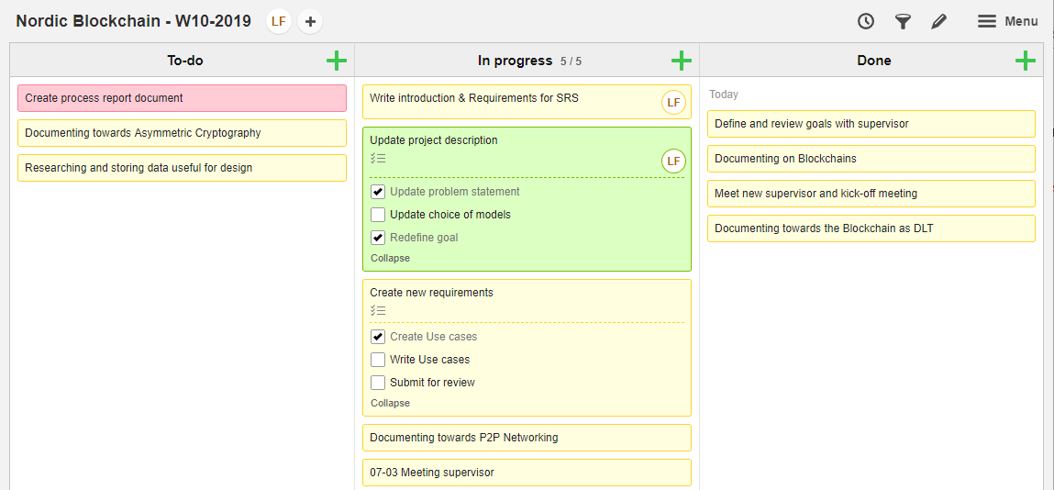

I organized another meeting with Michael, as the requirements were being written and I wanted to be sure I was doing it right.

**Week 11**

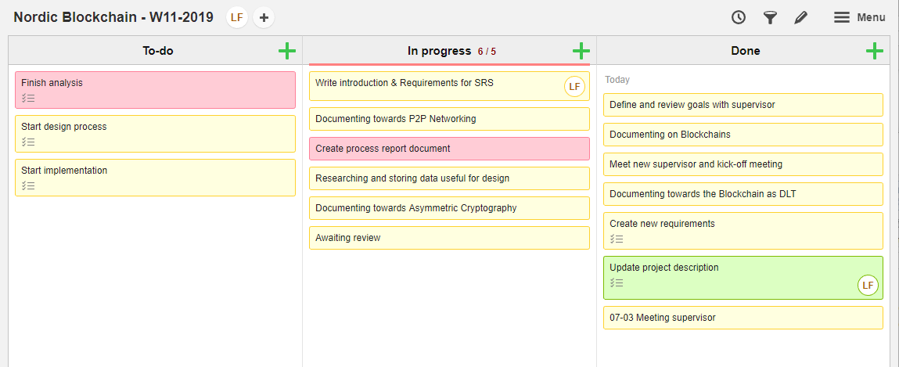

Having it done, more components for the project needed to be worked on (networking, security, data format) and started to consider various technologies.

**Week 12**

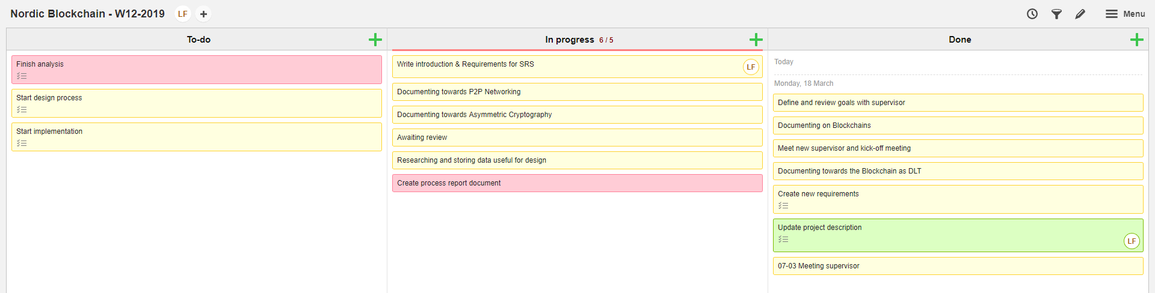

While I was waiting review from Michael, I started writing this process report, as I only dealt with the online Kanban model and saving the pictures of it, while writing a few notes.

**Week 13**

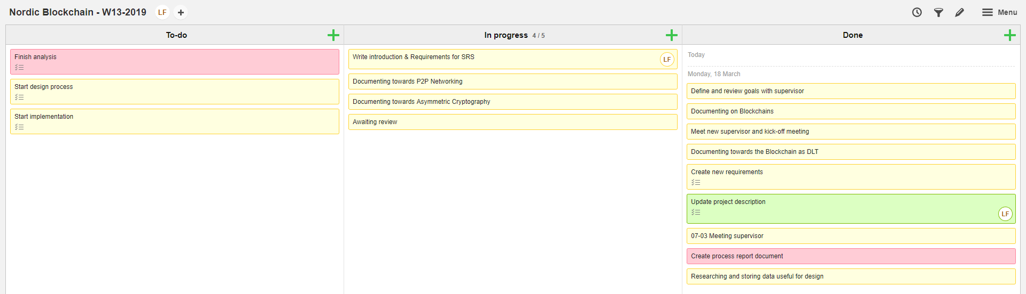

Process report had additional shapes around, while documenting myself further in technology choices I had.

**Week 14**

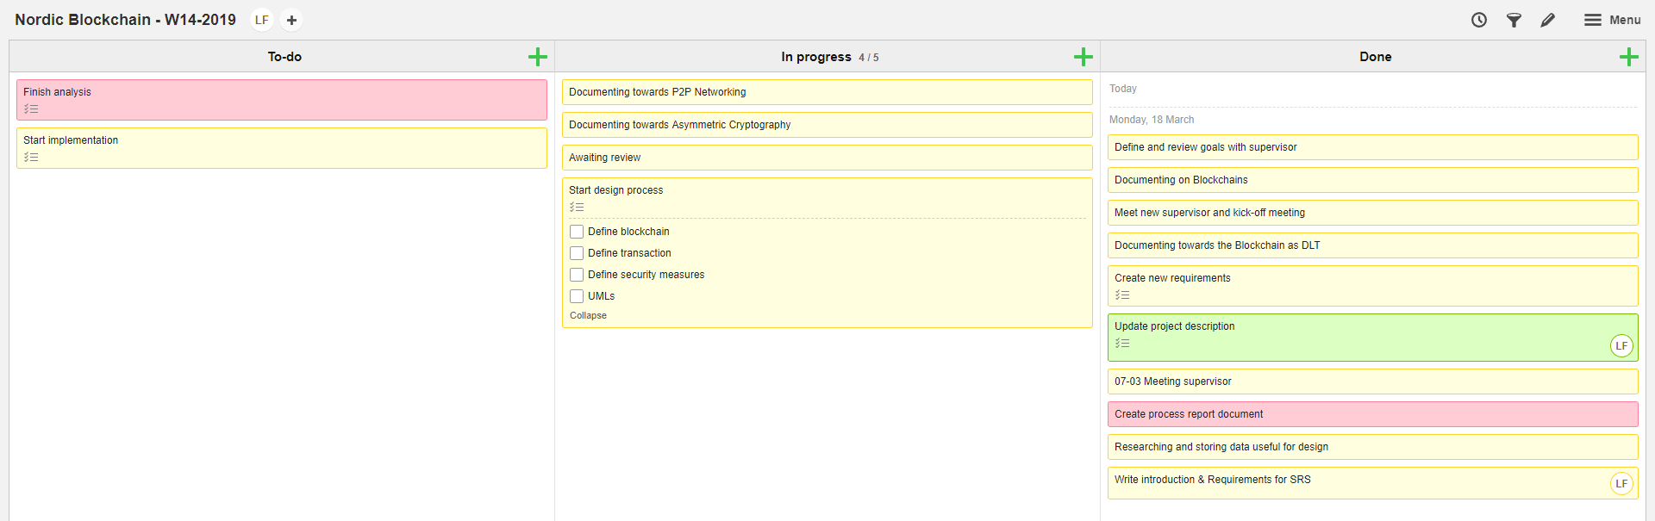

The requirements are ready, I know what I want to solve, it is time to design the system with the knowledge I acquired so far and keep finding.

**Week 15**

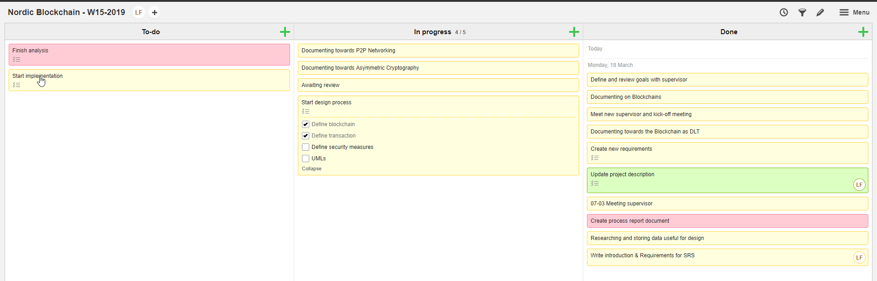

I needed to define the main structure of the entities involved with the requirements, the most important ones were, of course, the blockchain which is the entire baseline system and the transaction which is a core entity needed for most of the requirements.

**Week 16**

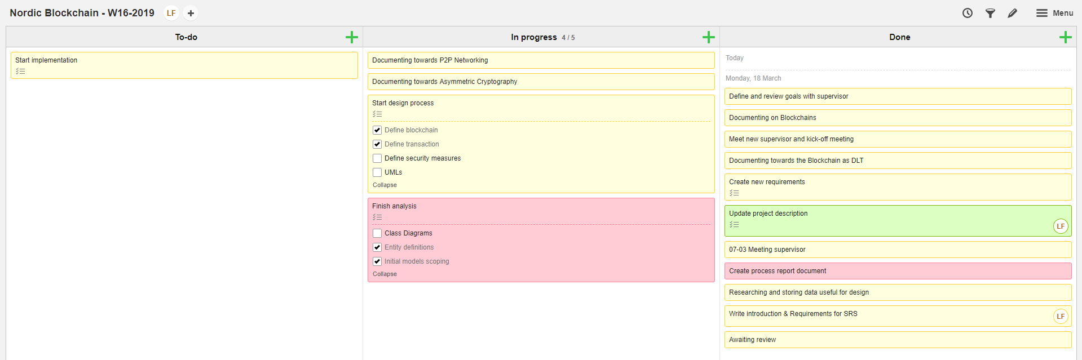

More and more definitions had to be written and perfectioned, improving the descriptions and creating graphical representations.

**Week 17**

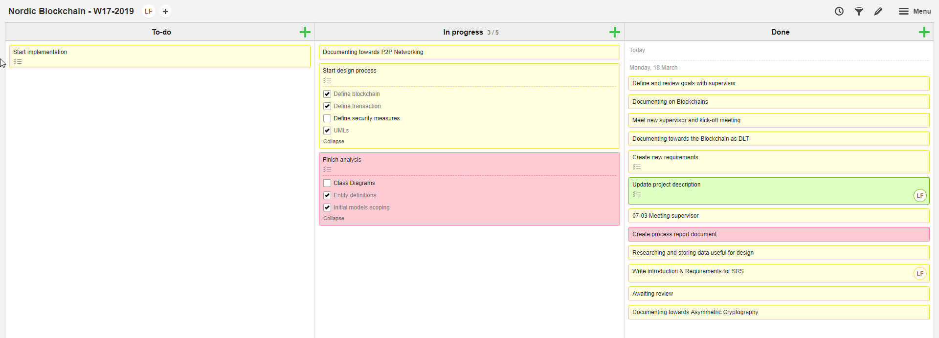

UML creation is taking a while, since the complexity of the software structure and design, but the big picture of the design started to be more recognizable to an implementable state.

**Week 18**

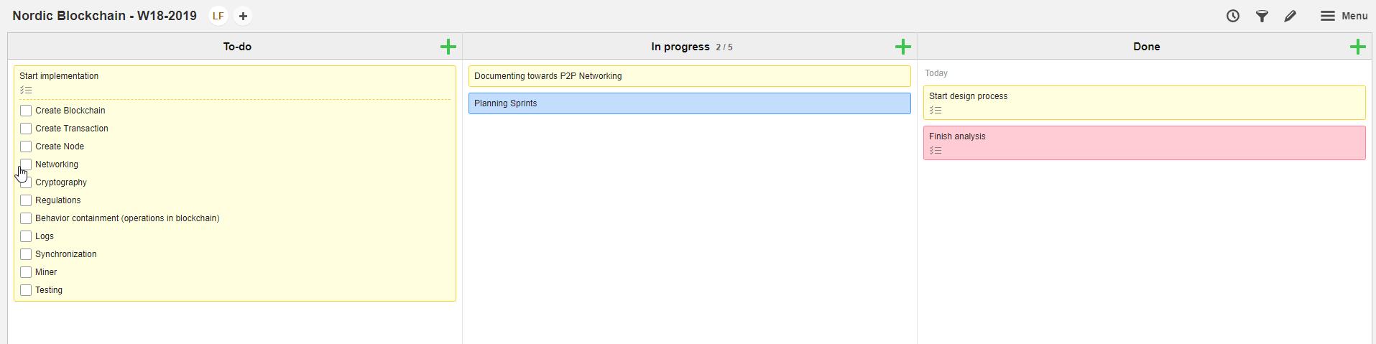

I started planning the sprints for the implementation, as the design was satisfying enough and looked stable.

**Week 19**

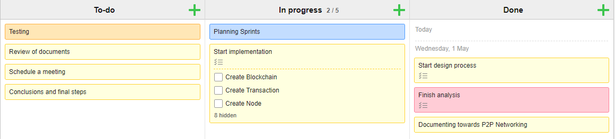

While keeping working on sprints planning, I kept identifying what else I had to do soon.

**Week 20**

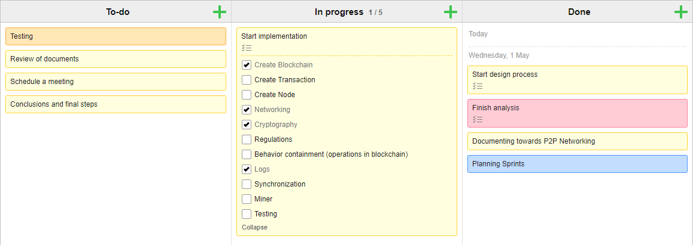

The first increment from the planned sprint revealed itself faster than previously planned, some more time has been dedicated to fix eventual mistakes and to improve its stability by performing debugging a small ad-hoc tests.

**Week 21**

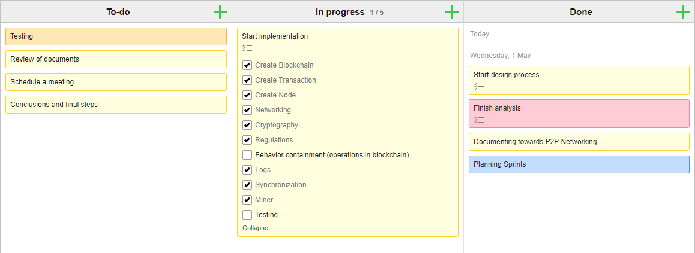

Once the additional time rewarded from the previous sprint, I moved forward and performed the second sprint completing it, this one instead stood within the time boxes previously planned, while connecting the classes lots of fixes or extensions have been made

**Week 22**

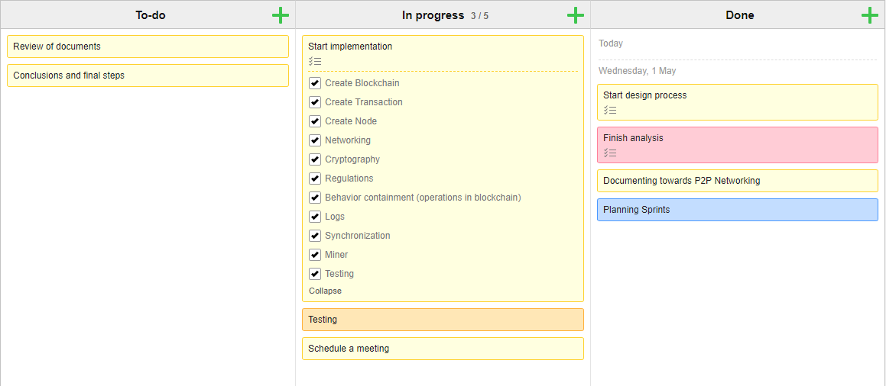

Implementation is finished, the previous ad-hoc tests have been removed (mostly) and the Unit-Tests are being used as a replacement for a former testing framework.

**Week 23**

# Personal Reflections

The creation of this project brought a certain interesting set of experiences: I learned about blockchains much more and how to interact with these, I dealt directly with WebSockets for the first time and I learned a mistake I did on the long-term (misuse of RSA signing and verifying); this is experience that can be added to my career set but the biggest flaw I found out while developing this project is the lack of better descriptive and expressive documentation writing; I feel like writing documentation took much more time for me than it should, so I feel like I should improve my writing skills towards academical language writing.

While being alone working on this project wasn’t a bad experience and gave me the possibility of doing faster decision-making sessions during requirements and design phases, I also thought that sometimes talking to a member of the group could’ve brought more interesting ideas or shapes of already taken design choice, while also helping with the implementation and the solving of technical problems encountered in a time critical and shortening situation.

# Supervision

Michael has been a good supervisor, readily responding to my emails and concerns, exposing and explaining defects in the writing process and helping me to understand needed reformulations of certain aspects of the documentation.

We did not have to meet very often, therefore only 3 meetings in total have been performed and these are the summaries of those:

* **Meeting 1 ()**:
* **Meeting 2 ()**:
* **Meeting 3 ()**:
* **Meeting 4 ()**:

# Conclusions

For content see Appendix 2 “Process Report – VIA Engineering Guidelines”.

**Appendices**

For content see Appendix 2 “Process Report – VIA Engineering Guidelines”.