Schedule Editor

Introduction

ScheduleDesigner.exe is the way to edit the schedule for the Smart Desk system. This application is split into multiple pages navigated by tabs at the top of the dialog. A word of warning, there is NO undo. Most operations happen immediately, and will make changes. Many operations such as changing members of some schedule group item are protected and must have editing enabled.

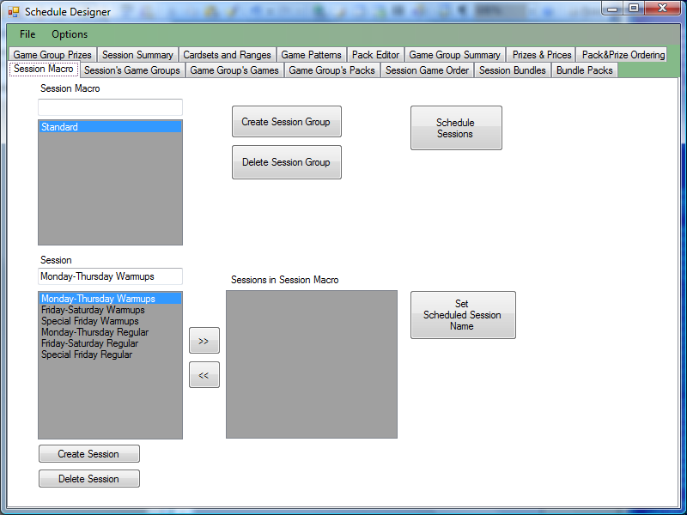

On the menu is a File menu
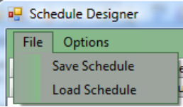

Here are options to save the schedule; which writes the entire schedule to an XML file; and to Load the schedule; Reads the entire schedule from an XML file. Before making any changes, it is highly recommended to save the current schedule to a file, which may be used to restore unwanted changes by loading it. A standard windows file explorer window is shown to select file to load, and where to save the file…

Save Schedule Dialog

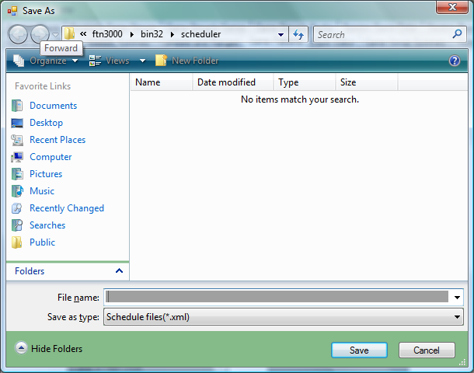

Load Schedule Dialog

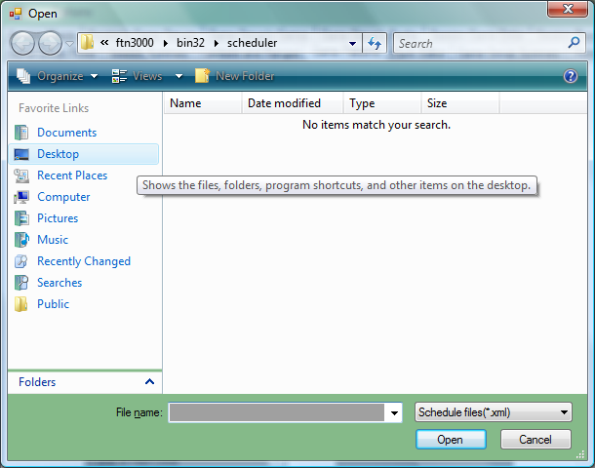

Enable Editing

Editing must be enabled before the editor will allow changing members of groups. Editing is enabled on the menu under ‘Options’
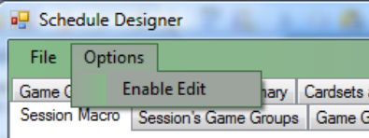

Selecting this menu option enables editing. Which allows changing of what members are in each group.

A Brief Overview
This schedule is based on schedule objects containing other objects.

A Calendar Day contains 1 Session Macro.
A Session Macro contains 1 or more Sessions.
A Session contains 1 or more Game Groups.
A Game Group contains Packs and Games and Prizes.
A Pack defines a set of bingo cards to play.
A Game contains one or more Patterns.
A Prize defines a payout for a group of games.

Each Game within a Game Group may have a prize defined for it.
Each Pack within a Game Group may be associated with one or more prizes.

Every Pack must have a unique name.
Every Game must have a unique name.
Every Game Group must have a unique name.
Every Session must have a unique name.
Every Prize Level must have a unique name.

Session Macro
The first tab is Session Macro. Session Macro contain a set of sessions scheduled for a day. Selecting the ‘session macro’ shows the sessions that are scheduled in the session macro.

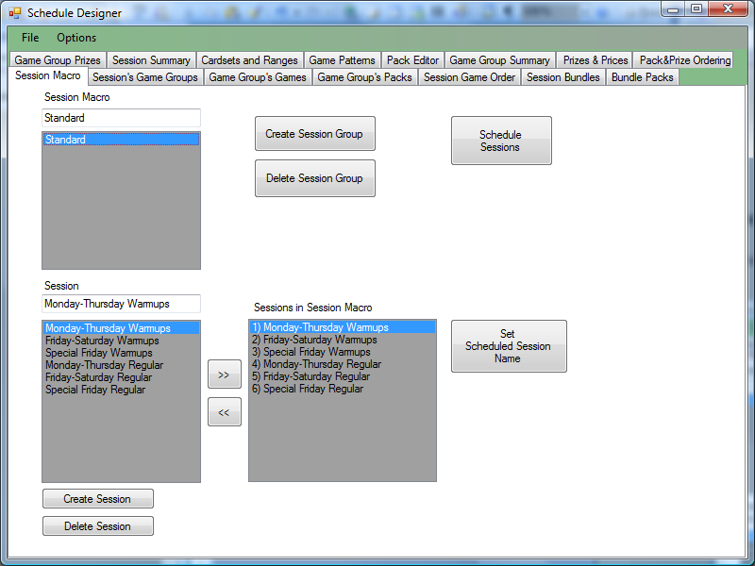

If a new session is desired, there is a ‘Create Session’ button.

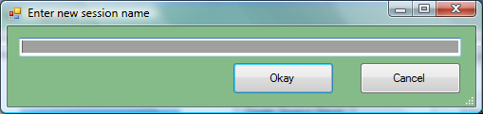
Enter the name of the new session. This must be a unique name.

Unused sessions may be deleted by selecting the appropriate session and clicking ‘Delete Session’. Again, changes are made immediately, and there is no Undo or warning.

To add a session to the session macro, either double click on the session name under ‘Session’ list, or select it and use the  button.

If a session is no longer played in a macro, double click on the session in the ‘Session in Session Macro’ list, or select the item in the right side list and use the  button.

The button ‘Set Scheduled Session Name’ may be used to provide an alternate name for the session when in a session macro. [This is used when there are like 8 sessions a day, that are all basically the same, the same session would be used 8 times, and a separate name per session would be defined]

Scheduling a Session Macro…

A Session Macro is scheduled for a day using the ‘Schedule Sessions’ Button, and brings up a dialog which looks similar to…

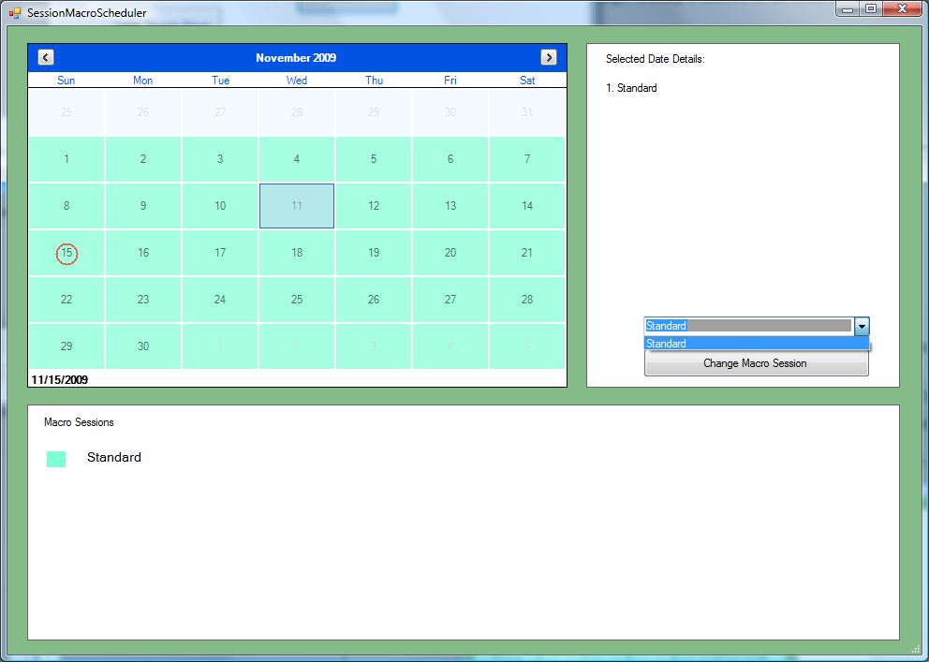

Select a day or days.
Select a session macro in the Combo-box (shown here dropped with just ‘Standard’ in the list).
Click the ‘Change Macro Session’ Button to apply that Session Macro to the selected days. Each Session Macro is indicated in a separate color on the calendar when changed.

Typically there is a single Session Macro on all days, and Sessions are added and removed from the Session Macro.

Session’s Game Groups
Each session has one or more groups of games in it. These are called game groups.
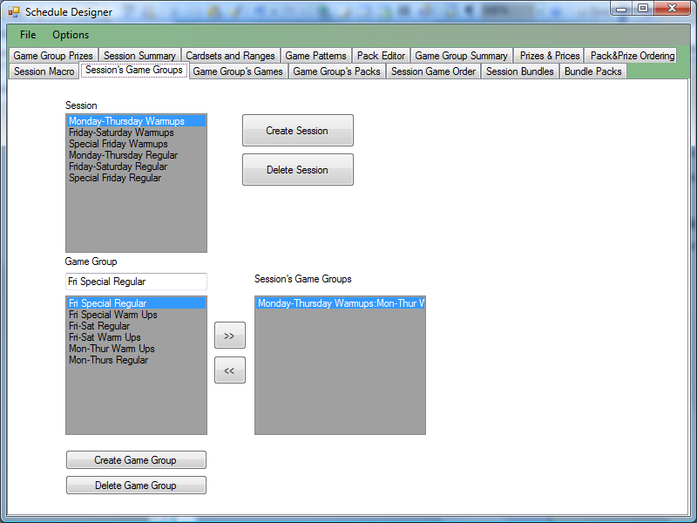

New game groups may be created here with the ‘Create Game Group’ Button. A simple dialog asking for a name will appear.

Game Group’s Games
Each game group has multiple games in it.
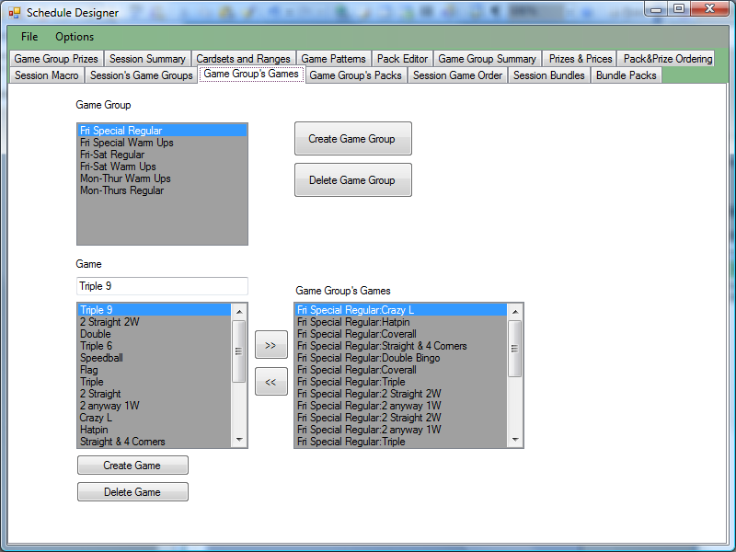

This dialog works much like session macro. Add games to the selected game group, you may double click on the game to add, or remove, or you may use the >> and << buttons to move the selected game into or out of the game group.
Game Group’s Packs
A game group has packs associated in it. (For this installation, we do not track packs)
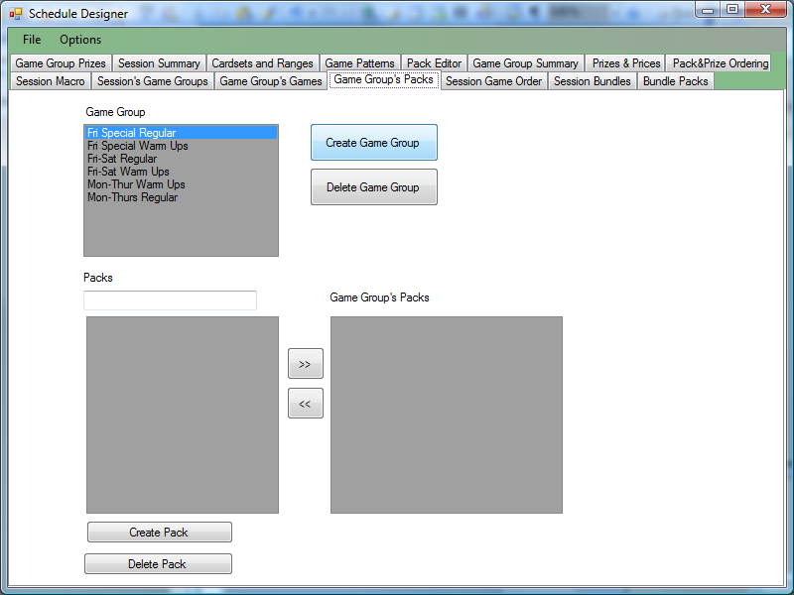

If barcoded paper or Fortunet electronic units are used, packs would be scheduled into Game Groups.

Session Game Order
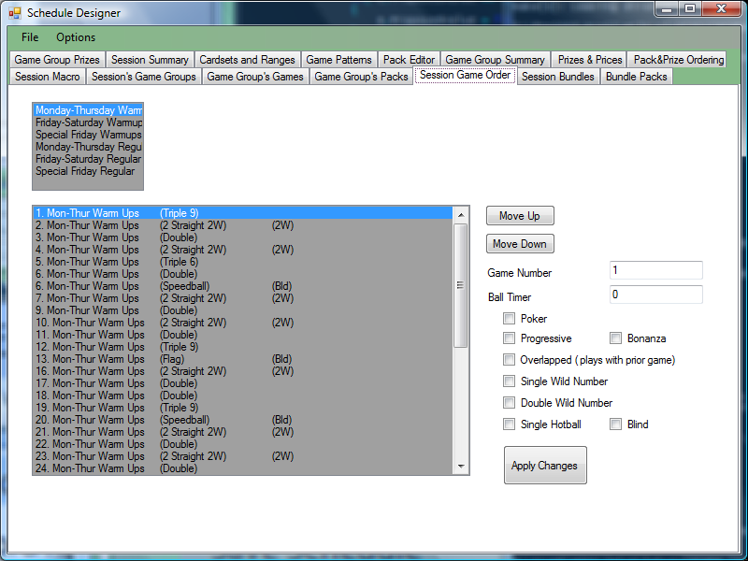

This page controls the order of all games in game groups in a session. Selecting a game you may change its order with the ‘Move Up’ and ‘Move Down’ buttons. This is where attributes of a game such as ‘Wild’ or ‘Double Wild’ are set.

Ball Timer may be set here. Setting 0 as the ball timer will just keep whatever the last ball timer was. [ If you set the timer in game 1 to 12, and game 2,3,4 all to 0, it will stay at 12]

Check Boxes
Poker – Unused
Progressive – This game progresses into the next game (changing games does not drop the balls)
Bonanza – This automatically enables the Bonanza mode.
Overlapped – This may combine multiple games into a single game (more on this if packs were used)
Single Wild Number – when starting the game, the first ball called will be wild according the the last digit of the ball. All balls ending with the last digit of the first ball are marked.
Double Wild Number – when starting a game, the first two unique digits on balls called will be wild. (All balls ending with each unique digit are marked automatically)
Single Hotball – unused
Blind – Set the blind call mode, where only the last number called is shown on the flashboard.

You may manually set the Game Number. This does not change the ordering, but if the list is for some reason not numbered correctly, this allows manual fixups. If you enter a new number, and the next item (it only checks the NEXT game) in the list is already that number, an option dialog appears, asking if you want to adjust all further games to +1 number from here
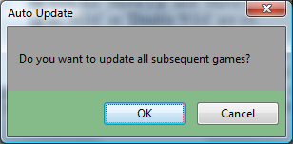

Selecting yes will add one to each game after the game being changed. (moves the whole list +1 number).

If you enter a number lesser, and the next game is +1 from the current game (is already in sequence) a dialog appears asking if you want to move all subsequent games (games after the currently selected game) down X numbers.
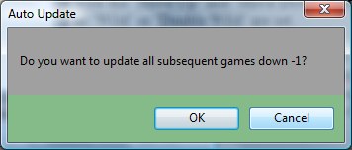

This allows gaps to be closed… if the games were numbered 1,2,3,4,8,9,10,11; then you might want to change game 8 to game 5, which will offer the option to update games 9,10, and 11 all together [ to 6,7,8].

If the games are numbered 1,2,3,4,4,5,6,7; then you might want to change the second game 4 to 5, which will offer the option to automatically renumber 5,6,7 all together [ to 6,7,8].
‘

Session Bundles
Not used.

Bundle Packs
Not used

Game Group Prizes
Each group of games has a prize or prizes associated with it.
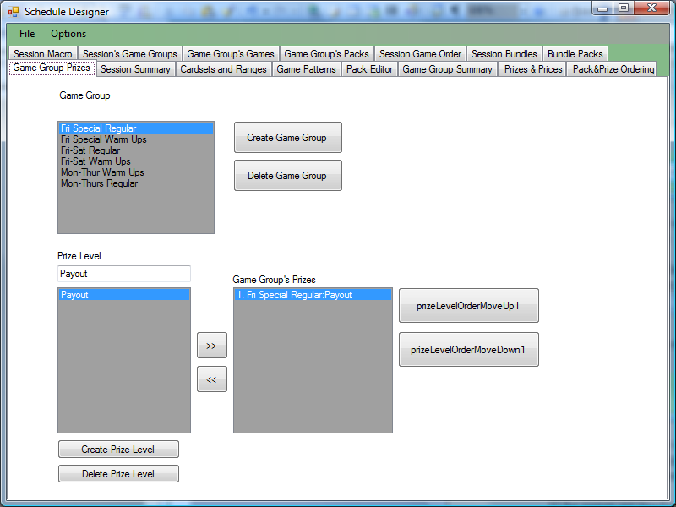

Many schedules just have a single prize level, but some have Level 1, Level 2, etc prizes.

Session Summary
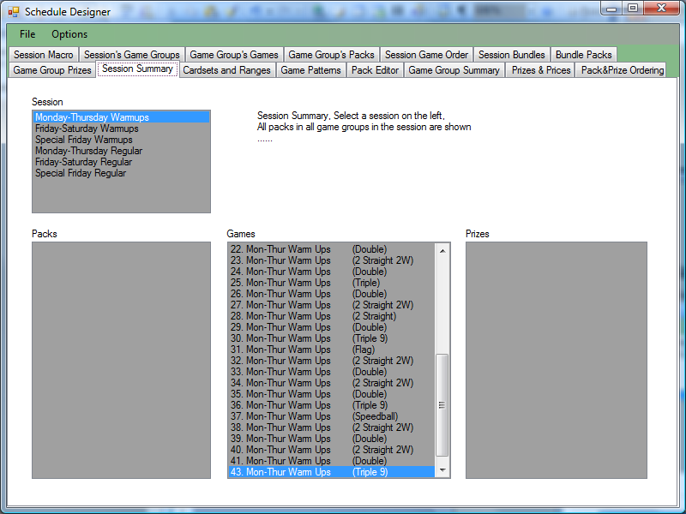

This page shows all packs, games and prizes associated in a session. (It should show prizes, it is currently broken)

Cardsets and Ranges
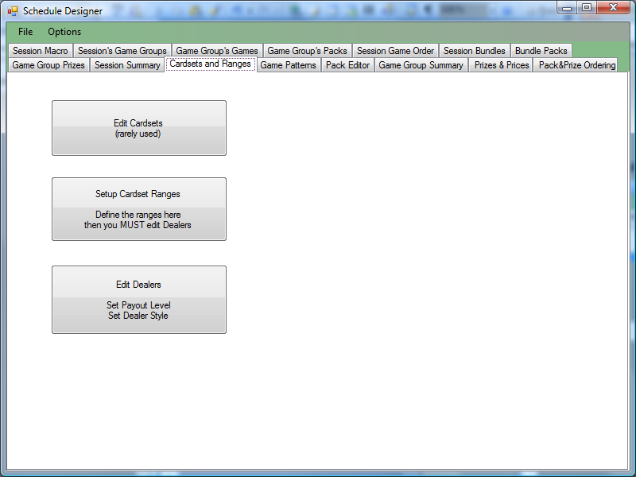

Edit Cardsets – Brings up a dialog to enter new card-sets.
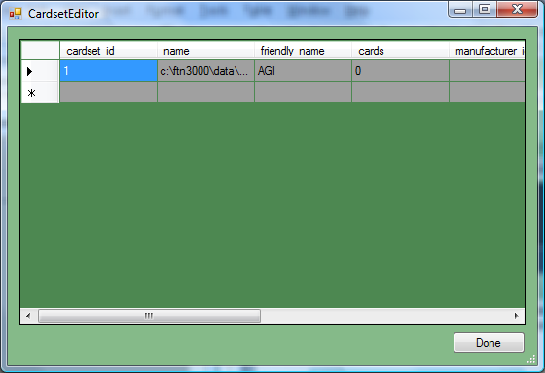
Name – this is the cardset file name (on the local drive)
Friendly_Name – this is the name shown
Other fields don’t matter.

Setup Cardset Ranges
Setup ranges within cardsets – not used
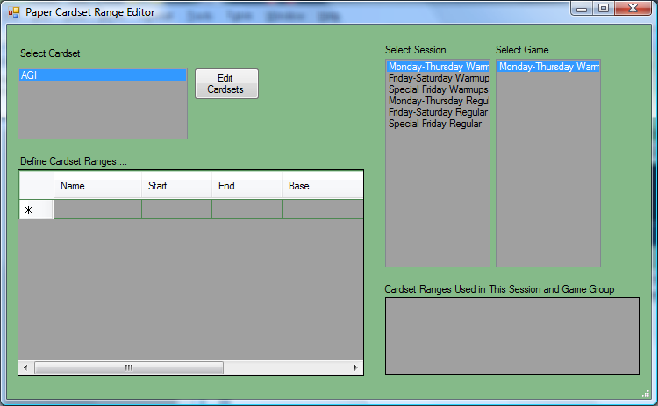

Selecting the cardset in the top left list, will show ranges defined in the lower grid. The names of ranges must be unique. (The name must be unique for all card ranges, even if they are in a different cardset). The start and end of the range is set here. The base and offset of the range within the cardset is also set. There are additional check boxes to the right that may be used to mark if the range is barcoded paper or electronic.
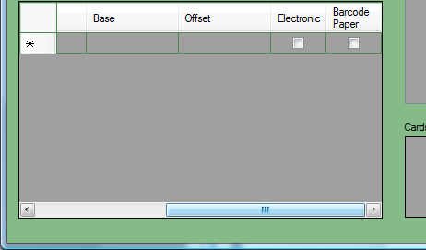

The check marks influence how the card is verified. If electronic, the sale is looked up in the elctronics database to verify the sale. If barcoded, the sale is looked up in paper transaction. If neither is set, then the face is checked and the sale is not verified.

Edit Dealers
Sets up how cards are dealt in electronic units – not used.
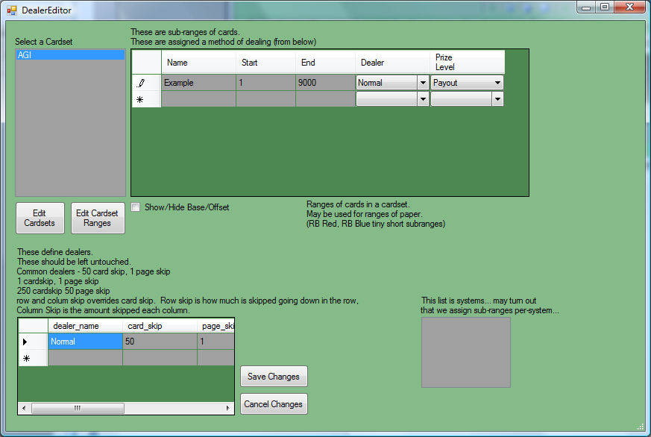

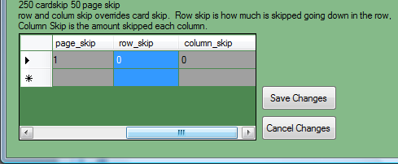

Dealers define how cards are sold. Barcoded paper and Electronics both require the layout of the page to be defined. The first options for the dealer is the name of the dealer [Normal for instance], the card skip is how many cards are skipped between each subsequent card, the page skip is how many cards are skipped from the first card between each page in a pack. (Each page has the page skip added, and then each card in a page has the face skip added). Additional features allow definition of ‘Row Skip’ and ‘Column Skip’ so instead of just card count, the skip between each column (vertical set of cards) and each row (horizontal set of cards). [Large Rainbows have a column skip of 6000, and a row skip of 50] If Row and Column are meant to be used, the card skip should be set to 0.

Each range of cards in a cardset is assigned a dealer, and a prize level. Only ranges defined completely (with cardset and prize level associated) are valid to be verified.
Game Patterns
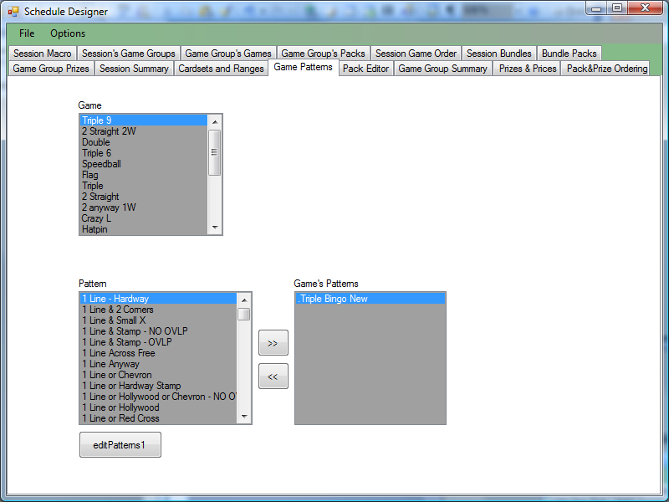

This page assigned patterns to games. Select the game in the top list, and add patterns to it or remove patterns from it by double clicking in the left Pattern list or the right Game’s Pattern list appropriately, or by making selections in either list and using the ‘<<’ and ‘>> buttons.

At the bottom of this page is a button ‘editPatterns1’ Clicking this button shows the pattern editor.

Pattern Editor
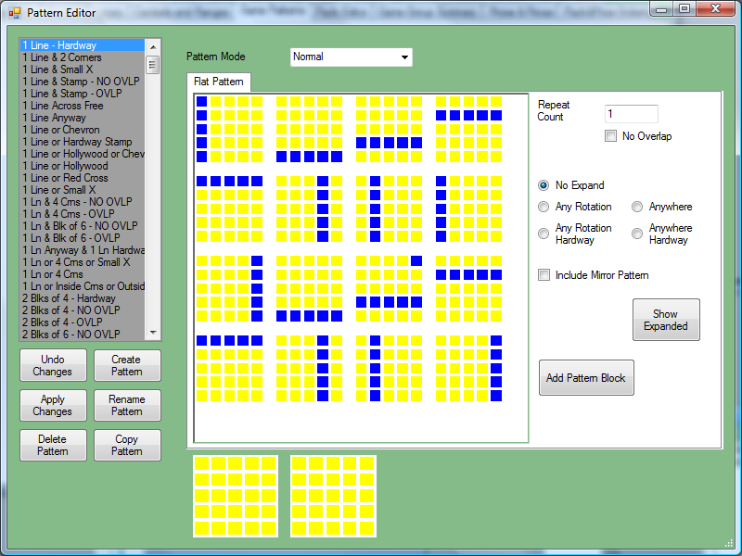

Patterns are listed on the left.

Normal pattern mode works.

Create Pattern – shows a dialog prompting for a name of the pattern to create.

Copy Pattern – shows a dialog prompting for a new name of the currently selected pattern, which is copied and given the name entered.

Rename Pattern – just changes the name of the currently selected pattern.

Delete Pattern – deletes the selected pattern from the list of patterns

Apply Changes – only applies to reading the pattern blocks and setting them in the selected pattern. If Apply changes is not clicked before changing patterns, all changes are lost.

Cancel Changes – this clears any changed pattern blocks, and reverts back to the pattern’s current definition.

Add Pattern Block to add a new empty block to be part of the pattern.

The option buttons ‘No Expand’ is basically all the blocks showing in the pattern are exactly the pattern, nothing more.

(Actually the pattern expand modes do not work in the smart-desk software at this time, so all patterns must be defined long-hand).

Double click on a pattern block will show a large block to edit; You may just click on a block and set the mask on or off. (Patterns spots required to mark are shown in blue, pattern spots in yellow are not meant to be marked).

Pack Editor

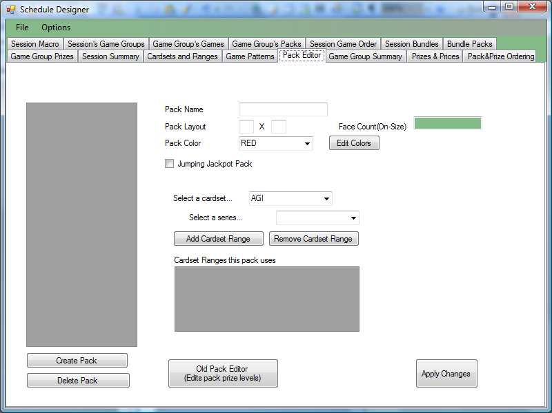

Game Group Summary
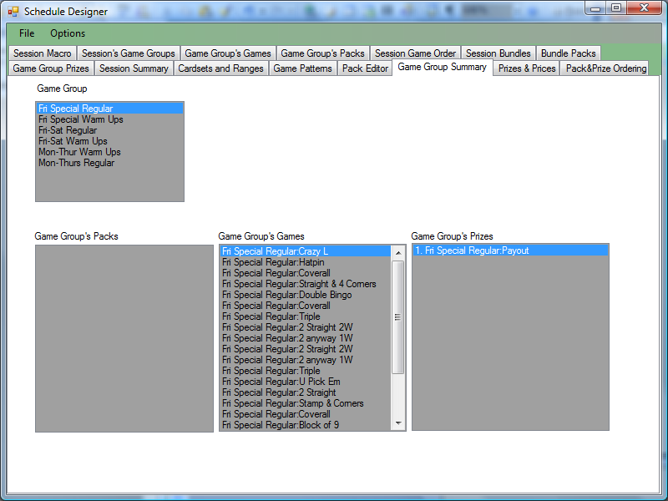

This is just a summary of packs, games and prizes assigned within a game group.

(A Session may contain multiple game-groups, so it’s summary is the same, but different.)
Prizes and Prices
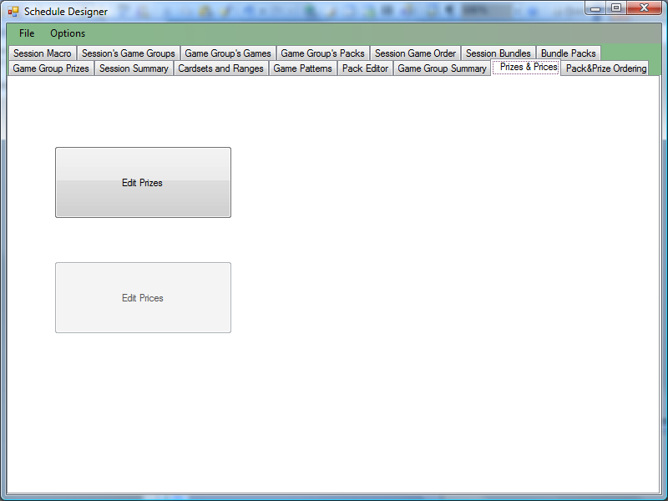

Edit Prizes form shown below.
Regular Prize Editor
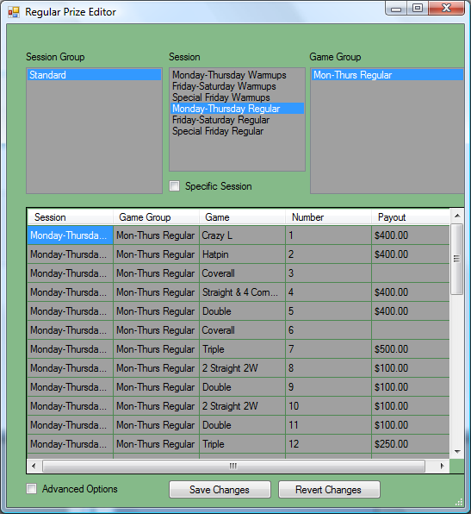

Save Changes must be used before changing Session Group, Session, or Game Group otherwise all changes to prizes will be dropped.

The above sample form shows a single payout level in these games.

Select a session-group, select a session within that group to edit, and select a specific game group to edit.

Game Groups have prize levels, so it will determine how many prizes per game are set.

Advanced options enabled on Prize editor…

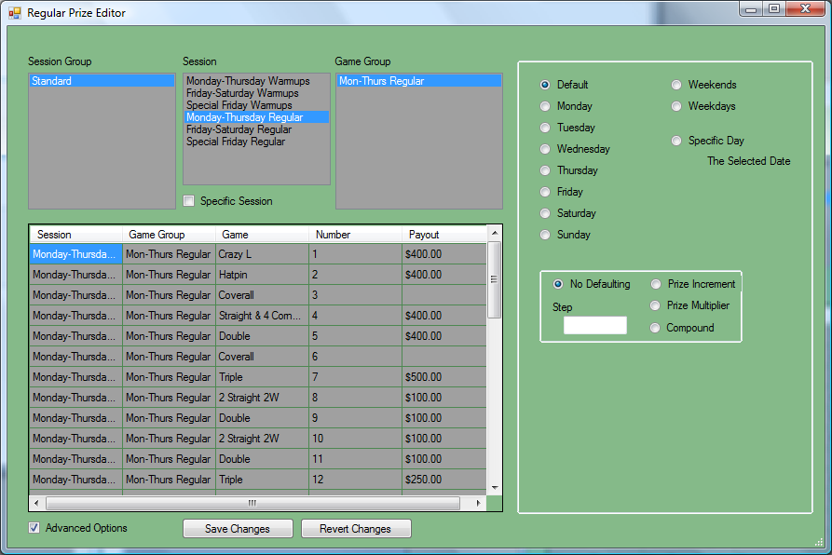

If the ‘Advanced Options’ option is checked, additional settings for day of week, weekday, weekend, and specific day can be set.

Multipliers per level can be determined (so you can set the first level prize, and auto-fill subsequent levels (times 2 multipler, or +50 or … )

Pack and Prize Ordering
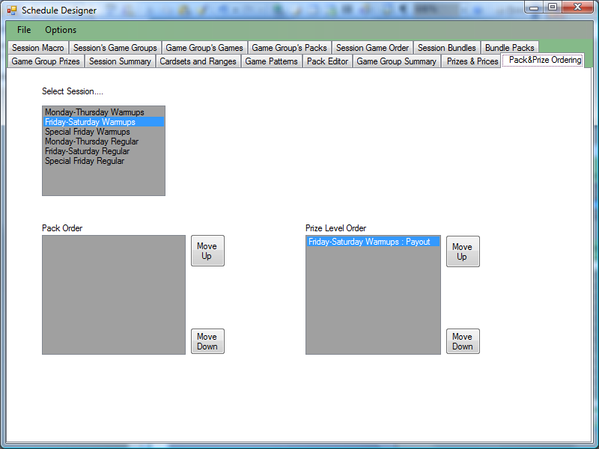

Unused.

Schedule Internal Design

Depending on the database version there will be a prefix prepended to tables...
version 2 prefixes : elec_sch2_/sch2_
Standard design; really 1.0 of the c# schedule is this; Games are in game groups which are in sessions. In version 2 there are a set of tables defining the cardsets, ranges and dealers that for some reason have a different name prefix; all subsequent versions fix this.
Packs relate to game groups, and prizes relate to game groups.

version 3 prefixes : elec_sch3_/elec_sch3_
Same structure as version 2, but uses GUIDs for key relations.

version 4 prefix : bingo_sched_
Packs relate to prizes directly instead of being related in the same game and having an additional relation to bind the packs to the prize levels.

version 5 prefix : bingo_sched2_
Same as version 4, but uses GUID for key relations.

version 6 prefix : elec_sch4_
games are related to sessions and ordered in that relationship; instead of being assigned within game groups which are in sessions.

Version 7 prefix : elec_sch5_
Same as version 6, but uses GUID for key relations.

Version 6a prefix : bingo_sched3_
Same as version 6, exept (same change as version 4)

Version 7a prefix : bingo_sched4_
Same as version 7, exept (same change as version 4)

Top level tables
session_macro_info
session_info
game_info
pack_info
prize_levels

First level relations

Relation name | Parent | Child
session_macro_session | session_macro_info | session_info
session_game | session_info | game_info
session_pack | session_info | pack_info
parent_child | parent | child
parent_child relation is build automatically from the parent's name with _info suffix trimmed and singularized, the child table name is similarly stripped of _info suffix and singularized.

Since this is built with code, it's hard to break the naming convensions, and tables will be created the same.

Relation names between tables are also automatically built and on the parent side to the relation table would be "parent_has_child" where parent would be substituted with the appropriate stripped table name and child would be the appropriate stripped name.

Tables which end in _info or _description have that suffix removed. Tables are singularized when stripped.

