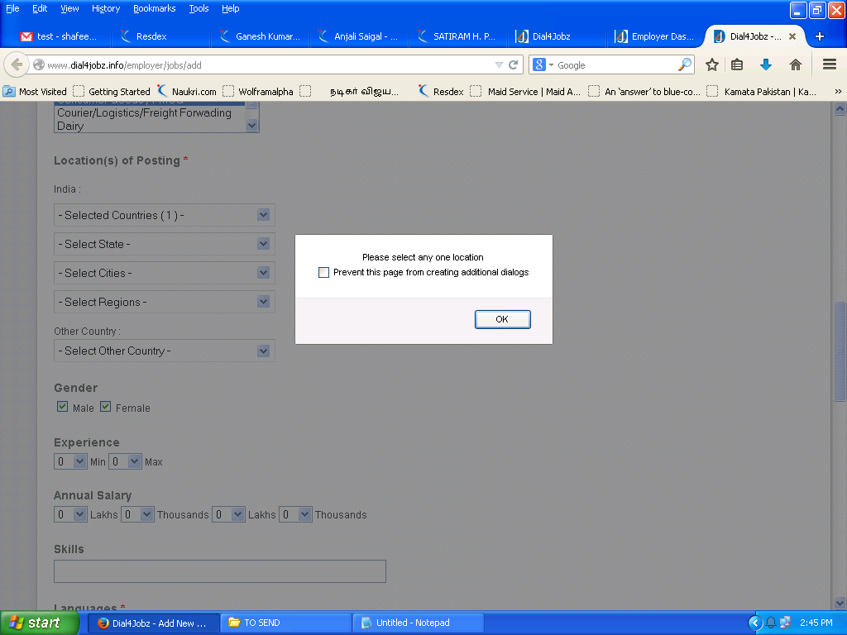

Why this ??? when we click the location

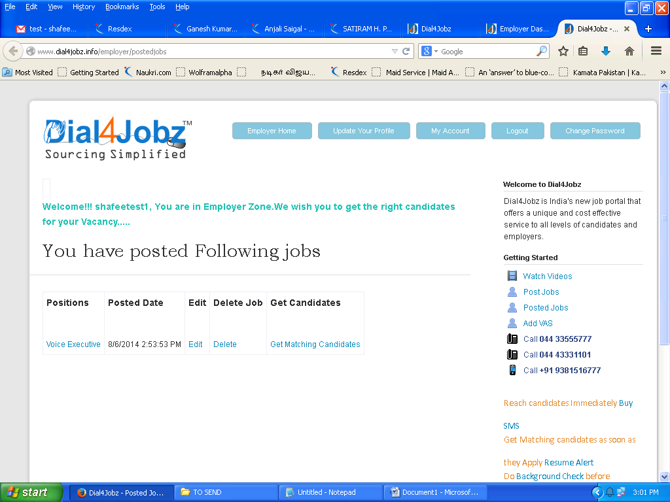

**ADD VAS Tab should be next to get candidates for easy access**

**Error Page after payment as follows**

**Server Error in '/' Application.**

***Security Exception***

**Description:** The application attempted to perform an operation not allowed by the security policy.  To grant this application the required permission please contact your system administrator or change the application's trust level in the configuration file.   
  
**Exception Details:** System.Security.SecurityException: That assembly does not allow partially trusted callers.  
  
**Source Error:**

|  |
| --- |
| An unhandled exception was generated during the execution of the current web request. Information regarding the origin and location of the exception can be identified using the exception stack trace below. |

**Stack Trace:**

|  |
| --- |
| [SecurityException: That assembly does not allow partially trusted callers.]  Dial4Jobz.Controllers.EmployerVasController.CCAVRequest(FormCollection collection) in EmployervasController.cs:1048  lambda_method(Closure , ControllerBase , Object[] ) +100  System.Web.Mvc.ActionMethodDispatcher.Execute(ControllerBase controller, Object[] parameters) +14  System.Web.Mvc.ReflectedActionDescriptor.Execute(ControllerContext controllerContext, IDictionary`2 parameters) +194  System.Web.Mvc.ControllerActionInvoker.InvokeActionMethod(ControllerContext controllerContext, ActionDescriptor actionDescriptor, IDictionary`2 parameters) +27  System.Web.Mvc.<>c__DisplayClassd.<InvokeActionMethodWithFilters>b__a() +56  System.Web.Mvc.ControllerActionInvoker.InvokeActionMethodFilter(IActionFilter filter, ActionExecutingContext preContext, Func`1 continuation) +256  System.Web.Mvc.<>c__DisplayClassf.<InvokeActionMethodWithFilters>b |