Finite Element Method
Final Project
機械系 陳建鳴 E14026046

公式整理

Bar Problem

程式說明

Programming Language – Matlab
MATLAB是一種用於演算法開發、資料視覺化、資料分析以及數值計算的高階技術計算語言和互動式環境。除了矩陣運算、繪製函式/資料圖像等常用功能外，MATLAB還可以用來建立使用者介面及與呼叫其它語言（包括C,C++,Java,Python和FORTRAN）編寫的程式。－維基百科

Functions
% Return meshed points
% X, Y: Boundary points
% rN, cN: Number of row and column
[x y] = MESH(X, Y, rN, cN)

% Return global K matrix with rN*cN mesh
k = Kg(rN, cN)

% Return local K matrix of (r, c) element
k = Ke(r, c)

% Return B matrix at (xi, eta) of (r, c) element
b = Be(xi, eta, r, c)

% Return dN/dx at (xi, eta) of (r, c) element
r = DNDX(xi, eta, r, c)

% Return Jacobian at (xi, eta) of (r, c) element
j = JAt(xi, eta, r, c)

% Return dN/dxi at (xi, eta)
b = dNAt(xi, eta)

% Return global force vector of the distributed load
f = Fg()

% Solve the equation K*d=F, return d vector as result
d = SOLVE(K, F, d)

% Calc Gaussian elimination of extend matrix A
x = gaussElim(A)

% Return stresses on the Gaussian points by res(result)
% Return: s(stresses), gp(coordinate of gaussian point)
[s gp] = STRESS(res)

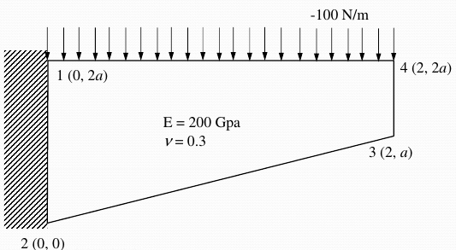
討論

Compare with exact solution
 |  | 1x1 mesh |  | 1x2 mesh |  | 20x40 mesh
 |  | Value | Error | Value | Error | Value
Disp
(m)
Stress
(MPa)
表一 1x1 & 1x2 mesh
 |  | 1x4 mesh |  | 4x2 mseh |  | 20x40 mesh
 |  | Value | Error | Value | Error | Value
Disp
(m)
Stress
(MPa)
表二 1x4 & 4x2 mesh

圖一 1x1 Mesh

圖二 1x2 Mesh

圖三 1x4 Mesh

圖四 2x4 Mesh

圖五20x40 Mesh

圖六 100x100 Mesh

Effect of parameter a

Effect of mesh density
從圖一～圖六可發現，Mesh row的數量會影響x方向位移的準確度，而column的數量會影響y方向位移的準確度

Stress on boundary

Stress on Gaussian point

