Finite Element Method
Project 1 & 2
機械系 陳建鳴 E14026046

公式整理

Bar Problem

Beam Problem

程式說明

Programming Language – Golang
Go，又稱golang，是Google開發的一種靜態強型別、編譯型，並發型，並具有垃圾回收功能的程式語言。－維基百科

Data Structure
// Linear-element FEM solver for bar
// k: local stifness matrix
// K: global stifness matrix
// Ne: amount of element
// No: order of shape function
// Ng: amount of gaussian points
// Le: lenth of each element
// E: Young's modulus of each element
// A: area of each element
// u: displacement vector
// f: force vector
// uNod, uVal: displacement boundary condition
// fNod, fVal: force boundary condition
type FEMsolver1dBar struct {
k, K *mat64.SymDense
Ne, No, Ng int
Le, E, A, u, f *mat64.Vector
uNod, fNod []int
uVal, fVal []float64
}
// Linear-element FEM solver for beam
// k: local stifness matrix
// K: global stifness matrix
// Ne: amount of element
// No: order of shape function
// Ng: amount of gaussian points
// Le: lenth of each element
// E: Young's modulus of each element
// A: area of each element
// d: displacement vector
// f: force vector
// dNod, dVal: displacement boundary condition
// fNod, fVal: force boundary condition
type FEMsolver1dBeam struct {
k, K *mat64.SymDense
Ne, No, Ng int
Le, E, I, d, f *mat64.Vector
dNod, fNod []int
dVal, fVal []float64
}

Functions
// Build a vector from nod and val
// nod: an array of node number which has value
// val: value of the node
func BuildVec(nod []int, val []float64, vec *mat64.Vector)

// Calculate Gaussian Quadracture of f from a to b with num Gaussian point
func GausQuad(f func(float64) float64, a, b float64, num int) float64

// Get the value of Gaussian points and the weight. Currently maximun num is 4.
func getGausQuadPoint(num int) (pt, w []float64)

// Change the interval from a, b to -1, 1
func changeInterval(f func (float64) float64, a, b float64) func (float64) float64

// Get differential of a function by Symmetric derivative
func d(f func (float64) float64) func (float64) float64

// Create a FEMsolver1dBar
func NewFEMsolver1dBar(No, Ne int, Le, E, A, u, f *mat64.Vector, uNod, fNod []int, uVal, fVal []float64) *FEMsolver1dBar

// Create a FEMsolver1dBar with const Le, E and A
func NewFEMsolver1dBarConstLeEA(No, Ne int, Le, E, A float64, u, f *mat64.Vector, uNod, fNod []int, uVal, fVal []float64) *FEMsolver1dBar

// Create a FEMsolver1dBeam
func NewFEMsolver1dBeam(No, Ne int, Le, E, I, d, f *mat64.Vector, dNod, fNod []int, dVal, fVal []float64) *FEMsolver1dBeam

// Create a FEMsolver1dBeam with const Le, E and I
func NewFEMsolver1dBeamConstLeEI(No, Ne int, Le, E, I float64, d, f *mat64.Vector, dNod, fNod []int, dVal, fVal []float64) *FEMsolver1dBeam

For both bar and beam, I have
// Return shape function of e-th element
func (fem *FEMsolver1dBar) NElem(j, e int) func(float64) float64
func (fem *FEMsolver1dBeam) NElem(j, e int) func(float64) float64

// Return derivative shape function of e-th element
func (fem *FEMsolver1dBar) BElem(j, e int) func(float64) float64
func (fem *FEMsolver1dBeam) BElem(j, e int) func(float64) float64

// Add body force (or distributed force) b to the solver
func (fem *FEMsolver1dBar) AddBodyForce(b func(float64) float64, Ng int)
func (fem *FEMsolver1dBeam) AddBodyForce(b func(float64) float64, Ng int)

// Calculate local k matrix
func (fem *FEMsolver1dBar) CalcLocK()
func (fem *FEMsolver1dBeam) CalcLocK()

// Calculate the global K matrix
func (fem *FEMsolver1dBar) CalcK()
func (fem *FEMsolver1dBeam) CalcK()

// Solve the problem
func (fem *FEMsolver1dBar) Solve()
func (fem *FEMsolver1dBeam) Solve()

// Get stress at x
func (fem *FEMsolver1dBar) Stress(x float64) float64
func (fem *FEMsolver1dBeam) Stress(x float64) float64

// Get displacement at x
func (fem *FEMsolver1dBar) Disp(x float64) float64
func (fem *FEMsolver1dBeam) Disp(x float64) float64

討論

Bar Problem

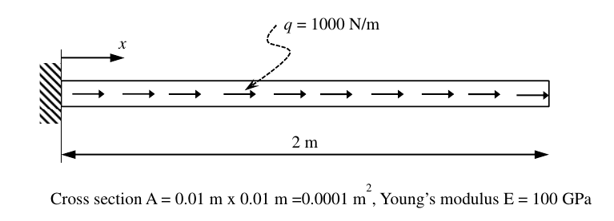
Compare with exact solution
 |  | Two 2-node element |  | Eight 2-node element |  | Exact Solution
 |  | Value | Error | Value | Error | Value
Disp  (m) | d(0.5) | 7.5e-5 | 14% | 8.75e-5 | 0% | 8.75e-5
Disp  (m) | d(1.5) | 1.75e-4 | 7% | 1.875e-4 | 0% | 1.875e-4
Stress  (MPa) | s(0.5) | 15 | 0% | 13.75 | 8% | 15
Stress  (MPa) | s(1.5) | 5 | 0% | 3.75 | 25% | 5
表一 兩節點元素
 |  | Two 3-node element |  | Two 4-node element |  | Exact Solution
 |  | Value | Error | Value | Error | Value
Disp  (m) | d(0.5) | 8.749e-5 | 0.011% | 8.75e-5 | 0% | 8.75e-5
Disp  (m) | d(1.5) | 1.8749e-4 | 0.005% | 1.875e-4 | 0% | 1.875e-4
Stress  (MPa) | s(0.5) | 14.9 | 0.067% | 15 | 0% | 15
Stress  (MPa) | s(1.5) | 4.9 | 0.2% | 5 | 0% | 5
表二 三節點元素與四節點元素

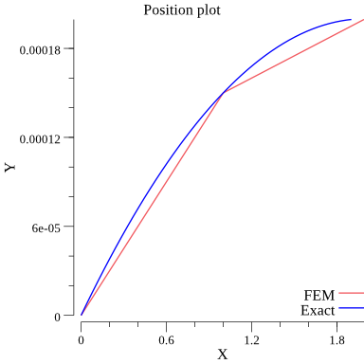
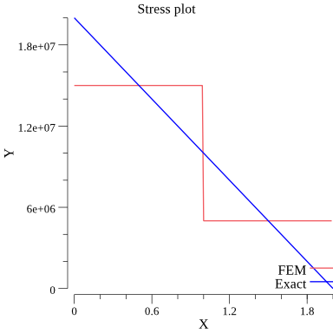
圖一 兩個兩節點元素
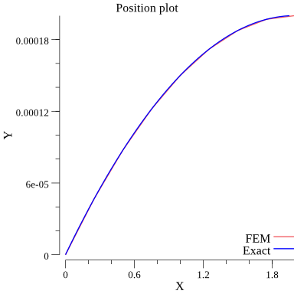
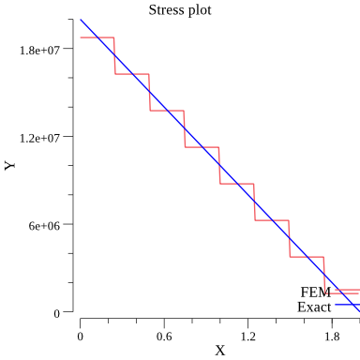
圖二 八個兩節點元素

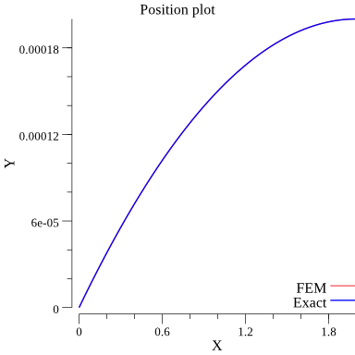
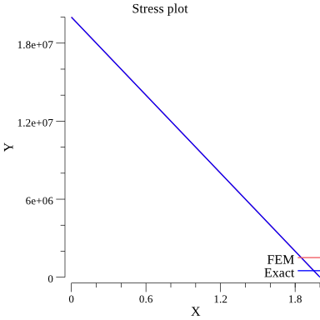
圖三 兩個三節點元素
圖四 兩個四節點元素

Concentrated load and distributed load
在計算Force vector時，分佈力無法直接使用而必須用Shape function去近似，而集中力可直接考慮作用在節點上的力，若Shape function的階數小於分佈力則會造成誤差。若力為集中力要注意集中力必須作用在mesh的節點上，否則會造成集中力沒被考慮到。

How the number of element affect the results
如表一所示，兩個兩節點元素時，因為x=0.5、1.5在元素內部，且Shape function為線性，位移的誤差較大，而八個元素因為兩個點剛好位於節點上，位移的值是準的。
但考慮應力時，則是相反的結果，元素內部的應力值會比較準，節點上是最不準的。
以上可歸納出節點數量越多可讓節點分佈得更密集，位移的值也會更接近Exact solution，同時節點跟節點間更接近也會縮小Stress的誤差。

How the type of element affect the results
如表二所示，兩個三節點元素時位移和應力都已經十分接近Exact solution，但仍有些許誤差，到了四節點元素時幾乎無誤差。
元素的節點數增加表示Shape function的階數增加，可以更準確的近似位移函數，以此題來說位移函數為二次曲線，理論上三節點元素就應該可以有很好的近似，誤差可能來自於高斯積分。

How to reduce the error when Young’s modulus or cross section varies with x
若節面積或楊氏模數會隨著x變化，會增加Exact solution的階次，可透過增加Shape function的階次、增加元素數量、增加高斯機分點數量等方法來降低誤差

Beam Problem

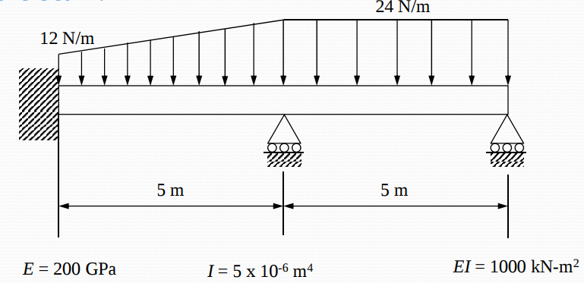
Compare with exact solution (Problem in ch7)
    - Displacement at node
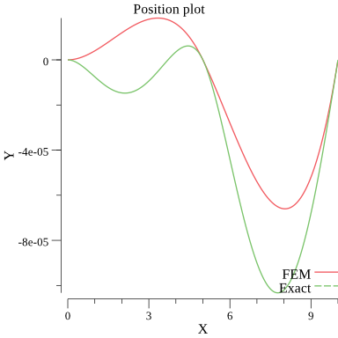
圖一 兩個元素
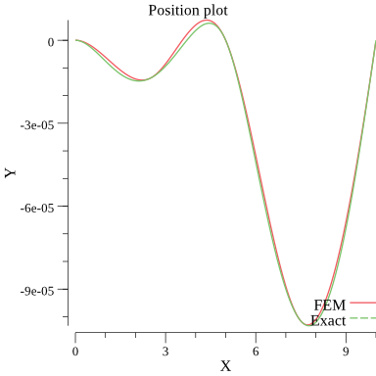
圖二 四個元素
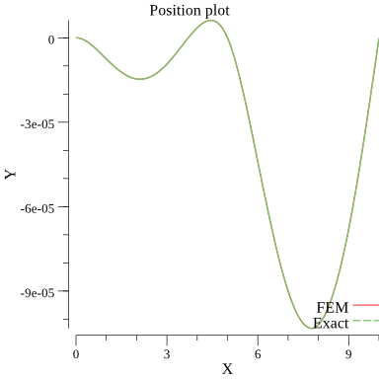
圖三 十個元素

    - Stresses at node and Gaussian points
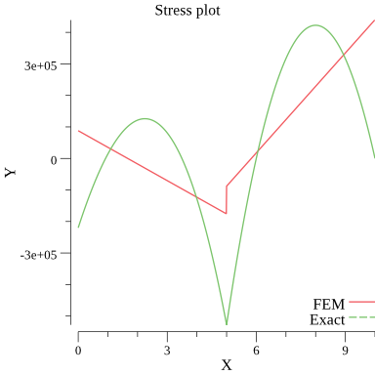
圖四 兩個元素
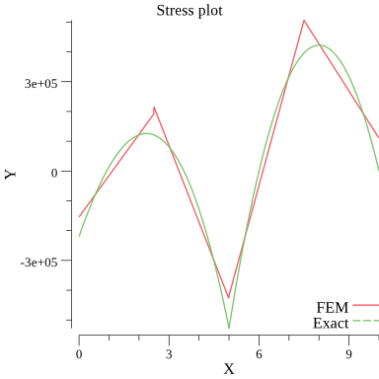
圖五 四個元素
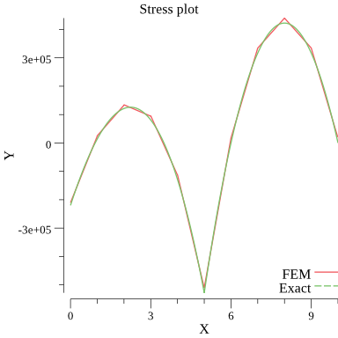
圖六 十個元素

How the number of element affect the results
    - Displacement
從圖一～圖三可以發現元素的數量越多位移越接近Exact solution，且在節點上的值會比較準確、在元素內部的點誤差較大。從圖二可以觀察到，前後半段比較的話後半段的誤差較小，因為前半段的分佈力是一次式，而後半段為常數，次方差一次，積分後得到位移分別為五次及四次，後者與Shape function的差異較小，因此誤差也會較小。
    - Stress
從圖四～圖五同樣可發現元素的數量越多應力越接近Eaxct solution，且在高斯積分點上的值會比較準確、在節點上的值誤差最大。從途中可以發現在節點處會有值不連續的狀況，這是因為應力值與位移的兩次微分有關，且不同的元素有自己的Shape function微分兩次後的值會有所差異。

