Internet Technologies – Lab #6: JavaScript on the backend part 2

Use of AI for this assignment: FORBIDDEN

**Assignment A – 10 points**

Implement a server-side application fulfilling the requirements below. You can use pure Node.js or Express.js (recommended). Use your own creativity to complete the "missing" elements of the requirements. Implementations of all requirements can be presented within a single application, with the exception of requirement a) – which can be done as a separate script, without web interface. Ensure at least basic usability and readability.

1. Initialize a SQLite database, create two tables – one, which will serve as a dictionary table with a primary key column and one Text column, second which will serve as a “main” table, with primary key column, foreign key column (referencing the dictionary table) and at least 3 other columns. Fill the dictionary table with at least 5 rows of data. (2 pts)

1. Create a view displaying the contents of the main table. Do it in a tabular form, ensure reasonable formatting. Table should have two additional columns – in the first there should be a link or button leading to view allowing editing this row (requirement d) ), in the second there should be a link or button leading to view used for deleting this row (requirement e) (2 pts)

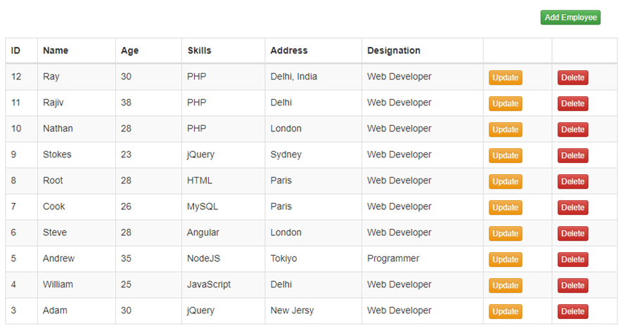

1. Create a view allowing the user to add new row to the main table. Validate data on the backend, execute the necessary SQL commands to insert a new row. Value of the field connected to the dictionary table should be selected using a dropdown using values from the dictionary table, view should be linked to from the page displaying table contents. Return to the main view (requirement b) ) afterwards (2 pts)
2. Create a view allowing the user to edit existing rows in the main table, run the necessary SQL commands to update the row. Validate data on the backend, value of the field connected to the dictionary table should be selected using a dropdown using values from the dictionary table. Return to the main view (requirement b) ) afterwards (2 pts)
3. Create a view allowing the user to confirm or cancel deletion of the row, execute the necessary SQL commands if user confirm deletion. Return to the main view (requirement b) ) afterwards (2 pts)