# Chapter 4: Using the WICED-SDK Library

## Objective

At the end of this chapter you should understand what is contained in the WICED-SDK library.

## Time: 15 Minutes

## Fundamentals

### WICED-SDK Library

At this point life is too short to develop all of the “stuff” that you might want to include in your IoT project. In order to accelerate your development cycle, the WICED SDK includes a bunch of code to handle many tasks that you might want to use in your design. If you look in the “libraries” folder you will find the following sub-folders:

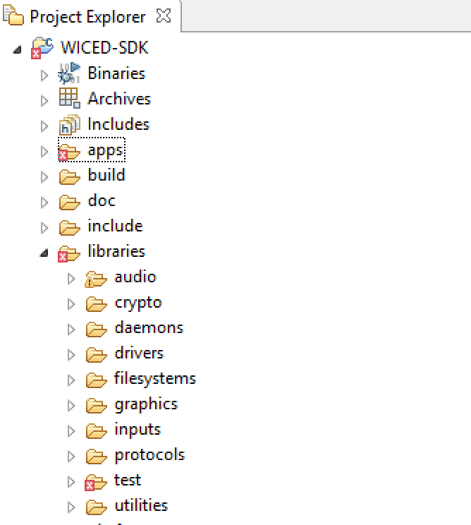

* **Audio:** Contains support for Appolo (a streaming audio standard), and codecs including Free Lossless Audio compression.
* **Crypto:** ?
* **Daemons:** Contains some typical “Unix” daemons to provide networking support including an HTTP Server, Gedday, TFTP, DHCP, DNS etc.
* **Drivers:** Contains hardware support files for SPI flash, USB etc.
* **Filesystems:** FAT, FILE and other file systems that could be written to an SPI flash.
* **Graphics:** Support for the U8G LCD displays.
* **Inputs:** Drivers for buttons and GPIOs.
* **Protocols**: Support for application layer protocols including HTTP, COAP, MQTT etc.
* **Test**:Tools to test network performance, iPerf, malloc, TraceX, audio.
* **Utilities**: Support for JSON, console, printf, buffers, etc.

## Exercise(s)

### 01 Browse the library directory to see what functions are available

### 02 Build and try the apps/test/console project

1. This project uses the Command Console library functions located in *libraries/utilities/command_console*.
2. Create a make target for *test.console* for your kit.
3. Program the project to your kit.
4. Open a terminal emulator to interact with the console.
5. Type “help” in the console to see available functions. Try using “scan” and “join”.

### 03 (Advanced) Build and try the iPerf performance testing application

1. Create a make target for *test.iperf_app* for you kit.
2. Program the project to your kit.
3. Open a terminal emulator.
4. Look at the *README-Iperf.pdf* file located inside the project folder for information on how to use Iperf.

### 04 (Advanced) Using the U8G graphics display on the shield (that does not yet exist) to display text