# Chapter 6: Putting/Getting data to/from the Cloud

## Objective

## Time: 4 Hours

## Fundamentals

### Networking Stack the Application Layer

http://microchip.wikidot.com/tcpip:tcp-ip-five-layer-model

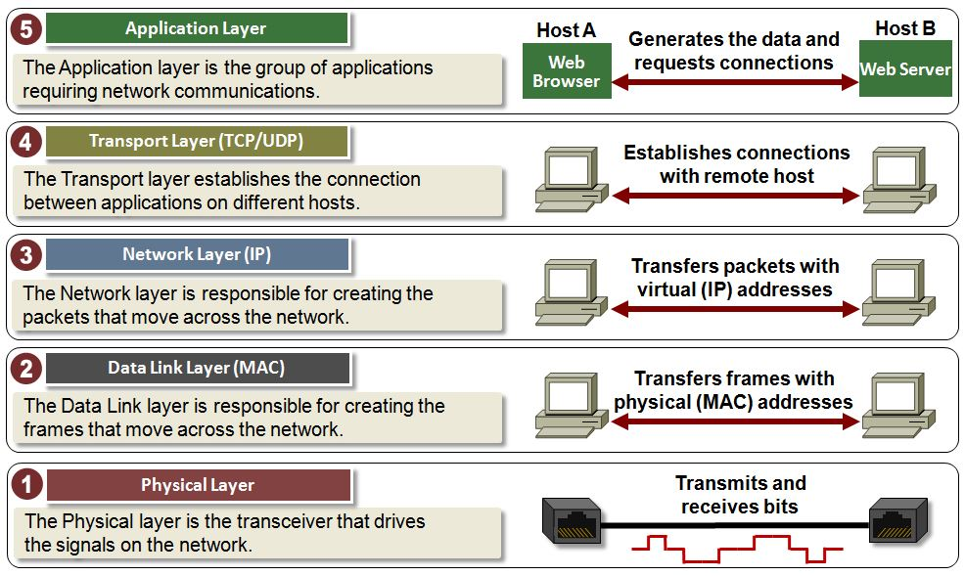

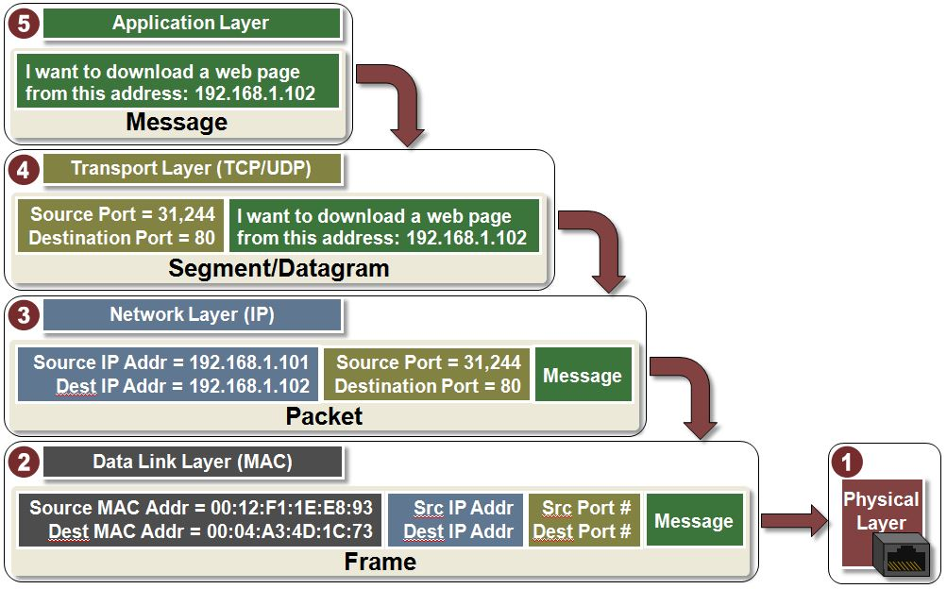

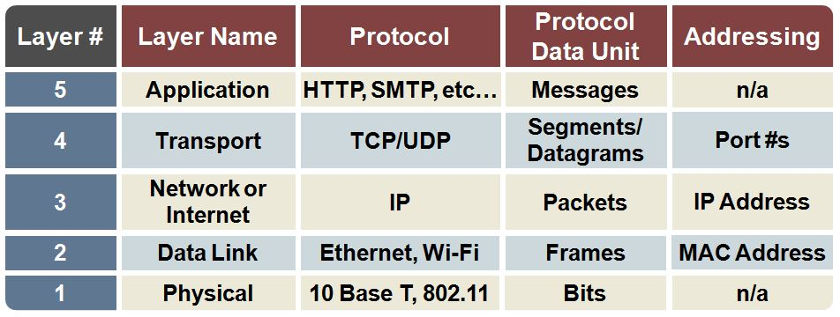

### (Application Protocol) HTTP

### (Application Protocol) MQQT

### (Application Protocol) COAP

### Sockets

### (Application Protocol) AMQP

### (Data Format) JSON

### (Cloud) AWS (MQTT)

#### <http://www.slideshare.net/PeterREgli/mq-telemetry-transport>

#### Introduction + Setup

#### Publisher

#### Subscriber

#### Shadow

### (Cloud) IBM Bluemix

### (Cloud) Ali

### (Cloud) Microsoft Azure

### (Cloud) Cypress (sockets)

## Exercise(s)

### Aws shadow

### Aws pub/sub